**Evaluation of Cardiovascular impact of Sodium Cyanide Exposure in Rabbits**

**ABSTRACT**

Cyanide is a fast acting, potentially and deadly chemical that can exists in various forms. Exposure to small amount of cyanide through breathing, absorption through the skin or foods may have some signs and symptoms within minutes such as dizziness, headache, nausea and vomiting, rapid breathing, rapid heart rate, restlessness and weakness. This study was designed to investigate cardiac marker levels in rabbits following administration of 0.05mg/kg sodium cyanide.The rabbits were grouped into treated and control, and the study lasted for thirty days, sixty days and ninety days respectively. Cardiac Markers investigated were Lactate Dehydrogenase (LDH), Creatine Kinase (CK) and Troponin (TP). The following were results of parameters investigated. Treated group for thirty days; LDH=183.70±2.46 IU/L, CK=259.20±2.55 IU/L, TP= 0.82±0.13 IU/L. Control group for thirty days; LDH=182.40±2.21 IU/L, CK= 237.10±1.67 IU/L, TP=0.41±0.08 IU/L. Treated group for sixty days; LDH=187.80±1.44 IU/L, CK=280.90±2.33 IU/L, TP=1.33±0.26 IU/L. Control group for sixty days; LDH=185.30±2.45 IU/L, CK=236.20±1.45 IU/L, TP=0.41±0.05 IU/L. Treated group for ninety days; LDH=189.30±0.41 IU/L, CK=296.30±2.18 IU/L, TP=1.87±0.12 IU/L. Control group for ninety days; LDH=184.50±2.35 IU/L, CK=236.70±1.57 IU/L, TP=0.40±0.05 IU/L. The results showed significant (p< 0.05) increase in the levels of cardiac markers in thirty days, sixty days and ninety days exposures respectively in treated group compare to control. These findings suggest that sodium cyanide is a potential toxic substance that could cause significant heart muscle damage and dysfunction in rabbits, which might worsen with increasing duration of exposure.

**Keywords**: Cardiac markers, Rabbits and Sodium cyanide.

**INTRODUCTION**

Cyanide is a fast acting, potentially and deadly chemical that can exists in various forms (Sanchez-Verlaan *et al*., 2011). The toxic effects of cyanide ion in humans and animals are generally similar and are believed to result from inactivation of cytochrome oxidase and inhibition of cellular respiration and consequent histotoxic anoxia. The primary targets of cyanide toxicity in humans are the cardiovascular, respiratory and central nervous systems (Gracia and Shepherd, 2004). The organs most susceptible to cyanide are the central nervous system (CNS) and the heart (ATSDR, 2006). Cyanide not only decrease the oxygen content of blood, but also decreases oxygen availability to tissue thereby producing a greater degree of tissue hypoxia than equivalent reduction in oxyhaemoglobin caused hypoxia. Organs with high oxygen demand, such as the heart and brain are most sensitive to hypoxia and account for the major clinical sequelae of cyanide poisoning (Carl and Edward, 2001).

Cyanide poisoning may produce some pathologic effects on different tissues that may manifest as alterations in biochemical parameters (Mulla *et al*., 2005). Cyanide chronic intoxication may also produce some pathologic effects on different tissues that precede alterations in biochemical parameters. Consequently, certain types of cells are damaged and leaked enzymes into the blood, where they can be measured as indicators of cell damage. Enzymes are the catalyst of all biological and metabolic reaction in cells and their activities are considered as sensitive biochemical indicators used to investigate cellular injury, metabolic disturbances and enzymes inactivation or induction by exogenous chemicals (Okolie and Osagie, 1999). Alterations of the enzymes activities in functional organs may reflect the description of metabolic integrity (Okolie and Iroanya, 2003). The most widespread problems arising from cyanide are from chronic /sub chronic exposures. Chronic cyanide toxicity is involved in the pathogenesis of some health problems. Moreover, chronic cyanide intoxication induces alteration in some tissue biochemical, histological and oxidative stress parameters in experimental animal model (Okolie and Iroanya, 2003). There are species difference on the organ-specific biochemical markers and the susceptibility to various toxic agents (Sousa *et al*., 2002).

**AIM OF THE STUDY:** Evaluation of cardiovascular impact of sodium cyanide exposure in rabbits

**OBJECTIVE:** Determination of cardiac marker levels in rabbits following administration of 0.05mg/kg sodium cyanide in 30 days, 60 days and 90 days respectively. Assessment of heart organ in rabbits following administration of 0.05mg/kg sodium cyanide in 30 days, 60 days and 90 days respectively.

**MATERIALS AND METHOD**

**PROCUREMENT OF MATERIALS**: Sodium cyanide, 98% purity, produced by Changsha Hekang Chemical Co. Ltd was purchased at Decosmiller Ventures, Ogbete, Enugu, Nigeria

**EXPERIMENTAL ANIMALS**: The experimental animals were purchased at Sandra Farm, Oyigbo, Rivers state, Nigeria.

**PLACE AND DURATION OF STUDY**: This study was carried out at Animal House, Applied and Environmental Biology Department, Rivers State University, Port Harcourt, Rivers State, Nigeria, between April, 2020 and November, 2020.

**STUDY DESIGN:** A total of twenty-four (24) rabbits were used for this study. The animals used were divided into three groups with matched control. Four rabbits were assigned to each group and the study lasted for 90 days as follows: group one (0 – 30) days, Group two (0 – 60) days, Group three (0 – 90) days. Rabbits in treated group were given 10ml of 0.05mg/kg sodium cyanide orallydaily for 90 days. Also, all rabbits in control and treated groups were given water *ad-libitum* and feed daily. The blood samples were taken for analysis at day 30, 60 and 90 respectively

**Collection of Sample:** At day 30, 60 and 90 respectively, four rabbits from each group were sacrificed under chloroform anesthesia. Alcohol swab was used to sterilised venepuncture site (jugular vein), then needle was inserted to collect blood samples for biochemical analysis. The heart organ was also harvested and preserved in 10% formal saline for histological analysis.

**BIOCHEMICAL ANALYSIS**: Troponin I was analysed using ELISA Method as Described by Bhayana and Henderson, (1995). Creatine Kinase Muscle and Brain (CKMB) was analysed using ELISA Method as Described by Apple, (1992). Lactate Dehydrogenase (LDH) was analysed using ELISA Method as Described by Steven *et al*., (1983).

**Statistical analysis.** Graph pad prism 7.0 versions 2017 statistical package was used to analyse the data generated, expressing mean and standard deviation. One-way analysis of variance (ANOVA) was also done using the same statistical package. From the values obtained statistical decisions were made. A probability (p) value of less than 0.05 was considered statistically significant.

**RESULTS**

The results of analysis of cardiac marker parameters were presented in Table 1, 2 and 3. The results showed increase in concentration of cardiac markers in thirty days, sixty days and ninety days respectively compare to control.

Table 1: Mean ± SD of Cardiac Markers of Rabbits Fed with Top feeds mixed with sodium cyanide solution for 30 days Treatment

|  |  |  |  |  |
| --- | --- | --- | --- | --- |
| S/N | **Experimental Groups** | Parameters | | |
| **Lactate Dehydrogenase (IU/L)** | **Creatine Kinase (CK-MB) (IU/L)** | **Troponin (IU/L)** |
| 1 | Control | 182.40±2.21 | 237.10±1.67 | 0.41±0.08 |
| 2 | Test | 183.70±2.46 | 259.20±2.55 | 0.82±0.13 |
| 3 | F –value | 0.7644 | 14.55 | 5.438 |
| 4 | P –value | 0.4736 | <0.0001 | 0.0016 |

Table 2: Mean ± SD of Cardiac Markers of Rabbits Fed with Top feeds mixed with sodium cyanide solution for 60 days Treatment

|  |  |  |  |  |
| --- | --- | --- | --- | --- |
| S/N | **Experimental Groups** | Parameters | | |
| **Lactate Dehydrogenase (IU/L)** | **Creatine Kinase (CK-MB) (IU/L)** | **Troponin (IU/L)** |
| 1 | Control | 185.30±2.45 | 236.20±1.45 | 0.41±0.05 |
| 2 | Treated Group | 187.80±1.44 | 280.90±2.33 | 1.33±0.26 |
| 3 | T value | 1.747 | 32.67 | 6.902 |
| 4 | P value | 0.1313 | <0.0001 | 0.0005 |

Table 3: Mean ±SD of Cardiac Markers of Rabbits Fed with Top feeds mixed with sodium cyanide solution for 90 days Treatment

|  |  |  |  |  |
| --- | --- | --- | --- | --- |
| S/N | **Experimental Groups** | **Parameters** | | |
| **Lactate Dehydrogenase (IU/L)** | **Creatine Kinase (CK-MB) (IU/L)** | **Troponin (IU/L)** |
| 1 | Control | 184.50±2.35 | 236.70±1.57 | 0.40±0.05 |
| 2 | Treated Group | 189.30±0.41 | 296.30±2.18 | 1.87±0.12 |
| 3 | T value | 4.035 | 44.35 | 22.23 |
| 4 | P value | 0.0008 | <0.0001 | <0.0001 |

**Histology result of the heart**

Photomicrographs showing the histological findings of the heart tissues harvested from the experimental animal, rabbit, from various groups were shown in fig. 1 to fig. 4. The control slide shown in fig. 1 represented rabbits that were not exposed to sodium cyanide, while fig. 2, fig. 3 and fig. 4 represented rabbits exposed to sodium cyanide for thirty, sixty and ninety days respectively. Histological examination revealed significant changes on sixty and ninety days while thirty days did not show any significant change. The different rabbits exhibited different features such as focal inflammatory cells and cardiomyocyte necrosis.

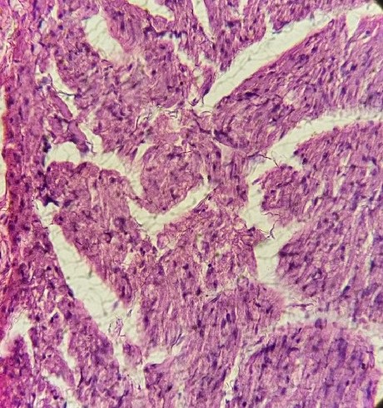

**281µm**

Branch bundle of Interventricular septum

**Fig. 1 Photomicrograph of Normal Heart Tissue Showing Normal Atria, Interventricular**

**Septa and Ventricules. H & E x400.**

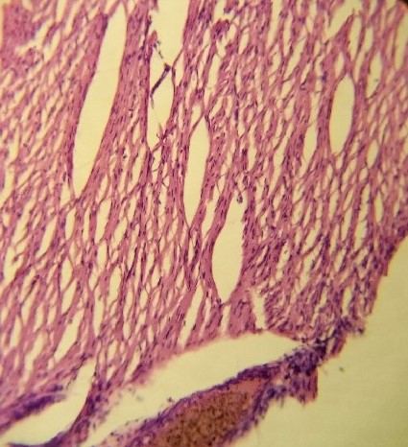

Cardiac muscle fibres

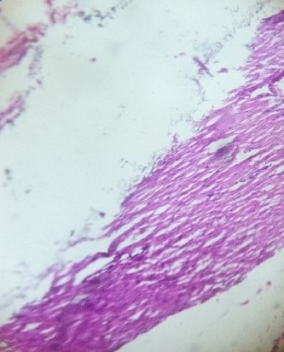

Cardiomyocyte

**Fig. 2 Photomicrograp of Heart Tissue Exposed to Sodium Cyanide for Thirty Days**

**Showing Areas of Cardiac Muscle Fibres. H & E x400.**

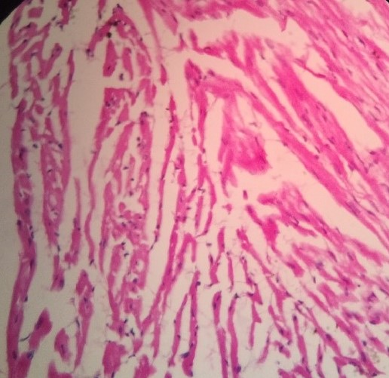

Papillary muscles

Cardiac muscle fibres

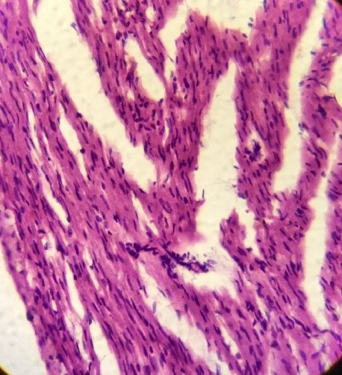

Focal inflammatory cells

**Fig. 3 Photomicrograph of Heart Tissue Exposed to Sodium Cyanide for Sixty Days**

**Showing Area of Focal Inflammatory Cells. H & E x400.**

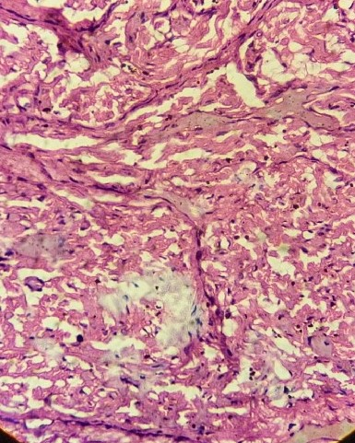

Cardiomyocytes

Cardiomyocyte necrosis

**Fig. 4 Photomicrograph of Heart Tissue Exposed to Sodium Cyanide for Ninety Days Showing Area of Cardiomyocyte Necrosis. H & E x400.**

**DISCUSSION**

The result of this study showed that serum lactate dehydrogenase concentration of the treated group was not significant in thirty days and sixty days compare to control group; however, in ninety days its serum concentration was significantly increased compare to control. This result revealed the chronic effect of cyanide on the heart muscle as reported by Amodu *et al*., (2020) which observed significant increase in the serum concentration of lactate dehydrogenase in rats exposed to cyanide. The observed increase could be attributed to the histotoxic hypoxia effect of cyanide exposure on the myocardial cells; consequently, this enzyme, lactate dehydrogenase, was released into the plasma resulting to its serum concentration increase.

Heart is one of the target organs for cyanide exposure; the resultant effect is myocardial necrosis leading to increase in serum creatine kinase enzyme (Gracia and Shepherd, 2004). This study observed significant increase in serum concentration of Creatine kinase in 30 days, 60 days and 90 days respectively. The observed increase could be linked to the hypoxia effect of cyanide exerted on the heart that is most sensitive to oxygen and the heart also demand more energy for its activity. The hypoxia condition occasioned by cyanide reduce cellular oxygen content and energy supply to the heart, this led to myocardial necrosis (as seen in fig. 4) and cardiac markers (lactate dehydrogenase, creatine kinase and troponin 1) which was contained in the cytoplasm leaked into the plasma causing a rise in their plasma levels. This finding is in line with the report of Koschel, (2006) which showed increased level of cardiac markers in serum of rabbits exposed to cyanide.

Similarly, this study observed significant increase in serum concentration of Troponin 1 in the treated group in 30 days, 60 days and 90 days respectively compare to control. The observed increase in serum concentration of Troponin 1could be attributed to the hypoxia condition occasioned by cyanide which induced myocardial cellular necrosis and eventually the cytoplasmic content including Troponin 1leaked into plasma leading to its serum level increase. This result agrees with the report of Sarko and Pollack, (2002) that observed increase level of Troponin 1 in the serum of rabbit exposed to cyanide.

The histopathology result of the heart tissue showed focal inflammatory cells and cardiomyocyte necrosis. Heart is of the primary target organs of cyanide intoxication; therefore, this result did not only confirm histotoxic effect of cyanide on cardiomyocyte but also revealed the basis of increased serum cardiac markers observed in the biochemical analysis. This result is in line with the report of 3 that observed blood in ventricles and necrosis of the heart muscles in rabbits exposed to cyanide.

Sodium cyanide exposure can have severe cardiovascular impacts as evidenced by elevated cardiac markers such as lactate dehydrogenase, troponin, creatine kinase and histological changes in the heart tissues. These findings suggest that sodium cyanide exposure can have significant and potentially life-threatening cardiovascular consequences.

**CONCLUSION**

The study demonstrated that sodium cyanide administration caused significant heart muscle damage and dysfunction in rabbits, which worsens with increasing duration of exposure. These findings suggest that sodium cyanide is a potential toxic and can cause heart muscle damage in animals.

**Ethical Approval:** The Animal Welfare Act of 1985 of the United State of America for research and Institutional Animal Care and Use Committee (IACUC) protocol were strictly adhered to. All experiments have been examined and approved by the appropriate ethic committee.

**DSCLAIMER (ARTIFICIAL INTELLIGENCE)**

Author(s) hereby declare that NO generative AI technologies such as Large Language Models (ChatGPT, COPILOT, etc) and text-to-image generators have been used during writing or editing of this manuscript.

**COMPETING INTERESTS**

Authors have declared that no competing interest exist.

**REFERENCES**

1. Sanchez-Verlaan, P., Geeraerts, T., Buys, S., Riu-Poulene, B. Cabot, C., Fourcade, O., Megarbane, R. and Genestal, M. (2011). An unusual cause of severe lactic acidosis: cyanide poisoning after bitter almond ingestion. *Intensive Care Medicine,* 37(1), 168 - 169.
2. Gracia, R. and Shepherd, G. (2004). Cyanide Poisoning and Its Treatment. *Pharmacotheraphy,* 24, 1358 - 1365.

1. Agency for Toxic Substances and Disease Registry (ATSDR) (2006). Toxicological profile for cyanide. Atlanta, GA. USA. 56 - 67.

1. Carl, A. B.., Edward, R. A. (2001). Analytes of Hemoglobin Metabolism-Porphyrin, Iron and Bilirubin. In: Fundamentals of Clinical Chemistry, Fifth edition. Saunders. 603 - 621.
2. Mulla, A., Massey, K. L. and Kalra, J. (2005). Vitreous humor biochemical constituents: evaluation of between-eye differences. *American Journal of Forensic Medicine and Pathology*, 26, 146 - 159.
3. Okolie, N. P. and Osagie, A. U. (1999). Liver and Kidney Lesions and Associated Enzymes Changes Induced in Rabbits by Chronic Exposure of Cyanide. *Food and Chemistry Toxicology,* 37, 745 - 750.
4. Okolie, N. P. and Iroanya, C. U. (2003). Some Histologic and Biochemical Evidence for Mitigation of Cyanide Induced Tissue Lesions by Antioxidant Vitamin Administration in Rabbits. *Food and Chemistry toxicology,* 41, 463 - 469.
5. Sousa, A. B., Soto-Blanco, B. Guerra, J. L., Kimura, E. T. and Gorniak, S. L. (2002). Does Prolonged Oral Exposure to Cyanide Promote Hepatotoxicity and Nephrotoxicity? *Toxicology,* 174, 87 - 95.
6. Bhayana, V. and Henderson, A. (1995). Biochemical markers of myocardial damage. *Clinical Biochemistry,* 28, 1 - 29.
7. Apple, F. S. (1992). Acute myocardial infarction and coronary reperfusion. Serum cardiac markers for the 1990’s. *American Journal of Clinical Pathology*, 97(2), 217 – 226
8. Stevens, J. F., Tsang, W. and Newall, R. G. (1983). Measurement of the enzymes lactate dehydrogenase using enzyme linked immunosorbent assay. *Journal of Clinical Pathology*. 36, 1371 - 1376.
9. Amodu, A, Reuben, A. and Thagriki, D. (2020). Effect of Manihot esculenta and Manihot utilissima Cyanide extract on some biochemical parameters of albino rats. *Asian Journal of Research in Biochemistry*, 6, 13 – 28

1. Koschel, M. J. (2006). Management of the Cyanide-poisoned Patient. *Journal of Emergency Medicine,* 32, 19 - 26.
2. Sarko, J. and Pollack, C. V. (2002). Cardiac Troponin. *Journal of Emergency Medicine*, 23(1), 57 - 65.