**Gallbladder Primary Hydatid Cyst: A Very Rare Case Report**

ABSTRACT

### Introduction: hydatid disease, is endemic in méditerranéen countries. Primary hydatid cyst of the gallbladder is an unusual and very rare localization of hydatid disease. around thirty cases fulfill the criteria of primary gallbladder hydatidosis have been published.

### Case presentation: We report a case of a 43-year-old woman referred to surgical outpatient department for “homogeneously hypoechogenic hydatid cystic oval mass with partially calcified wall in segment 4 of the liver measuring 9.5 × 11 cm”. Her history showed mild tenderness of the right upper quadrant of the abdomen accompanied by vomiting. Hydatid serology tests (ELISA) were positive. The patient underwent right laparotomy. Intra-operatively, primary hydatid cyst of the gallbladder with partial calcified wall was found. Complete pericystectomy with cholecystectomy followed. The histopathology confirmed the presence of calcified hydatid cyst of the gallbladder. three  year follow-up showed no recurrence of disease.

### Conclusion: Primary hydatid cyst of the gallbladder is a very rare and unusual clinical entity. Accurate preoperative diagnostic localization is not always easy. Treatment of choice is open cholecystectomy with pericystectomy. Compare to liver hydatidosis, the gallbladder primary hydatid cyst has a better prognosis.

### *KEYWORDS : Echinococcus, gallbladder, hydatid cyst,* *cholecystectomy*

### INTRODUCTION

“Hydatid cyst is a zoonotic infection caused by Echinococcus tapeworm parasite, mainly echinococcus granulosus (family Taeniidae). it is endemic in Mediterranean countries” [1]. “The parasite is found in the small intestine of the definitive hosts like dogs and foxes and is transmitted to the intermediate hosts such as sheep and humans by ingestion of ova in feces. After ingestion, the embryonic form of the parasite passes to the liver via the portal vein. If it escapes trapping in the liver (first filter), the second most frequent location is the lung (second filter). If the embryos escape the liver and lung filters or by-pass them via lymphatics, this results in hematogenous and lymphatic dissemination. Thereafter, the embryo can lodge in any part of the body and develop into the larval stage” [4]. The primary (or definitive) host is carnivores such as dogs. Eggs of the parasite are passed outside in the feces of the dog, ingested by intermediate host (usually, cattle, sheep, goats), and migrate from the cattle intestine to all parts of the body via circulatory system. Humans are only accidental hosts of Echinococcus infection which leads to the development of one or more hydatid cysts located mainly in the liver or lungs. other atypical localizations, as in our case, are very rare.

### CASE PRESENTATION

A 43 year old woman presented to surgical outpatient department with complaint of right upper quadrant abdominal pain from past 10 months. Patient also had occasional complaints of vomiting. No other significant complaints like fever or chills were present. There was no history of jaundice. Physical examination showed mild tenderness of the right upper quadrant of the abdomen. The rest of examination was unremarkable.

Laboratory results on admission showed a white blood cell count of 7800 mm3 (61% neutrophils, 12% eosinophils), an erythrocyte sedimentation rate of 16 mm in the first hour and C-reactive protein of 9mg/l. total bilirubin, Alanine aminotransferase (ALT) and aspartate aminotransferase (AST) were normal. Thoracic and abdominal computed tomography were performed, It concluded to: "homogeneously hypoechogenic cystic oval mass with partially calcified wall in segment 4 of the liver measuring 9.5 × 11 cm (Fig. 1). Gallbladder, architecture and size of biliary ducts were normal. The cystic lesion has close connections with the gallbladder. No fistula was detected. No other Cystic lesions were observed in the hepatic parenchyma". Hydatid serology tests (ELISA) were positive. Chest X-ray showed no evidence of localisation in the lung. The patient underwent a right subcostal laparotomy. Exploration revealed that the hydatid cyst had developed from the wall of the gallbladder without fistula or connection with neighboring organs (Fig. 2). A Complete pericystectomy with cholecystectomy was performed. Careful exploration of the liver and peritoneal cavity revealed no other cysts. Histopathology of the surgical specimen confirmed the diagnosis of primary gallbladder hydatid cyst. The patient's postoperative course was uneventful; he was discharged in good condition on the fourth postoperative day. no medical treatments were associated. Regular follow-up consultations revealed no complications or recidivism. At three-year follow up, she has had no recurrence of hydatid disease.

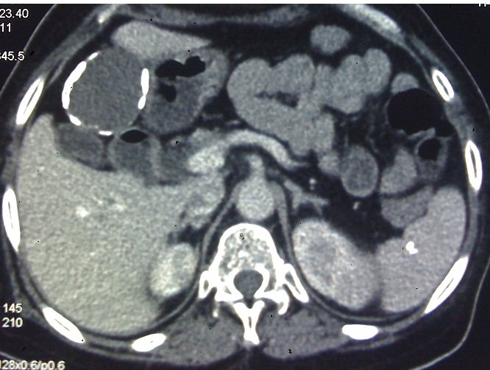

Figure 1: Computed tomography (CT) scan showing a hydatid cyst with partial calcified wall and gallbladder adhesions at liver segment4

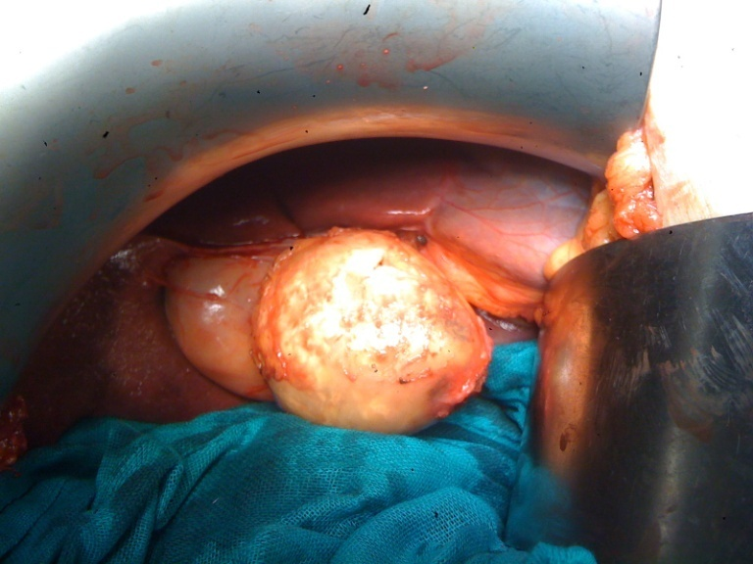

Figure 2: Intraoperative view: hydatid cyst of the gallbladder body

### DISCUSSION

“Echinococcus is a significant public health concern in the Mediterranean region, particularly in Morocco” [1]. “Pathogenesis begins with the ingestion of Echinococcus granulosus eggs, which, in the human intestine transform into embryos, due to gastric acidity, then, penetrate actively the small bowel mucosa, enter venules and travel via portal circulation to the liver, the first biological filter, then lung and all parts of the body via venous cava stream or lymphatic system” [2,3]. “Liver (76 %), lungs (15 %) and spleen (5%) are commonly affected organs. unusual sites can include kidneys, brain, bone tissue, heart, mediastinum, Thyroid, ovaries, pancreas, retroperitoneum, orbit… Gallbladder hydatic cyst constitutes 0,3–0,4% of all atypically located hydatid cysts, is usually a secondary manifestation of the disease” [4]. Isolated or primary gallbladder hydatic cyst is even rarer [2-3,5-7] and must be segregated from gallbladder daughter cysts secondary to liver primary hydatidosis. “The pathogenesis of primary hydatid gallbladder cysts depends whether the cyst is developed in the lumen of the gallbladder or on its external surface as in our case. In fact, in the first situation, the cysts result from the dissemination of brood capsules through the biliary tract, while in the second, they develop on the wall of the gallbladder after spreading through the lymphatic circulation” [2,3]. “The hydatid cysts developing primarily from the gallbladder become symptomatic earlier, the symptoms were pain, midabdominal discomfort and dyspepsia” [2-7]. “The diagnosis of hydatic cyst is based on serological tests” [4] and imaging techniques (ultrasound, computed tomography and magnetic resonance imaging) [5,8,9]. The classification proposed by Gharbi can be used in majority of cases [8]. “Usually, Preoperative localization of gallbladder hydatid cysts is difficult” [3,5]. “As in our case, the computed tomography scans described the cystic lesion as a hydatid cyst of the liver with gallbladder adhesions, only to have the diagnosis corrected intra-operative. Surgery is the optimal treatment of hydatid cyst. The aim is the eradication of the parasite without spillage of the cyst content” [6]. “The localisation of the hydatid cyst in the gallbladder seems to offer the possibility of total removal in all cases. total pericystectomy with open cholecystectomy was performed in majority of reported observations” [2-3,6,7,9]. “Only two cases operated by laparoscopic technique were reported [10,11]. Nowadays, in experienced hands, laparoscopy is as safe as the open procedure for hydatid disease with the advantage of minimal access surgery. Some authors recommend the use of a scolicidal agent in the surgical field to avoid dissemination in case of rupture” [6]. Mebendazole or albendazole can be used as an adjunct to surgery when resection is incomplete

[4,6], but in our experience we only use this treatment when surgery cannot be performed.

CONCLUSIONS

Primary hydatid cyst of the gallbladder is a very rare disease and is often missed on clinical diagnosis. Open cholecystectomy with careful pericystectomy is the treatment of choice. Early manifestations of gallbladder primary hydatid cyst leads to a complete cystectomy and good prognosis.

COMPETING INTERESTS DISCLAIMER:

Authors have declared that they have no known competing financial interests OR non-financial interests OR personal relationships that could have appeared to influence the work reported in this paper.

CONSENT

As per international standards or university standards, patient(s) written consent has been collected and preserved by the author(s).

DISCLAIMER (ARTIFICIAL INTELLIGENCE)

Author(s) hereby declare that NO generative AI technologies such as Large Language Models (ChatGPT, COPILOT, etc) and text-to-image generators have been used during writing or editing of this manuscript.

Authors’ contributions

This work was carried out in collaboration among all authors. All authors read and approved the final manuscript.

# REFERENCES

[1]. Budke CM. Global socioeconomic impact of cystic echinococcosis. Emerg Infect Dis 2006, 12:56-64.

[2]. Razaz MH, Harris SH, Khan R. Hydatid cyst of gallbladder. Indian J Gastroenterol 2003, 22:67-68.

[3]. Safioleas M, Stamoulis I, Theoqaris S, Moulakakis K, Makris S, Kostakis A. Primary hydatid disease of the gallbladder: a rare clinical entity. J Hepatopancreat Surg 2004, 11:352-6.

[4]. Yagnik YD, Dawka S, Patel N. Gallbladder Hydatid Cyst: A Review on Clinical Features, Investigations and Current Management. Clinical and Experimental Gastroenterology 2020:13 : 87-97

[5]. Krasniqi A, Limani D, Gashi-Luci L, Spahija G, Dreshaj IA. Primary hydatid cyst of the gallbladder: a case report. J Med Case Rep 2010, 4:29.

[6]. Rabbani K, Yila A, El baroudy G, El mansouri M A, Ahbala T, Louzi A. Exceptional Location of Hydatidosis: Hydatid Cyst of the Gallbladder: A Case Report. SAS J Surg 2023, 9(5): 407-9.

[7]. Touma D, Sersté T, Ntounda R, Mulkay JP, Buset M, Van Laethem Y. The liver involvement of the hydatid disease: a systematic review designed for the hepato-gastroenterologist. Acta Gastroenterol Belg 2013, 76(2):210-8.

8]. Gharbi HA, Hassine W, Brauner MW, Dupuch K. Ultrasound Examination of the Hydatic Liver. Radiology 1981, 139:459-463

[9]. Shukla P, Agrawal M, Simran, Kaur N. A rare case of primary gall bladder hydatid disease. J Clin Images Med Case Rep 2023, 4(12): 2760.

[10]. Ertem M, Aytaç E, Karaduman Z. Cystic hydatid disease of the gallbladder. Turk J Gastroenterol 2012, 23:825–826. doi: 10.4318/tjg.2012.0440

[11]. Kazzaz R, Nashed D, Sattout GIA, Issa N, Aldakhil A, Bitar O, Danial A K. Laparoscopic management of a primary gallbladder hydatid cyst with daughter cysts in the common bile duct: Case report. Ann Med Surg (Lond) 2022, 80:104165.

[12] Kbir GH, Messaoudi S, Selmi M, Maatouk M, Bouzidi MT, Ennaceur F, Ben Moussa M. An unusual localization of echinococcosis: Gallbladder hydatid cyst. IDCases. 2022 Feb 18;27:e01455. doi: 10.1016/j.idcr.2022.e01455. PMID: 35242561; PMCID: PMC8866152.