*Case report*

Comprehensive Diagnosis of Recurrent Inflammatory Myofibroblastic Tumor in a Young Male using Immunohistochemistry

.

ABSTRACT

|  |
| --- |
| Inflammatory myofibroblastic tumor (IMT) is a rare neoplasm composed of myofibroblastic spindle cells mixed with inflammatory cells. This case report describes an unusual presentation of an IMT in the thigh of a young adult male who presented with painful swelling and multiple ulcerations. The patient had a history of recurrent swellings in the same region, with a previous biopsy suggesting liposarcoma. On examination, the lesion was associated with maggot-infested ulcers and regional lymphadenopathy. Surgical excision and histopathological evaluation revealed spindle-shaped myofibroblasts in a myxoid stroma with mixed inflammatory infiltrate and foreign body-type granulomatous reaction. Periodic acid-Schiff (PAS) stain for fungal elements and Ziehl Neelsen (ZN) stain for acid-fast bacilli (AFB) were negative. Immunohistochemistry demonstrated positivity for smooth muscle actin (SMA) and negativity for anaplastic lymphoma kinase (ALK), Desmin, CD34, S100, STAT6, and Pancytokeratin, confirming the diagnosis of ALK-negative IMT. This case underscores the diagnostic challenges posed by IMTs, particularly when they mimic malignant soft tissue tumors. The ALK-negative status further emphasizes the risk of recurrence and the need for long-term follow-up. Accurate diagnosis requires integration of clinical, histological, and immunohistochemical findings. This case contributes to the limited literature on extrapulmonary, ALK-negative IMT involving the lower extremity and highlights the role of immunohistochemistry in differentiating IMT from its histologic mimics. |

*Corresponding author: Tel.: +91 9972929554; E-mail address: mamatha.k@bldedu.ac.in

*Keywords: Inflammatory myofibroblastic tumor, ALK-negative, thigh swelling, immunohistochemistry, soft tissue tumor.*

1. INTRODUCTION

Inflammatory myofibroblastic tumors (IMT) are histopathologically distinctive neoplasms primarily affecting children and young adults, characterized by myofibroblastic spindle cells intermingled with plasma cells, lymphocytes, and eosinophils, according to the World Health Organization (WHO) [1]. Initially described in the lung by Umiker and Iverson in 1954 [2], Inflammatory myofibroblastic tumors can occur at various anatomic sites, with the lung being the most common location. It is a borderline tumor with a tendency for local recurrence but rarely metastasizing [3]. Initially considered reactive, the neoplastic nature of inflammatory myofibroblastic tumors was revealed through molecular analyses demonstrating clonal rearrangements of the anaplastic lymphoma kinase (ALK) gene at 2p23, fusing its 3' kinase region with various partners like TPM3, TPM4, CLTC, and RANBP2 in 50%-70% of cases [1].

Some cases of Inflammatory myofibroblastic tumors can undergo malignant transformation, such as epithelioid inflammatory myofibroblastic sarcoma, characterized by large polygonal cells, increased mitotic activity, and atypical mitosis [4]. This aggressive phenotype is often associated with RANBP2-ALK fusion, predicting a poor prognosis [5]. Immunohistochemistry is crucial in detecting ALK fusion proteins, with staining patterns varying based on the fusion partner [4].

Despite the typically benign histologic appearance, inflammatory myofibroblastic tumors can exhibit aggressive behavior, highlighting the importance of careful management and follow-up [6]. While no definitive markers exist to predict malignant transformation, recurrence, or metastasis, surgical resection remains the primary treatment for inflammatory myofibroblastic tumors, with adjuvant therapies like nonsteroidal anti-inflammatory drugs (NSAIDs), steroids, chemotherapy, and radiotherapy used in select cases [7,8]. Here, we present a rare case of an Inflammatory myofibroblastic tumor of the right lower extremity with multiple recurrences in a young male.

**2. PRESENTATION OF CASE**

A young male in his early 20s presented with complaints of swelling and pain along with multiple ulcerations on his right lower limb for the past 15 days. On physical examination, there was an irregular prominence in the swelling over the anteromedial aspect of the right thigh, with a circumference of about 30 cm (Figure 1). The largest ulcer was measuring 15 x 3 cm (Figure 1). Some of the ulcers were infested with maggots and associated with foul-smelling discharge. Additionally, an ipsilateral inguinal region swelling measuring 5 x 3 cm and a right gluteal region surgical scar measuring 5 x 3 cm was noted.

The patient had a history of multiple occurrences of swelling over the right gluteal and thigh region. The patient had the first swelling three years ago, for which he underwent surgery, and the reports were not available with the patient.

The first recurrence was noted one year ago, during which he underwent fine needle aspiration cytology (FNAC) and Trucut biopsy at a private diagnostic laboratory. FNAC was reported as an "extensive foreign body reaction with mixed inflammation, with few areas showing mild pleomorphic spindle cells-? Proliferative lesion.”

Trucut biopsy was reported as “? Liposarcoma of the right thigh and buttock.” The swelling regressed spontaneously over time without any surgical intervention.

The patient was advised surgical intervention and underwent tumor debulking of right thigh mass along with debridement of ulcers over the right lower limb in our hospital. The excised tumor specimen was sent for histopathological study (Figure 2-3).

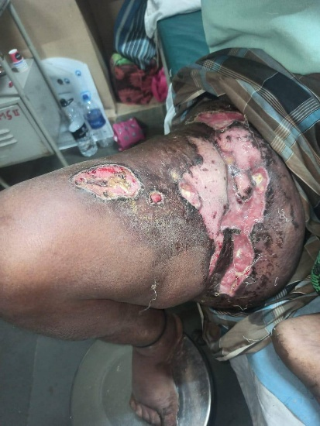

**Figure 1-** **Physical examination of right lower limb: Multiple ulcerations noted on the anteromedial aspect of the right thigh along with a prominent swelling over right medial thigh and buttock.**

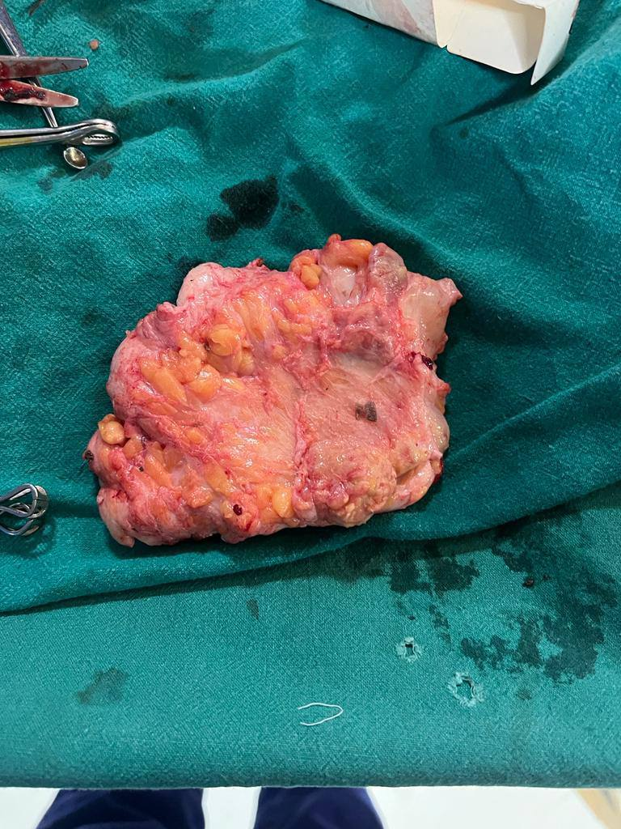

**Figure 2-** **Gross examination of excised right thigh mass: A pale pink irregular tissue mass with attached fibrofatty tissue measuring 16x9x1cm.**

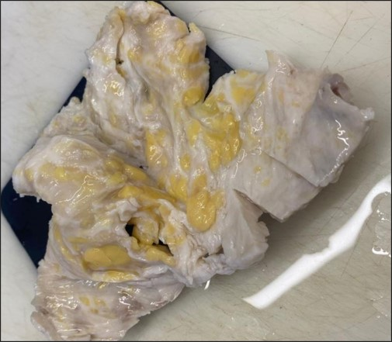

**Figure 3-** **Cut section of the mass: Solid, pale white, homogenous, firm to hard, with fibrofatty areas.**

Histopathological microscopic examination of hematoxylin & eosin-stained slides (Figure 4-7) revealed tumor tissue composed of myofibroblasts arranged in hypocellular and myxoid patterns. Individual cells were stellate to plump spindle-shaped with oval to elongate nucleus, fine chromatin and moderate to abundant eosinophilic cytoplasm. Some of the cells showed small nucleoli. Stroma showed myxoid areas, collagen bundles in places and areas of necrosis. Also seen were mixed inflammatory cell infiltrates in the tumor tissue predominantly comprising of lymphocytes, plasma cells, neutrophils, mast cells, and foreign body type granuloma comprising of epithelioid cells, lymphocytes, and fibroblasts with multinucleated giant cells. Periodic acid-Schiff (PAS) stain for fungal elements and Ziehl Neelsen (ZN) stain for acid-fast bacilli (AFB) were negative.

Based on these microscopic findings, the diagnosis was given as an Inflammatory myofibroblastic tumor (intermediate grade, rarely metastasizing) with foreign body granulomatous reaction.

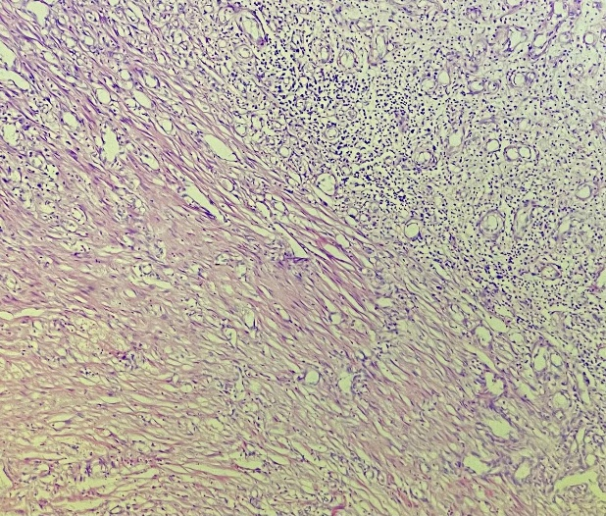

**Figure 4-** **Photomicrograph (100x, Hematoxylin & Eosin) showing tumor tissue along with mixed inflammatory cell infiltrate and blood vessels.**

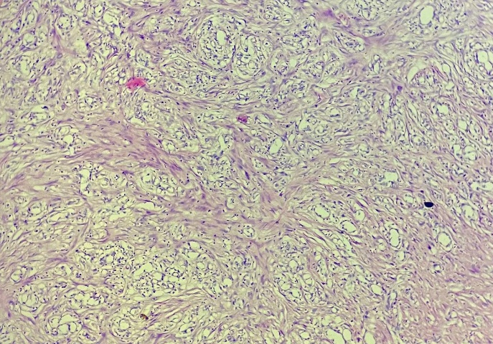

**Figure 5-** **Photomicrograph (100x, Hematoxylin & Eosin) showing spindle shaped tumor cells arranged in interlacing fascicles.**

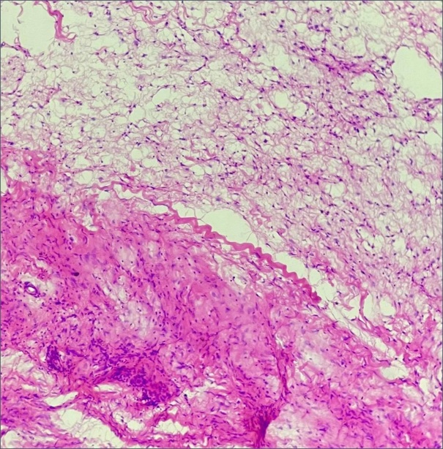

**Figure 6-** **Photomicrograph (100x, Hematoxylin & Eosin) showing myxoid areas and hypercellular areas.**

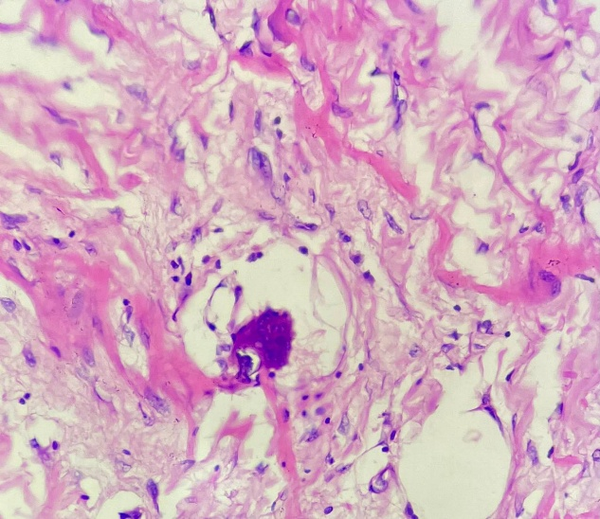

**Figure 7-** **Photomicrograph (400x, Hematoxylin & Eosin) showing foreign body type multinucleated giant cell.**

Immunohistochemistry was advised and reported as immunopositive (Figure 8) for SMA (smooth muscle actin) and immunonegative (Figure 9) for ALK (anaplastic lymphoma kinase), Desmin, CD34, S100, STAT6 and Pancytokeratin (AE1/AE3), thus establishing a diagnosis of ALK-negative Inflammatory myofibroblastic tumor.

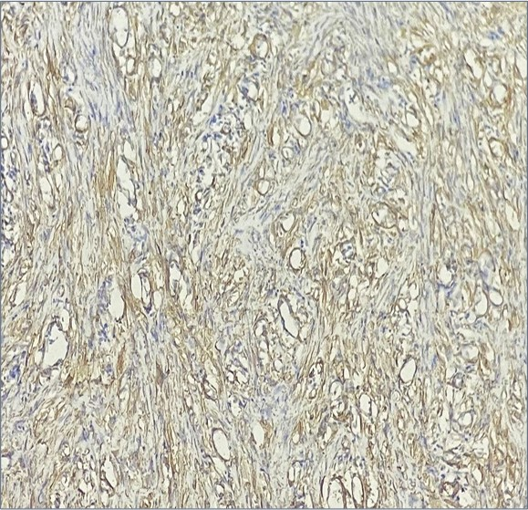

**Figure 8-** **Photomicrograph (100x) of immunohistochemistry study of SMA (smooth muscle actin) showing tram-track membranous staining of myofibroblasts. Muscle layer of blood vessels also stained positive.**

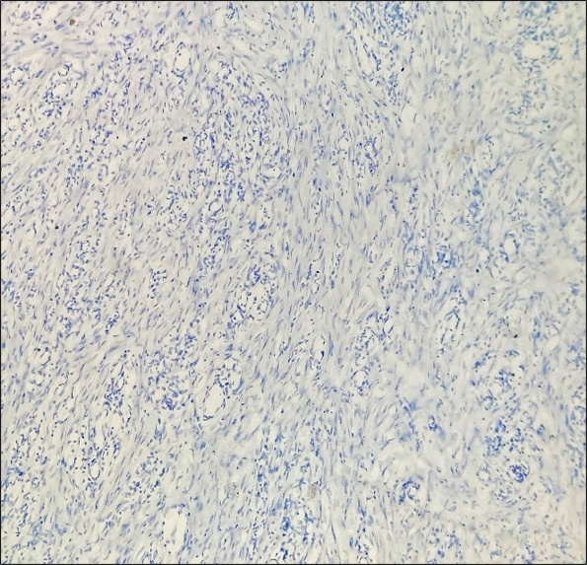

**Figure 9- Photomicrograph (100x) of immunohistochemistry study of ALK (anaplastic lymphoma kinase) showing negative nuclear and cytoplasmic staining of myofibroblasts.**

3. discussion

Inflammatory myofibroblastic tumors are rare neoplasms with distinctive clinical, pathological, and molecular features. While they most commonly occur in the lung, they can also manifest in various extrapulmonary sites, including the stomach, mesentery, and omentum. Uncommonly, they are found in the pelvis, head and neck, trunk, and extremities [9].

Although the actual etiology of the disease is not always determined, reports on the condition have detailed cases in which trauma, surgery, autoimmune reactions, infections, Epstein-Barr virus, and other variables were the cause [9].

In 50-60% of cases of Inflammatory myofibroblastic tumors in children and young adults, the tumors harbor clonal cytogenetic rearrangements involving chromosome band 2p23 that fuse the 3’ kinase region of the ALK gene with various partner genes [3].

Diagnosing Inflammatory myofibroblastic tumors can be challenging due to their variable clinical presentation and histological features, which can mimic other soft tissue tumors, including sarcomas. The main histolopathogic differentials for a spindle cell lesion with myxoid stroma and inflammation in the thigh of a young adult include nodular fasciitis, myxoinflammatory fibroblastic sarcoma (MIFS), low-grade myofibroblastic sarcoma (LGMS), and inflammatory well-differentiated liposarcoma (WDLS).

Imaging investigations such as ultrasound, MRI, and CT scans can help evaluate the lesion’s extent. However, definitive diagnosis relies on histopathological examination, often aided by immunohistochemistry, to identify specific markers such as ALK expression.

Nodular fasciitis lacks the dense chronic inflammatory infiltrate and foreign body granulomas seen in this case. MIFS shows virocyte-like cells, bizarre atypia, and is typically CD34 positive—all absent here. LGMS demonstrates significant nuclear atypia, mitotic activity, and diffuse desmin positivity, which were not present. Inflammatory WDLS usually shows lipoblasts and MDM2 or CDK4 expression, which were not identified.

TPM3, TPM4, ATIC, SEC31L1, and CARS fusions are commonly associated with diffuse cytoplasmic staining for ALK, while CLTC fusion is associated with granular cytoplasmic staining. Epithelioid inflammatory myofibroblastic sarcomas linked to RANBP2-ALK fusions exhibit nuclear membrane ALK staining and, in some instances, perinuclear ALK staining. [3].

Immunohistochemistry for ROS1 and/or molecular testing for non-ALK gene fusions (e.g., NTRK3) may be helpful in ALK-negative instances [1]. Identified fusion partners include TFG::ROS1, YWHAE::ROS1, and ETV6::NTRK3 [58,59,72,73]. ROS1 gene rearrangements lead to continuous activation of the ROS1 receptor tyrosine kinase, which promotes tumor development [9].

Conventional detection methods such as IHC and FISH may fail to detect a range of actionable gene rearrangements including ROS1, RET, NTRK, and PDGFRβ in IMTs, indicating the need for broader molecular testing, for example, Next generation sequencing (NGS), to explore genetic characteristics more fully [10].

In a study by Lovly CM et. Al. on ALK-negative inflammatory myofibroblastic tumors (IMTs), ROS1 and PDGFRβ gene fusions were identified as actionable targets. Specifically, ROS1 fusions (YWHAE–ROS1, TGF–ROS1) and NAB2–PDGFRβ fusions were detected. These targets are associated with FDA-approved therapies, including ROS1 inhibitors (e.g., crizotinib) and PDGFR inhibitors (e.g., imatinib) [11].

Thus, the recent literature underscores the importance of histopathological examination combined with immunohistochemistry and molecular diagnostics in the accurate diagnosis of Inflammatory myofibroblastic tumors. The prognosis and clinicopathologic characteristics of these tumors do have an imperfect association. Conventional characteristics exhibit poor correlations with clinical prognosis, such as tumor size, nuclear atypia, mitotic activity, and necrosis [3].

Management of Inflammatory myofibroblastic tumors is nonspecific due to their rarity and variable clinical behavior. However, surgical resection is generally considered the primary treatment modality for localized Inflammatory myofibroblastic tumors [6]. Adjuvant therapies such as nonsteroidal anti-inflammatory drugs (NSAIDs), steroids, chemotherapy, and radiotherapy may be considered in select cases, particularly those with unresectable or recurrent tumors.

Approximately 25% of extrapulmonary Inflammatory myofibroblastic tumors recur, in part depending on anatomical site and resectability. ALK-negative Inflammatory myofibroblastic tumors carry a high risk of recurrence and metastases, leading to poor prognosis. Targeted ALK inhibitor therapy can be effective in unresectable or metastatic ALK-positive Inflammatory myofibroblastic tumors [3], whereas ROS1 inhibitors and PDGFR inhibitors can be useful in ALK-negative IMTs [11].

4. Conclusion

This case highlights the significance of considering Inflammatory myofibroblastic tumors in the differential diagnosis of soft tissue tumors, especially when there is a discrepancy between clinical and histopathological findings, as demonstrated in this case. It emphasizes the significance of thorough histopathological examination, including immunohistochemistry, in establishing an accurate diagnosis.

Consent (where ever applicable)

All authors declare that written informed consent was obtained from the patient (or other approved parties) for publication of this case report and accompanying images. A copy of the written consent is available for review by the Editorial office/Chief Editor/Editorial Board members of this journal.

Ethical approval (where ever applicable)

As per international or university standards written ethical approval has been collected and preserved by the authors.

Disclaimer (Artificial intelligence)

Authors hereby declare that NO generative AI technologies such as Large Language Models (ChatGPT, COPILOT, etc.) and text-to-image generators have been used during the writing or editing of this manuscript.

References

1. World Health Organization (WHO). (2021). Soft Tissue and Bone Tumours. WHO Classification of Tumours Editorial Board. International Agency for Research on Cancer (IARC).
2. Umiker WO, Iverson L. Postinflammatory tumors of the lung: report of four cases simulating xanthoma, fibroma or plasma cell tumor. J Thorac Surg 1954; 28: 55–63.
3. Goldblum JR, Folpe AL, Weiss SW. Enzinger & Weiss’s soft tissue tumors. Philadelphia, Pa: Elsevier; 2020
4. Marino-Enriquez A, Wang WL, Roy A, et al. Epithelioid inflammatory myofibroblastic sarcoma: an aggressive intra-abdominal variant of inflammatory myofibroblastic tumor with nuclear membrane or perinuclear ALK. Am J Surg Pathol 2011; 35: 135–44.
5. Li J, Yin WH, Takeuchi K, Guan H, Huang YH, Chan JK. Inflammatory myofibroblastic tumor with RANBP2 and ALK gene rearrangement: a report of two cases and literature review. Diagn Pathol 2013; 8: 147.
6. Savvidou OD, Sakellariou VI, Papakonstantinou O, Skarpidi E, Papagelopoulos PJ. Inflammatory myofibroblastic tumor of the thigh: presentation of a rare case and review of the literature. *Case Rep Orthop*. 2015;2015:814241. doi:10.1155/2015/814241.
7. Coffin CM, Hornick JL, Fletcher CD. Inflammatory myofibroblastic tumor: comparison of clinicopathologic, histologic, and immunohistochemical features including ALK expression in atypical and aggressive cases. Am J Surg Pathol 2007; 31: 509–20.
8. Tao YL, Wang ZJ, Han JG, Wei P. Inflammatory myofibroblastic tumor successfully treated with chemotherapy and nonsteroidals: a case report. World J Gastroenterol 2012; 18: 7100–3.
9. Choi JH. Inflammatory myofibroblastic tumor: an updated review. Cancers. 2025;17(8):1327. doi:10.3390/cancers17081327.
10. Debonis SA, Bongiovanni A, Pieri F, Fausti V, De Vita A, Riva N, et al. ALK-negative lung inflammatory myofibroblastic tumor in a young adult: a case report and literature review of molecular alterations. Medicine (Baltimore). 2021;100(20):e25972. doi:10.1097/MD.0000000000025972.
11. Lovly CM, Gupta A, Lipson D, et al. Inflammatory myofibroblastic tumors harbor multiple potentially actionable kinase fusions. Cancer Discov 2014;4:889–95.