*Case Report*

MEDIAN UMBILICAL LIGAMENT FLAP COVER FOR AN EXPOSED MESH : AN INTERESTING CASE REPORT

**ABSTRACT:**

**Aim:** Our aim is to highlight the alternative methods to cover an exposed mesh due to lack of peritoneum secondary to the mesh related complications following a transabdominal pre-peritoneal inguinal hernia repair.

**Case presentation:** An elderly male presented with the symptoms of subacute intestinal obstruction following a laparoscopic transabdominal pre-peritoneal right inguinal repair a month ago. CT scan with oral contrast of the whole abdomen showed low-grade partial mechanical small bowel obstruction secondary to adhesions of the mesh.

**Discussion:** Mesh reinforcement is generally considered the standard of care in hernia repair. Infection is a known complication following hernia repair. Modifiable risk factors for mesh infections include active smoking, poorly controlled diabetes mellitus, abdominal skin or wound issues, and obesity. Operative factors that increase the risk of mesh infection include prior hernia repair, enterotomy and contamination of the surgical field. It is important to completely close the peritoneum when placing the mesh. There are various methods available for mesh cover such as primary peritoneal closure, omental flap, prosthetic mesh and median umbilical ligament flap. Here, we report our experience with a patient presenting with subacute intestinal obstruction,  following transabdominal pre-peritoneal inguinal hernia repair.

**Conclusion:** Among all the above mentioned methods,the median umbilical ligament flap is the ideal choice in our case by providing a natural, autologous tissue option and potentially reducing the risk of complications.

**Keywords:** Transabdominal pre-peritoneal repair(TAPP), Totally extra-peritoneal repair(TEP), Subacute intestinal obstruction(SAIO), Median umbilical ligament(MUL).

**INTRODUCTION:**

“A transabdominal pre-peritoneal hernioplasty (TAPP) is a common procedure for groin hernia repair in adults. The peritoneal closure after mesh placement can be performed in various ways. In any case, thorough closure is recommended to avoid mesh exposure to the viscera with the risk of adhesions and bowel incarceration into peritoneal defects. Postoperative intestinal obstructions can mainly occur due to adhesions or bowel herniation through peritoneal defects into the dissected pre-peritoneal space” **[1]**. “Tension-free repair using mesh has become a widely utilised technique in inguinal hernia surgery because it has a lower relapse rate and fewer postoperative complications than other procedures” **[2]**. “However, mesh-specific complications have also been reported, including mesh infection and migration. Normally, the peritoneum is between the mesh and the abdominal cavity, so the mesh cannot come into direct contact with the intestines or other organs. However, mesh migration is believed to occur because of a defect in the peritoneum due to incomplete peritoneal repair  or because of peritoneal damage due to excess tension from the mesh. When the mesh comes into contact with the organs of the digestive tract or elsewhere, rigid adhesions can occur, causing intestinal obstruction and migration of the mesh into the internal organs” **[3]**. There are different ways to cover the exposed mesh such as omental flap, prosthetic mesh and MUL. In our case we mobilised the median umbilical ligament for closure and to avoid the small bowel obstruction in future.

**CASE PRESENTATION:**

A 75 year old gentleman, presented with the complaints of lower abdominal pain for 5 days which was acute in onset, intermittent in nature, aggravated on food intake and relieved on rest. He had undergone a laparoscopic TAPP Right inguinal hernia repair a month ago in a different centre. Physical examination showed moderately distended abdomen  with generalised tenderness, bowel sounds were present and evidence of port site scars. CT scan of the whole abdomen with oral contrast showed Low-grade partial mechanical small bowel obstruction secondary to adhesions (entero-enteric and entero-parietal adhesions in right lower quadrant at the site of hernia surgery, abrupt transition zone noted at the adhesion site with kinking, mild dilatation of proximal segment and collapsed distal segment). After preoperative optimisation, we did **“Diagnostic laparoscopy with extensive adhesiolysis + Open small bowel resection and anastomosis + Laparoscopic median umbilical ligament flap cover for an exposed mesh”**.

1. 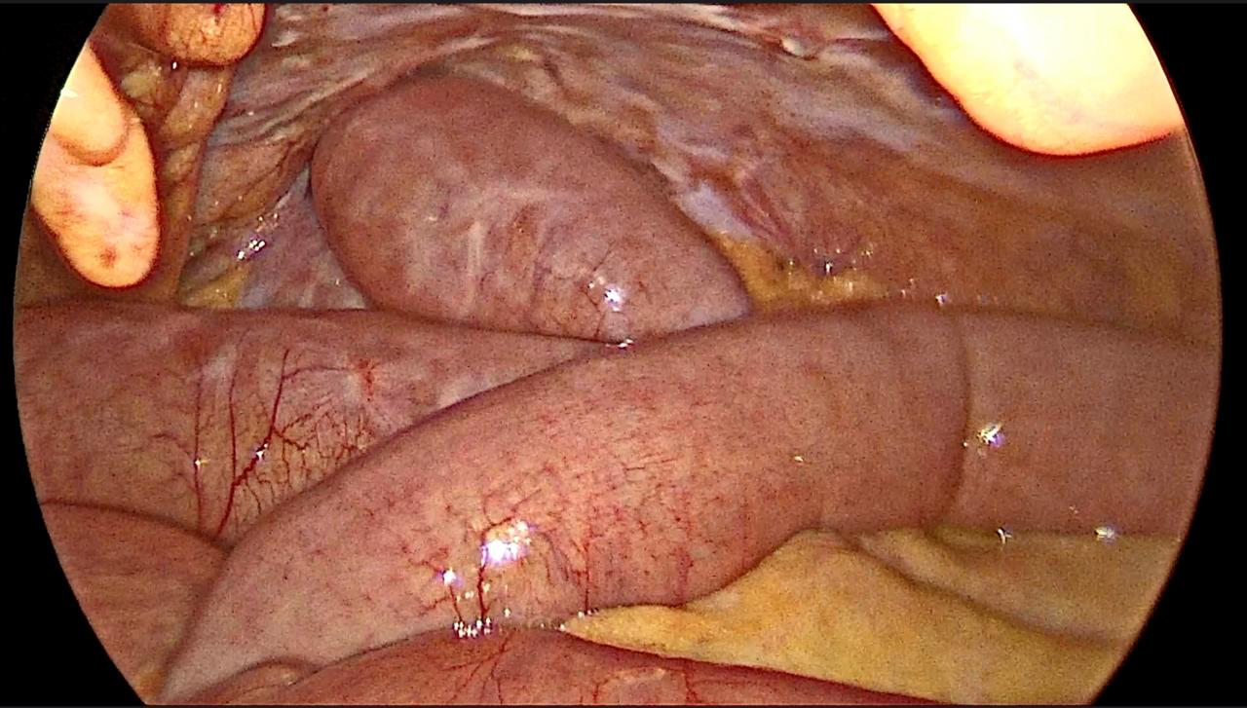The extensive small bowel adhesions to the previous mesh causing acute kinking with transition zone leading to SAIO ***Fig 1,2***.

***Fig 1***: Small bowel adhesions to the previous mesh causing acute kinking.

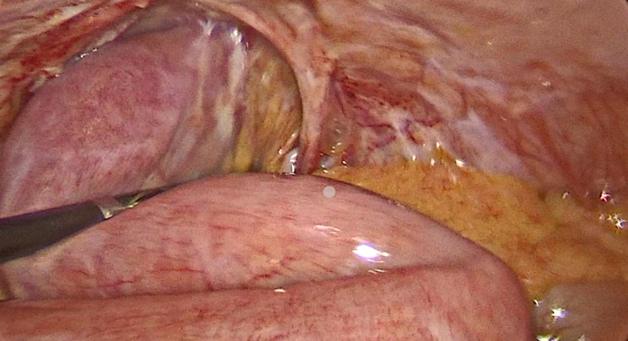

***Fig 2***: Extensive bowel adhesions to the abdominal wall.

1. There were extensive serosal injury of the bowel due to adhesiolysis.
2. No enterotomy and no intra-abdominal contamination.
3. An infra umbilical incision made - Open small bowel resection and side to side anastomosis was done 1 feet from ileo-caecal junction to proximal ileum.
4. 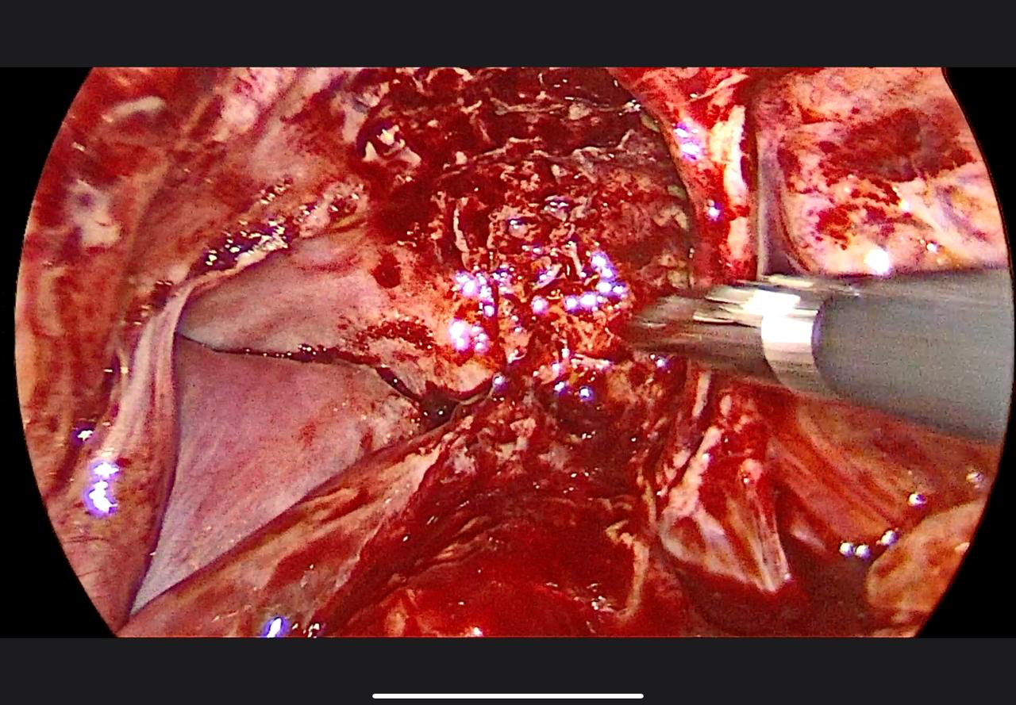The area where adhesiolysis was done was devoid of peritoneum and mesh was exposed ***Fig 3***.

***Fig 3*** :Extensive adhesiolysis done, separating small bowel segments from the mesh.

1. The median umbilical ligament was released intra abdominally and flap was used to cover the bare area ***Fig 4***.

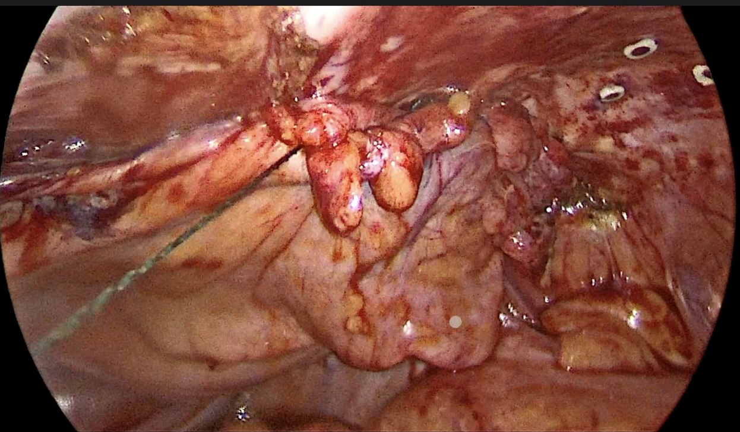 ***Fig 4***: Mobilisation of median umbilical ligament , flap created and covered the exposed mesh.

The intraoperative and postoperative periods were uneventful. He was discharged on postoperative sixth day.

**DISCUSSION:**

“The TAPP and totally extra-peritoneal repair(TEP) has been widely used in the repair of various inguinal hernias” **[4]**. “A TAPP is performed by dissection of the pre-peritoneal space and mesh repair of the hernial defect. The closure of the peritoneum after mesh placement must be performed uninterrupted and completely to avoid adhesions of viscera to the mesh and intestinal obstructions by bowel herniation through peritoneal defects into the pre-peritoneal space” **[5]**. “There are various ways to close the peritoneum. Incomplete peritoneal closure in a laparoscopic pre-peritoneal hernia repair increases the risk of bowel obstruction” **[6]**. In recent years, self-anchoring, knotless, and barbed wound closure devices were designed and should offer secure, fast, and effective closure of different tissue incisions.

“The complete closure of the peritoneum after a laparoscopic TAPP repair is an essential step of the operation to avoid on the one hand mesh exposure to the bowel with the risk of adhesions and bowel obstructions and on the other hand bowel incarcerations through herniation into the pre-peritoneal space . The most appropriate peritoneal closure is achieved by running sutures” **[6]**. “Penetrating devices such as tacks, clips, staples or strap devices should be avoided for mesh fixation but also for peritoneal closure, because of the risk of nerve injuries and adhesions. The Bowel obstruction as a complication of a TAPP hernia repair, can be divided into adhesive disease and herniation. Herniation can occur as a consequence of incarceration through peritoneal defects or trocar site herniation.” **[5,6]**.

“Incarcerations after a TAPP repair occur as a rule earlier than obstructive adhesions due to contact between bowel and the prosthetic mesh material. Duran et al. reported a 2.5 % (5/196) incidence of postoperative bowel obstructions after abdominal surgery, which included four incarcerations and one adhesive bowel obstruction” **[7]**. “However, Lovisetto et al. reported a single case of postoperative intestinal obstruction between two clips used for peritoneal closure in 1973 patients, who underwent TAPP repairs” **[8]**. “One rare case of a small bowel obstruction after a TAPP repair owing to a displaced spiral tack was reported by Fitzgerald et al. in 2010” **[9]**.”When inguinal hernia surgery is performed, the tension-free method is standard, but operative techniques such as the plug and Kugel method utilising various meshes are also performed. However, as the use of mesh has become more common, mesh-specific complications such as intestinal obstruction and migration of the mesh into the bladder have been reported” **[10]**.

“Direct contact between the mesh and the organs and strong tension on the organs has been implicated as the mechanism of mesh migration into the internal organs or fistula formation following inguinal hernia surgery. The displacement due to insufficient fixation can also result in migration” **[11]**. “The mesh is conventionally placed in the pre-peritoneal space, direct contact between mesh and intestinal tract is impossible because of the presence of the peritoneum. However, if closure of the peritoneum at the high ligation is incomplete or if damage to the pre-peritoneal space is overlooked, it causes the mesh to come into contact with the intestinal tract” **[12,13]**. “For recurrent cases, especially those with unknown previous surgical details, transabdominal laparoscopy can explore the operative area more better to formulate appropriate treatment strategies, which has great significance for reducing surgical risks and complications” **[14]**.

“The aim is to decrease small bowel descent, small bowel obstruction and perineal wound complications. In the case of commonly practised omental placement, the technical challenge can be reaching into the rectal space. However, the omentum can be lengthened based on the left gastro-epiploic pedicle. Furthermore, a free-placed omentum can move out of the pelvis based on the patient’s position. Recent studies also show that omental flaps do not reduce the rates of small bowel obstruction and perineal complications” **[15]**. “When compared to autologous tissue methods of pelvic closure, namely omentum, myocutaneous flaps and pelvic peritoneum, the use of mobilised umbilical ligament is particularly attractive as it takes the least amount of time, the tissue being available in the pelvis itself and is technically the simplest to perform even with minimally invasive approaches” **[16]**.

 The surgical dissection was carried out and the median umbilical ligament was carefully dissected free from surrounding tissues, such as the peritoneum and bladder. Then accessed the space of Retzius, the space between the bladder and the pubic bone can be accessed by mobilising the ligaments, allowing for further surgical manoeuvres . Once mobilised, the ligaments can be secured with sutures to the pelvic inlet or other structures to achieve the desired surgical outcome **[17]**.  
  
“Moreover, the patient's MUL was big enough and could be completely released by separating the Retzius space, which provided an opportunity to close the pre-peritoneal space. The results showed that using MUL to deal with pre-peritoneal problems was practical and feasible. We believe that most patients can achieve tension-free peritoneal closure by separating the Retzius space. From our experience, mobilisation and lateral shift of the “Plica umbilicalis medialis” can be helpful in such cases. Otherwise, if no peritoneal layer is remaining due to extended adhesiolysis, an intraperitoneal on-lay placement (IPOM) of a suitable mesh can be performed completely without peritoneal closure” **[18]**.

“With regard to the use of prosthetics to prevent small bowel obstruction, the median umbilical ligament flap offers a much cheaper solution to the unrelenting problem of small bowel descent and obstruction while circumventing the issues surrounding foreign bodies, infections and the need for repeat operations” **[19].**

**CONCLUSION:**

It is important to meticulously close the peritoneum after the mesh placement. This prevents the internal herniation of bowel within peritoneal gaps. It is of prime importance to avoid exposure of mesh to the visceral contents **[18]**. In situations where the peritoneal cover were not adequate other methods like use of omentum, composite mesh and median umbilical ligament can be used, of all these the median umbilical ligament seems to be the good option of choice when faced with these situation **[19]**.

Declaration of patient consent

The authors certify that they have obtained all appropriate patient consent forms. In the form, the patient has given his consent for his images and other clinical information to be reported in the journal. The patient understands that his name and initials will not be published and due efforts will be made to conceal identity, but anonymity cannot be guaranteed.

Disclaimer (Artificial intelligence)

Option 1:

Author(s) hereby declare that NO generative AI technologies such as Large Language Models (ChatGPT, COPILOT, etc.) and text-to-image generators have been used during the writing or editing of this manuscript.

Option 2:

Author(s) hereby declare that generative AI technologies such as Large Language Models, etc. have been used during the writing or editing of manuscripts. This explanation will include the name, version, model, and source of the generative AI technology and as well as all input prompts provided to the generative AI technology

Details of the AI usage are given below:

1.

2.

3.

**REFERENCES:**

1. Köhler G, Mayer F, Lechner M, Bittner R. Small bowel obstruction after TAPP repair caused by a self-anchoring barbed suture device for peritoneal closure: case report and review of the literature. Hernia. 2015;19:389–94.

2.Simons MP, Aufenacker T, Bay-Nielsen M, Bouillot JL, Campanelli G, Conze J, et al. European Hernia Society guidelines on the treatment of inguinal hernia in adult patients. Hernia. 2009;13:343–403. doi: 10.1007/s10029-009-0529-7. [[DOI](https://doi.org/10.1007/s10029-009-0529-7)] [[PMC free article](https://pmc.ncbi.nlm.nih.gov/articles/PMC2719730/)] [[PubMed](https://pubmed.ncbi.nlm.nih.gov/19636493/)] [[Google Scholar](https://scholar.google.com/scholar_lookup?journal=Hernia&title=European%20Hernia%20Society%20guidelines%20on%20the%20treatment%20of%20inguinal%20hernia%20in%20adult%20patients&author=MP%20Simons&author=T%20Aufenacker&author=M%20Bay-Nielsen&author=JL%20Bouillot&author=G%20Campanelli&volume=13&publication_year=2009&pages=343-403&pmid=19636493&doi=10.1007/s10029-009-0529-7&)]

3.Agrawal A, Avill R. Mesh migration following repair of inguinal hernia: a case report and review of literature. Hernia. 2006;13:79–82. doi: 10.1007/s10029-005-0024-8. [[DOI](https://doi.org/10.1007/s10029-005-0024-8)] [[PubMed](https://pubmed.ncbi.nlm.nih.gov/16258705/)] [[Google Scholar](https://scholar.google.com/scholar_lookup?journal=Hernia&title=Mesh%20migration%20following%20repair%20of%20inguinal%20hernia:%20a%20case%20report%20and%20review%20of%20literature&author=A%20Agrawal&author=R%20Avill&volume=13&publication_year=2006&pages=79-82&pmid=16258705&doi=10.1007/s10029-005-0024-8&)]

4. Wang C, Lin R, Lin X, Lu F, Chen Y, Huang H. Transabdominal preperitoneal repair for a recurrent inguinal hernia after Kugel procedure using the medial umbilical ligament: A case report. J Minim Access Surg. 2022 Oct-Dec;18(4):629-631. doi: 10.4103/jmas.jmas_283_21. PMID: 35915518; PMCID: PMC9632708.

5.McKay R (2008) Preperitoneal herniation and bowel obstruction post laparoscopic inguinal hernia repair: case report and review of the literature. Hernia 12(5):535–537

6.Bittner R, Arregui ME, Bisgaard T, Dudai M, Ferzli GS, Fitzgibbons RJ, Fortelny RH, Klinge U, Kockerling F, Kuhry E, Kukleta J, Lomanto D, Misra MC, Montgomery A, Morales-Conde S, Reinpold W, Rosenberg J, Sauerland S, Schug-Pass C, Singh K, Timoney M, Weyhe D, Chowbey P (2011) Guidelines for laparoscopic (TAPP) and endoscopic (TEP) treatment of inguinal hernia [International Endohernia Society (IEHS)]. Surg Endosc 25(9):2773–2843

7.Duran JJ, May JM, Msika S, Gaschard D, Domergue J, Gainant A, Fingerhut A (2000) Prevalence and mechanisms of small intestinal obstruction following laparoscopic abdominal surgery. Arch Surg 135:208–212

8.Lovisetto F, Zonta S, Rota E, Bottero L, Faillace G, Turra G, Fantini A, Longoni M (2007) Laparoscopic transabdominal preperitoneal (TAPP) hernia repair: surgical phases and complications. Surg Endosc 21(4):646–652

9.Fitzgerald HL, Orenstein SB, Novitsky YW (2010) Small bowel obstruction owing to displaced spiral tack after laparoscopic TAPP inguinal hernia repair. Surg Laparosc Endosc Percutan Tech 20(3):e132–e135

10.Yamamoto S, Kubota T, Abe T. A rare case of mechanical bowel obstruction caused by mesh plug migration. Hernia. 2015;19:983–5.

11.Chen M-JJ, Tian Y-FF. Intraperitoneal migration of a mesh plug with a small intestinal perforation: Report of a case. Surg Today. 2010;40:566–8.

12.Hamouda A, Kennedy J, Grant N, Nigam A, Karanjia N. Mesh erosion into the urinary bladder following laparoscopic inguinal hernia repair; is this the tip of the iceberg? Hernia. 2010;14:317–9.

13.Novaretti JPT, Silva RDP, Cotrim CAC, Souto LRM. Migration mesh mimicking bladder malignancy after open inguinal hernia repair. Hernia. 2012;16:467–70.

14.Köckerling F, Schug-Pass C. Diagnostic laparoscopy as decision tool for re-recurrent inguinal hernia treatment following open anterior and laparo-endoscopic posterior repair. Front Surg. 2017;4:22. doi: 10.3389/fsurg.2017.00022. [[DOI](https://doi.org/10.3389/fsurg.2017.00022)] [[PMC free article](https://pmc.ncbi.nlm.nih.gov/articles/PMC5410610/)] [[PubMed](https://pubmed.ncbi.nlm.nih.gov/28507989/)] [[Google Scholar](https://scholar.google.com/scholar_lookup?journal=Front%20Surg&title=Diagnostic%20laparoscopy%20as%20decision%20tool%20for%20re-recurrent%20inguinal%20hernia%20treatment%20following%20open%20anterior%20and%20laparo-endoscopic%20posterior%20repair&author=F%20K%C3%B6ckerling&author=C%20Schug-Pass&volume=4&publication_year=2017&pages=22&pmid=28507989&doi=10.3389/fsurg.2017.00022&)]

15.Van Campenhout I, van Rees JM, Ceelen W, Tanis PJ, Rothbarth J, Verhoef C (2023) Omentoplasty in patients undergoing abdominoperineal resection after long-course chemoradiation for locally advanced and locally recurrent rectal cancer: a comparative single-institution cohort study. Dis Colon Rectum 66(7):994–1002. <https://doi.org/10.1097/DCR.0000000000002523>

16.Blok RD et al (2018) Snapshot study on the value of omentoplasty in abdominoperineal resection with primary perineal closure for rectal cancer. Ann Surg Oncol 25(3):729–736. <https://doi.org/10.1245/s10434-017-6273-9>

17.Thomas, A., TS, S., Sleeba, T. et al. Median and medial umbilical ligament repositioning for prevention of pelviperineal complications following abdominoperineal resection—a case series and novel technique. Langenbecks Arch Surg 409, 41 (2024). https://doi.org/10.1007/s00423-024-03225-y

18.Dumitrescu V, Tribus LC, Trotea T, Costea DO, Dumitrescu D. Anatomical peculiarities of dissection in the transabdominal preperitoneal procedure for inguinal hernias. J Med Life. 2023 Jun;16(6):948-952. doi: 10.25122/jml-2023-0235. PMID: 37675161; PMCID: PMC10478660.

19. Kazi M et al (2023) The use of an obstetric balloon as a pelvic spacer in preventing empty pelvis syndrome after total pelvic exenteration in rectal cancers - a prospective safety and efficacy study for the Bakri balloon. Colorectal Dis 25(4):616–623. <https://doi.org/10.1111/codi.16424>