Case report

A Case report of fatal colonic perforation due a necrotizing pancreatitis

Abstract :
Severe acute pancreatitis can lead to rare but potentially fatal complications, including colonic perforation. We report the case of a 38-year-old patient, with no previous medical history, admitted for colonic perforation following severe acute pancreatitis of gallstone origin, whose progression was marked by hemodynamic instability and, subsequent, intraoperative death.
This serious complication remains rare but should be considered in the face of a sudden deterioration in the clinical condition of a patient with necrotizing pancreatitis. Parietal ischemia secondary to local inflammation, vascular compression, and enzymatic necrosis phenomena may explain this perforation. Close monitoring and repeated imaging are essential for early diagnosis and appropriate surgical management.
KEYWORDS: acute pancreatitis, colonic perforation, digestive complication, pancreatic necrosis, emergency surgery
INTRODUCTION :
Acute pancreatitis is a pathology with an unpredictable progression and variable severity that may require multidisciplinary management. Approximately 20% of patients admitted for acute pancreatitis (AP) suffer from a severe form that generally manifests quickly after the onset of abdominal symptoms. The severity of pancreatitis is linked to the extension of the necrotizing inflammatory process; mortality in severe forms is often less than 10%, increasing to more than 50% if the necrosis becomes infected during the first week. Severe acute pancreatitis is multi-organ failure (> 48 h). Its evolution is marked by two phases: - Initial (first week), which is accompanied by organ dysfunction(s) or failure(s). - Late (after the first week), which is accompanied by local complications (pancreatic necrosis which can become superinfected, abscess, pseudocyst formation, intestinal ischemia, hemorrhage and false aneurysm, etc.). In our article we will shed light on a case of colonic perforation following severe acute pancreatitis of lithiasic origin.
CASE PRESENTATION:

This is a 38-year-old patient with no particular medical history who was hospitalized 2 months prior to his admission for stage E pancreatitis of lithiasis origin with gallbladder cholecystitis. He underwent laparoscopic cholecystectomy with intraoperative endoscopic retrograde cholangiopancreatography, where he underwent sphincterotomy and removal of the lithiasis.
On pathology: focus of low-grade dysplasia according to the Vienna classification (classification of intraepithelial neoplasia and superficial cancers) against a background of chronic cholecystitis with acute retention microlithiasis, with no signs of invasion in the specimen.
The history of his illness dates back 4 days before his admission with the onset of generalized abdominal pain associated with nausea and bilious vomiting, without HDE, jaundice, or clinical cholestasis syndrome. All of this developed against a background of fever and a deterioration in his general condition. The general examination on admission found a conscious patient, stable in terms of hemodynamics and respiratory, blood pressure: 100/70 mmHg, heart rate: 90 beats/min, respiratory rate: 16 cycles/min, temperature: 36.2°C, with on clinical examination: presence of cholecystectomy trocar scars, generalized abdominal guarding, the hernial orifices are free and the rectal examination is unremarkable.
- On biological assessment: hemoglobin: 13.6g/dl, hematocrit: 41%, leukocytes: 16670/mm3, platelets: 635,000 /mm3, CRP= 57 mg/l, Lipase: 170 IU/l, TP: 85%, TCA: 23 sec Na+: 132 meq/l, K+: 3.9 meq/l, Urea: 1.10 g/l, Creatine: 8.9 mg/l, ASAT: 69 IU/L, ALAT: 94 IU/l, PAL: 303 IU/l, GGT: 400 IU/l, CRP: 70.8 mg/L
- Abdomino-pelvic CT scan with injection of contrast agent:
Before gastrografin ingestion:
The pancreas is of normal volume, with preservation of its physiological lobulations, normally enhanced after injection of PDC. A collection is present under the head of the pancreas, enhanced peripherally, containing air bubbles, measuring 66x55mm with surrounding fat infiltration. This collection is in contact with the gastric and duodenal walls, with individualization of a fistulous tract communicating the collection with the pyloric region, measuring 8mm. Bulbo-pyloric gastric wall thickening with exaggerated submucosal enhancement. It is associated with other small subpancreatic collections, precaval, perigastric, and retrocecal, hypodense, enhanced peripherally. The liver is of normal size, with regular contours and homogeneous density, without notable lesions. Aerobilia of the left bile ducts with slight dilatation of the intrahepatic bile ducts. Free gallbladder bed.
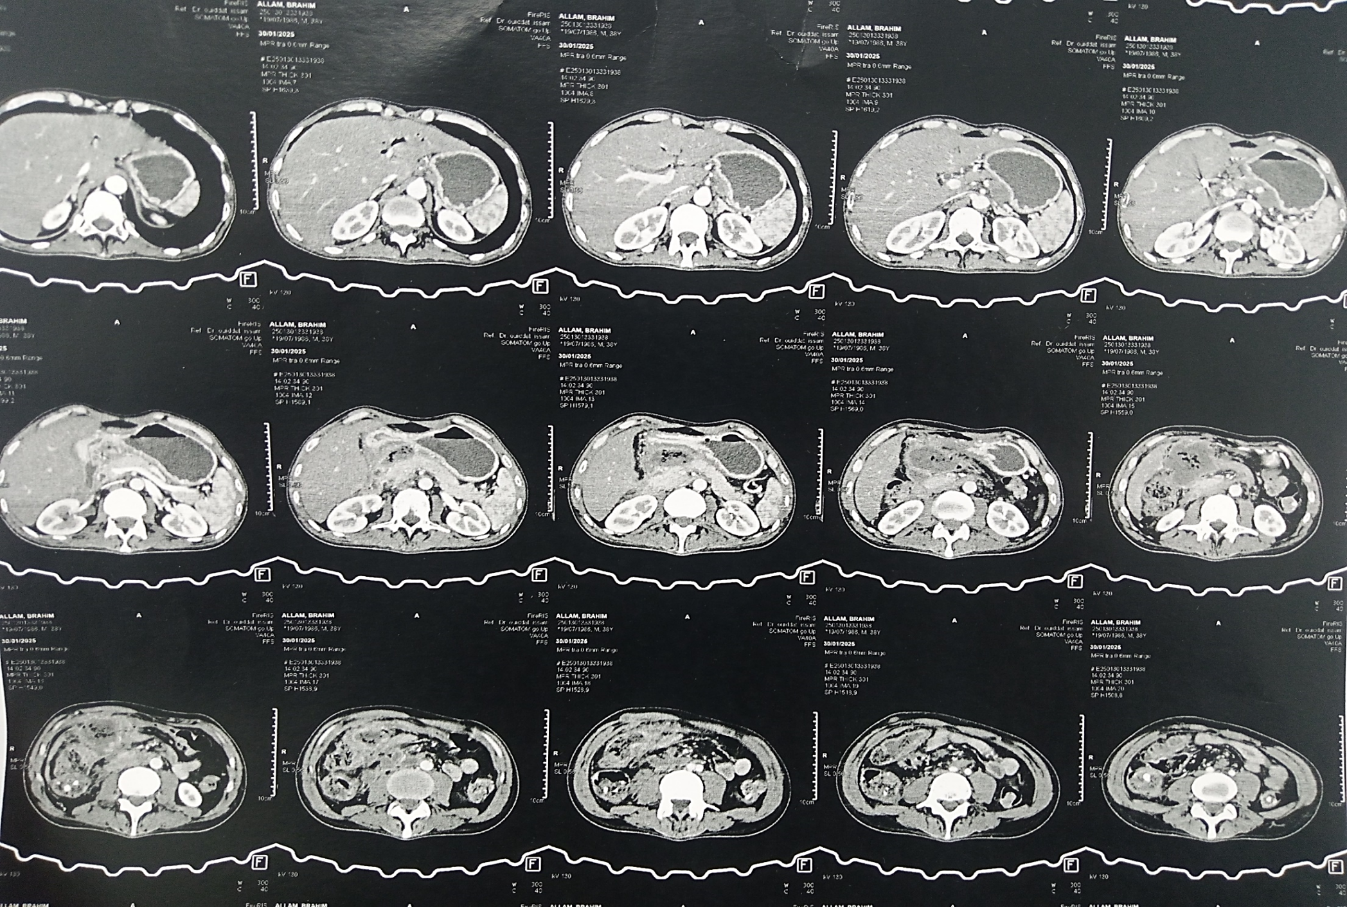
Figure 1 : Sagittal sections of an abdominal CT scan showing organized peripancreatic necrosis measuring 66x55mm, which appears to be complicated by a cystogastric fistula. Evidence of spontaneously hyperdense material in the gallbladder bed, generating a metallic artifact (surgical clip). Presence of aerobilia and dilation of the intrahepatic bile ducts.

After gastrografin ingestion:
Demonstration at the level of the ACE between the head of the pancreas and the antropyloric region of a roughly oval, fairly well-defined fluid collection, containing air bubbles, measuring approximately 59x43 mm and extending over 70 mm. This collection reaches intimate contact with the hepatic segment V with a persistent thin fatty border separating it. It also reaches contact with the anterior abdominal wall at the level of L3 with thickening of the adjacent peritoneal layer. Absence of extradigestive passage of gastrografin at the explored level (at the level of the stomach, D1 and D2). Reflux of gastrografin at the level of the Wirsung duct. This is associated with infiltration of the surrounding mesenteric fat. Deep intra-abdominal lymphadenopathy, less than a centimeter in size, of the coeliomesenteric and right mesenteric lymph nodes.

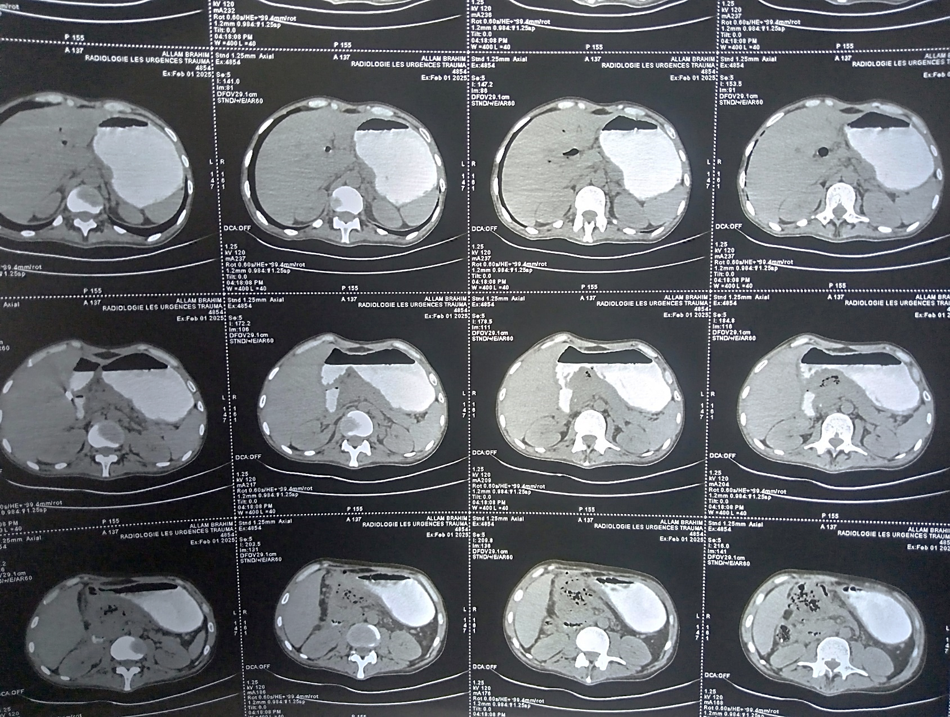
Figure 2 : CT appearance after ingestion of gastrografin of a fluid collection from the back of the omentum cavity without signs of a digestive fistula clearly detectable within the limits of this examination.

The patient presented with hemodynamic instability, with hypotension at 05/03 mmHg and bradycardia at 45 beats/min, requiring emergency transport to the operating room. After a midline incision, exploration revealed the presence of several epiplo-parietal, epiplo-hepatic, epiplo-spleen, and epiplo-colic adhesions. The presence of subhepatic shielding made any dissection dangerous. A necrotic flow was present at the level of the pancreatic head, fistulized at the level of the transverse colon.
During exploration, the patient presented bilateral non-reactive mydriasis with hypotension at 04/02 mmHg, then cardiac arrest that was not recoverable despite resuscitation measures.

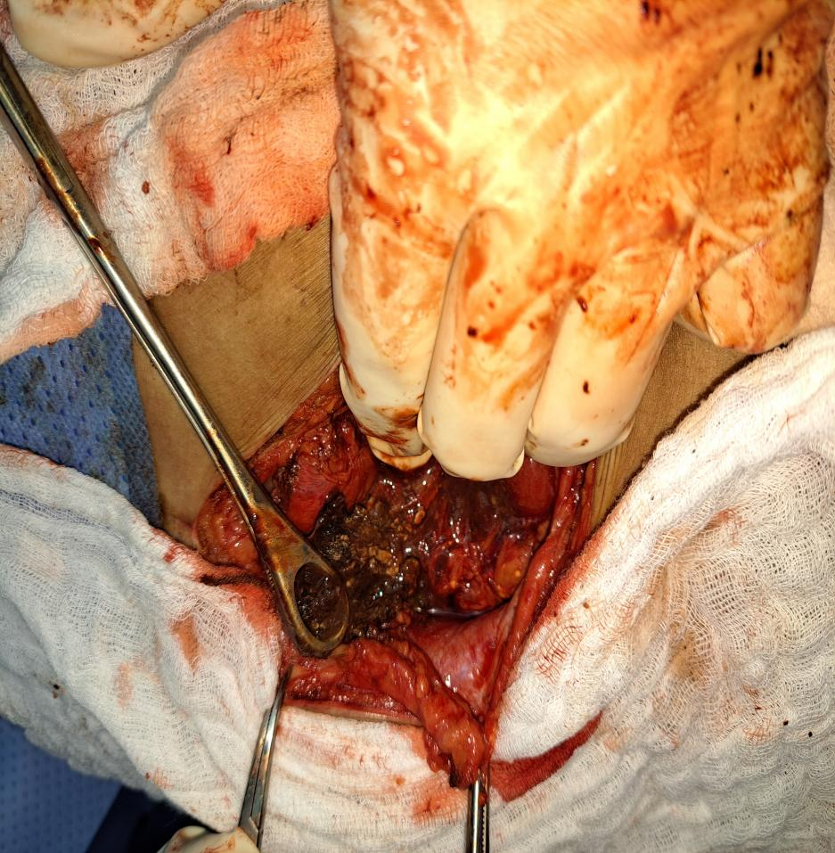 A 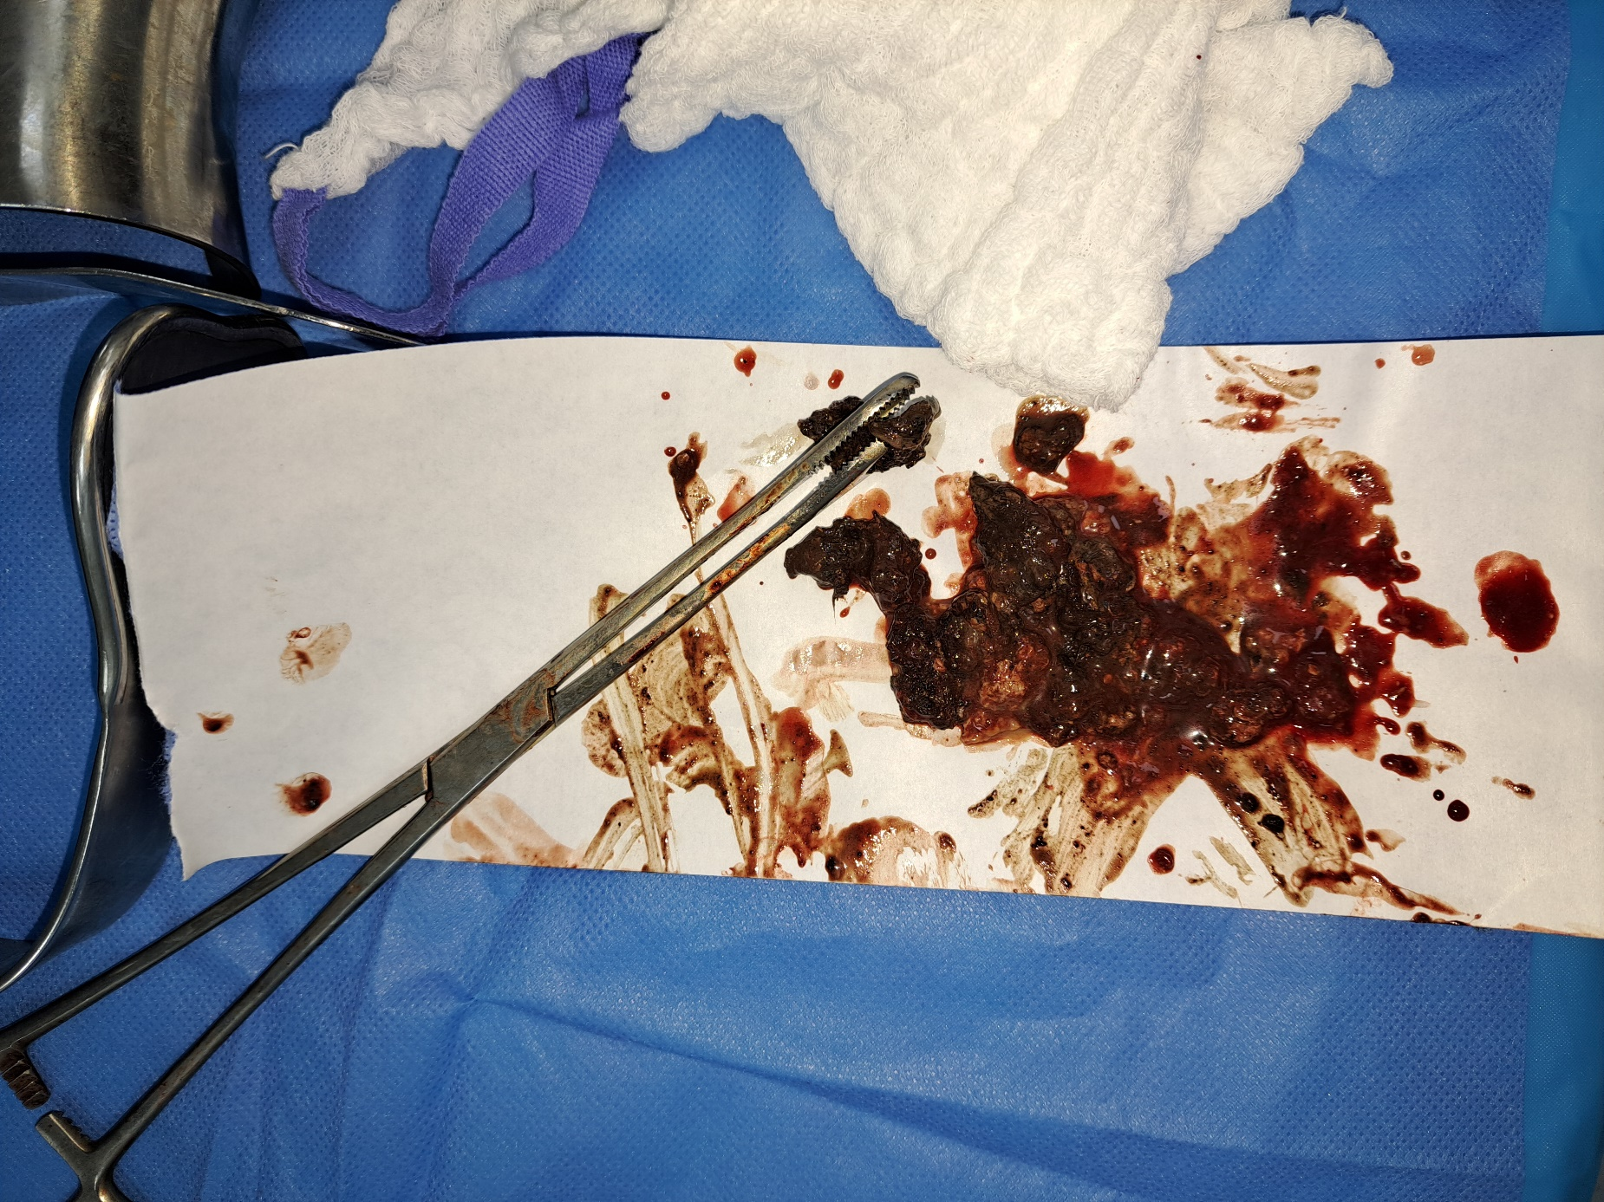 B
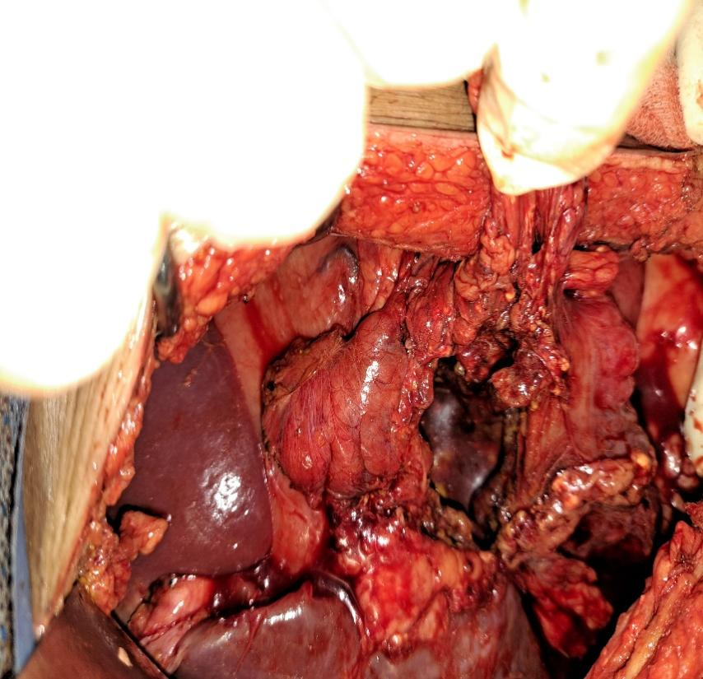 C
Figure 3 : Intraoperative images of the fistulization of a necrotic stream through the wall of the transverse colon:
A: Appearance upon opening the wall.
B: The extracted necrotic stream.
C: Revelation of the colonic perforation: liver (triangle), stomach (star), transverse colon (arrowhead), perforation of the posterior wall of the transverse colon communicating with the head of the pancreas, site of necrosis (arrow).

II. DISCUSSION
Acute pancreatitis is an acute inflammatory disorder of the pancreatic gland, causing its autodigestion with variable spread to neighboring tissues and distant organs, associated with a significant elevation of pancreatic enzymes in the blood.
It can be classified according to its severity according to the 2012 revised Atlanta classification:
1. Mild acute pancreatitis: With no organ failure, local or systemic complications, and/or necrosis
2. Moderately severe acute pancreatitis: With the presence of rapidly improving organ failure, and/or local complications, and/or systemic complications
3. Severe acute pancreatitis: With persistent organ failure for more than 48 hours.
In the past, surgery was used to diagnose pancreatitis during autopsies. Indeed, a report dating from 1988 stated that nearly half of pancreatitis cases were diagnosed post-mortem. Before the arrival of CT scans and lipase assays, any surgical abdomen led to an exploratory laparotomy, which then led to the diagnosis of acute pancreatitis due to the presence of pathognomonic lesions of cystosteatonecrosis (fat necrosis caused by pancreatic enzymes). Given the survival of some of these patients, the notion of "therapeutic surgery" for acute pancreatitis was born.
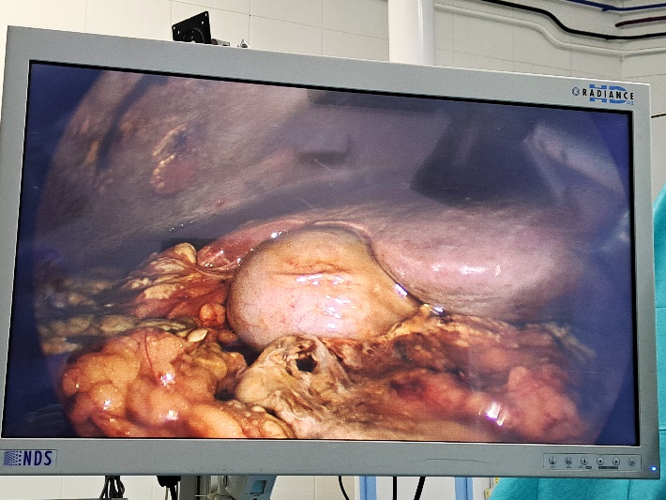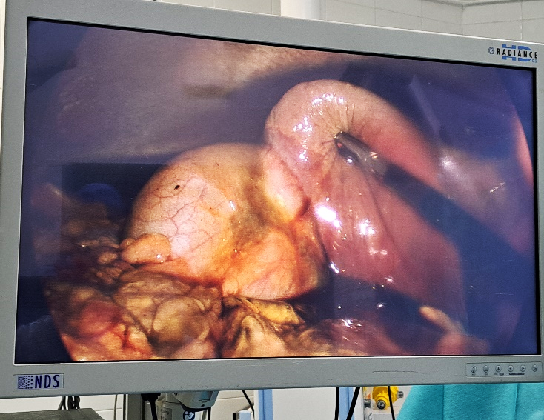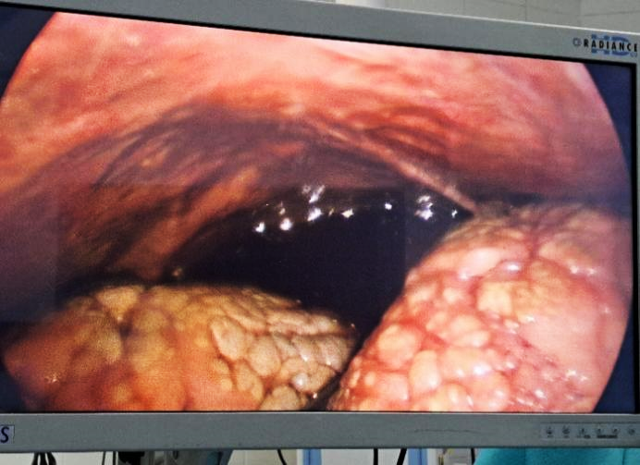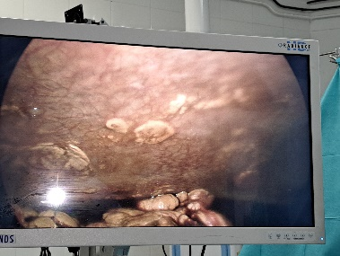
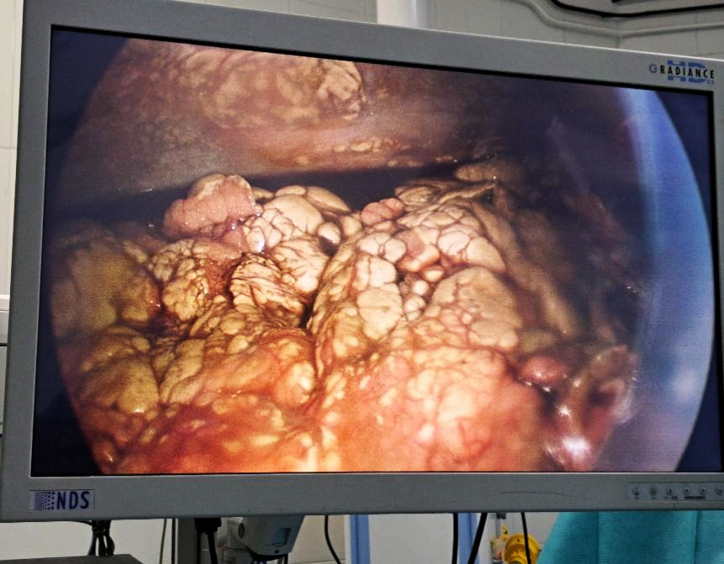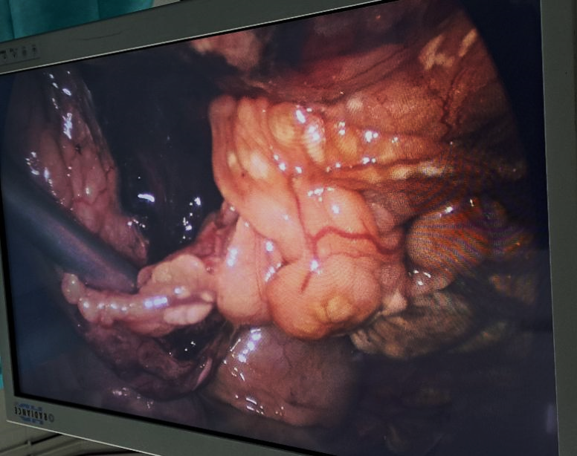
Figure 4 : This is a 54-year-old patient admitted for stage E pancreatitis of unknown etiology and whose clinical picture suggested peritonitis due to perforation of a hollow organ. Above are intraoperative images during exploration by coelioscopy, highlighting pancreatic collections and cystosteatonecrosis lesions (candle stains) extended throughout the peritoneal cavity and to the loops, with no perforation or stigmata of peritonitis.

Since 1965, several surgical treatments for acute pancreatitis have been proposed and the most popular was peritoneal lavage with pancreatic drainage. Over time, studies on the subject have demonstrated the importance of respiratory and cardiovascular complications as well as the lack of impact on sepsis or overall mortality, which has led to abandoning this practice in favor of medical treatment alone in the acute phase, which is simple intravenous hydration.
Intravenous hydration improves acute pancreatitis by rapidly restoring fluid and electrolyte balance, which is essential for pancreatic function, which can aid in recovery and prevention of necrosis and complications such as renal failure, hypotension, and multiple organ failure syndrome (MODS). It also promotes the excretion of pancreatic enzymes and toxins produced during inflammation, which can improve the overall prognosis of the patient. Apart from surgery for secondary complications such as infected encapsulated necrotic flows or symptomatic pseudocysts, early surgery for acute pancreatitis has only recently been dethroned by advances in radiology and interventional endoscopy, reducing morbidity and mortality.

The pathophysiology of gastrointestinal perforation in severe acute pancreatitis involves a cascade of events that begins with the premature activation of pancreatic enzymes, leading to autodigestion of the pancreas and surrounding tissues. This intense inflammation can spread, resulting in fluid collections, necrosis, and potentially perforation of adjacent organs such as the stomach or duodenum.
Key mechanisms of gastrointestinal perforation in severe pancreatitis involve a cascade of events:
- Inappropriate enzyme activation:
Trypsin, a normally inactive enzyme in the pancreas, is activated prematurely, beginning to digest pancreatic and surrounding tissues.
- Intense inflammatory reaction:
Enzyme activation triggers a massive inflammatory reaction, with the release of cytokines and other inflammatory mediators that exacerbate tissue damage.
- Necrosis and fluid collections:
Inflammation and autodigestion can lead to the death of pancreatic tissue (necrosis) and the formation of fluid collections around the pancreas (pseudocysts).
- Perforation of adjacent organs:
In severe cases, inflammation and fluid collections can erode adjacent organs, such as the stomach, duodenum, or colon, causing gastrointestinal perforation.
- Peritonitis:
If the contents of the perforated organ spill into the abdominal cavity, it can lead to peritonitis, a potentially fatal inflammation of the membrane lining the abdominal cavity.
- Systemic complications:
Severe pancreatitis can also lead to systemic complications, such as lung, kidney, or heart damage, due to the release of inflammatory substances into the bloodstream.
Surgical management of colonic fistulas will depend on the patient's hemodynamics, the diameter of the fistula, and the condition of the rest of the colon.
1. Presence of a fistula with no sepsis: Management will consist of drainage with monitoring; enteral nutrition can be maintained.
2. In cases of sepsis and/or organized collection, a sufficiently caliber drain can be placed. Irrigation is essential here to prevent obstruction of the drain by necrosis. In the study by Gao et al. of 1,750 patients with acute pancreatitis, 711 of whom developed necrotic flows and 132 (19%) developed colonic fistulas, non-surgical management of selected patients appeared feasible in 47% of cases. Some describe endoscopic techniques using a clip to obliterate the fistulous orifice and an intraductal pancreatic stent to dry the fistula.
3. In the event of failure of these procedures after a 72-hour delay, or in the event of extensive colonic ischemia from the outset, surgical management will be required, ranging from ileostomy to colonic resection with colostomy. The strategies are diverse and will depend on intraoperative findings.
This surgery remains morbid, with a high mortality rate.
III. CONCLUSION
Colonic perforation complicating severe acute pancreatitis, although rare, represents a major medical and surgical emergency. This case illustrates the potential severity of gallstone-induced pancreatitis, particularly when it progresses to extensive necrohemorrhagic forms. Diagnosis relies on rigorous clinical monitoring and appropriate imaging, allowing for early identification of digestive complications. Management must be multidisciplinary, combining resuscitation, targeted antibiotic therapy, and surgical treatment adapted to the extent of the lesions. This case highlights the importance of increased vigilance in the face of any adverse progression of pancreatitis and the value of early treatment of gallstones to prevent these daunting complications.

Consent
As per international standards or university standards, patient(s) written consent has been collected and preserved by the author(s).
Disclaimer (Artificial intelligence)
Option 1:
Author(s) hereby declare that NO generative AI technologies such as Large Language Models (ChatGPT, COPILOT, etc.) and text-to-image generators have been used during the writing or editing of

IV. REFERENCES

Werge M, Novovic S, Schmidt PN, Gluud LL. Complications and mortality in necrotizing pancreatitis: Asystematic review and meta-analysis. Pancreas. 2016;45(6):794-800.
Sreide JA. Pancreatic necrosis and infection. Br J Surg. 1998;85(7):905-912. doi:10.1046/j.1365-2168.1998.00725.
Zerem E, Hadzic A. Liver, biliary and pancreatic diseases: Acute biliary pancreatitis. World J Gastroenterol.2014;20(44):16589-16596. doi:10.3748/wjg.v20.i44.16589
Banks PA, Bollen TL, Dervenis C, et al. Classification of acute pancreatitis-2012: Revision of the Atlanta
Wilson, C., Imrie, C. W. & Carter, D. C. Fatal acute pancreatitis. Gut 29, 782–788 (1988) classification and definitions by international consensus. Gut. 2013;62(1):102-111.doi:10.1136/gutjnl-2012-302779
Isenmann R, Beger HG. Severe acute pancreatitis: Clinical course and management. World JGastroenterol. 1999;5(2):75-78. doi:10.3748/wjg.v5.i2.75
Sakorafas GH, Tsiotou AG. Perforation of the colon in severe acute pancreatitis: Pathogenesis andmanagement. Surgical Today. 2000;30(6):504-509. doi:10.1007/s005950070038
Acosta JM, Katkhouda N, Tanaka J, et al. Colonic complications of severe acute pancreatitis. Am Surg.1998;64(3):250-254.
Gornals JB, De-la-Hera M, Crdenas-Jan K, et al. Colonic perforation: An uncommon but severe complication in necrotizing pancreatitis. Pancreatology. 2013;13(4):415-418. doi:10.1016/j.pan.2013.04.003
Aghenta, Anthony A., et Hack J. Kim. « An Unusual Case of Colon Perforation Complicating Acute Pancreatitis ». Case Reports in Gastroenterology 3, nº 2 (2009): 207-13. https://doi.org/10.1159/000226609.
Gao, L. et al. Management of colonic fistulas in patients with infected pancreatic necrosis being treated with a step-up approach. HPB 22, 1738–1744 (2020)

