*Case report*

Double gastric peptic perforation in a 61-year-old patient: A case report

.

ABSTRACT

|  |
| --- |
| **Introduction:** Peptic ulcer perforation is one of the most frequent surgical emergencies, the major predisposing factor are Helicobacter pylori infection and NSAIDs chronic use, multiple simultaneous gastric perforations are extremely rare, and are described in literature in fragile patients.  **Presentation of the Case:** Our patient is a 61 year old male, with history of chronic smoking, admitted to the emergency room for generalized abdominal pain and vomiting, evolving for 5 days.  CT scan showed multiple fluid collections with gas bubbles, the patient wa operated on with the discovery of 2 gastric perforations, one in the pylorus and the other in the antrum, primary suture was perfomed with omental patch and peritoneal lavage, the post operative course was uneventful and the patient was discharged on the fifth day.  **Discussion:** peptic ulcer perforation is a frequent surgical emergency, however, double peptic perforation of the stomach is an extremely rare entity, its has been described few times in literature in patients with multiple risk factors.  **Conclusion:** Double peptic perforation is a rare entity that should be known by surgeons in order to minimize complications and mortality |

*Keywords: ACUTE ABDOMEN, CASE REPORT, DOUBLE PEPTIC PERFORATION, PEPTIC ULCER.*

1. INTRODUCTION

Peptic ulcer disease is one of the most prevalent gastro intestinal diseases [1], Frequency varies in countries, and the major factors are Helicobacter pylori infection and the consumption of non steroidal anti inflammatory drugs [2], Perforation occurs in about 5 to 10% of patients with active ulcer disease. Smoking independently increases acid secretion, impairs mucosal defenses, delays healing, and elevates complication rates[3]. The diagnosis of the perforation is done by x ray and treatment is mostly surgical. Double peptic perforation is extremely rare, and mostly are related to trauma or occur in patients with multiple risk factor. Although perforations can occur in various parts of the gastrointestinal tract, a dual perforation in the stomach is uncommon and poses unique management challenges, particularly when not immediately recognized.

We present a rare case of simultaneous antral and pyloric perforation in a heavy smoker without NSAID exposure.

2. Presentation of the case

We present the case of a 61-year-old male with history of smoking, presenting with generalized abdominal pain evolving for 5 days, associated with nausea, vomiting, and abdominal distension. He reported no history of prior abdominal trauma or recent surgery. The patient was admitted to the emergency room, and physical examination revealed a stable patient, with generalized abdominal tenderness and rigidity. Plain abdominal Xray showed no signs of pneumoperitoneum.

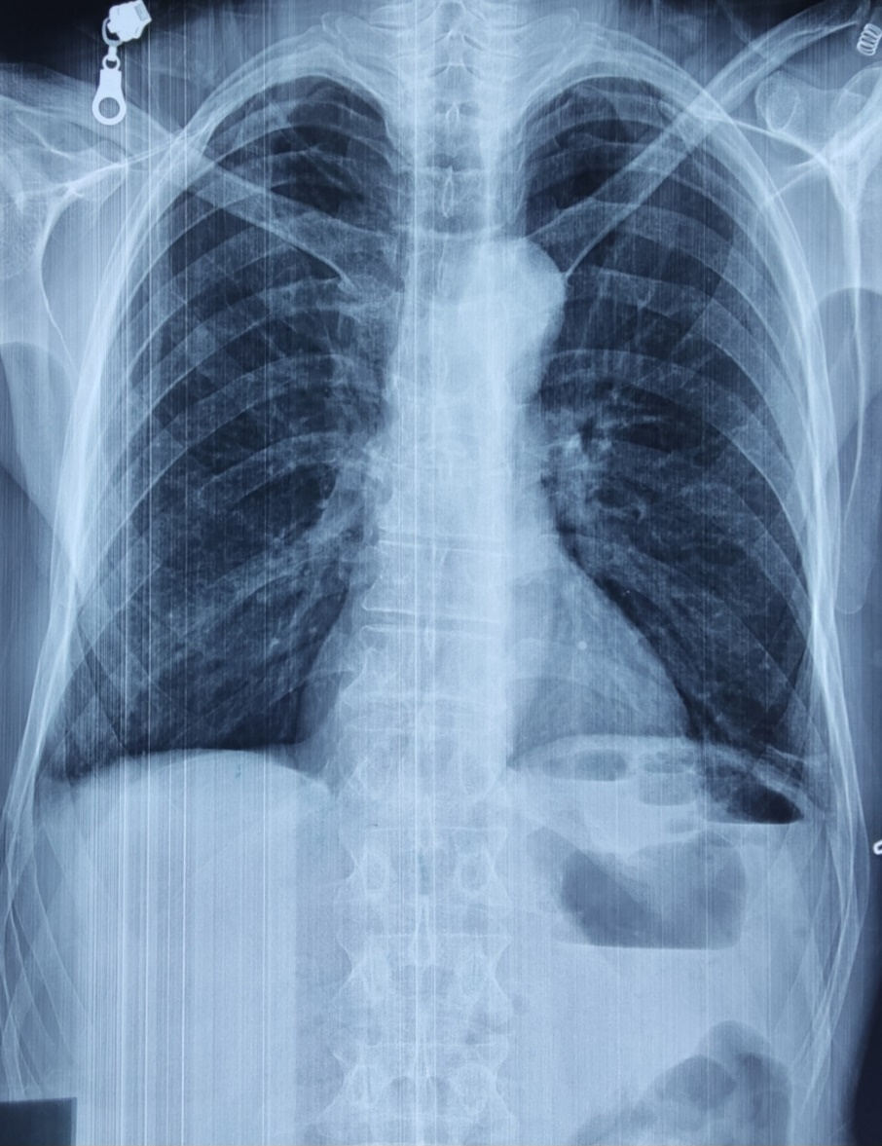

Figure1: plain abdominal x ray centered on the diaphragm.

A CT scan revealed the presence of 3 fluid collections with gas bubbles, in the gastric hepatic space, peri splenic, and in the liver measuring respectively 74x50mm, 40x80mm and 20x30mm.

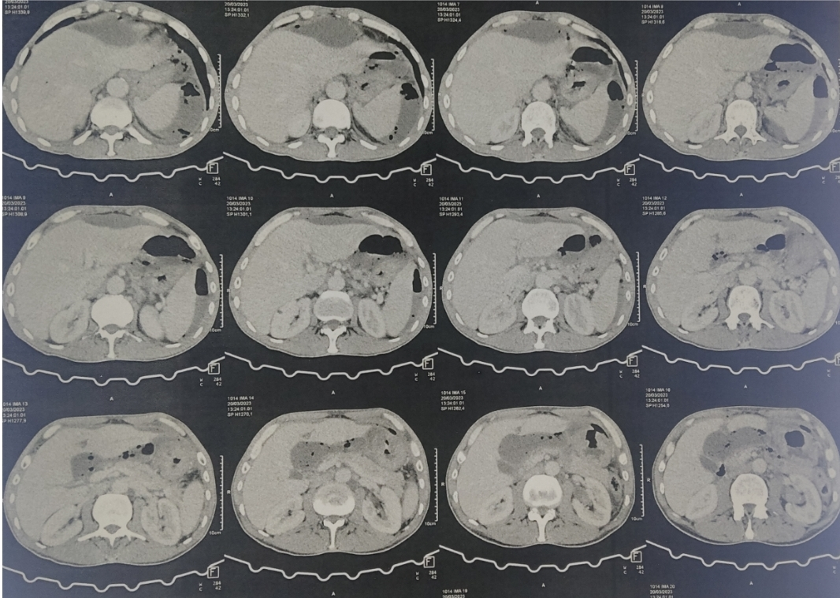

Figure 2: CT scan showing the fluid collections.

Given the patient's clinical presentation and radiologic findings, an emergency laparotomy was performed. Upon incising, we found some adhesions with infra hepatic and peri splenic pus collections, and we discovered after liberating the adhesions, two gastric perforations of 0.5cm each, one in the antrum and the other was pyloric.

Both perforations were sutured primarily, with omental patch, a peritoneal lavage was performed and infra hepatic and left infra diaphragmatic drains were placed.

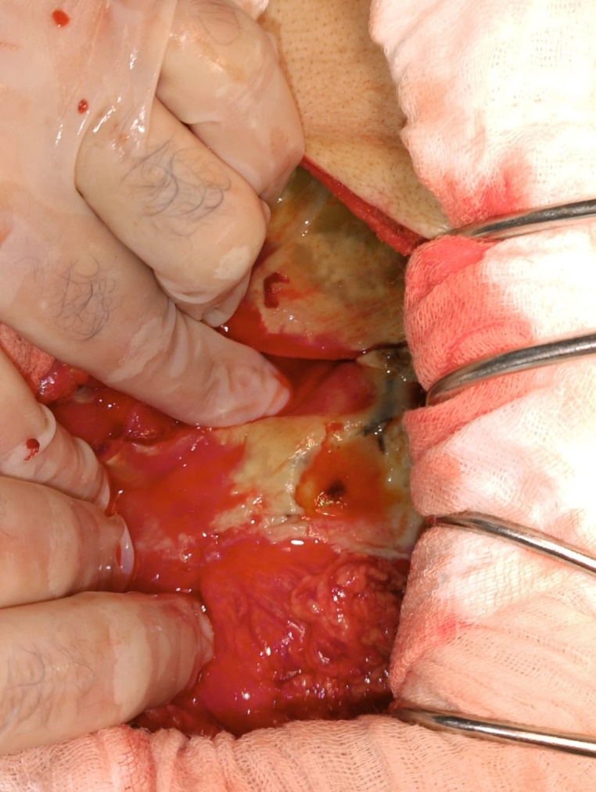

Figure 3: antrum perforation

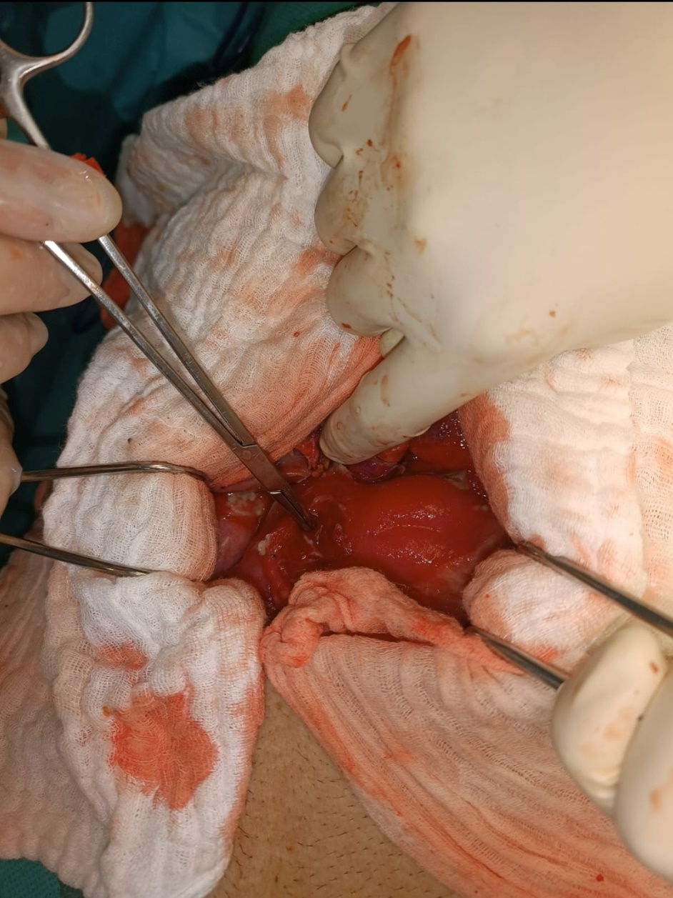

Figure4: the pyloric perforation

Postoperatively, the patient was transferred to the intensive care unit for **close monitoring**. He was started on **broad-spectrum antibiotics**, including **piperacillin-tazobactam** and **metronidazole**, as well as **proton pump inhibitors** to reduce gastric acid secretion.

The post operative course was uneventful, and the patient was discharged on the fifth day.

The anatomopathological results of the biopsy of the perforation showed no malignancy, and the patient made a full recovery.

3. discussion

Peptic ulcer perforation is one of the most frequent surgical emergencies, it is most frequently located in the pylorus and first part of the duodenum [4], the most common risk factors are Helicobacter pylori and chronic non-steroidal anti-inflammatory drugs use [5], other factor inducing chronic inflammation are stress, smoking and alcohol use.

Double peptic perforation is a very rare surgical entity, with only few articles describing such occurrence [6,7], it is mostly described in relation to trauma and fragile patients.

Double gastric perforation is particularly uncommon and presents a unique challenge for the surgeon, as the extent of contamination of the peritoneal cavity is much greater than with a single perforation. This can lead to more severe sepsis, acute renal failure, and cardiovascular collapse if not addressed promptly.

Bhargav et al. described a similar presentation in a 70‑year‑old man with two adjacent perforations in the antrum/pylorus region. These cases underscore the necessity of inspecting the entire stomach during surgery to identify multiple perforations [8].

Our patient did not have a history of chronic NSAIDs usage, his only predisposing factor was heavy smoking (30 packs-years),

Conservative treatment is well described literature requiring close monitoring by a qualified team [8,9], laparoscopic repair by primary closure or grahams patch are the most used techniques [5,10], our patient had symptoms evolving for 5 days, and was on sepsis when admitted so the surgery was performed by laparotomy.

The role of H. pylori eradication therapy and smoking cessation cannot be overstated in preventing further complications in such patients. This patient was counseled on both smoking cessation and the need for follow-up regarding potential H. pylori treatment.

4. Conclusion

Peptic ulcer perforation is one of the most frequent abdominal emergencies, requiring prompt diagnosis, and expedited surgical treatment, double peptic perforation however, is a rare entity that should be known by surgeons and looked for during surgery.

Competing interests

Authors have declared that no competing interests exist.

Ethical approval AND CONSENT

All authors declare that ‘written informed consent was obtained from the patient (or other approved parties) for publication of this case report and accompanying images. A copy of the written consent is available for review by the Editorial office/Chief Editor/Editorial Board members of this journal.

As per international standards or university standards written ethical approval has been collected and preserved by the author(s).

Disclaimer (Artificial intelligence)

Option 1:

Author(s) hereby declare that NO generative AI technologies such as Large Language Models (ChatGPT, COPILOT, etc.) and text-to-image generators have been used during the writing or editing of this manuscript.

Option 2:

Author(s) hereby declare that generative AI technologies such as Large Language Models, etc. have been used during the writing or editing of manuscripts. This explanation will include the name, version, model, and source of the generative AI technology and as well as all input prompts provided to the generative AI technology

Details of the AI usage are given below:

1.

2.

3.

References

1. Lanas A, Chan FKL. Peptic ulcer disease. Lancet. 2017 Aug 5;390(10094):613-624. doi: 10.1016/S0140-6736(16)32404-7. Epub 2017 Feb 25. PMID: 28242110.

2. BANZET P, PERNOD P. Un cas d'ulcère double perforé; bons résultats d'une opération de Dragstedt [Case of perforated double ulcer; successful results following Dragstedt operation]. Arch Mal Appar Dig Mal Nutr. 1953 Sep-Oct;42(9-10):1114-9. PMID: 13125702.

3.Katagiri, Hideki MD1; Lefor, Alan Kawarai. MD, MPH, PhD2; Kubota, Tadao MD1; Mizokami, Ken MD, PhD1. Smoking History Is More Highly Associated with Perforated Peptic Ulcer Than the Rate ofHelocobacter pyloriInfection: 1071. American Journal of Gastroenterology 111():p S466-S467, October 2016.

4. Bulut OB, Rasmussen C, Fischer A. Acute surgical treatment of complicated peptic ulcers with special reference to the elderly. World J Surg. 1996;20:574–7. doi: 10.1007/s002689900089.

5. Weledji EP. An Overview of Gastroduodenal Perforation. Front Surg. 2020 Nov 9;7:573901. doi: 10.3389/fsurg.2020.573901. PMID: 33240923; PMCID: PMC7680839.

6. Atul K. Sharma, Rakesh K. Sharma, Santosh K. Sharma, Devendra Soni, Tej Pratap Singh, Double peptic perforation: Report of a rare case, Asian Journal of Surgery,Volume 38, Issue 4,2015,Pages 239-241,ISSN 1015-9584,https://doi.org/10.1016/j.asjsur.2013.04.001.

7. Ozdemir K, Mantoglu B, Cakmak G, Dulger U, Bayhan Z, Eroz E. Double peptic ulcer perforation in a Covid-19 patient, extremely rare entity. Ulus Travma Acil Cerrahi Derg. 2023 Feb;29(2):252-254. doi: 10.14744/tjtes.2021.56346. PMID: 36748769; PMCID: PMC10198331.

8. Bhargav R, Acharya B. Double gastric perforation as a complication of peptic ulcer disease: a rare surgical entity. *Asian J Case Rep Surg*. 2023;6(1):202–205 .

9. Conservative management of perforated peptic ulcer. Lancet. 1989 Dec 16;2(8677):1429-30. PMID: 2574364.

10. Abdalgalil HH, Ismail AS, Alshmaily HO, Alshammari DS. A Conservative Management of Perforated Peptic Ulcer: A Case Report. Cureus. 2024 Mar 19;16(3):e56491. doi: 10.7759/cureus.56491. PMID: 38638727; PMCID: PMC11026102.

11. Nirula R. Gastroduodenal perforation. Surg Clin North Am. 2014 Feb;94(1):31-4. doi: 10.1016/j.suc.2013.10.002. Epub 2013 Nov 5. PMID: 24267494.