**Renal Epithelioid Angiomyolipoma in a Rural Indian Setting: A Case Series Emphasizing Morphological Diagnosis and Malignant Potential Amidst Resource Constraints**

.

ABSTRACT

|  |
| --- |
| Epithelioid angiomyolipoma (EAML), a rare kinship within the perivascular epithelioid cell tumor (PEComa) family, presents a diagnostic conundrum. Unlike its classical counterpart, EAML often lacks the tell-tale fatty signature on imaging and harbors a significant propensity for malignant behavior, frequently masquerading as renal cell carcinoma (RCC). This diagnostic obscurity poses a considerable clinical hurdle, particularly within the constraints of resource-limited healthcare environments  **Objective:** To highlight the diagnostic difficulty of EAML and emphasize the critical role of histopathology in its identification, particularly in the absence of immunohistochemistry. The study also underlines the tumor’s malignant potential and the need for appropriate management. Our study focuses on morphological histopathological findings of EAML in a resource-limiting setting, specifically in a tertiary care center of rural background in North India.  **Methods:** We report three cases of EAML in patients presenting with flank pain, hematuria, or abdominal mass at a rural tertiary center in Uttar Pradesh, India. Contrast-enhanced CT showed solid renal masses without visible fat, leading to a provisional diagnosis of malignancy. One case involved bilateral kidneys. All patients underwent surgical excision due to lesion size and suspicious imaging features.  **Results:** Histopathological examination confirmed EAML in all cases based solely on morphology, in the absence of immunohistochemical facilities. Distinct cellular features and growth patterns were diagnostic. Surgical resection was curative, with no recurrence or metastasis during follow-up.  **Conclusion:** EAML, though rare, must be considered in the differential diagnosis of fat-poor renal masses. Its malignant potential and ability to radiologically mimic RCC necessitate high clinical suspicion. In settings lacking immunohistochemistry, careful histopathological evaluation is essential. Surgery remains the mainstay of treatment, serving both diagnostic and therapeutic roles. |

*Keywords: Angiomyolipoma; Perivascular Epithelioid Cell Tumor; Histopathology; Renal Neoplasm; Contrast Tomography; Rural Healthcare; Malignant Potential; Local Aggression*

1. INTRODUCTION

Renal angiomyolipoma (AML), a benign mesenchymal tumor, constitutes ~1% of surgically treated renal masses, with reported frequencies ranging from 0.3% to 3.0%¹. While most AMLs are asymptomatic and small, “giant” forms (>10 cm) are rare, and those >20 cm are exceptionally uncommon². AMLs belong to the perivascular epithelioid cell tumor (PEComa) family, characterized by co-expression of melanocytic (HMB-45, Melan-A) and smooth muscle markers³.

The World Health Organization (WHO) classifies AMLs into classical and epithelioid types. Epithelioid angiomyolipoma (EAML), an infrequent but clinically significant variant, harbors malignant potential. It predominantly comprises epithelioid cells with minimal adipose tissue (<5%), often making radiologic distinction from renal cell carcinoma (RCC) difficult⁴. Though primarily renal, extra-renal sites like liver, lung, and uterus have been reported⁵.

Malignancy risk correlates with epithelioid cell content: >95% epithelioid composition portends up to 51.5% progression risk⁶. Nese et al. outlined poor prognostic markers, including size >7 cm, necrosis, renal vein/extra-renal extension, TSC association, and carcinoma-like growth⁷.

Given its RCC mimicry and potential for aggression, accurate diagnosis hinges on histopathology. In resource-limited rural settings, where immunohistochemistry is often unavailable, careful hematoxylin and eosin (H&E) evaluation becomes vital.

We present three renal EAML cases from a rural Indian tertiary care center, emphasizing diagnosis based on detailed morphological assessment without IHC, and highlighting its diagnostic value in low-resource settings.

2. Presentation of Case

**Case 1**

A 50-year-old male from rural Uttar Pradesh presented with dull abdominal pain, anorexia, and urinary hesitancy for 3 months. Examination revealed a 20×20 cm non-tender mass in the right renal region. Contrast-enhanced CT scan showed a 14×14×20 cm predominantly solid, fat-poor lesion arising from the lower pole of the right kidney, raising suspicion for epithelioid angiomyolipoma (EAML) versus renal cell carcinoma (RCC) (Figure 1a). The patient underwent radical nephrectomy.On gross examination, the tumor was well-circumscribed with variegated yellowish to whitish areas with zones of hemorrhage and necrosis (Figure 1b). Low-power view showing adipose and epithelioid elements with perivascular arrangement). Microscopy revealed sheets of epithelioid cells with clear to granular eosinophilic cytoplasm, intermixed with mature adipocytes, thick-walled dysplastic blood vessels, and smooth muscle bundles (Figure 1c-h). Despite the unavailability of immunohistochemistry, the classic histopathological triad, epithelioid morphology, large tumor size, and necrosis supported the diagnosis of EAML with aggressive potential. The postoperative recovery was uneventful, and no recurrence was noted at 3-month follow-up.

**Case 2**

A 60-year-old female presented with sudden severe left flank pain and gross hematuria. Contrast-enhanced CT revealed a 48×38 mm hyperdense, slightly enhancing mass in the left kidney with invasion into the renal pelvis (Figure 2a). Hemorrhagic angiomyolipoma was suspected. She underwent partial nephrectomy via retroperitoneal laparoscopy.Grossly, the tumor was yellowish and well-circumscribed (Figure 2b). Microscopy revealed an admixture of epithelioid and spindle cells, thick-walled dysplastic blood vessels, and focal adipose tissue (Figure 2c-d). Higher magnification revealed sheets of pleomorphic epithelioid cells with prominent nucleoli, mitoses, and focal tumor giant cells (Figure 2e-g). HMB-45 positivity confirmed melanocytic marker expression. The presence of renal pelvic invasion and moderate nuclear atypia suggested EAML with aggressive potential. The postoperative course was uneventful, and follow-up imaging has shown no recurrence.

**Case 3**

A 70-year-old male with bilateral renal masses previously labeled as AMLs presented with anemia (Hb: 7.9 g/dL) and renal dysfunction (eGFR: 8 mL/min/1.73m²; serum creatinine: 512 µmol/L). There was no history of tuberous sclerosis complex (TSC). He underwent left partial nephrectomy. Grossly, the tumor was yellow-tan and well-circumscribed (Figure 3b). Microscopy showed minimal fat, with intervening smooth muscle and thick-walled blood vessels. Sheets of epithelioid cells confirmed the diagnosis of EAML (Figure 3c–e). Although IHC was not performed, morphology was sufficient for diagnosis. The contralateral lesion is being managed conservatively with multidisciplinary input due to his renal status.

**3. DISCUSSION**

Renal epithelioid angiomyolipoma (EAML) is a rare mesenchymal tumor classified under the perivascular epithelioid cell tumor (PEComa) family [1,3]. Unlike conventional AML, which is fat-rich and often detected incidentally, EAML typically lacks macroscopic fat, making it radiologically indistinguishable from renal cell carcinoma (RCC) [2,4]. This diagnostic ambiguity is especially challenging in resource-limited settings, where advanced imaging and immunohistochemical (IHC) tools are often unavailable.

Clinically, EAML presents with nonspecific symptoms—flank pain, hematuria, or palpable mass. Metastatic cases may manifest systemic symptoms [1,5]. Imaging typically reveals a solid, fat-poor renal mass, often leading to a presumptive diagnosis of RCC [2,6]. In our series, the presence of enhancing renal masses without fat necessitated surgical management for both diagnosis and treatment.

Histologically, EAML comprises epithelioid cells with eosinophilic to clear cytoplasm, nuclear atypia, and a variable admixture of dysplastic blood vessels and adipocytes [1,4]. In our rural setup, lacking IHC facilities, diagnosis relied entirely on morphology using hematoxylin and eosin (H&E) staining. Distinguishing features—intimate admixture of epithelioid cells, thick-walled vessels, and sparse adipocytes—enabled confident differentiation from RCC. While IHC confirms EAML via melanocytic markers (HMB-45, Melan-A) and absence of epithelial markers, our cases show that detailed morphological interpretation alone can suffice in expert hands.

EAML’s malignant potential is well-documented. Nese et al. outlined adverse features including tumor size >7 cm, necrosis, TSC association, renal vein or extra-renal invasion, and carcinoma-like architecture [7]. In our cases, large tumor size (Case 1), necrosis (Figure 1C), and pelvicalyceal invasion (Case 2) reinforced the need for long-term monitoring. Literature also correlates poor outcomes with marked pleomorphism, high mitotic rate, and atypical mitoses.

Surgical excision—radical or partial nephrectomy—remains the mainstay of treatment [3,6,9]. In unresectable or metastatic cases, mTOR inhibitors such as everolimus have shown efficacy [9]. Metastatic potential is well documented, with reports of lung, liver, lymph node, and bone involvement [3, 6, 13]. Saoud et al. emphasized that even histologically bland tumors may behave aggressively, underscoring the need for vigilant follow-up [11]. Though rare, pediatric cases also show potential for aggressive behavior [12].

Our series from a rural Indian tertiary center highlights that EAML, though infrequent, must be considered in fat-poor renal masses, even in the absence of classic risk factors for RCC. Critically, these cases affirm that with careful attention to histomorphology, definitive diagnosis is possible without IHC. Given its unpredictable course, vigilant clinical and radiological follow-up is essential. The role of the pathologist, particularly in resource-constrained settings, remains pivotal in identifying this aggressive but diagnosable neoplasm.

4. Conclusion

Renal epithelioid angiomyolipoma (EAML), though rare, poses a significant diagnostic challenge due to its radiological resemblance to renal cell carcinoma and its malignant potential. In resource-limited rural settings where immunohistochemistry is unavailable, accurate diagnosis relies on meticulous interpretation of hematoxylin and eosin-stained sections. Our case series highlights that, with careful morphological evaluation, EAML can be confidently diagnosed without ancillary tests. Given its unpredictable behavior and risk of recurrence or metastasis, long-term clinical and radiological follow-up is essential. This underscores the critical role of the pathologist in recognizing EAML based on morphology alone to guide timely management and prognosis.

AcknowledgEments

None.

Competing interests

The authors declare no conflicts of interest.

Authors’ Contributions

All authors contributed equally to the diagnosis, clinical management, literature review, and final manuscript preparation.

Consent

Informed written consent was obtained from all patients for the publication of their clinical details and images.

Disclaimer (Artificial intelligence)

Option 1:

Author(s) hereby declare that NO generative AI technologies such as Large Language Models (ChatGPT, COPILOT, etc.) and text-to-image generators have been used during the writing or editing of this manuscript.

References

1. Park JH, Lee C, Suh JH, Kim G, Song B, Moon KC. Renal epithelioid angiomyolipoma: histopathologic review, immunohistochemical evaluation and prognostic significance. Pathol Int. 2016;66(10):571-577.
2. Flum AS, Hamoui N, Said MA, et al. An update on the diagnosis and management of renal angiomyolipoma. J Urol. 2015;195(3):834-846.
3. Guo B, Song H, Yue J, Li G. Malignant renal epithelioid angiomyolipoma: a case report and review of the literature. Oncol Lett. 2016;11(1):95-98.
4. Li H, Zhang X, Zhao Q, Wang J, Yang X, Huang S. Renal epithelioid angiomyolipoma: a case report. Oncol Lett. 2023;26(3):1-8.
5. Tsai HY, Kao Y, Chuang CK, Lee KH. Huge retroperitoneal epithelioid angiomyolipoma: a case report. Urol Case Rep. 2017;17:10-11.
6. Zhan R, Li YQ, Chen CY, Hu HY, Zhang C. Primary kidney malignant epithelioid angiomyolipoma: two cases report and review of literature. Medicine (Baltimore). 2018;97(32):e11805.
7. Nese N, Martignoni G, Fletcher CD, et al. Pure epithelioid PEComas (so-called epithelioid angiomyolipoma) of the kidney: a clinicopathologic study of 41 cases: detailed assessment of morphology and risk stratification. Am J Surg Pathol. 2011;35(2):161-176.
8. Mai KT, Perkins DG, Collins JP. Epithelioid cell variant of renal angiomyolipoma. Histopathology. 1996;28(3):277-280.
9. Tayal J, Doval DC, Kamboj M, Suryavanshi M. Case report of everolimus-induced sustained partial response in metastatic renal epithelioid angiomyolipoma. Turk J Urol. 2019;45(Suppl 1):S139-S142.
10. Sun DZ, Campbell SC. Atypical epithelioid angiomyolipoma: a rare variant with malignant potential. Urology. 2018;112:20-22.
11. Saoud R, Kristof TW, Judge C, et al. Clinical and pathological features of renal epithelioid angiomyolipoma (PEComa): a single institution series. Urol Oncol. 2022;40(1):18-24.
12. Mahajan D, Jain V, Agarwala S, Jana M, Ramteke PP. Renal epithelioid angiomyolipoma in children. J Kidney Cancer VHL. 2021;8(1):20-26.
13. Sato K, Ueda Y, Tachibana H, et al. Malignant epithelioid angiomyolipoma of the kidney in a patient with tuberous sclerosis: an autopsy case report with p53 gene mutation analysis. Pathol Res Pract. 2008;204(10):771-777.
14. Brimo F, Guillot A, Camparo P, et al. Renal epithelioid angiomyolipoma with minimal fat: a series of 40 cases with outcome analysis. Am J Surg Pathol. 2010;34(12):1726-1732.
15. Li Z, Zhang S, Liu B, et al. Clinicopathological characteristics and prognosis of renal epithelioid angiomyolipoma: a retrospective cohort study of 63 cases. World J Surg Oncol. 2022;20(1):402.
16. Zhou Y, Zhang Y, Qin B. Malignant renal epithelioid angiomyolipoma with metastasis to the abdominal cavity and liver: a case report and literature review. World J Clin Cases. 2023;11(11):2559-2567.

Table 1: Clinical and Pathological Details of the Cases

|  |  |  |  |  |  |  |
| --- | --- | --- | --- | --- | --- | --- |
| Patient | Age/Sex | Location | Imaging Findings | Histology (Morphology) | Surgery | Outcome |
| Case 1 | 50/M | Right kidney | Large, fat-poor mass (20×20 cm), raising suspicion for malignancy | Predominantly Epithelioid + Fat + Vessels, with features concerning for aggressive behavior | Radical Nephrectomy | No recurrence at 3 months |
| Case 2 | 60/F | Left kidney | Enhancing mass (48×38 mm), evidence of pelvicalyceal invasion | Spindle + Epithelioid + Pleomorphism, consistent with aggressive EAML | Partial Nephrectomy | No recurrence |
| Case 3 | 70/M | Bilateral | Bilateral AMLs reported on outside imaging, large masses | Epithelioid + Fat, confirming EAML with concern for malignant potential | Left Nephrectomy | Under ongoing evaluation |

Table 2: Summary of Literature Review on Epithelioid Angiomyolipoma (Highlighting Malignant Potential and Local Aggression)

|  |  |  |  |  |  |  |  |
| --- | --- | --- | --- | --- | --- | --- | --- |
| Author details | Type of study | Number of cases | Clinical features | Radiology findings | Management | Outcome | Malignant/Aggressive Features Noted |
| Park JH et al. (2016) [1] | Retrospective review | 41 | Flank pain, hematuria | Fat-poor lesions mimicking RCC | Surgery | Prognostic scoring attempted; malignant potential recognized | High epithelioid component, necrosis, larger size correlated with increased risk of progression. |
| Flum AS et al. (2015) [2] | Review article | - | - | Fat-poor AMLs difficult to distinguish from RCC | Surgery, mTOR inhibitors | Comprehensive diagnostic and management overview | Discusses aggressive clinical behavior, including local invasion and the potential for distant metastasis. |
| Guo B et al. (2016) [3] | Case report + review | 1 | Hematuria, abdominal mass | Solid lesion without macroscopic fat | Nephrectomy | Malignant behavior confirmed histologically | Direct extension into surrounding tissues, presence of distant metastasis, high mitotic index. |
| Li H et al. (2023) [4] | Case report | 1 | Gross hematuria | No fat on imaging; suspicious for RCC | Radical nephrectomy | Final diagnosis: EAML; uneventful postoperative recovery | Absence of macroscopic fat, significant tumor size, and contrast enhancement pattern raised suspicion for malignancy. |
| Tsai HY et al. (2017) [5] | Case report | 1 | Large retroperitoneal mass | Large solid lesion, radiologically malignant | Surgical resection | Histopathology diagnostic; good recovery | Significant tumor size, infiltrative appearance on imaging suggestive of aggressive growth. |
| Zhan R et al. (2018) [6] | Case reports + review | 2 | Hematuria, palpable mass | No fat density; mimicked malignancy | Nephrectomy | Both cases confirmed malignant EAML | Local invasion into adjacent structures, development of distant metastases reported. |
| Nese N et al. (2011) [7] | Clinicopathologic study | 41 | Varied; some aggressive | Often lacks fat; confused with RCC | Surgery | Risk stratification proposed based on morphology | Tumor size > 7cm, presence of necrosis, extra-renal extension/renal vein involvement, carcinoma-like growth pattern identified as adverse prognostic factors. |
| Mai KT et al. (1996) [8] | Case series | Not stated | Variable | Mimics RCC | Surgical resection | EAML proposed as a distinct entity | Initial recognition of the distinct epithelioid morphology and its potential for atypical or aggressive behavior. |
| Tayal J et al. (2019) [9] | Case report | 1 | Metastatic disease | Multiple lesions | Everolimus (mTORi) | Sustained partial response observed in metastatic disease | Confirmed metastatic disease at presentation, treated with systemic targeted therapy. |
| Sun DZ et al. (2018) [10] | Case report | 1 | Asymptomatic renal mass | RCC-like appearance | Partial nephrectomy | Pathology revealed atypical EAML | Atypical histological features raising suspicion for malignant potential. |
| Saoud R et al. (2022) [11] | Institutional series | 7 | Mass effect, hematuria | Solid tumors, low fat | Surgery ± surveillance | Some cases exhibited aggressive behavior | Local recurrence and development of distant metastatic disease observed in a subset of cases. |
| Mahajan D et al. (2021) [12] | Pediatric case series | 2 | Hematuria, palpable mass | Solid renal tumors | Surgery | Rare in children; diagnosis via morphology | Aggressive clinical behavior reported in some pediatric cases of EAML. |
| Sato K et al. (2008) [13] | Autopsy case report | 1 | Rapid deterioration, metastases | Not detailed | Autopsy only | Malignant EAML with widespread metastases confirmed at autopsy | Autopsy findings revealed extensive metastatic involvement of multiple organs, rapid clinical decline. |
| Brimo F et al. (2010) [14] | Clinicopathologic study | 40 | Varied | Varied | Surgery | Risk stratification based on morphology | Atypical epithelioid cell morphology (≥70%), mitotic activity (≥2 mitotic figures/10 HPF), presence of atypical mitoses, and necrosis as high-risk features. |
| Li Z et al. (2022) [15] | Retrospective cohort | 63 | Varied | Varied | Surgery | Recurrence or metastasis noted in a subset of patients | Larger tumor size, higher pathological T stage, presence of necrosis, severe nuclear atypia, higher mitotic count, and atypical mitoses associated with adverse outcomes. |
| Zhou Y et al. (2023) [16] | Case report + review | 1 (+46 review) | Abdominal mass, metastasis | Heterogeneous enhanced mass, blurred margins | Surgery + Targeted therapy | Sustained partial response with apatinib in a case with metastasis | Presence of liver and abdominal metastases at diagnosis; review of literature highlighting aggressive progression in some cases. |

**Figure 1:**

CT scan and gross specimen of a large right renal mass (a, b) with histopathology showing a mixture of epithelioid cells, adipocytes, thick-walled vessels, and smooth muscle (c–h), consistent with epithelioid angiomyolipoma (EAML) exhibiting features of aggressive behavior.

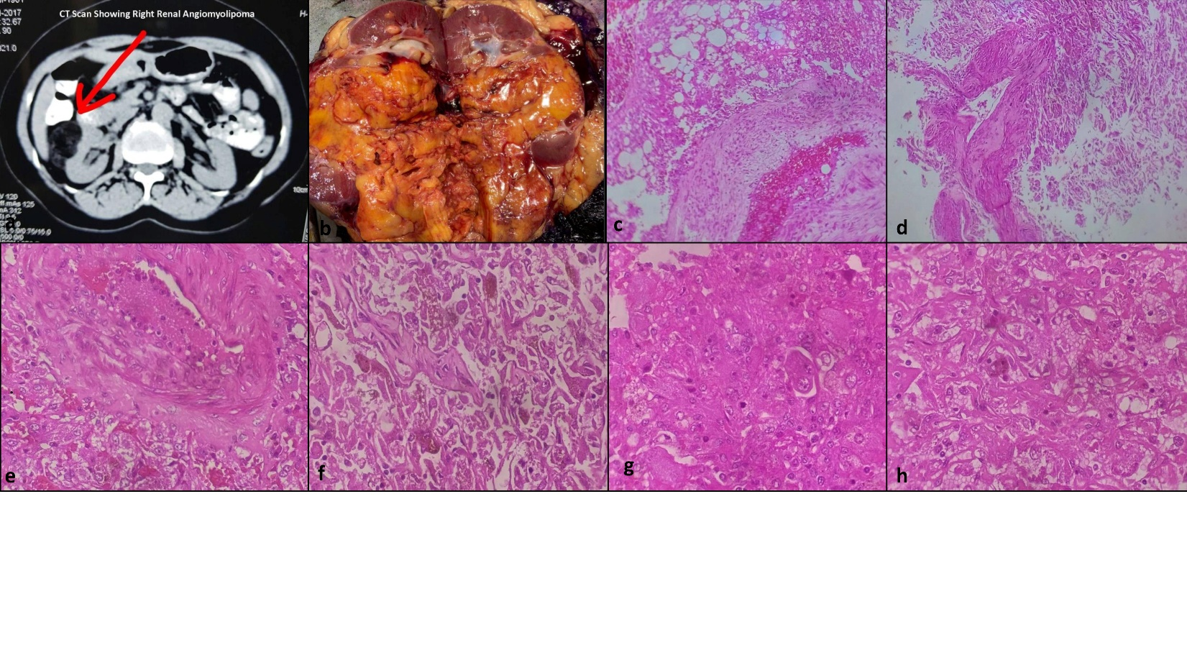

**Figure 2:**  
Left renal EAML presenting with hematuria and renal pelvic invasion. CT and gross findings (a, b) with histology showing epithelioid and spindle cells, dysplastic vessels, adipose tissue (c–g), and HMB-45 positivity, suggestive of malignant potential.

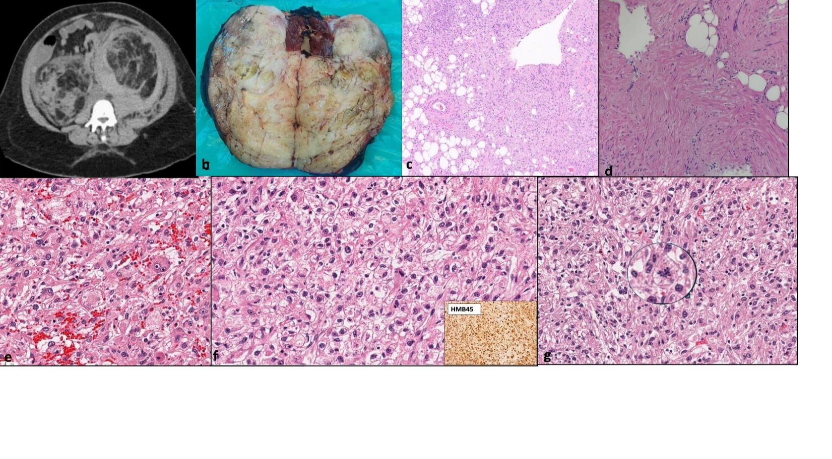

**Figure 3:**  
Bilateral AMLs in a patient with renal dysfunction. Ultrasound and gross appearance of left-sided tumor (a, b), with classical triphasic histology comprising adipose tissue, smooth muscle, and vessels (c–e), confirming AML morphology with epithelioid areas.

