*Case report*

Intra peritoneal migration of an intrauterine device: a case report

.

ABSTRACT

|  |
| --- |
| **Introduction:** Intrauterine devices are effective and reversible contraception methods, migration is rare complication described in this case report  **Presentation of the Case:** our patient is a 31 year old female, with history of surgery for small bowel obstruction 8 years ago, and placement of IUD 5 years ago. She presented symptoms of bowel obstruction, with tenderness of right lower quadrant. An emergency CT scan showed small bowel obstruction with a foreign object in the lower right quadrant of the abdomen.  The patient was operated urgently and a IUD was found in the peritoneum next to the caecum, the post operative course was uneventful and the patient discharged two days later.  **Discussion:** Migrating IUD is a rare complication although it is described in literature, it may occur during the insertion by an unnoticed perforation, or progressive transmural migration, it may be asymptomatic for a long time but once the migration is discovered it has to be extracted.  **Conclusion:** IUD is an effective, safe and reversible contraception method, the complications of which should be known by practitioners for an effective follow up. |

*Keywords: intrauterine device, acute abdomen, case report, migration.*

1. INTRODUCTION

Intrauterine devices (IUD) are effective, safe, and reversible methods of contraception, they work by either releasing copper or hormones rendering the environment unfavorable for sperm permeability, and fertilization. Complications related to IUDs, though rare, can lead to significant morbidity. The complications of IUD include expulsion, cycle disruptions, increased risk of ectopic pregnancy and uterine perforation. Pregnancies and IUD migration are uncommon complications, occurring in 1 to 2 from 1,000 users [1].

This case presents a 31-year-old female with a history of surgical bowel obstruction and IUD insertion, who developed signs of acute bowel obstruction, surgery found a migrated IUD in the peritoneum.

2. Presentation of the case

We present the case of a 31 year old female, with a history of an abdominal surgery 8 years ago for small bowel obstruction, and placement of a IUD 5 years ago, Presenting generalized abdominal pain with bowel obstruction symptoms including colicky abdominal pain, nausea, and vomiting , physical examination of the patients found her in a stable condition with distended abdomen and tenderness in the right lower quadrant.

A plain abdominal x ray found some air-fluid levels with a foreign body in right lower quadrant of the abdomen.

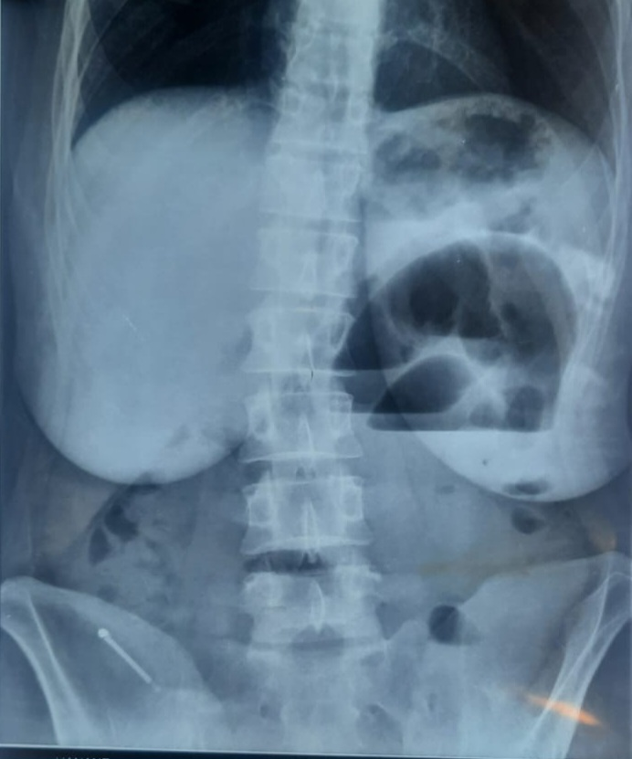

Figure1: plain abdominal x ray.

The CT scan showed signs of small bowel obstruction with suspicion of strangulation, and a foreign body in the right lower quadrant inside a 5cm collection.

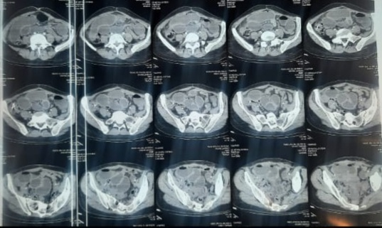

Figure 2: CT scan showing signs of obstruction and a foreign body.

The patient was transferred to the operating room, and was operated urgently. Upon incision there was a dilated small bowel with no obstruction probably due to an ileus, and there was a small collection of about 3cm in right lower quadrant of the abdomen next to the caecum which contained the IUD, the appendix was normal, the foreign body was extracted, and a peritoneal lavage was performed, no other pathological findings were noted, including the uterus which was not perforated.

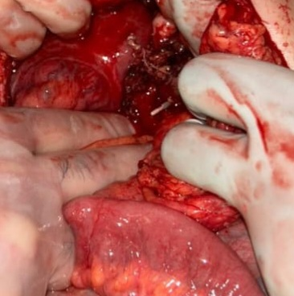

Figure 3: the foreign body in the right lower quadrant

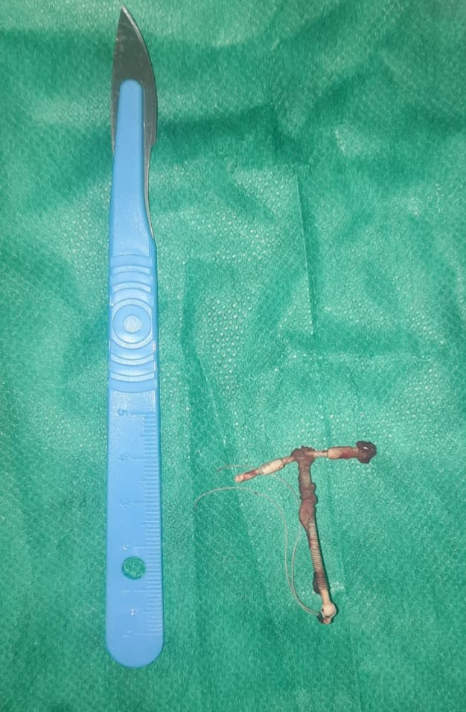

Figure 4: the IUD after extraction

The post operative course was uneventful, and the patient was discharged 2 days later with instructions for follow-up care and contraception counseling. The patient was advised on alternative contraceptive methods, as the IUD was no longer deemed suitable for use due to its migration

3. discussion

IUD are safe, reversible and effective methods of contraception, they are either copper based or hormonal, it is up the patient to choose which variant to use [2].

The most common side effects of IUD are pain, irregular cycles, and rarely pelvic inflammatory disease, expulsion, perforation, and migration [3]

The misplacement of the device may occur and be unnoticed during insertion related to an unseen perforation, or be the result of gradual transmural migration [4], the IUD may be misplaced in any abdominal organ, including peritoneum [5], small bowel of colon [6], anterior abdominal wall [7].

IUD migration is a rare complication but one that can lead to significant morbidity if not diagnosed promptly. Migration occurs when the IUD either perforates the uterine wall or displaces from the uterine cavity, moving into adjacent structures, including the bowel, bladder, or abdominal cavity. The most common presentation is abdominal pain or irregular bleeding, but complications like bowel obstruction, peritonitis, and intestinal perforation can occur, leading to emergency situations [8].

In this case, the patient presented with signs of bowel obstruction, which is uncommon in IUD migration. While adhesions from the prior surgery could have contributed to the obstruction, the CT scan was crucial in identifying the IUD as the cause. The localized collection in the right lower quadrant, with surrounding fat stranding and the presence of the IUD, strongly suggested that the device had migrated into the mesenteric fat. Fortunately, bowel perforation was not noted intraoperatively, and there was no significant mechanical obstruction caused by the IUD [9].

When migrated, the device may be asymptomatic for a long time, and be discovered on a routine radiology test, however, it has to be extracted whenever discovered due to possible secondary complications as per the recommendations of the WHO [10].

Management of this condition requires early identification and prompt surgical intervention to prevent complications such as sepsis or worsening infection. In this case, laparotomy with removal of the IUD and inflammatory mass was successful [11].

4. Conclusion

The IUD is a globally accepted contraceptive method, they are highly effective, with low risks and relatively low cost, post insertion follow up and even self examination of the strings should help with early diagnosis of complications.

Ethical approval AND CONSENT

All authors declare that ‘written informed consent was obtained from the patient (or other approved parties) for publication of this case report and accompanying images. A copy of the written consent is available for review by the Editorial office/Chief Editor/Editorial Board members of this journal.

As per international standards or university standards written ethical approval has been collected and preserved by the author(s).

Disclaimer (Artificial intelligence)

Option 1:

Author(s) hereby declare that NO generative AI technologies such as Large Language Models (ChatGPT, COPILOT, etc.) and text-to-image generators have been used during the writing or editing of this manuscript.

Option 2:

Author(s) hereby declare that generative AI technologies such as Large Language Models, etc. have been used during the writing or editing of manuscripts. This explanation will include the name, version, model, and source of the generative AI technology and as well as all input prompts provided to the generative AI technology

Details of the AI usage are given below:

1.

2.

3.

References

1. Addis NA, Sibhat YA, Molla YD, Mengestu WN, Seid AS, Damite MA, Worku MA. Migrated intra-uterine device to infra-umbilical skin: a rare case report. BMC Womens Health. 2024 Dec 30;24(1):672. doi: 10.1186/s12905-024-03522-0. PMID: 39736668; PMCID: PMC11684260.

2. Stephen Searle E. The intrauterine device and the intrauterine system. Best Pract Res Clin Obstet Gynaecol. 2014 Aug;28(6):807-24. doi: 10.1016/j.bpobgyn.2014.05.004. Epub 2014 Jun 5. PMID: 24947600.

3. Aoun J., Dines V.A., Stovall D.W., Mete M., Nelson C.B., Gomez-Lobo V. Effects of Age, Parity, and Device Type on Complications and Discontinuation of Intrauterine Devices. Obstet. Gynecol. 2014;123:585–592. doi: 10.1097/AOG.0000000000000144

4. Amaya SI, Henkel A, Blumenthal PD. Words matter: perforation… or transmural migration? BMJ Sex Reprod Health. 2023 Apr;49(2):74-75. doi: 10.1136/bmjsrh-2022-201738. Epub 2022 Dec 23. PMID: 36564157.

5. Benaguida H, Kiram H, Telmoudi EC, Ouafidi B, Benhessou M, Ennachit M et al. Intraperitoneal migration of an intrauterine device (IUD): A case report. Annals of medicine and surgery (2012). 2021;68:102547

6. Aliukonis V, Lasinskas M, Pilvelis A, Gradauskas A. Intrauterine device migration into the lumen of large bowel: a case report. Int J Surg case Rep. 2020;72:306–8.

7. Jing J. Case report: an intrauterine device hugging the musculus Rectus abdominis through the center of a cesarean scar. Front Surg. 2022;9:956856.

8. Kothari ST, et al. "IUD migration: A rare cause of bowel perforation and obstruction." Case Reports in Surgery 2015; 2015: 306783.

9. Pucarelli P, et al. "Intra-abdominal migration of an intrauterine device: A rare cause of acute abdomen." World Journal of Gastroenterology 2010;16(1): 110-113.

10. WHO Scientific Group on Mechanism of Action, Efficacy of Intrauterine Devices . Mechanism of Action, Safety and Efficacy of Intrauterine Devices. Report of a WHO Scientific Group. Volume 753. WHO; Geneva, Switzerland: 1987. pp. 1–91. (World Health Organization Technical Report Series)

11. Sharma A, et al. "Abdominal complications of intrauterine devices: A review and case report." The European Journal of Contraception & Reproductive Health Care 2018;23(3): 177-182.