***Case report***

INVASIVE HEMIFACIAL MYCOSIS MIMICKING FACIAL MALIGNANCY: A CASE REPORT

ABSTRACT

Invasive facial fungal infections are confusing disease processes that can involve one, or more regions of the face, presenting with varied clinical features that mimic other clinical conditions that could range from benign disease conditions to malignancies. While typically exhibiting characteristic features of fungal disease, facial mycosis can sometimes present in an unusual manner, having improbable localization to different aspect of the face such as the eyelids, cheeks, ear, etc. We present a 75-year-old retired military man from the rural part of southern Nigeria who presented with left hemifacial growth and deformity, and ptosis of the left upper eyelid. Tissue biopsy analysis yielded Histoplasmosis which when treated with the use of oral and topical anti-fungal medications led to complete resolution of all presenting complaints.

Keywords: fungal infections, medications, Darling disease, mucous membrane

INTRODUCTION

Histoplasmosis, also known as “Darling disease”, “Cave disease”, and “Ohio valley disease” is a systemic fungal infection caused by the thermally dimorphic fungus *Histoplasmosis capsulatum*.1 The causative agent *H.capsulatum* is found globally in the soil, especially in soil containing high concentrations of bird and bat droppings.2 The clinical manifestations of histoplasmosis are of three main types viz pulmonary, progressive disseminated, and chronic cavitary forms. Following exposure to the fungus, the disease process is either self-limiting, or restricted to the lungs in 99% of the individuals, while the remaining 1% progress to either disseminated, or chronic disease involving the lungs, liver, spleen, lymph nodes, bone marrow, and sometimes, the skin and mucous membrane.3 Skin lesions may occur with all the three forms of histoplasmosis or rarely, as a primary cutaneous histoplasmosis.1 Cutaneous lesions occur in about 17% of patients with disseminated histoplasmosis. This can present as papular or pustular skin lesions, plaques, ulcers, molluscum or wart-like lesions, and rarely, as erythema nodosum-like skin lesions.2

The common routes of infection are through direct inoculation of spores through the skin, mucous membranes, and thorn pricks injury.4 Our patient had several unique characteristics in the sense that he was an immunocompetent individual who lives in a non-endemic region of the southern region of Nigeria. Also, the primary hemifacial skin lesions had mimicry of a malignant cutaneous ulcer with raised everted edges, invasion of the left upper eyelid causing ptosis which was initially misdiagnosed as a malignant squamous lesion.

CASE REPORT

The patient is a 75-year-old man who presented with a 2-month history of left hemifacial swelling, drooping of the left upper eyelid and wound on the left side of the forehead. There is no history of weight loss or anorexia, no history of excessive exposure to ultraviolet radiation, he doesn't smoke cigarettes He had earlier presented to the dermatology clinic from where he was referred to plastic surgery clinic. He was a recently diagnosed diabetic patient on oral euglycemic medications. On examination elderly man afebrile, not pale, anicteric, and well hydrated. His vital signs were within normal limits.

Examination of his face revealed a large plaque 7cm X 5cm over the left temporo-frontal-zygomatic region with a central necrotic patch, crusty margin and raised and everted edge. There was associated drainage of serous effluent from the wound, oedematous left eyelids and ptosis of the left upper eyelid (figure 1).

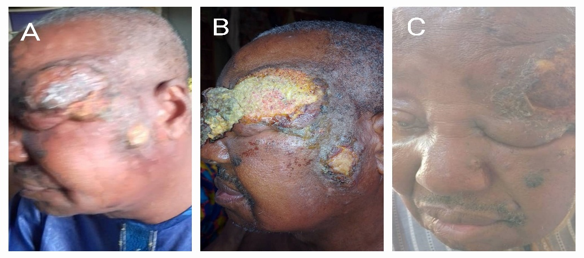

Figure 1: Pre-intervention clinical photographs. A: Left hemifacial mass with ulcerated crater, and elevated edge. B: Ulcerated crater at the epicentre of the mass following debridement of the necrotic floor. C: Ptosis of the left upper eyelid.

A clinical diagnosis of left hemifacial squamous cell carcinoma was made. He had wound debridement and tissue samples were sent for histopathological analysis, microscopy, culture and sensitivity (MCS), and fungal study. The MCS result yielded mixed growth of Enterobacter spp and Staphylococcus aureus, fungal study yielded growth of *Histoplasma capsulatum*. Macroscopic analysis of the tissue showed a skin fragment with an irregular epidermal surface. Histopathological examination revealed a chronic diffuse mixed inflammatory cell infiltrates within a hyperplastic skin epidermis with areas mimicking malignant lesion due to the formation of keratin plugs and pearls in the areas. However, there was no breach in the epidermal keratinocytic basement membrane lympho-plasma-histiocytic infiltrate (figure 2).

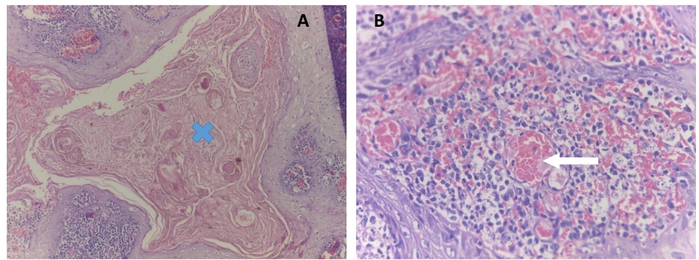

**Fig 2 A:** X4 magnification of H&E stain showing keratin horn cysts, marked blue-**X** within a hyperplastic squamous epithelium with infection and hemorrhage. **B.** Larger magnification (X40 magnification H&E stain) showing dense acute inflammation and congested new vessels (white arrow), and intact basement membrane of the keratinocytes.

Periodic Acid Schiff (PAS) stain showed numerous spore-like fungal structures, having regular morphology, presenting as 2-4mm oval-shaped yeasts in rows and stained in red and brown colours (figure 3).

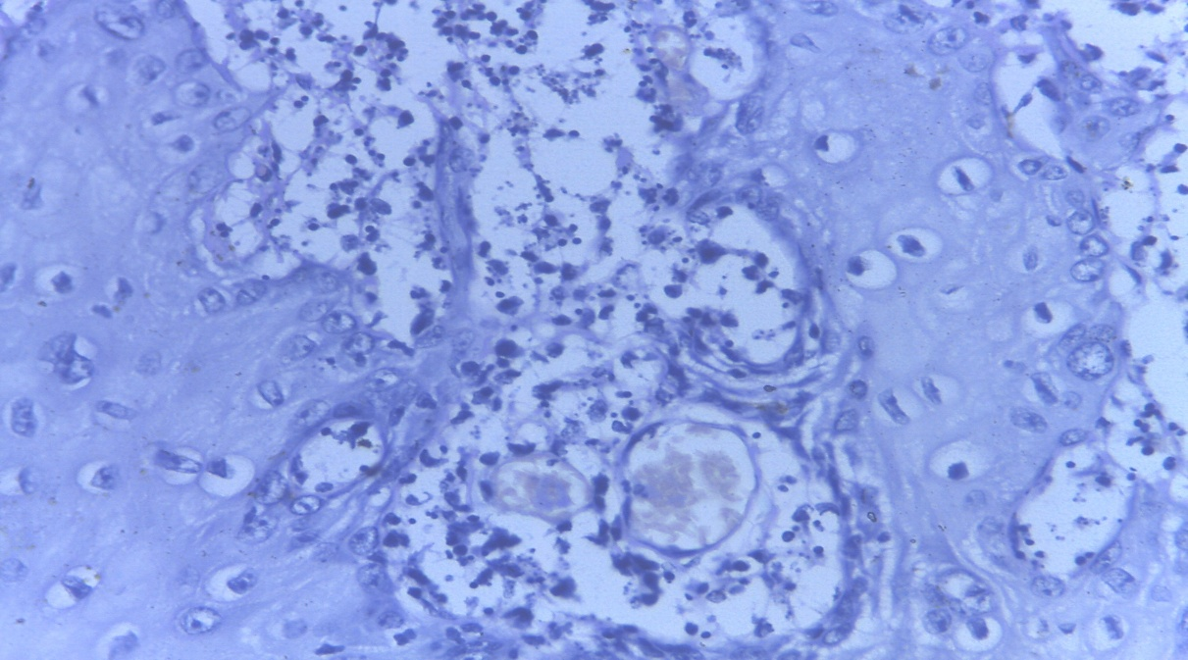

Figure 3: Periodic Acid Schiff (PAS) stain showing numerous intracellular yeasts with retraction of the host cellular inflammatory response. They are seen as yeast fragments within the inflammatory milieu (starred at the centre between the epithelial sheet) and some congested blood vessels. The classical “halo” sign which are yeasts seen within large intracellular vacuoles were not seen as this may be due to the fact that the patient is immunocompetent as at the time of biopsy.

Serological tests (anti-hepatitis C, anti-hepatitis B, VDRL, anti-HIV) were negative. Blood tests (full blood count, lipid profile, clotting profile, fasting blood glucose showed no abnormalities. He was placed on intravenous Fluconazole 200mg 12 hourly for 5 days thereafter oral fluconazole 200mg daily. The wound dressing the face was performed daily using 2% Salicylic acid (Nixoderm) cream. Patient symptoms resolved remarkably with complete resolution of the facial lesions and ptotic left upper eyelid (figure 4).

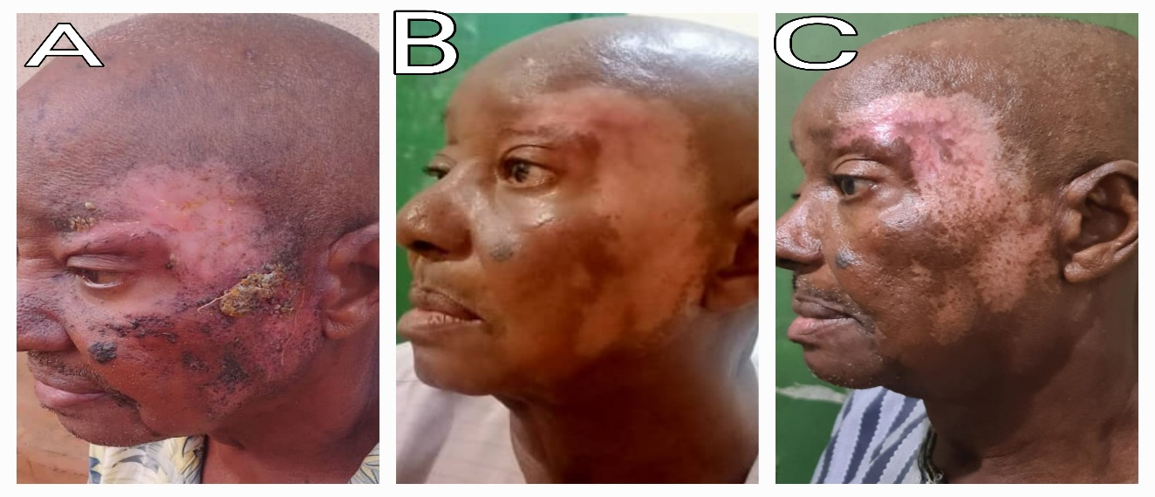

Figure 4: A: 2 months post antifungal therapy. B: 4 months post antifungal therapy. C: 6 months post antifungal therapy

DISCUSSION

Masquerades are an integral part of surgical practice, and oncological surgery is no exception.2 Primary cutaneous histoplasmosis is very rare and can present with papules, nodules, plaques, pustules, acneiform eruptions, ulcers, abscesses, or umbilicated papules resembling molluscum contagiosum-like lesions.2,5,6 The route of infection is through direct inoculation of spores through the skin, and mucous membranes, and thorn pricks are the most common mode of acquiring this variant of histoplasmosis.2,6,7 The disease occurs commonly in immunocompromised individuals, more so, in HIV-infected persons having CD4+ count <75cells/ml. In immunocompetent individuals, about 95% of histoplasmosis infections are asymptomatic.2,5 However, prolonged exposure to high number of spores may lead to acute or chronic infection.3 The clinical spectrum of histoplasmosis is variable, ranging from a severe multisystemic illness involving the bone, liver, spleen, and lungs, to an indolent infection localised to the gastrointestinal tract (GIT), skin, adrenal glands, brain, meninges, or extrapulmonary tissues.2 There are many clinical presentations of histoplasmosis infection which usually starts as a primary lung histoplasmosis. This primary lung histoplasmosis can evolve to compromise the central and lateral regions of the face. Other areas of the head reported in the literature include oral mucosa, upper eyelids, and the nasal septum.1,5,6

Delineating histoplasmosis from malignancies requires a high index of suspicion and an apt cognizance from the physician and the pathologist involved in the evaluation of the patient and the tissue biopsy respectively. Clinically, histoplasmosis lesions are seen as firm, painful ulcers with verrucous, necrotic and polypoid proliferations which may be accompanied by regional lymphadenopathy, with a close resemblance to cutaneous squamous cell carcinoma.5,8 The destruction of tissues is the result of hematogenous dissemination of the fungus spores, triggering a cascade of proinflammatory cytokines and the cytogenetic effects generated by tissue macrophages, lymphocytes, and neutrophils that progressively destroy the fine and delicate tissues.6 Definitive diagnosis is made by culture of the organism. Periodic Acid Schiff (PAS) and Grocott Methamine Silver (GMS) are used in the screening of tissues for the presence of histoplasmosis.6 A classic “halo” appearance caused by retraction of the cytoplasm from the cell wall is helpful in the identification of the organism. Specific stains like PAS and GMS stains highlight the fungus, its capsule consisting of a polysaccharide and stains poorly with hematoxylin and eosin (H & E) stain.1

The histologic findings of histoplasmosis are equally perplexing, with features of pseudoepitheliomatous hyperplasia (PEH) of the overlying epithelium. PEH is the common histologic feature of histoplasmosis that misleads unsuspecting pathologists due to its close resemblance to squamous cell carcinoma.1 The distinctive feature of PEH from squamous cell carcinoma in a biopsy is invasion of the overlying epithelium in the dermis. Also, PEH is a benign feature seen in variety of conditions such as inflammatory conditions and trauma. It is also known that atypical mitosis, formation of keratin pearls, lymphovascular invasion and perineural invasion are features seen in squamous cell carcinoma, but not in PEH.1

The first line agent of treatment of histoplasmosis is amphotericin given at a dose of (3-5mg/day). However, poor response to amphotericin has been reported in the literature.9,10 The patient in this report was treated with daily topical 2% salicylic acid (Nixoderm), intravenous fluconazole 400mg/day for one week, and had oral fluconazole (50mg/day) for the next six months. His symptoms resolved remarkably during the course of the treatment and by the end of 6th months, he had achieved complete remission of his symptoms.

CONCLUSION:

Every growth is not cancer, and all cancer may not present as a growth. Cutaneous mycosis is a rare but emerging fungal infection of the skin which can present with features that mimic cutaneous malignancies. Thus, it should be considered in most cutaneous lesions that appear like abnormal. This report elaborates the mimicry of hemifacial histoplasmosis to cutaneous malignancy. The unusual location, complex presentation and dramatic remission following treatment with 2% salicylic acid and systemic fluconazole emphasizes the importance of a high index of suspicion of cutaneous mycosis in skin lesions with malignant characteristics.

Conflict of interest: None

Funding: None

Consent

The authors certify that they have obtained the appropriate patient consent forms for use of their image in the scientific community. In the form the patient gave his consent for his images and other clinical information to be reported in the journal. The patient understands that his name and initials will not be published and due efforts will be made to conceal his identity, but anonymity may not be guaranteed due to displaying of his eyes to demonstrate the ptosis and its resolution following therapy.

Ethical Approval:

As per international standards or university standards written ethical approval has been collected and preserved by the author(s).

Disclaimer (Artificial intelligence): Author(s) hereby declare that NO generative AI technologies such as Large Language Models (ChatGPT, COPILOT, etc.) and text-to-image generators have been used during the writing or editing of this manuscript.

REFERENCE

1. Mittal N, Patil A, Singhal P, Bael MM, Rane SU, Thiagarayan S. Histoplasmosis of the head and neck region mimicking malignancy: a clinical-pathological predicament. Turk Patoloji Derg. 2023; 39: 133-139.
2. Raina RK, Mahajan V, Sood A, Saurabh S. Primary cutaneous histoplasmosis in an immunocompetent host from a non-endemic area. Indian J Dermatol. 2016; 61(4): 467-470.
3. Batista JM, Martins MA, Bertollo CM. Primary cutaneous histoplasmosis difficult to treat in an immunocompetent patient: case report and literature review. Einstein. 2021; 19: 1-4.
4. Histoplasmosis-PAS. Available at: <https://imagebank.hematology.org/image/61208/histoplasmosis--pas-stain>. Assessed 27/05/2025.
5. Gupta H, Tankhiwale SS. A case of bilateral eyelid histoplasmosis mistaken as basal cell carcinoma. Can J Ophthalmol. 2017; 52: 45-46.
6. Escalante L, Granizo-Rubio J, Pinos-León V, Tello S, Maldonado A, Cherrez-Ojeda I. Nasal cartilage destruction associated to cutaneous histoplasmosis in AIDS. BMC Infect Dis. 2022; 22(1):377-381.
7. Kriplani DM, Kante KA, Maniar JK, Khubchandani SR. Histoplasmosis in an immunocompetent host: a case report. Int J Res Med Sci. 2017; 4(3): 1148-1150.
8. Benjamin OE, Bassey TE, Nwagboso CI, Onwukak A, Nlemadim AC, Akpu BB, et al. Histoplasmosis misdiagnosed as malignancies in immunocompetent and immunocompromised patients: a global perspective on clinical presentation, radiological and pathological findings. h life. 2024; 1-7.
9. Sharma P, Singh G, Sharma D, Giri S. Laryngeal histoplasmosis mimicking glottic cancer in an immunocompetent host. Int J Clin. Diag Pathol. 2020; 3(1): 73-75.
10. Farfan-Cano GG, Farfan-Cano SG, Farfan-Cano HR, Silva-rojas GA Solorzano-Bravo MT. Cutaneous histoplasmosis: a case report. Microbes infect Chemother. 2022; 2: 1-5.