Case Report

Todani Type 1B Choledochal Cyst in Two Cases of Choledochal Cyst in 2-Year-Old Children: A Rare Case With Biliary Reconstruction Using Roux-en-Y Hepaticojejunostomy

|  |
| --- |
| **Aims:** To report cases of choledochal cyst, the flow of diagnosis, and the management of these cases.  **Case Description:** Two 2-year-old children who presented with abdominal mass, jaundice, abdominal discomfort, pale stools, and vomiting were found to have choledochal cysts. The results of the laboratory tests showed increased levels of SGOT and SGPT, as well as direct and total bilirubin. A type 1B choledochal cyst was indicated by abdominal ultrasonography, which revealed saccular dilatation of the common hepatic duct (CBD) extending to the proximal CBD without intrahepatic bile duct dilatation. Cystic duct dilatation, gallbladder wall edema, contrast enhancement, and a fusiform cystic lesion from the CHD to the CBD were all seen on an abdominal CT scan. Upon pathological examination, no carcinoma cells were found.  **Discussion:** Discussion: Although choledochal cysts, especially Todani type IB, have similar anatomical involvement, their clinical manifestations vary. Imaging is crucial for early diagnosis, and MRCP provides the best diagnostic accuracy. The preferred course of treatment is still surgical excision followed by Roux-en-Y hepaticojejunostomy. Complete resection reduces the risk of malignancy, but incomplete excision greatly raises it, underscoring the significance of early detection, thorough imaging, and careful surgical planning. **Conclusion:** choledochal cysts must be identified early and surgically managed to avoid complications and lower the chance of malignant transformation. |

*Keywords: choledochal cyst; hepaticojejunostomy; Todani Type 1b*

1. INTRODUCTION

A Choledochal cyst is a congenital dilatation of the bile duct that can occur in the intrahepatic, extrahepatic, or both segments of the biliary tree. The incidence in Western populations is approximately 1 in 100,000–150,000 live births, while in Asian populations it ranges from 1 in 1,000–13,000 live births(1). This condition is more common in females, particularly during the first decade of life, with type I being the most frequent subtype(2).

In infants and children, choledochal cysts are diagnosed in about 80% of cases during the first ten years of life(3). The age of the patient has an impact on the pathological and clinical manifestations. The classical triad abdominal discomfort, jaundice, and an abdominal mass is the most prevalent symptom in children, though it only occurs in 20% of cases. Only two of these symptoms, typically abdominal mass and jaundice, are present in about 85% of pediatric patients. Jaundice, acholic stools, and vomiting are symptoms that can mimic cirrhosis, hepatic fibrosis, or biliary atresia in infants. Adults with choledochal cysts are more likely to experience complications like pancreatitis, cholangitis, or peritonitis due to cyst rupture. About 10%-30% of biliary tracts undergo malignant transformation(4–8)

Complete cyst excision followed by biliary reconstruction is the preferred course of treatment. It has been demonstrated that laparoscopic Roux-en-Y hepaticojejunostomy (RYHJ) is a safe and successful procedure for both infants and children(9–11). The purpose of this case report is to describe and assess a 2-year-old child who has a Todani Type IB choledochal cyst, with an emphasis on the RYHJ technique for biliary reconstruction and clinical diagnosis.

2. Presentation of case

We report two cases of choledochal cysts in 2-year-old children. The first patient presented with intermittent right upper quadrant abdominal pain and jaundice. Laboratory results showed elevated liver enzymes (SGOT 95 U/L, SGPT 149 U/L) and increased direct (1.02 mg/dL) and total bilirubin (1.71 mg/dL). The second patient had similar abdominal pain, accompanied by steatorrhea and tea-colored urine, but laboratory parameters were within normal limits.

Abdominal ultrasonography in both patients revealed saccular dilatation of the common hepatic duct (CHD) extending into the proximal common bile duct (CBD), with no intrahepatic bile duct (IHBD) involvement suggestive of a Todani type IB choledochal cyst. Contrast-enhanced CT confirmed cystic duct dilatation and a fusiform fluid-density lesion extending from the CHD to the CBD, without gallstones.

Both patients underwent open surgical excision of the cyst and gallbladder, followed by Roux-en-Y hepaticojejunostomy (RYHJ) reconstruction. The cyst was completely resected, and the hepaticojejunostomy was performed using a 50 cm Roux limb. Postoperative recovery was uneventful.

Macroscopic pathology showed a dilated CBD measuring approximately 2 cm in length and 1.5 cm in diameter, and a gallbladder measuring 9.5 × 6 × 1.5 cm with no stones or masses. Microscopic examination revealed cystic duct lined with columnar epithelium, fibrous stroma, focal mucosal erosion, lymphohistiocytic infiltration, and dilated blood vessels. No signs of malignancy were observed. By postoperative day two, the first patient showed clinical improvement with declining bilirubin and normalized liver enzyme levels.

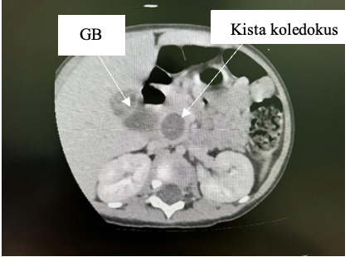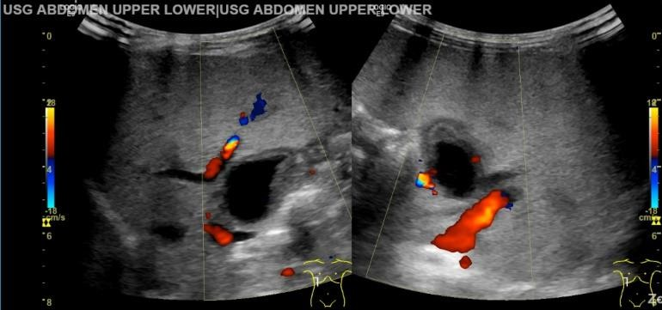

**Fig. 2. Contrast-enhanced axial abdominal CT scan of the first patient revealed a saccular cystic dilatation measuring approximately 1.9 × 2 × 2.5 cm in the proximal common bile duct, consistent with Todani type 1b.**

**Fig. 1. Abdominal ultrasound revealed an anechoic cyst measuring approximately 1.6 × 2.1 cm in the biliary tract.**

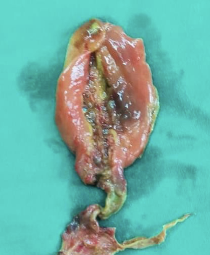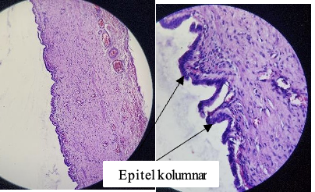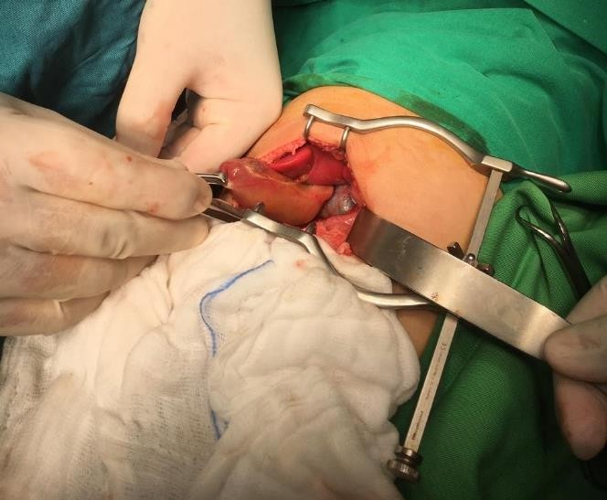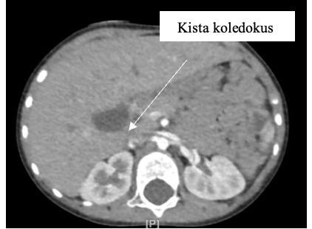3. discussion

**Fig. 3. Abdominal CT scan of the second patient revealed a saccular cystic dilatation measuring approximately 1.9 × 2 × 2.5 cm in the proximal common bile duct.**

Choledochal cysts are rare congenital anomalies of the biliary tract, most commonly diagnosed during childhood. The classical triad—abdominal pain, right upper(12) quadrant mass, and jaundice—is present in only a minority of pediatric patients.Todani type I is the most common, and subtype IB, involving segmental saccular dilatation of the common bile duct, is among the rarest(13,14)

In this report, we describe two cases of Todani type IB cysts in 2-year-old children with differing clinical manifestations, highlighting the variability of presentation even in anatomically similar lesions. One patient exhibited jaundice and elevated liver enzymes, while the other presented with steatorrhea and tea-colored urine but normal laboratory results. These differences emphasize the importance of including choledochal cysts in the differential diagnosis of abdominal symptoms in young children.

**Fig. 6. The cystically dilated coledocus duct appears partially lined with columnar epithelium. Stroma fibrous tissue.**

**Fig. 4. Intraoperatif exisi CC with hepaticojejunostomy roux-en-Y reconstruction**

**Fig. 5. Surgical removal of the gallbladder and the choledochal duct.**

Both primary hepatic injury and secondary inflammatory processes can cause an increase in liver enzymes. Elevations in ALT and AST are commonly caused by hepatocellular damage, which is observed in drug-induced liver injury and viral or ischemic hepatitis. On the other hand, immune-mediated reactions in inflammatory diseases like autoimmune hepatitis, NASH, or systemic inflammation can result in abnormalities of the enzymes. This idea is especially relevant in cases of choledochal cysts, where elevated liver enzymes can be a sign of both chronic inflammation brought on by bile stasis or pancreatic enzyme reflux and mechanical biliary obstruction that results in cholestatic patterns like elevated ALT and AST. Accurate interpretation requires an understanding of this multifactorial mechanism, which also emphasizes the significance of early surgical intervention to stop progressive hepatobiliary damage(15,16).

Steatorrhea can happen even if liver function tests don't show any big changes because its main cause is a lack of bile acids, which makes it hard for fat to be emulsified and absorbed. Choledochal cysts or other biliary system blockages can make it hard for bile to move into the duodenum through the ampulla of Vater. This can make it hard for the body to digest fat.In the early stages of blockage, the liver cells may still work normally, and test values like bilirubin, ALT, and AST may still be normal.But when the obstruction lasts a long time or is chronic, the buildup of conjugated bilirubin and higher intraductal pressure might hurt liver cells, which can lead to higher liver enzymes. So, steatorrhea doesn't always mean that liver function tests are bad. It should be seen as a sign of biliary flow impairment, even when liver biochemical indicators are normal(17,18).

Type I cysts are frequently associated with abnormal pancreaticobiliary ductal junctions (APBDJ), allowing pancreatic enzyme reflux into the bile duct and contributing to chronic irritation and cyst formation. Diagnosis relies heavily on imaging. Ultrasound remains the initial modality due to its accessibility and sensitivity (71–97%), while contrast-enhanced CT helps delineate cyst anatomy. MRCP is considered the gold standard due to its non-invasiveness and high diagnostic accuracy (90–100%)(4,19,20). ERCP, while therapeutic, is less favored due to its invasive nature and associated risks.

Management depends on cyst type and hepatobiliary involvement. Complete excision followed by biliary reconstruction is essential(21). For type I cysts, Roux-en-Y hepaticojejunostomy (RYHJ) is widely accepted as the gold standard due to its safety and low complication rate(22).Both of our patients underwent open total cyst excision with RYHJ, with no immediate postoperative complications.

Histopathological examination confirmed chronic inflammatory changes without malignancy. Although the risk of malignant transformation after complete excision is low (<1%), it rises significantly with incomplete resection, underscoring the importance of thorough surgical planning(23). The overall malignancy risk in choledochal anomalies has been reported at 0.7%–6%, with chronic inflammation and cellular regeneration contributing to carcinogenesis(24,25).

4. Conclusion

Choledochal cyst should be considered as a differential diagnosis in children presenting with abdominal pain. Early detection of this condition is crucial to prevent prolonged symptoms and to avoid delays in necessary surgical intervention. Once the diagnosis is established, timely surgical management is essential to prevent complications. Postoperative histopathological examination also plays a

vital role in identifying any potential malignant transformation.

contributions included detailed documentation of the clinical case(26).

Consent AND ATHICAL APPROVAL

In accordance with university regulations, participant consent and ethical clearance have been obtained and are securely retained by the authors.

Disclaimer (Artificial intelligence)

Option 1:

Author(s) hereby declare that NO generative AI technologies such as Large Language Models (ChatGPT, COPILOT, etc.) and text-to-image generators have been used during the writing or editing of this manuscript.

Option 2:

Author(s) hereby declare that generative AI technologies such as Large Language Models, etc. have been used during the writing or editing of manuscripts. This explanation will include the name, version, model, and source of the generative AI technology and as well as all input prompts provided to the generative AI technology

Details of the AI usage are given below:

1. Quillbolt (for checking grammar)

2. Chatgpt (was used to translate several sentences and to check their alignment with the journal's formatting guidelines)

References

1. Tariq W Bin, Twayana AR, Sunuwar N, Anjum A, Deo S, Rayamajhi S, et al. Case Report: A rare case of choledochal cyst. F1000Res. 2022;11:919.

2. Hung MH, Lin LH, Chen DF, Huang CS. Choledochal cysts in infants and children: Experiences over a 20-year period at a single institution. Eur J Pediatr. 2011;170(9):1179–85.

3. Tigabie W, Tesfay H, Tamrat D, Raya K, Negussie T. Unusual variant of choledochal cyst in a child: A case report, in Tertiary Specialized Hospital, Ethiopia. Int J Surg Case Rep [Internet]. 2020;75:117–21. Available from: https://doi.org/10.1016/j.ijscr.2020.09.023

4. Gilles J. Hoilat; Savio John. StatPearls [Internet]. Treasure Island (FL): StatPearls Publishing. 2023. Choledochal Cyst.

5. Dira IKPA, Putra IGNS, Karyana IPG, Nesa NNM, Ariyanta KD, Dharmajaya IM. Choledochal Cyst (CC) Todani type I in two years old girl: a case report. Intisari Sains Medis. 2023;14(3):1124–9.

6. Soares KC, Kim Y, Spolverato G, Maithel S, Bauer TW, Marques H, et al. Presentation and clinical outcomes of choledochal cysts in children and adults: A multi-institutional analysis. JAMA Surg. 2015;150(6):577–84.

7. Murphy AJ, Axt JR, Lovvorn HN. Associations between pediatric choledochal cysts, biliary atresia, and congenital cardiac anomalies. Journal of Surgical Research [Internet]. 2012;177(2):e59–63. Available from: http://dx.doi.org/10.1016/j.jss.2012.04.018

8. Bhavsar MS, Vora HB, Giriyappa VH. Choledochal cysts : A review of literature. Saudi Journal of Gastroenterology. 2012;18(4):230–6.

9. Jatal SN, Jatal S, Punpale A, Jatal S. Clinical Manifestations of Choledochal Cysts: Two Case Studies. Asian Journal of Research in Surgery [Internet]. 2025 May 5;8(1):158–65. Available from: https://journalajrs.com/index.php/AJRS/article/view/277

10. Sapulete EJ, Putra IGNS, Karyana IPG, Nesa NNM, Darmajaya IM, Ariyanta KD. A giant choledochal cyst in 8 years old female. Medicina (B Aires). 2019;50(2):410–4.

11. Yurttutan N, Karakus SC, Koku N, Demirci M, Ucak R. A giant choledochal cyst in infancy: A case report. Korean J Pediatr. 2016;59(5):239–41.

12. Shah OJ, Shera AH, Zargar SA, Shah P, Robbani I, Dhar S, et al. Choledochal cysts in children and adults with contrasting profiles: 11-year experience at a tertiary care Center in Kashmir. World J Surg. 2009;33(11):2403–11.

13. Todani T, Watanabe Y, Narusue M, Tabuchi K, Okajlma K. Congenital Bile Duct Cysts Classification, Operative Procedures, and Review of Thirty-Seven Cases Including Cancer Arising from Choledochal Cyst. Pediatric Surgeon. 1977;134(August):77–80.

14. Miron A, Popa LG, Toma EA, Calu V, Parvuletu RF, Enciu O. The Curious Case of the Choledochal Cyst—Revisiting the Todani Classification: Case Report and Review of the Literature. Diagnostics. 2023;13(6).

15. Jung SM, Seo JM, Lee SK. The relationship between biliary amylase and the clinical features of choledochal cysts in pediatric patients. World J Surg. 2012;36(9):2098–101.

16. Kalas A, Chavez L. Abnormal liver enzymes: A review for clinicians [Internet]. Vol. 13, World Journal of Hepatology. 2021 Nov. Available from: https://www.wjgnet.com

17. Azer S, Sankararaman S. StatPearls [Internet]. Treasure Island (FL): StatPearls Publishing. 2025. Steatorrhea.

18. Reshetnyak VI, Maev I V. Features of Lipid Metabolism Disorders in Primary Biliary Cholangitis. Vol. 10, Biomedicines. MDPI; 2022.

19. Fumino S, Ono S, Kimura O, Deguchi E, Iwai N. Diagnostic impact of computed tomography cholangiography and magnetic resonance cholangiopancreatography on pancreaticobiliary maljunction. J Pediatr Surg [Internet]. 2011;46(7):1373–8. Available from: http://dx.doi.org/10.1016/j.jpedsurg.2011.01.026

20. Ohashi T, Wakai T, Kubota M, Matsuda Y, Arai Y, Ohyama T, et al. Risk of subsequent biliary malignancy in patients undergoing cyst excision for congenital choledochal cysts. Journal of Gastroenterology and Hepatology (Australia). 2013;28(2):243–7.

21. Khandelwal C, Anand U, kumar B, Priyadarshi RN. Diagnosis and Management of Choledochal Cysts. Indian Journal of Surgery. 2012;74(1):29–34.

22. Narayanan SK, Chen Y, Narasimhan KL, Cohen RC. Hepaticoduodenostomy versus hepaticojejunostomy after resection of choledochal cyst: A systematic review and meta-analysis. J Pediatr Surg [Internet]. 2013;48(11):2336–42. Available from: http://dx.doi.org/10.1016/j.jpedsurg.2013.07.020

23. A.K.M S, Rahman M, Sarwar JM, Alam MM, Sultana N, Rahman A. Treatment and Outcome of Choledochal Cyst, our Experience in Sheikh Russel National Gastroliver Institute and Hospital, Mohakhali Dhaka, Bangladesh. Asian Journal of Pediatric Research. 2024 Mar 30;14(4):11–9.

24. ten Hove A, de Meijer VE, Hulscher JBF, de Kleine RHJ. Meta-analysis of risk of developing malignancy in congenital choledochal malformation. British Journal of Surgery. 2018;105(5):482–90.

25. Imazu M, Iwai N, Tokiwa K, Shimotake T, Kimura O, Ono S. Factors of biliary carcinogenesis in choledochal cysts. European Journal of Pediatric Surgery. 2001;11(1):24–7.

26. Watanabe Y, Toki A, Todani T. Bile duct cancer developed after cyst excision for choledochal cyst. J Hepatobiliary Pancreat Surg. 1999;6(3):207–12.