***Case report***

**Cholecystogastric Fistula with Perforation Peritonitis : A Rare Case Report**

**Abstract**

|  |
| --- |
| A cholecystogastric fistula is among the rarest and most serious complications of peptic ulcer disease. It can present with non-specific symptoms and resemble other conditions, such as perforation peritonitis. This makes it preoperative diagnosis challenging. This case report describes a 33-year-old woman presenting with abdominal pain and vomiting. An X-ray of the abdomen revealed gas under the diaphragm. An emergency laparotomy revealed a cholecystogastric fistula with perforation peritonitis. Cholecystectomy and a modified Graham patch repair were performed. Patient had an uneventful recovery and was later confirmed to have peptic ulcer disease through endoscopy. The case highlights the importance of cholecystogastric fistula as an important differential diagnosis as well as a complication in patients experiencing abdominal pain, vomiting, and symptoms of peptic ulcers. |

Keywords: Peptic ulcer, Cholecystogastric fistula, Perforation peritonitis, Laparotomy, Cholecystectomy, Gastric malignancy

**Introduction**

“Peptic ulcer disease is characterized by discontinuation in the inner lining of the gastrointestinal tract caused by gastric acid secretion and pepsin. It can extend into the muscularis propria layer of the gastric epithelium. It affects four million people worldwide annually” [[1](https://www.ncbi.nlm.nih.gov/pmc/articles/PMC9342757/#pone.0271284.ref001)] “and has an estimated lifetime prevalence of 5−10% in the general population” [[2](https://www.ncbi.nlm.nih.gov/pmc/articles/PMC9342757/#pone.0271284.ref002)]. “Although the global prevalence of PUD has dramatically decreased in the past decades because of proton pump inhibitors” [[3](https://www.ncbi.nlm.nih.gov/pmc/articles/PMC9342757/#pone.0271284.ref003)], “the incidence of its complications has remained constant, which include bleeding, perforation, gastric outlet obstruction, gastric malignancy and rarely biliary-gastric fistulae”[[4](https://www.ncbi.nlm.nih.gov/pmc/articles/PMC9342757/#pone.0271284.ref004)].

“Cholecystoenteric fistula (CEF) is an abnormal communication between the gallbladder and the luminal gastrointestinal (GI) tract. Cholecystoduodenal fistula (CDF) is the most common, followed by cholecystocolonic fistula (CCF) and rarely cholecystogastric fistula (CGF)” [5]. “There have been multiple reports of CGF dating back to 1956” [6]. “While CGF is usually associated with chronic cholecystitis or long-standing cholelithiasis, other reported causes include peptic ulcer disease, inflammatory bowel disease, and GI malignancy” [1,7]. We present a rare case of cholecystogastric fistula secondary to peptic ulcer disease.

**Case Presentation**

We present the case of a lean 33-year-old female, a home-maker by profession. Patient provided a history of nausea, and epigastric fullness over the past 2 months, for which an ultrasound of the abdomen was performed, revealing no significant abnormalities. There was no history of chronic illness, substance abuse, or previous surgeries. The patient presented to the Surgical Emergency Department at Mathura Das Mathur Hospital, Jodhpur, Rajasthan, with complaints of severe abdominal pain, vomiting, and abdominal distention for two days. The pain was sudden in onset, burning in nature, initially localised to the epigastric region, then becoming generalised across the entire abdomen. It was non-radiating with 3-4 episodes of bilious vomiting, accompanied by fever and unrelieved by analgesics. On examination, her vital signs were: pulse 114 bpm, blood pressure 90/60 mmhg, and SpO2 97% on room air. She appeared pale and febrile. Abdominal examination showed distention, generalised tenderness, and localisation of guarding in the epigastric and right hypochondrium regions. Percussion revealed a tympanic note over the epigastrium and right hypochondrium, with dullness at the lower abdomen. The patient was resuscitated with intravenous fluids. Antibiotics were administered intravenously.

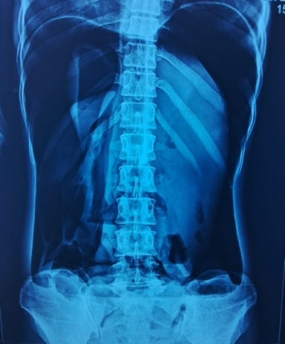.

Figure 1 - (Showing gas under diaphragm)

An abdominal X-ray (FPA view) revealed the presence of free air under the diaphragm (Figure 1). Ultrasonography of the abdomen was limited due to excessive bowel gas but demonstrated a moderate amount of free fluid with internal septations. Contrast-enhanced computed tomography (CECT) of the abdomen showed a serpiginous, enhancing fistulous tract extending between the gallbladder and the antro-pyloric region of the stomach, suggestive of a possible rupture. Air foci were identified within the gallbladder lumen. Additionally, there was evidence of gross pneumoperitoneum and significant ascites (Figures 2 and 3).

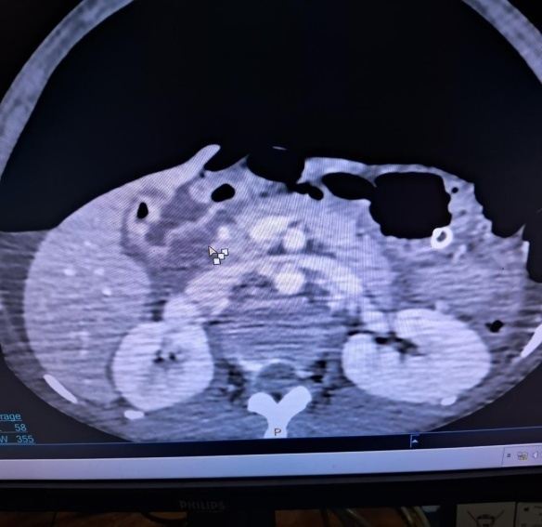 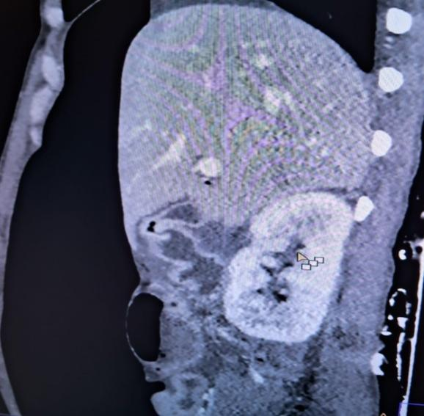

Figure 2 (Axial view of cect shows gas in gall

bladder with a fistula between the GB and the stomach) Figure 3 (Sagittal view of cect shows gas in the GB)

Under general anaesthesia, the patient was operated on through a classical midline vertical incision. Intraoperatively, there was approximately 1.5 litres of bilious collection with around 200 grams of pus flakes. The entire gut was edematous and inflamed. The pylorus was densely adherent to the gallbladder fundus; on separation, a fistulous tract was noted between the stomach and gallbladder, with a 3 × 4 cm perforation at the pyloric region and a 2 × 3 cm rent at the fundus of the gallbladder (Figure 4), with no gallstones found within the gallbladder lumen or at any ectopic site.

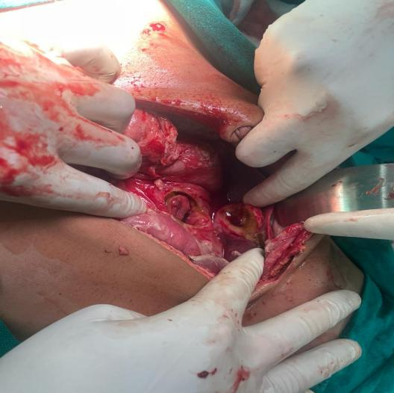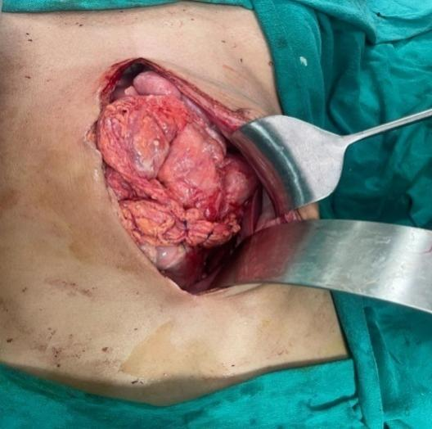

Figure 4 (blue arrow shows 2*3cm GB perforation,

white arrow shows 3*4cm gastric perforation) Figure 5 (modified grahm patch repair )

Peritoneal lavage was performed with 5 liters of normal saline, followed by cholecystectomy and modified Graham patch repair using 2-0 Prolene with a round-bodied needle (Figure 5). A peritoneal drain was placed in the Morrison's pouch. The postoperative period was uneventful.

Table 1 : Parameters analysed at the time of admission and postoperative day 1

|  |  |  |  |
| --- | --- | --- | --- |
| Parameter | At time of admission | Postoperative day 1 | Reference value |
| Hemoglobin | 9.6g/dl | 11.5g/dl | 11.0-15.0g/dl |
| Total leucocyte count | 17.79*103 | 15.4*103 | 4-10*103 |
| Blood urea | 30mg/dl | 18mg/dl | 17-43mg/dl |
| Serum creatinine | 0.68mg/dl | 0.63mg/dl | 0.6-1.2mg/dl |
| SGOT/SGPT | 56/28 IU | 11/10 | 37/42IU |
| Serum albumin | 3.0gm/dl | 2.3gm/dl | 3.5-5.3gm/dl |

The patient was allowed oral intake on postoperative day 5, and the drain was removed on postoperative day 6. The patient was discharged with advice to follow up in the Gastroenterology outpatient department. One month later, the patient presented to the Gastroenterology department with a single episode of hematemesis. Upper gastrointestinal endoscopy was performed, which was suggestive of peptic ulcer disease (Figure 6). The patient was managed accordingly.

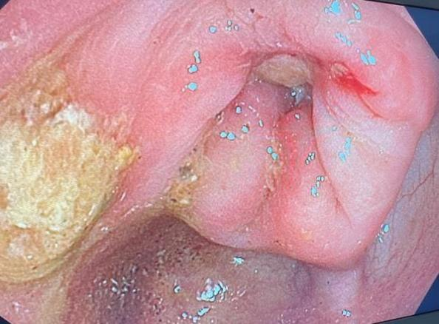

Figure 6 (UGI endoscopy shows deep prepyloric ulcer

of size 5*5mm with yellowish exudates at the base extending

into the pyloric opening with erythematous

surrounding, causing pyloric lumen narrowing)

**Discussion**

“Biliary fistulas occur in 3–5% of patients with gallstones” [8], “with the duodenum being the most common site of fistulation, followed by the stomach” [9]. “The risk associated with fistulation is the potential for gastrointestinal tract obstruction, which is said to happen most frequently at the terminal ileum and ileocecal valve.” [10]. “In our case, the patient displayed signs of perforation peritonitis, which is due to fistulating by peptic ulcer disease. This most commonly occurs in females in the seventh and eighth decades of life” [11], “and whilst this syndrome remains a rare clinical entity it is worth considering when evaluating elderly patients with chronic abdominal pain. With regards to imaging, CT remains the modality of choice when investigating a patient with suspected Cholecystogastric fistulas. Cholecystogastric fistulas have been reported as far back as 1956, and thoughonce associated with high mortality the majority are now managed successfully due to improved radiological and endoscopic modalities and subsequent surgical intervention, as demonstrated in this case. Many still argue that ‘one-stage’ surgery involving fistula repair and cholecystectomy remains the only effective means of treatment” [12]. “However, our patient also underwent ‘one-stage’ surgery as the patient presented with peritonitis and underwent laparotomy with cholecystectomy and modified Graham patch repair . There is also increasing evidence for the use of interval cholecystectomy in patients where the removal of the gallbladder at the time of first operation is deemed inappropriate” [13,14]. Some may argue that the patient should have undergone ‘two-stage’ surgery and return for a cholecystectomy and fistula repair, given the risk of disease recurrence. However, our patient experienced minimal morbidity and had no necessity for further surgery. Endoscopic treatment of cholecystogastric fistulas often offers a safer and more prudent solution to the problem, given the patient group and likely associated co-morbidities, gastrointestinal haemorrhage, stone impaction and improper or partial stone manipulation and perforation peritonitis are often the mitigating factors for such failure and so surgical intervention is warranted.

Study limitations

This case report highlights a rare sequelae of a relatively common condition; however, it offers limited evidence regarding optimal management strategies of such complications. Further validation through higher-quality studies is necessary to increase our understanding and guide treatment approaches for this condition.

**Conclusions**

Cholecystogastric Fistula is a rare complication of peptic ulcer disease. Patients may present with non-specific clinical symptoms, which makes the diagnosis difficult. Gas in Gall bladder and the presence of contrast in the gall bladder should always alert the clinician to the possibility of Cholecystogastric Fistula. Surgery should be considered in such cases. This case report is a reminder of a rare complication for a relatively common disease: peptic ulcer disease.

**Consent**

**As per international standards or university standards, patient(s) written consent has been collected and preserved by the author(s).**

Disclaimer (Artificial intelligence)

Option 1:

Author(s) hereby declare that NO generative AI technologies such as Large Language Models (ChatGPT, COPILOT, etc.) and text-to-image generators have been used during the writing or editing of this manuscript.

## REFERENCES

1. Zelickson MS, Bronder CM, Johnson BL, Camunas JA, Smith DE, Rawlinson D, et al. Helicobacter pylori is not the predominant etiology for peptic ulcers requiring operation. *Am Surg*. 2011;77: 1054–1060. [[PubMed](https://pubmed.ncbi.nlm.nih.gov/21944523)] [[Google Scholar](https://scholar.google.com/scholar_lookup?journal=Am+Surg&title=Helicobacter+pylori+is+not+the+predominant+etiology+for+peptic+ulcers+requiring+operation&author=MS+Zelickson&author=CM+Bronder&author=BL+Johnson&author=JA+Camunas&author=DE+Smith&volume=77&publication_year=2011&pages=1054-1060&pmid=21944523&)]

2. Lanas A, Chan FKL. Peptic ulcer disease. *Lancet (London, England).* 2017;390: 613–624. doi: 10.1016/S0140-6736(16)32404-7 [[PubMed](https://pubmed.ncbi.nlm.nih.gov/28242110)] [[CrossRef](https://doi.org/10.1016%252FS0140-6736(16)32404-7)] [[Google Scholar](https://scholar.google.com/scholar_lookup?journal=Lancet+(London,+England).&title=Peptic+ulcer+disease&author=A+Lanas&author=FKL+Chan&volume=390&publication_year=2017&pages=613-624&pmid=28242110&doi=10.1016/S0140-6736(16)32404-7&)]

3. Kavitt RT, Lipowska AM, Anyane-Yeboa A, Gralnek IM. Diagnosis and Treatment of Peptic Ulcer Disease. *Am J Med*. 2019;132: 447–456. doi: 10.1016/j.amjmed.2018.12.009 [[PubMed](https://pubmed.ncbi.nlm.nih.gov/30611829)] [[CrossRef](https://doi.org/10.1016%252Fj.amjmed.2018.12.009)] [[Google Scholar](https://scholar.google.com/scholar_lookup?journal=Am+J+Med&title=Diagnosis+and+Treatment+of+Peptic+Ulcer+Disease&author=RT+Kavitt&author=AM+Lipowska&author=A+Anyane-Yeboa&author=IM+Gralnek&volume=132&publication_year=2019&pages=447-456&pmid=30611829&doi=10.1016/j.amjmed.2018.12.009&)]

4. Sung JJY, Kuipers EJ, El-Serag HB. Systematic review: the global incidence and prevalence of peptic ulcer disease. *Aliment Pharmacol Ther*. 2009;29: 938–946. doi: 10.1111/j.1365-2036.2009.03960.x [[PubMed](https://pubmed.ncbi.nlm.nih.gov/19220208)] [[CrossRef](https://doi.org/10.1111%252Fj.1365-2036.2009.03960.x)] [[Google Scholar](https://scholar.google.com/scholar_lookup?journal=Aliment+Pharmacol+Ther&title=Systematic+review:+the+global+incidence+and+prevalence+of+peptic+ulcer+disease&author=JJY+Sung&author=EJ+Kuipers&author=HB+El-Serag&volume=29&publication_year=2009&pages=938-946&pmid=19220208&doi=10.1111/j.1365-2036.2009.03960.x&)]

5.Nayak SK, Parthasarathi R, Gupta GHVR, Palanivelu C: [Laparoscopic approach in cholecystogastric fistula with cholecystectomy and omental patching: a case report and review](https://dx.doi.org/10.4103/jmas.JMAS_87_20). J Minim Access Surg. 2021, 17:245-8. [10.4103/jmas.JMAS_87_20](https://dx.doi.org/10.4103/jmas.JMAS_87_20)

6.Melamed JL, Parker ML: [Cholecystogastric fistula: report of a case](https://dx.doi.org/10.1001/jama.1956.02960410039009a). JAMA. 1956, 160:463-4.[10.1001/jama.1956.02960410039009a](https://dx.doi.org/10.1001/jama.1956.02960410039009a)

7.Nakamura M, Hamanaka Y, Kawamura A, Suzuki T: [Successful preoperative diagnosis of a cholecystogastric fistula using endoscopic retrograde cholangiography: report of a case](https://dx.doi.org/10.1007/BF02385814). Surg Today. 1997, 27:567-70. [10.1007/BF02385814](https://dx.doi.org/10.1007/BF02385814)

8. Angrisani L, Corcione F, Tartaglia A, Tricarico A,Rendano F, Vincenti R, et al. Cholecystoenteric fistula (CF) is not a contraindication for laparoscopic surgery, *Surg Endosc*, 2001, vol. 15 (pg. 1038-41)[10.1007/s004640000317](https://doi.org/10.1007/s004640000317) [Google Scholar](https://scholar.google.com/scholar_lookup?title=Cholecystoenteric%2520fistula%2520(CF)%2520is%2520not%2520a%2520contraindication%2520for%2520laparoscopic%2520surgery&author=L%2520Angrisani&author=F%2520Corcione&author=A%2520Tartaglia&author=A%2520Tricarico&author=F%2520Rendano&author=R%2520Vincenti&publication_year=2001&journal=Surg%2520Endosc&volume=15&pages=1038-41) [Crossref](http://dx.doi.org/10.1007/s004640000317) [PubMed](http://www.ncbi.nlm.nih.gov/pubmed/11443421) [WorldCat](https://www.worldcat.org/search?q=ti:Cholecystoenteric%2520fistula%2520(CF)%2520is%2520not%2520a%2520contraindication%2520for%2520laparoscopic%2520surgery&qt=advanced&dblist=638)

9. Chowbey PK, Bandyopadhyay SK, Sharma A, Khullar R, Soni V, Baijal M.Laparoscopic management of cholecystoenteric fistulas, *J Laparoendosc Adv Surg Tech A* ,2006, vol. 16 (pg. 467-72)[10.1089/lap.2006.16.467](https://doi.org/10.1089/lap.2006.16.467) [Google Scholar](https://scholar.google.com/scholar_lookup?title=Laparoscopic%2520management%2520of%2520cholecystoenteric%2520fistulas&author=PK%2520Chowbey&author=SK%2520Bandyopadhyay&author=A%2520Sharma&author=R%2520Khullar&author=V%2520Soni&author=M%2520Baijal&publication_year=2006&journal=J%2520Laparoendosc%2520Adv%2520Surg%2520Tech%2520A&volume=16&pages=467-72) [Crossref](http://dx.doi.org/10.1089/lap.2006.16.467) [PubMed](http://www.ncbi.nlm.nih.gov/pubmed/17004870) [WorldCat](https://www.worldcat.org/search?q=ti:Laparoscopic%2520management%2520of%2520cholecystoenteric%2520fistulas&qt=advanced&dblist=638).

10. Arioli D, Venturini I, Masetti M, Romagnoli E, Scarcelli A, Ballesini P, et al. Intermittent gastric outlet obstruction due to a gallstone migrated through a cholecysto-gastricfistula: a new variant of ‘Bouveret's syndrome, *World J Gastroenterol*, 2008, vol. 14(pg.125-8)[10.3748/wjg.14.125](https://doi.org/10.3748/wjg.14.125) [Google Scholar](https://scholar.google.com/scholar_lookup?title=Intermittent%2520gastric%2520outlet%2520obstruction%2520due%2520to%2520a%2520gallstone%2520migrated%2520through%2520a%2520cholecysto-gastricfistula:%2520a%2520new%2520variant%2520of%2520%25E2%2580%2598Bouveret's%2520syndrome&author=D%2520Arioli&author=I%2520Venturini&author=M%2520Masetti&author=E%2520Romagnoli&author=A%2520Scarcelli&author=P%2520Ballesini&publication_year=2008&journal=World%2520J%2520Gastroenterol&volume=14&pages=125-8) [Crossref](http://dx.doi.org/10.3748/wjg.14.125) [PubMed](http://www.ncbi.nlm.nih.gov/pubmed/18176974) [WorldCat](https://www.worldcat.org/search?q=ti:Intermittent%2520gastric%2520outlet%2520obstruction%2520due%2520to%2520a%2520gallstone%2520migrated%2520through%2520a%2520cholecysto-gastricfistula:%2520a%2520new%2520variant%2520of%2520%25E2%2580%2598Bouveret's%2520syndrome&qt=advanced&dblist=638)

11. Masson JW, Fraser A, Wolf B,  Duncan K, Brunt PW, Sinclair TS .Bouveret's syndrome: gallstone ileus causing gastric outlet obstruction, *Gastrointest Endosc*, 1998, vol. 47 (pg. 104-5)[10.1016/S0016-5107(98)70308-6](https://doi.org/10.1016/S0016-5107(98)70308-6) [Google Scholar](https://scholar.google.com/scholar_lookup?title=Bouveret's%2520syndrome:%2520gallstone%2520ileus%2520causing%2520gastric%2520outlet%2520obstruction&author=JW%2520Masson&author=A%2520Fraser&author=B%2520Wolf&author=K%2520Duncan&author=PW%2520Brunt&author=TS%2520Sinclair&publication_year=1998&journal=Gastrointest%2520Endosc&volume=47&pages=104-5) [Crossref](http://dx.doi.org/10.1016/S0016-5107(98)70308-6) [PubMed](http://www.ncbi.nlm.nih.gov/pubmed/9468440) [WorldCat](https://www.worldcat.org/search?q=ti:Bouveret's%2520syndrome:%2520gallstone%2520ileus%2520causing%2520gastric%2520outlet%2520obstruction&qt=advanced&dblist=638)

12.Pavlidis TE, Atmatzidis KS, Papaziogas BT, Papaziogas TB. Management of gallstone ileus, *J Hepatobiliary Pancreat Surg*, 2003, vol. 10(pg. 299-302)[10.1007/s00534-002-0806-7](https://doi.org/10.1007/s00534-002-0806-7) [Google Scholar](https://scholar.google.com/scholar_lookup?title=Management%2520of%2520gallstone%2520ileus&author=TE%2520Pavlidis&author=KS%2520Atmatzidis&author=BT%2520Papaziogas&author=TB%2520Papaziogas&publication_year=2003&journal=J%2520Hepatobiliary%2520Pancreat%2520Surg&volume=10&pages=299-302) [Crossref](http://dx.doi.org/10.1007/s00534-002-0806-7) [PubMed](http://www.ncbi.nlm.nih.gov/pubmed/14598150) [WorldCat](https://www.worldcat.org/search?q=ti:Management%2520of%2520gallstone%2520ileus&qt=advanced&dblist=638)

13.McGillicuddy EA, Schuster KM, Barre K, Suarez L, Hall MR, Kaml GJ, et al. Non-operative management of acute cholecystitis in the elderly, *Br J Surg*, 2012, vol. 99 (pg. 1254-61) [10.1002/bjs.8836](https://doi.org/10.1002/bjs.8836) [Google Scholar](https://scholar.google.com/scholar_lookup?title=Non-operative%2520management%2520of%2520acute%2520cholecystitis%2520in%2520the%2520elderly&author=EA%2520McGillicuddy&author=KM%2520Schuster&author=K%2520Barre&author=L%2520Suarez&author=MR%2520Hall&author=GJ%2520Kaml&publication_year=2012&journal=Br%2520J%2520Surg&volume=99&pages=1254-61) [Crossref](http://dx.doi.org/10.1002/bjs.v99.9) [PubMed](http://www.ncbi.nlm.nih.gov/pubmed/22829411) [WorldCat](https://www.worldcat.org/search?q=ti:Non-operative%2520management%2520of%2520acute%2520cholecystitis%2520in%2520the%2520elderly&qt=advanced&dblist=638)

14. Bass G, Walsh TN. Non-operative management of acute cholecystitis in the elderly, *Br J Surg*, 2012, vol. 99 (pg. 1254-61)[Google Scholar](https://scholar.google.com/scholar_lookup?title=Non-operative%2520management%2520of%2520acute%2520cholecystitis%2520in%2520the%2520elderly&author=G%2520Bass&author=TN%2520Walsh&publication_year=2012&journal=Br%2520J%2520Surg&volume=99&pages=1254-61) [Crossref](http://dx.doi.org/10.1002/bjs.v99.12) [PubMed](http://www.ncbi.nlm.nih.gov/pubmed/22829411) [WorldCat](https://www.worldcat.org/search?q=ti:Non-operative%2520management%2520of%2520acute%2520cholecystitis%2520in%2520the%2520elderly&qt=advanced&dblist=638)

15. Boland, M. R., Bass, G. A., Robertson, I., & Walsh, T. N. (2013). Cholecystogastric fistula: a brief report and review of the literature. Journal of surgical case reports, 2013(4), rjt028.