***Case report***

**Laparoscopic Evacuation of Retroperitoneal Hematoma After Blunt Trauma Abdomen: A Case Report**

**Abstract**

Retroperitoneal hematoma is an uncommon and potentially life-threatening condition that rarely requires surgical intervention. In most cases, uncomplicated retroperitoneal hematomas are managed conservatively with close observation, blood transfusions, and correction of coagulopathy. Laparoscopic evacuation offers a minimally invasive alternative, allowing effective control of bleeding, removal of the hematoma, and reducing the need for extensive open surgery. A case of a 25-year-old man who developed a large retroperitoneal hematoma following blunt abdominal trauma from a kick was presented. Laboratory investigations showed: Haemoglobin: 8 gm/dL, for which the patient received two units of blood transfusion. Normal kidney function tests. Ultrasonography revealed a large retroperitoneal hematoma in the central (Zone 1) region of the abdomen, located on the right side of the aorta and inferior vena cava, measuring 12 x 10 cm. The patient was successfully managed with laparoscopic evacuation and treatment. Laparoscopic management is especially valuable when conservative treatment fails or interventional radiology is not available. Overall, laparoscopic evacuation of large retroperitoneal hematomas is a safe and feasible technique in appropriately selected, stable patients.

**Key words**

Retroperitoneal hematoma, abdominal kick, laparoscopic evacuation

**Introduction**

The retroperitoneum is the anatomical space located behind the peritoneal lining of the abdomen. Lesions in the retroperitoneum may present as an acute abdomen, characterised by pain in the abdominal region, including the epigastric, flank, or back areas. The clinical presentations may be ambiguous and sometimes lead to a delayed diagnosis (Liu et al., 2024). For the purpose of diagnosing and managing retroperitoneal injuries, it is classified into three anatomical zones: [1,2,3]

**Zone 1 – Central Retroperitoneum**

* This zone extends from the diaphragm to the aortic bifurcation and contains vital vascular and visceral structures, including: The aorta and its branches (e.g., celiac axis, superior mesenteric artery).
* The inferior vena cava (IVC). The duodenum, pancreas, and major visceral vessels
* Injuries in Zone 1 often involve major vascular or visceral structures and typically require prompt surgical intervention. [1,2,4,5]

**Zone 2 – Lateral (Perinephric) Retroperitoneum**

This zone includes:

* Kidneys, adrenal glands, renal vessels, and ureters
* Portions of the ascending and descending colon

Management of Zone 2 injuries is more variable and depends on the type of injury and the patient's hemodynamic status. [1,2,3]

**Zone 3 – Pelvic Retroperitoneum**

* Located below the aortic bifurcation, this zone contains:
* Iliac vessels, distal ureters, rectum, and sigmoid colon
* Zone 3 injuries are commonly associated with pelvic fractures and often carry a high mortality rate due to the complexity of pelvic vascular structures. [1,5,6]

**There are two types of retroperitoneal hematoma-**

1. Traumatic  
2. Non-Traumatic

**1. Traumatic Retroperitoneal Hematoma**

Traumatic retroperitoneal hematomas can be further divided into blunt and penetrating types. Blunt trauma accounts for approximately 67% to 80% of traumatic retroperitoneal hematomas. Penetrating trauma contributes to 20% to 33% of cases. Typically, blunt injuries will remain contained in a single zone. This is in contrast to penetrating injuries that often cross into neighbouring zones (Smith et al., 2023). Vascular injuries are more commonly associated with penetrating trauma than with blunt trauma.

Blunt injuries to retroperitoneal organs are relatively rare, with an incidence of 0.2% to 5%, but they carry a high mortality rate exceeding 20% due to delayed diagnosis and the complexity of management. [1,2,3]

**2. Non-Traumatic Retroperitoneal Hematoma**

Non-traumatic retroperitoneal hematomas may occur spontaneously or as a result of iatrogenic causes. Spontaneous retroperitoneal hematomas are rare, with a reported incidence of around 0.6%. They typically occur in patients receiving antiplatelet or anticoagulant therapy and may present as life-threatening emergencies.

Iatrogenic hematomas are often related to invasive procedures, such as cardiac catheterisation via the femoral route, which can inadvertently injure retroperitoneal vessels.

Both spontaneous and iatrogenic retroperitoneal hematomas require a high index of suspicion for timely diagnosis and management, as they can lead to significant morbidity and mortality. [4,5,6]

**Case Presentation**

A 25-year-old male was admitted to our centre on 20th January 2020 with complaints of abdominal pain and vomiting. The patient had a history of blunt abdominal trauma sustained seven days prior, following a physical altercation in which his uncle forcefully kicked him in the abdomen. He was initially managed at a primary health centre and was referred to our facility after his condition did not improve.

On examination, the patient was having tachycardia, pale and complaining of abdominal pain. Abdominal examination revealed: Tenderness, A palpable lump in the right side of the abdomen

Laboratory investigations showed: Haemoglobin: 8 gm/dL, for which the patient received two units of blood transfusion. Normal kidney function tests. Ultrasonography revealed a large retroperitoneal hematoma in the central (Zone 1) region of the abdomen, located on the right side of the aorta and inferior vena cava, measuring 12 x 10 cm. The right kidney was normal. A CT scan was not performed due to logistical reasons.

Under general anaesthesia, pneumoperitoneum was created using a Veress needle, maintaining intra-abdominal pressure at 14 mmHg. The following ports were inserted: 10 mm umbilical port (for a 30-degree camera), 5 mm port in the right iliac fossa and 10 mm operating port in the left anterior axillary line

Upon laparoscopic inspection, the liver, spleen, and hollow viscera were found to be normal. A large right-sided retroperitoneal hematoma in Zone 1 was identified, displacing the ascending colon laterally, the transverse colon superiorly, and lying lateral to the aorta and inferior vena cava.

A Veress needle was used to aspirate the hematoma, which yielded no fresh blood, indicating an organised hematoma approximately 7 days old. Using a harmonic scalpel, the anterior bare surface of the hematoma was incised. Approximately 300 grams of clotted blood was evacuated using suction and saline irrigation. There was no active bleeding observed. A drainage tube was placed in the cavity and removed on the third post-operative day.

The postoperative course was uneventful, and the patient was discharged on the 5th postoperative day. On follow-up at six months, the patient remained clinically well with no complications. **(Fig. 1-8)**

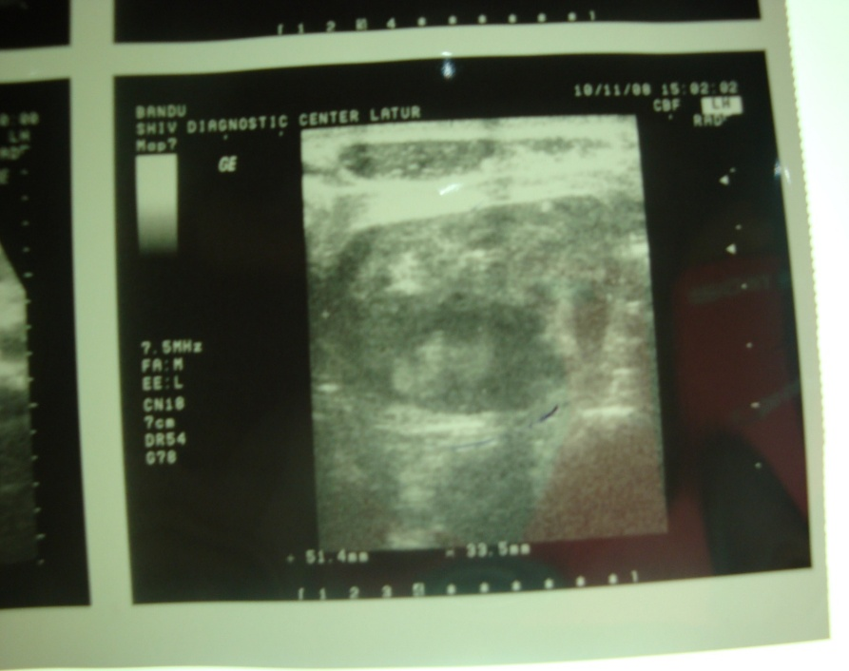

**Fig-1 Ultrasonography revealed a large retroperitoneal hematoma on the right side of the abdomen, measuring 12 × 10 cm.**

**Fig-2 Laparoscopic image showing a large right-sided retroperitoneal hematoma in central zone 1, measuring 12 × 10 cm.**

**Fig-3 Laparoscopic image demonstrating the use of a Veress needle for hematoma aspiration**

**Fig-4 Laparoscopic image showing excision on the anterior surface of the hematoma using a harmonic scalpel.**

**Fig-6 Laparoscopic image showing a large hematoma, approximately 300 grams in size, being evacuated using a suction cannula.**

**Fig-5 Laparoscopic image showing evacuation of the hematoma using suction and saline irrigation**

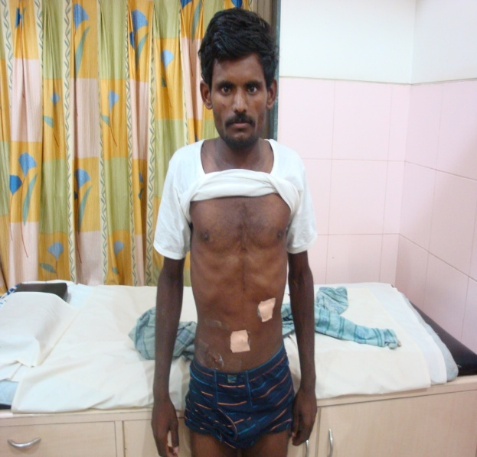

**Fig-7 Laparoscopic image showing placement of a drainage tube within the cavity**

**Fig-8 Postoperative image showing port site locations and an uneventful recovery.**

**Discussion**

Trauma surgeons utilise a range of imaging modalities to diagnose retroperitoneal injuries. While Focused Assessment with Sonography in Trauma (FAST) is widely used for the rapid detection of intraperitoneal bleeding, its utility in evaluating retroperitoneal injuries is limited. CT scan, however, remains the cornerstone in the assessment and management of retroperitoneal trauma. It demonstrates 100% sensitivity and 96% specificity in detecting injuries that require surgical intervention (laparotomy). [1,2,3,10]

**Types of Management Approaches**

1. Conservative Management
2. Open Surgical Management
3. Laparoscopic Surgical Management [1,2,3]

**1. Conservative Management**

Conservative treatment is appropriate for hemodynamically stable patients without signs of active bleeding or compression symptoms. Key elements include:

* Hemodynamic stabilisation: Fluid resuscitation and blood transfusions to maintain circulatory volume and oxygen-carrying capacity.
* Correction of coagulopathy: Essential for patients on anticoagulants or with bleeding disorders.
* Close monitoring: Frequent abdominal examinations and serial CT scans to monitor hematoma size and progression.
* Antibiotic prophylaxis: To reduce the risk of secondary infection. [1,2,3,4]

**2. Open Surgical Management**

Open surgery is indicated in cases where conservative treatment is insufficient or the patient’s condition deteriorates.

**Indications:**

* Hematoma volume > 500 mL
* Hemodynamic instability (persistent hypotension, unresponsive to fluids)
* Abdominal compartment syndrome
* Neuropathy due to femoral nerve compression
* Failure of conservative or interventional radiological measures [1,2,6,7]

**Surgical Approaches:**

* Midline laparotomy
* Ipsilateral hockey-stick incision

**Procedure:**

Open the retroperitoneal space. Evacuate the hematoma. Ligation of any bleeding vessels. Drain placement. Close the abdominal cavity**.** [1,2,3,8]

**3. Laparoscopic Surgical Management**

Laparoscopic evacuation is a minimally invasive alternative to open surgery and is particularly suitable for hemodynamically stable patients.

Indications:

* Failure of conservative management
* Persistent hemodynamic instability
* Compression of vital organs (e.g., kidney, bowel)
* Femoral neuropathy due to nerve compression
* Abdominal compartment syndrome

**Advantages of Laparoscopy:**

Direct visualisation of the hematoma. Precise evacuation and ligation of bleeding vessels. Reduced postoperative pain. Shorter hospital stays and faster recovery**.** Laparoscopic evacuation is both safe and effective in selected patients, particularly when performed early in the course of the condition before significant complications develop. [1,2,3,4,9]

**Conclusion**

Laparoscopic evacuation of a large retroperitoneal hematoma in Zone 1 following blunt abdominal trauma, such as an abdominal kick, is a rare but significant clinical scenario. In hemodynamically stable patients, laparoscopy offers a minimally invasive and effective alternative to open surgery.

This approach allows for accurate localisation and evacuation of the hematoma, with the added advantage of identifying and controlling bleeding points using techniques such as bipolar cauterisation. The enhanced visualisation provided by laparoscopy facilitates careful inspection of the retroperitoneal space and precise surgical intervention.

Laparoscopic management is especially valuable when conservative treatment fails or interventional radiology is not available. It promotes faster recovery, shorter hospital stays, and less postoperative pain. Overall, laparoscopic evacuation of large retroperitoneal hematomas is a safe and feasible technique in appropriately selected, stable patients.

Consent

As per international standards or university standards, patient(s) written consent has been collected and preserved by the author(s).

Disclaimer (Artificial intelligence)

Option 1:

Author(s) hereby declare that NO generative AI technologies such as Large Language Models (ChatGPT, COPILOT, etc.) and text-to-image generators have been used during the writing or editing of this manuscript.

Option 2:

Author(s) hereby declare that generative AI technologies such as Large Language Models, etc. have been used during the writing or editing of manuscripts. This explanation will include the name, version, model, and source of the generative AI technology and as well as all input prompts provided to the generative AI technology

Details of the AI usage are given below:

1.

2.

3.

**References**

* 1. Koto MZ, Matsevych OY, Mosai F, Balabyeki M, Aldous C. Laparoscopic management of retroperitoneal injuries from penetrating abdominal trauma in haemodynamically stable patients. J Minim Access Surg. 2019 Jan-Mar;15(1):25-30. doi: 10.4103/jmas.JMAS_199_17. PMID: 29483377; PMCID: PMC6293668.
  2. Bhama AR, Weigel RJ, Chong HS. Laparoscopic drainage of retroperitoneal hematoma. CRSLS e2014.00054. DOI: 10.4293/CRSLS.2014.00054
  3. Yokoe T, Kita M, Suzuki K, Butsuhara Y, Yoshida A, Morikawa M, Okada H. Laparoscopic hemostasis and drainage for postpartum retroperitoneal hematoma complicated with an infection: A case report and surgical video. Ann Med Surg (Lond). 2022 Apr 28;77:103686. doi: 10.1016/j.amsu.2022.103686. PMID: 35638002; PMCID: PMC9142646.
  4. AlRumaih, A., Alzakari, A., Alkhaibary, A., & Alghanim, F. (2018). Extensive retroperitoneal hematoma after laparoscopic appendectomy. International Surgery Journal, 5(10), 3399–3402. <https://doi.org/10.18203/2349-2902.isj20184097>
  5. Meltem Tekelioğlu1, Osman Temizkan2, Osman Aşıcıoğlu3, , Retroperitoneal Hematoma by Veress Needle During Laparoscopic Surgery: Expectant Management, Smyrna Tıp Dergisi, Kabul tarihi: 07.12.2017
  6. Mondie C, Maguire NJ, Rentea RM. Retroperitoneal Hematoma. [Updated 2024 Jun 7]. In: StatPearls [Internet]. Treasure Island (FL): StatPearls Publishing; 2025 Jan
  7. junaid sultan, haris bin bilal, management of retro peritoneal haematoma, professional med j sept 2005; 12(3): 230-236.
  8. Kurotaki, T., Okada, N., Sakurai, Y. et al. Spontaneous retroperitoneal hematoma: a case report. J Med Case Reports 17, 70 (2023). <https://doi.org/10.1186/s13256-023-03794-4>
  9. Lukies, M., Gipson, J., Tan, S.Y. et al. Spontaneous Retroperitoneal Haemorrhage: Efficacy of Conservative Management and Embolisation. Cardiovasc Intervent Radiol 46, 488–495 (2023). <https://doi.org/10.1007/s00270-023-03359-4>
  10. Nakajima T, Nakanishi K, Harada K, et al. (December 25, 2023) A Case of Massive Retroperitoneal Hematoma After High-Energy Trauma. Cureus 15(12): e51080. doi:10.7759/cureus.51080
  11. Liu, H. H., Lin, Y., Lin, G., Wang, L. J., & Wan, Y. L. (2024). Ultrasonography of acute retroperitoneum. *Ultrasonography*, *43*(3), 179.
  12. Smith, C., Stephenson, G., Wray, A., & Hatter, M. (2023). Trauma by Couch: A Case Report of a Massive Traumatic Retroperitoneal Hematoma. *Journal of Education & Teaching in Emergency Medicine*, *8*(3), V5.