Case report
Integrative Management of a Post-Debridement Non-Healing Diabetic Foot Ulcer: A Case Report

Abstract
Diabetic foot, including diabetic foot ulcers, is a major complication that many people with diabetes experience at some point in their lives. Diabetic wounds, especially foot ulcers, are a significant long-term complication in diabetic patients, frequently leading to a decline in their quality of life. This case report describes the successful management of a non-healing diabetic foot ulcer in a 73-year-old male with a 10-year history of type 2 diabetes. The patient presented with a post-debridement wound on the plantar aspect of the right heel, complicated by infection. Treatment involved a combination of local and systemic Ayurvedic interventions, including wound cleansing with Phalatrikadi Kwatha, dressings with Apamarga Kshara Taila and later Yashtimadhu Ghrita, and oral Ayurvedic medications. A posterior below-knee Plaster of Paris slab was applied for offloading. Significant wound healing was observed within two weeks, with complete closure achieved by the ninth week. Microbiological analysis confirmed the resolution of infection. There was no wound recurrence in 1.5 years of follow-up. This case highlights the potential of an integrative approach for managing challenging diabetic foot ulcers. In conclusion, despite the challenges of non-healing diabetic wounds post-debridement, thorough integrative management can yield positive outcomes.
Keywords: Ayurveda, Case report, Dushtavrana, Diabetic foot ulcer, Post-debridement wound.
Introduction
Diabetes mellitus is a complex metabolic condition, the classification and diagnosis of which has been the subject of intense scrutiny over decades (Forouhi & Wareham, 2019). Diabetes and its complications represent a significant global health burden. Diabetic foot, including diabetic foot ulcers, is a major complication that many people with diabetes experience at some point in their lives. Diabetic foot ulceration is a devastating complication of diabetes that is associated with infection, amputation, and death, and is affecting increasing numbers of patients with diabetes mellitus. The pathogenesis of foot ulcers is complex, and different factors play major roles in different stages (Wang et al., 2022). International Diabetes Federation (IDF) suggested that 537 million people live with diabetes today, and it is projected that by 2045, 700 million people will have the disease worldwide.^{[1]} This data underscores the growing concern about diabetes-related complications, such as diabetic foot ulcers (DFUs). A meta-analysis in 2022 found the global prevalence of DFUs to be 6.3%, with an expected increase in the coming years.^{[2]}
DFUs are a serious complication of diabetes that results in significant morbidity and mortality. Mortality rates associated with the development of a DFU are estimated to be 5% in the first 12 months, and 5-year mortality rates have been estimated at 42% (Everett & Mathioudakis, 2018; Deng et al., 2023). Diabetic foot ulcer significantly impacts all aspects of a patient's well-being, necessitating comprehensive treatment. While modern medicine offers various treatment options but each with limitations. Ayurveda, with its integrative approach, offers renewed hope for managing these chronic ulcers. The Sushruta Samhita, an ancient text, provides a detailed description of wound management in the "Dvivraniya Adhyaya".^{[3]}
Post-debridement non-healing diabetic wounds require thorough systematic and localised treatment to prevent further complications such as lower limb amputation and recurrence of ulcer. This case report highlights the successful management of such a diabetic wound using integrative therapy.

Case presentation
Patient information
A 73-year-old retired man presented to the outpatient department of our institute with a non-healing wound on the plantar aspect of his right foot and difficulty walking, which he had experienced for the past six months. The patient had a 10-year history of type 2 diabetes mellitus and was taking regular oral anti-hyperglycaemic medication (Tab Metformin 500mg twice daily after meals). Patient had addiction history of smoking for 40 years. Two months prior, he underwent surgical debridement of the wound at the government hospital in Jamnagar. Despite conventional dressing treatments, the wound showed no improvement and amputation of the foot was recommended by an allopathic surgeon.
Clinical Findings
Physical examination revealed a post-debridement wound on the right heel, measuring 7 cm x 5 cm with a depth of 3 cm. (Figure no. 1) The wound bed exhibited a high amount of slough and unhealthy granulation tissue. The wound edges were inflamed, and a foul-smelling exudate was present. The surrounding wound margins were irregular, and peripheral skin around the wound was macerated and dry. Dorsalis pedis, anterior tibial, and posterior tibial pulses in the right lower limb were feeble and palpable. The patient also presented with brittle nails and clawed toes in both legs. The left leg showed no signs of ulceration. A probe-to-bone test was performed to rule out wound connection to bone or osteomyelitis, and the result was negative. Peripheral diabetic neuropathy was confirmed by a positive monofilament test in both legs.
Diagnostic focus and assessment
Clinical evaluation of the wound was noted. Laboratory investigation; Haemoglobin (Hb) 10.8 g/L, Erythrocyte sedimentation rate (ESR) 40 mm/hr, Fasting blood sugar (FBS) -122 mg/dl, Postprandial blood sugar (PPBS) 140 mg/dl and other baseline parameters within normal range. Details of blood investigation before and after treatment are depicted in the table. (Table no. 1) Serology investigations, i.e., Human Immunodeficiency Virus (HIV), Hepatitis B surface Antigen (HbsAg), Hepatitis C virus (HCV) and Venereal Disease Research Laboratory (VDRL) were negative. Electrocardiogram (ECG) and Abdomen ultrasonography found no abnormalities. X-ray foot (AP & Lat view) of affected foot showed absence of osteomyelitis. On Wound discharge swab culture; Pseudomonas aeruginosa and E. coli were positive and fungal growth was negative. Following comprehensive diagnostic assessment and evaluation, the case was diagnosed as a post-debridement non-healing diabetic foot ulcer. (Wagner’s grade 2 classification). The diagnosis highlighted the persistent challenge of wound healing in the context of diabetes, even after surgical debridement, emphasising the need for an integrative and potentially multi-faceted therapeutic approach.
Therapeutic intervention
Drawing upon Acharya Sushruta's principles of wound care, the treatment strategy in this case incorporated both local and systemic Ayurvedic interventions, alongside modern off-loading. Locally, the wound was cleansed with lukewarm Phalatrikadi Kwatha, followed by an initial four-week phase of aseptic dressings using Apamarg Kshara Taila. As healing progressed, the dressings were transitioned to Yashtimadhu Ghrita to further support tissue regeneration. To mechanically manage pressure on the wound, a posterior below-knee POP slab was applied. Systemically, the patient received oral Ayurvedic medicines: Sanjivani Vati (125mg four times daily after food with water) and a combination of Arogyavardhini Rasa (250mg), Gandhak Rasayan (250mg), and Guduchi Churna (3gm twice daily after food with lukewarm water) to facilitate internal healing mechanisms. Patient was under local as well as systemic Ayurveda treatment for almost three months of duration. Importantly, the patient's existing oral anti-hyperglycaemic medication regimen was maintained throughout the course of treatment. The patient was advised to adhere to a daily regimen that restricts the consumption of bakery products, processed foods, and items high in spice, salt, and refined sugar, in order to optimise blood glucose control.
Outcome and follow-up
Significant wound healing was observed within approximately two weeks, characterised by a notable reduction in wound exudate. Subsequently, the wound area progressively decreased, with substantial contraction evident after four weeks of treatment. At day 35, microbiological analysis of wound exudate via swab culture revealed the absence of Pseudomonas aeruginosa and Escherichia coli. By week eight, the wound exhibited marked epithelialization, and exudate was no longer present. Complete wound closure was achieved by week nine. The total unit healing time (UHT) in this patient was 0.6 days/cm³. Notably, the patient has demonstrated no wound recurrence over the subsequent follow-up for 1.5 years. The daily progression of wound healing can be quantified through pictures. (Figures 2 to 8)
Timeline
The timeline of clinical scenario and therapeutic measures in this case is drawn in a table. (Table no. 2)

Tables
Table no. 1 Laboratory investigation before and after treatment
Sr. No. | Name | Before treatment | After treatment
1. | Hb | 10.8gm% | 11.2gm%
2. | Total WBC | 10000/cu mm | 8895/cu mm
3. | ESR | 40 mm | 19 mm
4. | FBS | 122 mg/dl | 124 mg/dl
5. | PPBS | 140 mg/dl | 136 mg/dl
6. | S. creatinine | 1.06 mg/dl | 1.04 mg/dl
7. | T Bilirubin | 0.57 mg/dl | 0.58 mg/dl
8. | T Protein | 6.86 gms/dl | 7.00 gms/dl

Table no. 2 Timeline
Sr.no. | Year | Clinical scenario and therapeutic measures
1. | August 2021 – November 2021 | Non-healing wound at right heel associated with foul-smelling pus discharge, and treatment was taken from a conservative general practitioner, but no condition was worsened
2. | December 2021 – January 2022 | Patient underwent surgical debridement of wound at right heel under local anaesthesia and took some IV or oral antibiotics from the civil hospital.
3. | 10th Feb 2022 (Day 1) | Patient visited Shalya Tantra OPD; Unhealthy Post debridement non-healing wound, Slough, and foul-smelling discharge present. (Wagner’s classification grade 2 noted)  - Advised laboratory investigation and Radi-imaging study.  - On Wound discharge swab culture; Pseudomonas aeruginosa and E. coli positive and fungal growth was negative  - Therapeutic intervention locally; Wound irrigation with Phalatrikadi Kwath for five minutes initially, followed by aseptic dressing with application of Apamarga Kshara Taila was done.  - Oral Ayurveda medicines prescribed  - Below knee plate of peris (POP) posterior slab applied to the affected foot  - Continue oral anti-hyperglycaemic medications (Tab metformin 500mg BD)
4. | 21st Feb 2022 (Day 14) | Wound became healthy. Mild Seropurulent discharge. Wound size decreased
5. | 28th Feb 2022 (Day 21) | Healing with sloping edge
6. | 7th March 2022 (Day 28) | Significant wound contraction noted, serous discharge present  Apamarga Kshara Taila discontinued, and dressing started with Yashtimadhu Ghrita  Sanivani Vati stopped. Continued other medicines
7. | 14th March 2022 (Day 35) | Healing wound with minimal serous discharge  On repeat wound discharge swab culture; Pseudomonas aeruginosa and E. coli negative
8. | 21st March 2022 (Day 42) | Good healing and epithelialization noted
9. | 14th April 2022 (Day 56) | Marked wound contraction and epithelization. No discharge present
10. | 21st April 2022 (Day 63) | Complete wound contraction noted  Advised to wear diabetic footwear and have regular checkups of the foot  Stopped all medicines and asked to continue anti-diabetic medicines
11. | Follow up for 1.5 years | No recurrence was found

Discussion
The recalcitrant nature of non-healing diabetic wounds exhibits a notable correlation with the concept of Madhumehjanya Dushtavrana, as described in the classical text Sushruta Samhita. The term 'Dushtavrana' itself denotes a putrefied and therapeutically challenging wound. While surgical debridement is often necessary, meticulous postoperative management of secondary intention wound healing is crucial to mitigate infection and promote tissue repair.
To address the wound infection and prevent its spread, sterile aseptic dressing plays a crucial role. Several Ayurvedic formulations possess wound cleansing and healing properties. Given the unhealthy state of the wound, initial management involved cleansing with Phalatrikadi Kwatha, an Ayurvedic preparation with Tridoshshamaka properties.^{[4]} This formulation is predominantly composed of Kashaya Rasa herbs, known for their role in wound cleansing and healing. The pharmacological properties of Phalatrikadi Kwatha, including anti-inflammatory, antioxidant, and antimicrobial activities, are considered beneficial in combating wound infection.^{[5]}
Apamarga Kshara Taila was selected for wound dressing in this patient, owing to its multifaceted action, specifically its ability to promote Vrana Shodhana (wound cleansing). Its antiseptic and debridement properties target harmful microorganisms, while its anti-inflammatory action promotes a conducive environment for wound healing by facilitating healthy granulation and improving local blood circulation.^{[6]} Once the wound became healthy, Yashtimadhu Ghrita was selected to accelerate Vrana Ropana. Yashtimadhu Ghrita exhibits anti-inflammatory, antioxidant, and antimicrobial actions, attributed to its chemical constituents, including glycyrrhizin, glycyrrhizic acid, isoflavones, glyzaglabrin, glycerides, and free fatty acids. These properties collectively promote rapid epithelialization and stimulate skin regeneration at the wound site.^{[7]}
In individuals with diabetes, pressure areas on the foot are the most common site for wound development, with the heel being particularly vulnerable, a finding consistent with the present case. It is well-established that sustained pressure impedes wound healing in this population. Posterior below-knee plaster of Paris offloading is one strategy to effectively reduce pressure and promote healing.^{[8]}
Conclusion
This case presented a significant clinical challenge due to the development of infection and its subsequent spread in a post-surgical debridement wound, located at a pressure point on the heel region, in a diabetic patient. Despite the challenges of non-healing diabetic wounds post-debridement, thorough integrative management can yield positive outcomes.
Disclaimer (Artificial intelligence)

Option 1:

Author(s) hereby declare that NO generative AI technologies such as Large Language Models (ChatGPT, COPILOT, etc.) and text-to-image generators have been used during the writing or editing of this manuscript.

Option 2:

Author(s) hereby declare that generative AI technologies such as Large Language Models, etc. have been used during the writing or editing of manuscripts. This explanation will include the name, version, model, and source of the generative AI technology and as well as all input prompts provided to the generative AI technology

Details of the AI usage are given below:
1.
2.
3.

References
- International Diabetes Federation IDF Diabetes Atlas, Tenth Edition 2021. Available at: https://diabetesatlas.org/atlas/tenth-edition/ Accessed at: 07.02.2025.
- Katherine McDermott, Michael Fang, Andrew J.M. Boulton, Elizabeth Selvin, Caitlin W. Hicks; Etiology, Epidemiology, and Disparities in the Burden of Diabetic Foot Ulcers. Diabetes Care 2 January 2023; 46 (1): 209–221.
- Acharya JT, editor. Reprint ed. Susruta Samhita of Susruta, Chikitsa Sthana Ch. 1, Ver. 8. Varanasi: Chaukhamba Surbharti Prakashan; 2019.; p. 317.
- Kumar N, Kumar A. Phalatrikadi Kvatha – A Ayurvedic hepatoprotective drug. International Journal of research in pharmacy and chemistry (IJRPC) 2013, 3(3): 591- 594.
- Patel JK. Management of Agantuja Vrana (Non-healing Traumatic Wound) by Madhukadi Yoga: A Single Case Study, J Res Ayurvedic Sci 2018;2(2):132-135.
- Singh N, Dasar D. Healing properties of Apamarga Kshara (Achyranthes aspera) in Ayurvedic medicine: A narrative review, Journal of Clinical and Diagnostic Research 2024;18(9): 1-5.
- Patel JR, Dudhamal TS. A comparative clinical study of Yashtimadhu Ghrita and lignocaine-nifedipine ointment in the management of Parikartika (acute fissure-in-ano). Ayu. 2017 Jan-Jun;38(1-2):46-51.
- Peter R, Sicco A. Off-loading the diabetic foot for ulcer prevention and healing. Journal of Vascular Surgery 2010;52(3): 37s-43s.
- Wang, X., Yuan, C. X., Xu, B., & Yu, Z. (2022). Diabetic foot ulcers: Classification, risk factors and management. World journal of diabetes, 13(12), 1049.
- Forouhi, N. G., & Wareham, N. J. (2019). Epidemiology of diabetes. Medicine, 47(1), 22-27.
- Everett, E., & Mathioudakis, N. (2018). Update on management of diabetic foot ulcers. Annals of the New York Academy of Sciences, 1411(1), 153-165.
- Deng, H., Li, B., Shen, Q., Zhang, C., Kuang, L., Chen, R., ... & Li, G. (2023). Mechanisms of diabetic foot ulceration: A review. Journal of diabetes, 15(4), 299-312.

Figures no. 1 to 8

  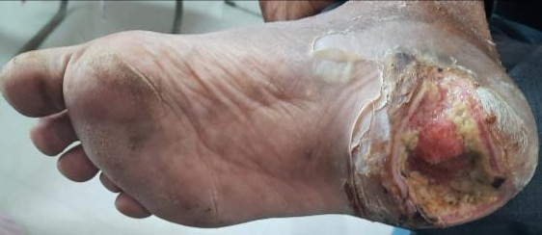  Figure 1  Figure no. 1 Day 1 - Before treatment |   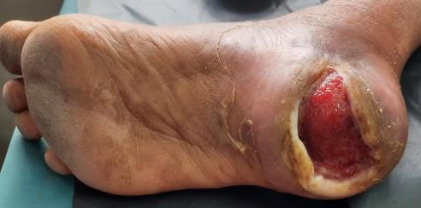  Figure 2  Figure no. 2 Day 14 – During treatment
  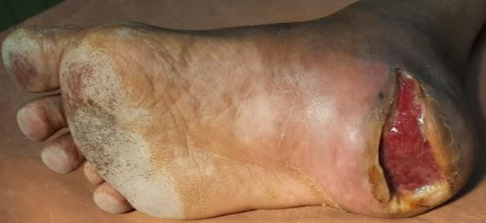  Figure 3  Figure no. 3 Day 21 – During treatment |   Figure 4  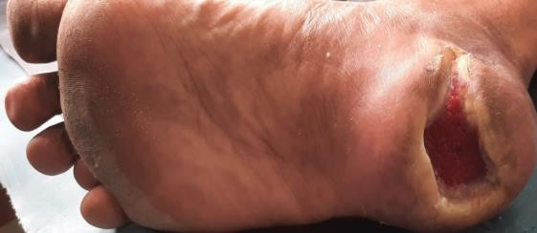  Figure no. 4 Day 28 – During treatment
  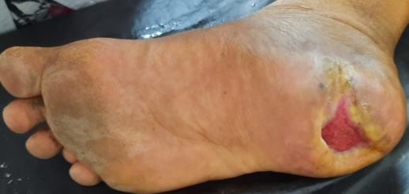  Figure 5  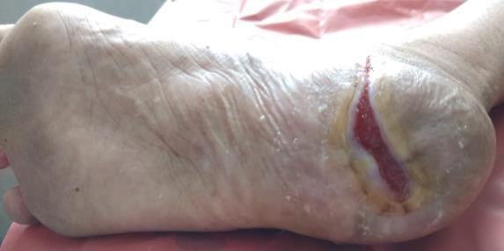    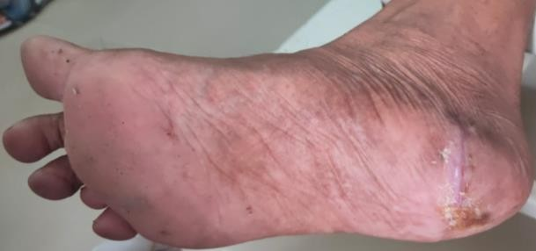  Figure no. 5 Day 35 – During treatment |   Figure 6  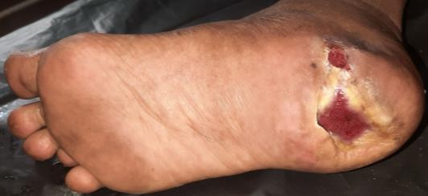  Figure no. 6 Day 42 – During treatment
  Figure 7  Figure no. 7 Day 56 – During treatment | Figure 8  Figure no. 8 Day 63 – After treatment complete wound contraction noted

