**Pediatric Intracranial Lipoma of the Corpus Callosum:** **A case report with Diagnostic Approach and Computed Tomography Imaging Review**

**ABSTRACT**

Corpus callosum lipoma is a rare congenital intracranial malformation, often identified by chance in imaging studies. We report the case of a girl aged 4 with a history of two-year epilepsy, whose medication was discontinued. She presented in the emergency department with a febrile seizure episode. Brain CT scan revealed interhemispheric fatty-density mass with lobulated contours, with peripheral calcifications, and extension to the ventricles. Clinical presentation, imaging characteristics, and a review of the literature made the diagnosis of tubulonodular lipoma of the corpus callosum.

**Keywords:** Intracranial lipoma, corpus callosum, CT imaging, congenital malformation, epilepsy, child.

**INTRODUCTION**

Intracranial lipomas are exceedingly rare congenital malformations, accounting for less than 0.5% of all intracranial lesions [1]. These lesions are not neoplastic but rather developmental anomalies resulting from the abnormal differentiation and persistence of the primitive meninx during embryogenesis, particularly between the 8th and 10th weeks of gestation [2]. Histologically, they consist of mature adipose tissue and may be associated with fibrovascular elements, calcifications, or even osseous metaplasia [3].

Among the various types of intracranial lipomas, corpus callosum lipomas (CCLs) are the most frequent, comprising up to 45% of all cases, though they remain extremely rare in absolute terms [4]. CCLs are commonly diagnosed incidentally during neuroimaging performed for unrelated clinical complaints, particularly in children and young adults. However, some patients may present with seizures, headaches, or neuropsychiatric symptoms, often due to associated anomalies such as callosal dysgenesis or hydrocephalus [5,6].

CCLs are broadly classified into two morphological subtypes: tubulonodular and curvilinear. The tubulonodular type tends to be larger (typically >2 cm), has a lobulated contour, is more often associated with callosal dysgenesis and calcifications, and may extend intraventricularly. In contrast, the curvilinear form is usually thin, elongated, located posteriorly, and less frequently associated with anomalies [4].

Given their characteristic imaging features—such as a non-enhancing fat-density mass with or without calcifications—these lesions are generally easy to identify on non-invasive neuroimaging techniques like CT and MRI [7]. In this report, we describe a case of a tubulonodular lipoma of the corpus callosum in a child presenting with a febrile seizure, highlighting its diagnostic radiological features and conservative management approach.

**CASE REPORT**

The girl, aged 4 years and 4 months, was followed since she was one year old for epilepsy, treated with Depakine, which was withdrawn two years ago after marked improvement. She was admitted in pediatric emergency department with a febrile seizure that was accompanied by a generalized seizure**.**

Her overall condition was stable following initial management (administration of midazolam and restoration of consciousness) in the initial examination. She was a conscious patient with normal ENT, cardiopulmonary, and neurological examination findings, with no dysmorphic features. She was submitted to biological tests like CRP, hemogram, and liver function.

A CT scan of the brain(figure 1 and 2), which was acquired with axial helically acquired slices before and after contrast administration, showed a large interhemispheric mass in the corpus callosum. The lobulated mass was approximately 57 × 35 mm (approximately 5 cm) in size and was negative in density, as would be expected for adipose tissue, with peripheral calcifications and with some traversing vascular structures. The mass was nonenhancing following contrast administration. The mass extended intraventricularly, involving the bilateral choroid plexuses in part and displacing the frontal horns, with resulting dilation of the occipital horns. There was no evidence for any other density abnormalities or pathologic contrast uptake.

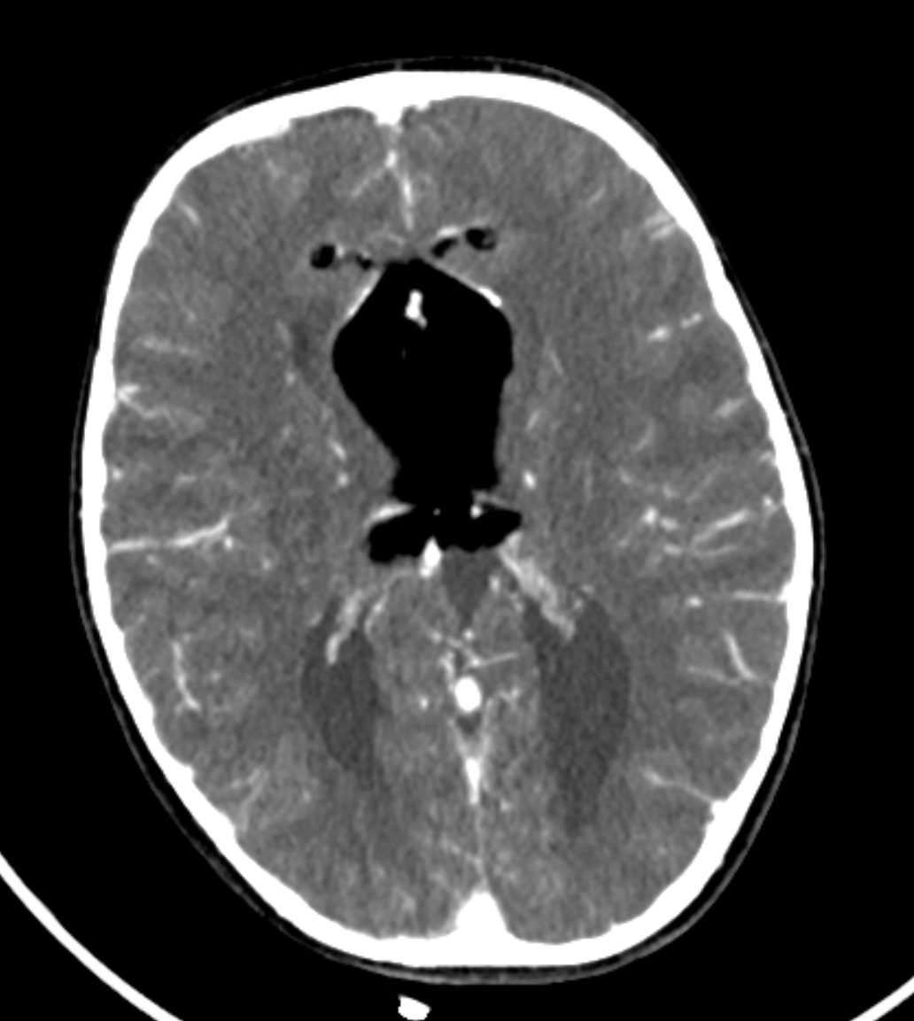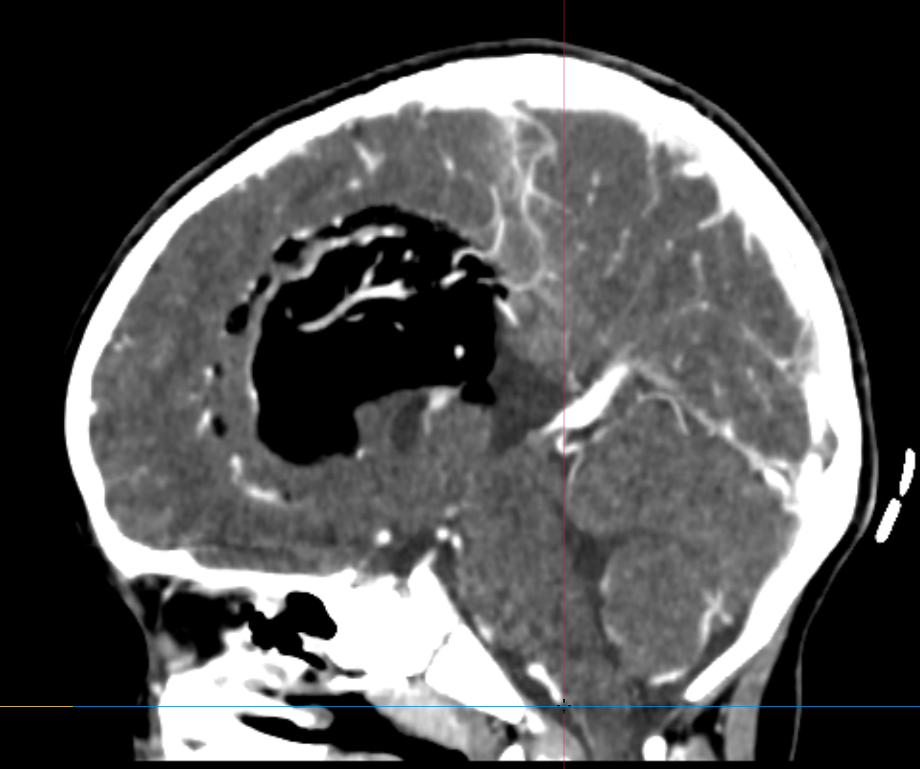

***Figure 1 and 2: Coronal and sagittal axial sections of the brain CT scan showing a formation of fatty density, lobulated configuration, located at the level of the corpus callosum and extending to the lateral ventricles, with the presence of peripheral calcifications.***

**DISCUSSION**

Intracranial lipomas result from embryological malformations due to the abnormal persistence of the meninx primitiva, the mesenchymal precursor of the leptomeninges [2,3]. This leads to the formation of mature adipose tissue in the central nervous system. While these lesions can occur in multiple locations, the pericallosal region is the most commonly affected site [1,4].

The tubulonodular variant, as seen in our patient, typically appears as a large, lobulated fat-attenuation lesion on CT, often containing peripheral calcifications and interspersed vascular structures [5]. These lipomas are commonly associated with callosal agenesis or hypogenesis due to concurrent developmental disruptions [6]. In this case, the lesion extended into the ventricles and involved the choroid plexuses, leading to dilation of the occipital horns, consistent with imaging features reported in the literature.

MRI remains the gold standard for further characterization. The lipoma displays a high T1 and T2 signal, with signal suppression on fat-saturated sequences confirming its adipose composition. MRI also assists in detecting associated anomalies such as cortical dysplasia, colpocephaly, or vascular malformations, which are critical for prognosis and treatment planning [7,8].

Management is generally conservative, especially in asymptomatic or mildly symptomatic cases. Seizures, when present, are managed medically. Surgical excision is contraindicated due to the lesion’s proximity to critical neurovascular structures and its typically benign nature [6,9]. A multidisciplinary approach, including neurology, radiology, and genetics, may be necessary, particularly in cases with syndromic features or developmental delays [8,10].

**CONCLUSION**

Corpus callosum lipomas are exceedingly rare congenital malformations that often remain asymptomatic and are discovered incidentally during neuroimaging for unrelated conditions. Despite their benign nature, their location within critical neural structures may occasionally result in neurological symptoms, particularly when associated with other central nervous system anomalies such as agenesis or dysgenesis of the corpus callosum. Accurate diagnosis relies primarily on MRI, which characteristically demonstrates a non-enhancing, hyperintense lesion on T1-weighted images. Understanding their embryological origin and imaging features is essential for avoiding unnecessary interventions. As therapeutic management is typically conservative, awareness among clinicians and radiologists is crucial to guide appropriate clinical decision-making and patient reassurance. Further studies and case reports will help refine our understanding of the clinical spectrum and long-term outcomes of these lesions.

**CONSENT**

All authors declare that ‘written informed consent was obtained from the patient family for publication of this case report and accompanying images’.

**ETHICAL APPROVAL**

All authors hereby declare that all experiments have been examined and approved by the appropriate ethics committee and have therefore been performed in accordance with the ethical standards.

**DISCLAIMER (ARTIFICIAL INTELLIGENCE)**

Author(s) hereby declares that NO generative AI technologies such as Large Language Models (ChatGPT, COPILOT, etc.) and text-to-image generators have been used during the writing or editing of this manuscript.

**COMPETING INTERESTS**

Authors have declared that no competing interests exist.

**REFERENCES**

1. 1- Jha VC, Parihar V, Parihar S. Primary congenital intracranial lipoma with extracranial extension. Surg Neurol Int. 2025;16:80. <https://doi.org/10.25259/SNI_965_2024>
2. El Marrakhchi M, Benani A, Rifi L, et al. Association of limited dorsal myeloschizis and corpus callosum lipoma. Surg Neurol Int. 2024;15:151. <https://doi.org/10.25259/SNI_165_2024>
3. Jabot, G., Stoquart-Elsankari, S., Saliou, G., Toussaint, P., Deramond, H., & Lehmann, P. (2009). Intracranial lipomas: clinical appearances on neuroimaging and clinical significance. Journal of neurology, 256(6), 851-855.
4. Bozorgi H, Asghari A, Moradi F, et al. Lipoma of the corpus callosum: A case report and review of literature. Iran J Child Neurol. 2022;16(4):81-90. <https://doi.org/10.22037/ijcn.v16i4.32627>
5. Yilmaz MB, Gulsen S, Aydin AL, et al. Pericallosal lipomas: A clinical and radiological analysis. Turk Neurosurg. 2016;26(3):364–368. <https://doi.org/10.5137/1019-5149.JTN.13008-14.0>
6. Zhang L, Zhu Y, Zhang M. Wilson's disease with intracranial lipoma and corpus callosum dysplasia. BMC Neurol. 2024;24:44. <https://doi.org/10.1186/s12883-024-03541-2>
7. Tambuzzi S, Castiglioni V, Gibelli D, et al. Sudden death due to cerebellopontine angle lipoma: A rare autopsy finding. Autops Case Rep. 2022;12:e2021396. <https://doi.org/10.4322/acr.2021.396>
8. Paul, L. K. (2011). Developmental malformation of the corpus callosum: a review of typical callosal development and examples of developmental disorders with callosal involvement. Journal of neurodevelopmental disorders, 3(1), 3-27.
9. Yildiz, H., Hakyemez, B., Koroglu, M., Yesildag, A., & Baykal, B. (2006). Intracranial lipomas: importance of localization. Neuroradiology, 48(1), 1-7.
10. Manoranjan, B., & Provias, J. P. (2011). Congenital brain tumors: diagnostic pitfalls and therapeutic interventions. Journal of Child Neurology, 26(5), 599-614.