***Case report***

**Mucinous Tubular and Spindle Cell Carcinoma: A Case Report and Review of the Literature**

**Abstract:**

**Mucinous tubular and spindle cell carcinoma (MTSCC)** is a rare epithelial renal tumor, first recognized as a distinct subtype of renal cell carcinoma (RCC) in the 2004 WHO classification. It is characterized by **low malignant potential and typically indolent clinical behavior**. Due to its rarity and **overlapping imaging features with other renal tumors**, accurate preoperative diagnosis remains challenging.

We report the case of a **42-year-old woman presenting with painless, non-clotting gross hematuria** persisting for four months. Ultrasound revealed a suspicious renal mass, which was further evaluated by **contrast-enhanced CT**, showing a **12 cm heterogeneous lesion** in the lower pole of the right kidney. The mass demonstrated **areas of hemorrhage and punctate calcifications**, along with **delayed, progressive enhancement**. There was **no evidence of adjacent organ invasion**. Histopathological examination following **right radical nephrectomy confirmed the diagnosis of MTSCC**.

Although the definitive diagnosis relies on histological examination, imaging plays a key role in detecting the tumor, assessing its contrast enhancement pattern, evaluating its morphological characteristics, and determining the extent of the lesion. These elements help guide the preoperative diagnosis, suggest potential histological subtypes, and support appropriate management planning, particularly in terms of surgical approach.

**Keywords:** Mucinous tubular and spindle cell carcinoma, computed tomography, renal mass, low-grade tumor

**Introduction:**

**Mucinous tubular and spindle cell carcinoma (MTSCC)** is a rare renal epithelial neoplasm, recognized as a distinct subtype of renal cell carcinoma (RCC) in the **2004 World Health Organization (WHO) classification of urogenital tumors [3, 20]**. It accounts for **less than 1% of all RCCs** and is typically associated with **indolent behavior, low metastatic potential,** and a **predilection for middle-aged women [1, 19].** Clinically, MTSCC is often detected incidentally during imaging studies or may present with **non-specific symptoms such as hematuria or flank pain [5].**

Imaging—particularly **contrast-enhanced computed tomography (CT)**—plays a central role in the detection and **initial characterization** of renal masses. However, the imaging findings of MTSCC are **non-specific and frequently overlap with those of other hypovascular RCC subtypes**, such as papillary or chromophobe RCC **[16].** Therefore, **histopathological evaluation, supplemented by immunohistochemistry, remains essential for a definitive diagnosis [11]**.

We report a rare case of MTSCC in a 42-year-old woman, highlighting its CT characteristics and histopathological correlation. **This manuscript adds to the limited literature on MTSCC by providing a detailed radiologic-pathologic correlation. In the context of a rare and diagnostically challenging tumor, such case reports are valuable for improving recognition and diagnostic confidence in clinical practice.**

**Case presentation:**

A 42-year-old woman with no significant medical, familial, occupational, or smoking history presented with a four-month history of intermittent, painless gross hematuria without associated clotting. She reported no fever, weight loss, fatigue, or abdominal pain. Physical examination was unremarkable.

Laboratory investigations revealed normal renal function (urea: 0.28 g/L [normal ≤ 0.5 g/L]; creatinine: 8 mg/L [normal < 13 mg/L]), a hemoglobin level of 13.2 g/dL, white blood cell count of 7,500 /mm³, and platelet count of 250,000 /mm³. Inflammatory markers, including C-reactive protein and erythrocyte sedimentation rate, were within normal limits. Urinalysis confirmed macroscopic hematuria, without leukocyturia or proteinuria.

Renal ultrasound identified a heterogeneous solid mass at the lower pole of the right kidney. A contrast-enhanced thoraco-abdominopelvic CT scan revealed a large, well-encapsulated soft tissue mass measuring 12 cm in its greatest diameter. The lesion showed a **spontaneous density of 40 Hounsfield Units (HU)**, with areas of hyperdensity suggestive of intratumoral hemorrhage, and punctate calcifications visible both centrally and peripherally **(Figure 1)**. After contrast administration, it demonstrated progressive and heterogeneous enhancement: 64 HU in the arterial phase, 76 HU in the nephrographic phase, and 92 HU in the delayed phase **(Figure 2)**. The tumor exerted a compressive effect on adjacent structures including the duodenum, pancreas, liver, and gallbladder, without signs of direct invasion. No regional lymphadenopathy or distant metastases were identified.

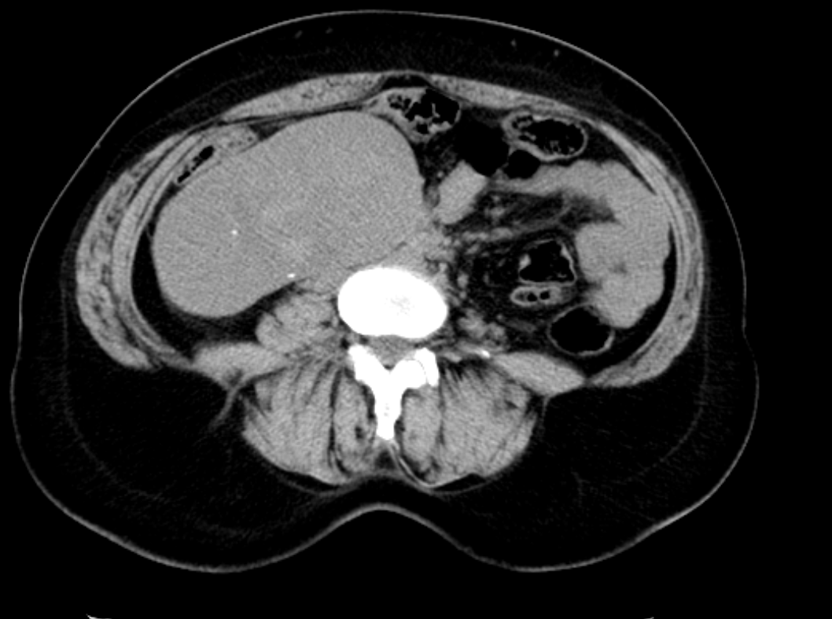

Figure 1: Non-contrast-enhanced abdominal CT showing a heterogeneous right renal mass with a spontaneous attenuation of approximately 40 Hounsfield Units (HU) and punctate calcifications.

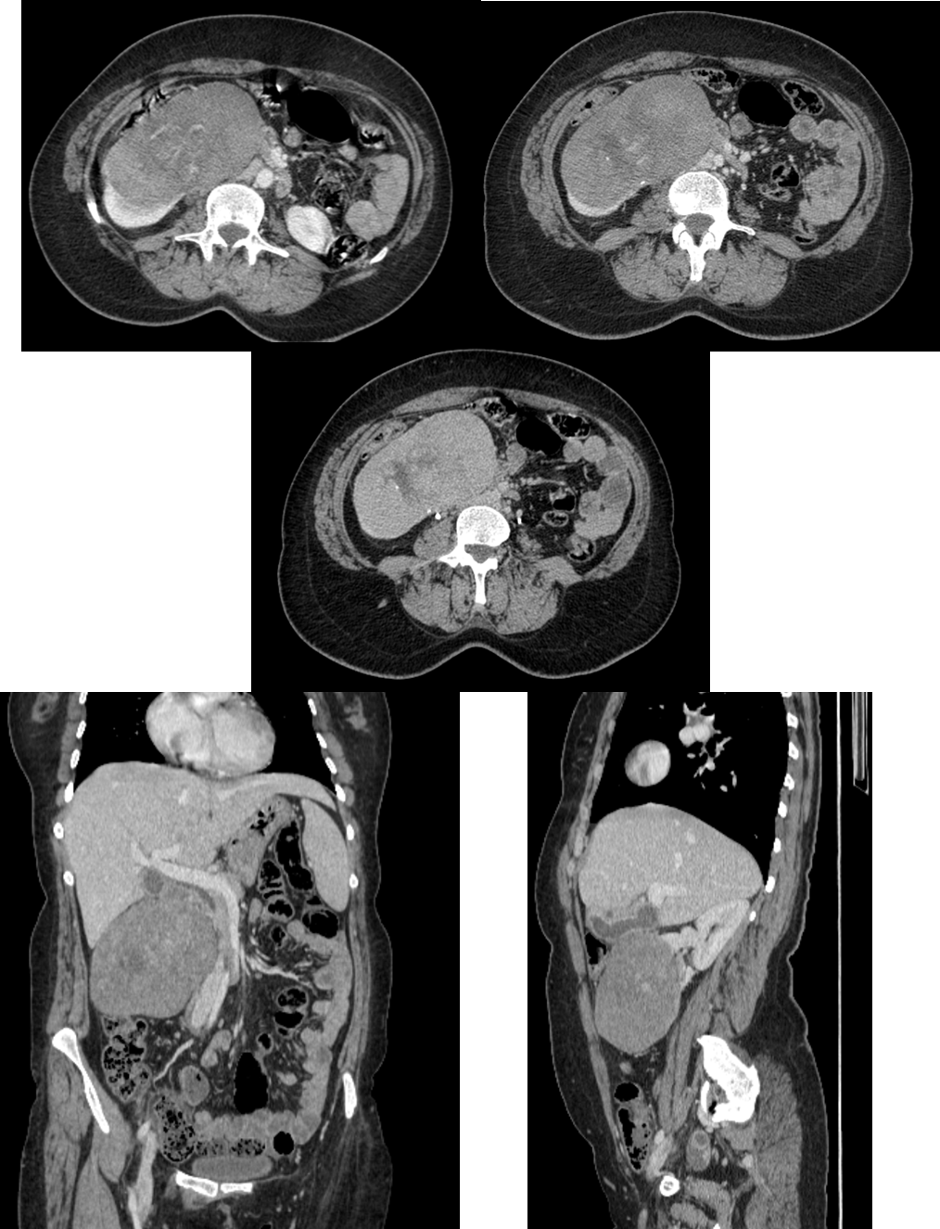

**E**

**D**

**C**

**B**

**A**

Figures 2 : Contrast-enhanced abdominal CT scan in axial, coronal (D),and sagittal (E) views showing a well-encapsulated right renal soft tissue mass with expansive growth. The lesion demonstrates progressive and heterogeneous enhancement after contrast administration: 64 Hounsfield Units (HU) in the arterial phase (A), 76 HU in the nephrographic phase (B), and 92 HU in the delayed phase (C).

The patient underwent **right radical nephrectomy.** Gross pathological examination of the specimen revealed a **tan-brown tumor localized to the lower pole of the kidney,** with **a well-demarcated margin. Histological analysis** showed **branching tubules and spindle-shaped epithelial cells embedded in abundant mucinous stroma,** along with **areas of necrosis and hemorrhage**. Immunohistochemical staining demonstrated **diffuse positivity for CK7, CK14, AE1/AE3 (CK8/18), and vimentin,** while **CD10 was negative**, helping to differentiate MTSCC from papillary RCC.

The **surgical margins were free of tumor**, and there was no involvement of the renal vein or ureter. The **postoperative course was uneventful**, and follow-up imaging revealed **no signs of recurrence or metastasis.**

**Discussion:**

Mucinous tubular and spindle cell carcinoma (MTSCC) is a rare and distinct subtype of renal cell carcinoma (RCC), accounting for less than 1% of all renal tumors **[1, 2, 19, 20]**. First classified as a separate entity in the 2004 WHO classification, MTSCC is generally considered a low-grade malignancy with a favorable prognosis **[3, 20]**. It most commonly affects middle-aged women and is frequently discovered incidentally during imaging performed for unrelated reasons. However, when the tumors are large, patients may present with symptoms such as flank pain or gross hematuria **[4, 5, 18, 19]**.

From a radiologic standpoint, MTSCC typically presents as a well-circumscribed renal mass with an expansile, ovoid or spherical shape, usually separated from the adjacent parenchyma. It tends to be iso- to hypodense on unenhanced CT and exhibits a slow, progressive enhancement pattern that peaks during the nephrographic or delayed phases. Lesions may appear homogeneous when small, but larger tumors often demonstrate heterogeneous enhancement due to areas of internal necrosis, hemorrhage, or mucinous degeneration **[6, 7, 15, 17]**. On MRI, the tumor classically displays iso- to hyperintense signal on T2-weighted sequences — a feature attributed to its mucin-rich stroma — and shows delayed progressive enhancement following gadolinium administration. Restricted diffusion may also be observed in solid components, though not specific **[5, 6, 21]**.

MTSCC shares overlapping imaging features with other hypovascular subtypes of renal cell carcinoma, such as papillary RCC, chromophobe RCC, and collecting duct carcinoma **[16]**. Among these, papillary RCC is the most common differential diagnosis, as both typically exhibit hypovascular enhancement patterns on imaging **[6, 7]**. However, papillary RCCs are generally smaller—often measuring less than 2 cm—and frequently appear as multifocal or bilateral lesions **[5, 9]**. On MRI, they characteristically show low signal intensity on T2-weighted sequences **[5, 9, 10]**.

In contrast, clear cell RCC usually presents as a hypervascular tumor, with intense early enhancement during the corticomedullary phase followed by rapid washout—a dynamic pattern rarely observed in MTSCC **[8, 16]**.

In our case, CT findings were consistent with classic MTSCC features. The tumor was large, well-defined, and heterogeneous, with moderate, progressive enhancement peaking in the delayed phase. The presence of intratumoral hemorrhage and punctate calcifications further supported the radiologic impression. While not pathognomonic, the combination of hypovascularity, internal complexity, and absence of invasive behavior suggested a low-grade neoplasm.

Although a combination of CT and MRI findings may raise suspicion for MTSCC and help differentiate it from other RCC subtypes, histopathological confirmation remains mandatory. Macroscopically, MTSCCs are usually well-circumscribed lesions with a broad size range (from <1 cm to >18 cm). Microscopically, they are composed of elongated, tightly packed tubules lined by spindle-shaped epithelial cells within a mucin-rich stroma **[11]**. Our case showed immunohistochemical results consistent with literature, with diffuse CK7, CK14, AE1/AE3, and vimentin positivity, and negative CD10 staining, which assists in differentiating MTSCC from papillary RCC **[12, 13, 14, 15, 18, 19, 20]**.

Surgical excision remains the treatment of choice, and prognosis is generally excellent in localized cases. Nevertheless, rare instances of sarcomatoid transformation or metastasis have been reported, which underscores the importance of appropriate postoperative surveillance **[5, 17, 18, 19, 20]**. In our case, the patient had an uncomplicated recovery, with no evidence of recurrence on follow-up imaging.

This case adds to the limited number of published MTSCC reports, particularly those with detailed imaging documentation. Given its rarity, well-characterized case reports are essential to better define the radiological spectrum of MTSCC and help distinguish it from other hypovascular renal tumors. By correlating imaging features with histopathology, this report contributes to the growing body of literature on MTSCC and highlights the value of CT in its non-invasive evaluation and surgical planning.

**Conclusion:**

In summary, MTSCC is a rare renal tumor with imaging features that, even on CT alone, may suggest the diagnosis. The typical pattern of a well-defined, hypovascular mass with gradual enhancement can raise preoperative suspicion and help guide pathological analysis. Although MRI may offer complementary information, CT remains a valuable tool in the initial evaluation and diagnostic orientation of this entity.

**Consent:**

Written informed consent was obtained from the patient’s family for the publication of this case report and any accompanying images.

**Ethical approval:**

All authors declare that this study was reviewed and approved by the appropriate institutional ethics committee and conducted in accordance with the ethical standards of the 1964 Declaration of Helsinki and its later amendments.

**Disclaimer (artificial intelligence):**

The authors declare that no generative AI technologies (e.g., ChatGPT, Copilot, or text-to-image generators) were used in the writing or editing of this manuscript.

**Competing interests:**

The authors declare that they have no competing interests.

**Reference:**

[1] **Wang H**, **Peng X**, **Li L**, **Yang Y**. A retrospective study of imaging characteristics of mucinous tubular and spindle cell carcinoma in the kidney. Frontiers in Oncology, eCollection 2025.  
[2] **Bhardwaj N**, **Parkhi M**, **Chatterjee D**, **Singh SK**. Mucinous tubular and spindle cell carcinoma of the kidney. Autops Case Rep. 2023;13:e2023415.  
[3] **Nathany S**, **Monappa V**. Mucinous tubular and spindle cell carcinoma: a review of histopathology and clinical and prognostic implications. Arch Pathol Lab Med. 2020 Jan;144(1):115–118.  
[4] **Ziouani O**, **Rabil M**, **Elkhiyati A**, **Laghmari M**, **Ibn Attya A**. Mucinous Tubular and Spindle Cell Carcinoma of the Kidney: A Case Report. Pan African Medical Journal. 2017;26:187.  
[5] **Alves AS**, **Gaivão AM**, **Marques RC**, **Matos C**. Two rare entities in one patient: Mucinous tubular and spindle cell carcinoma of the kidney and peritoneal adenomyomas. Radiology Case Reports. 2021;16(8):1974–1979.  
[6] **Cornelis F**, **Ambrosetti D**, **Rocher L**, et al. CT and MR imaging features of mucinous tubular and spindle cell carcinoma of the kidneys: A multi-institutional review. European Radiology. 2016;27:1087–1095.  
[7] **Kenney P**, **Vikram R**, **Prasad S**, et al. Mucinous tubular and spindle cell carcinoma (MTSCC) of the kidney: A detailed study of radiological, pathological and clinical outcomes. BJU International. 2015;116:85–92.  
[8] **Hélénon O**, **Crosnier A**, **Eiss D**, **Poirée S**, **Méjean A**, **Correas JM**. Diagnostic and Pre-Therapeutic Imaging of Malignant Renal Tumors in Adults. EMC Radiologie et Imagerie Médicale – Génito-urinaire – Gynéco-obstétricale – Mammaire. 2019;32(2):1–31.  
[9] **Roy C**, **Sauer B**, **Lindner V**, **Lang H**, **Saussine C**, **Jacqmin D**. MR imaging of papillary renal neoplasms: potential application for characterization of small renal masses. Eur Radiol. 2006;17(1):193–200.  
[10] **Cornelis F**, **Tricaud E**, **Lasserre A**, et al. Routinely performed multiparametric magnetic resonance imaging helps to differentiate common subtypes of renal tumours. Eur Radiol. 2014;24(5):1068–1080.  
[11] **Lopez-Beltran A**, **Scarpelli M**, **Montironi R**, **Kirkali Z**. 2004 WHO Classification of the renal tumors of adults. Eur Urol. 2006;49(5):798–805.  
[12] **Zhao M**, **He X**, **Teng X**. Mucinous tubular and spindle cell renal cell carcinoma: a review of clinicopathologic aspects. Diagn Pathol. 2015;10(1):168.  
[13] **Paner G**, **Srigley J**, **Radhakrishnan A**, et al. Immunohistochemical analysis of mucinous tubular and spindle cell carcinoma and papillary renal cell carcinoma of the kidney. Am J Surg Pathol. 2006;30(1):13–19.  
[14] **Sarsik B**, **Simsir A**, **Karaarslan S**, **Sen S**. Mucinous tubular and spindle cell carcinoma of kidney and problems in diagnosis. Turk J Pathol. 2011;27(2):116.  
[15] **Gong P**, **Zhuang Q**, **Wang X**, **Xu R**, **Ding T**, **Yin S**, **He X**. Mucinous tubular and spindle cell carcinoma of the kidney: Five case reports and review of the literature. Oncol Lett. 2020 Oct 7;20(6):337.  
[16] **Xu X**, **Zhong J**, **Zhou X**, **Wei Z**, **Xia Q**, **Huang P**, **Shi C**, **Da J**, **Tang C**, **Cheng W**, **Ge J**. Mucinous tubular and spindle cell carcinoma of the kidney: Study of clinical, imaging features, and treatment outcomes. Front Oncol. 2022 Apr 11;12:865263.  
[17] **Ling C**, **Tan R**, **Li J**, **Feng J**. Mucinous tubular and spindle cell carcinoma of the kidney: a report of seven cases. BMC Cancer. 2023;23:815.  
[18] **Ali RH**, **Ali RM**, **Ali SM**, **Ari MA**, **Abdullah ÅS**, **Abdullah SA**, **Abbas AJ**, **Ibrahim HL**, **Pshtiwan RA**, **Abdalla FA**, **Kakamad FH**. Mucinous tubular and spindle cell carcinoma: A case report. World Acad Sci J. 2024;6(1):14.  
[19] **Tamir KT**, **Ademe SA**, **Mikru AM**, **Jiffar AD**, **Hamza AK**, **Ayalew ZS**. Mucinous tubular and spindle cell carcinoma very rare variant kidney cancer: Case report. Int J Surg Case Rep. 2024 Oct;123:110193.  
[20] **Xiao L**, **Xiao W**, **Guo Y**, **Jin P**. Huge mucinous tubular and spindle cell carcinoma of the kidney: A case report. Urol Case Rep. 2022 Jan;40:101914.  
[21] **Tsang SL**, **Hsu SS**, **Cheung AN**, **Ho SHB**, **Ng ATL**. Mucinous Tubular and Spindle Cell Carcinoma: Case Report and Literature Review. J Kidney Cancer. 2025;12(1):6–11.