**A CASE REPORT ON EMPHYSEMATOUS PYELONEPHRITIS IN PATIENT ON SGLT2 INHIBITOR THERAPY**

**Dr. P. Kishore Kumara, Pasumala Varunb, Thokala Ruchithab, Chinta. Rohit Kumarb, Dr. T. Rama Raoc**

1. Associate Professor, Department of PharmD, CMR College of Pharmacy, Hyderabad, India. kishorekumarpasupuleti189@gmail.com
2. Students, Department of PharmD, CMR College of Pharmacy, Hyderabad, India. ruchithathokala2801@gmail.com, varunsep13@yahoo.com, chintarohitkumar10@gmail.com
3. Principal, CMR College of Pharmacy, Hyderabad, India. tadikondarao7@gmail.com

**Corresponding Author:**

Dr. P. Kishore Kumar,

CMR College of Pharmacy, Medchal.

kishorekumarpasupuleti189@gmail.com

**ABSTRACT:**

Emphysematous pyelonephritis, or EPN, is a life-threatening necrotizing infection that affects the renal parenchyma and, in certain cases, the perirenal tissue of the kidney. This condition most commonly results in gas formation within the renal parenchyma, the collecting system, or the perinephric tissue. Patients with diabetes mellitus are particularly susceptible to emphysematous pyelonephritis with a reported mortality rate of 40% to 90%. Clinical presentation of the disease is almost identical to acute pyelonephritis and requires precise assessment using imaging, particularly computed tomography (CT).

This case report covers the clinical presentation of EPN in a patient in his 70s and is on SGLT2 inhibitor therapy. The causative organism here is *Pseudomonas aeruginosa*, a gram-negative bacterium which is a common pathogen that causes systemic infections affecting organs. This also brings to light the importance of an organized healthcare team's approach in adopting multidisciplinary management for better patient outcomes, including aggressive surgery options and less aggressive options like percutaneous drainage and antimicrobial therapy. The patient has recovered from the infection after a surgery and antimicrobial therapy for an almost 1 month.

**KEYWORDS:** Emphysematous pyelonephritis,antibiotics, diabetes mellitus, kidneys, renal function tests.

**INTRODUCTION:**

Emphysematous pyelonephritis is a lethal and rare medical condition where gas bubble formation because of urinary tract infection takes place over the kidneys and is more common in diabetic mellitus patients with poor control of diabetes. Although it is also present in non-diabetic individuals, the accounting percentages are uncommon and some of the risk factors include DM, immunosuppressive medication, SGLT2 inhibitor patients etc. EPN is a life-threatening form of infection and if untreated can be fatal and lead to mortality of the patient.

We present a case of emphysematous pyelonephritis in a diabetic patient diagnosed by radiological imaging with a successful outcome using DJ stenting and bilateral pyelography on the basis of antibiotic therapy. There is also a history of SGLT2 inhibitors earlier and the causative agent for UTI was Pseudomonas aeruginosa.

**CASE REPORT:**

A 71-year-old male, diabetic and on oral hypoglycaemic agents for the past 17 years, was admitted with chief complaints of diffuse abdominal pain along with increased frequency and urgency of urine since past 1 month. No history of haematuria or vomiting or fever or burning micturition. However, patient’s spouse complains of foul-smelling urine observed since past 2 weeks. Patient shares a history of use of Dapagliflozin, Metformin + Glimeperide drugs for diabetes and Perindopril, Amlodipine drugs for hypertension.

Upon examination the patient was febrile, pulse rate of 109 bpm, BP of 157/77 mmHg, respiratory rate of 22 cpm. HbA1c was found 7%, haemoglobin of 10.4 g/dL, serum creatinine 1.26 mg/dL, TSH of 1.31 mU/L.

An USG was performed initially and showed the presence of gas bubbles but was misinterpreted to be lithiasis, however patient was diagnosed having prostatomegaly. But later the patient developed symptoms such as flank pain and a CT scan was performed. It showed gas in renal parenchyma suggesting evidence of emphysematous pyelonephritis.

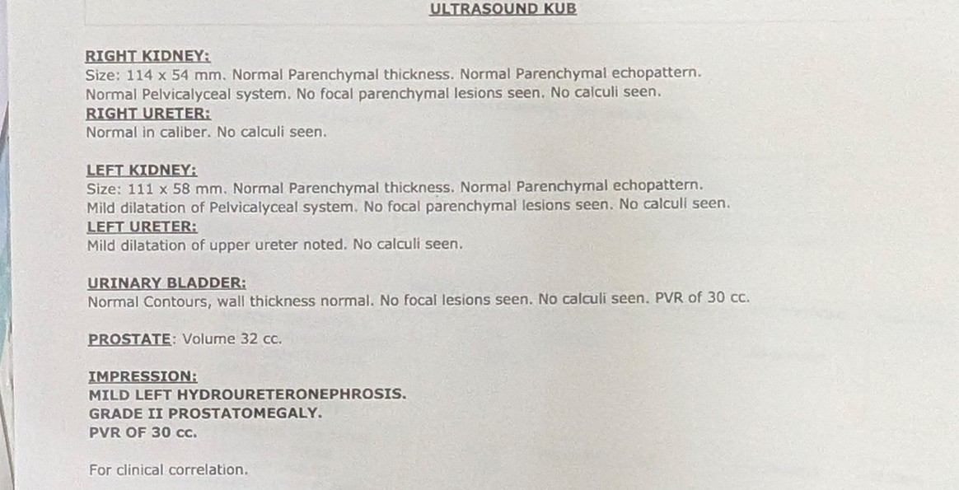

Figure 1 USG Abdomen and pelvis report of the patient.

Antibiotic treatment was initiated shortly after a urine culture test was performed and the organism was reported to be *Pseudomonas aeruginosa* with sensitivity towards some β-lactams such as carbapenems, piperacillin/tazobactam, fluoroquinolones such as levofloxacin, moxifloxacin and others. Initially, surgery involving bilateral retrograde pyelography along with DJ stenting was done under local anaesthesia. Initially, the patient’s serum creatine levels were 2.76 mg/dL immediately after the surgery, 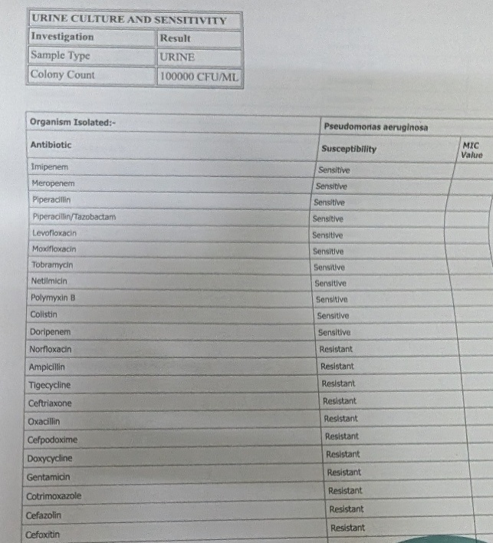dropped to 1.72 mg/dL and then to 1.26 mg/dL on day 5 and day 14 respectively.

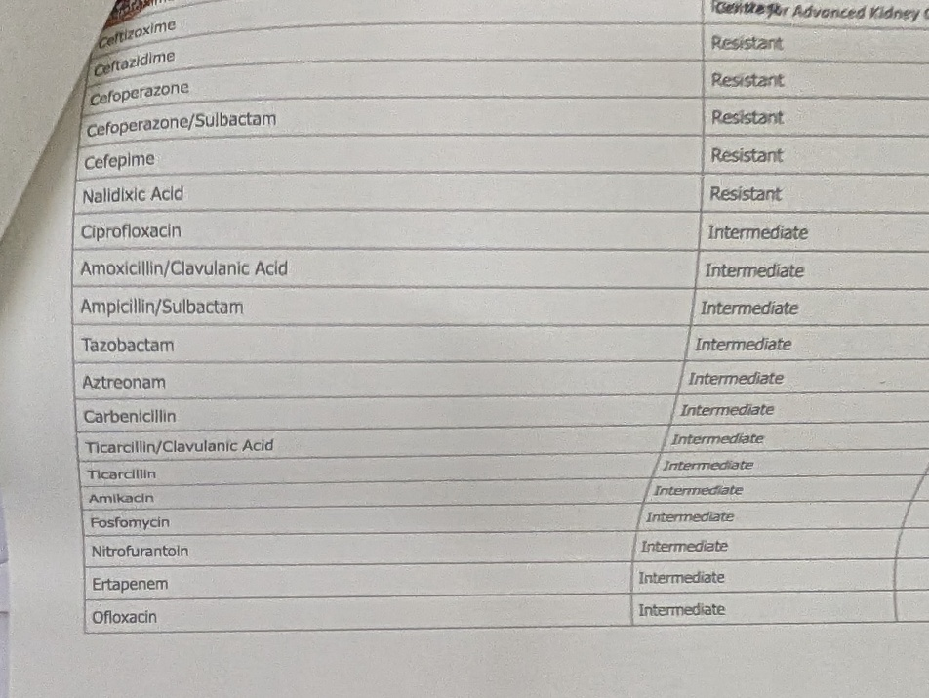

Figure 2(a,b) Urine culture & sensitivity report

The treatment included Meropenem 1gm IV BD for 10 days, Tab. Levofloxacin 500mg BD for 10 days, Tab, Pantoprazole 40mg PO OD for 10 days, Tab. Tamsulosin 0.4mg OD till removal of stent, Tab. Amlodipine 5mg BD PO, Tab. Gliclazide 30mg OD, Tab. Linagliptin 5mg OD to be continued for control of comorbidities. Patient was also prescribed with Fosfomycin 3 gm PO OD, Tab. N- Acetylcysteine 600mg OD for 10 days to be taken at home.

Initially the stent was planned to be removed after 3 weeks but due to poor recovery the antibiotic therapy was continued for another 2 weeks and the stent was removed after 5 weeks of the surgery. The patient has been asked to follow up after 2 months with counselling done regarding management of comorbidities. The patient did present for the follow up with test results negative for urinary tract infection, better glycaemic and hypertension control and better quality of life. A follow up USG showed benign neoplasm of prostate for which Tamsulosin 0.4mg OD was prescribed or a period of 6 months.

**DISCUSSION:**

Emphysematous pyelonephritis is a fatal form of acute pyelonephritis, which is characterized by formation of gas bubbles by microbial organisms in the renal parenchyma which can lead to necrosis of the tissue. In this case report the findings align with the case reports by **Ubee SS et al.** that EP is presented in severe form in patients with uncontrolled diabetes.1 The occurrence also supports evidence derived from mendelian randomization and meta-analysis studies by **Jie Ren et al.** who studied the corelation between SGLT2 inhibitors and urinary tract infections.2 Another pharmacovigilance study on adverse drug reactions (ADRs) associated with SGLT-2 inhibitors also suggests that urinary tract infections are reported.3 The patient’s symptom for which he was hospitalized aligns with the study findings of **Koch GE et al**. which say requiring a surgical intervention in 40 to 90% of the cases.4

The symptoms with which the complication is presented are fever, chills, nausea, vomiting, flank pain, pneumaturia etc. The patient here also experiences same symptoms such as pain in the back, fever, vomitings etc.5 The conditions that favour the environment for emphysematous pyelonephritis are presence of acid fermenting bacteria, hyperglycemia in surrounding tissues, decreased perfusion to tissue.6 When these factors are present at same time, the disease progresses to worsening and rapid disease progression. While the common pathogens that cause EPN are *E. coli* and *Klebsiella pneumoniae* cases are reported with strains of *Pseudomonas aeruginosa*, *Enterococcus sp.* as well.7,8 Early interventions and management with antibiotics based on strains can not only be life saving but also reduces mortality rate and preserving kidney functioning.9 However, poor outcomes are associated with factors such as age on higher side, internal bleeding, thrombocytopenia. However, hydronephrosis, urolithiasis and bacteremia do not influence the outcome.10 Another intervention that might influence the outcome is percutaneous drainage of abscesses over the kidney which may or may not be feasible in all patients.

It is to notice that the treatment of EPN varies and is usually followed in 3 steps: antibiotic therapy against causative organism (suitable for geriatric population where surgery is ruled out), percutaneous drainage (minimally invasive). The 3rd option of nephrectomy is only opted in severe forms of EPN like stage – III, IV.11

Although SGLT2 inhibitor remain crucial for diabetes management, patient’s affordability, genital infection risk, cardiometabolic factors must be considered while prescribing for first time. There are conclusive evidences about the requirement of monitoring while a patient is on SGLT2 inhibitors =, however in multiple comorbidities such as hypertension and diabetes mellitus, further studies are needed in studying the concomitant use of SGLT2 inhibitors with other classes of drugs such as RAAS inhibitors regarding the safety, magnification of risk of kidney complications etc.12

**CONCLUSION:**

Emphysematous pyelonephritis is a life-threatening rare infection with high mortality, and thus there is a need for early diagnosis and management. The specialists should thus understand the most important predisposing factors that result in its occurrence. They should also take into consideration other though less common predisposing conditions, such as SGLT2 inhibitors use. While the incidence of urinary tract infections after SGLT2 inhibitor use is quite low, their universal usage for treatment of many socially important diseases makes it important to know all possible hazards of their usage, including the onset of severe urinary tract infections like emphysematous pyelonephritis.

**DISCLAIMER (ARTIFICIAL INTELLIGENCE):**

Author(s) hereby declare that no generative AI technologies such as Large Language Models (ChatGPT, COPILOT, etc.) and text-to-image generators have been used during the writing or editing of this manuscript.

**CONFLICT OF INTEREST:**

The authors declare no conflict of interest in preparing this article.

**REFERENCES:**

1. Ubee SS, McGlynn L, Fordham M. Emphysematous pyelonephritis. BJU international. 2011 May;107(9):1474-8.
2. Ren J, Yang S, Wang Y, et al. Sodium–glucose cotransporter 2 inhibitor increases risk of urinary tract infection: Evidence from mendelian randomization and meta-analysis. *Br J Clin Pharmacol*. 2025; 1-7.
3. Dong Y, Wang Y, Lan X, Zeng H. A study on the pharmacovigilance of various SGLT-2 inhibitors. Front Med (Lausanne). 2025 Jan 15;11:1515847. doi: 10.3389/fmed.2024.1515847. PMID: 39882521; PMCID: PMC11774954.
4. Koch GE, Johnsen NV. The Diagnosis and Management of Life-threatening Urologic Infections. Urology. 2021 Oct;156:6-15.
5. Desai R, Batura D. A systematic review and meta-analysis of risk factors and treatment choices in emphysematous pyelonephritis. Int Urol Nephrol. 2022 Apr;54(4):717-736.
6. Vivek V, Panda A, Devasia A (2012) Emphysematous pyelonephritis in a renal transplant recipient—Is it possible to salvage the graft? Ann Transpl 17(3):138–141
7. Aboumarzouk OM, Hughes O, Narahari K, Coulthard R, Kynaston H, Chlosta P et al (2014) Emphysematous pyelonephritis: time for a management plan with an evidence-based approach. Arab J Urol 12:106–115
8. Lu YC, Chiang BJ, Pong YH, Huang KH, Hsueh PR, Huang CY et al (2014) Predictors of failure of conservative treatment among patients with emphysematous pyelonephritis. BMC Infect Dis 14:418.
9. Gite VA, Shaw V, Agrawal M, Sankapal P, Maheshwari M (2021) Minimally invasive techniques as a first line approach in the management of emphysematous pyelonephritis—a single centre experience. J Postgrad Med 67(3):146–153
10. Wu SY, Yang SS, Chang SJ, Hsu CK. Emphysematous pyelonephritis: classification, management, and prognosis. Tzu Chi Med J. 2022 Apr 13;34(3):297-302. doi: 10.4103/tcmj.tcmj_257_21. PMID: 35912050; PMCID: PMC9333110.
11. Pontin AR, Barnes RD. Current management of emphysematous pyelonephritis. Nature Reviews Urology. 2009 May;6(5):272-9.
12. Alharbi SA, Alqahtani AM, Alnasser SN, Lafi G, Alfuhaydi RA, Asiri FA, Almutairi AA. Evaluating the Efficacy of SGLT2 Inhibitors in Preventing Diabetic Kidney Disease.