An Analysis of Specific Nutritional Interventions as a Regional Development Program and Their Impact on Stunting Prevalence in Batu Bara Regency
Abstract
Stunting is a persistent public health issue in Indonesia, particularly in districts such as Batu Bara, which has historically reported high prevalence rates. This study examines the effectiveness of specific nutritional interventions—namely Vitamin A supplementation and supplementary feeding—in reducing stunting prevalence from 2021 to 2023. Utilizing a cross-sectional design, secondary data from 12 sub-districts were analyzed through multiple regression modeling using EViews version 10, employing the Fixed Effect Model to determine statistical significance. Results indicate a substantial reduction in stunting prevalence, from 30.9% in 2021 to 15.7% in 2023. Vitamin A supplementation coverage reached 87.6%, while supplementary feeding achieved 78.6% coverage. Both interventions were found to significantly contribute to stunting reduction (p < 0.05), with the most notable impact observed in Medang Deras and Ujung Kubu. These findings underscore the importance of sustained inter-sectoral coordination and community engagement to close implementation gaps and meet Indonesia’s national target of 14% by 2024.
Keywords: Stunting, Vitamin A, Nutritional Interventions, Supplementary Feeding, Public Health, Indonesia, Batu Bara

- Introduction
Stunting is a chronic linear growth disorder that serves not only as an indicator of long-term nutritional deficiency but also as a reflection of broader socio-economic disparities. The World Health Organization (WHO) defines stunting as a child's height being more than two standard deviations below the median height-for-age and has consistently linked it to diminished cognitive development, economic productivity, and long-term health outcomes (Deshpande, 2022, Ekholuenetale., 2020).
Indonesia is among the countries with the highest burden of stunting globally, with a national prevalence of 21.6% in 2022 according to the Indonesian Nutrition Status Survey (SSGI). The Indonesian government, through national policy instruments including Presidential Regulation No. 72 of 2021, aims to reduce this figure to 14% by the end of 2024. The role of local governments is particularly pivotal, as the implementation of nutritional programs occurs at the community and household levels (Morcel, 2022).
Stunting has a multifactorial etiology, encompassing biomedical, behavioral, and environmental dimensions. Multiple studies have identified critical risk factors contributing to stunting in Indonesia, such as maternal chronic energy deficiency (CED) during pregnancy, suboptimal exclusive breastfeeding practices, poor sanitation, and limited household nutritional knowledge (Wati., 2024, Rachmi., 2024).
Vitamin A is an essential micronutrient directly involved in child growth, immune function, and ocular health. Deficiency in vitamin A not only increases vulnerability to infections but is also strongly associated with growth impairment. In Indonesia, the government implements biannual vitamin A supplementation, although coverage remains inconsistent across regions (Niguse, 2021, WHO 2011, Unicef 2022).
The effectiveness of vitamin A supplementation in reducing stunting has been demonstrated in various intervention trials. Research across different countries shows that regular vitamin A intake accelerates growth and strengthens immune response in children. However, program success depends heavily on the consistency, coverage, and sustainability of implementation (Villamor., 2005, Wirth., 2017).
In addition to vitamin A, supplementary feeding (PMT/ Improving the nutritional status) is a crucial component of specific nutritional interventions. PMT addresses macro- and micronutrient gaps, particularly among underprivileged children. The Indonesian Ministry of Health operationalizes this through district-level health offices targeting children under five who are at high nutritional risk (UNICEF, 2022).
Beyond nutrition-specific actions, a multisectoral approach is indispensable. Longitudinal studies in Indonesia have shown that community-based interventions involving family, health services, education, and water and sanitation improvements yield significant and sustained reductions in stunting prevalence (Rah, 2020).
The first 1,000 days of life—from conception to a child’s second birthday—have been identified as the most critical window for stunting prevention. Interventions during this period, including maternal nutrition, antenatal care, early initiation of breastfeeding, and complementary feeding, are vital to ensuring optimal growth and development (Torlese., 2021).
However, disparities in implementation remain a major challenge. Districts with low healthcare access, inadequate health workforce distribution, and limited community engagement often struggle to meet program targets, despite national-level guidelines and support. Monitoring and evaluation mechanisms are thus essential to track intervention coverage and adapt strategies accordingly.
Batu Bara District in North Sumatra, once reporting stunting rates as high as 30.9%, has been a key focus of local government interventions. With the adoption of Vitamin A supplementation and supplementary feeding integrated into district and village development plans, stunting rates have significantly declined. Nevertheless, inter-subdistrict disparities and implementation gaps necessitate further empirical evaluation to inform strategic policy decisions and ensure equitable health outcomes by 2024.

- Methodology
Research Approach and Design
This study utilized a quantitative cross-sectional research design to examine the relationship between specific nutritional interventions and stunting prevalence in Batu Bara District. A cross-sectional approach was chosen to capture a snapshot of intervention implementation and its outcomes across all 12 sub-districts during the year 2023.

Research Area, Population and Sample
Batu Bara Regency is one of the regencies located in North Sumatra Province, Indonesia. Strategically positioned along the eastern coastline, it is bordered by Asahan Regency to the north and Simalungun Regency to the west. The regency comprises 12 sub-districts, each varying in population density, economic activity, and infrastructure development. This geographic distribution plays a crucial role in the disparities observed in public health indicators, including child nutrition and stunting.
The geographic characteristics include a mix of coastal, lowland, and inland terrain, with significant portions of the population residing in rural and peri-urban areas. The distribution of health facilities, educational institutions, and access to clean water and sanitation services remains uneven, influencing the efficacy of community-based nutrition programs.
Figure 1 illustrates the administrative map of Batu Bara Regency, highlighting its sub-district boundaries and geographic features.
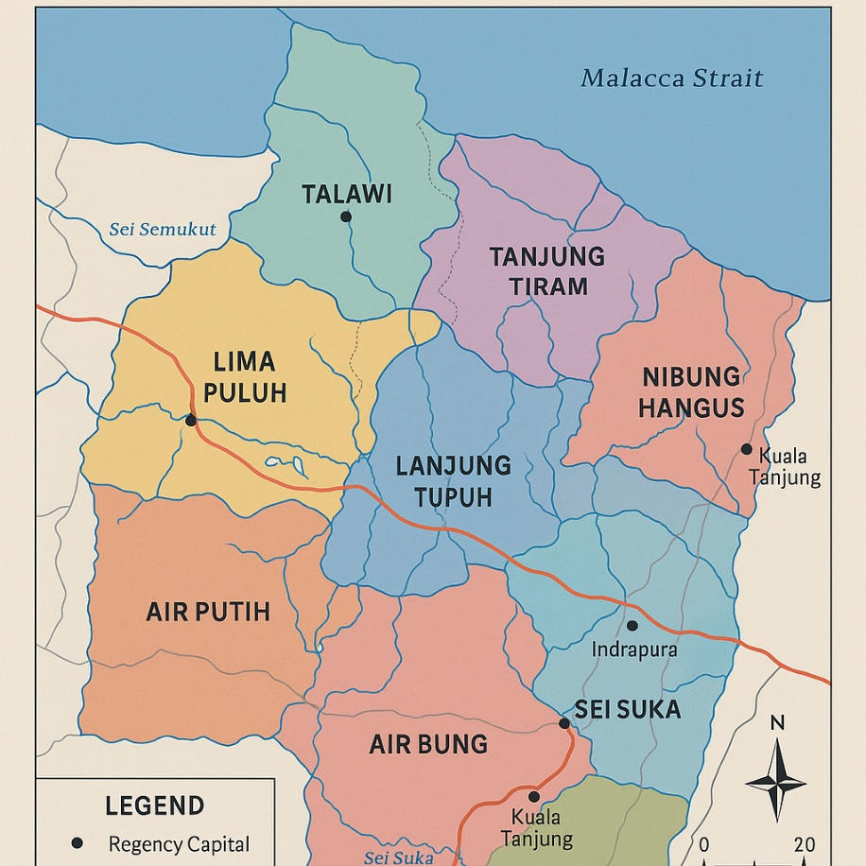
Figure 1 Administrative Map of Batu Bara Regency
Source: Regional Planning Agency (Bappeda) of Batu Bara, 2023.
The population consisted of all children under the age of five residing in Batu Bara District from 2021 to 2023. The unit of analysis was at the sub-district level (kecamatan), totaling 12 units. Given the census-like nature of the data, all 12 sub-districts were included, making the sampling exhaustive (total sampling technique).
Data Collection
Data were obtained from secondary sources, including the District Health Office and Bappeda Batu Bara. Variables collected included the number of children receiving Vitamin A, children receiving supplementary food, and reported stunting cases in each sub-district. Observations also covered program coverage levels and health infrastructure data across different geographic areas.

Operational Definitions and Variables
The dependent variable was the prevalence of stunting, operationalized as the percentage of stunted children out of the total number of children under five in each sub-district. Independent variables included:
- Vitamin A Supplementation: the percentage of children who received vitamin A capsules during scheduled distribution periods.
- Supplementary Feeding: the percentage of under-five children who received additional nutrition through government-supported food programs.

Validity and Reliability Testing
As secondary data from government institutions were used, content validity was ensured through official standardization of definitions and indicators. Reliability was assessed through consistency checks between multiple yearly reports, ensuring data coherence across 2021 to 2023. Any discrepancies were verified with source institutions.

Data Analysis
Multiple linear regression analysis was employed using EViews 10 software to evaluate the impact of both independent variables on stunting prevalence. The model used was:
Y = a + b₁X₁ + b₂X₂ + e
Where
Y = stunting prevalence X₁ = Vitamin A supplementation,
X₂ = supplementary feeding a = constant,
b₁/b₂ = coefficients e = error term.
Statistical tests included the Jarque-Bera test for normality and t-tests for individual variable significance. A 5% significance threshold was applied.

- Results and Discussion
Results
Trends in Stunting Prevalence (2021–2023)
Between 2021 and 2023, Batu Bara Regency demonstrated notable progress in reducing stunting prevalence. The rate declined from 30.9% in 2021 to 15.7% in 2023, surpassing the national average reduction target. This achievement highlights the effectiveness of district-wide health interventions and policy alignment with national stunting reduction goals.
Prevalence varied across districts. In 2023, the highest rates were observed in Medang Deras (27.2%) and Tanjung Tiram (24.9%), while the lowest were in Lima Puluh (10.0%) and Datuk Lima Puluh Pesisir (11.7%). These figures underscore geographic disparities and the importance of localized strategies.
Table 1. Stunting Prevalence by District, 2021–2023
District | 2021 |  |  |  | 2022 |  |  |  | 2023
District | Very Short | Short | Normal | % | Very Short | Short | Normal | % | Very Short | Short | Normal | %
Sei Balai | 110 | 215 | 1609 | 20.2 | 87 | 156 | 1570 | 15.6 | 134 | 187 | 1872 | 10.8
Tanjung Tiram | 508 | 613 | 2633 | 42.6 | 309 | 318 | 2647 | 23.6 | 267 | 411 | 2718 | 24.9
Ujung Kubu | 219 | 254 | 1411 | 33.5 | 143 | 197 | 1140 | 29.8 | 114 | 279 | 2144 | 18.3
Talawi | 234 | 306 | 1776 | 30.4 | 143 | 215 | 1592 | 22.5 | 72 | 114 | 1959 | 12
Tanah Datar | 186 | 243 | 1252 | 34.3 | 97 | 210 | 1254 | 24.5 | 89 | 178 | 1539 | 17.3
Lima Puluh | 136 | 211 | 1340 | 25.9 | 87 | 213 | 1494 | 20.1 | 67 | 130 | 1961 | 10
Lima Puluh Pesisir | 298 | 354 | 2734 | 23.8 | 157 | 344 | 2233 | 22.9 | 132 | 168 | 2556 | 11.7
Datuk Lima Puluh | 118 | 362 | 1749 | 27.4 | 176 | 176 | 1348 | 18.9 | 93 | 150 | 1506 | 14.7
Air Putih | 247 | 409 | 1678 | 39.1 | 183 | 311 | 2510 | 19.7 | 176 | 306 | 1961 | 15.1
Sei Suka | 216 | 351 | 2277 | 24.9 | 185 | 231 | 2221 | 20.4 | 110 | 197 | 2300 | 13.2
Medang Deras | 612 | 578 | 2926 | 40.7 | 543 | 393 | 3404 | 27.2 | 543 | 454 | 3083 | 27.2
Laut Tador | 56 | 77 | 508 | 26.2 | 41 | 102 | 1000 | 14.3 | 41 | 112 | 1136 | 12.6
Total | 2940 | 3973 | 21893 | 30.8 | 2073 | 2866 | 22269 | 21.7 | 1773 | 2741 | 26919 | 15.7

Impact of Vitamin A Supplementation on Nutritional Outcomes
he Batu Bara Regency government has taken strategic steps to combat stunting through targeted nutritional interventions, including the widespread distribution of vitamin A supplements. This initiative, reinforced by local regulation Perbup No. 41 of 2021, emphasizes integrated efforts combining promotive, preventive, and rehabilitative approaches in community health programs. Field implementation is carried out through coordinated activities in local health centers (Posyandu), clinics, and district hospitals, involving nutritionists and health cadres.

Table 2. Vitamin A Coverage by District, 2023
District | Normal | Short | Very Short | Total | Vitamin A Given | Coverage (%)
Sei Balai | 1872 | 134 | 69 | 2075 | 1850 | 89.16
Tanjung Tiram | 2718 | 411 | 267 | 3396 | 2459 | 72.41
Nibung Hangus | 2144 | 279 | 114 | 2537 | 2072 | 81.67
Talawi | 1959 | 114 | 122 | 2195 | 1931 | 87.97
Datuk Tanah Datar | 1539 | 189 | 78 | 1806 | 1493 | 82.67
Lima Puluh | 1961 | 130 | 67 | 2158 | 1941 | 89.94
Lima Puluh Pesisir | 2556 | 168 | 132 | 2856 | 2521 | 88.27
Datuk Limapuluh | 1506 | 159 | 63 | 1728 | 1473 | 85.24
Air Putih | 3196 | 306 | 176 | 3678 | 3123 | 84.91
Sei Suka | 2330 | 197 | 110 | 2637 | 2290 | 86.84
Medang Deras | 3992 | 542 | 543 | 5077 | 3697 | 72.82
Laut Tador | 1146 | 112 | 32 | 1290 | 1128 | 87.44
Total | 26919 | 2741 | 1773 | 31433 | 25978 | 82.65
Source: Batu Bara District Health, Population Control, and Family Planning Office, 2023 (Processed Data)

The effectiveness of this intervention is also supported by essential health infrastructure, detailed in Table 1, which documents the number of hospitals, clinics, and nutritionists distributed across districts. This infrastructure is crucial in facilitating the delivery of vitamin A supplements and supporting broader child health initiatives.
To assess program implementation outcomes, key performance indicators were monitored at the district level. One such indicator is the coverage rate of vitamin A supplementation, which serves as a proxy for access to essential nutrition services. While several districts demonstrated strong performance, the overall achievement rate reached 73.51% in 2023, which—although commendable—still falls short of the national target of 90%.
Figure 2 presents a visual summary of the performance of essential stunting reduction programs, including vitamin A supplementation, supplementary feeding, and related interventions across Batu Bara Regency:

Figure 2. Graph indicating the performance of essential stunting reduction programs in Batu Bara Regency, 2023.
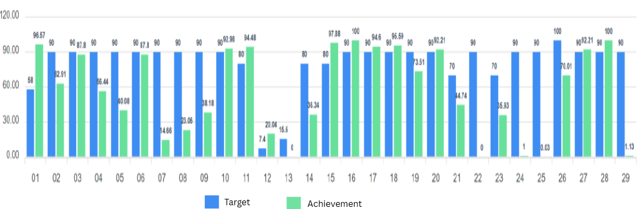
Efficacy of Supplementary Feeding Programs in Stunting Reduction
Another pivotal intervention is the provision of supplementary feeding for stunted children. The 2023 coverage stood at 72.75%, with Lima Puluh again achieving the highest reach (87.16%) and Tanjung Tiram the lowest (48.14%).

Table 3. Supplementary Feeding Coverage for Stunted Children, 2023
District | 2021 |  |  | 2022 |  |  | 2023
District | Stunting | PMT | % | Stunting | PMT | % | Stunting | PMT | %
SEI BALAI | 325 | 187 | 57.5 | 243 | 182 | 74.9 | 203 | 167 | 82.3
TANJUNG TIRAM | 1121 | 415 | 37 | 627 | 410 | 65.4 | 678 | 395 | 58.3
UJUNG KUBU | 473 | 311 | 65.8 | 340 | 306 | 90 | 393 | 291 | 74
TALAWI | 540 | 233 | 43.1 | 358 | 228 | 63.7 | 236 | 213 | 90.3
TANAH DATAR | 429 | 278 | 64.8 | 307 | 273 | 88.9 | 267 | 258 | 96.6
LIMA PULUH | 347 | 212 | 61.1 | 300 | 207 | 69 | 197 | 192 | 97.5
LIMA PULUH PESISIR | 652 | 254 | 39 | 501 | 249 | 49.7 | 300 | 234 | 78
DATUK LIMA PULUH | 480 | 209 | 43.5 | 274 | 204 | 74.5 | 222 | 189 | 85.1
AIR PUTIH | 656 | 429 | 65.4 | 494 | 424 | 85.8 | 482 | 409 | 84.9
SEI SUKA | 567 | 287 | 50.6 | 416 | 282 | 67.8 | 307 | 267 | 87
MEDANG DERAS | 1190 | 815 | 68.5 | 936 | 810 | 86.5 | 1085 | 795 | 73.3
LAUT TADOR | 133 | 158 | 118.8 | 143 | 153 | 107 | 144 | 138 | 95.8

Temporal data, as presented in Table 3, reveal substantial progress since 2021, when the supplementary feeding coverage was only 54.8%. However, geographic disparities persist. The gap between the current achievement and the 90% national target—especially in districts like Medang Deras and Nibung Hangus—calls for intensified local engagement and strengthened monitoring mechanisms.
Supplementary feeding programs are jointly executed by local government units, health departments, and family planning personnel, forming a multi-sectoral approach aligned with national development goals.
Statistical Analysis of the Effects of Nutrition Interventions on Stunting Prevalence
Understanding the multifaceted dynamics of stunting reduction requires not only the implementation of programs but also a rigorous examination of their statistical impact across regions. This study employed a descriptive and inferential approach to analyze the effectiveness of two key nutrition-specific interventions—vitamin A supplementation and supplementary feeding—on stunting prevalence in Batu Bara Regency between 2021 and 2023. The dataset encompassed 36 observations, representing 12 districts over a three-year span, and was derived from credible governmental sources including the District Health Office and Bappelitbangda.
Descriptive Summary of Core Variables
At the outset, descriptive statistics provided a general picture of how stunting and the two interventions varied across districts. The average stunting prevalence stood at 454 children per year per district, with a noticeable spread indicating heterogeneity in both health outcomes and service delivery. Vitamin A supplementation reached an average of approximately 340 children per district, while supplementary feeding programs recorded a slightly lower average of 307 children. Importantly, statistical tests of normality (e.g., Jarque-Bera) confirmed that the data distributions were reasonably normal across all variables, allowing for the application of panel regression models with confidence.
The data highlighted considerable disparities between districts. For example, Medang Deras and Sei Balai consistently exhibited high outreach in vitamin A supplementation, which coincided with relatively lower rates of stunting. In contrast, districts such as Lima Puluh Pesisir and Tanjung Tiram reported lower intervention coverage and persistently higher stunting rates, suggesting gaps in implementation or contextual challenges.

Modeling the Impact: Regression Analysis Using Panel Data
To identify the causal linkages between the interventions and stunting, three econometric models were estimated: the Common Effect Model (CEM), Fixed Effect Model (FEM), and Random Effect Model (REM).
The Common Effect Model, which assumes homogeneous intercepts across districts, showed that vitamin A supplementation was significantly associated with a reduction in stunting (p = 0.0045), whereas supplementary feeding did not reach statistical significance (p > 0.75). This model, though informative, failed to account for unobserved district-specific factors, limiting its utility for policy targeting.
Recognizing this limitation, the Fixed Effect Model was then applied to control for district-level heterogeneity. The FEM results demonstrated substantial improvement in explanatory power, with an adjusted R-squared value exceeding 0.90. Notably, both vitamin A supplementation (p = 0.0010) and supplementary feeding (p = 0.0373) showed statistically significant impacts on reducing stunting rates. These results underline the importance of considering localized factors—such as infrastructure, staffing, and socio-cultural practices—when evaluating program outcomes.

To validate the superiority of FEM over CEM, the Chow Test was conducted. The results strongly favored FEM (p < 0.01), confirming that district-specific intercepts provided a more accurate depiction of intervention effects.
Subsequently, the Random Effect Model was explored under the assumption of uncorrelated district-specific errors. While vitamin A supplementation remained significant (p = 0.0035), supplementary feeding again lost significance (p = 0.8039), echoing the inconsistencies observed in the CEM. However, a Hausman Test comparing FEM and REM ultimately endorsed the fixed effects approach (p < 0.01), indicating that unobserved heterogeneity was correlated with the independent variables—a violation of the REM assumption.

District-Level Insights and Policy Implications
The final FEM specification provided nuanced insights at the district level. Medang Deras emerged as the most responsive district, with the strongest negative fixed effects, suggesting that combined nutrition interventions had the most pronounced impact there. Similarly, districts such as Ujung Kubu and Tanjung Tiram showed considerable reductions in stunting correlated with increased program coverage. These areas likely benefitted from better program targeting, community engagement, or health infrastructure.
Conversely, districts like Laut Tador and Lima Puluh, despite moderate levels of intervention coverage, showed weaker associations, implying either operational inefficiencies or demographic factors that muted program effectiveness. Such disparities highlight the necessity of tailoring interventions not only by need but also by capacity and contextual fit.
In aggregate, the findings affirm that vitamin A supplementation is a statistically robust predictor of reduced stunting, reinforcing its prioritization in child health programs. Supplementary feeding, while theoretically impactful, demonstrated more variable results, suggesting it may require more consistent delivery, higher nutritional quality, or complementary behavioral interventions to realize its full potential.
Moreover, the superiority of the fixed effects model underscores the importance of localized policy frameworks. Centralized program targets must be accompanied by flexibility at the local level, enabling adaptations to specific community needs and challenges. The statistical significance of the FEM model provides empirical support for continuing and scaling up district-focused strategies that combine data-driven targeting with community-based implementation.

Discussion
This study highlights the progress and challenges in reducing stunting prevalence in Batu Bara Regency between 2021 and 2023. The observed reduction in stunting—from 30.9% to 15.7%—suggests that ongoing efforts, including vitamin A supplementation and supplementary feeding programs, have yielded meaningful impacts. Nevertheless, the regression models employed in this study underscore the critical importance of local context and variation in the effectiveness of these interventions.

The fixed effects model revealed that vitamin A supplementation has a consistent and statistically significant association with lower stunting prevalence across districts. This aligns with global literature indicating the essential role of micronutrients, especially vitamin A, in child growth and immunity. The significant p-value (0.0010) obtained in the FEM confirms this relationship within the Batu Bara context, where targeted vitamin A delivery appears to be an effective tool in stunting prevention.
In contrast, supplementary feeding interventions demonstrated more variable outcomes. While the FEM indicated statistical significance (p = 0.0373), both the common and random effect models showed weaker associations. This discrepancy may be attributed to inconsistent program implementation, disparities in food quality, or lack of concurrent behavioral education. Furthermore, geographic disparities in stunting prevalence—especially in districts like Tanjung Tiram and Medang Deras—highlight the need for refined delivery strategies and more robust local monitoring systems.
Importantly, the geographic and administrative profile of Batu Bara plays a foundational role in shaping health outcomes. Rural and peri-urban regions, with limited infrastructure and lower health service access, exhibited both higher stunting rates and lower intervention coverage. This contextual insight justifies the use of the fixed effects model, which effectively accounts for such unobserved heterogeneity and emphasizes that "one-size-fits-all" strategies are insufficient in a diverse administrative landscape.
Finally, the study's panel regression analysis, validated by robust statistical tests such as the Chow and Hausman tests, affirms the superiority of the Fixed Effect Model in this setting. The use of district-level data over a three-year period offers strong empirical grounding for targeted policy decisions.
In summary, while Batu Bara Regency has made commendable progress in addressing child stunting, this discussion suggests that sustainable success depends on localized, evidence-driven strategies that integrate nutritional, infrastructural, and behavioral components.

- CONCLUSION AND RECOMMENDATIONS
CONCLUSION
This study analyzed the relationship between stunting prevalence and two primary health interventions—Vitamin A supplementation and the provision of supplementary food (PMT)—in Batu Bara Regency from 2021 to 2023. Using a panel regression approach, the Fixed Effect Model was identified as the best-fitting model based on Chow and Hausman test results, with an adjusted R² of 0.908. This indicates that over 90% of the variation in stunting across districts can be explained by these two interventions.
The analysis demonstrated that Vitamin A supplementation had a significant negative effect on stunting prevalence (p = 0.0010), underscoring its crucial role in child growth and immunity. Supplementary feeding also showed a significant effect (p = 0.0373), although the magnitude was more modest. District-level results further highlighted spatial disparities, with Medang Deras showing the most significant improvements, while others such as Laut Tador and Lima Puluh were less responsive.
Overall, this study affirms the critical impact of nutrition-based interventions on child health outcomes and supports the continued prioritization of these programs within regional development strategies.
RECOMMENDATIONS
To enhance the effectiveness of stunting reduction programs in Batu Bara Regency, several strategic recommendations emerge from the study. First, there is a clear need to scale up the implementation of Vitamin A supplementation and supplementary feeding programs, particularly in districts that have demonstrated strong responsiveness such as Medang Deras. The success in these areas suggests that with adequate coverage and community engagement, significant reductions in stunting are achievable. In contrast, districts such as Laut Tador and Lima Puluh require targeted interventions that address localized barriers—these may include infrastructure gaps, limited health worker capacity, or low caregiver awareness. Integrating nutrition-specific interventions with broader maternal and child health services, including immunization and routine growth monitoring, can create synergies that improve overall program impact. Equally important is the role of community engagement; increasing public awareness about the benefits of nutritional supplementation and ensuring consistent participation are essential for long-term success. Lastly, the establishment of a robust, real-time monitoring and evaluation system is crucial to inform evidence-based decision-making, allowing policymakers to adapt strategies dynamically and ensure that resources are allocated effectively and equitably across all districts.
Ethical Approval and consent
Ethical approval was obtained from the institutional review board at the corresponding author’s university. Participation in interviews and questionnaires was voluntary, and informed consent was secured. Data confidentiality and anonymity were maintained in accordance with academic ethical standards.

COMPETING INTERESTS DISCLAIMER:
Authors have declared that they have no known competing financial interests OR non-financial interests OR personal relationships that could have appeared to influence the work reported in this paper.
Disclaimer (Artificial intelligence)
Option 1:
Author(s) hereby declare that NO generative AI technologies such as Large Language Models (ChatGPT, COPILOT, etc.) and text-to-image generators have been used during the writing or editing of this manuscript.
Option 2:
Author(s) hereby declare that generative AI technologies such as Large Language Models, etc. have been used during the writing or editing of manuscripts. This explanation will include the name, version, model, and source of the generative AI technology and as well as all input prompts provided to the generative AI technology
Details of the AI usage are given below:
1.
2.
3.

References
Deshpande, A., & Ramachandran, R. (2022). Early childhood stunting and later life outcomes: A longitudinal analysis. Economics & Human Biology, 44, 101099. https://doi.org/10.1016/j.ehb.2021.101099
Ekholuenetale, M., Barrow, A., Ekholuenetale, C. E., & others. (2020). Impact of stunting on early childhood cognitive development in Benin: Evidence from Demographic and Health Survey. Egypt Pediatric Association Gazette, 68, 31. https://doi.org/10.1186/s43054-020-00043-x
Morcel, J., Béghin, L., Michels, N., Vanhelst, J., Labreuche, J., Drumez, E., Polito, A., Ferrari, M., Censi, L., Deplanque, D., Miguel-Berges, M. L., De Ruyter, T., De Henauw, S., Moreno, L. A., & Gottrand, F. (2022). Identification of lifestyle risk factors in adolescence influencing cardiovascular health in young adults: The BELINDA study. Nutrients, 14(10), 2089. https://doi.org/10.3390/nu14102089
Niguse. (2021). Pengaruh budaya organisasi terhadap turnover intention melalui motivasi pada karyawan generasi milenial. Forum Ilmiah, 18(1), 11–25.
Rah, J. H., Sukotjo, S., Badgaiyan, N., Cronin, A. A., & Torlesse, H. (2020). Improved sanitation is associated with reduced child stunting amongst Indonesian children under 3 years of age. Maternal & Child Nutrition, 16(Suppl 2), e12741. https://doi.org/10.1111/mcn.12741
Rachmi, R., Marjan, A. Q., Sufyan, D. L., & Wahyuningsih, U. (2024). Factors affecting chronic energy deficiency among pregnant women in East Nusa Tenggara Province, Indonesia. Jurnal Gizi dan Pangan, 19(Supp.1), 95–104. https://doi.org/10.25182/jgp.2024.19.Supp.1.95-104
Reeve, B., Thow, A. M., Baker, P., Hresc, J., & May, S. (2020). The role of Australian local governments in creating a healthy food environment: An analysis of policy documents from six Sydney local governments. Australian and New Zealand Journal of Public Health, 44(2), 137–144. https://doi.org/10.1111/1753-6405.12968
Save the Children Indonesia & Nutrition International. (2024). A policy paper on integrated nutrition strategies for stunting reduction: BISA.
Torlesse, H., Benedict, R. K., Craig, H. C., & Stoltzfus, R. J. (2021). The quality of maternal nutrition and infant feeding counselling during antenatal care in South Asia. Maternal & Child Nutrition, 17(3), e13153. https://doi.org/10.1111/mcn.13153
UNICEF Indonesia. (2022). Delivering essential nutrition services through community action in Indonesia. United Nations Children’s Fund (UNICEF).
UNICEF Indonesia. (2022). Formative evaluation of the National Strategy to Accelerate Stunting Prevention. United Nations Children’s Fund (UNICEF).
Wati, E. K., Murwani, R., Kartasurya, M. I., & Sulistiyani, S. (2024). Determinants of chronic energy deficiency (CED) incidence in pregnant women: A cross-sectional study in Banyumas, Indonesia. Narra Journal, 4(1), e742. https://doi.org/10.52225/narra.v4i1.742
Wirth, J. P., Petry, N., Tanumihardjo, S. A., Rogers, L. M., McLean, E., Greig, A., Garrett, G. S., Klemm, R. D. W., & Rohner, F. (2017). Vitamin A supplementation programs and country-level evidence of vitamin A deficiency. Nutrients, 9(3), 190. https://doi.org/10.3390/nu9030190
World Health Organization. (2011). Guideline: Vitamin A supplementation in infants and children 6–59 months of age. World Health Organization.

