**A Brief Review on Invasion, Impact, and Ecology of Chilli Black Thrips *Thrips parvispinus* (Karny) in India.**

**Abstract:**

Thrips parvispinus (Karny) has recently emerged as a serious invasive pest, causing significant concern in agriculture across India and entire globe. Originally distributed in Southeast Asia and parts of Oceania, its rapid spread to various regions including India, China, Africa, and Europe has highlighted its adaptability and threat potential. This review paper provides a comprehensive overview of the pest’s life cycle, and reproductive behaviour, along with its extensive host range that includes economically important crops. The paper also discusses the damage symptoms associated with T. parvispinus infestation. Particular attention is given to its recent outbreaks in India. This review aims to consolidate current knowledge regarding the invasion, impact, and ecology of chilli black thrips in India.

**Keywords: invasive, chilli, thrips, black thrips, notorious, *Thrips parvispinus***

1. **Introduction:**

Chilli is one of the most important commercial crop grown for vegetables, condiments, sauces, pickles and spice purpose (*Capsicum annum* L.). India ranks first in consumption, export and production of chilli. Top growing states in India growing chilli includes AP, Telangana, Maharashtra, Odisha and W.B. *Thrips* L., is considered to be the largest genus in the subfamily Thripinae with almost 301 species found around world out of which about 44 species are reported from India (Rachana and Varatharajan, 2017). About three species in the genus is considered notorious and vectors of tospovirus [Mound,2002]. In chilli, *S. dorsalis* was considered to be the dominant native pest, but its introduction of *T.parvispinus* as an invasive pest forced the native one to share the ecological niche. *Thrips parvispinus* (Karny) is a cosmopolitan pest, reported from Thailand to Australia and Europe [Mound and Collins,2000]. It is seen that in recent year many invasive species have been introduced in India due to severe climate change and export-import trade. One such example seen in Maize is the invasive allien species *Spodoptera frugiperda*(Fall armyworm) **Panigrahi,2023**]. A drastic change in geographical distribution is seen in case of *T.parvispinus.* It is a polyphagous pest placed within *Thrips orientalis* group having brinjal, papaya, strawberry, anthurium, chrysanthemum and ficus as its host [Tyagi et al. 2015]. A recent report from Indonesia revealed that almost 23% yield loss in chilli is caused by the Invasive Chilli black thrips [Johari et al. 2014].

India recorded *T.parvispinus* in *Carica papaya* in Bangalore for the first time in the year 2015. Later on they reported the same from and eventually in *Brugmansia sp.* and *Dahlia sp*. [Tyagi et al. 2015]. Tyagi (2015) was the first to report the presence of Thrips parvispinus and highlighted the importance of regular monitoring to prevent the pest from becoming established and reaching outbreak levels. During the 2021–2022 period, chilli crops experienced an estimated yield loss of approximately 50–75% due to T. parvispinus infestations (Srinivasa et al., 2024). Research indicates that invasive species often cause significant damage because of the absence of natural enemies that typically regulate their populations (Sethy et al., 2022). In India, around 23 invasive insect pest species have been introduced, among which T. parvispinus, a member of the Thrips orientalis group, is considered to have a high invasive potential. It not only establishes rapidly but can also outcompete and displace native thrips species. The pest considerably has spread continuously in past seven years covering the entire Indian states. In India the pest is reported in AP, Assam, Chattisgarh, Gujarat, Karnataka, Kerela, Maharashtra, Odisha, Telangana and Tamil Nadu [Naik et al. 2020]. In Gujarat it is seen that infestations is higher in Non pungent chilli than the pungent ones [Lodaya et al. 2022]. About 85% yield loss is seen in Karnataka [Prasanna et al. 2021]. Estimated yield loss of about 50-75% in chilli was seen during 2021-2022 [Srinivasa et al. 2024

1. **Detailed Information regarding Invasive *Thrips Parvispinus* (Karny)**

Invasive thrips *T. parvispinus* isclassified under *Thrips orientalis* group with major quarantine significance. This has emerged as a serious agricultural pest in India, particularly devastating chilli crops and causing significant yield losses. In Andhra Pradesh, farmers have reported losses of up to ₹1 lakh per acre due to widespread flower drop, fruit malformation, and reduced yields. Across various chilli fields in Andhra Pradesh and Telangana, crop damage caused by T. parvispinus has ranged between 40% and 80%.

Despite its destructive impact on agriculture, this invasive chilli black thrips is not entirely detrimental. It also plays a role in pollinating several tropical and subtropical plants (Varatharajan et al., 2016). This opposite role as both a pest and a pollinator highlight the importance of developing integrated pest management against this invasive insect. This will help, not only to maintain its presence, but also to arrange a balance between ecological functions with the need to protect crops from severe economic losses.

**2.1 Lifecycle of the Pest**

The life cycle of *T. parvispinus* is temperature-dependent, So, the information received about the life cycle of this insect varies according to the research done by the different researchers. The time required from egg to adult is on an average around 15 days. After an incubation period of four to five days, females deposit their eggs into leaves. The emerging nymphs suck and rasp on foliage and flowers until they reach adulthood, these undergo two moults over a span of two to three days before pupation. Reproduction occurs primarily through sexual means, with females laying approximately 15 eggs over a lifespan of about nine days. Males, on the other hand, typically live for around six days. The pre-adult stage lasts roughly 12.97 days in both sexes and extends slightly to 13.57 days in females. Female adults live around nine days and produce about 15 eggs, while male adults average a lifespan of six days [**Ahmed et al. 2023**].

According to **Hutasoit et al. (2017**), *T. parvispinus* goes through five distinct immature stages: egg, two nymph stages, prepupa, and pupa. On an average, females begin laying eggs about 1.1 days after emerging. The full life cycle takes around 13.7 days. Males tend to live for about 8.5 days, while females live slightly shorter, around 6 days. Each female lays approximately 15 eggs during her lifetime.

The species follows a Type III survivorship curve, meaning many individuals die early, but those that survive tend to live longer. The intrinsic rate of population growth is about 0.15 per female per day, with each female producing an average of 5.71 daughters per generation. One full generation lasts about 11.5 days, and the population can double in just under 5 days. Borror et al. (2005) observed that this species exhibits developmental characteristics that lie between incomplete (paurometabolous) and complete (holometabolous) metamorphosis, indicating a unique intermediate life cycle pattern. Furthermore, it was documented that the reproductive potential and average generation time of *T. parvispinus,* contributing to a better understanding of its population dynamics and invasive capacity.

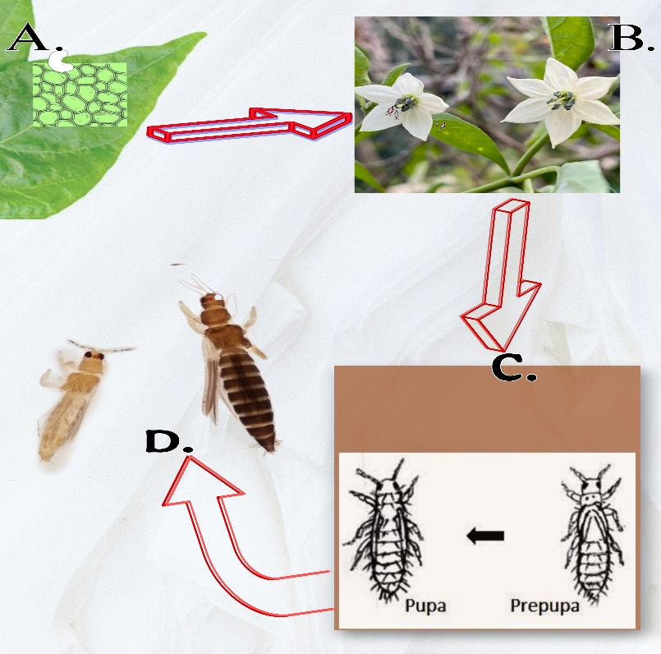

a-Site of Oviposition, b- site of larval feeding, c- site of pupation, d- adults

**fig 1-Pictorial Representation of Site of presence of biological stages of *T.parvispinus***

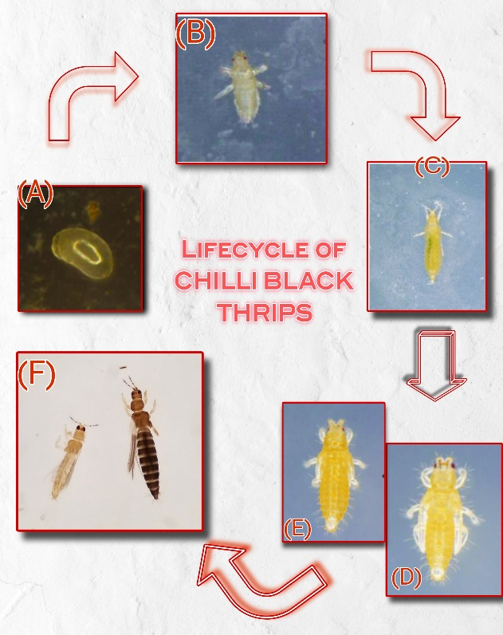

**Fig 2-Pictorial representation of Lifecycle of Chilli Black Thrips or Southeast Asian thrips**

**a- egg stage, b and c – two larval stage, d- pre pupa stage, e – pupal stage and f- adult stage**

**2.2 SPREAD : Worldwide and Indian Context.**

T. parvispinus has been reported in a wide range of regions across the globe. Initially found in areas like Thailand, Malaya, New Guinea, northern Australia, Hawaii, Micronesia, and Greece, its distribution has steadily expanded over time. According to Palmer (1992), the species spread further into Southeast Asia, including northern Australia and the Solomon Islands. Later studies documented its presence in Yunnan, China (Zhang et al., 2011), Taiwan (Mound and Masumoto, 2005), and India (Tyagi et al., 2015; Rachana et al., 2018). Its first recorded appearance in Hawaii was in 2006 (Sugano et al., 2013). In Africa, T. parvispinus has also established itself, being identified in locations such as La Réunion (Bournier, 2000), Mauritius, Dar-es-Salaam in Tanzania, and Kampala, Uganda (Moritz et al., 2013). As for Europe, it was first noted in Greece in 1998 (Mound and Collins, 2000), followed by reports from Spain in 2017 (Lacasa et al., 2019), and France in 2018

In 2021, a major outbreak of T. parvispinus was reported across the Indian states of Andhra Pradesh, Telangana, and Karnataka, causing severe damage to chilli crops ranging from 70% to complete crop loss. The first signs of thrips on chilli flowers were noted in January in the Chilakaluripeta and Pratipadu mandals of Andhra Pradesh’s Guntur district (Sireesha et al., 2021). Soon after, the pest spread rapidly across all chilli-growing regions of the state, also affecting red chilli crops in both Andhra Pradesh and Telangana. The infestation persisted throughout the flowering phase, leading to significant yield losses. Interestingly, T. parvispinus wasn't limited to chilli crops alone. It was also found on various weed species like Parthenium, Amaranthus, Axonopus, Ageratum, Alternanthera, and Thunbergia (Nagaraju et al., 2021), which likely aided its survival and spread. Initially, the pest population went through a lag phase, during which its numbers remained relatively stable. However, over the following four years, its population surged. Its ability to adapt to different host plants and expand its geographical range makes it an especially challenging pest to manage (Rachana et al., 2021). Notably, T. parvispinus has now displaced the previously dominant chilli pest, Scirtothrips dorsalis, becoming the primary thrips species affecting chilli crops in Andhra Pradesh, Telangana, and Karnataka (Sridhar et al., 2021).

**2.3 Host Range**

It is highly polyphagous with a broad range of infestation in fruits, vegetables, ornamentals and even weeds. Global distribution of the pest is due to its adaptability to diverse climates and varied host species. Existing literatures have also revealed that it is also associated with ornamentals grown in green house environments. India first recorded *T.parvispinus* in *Carica papaya* in Bangalore and eventually in *Brugmansia sp.* and *Dahlia sp*. [Tyagi et al. 2015].

Thrips parvispinus has an extensive host range, affecting a wide variety of economically important crops and ornamental plants. Among its major hosts are fruit crops such as papaya (Carica papaya) (Tyagi et al., 2015; Hutasoit et al., 2017), guava (Psidium guajava) (Ranjith et al., 2022), and watermelon (Factsheet - Thrips parvispinus, uni-halle.de). Vegetable hosts include chilli pepper, paprika, potato, eggplant, cucumber, green bean, onion, ridge gourd, and coriander (Factsheet - Thrips parvispinus, uni-halle.de; Hutasoit et al., 2017; Verghese et al., 2022; Fening et al., 2022; Saini et al., 2023). Leguminous crops such as mungbean, Vigna species, beans, crotalaria, and cotton are also susceptible (Hutasoit et al., 2017; Gothi et al., 2024; Amutha & Rachana, 2023). Ornamental plants like anthurium, hoya, chrysanthemum, dahlia, dipladenia, gardenia, and ficus have also been reported as hosts (Johari et al., 2014). In addition, T. parvispinus has been found on various weeds and non-cultivated plants including Parthenium, Amaranthus, Ageratum, Axonopus, Alternanthera, Thunbergia, neem, and pongamia (Nagaraju et al., 2021), which can act as reservoirs and facilitate its spread. The pest has even been reported on coffee, tobacco, strawberry, and mulberry (Factsheet - Thrips parvispinus, uni-halle.de; Kumar et al., 2024). This wide host range underlines the serious threat T. parvispinus poses to both agricultural and horticultural systems (Manideep et al., 2024).

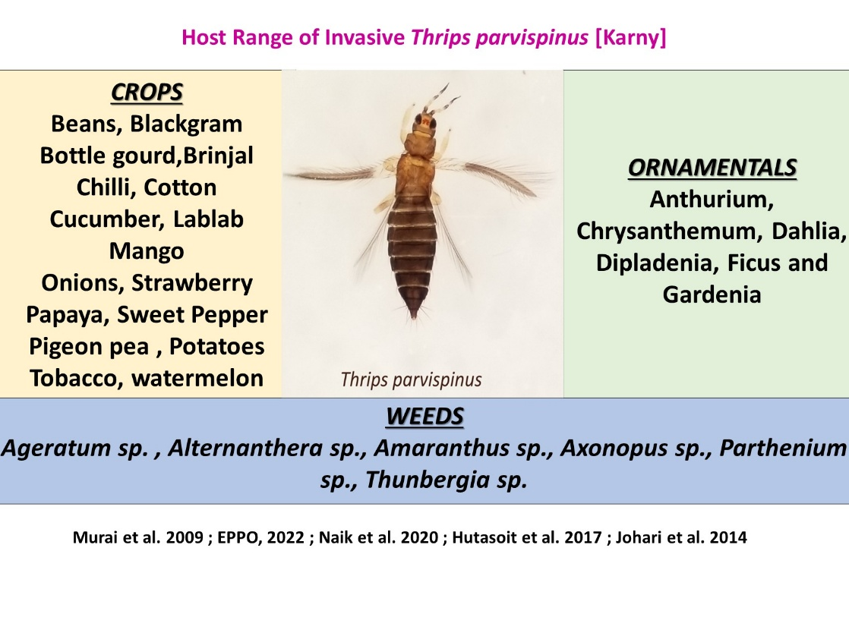

Fig 3- Host range of Invasive *Thrips parvispinus* [**Naik et al.2020: Hutasoit et al. 2017: Johari et al.2014**]

**2.4 Damage Symptoms**

Extensive and severe damage symptoms is observed in case of *Thrips parvispinus* due to its overall feeding ability. They generally rasp and suck plant tissues. Deep Punctures and scratches on underside of leaves which eventually turns to reddish brown appearance and yellowish patch on upper side is the prominent symptom. Later, distortion of leaf blades showing necrotic and yellow stains are observed. In floral parts, damage includes the scrapes on petals resulting in brown stripes. The infested fruit sets are withered and dried out. In heavy infestation, significant flower drop is seen which directly affects the productivity [**Siresha et al. 2021**]. In morning hours, flight activity is seen in case of adults, preferring to inhabit the flowers. Nymphs usually resides on the leaf surfaces [Pratiwi et al. 2018]. About 71% of infestation is found in flowers, 56% in leaves of chilli [Hutasoit et al. 2019]. Infestation often results to improper and malformed development of fruits. In bell peppers the fruit exhibit a rough scratchy appearance when infested and can lead to an abnormal shape in fruits (button like shape). Adults and nymphs cause the damage with heavy feeding on leaves, flowers and buds. Feeding may sometime create a scope for secondary infections in the entry points. In papaya the entry points are affected by *Cladosporium* spp. [Lim, 1989]. In ornamental crops the aesthetic value is lost directing to heavy commercial loss. During Offseason, weeds serve as the alternate host.

**Conclusion**

Thrips parvispinus (Karny) has emerged as a significant invasive pest with a rapidly expanding global distribution and a notable impact on agricultural systems, particularly in India. Its ability to infest a wide range of host plants, coupled with its capacity to cause extensive damage such as flower drop, fruit deformation, and yield reduction has made it a pest of growing concern. The outbreaks observed in recent years highlight its adaptability and biological success in new environments. Continued study of its biology, distribution, and host interactions is essential for a deeper understanding of this species and its role within both cultivated and natural environments.

Disclaimer (Artificial intelligence)

Option 1:

Author(s) hereby declare that NO generative AI technologies such as Large Language Models (ChatGPT, COPILOT, etc.) and text-to-image generators have been used during the writing or editing of this manuscript.

**References**

1. Ahmed, M. Z., Revynthi, A. M., McKenzie, C. L., & Osborne, L. S. (2023). *Thrips parvispinus (Karny), an emerging invasive regulated pest in the United States*.
2. Borror, D.J., Triplehorn, C.A. and Johnson, N.F. (2005). An Introduction to the Studies of Insects. 7th ed. United States of America, Brooks/Cole.
3. Bournier, J.P. (2000). Les Thysanoptères de l’île de la Réunion, Terebrantia. Bulletin de la Société Entomologique de France 105, 65-108.
4. EPPO (2022) Thrips parvispinus (THRIPV). European and Mediterranean Plant Protection Organization Global Database. https://gd.eppo.int/taxon/THRIPV/hosts. Accessed on 15 June 2022
5. Fening, K.O., Amouzou, K., Hevi, W., Forchibe, E.E., Billah, M.K. and Wamonje, F.O. (2022). First report and population dynamics of the Tobacco Thrips, *Thrips parvispinus* (Karny) (Thysanoptera, Thripidae) on ridged gourd, *Luffa acutangula* (L.) Roxy in selected export fields in southern Ghana.
6. Hutasoit RT, Triwidodo H, Anwar R (2017) Biology and demo graphic statistic of Thrips parvispinus Karny (Thysanoptera: Thripidae) in chilli pepper (Capsicum annuum Linnaeus). J Entomol Indones 14:107–116. https:// doi. org/ 10. 5995/ jei. 14.3. 107
7. Hutasoit, R.T., Triwidodo, H., Anwar, R. (2019). The abundance and diversity of thrips (Thysanoptera, Thripidae) on chili (*Capsicum annuum* L.) and cayenne (*Capsicum frutescens* L.) in Bogor. *J Hama dan Penyakit Tumbuhan,* **19**(1), 33–41.
8. Johari, A., Herlinda, S., Pujiastuti, Y., Irsan, C. and Sartiami, D., Morphological and genetic variation of Thrips parvispinus (Thy sanoptera: Thripidae) in chilli plantation (Caspicum annuum L.) in the lowland and highland of Jambi Province, Indonesia. Am. J. Bio Sci., 2014, 2, 17–21. . [https://doi.org/10.11648/j.ajbio.s. 2014020601.14](https://doi.org/10.11648/j.ajbio.s.%202014020601.14)
9. Johari, T.A. and Desfaur, N. (2018). The abundance of *Thrips parvispinus* Karny (Thysanoptera, Thripidae) on various crops in Jambi region, Sumatera, Indonesia. *Journal of Entomologic Research,* **42**(2), 237-244.
10. Lacasa, A., Lorca, M., Martinez, M. C., Bielza, P. and Guirao, P. (2019). *Thrips parvispinus* (Karny, 1922), un nuevo trips en cultivos de plantas ornamentales. *Phytoma España,* **311**, 62-69.
11. Lim, W. H. (1989). Bunchy and malformed top of papaya cv. Eksotika caused by *Thrips parvispinus* and Cladosporium oxysporum. *Mardi Research Bulletin-Journal,* **17**, 200-207.
12. Lodaya, J.P., Suthar, M., Patel, H.C., Sisodiya, D.B., Acharya, R.R., Raval, A.T., Trivedi, N.P. and Mohapatra, A.R. (2022). Status of invasive species of thrips, Thrips parvispinus (Karny) infesting chilli grown in middle Gujarat. Omega 5(3), 1298-1302.
13. Moritz, G., Brandt, S., Triapitsyn, S. and Subramanian, S. (2013). Identification and information tools for pest thrips in East Africa. QAAFI Biological Information Technology (QBIT), The University of Queensland, Brisbane, Australia.
14. Mound, L. A. and Collins, D. W., A Southeast Asian pest species newly recorded from Europe: Thrips parvispinus (Thysanoptera: Thripidae), its confused identity and potential quarantine significance. J. Eur. Entomol., 2000, 97, 197–200.
15. Mound, L. A., So many thrips – so few tospoviruses. In Thrips and Tospoviruses: Proceedings of the 7th International Sympo sium of Thysanoptera (eds Marullo, R. and Mound, L. A.), Aus tralian National Insect Collection, Canberra, Australia, 2002, pp. 3–6.
16. Nagaraju, D. K., Uppar, V., Ranjith, M., Sriharsha, R., Ramesh, G., Verma, O. M. and Prakash, R. (2021). Occurrence of *Thrips parvispinus* (Karny) (Thripidae, Thysanoptera) in major chilli (*Capsicum annum*) growing areas of Karnataka. *Insect Environment*, **24**(4), 523-532.
17. Nagaraju, D. K., Uppar, V., Ranjith, M., Sriharsha, R., Ramesh, G., Verma, O. M. and Prakash, R. (2021). Occurrence of *Thrips parvispinus* (Karny) (Thripidae, Thysanoptera) in major chilli (*Capsicum annum*) growing areas of Karnataka. *Insect Environment*, **24**(4), 523-532.
18. Naik VCB, Pusadkar PP, Waghmare ST, Kranthi S, Kumbhare S, Waghmare VN (2020) Evidence for population expansion of cotton pink bollworm Pectinophora gossypiella (Saunders) (Lepi doptera: Gelechiidae) in India. Sci Rep 10(1):4740. https:// doi. org/10.1038/s41598-020-61389-1
19. Naik VCB, Pusadkar PP, Waghmare ST, Kranthi S, Kumbhare S, Waghmare VN (2020) Evidence for population expansion of cotton pink bollworm Pectinophora gossypiella (Saunders) (Lepi doptera: Gelechiidae) in India. Sci Rep 10(1):4740. https:// doi. org/10.1038/s41598-020-61389-1
20. Palmer, J. M. (1992). Thrips (Thysanoptera) from Pakistan to the Pacific, a review. Bulletin of the British Museum Natural History (*Entomology*), **61**(1), 1-76.
21. Prasannakumar, N.R., Venkataravanappa, V., Rachana, R.R., Sridhar, V., Govindappa, M.R., Basavarajappa, M.P., Hemalatha, K.J., Aswathnarayana, D.S., Reddy, M.K. and Samuel, D.K. (2021). Status of the outbreak of Thrips parvispinus (Karny) on chilli in Karnataka. Pest Management in Horticultural Ecosystems, 27(2), 286-290.
22. Pratiwi, N. P. E., Supartha, I. W., & Yuliadhi, K. A. (2018). Aktivitas Penerbangan dan Perkembangan Populasi Thrips parvispinus Karny (Thysanoptera: Thripidae) pada Tanaman Cabai Besar (Capsicum annuum L.). *Agrotrop*, *8*(1), 29-37.
23. Rachana, R. R. and Varatharajan, R., Checklist of terebrantian thrips (Insecta: Thysanoptera) recorded from India. J. Threat. Taxa, 2017, 9(1), 9748–9755.
24. Rachana, R. R., Roselin, P., Amutha, M., Sireesha, K. and Reddy, N. G. (2021). Invasive pest, *Thrips parvispinus* (Karny) (Thysanoptera, Thripidae) - A looming threat to Indian agriculture. Current Science (In Press).
25. Ranjith, M., Nagaraju, D. K., Rachana, R. R., Ramya, R. S., Verma, O. P. and Prakash, R. (2022). New host record of *Thrips parvispinus* (Karny) (Thysanoptera, Thripidae) in India. *Pest Management in Horticultural Ecosystems,* **28**(1), 33-37.
26. Sireesha, K., Prasanna, B. V. L., Lakshmi, T. V. and Reddy, R. V. S. K. (2021). Outbreak of invasive thrips species *Thrips parvispinus* in chilli growing areas of Andhra Pradesh. *Insect Environment*, **24**(4), 514-519.
27. Sireesha, K., Prasanna, B. V. L., Lakshmi, T. V., & Reddy, R. V. S. K. (2021). Outbreak of invasive thrips species Thrips parvispinus in chilli growing areas of Andhra Pradesh.
28. Sridhar, V., Rachana, R. R., Prasannakumar, N. R., Venkataravanappa, V., Sireesha, K., Kumari, D. A., Reddy, K. M., Naik, O. S., Chandana, P. S. and Reddy, M. K. (2021). Dominance of invasive species, *Thrips parvispinus* (Karny) over the existing chilli thrips, *Scirtothrips dorsalis* Hood on chilli in the Southern states of India with a note on its host range, A likely case of species displacement. *Pest Management in Horticultural Ecosystems,* **27**(2), 132-136.
29. Srinivasnaik, Sabhavat & Lakshmi, Korlipara & Omprakash, s & Balram, Nenavath & Reddy, G.. (2024). Taxonomic characterization of invasive thrips species, Thrips parvispinus and its host range in Telangana,India.
30. Tyagi, K., Kumar, V., Singha, D. and Chakraborty, R., Morpho logical and DNA barcoding evidence for invasive pest thrips, Thrips parvispinus (Thripidae: Thysanoptera), newly recorded from India. J. Insect Sci., 2015, 15(1), 105.
31. Verghese, A., Rashmi, M.A. and Deepak, S. (2022). Report of heavy infestation of the thrips, *Thrips parvispinus* on coriander in Bangalore, India
32. Zhang, H.R., Xie, Y.H. and Li, Z.Y. (2011). Identification key to species of Thrips genus from China (*Thysanoptera, Thripidae*), with seven new records. Zootaxa 2810, 37-46