**Students’ perception toward Agricultural Education**

**Abstract**

Agriculture is a prominent subject in Bangladesh. This study examines the perception of selected university students’ on agriculture as an undergraduate subject in higher education of Bangladesh. Mixed methods approach was used to collect data from 100 randomly selected candidates. Quantitative data was analysed using descriptive statistics. Findings revealed that, most of the students came from urban areas. It was observed that, while students opined that agriculture has wide career prospects and understandable, but many expressed highly dissatisfaction regarding the practical book writing. Students expressed that career flexibility and personal choice influenced them to consider studying agriculture while parents background had lower impact. Students also expressed that if they were taught properly, all students could learn agriculture topics more effectively. Open form of question revealed that students are mainly concerned about the education system in agriculture in higher education being highly theoretical rather than practical and tiring practical work. So, the study emphasized the need for curriculum development and effective teaching strategies for better student participation in agricultural education.

**Keywords**: Agricultural Education, Perception, Attitude, Subjective Norm, Perceived Behavioural Control, Theory of Planned Behaviour

**1.INTRODUCTION**

Bangladesh is predominantly an agricultural country. Due to its very fertile land and favourable weather, varieties of crop grow abundantly in this country. Agriculture sector contributes about 11.38 percent in country`s Gross Domestic Product (GDP) and employs around 45.33 percent of total labor force (BBS, 2024).

Agriculture is a significant subject in Bangladesh. Several universities in Bangladesh are offering graduate and post graduate studies in Bangladesh. Some key subjects include agronomy, horticulture, soil science, crop botany, entomology, plant pathology, genetics and plant breeding and agricultural extension and rural development. There are many reputed public agricultural universities in our country. Gazipur Agricultural University (Gazipur), Bangladesh Agricultural University (Mymensingh), Patuakhali Science and Technology University (Patuakhali), and Sher-E-Bangla Agricultural University (Dhaka) are some of the best institutes to pursue higher studies. There are many other universities, offering agriculture as an undergraduate programme (Kidane & Worth, 2014). These subjects make students equipped with knowledge to face the new challenges in the agricultural field and take it to a new height. There are plenty of job opportunities for an agriculture graduate both in government and private job sectors. Also, there is much scope of research (Ortega-Dela Cruz, 2020).

Perception and attitude play crucial roles in shaping students' choices, influenced by factors such as parental advice , peer (Adejoh et al 2016; Osborne & Dyer, 2000). Agriculture encompasses various aspects beyond farming, contributing significantly to a nation's economy (Rehman,2022). To promote Agricultural Science in secondary schools, students must develop an interest and a positive attitude, encouraged by effective teaching strategies (Agbidi et al 2022) and adequate learning facilities. Agbidi et al 2022, suggests that there is a gap exacerbated by a declining attitude to improve Nigeria's agriculture beyond the classroom.

Work conducted by (Leavy & Hossain, 2014; Ojebiyi et al., 2015) have demonstrated that young curiosity in the agricultural area is waning internationally, notably in Latin America, Africa, and Asia. Tafere & Woldehanna (2012) claim that there are two main reasons why young individuals are disinterested in agriculture. One is that since non-agricultural occupations are expected to be less difficult, more secure, and offer greater compensation, young people often have "occupational goals" outside of farming. Another factor is that young people are prevented from pursuing careers in agriculture because they lack entree to ownership of industrious resources, notably farming land.

Despite being an progressive subject in Bangladesh, research related to students perception of agricultural subject is low in Bangladesh. In fact, still now few research has been conducted on the student’s perception of agricultural education in Bangladesh. For this reason, the research has been conducted: (i) To identify demographic characteristics of students and (ii) To investigate students’ perception of agricultural education.

**2. Methodology**

**2.1 Research Design**

This study employed mixed method approach, including both qualitative and quantitative approach to explore university students' perceptions of agricultural education.

**2.2 Study Area and Population**

The study was conducted among undergraduate students, enrolled in Agricultural education programs at Patuakhali Science and Technology University in Bangladesh. It is chosen due to its prominence in agricultural education and diverse student representing various socio-economic and geographic backgrounds.

**2.3 Sampling Procedure and Sample Size**

A simple random sampling technique was applied to collect data. A total of 100 students from 180 students participated in the study.

* 1. **Data Collection Instruments**

A well-structured questionnaire including both open and close ended questions used to gather data from students. The closed-ended section included: Demographic and academic variables (e.g., gender, Background, mothers’ occupation, fathers occupation and CGPA). Most popular perception theory developed by Ajzen named Theory of Planned Behavior (TPB) was applied in the paper focusing on three key constructs: Attitude Toward Agriculture (ATA): 10 items assessed students’ personal evaluations of Agricultural Science, Subjective Norms (SN): 4 items measured perceived social influences from parents and peers, Perceived Behavioral Control (PBC): 2 items assessed students’ perceived comfort of succeeding in the subject and employment chances.Responses were recorded on the basis of a five-point Likert scale: Strongly Disagree (1), Disagree (2), No Comment (3), Agree (4), and Strongly Agree (5).

**2.5 Data Analysis**

Quantitative data were analysed using descriptive statistics (mean and standard deviation) to interpret students’ perceptions. The results were presented in tabular form and bar graphs uesed to illustrate differences in perceptions. To analyse the quantitative data SPSS (version 23) was utilized and R Programming used to prepare bar graph.

**3. Results and Discussion**

**3.1. Demographic characteristics of the students:**

**Table 1: Characteristics of the Surveyed Students**

| **Variable** | **Category** | **Percent (%)** | **Mean** | **Standard Deviation** |
| --- | --- | --- | --- | --- |
| **Gender** | Male | 55.0 | 0.55 | 0.50 |
|  | Female | 45.0 |  |  |
| **Background** | Rural | 43.8 | 0.56 | 0.49 |
|  | Urban | 56.3 |  |  |
| **Mother's Occupation** | Home | 81.3 | 0.18 | 0.39 |
|  | Service | 18.8 |  |  |
| **Father's Occupation** | Home maker | 1.30 | 2.32 | 1.18 |
|  | Govt. service | 30.0 |  |  |
|  | Business | 28.7 |  |  |
|  | Farming | 15.0 |  |  |
|  | Others | 25.0 |  |  |
| **CGPA** | Low (2.57 – 3.02) | 11.3 | 3.36 | 0.30 |
|  | Moderate (3.03 – 3.48) | 51.2 |  |  |
|  | High (3.49 – 3.94) | 37.5 |  |  |

**Table 1** presents the demographic characteristics of the surveyed students. The data show that a majority of the respondents (55%) were male, while 45% were female. Most students (56.3%) came from urban areas, with the remaining 43.8% from rural backgrounds. Regarding parental occupation, a big proportion of the students' mothers (81.3%) were homemakers, whereas only 18.8% were engaged in service-oriented professions. In contrast, fathers were employed across more diverse sectors: 30% in government service, 28.7% in business, 15% in farming, and 25% in other occupations, with only 1.3% reported as homemakers. In terms of academic performance, based on CGPA scores, the majority of students (51.2%) fell within the moderate range category (3.03–3.48), followed by 37.5% in the high range (3.49–3.94), and 11.3% in the low range (2.57–3.02). The mean CGPA was 3.36 with a standard deviation of 0.30, indicating that most students maintained satisfactory academic performance.

**3.2. Perception of students in agricultural science:**

**3.2.1. Attitude Toward Agriculture (ATA)**

This reflects students’ personal evaluation of Agricultural Science whether they view it positively or negatively.

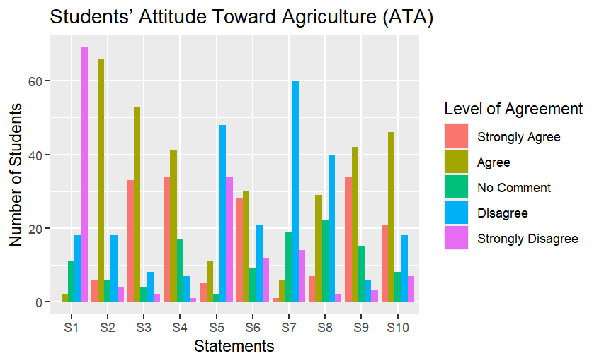

**Fig 1: Students attitude about different aspects of agricultural education**

**Legend:** S1**=**Limited future prospects, S2=Easy to understand, S3=Boring practical tasks, S4= Considered a lucrative profession, S5=Perceived as just farming, S6=Lacks social respect, S7=Easy to shift to other careers, S8=Enjoyable subject matter, S9=Uninterested in agricultural careers, S10=Tend to skip agriculture classes.

To evaluate students’ perceptions of agricultural science, ten well-structured statements (S1–S10) is presented using a five-point Likert scale: Strongly Agree, Agree, No Comment, Disagree, and Strongly Disagree.

In the first statement (S1) students were asked whether agriculture has limited future prospects. Students answer revealed that a significant number of students (69 students from 100) disagreed, suggesting that many perceived agriculture as a potential field. On the other hand, “agriculture is easy to understand” (S2) received generally positive responses, indicating that students found agricultural science clear and understandable.

Interestingly, when students were asked the question whether practical tasks was boring, got notable agreement by 53 students, suggesting dissatisfaction with the practical components of agricultural courses. In contrast, the forth statement considering “agriculture sector as a lucrative profession” received positive responses, indicating, students had a good impression towards agriculture job sector.

For the fifth statement S5: “Perceived as just farming” a considerable number of students (48 students) expressed disagreement, and sixth statement S6: “Lacks social respect”, regarding the question around 30 students agreed that people sometimes think negatively about studying in agriculture subject.

Responses to seventh statement “Easy to shift to other careers” and statement S8: “Enjoyable subject matter” received predominantly positive responses, maximum number of students (60 and 40 students) expressed their satisfaction.

However, concerning the nineth statement “Uninterested in agricultural careers” and tenth statement: “Tend to skip agriculture classes,” a number of students (42 and 46 respectively) agreed that they were not willing to choose agricultural sector as their career choice and they loved to avoid their classes. These findings point to a possible gap between academic content and students' career aspirations, highlighting the need for curriculum reform and better career guidance.

### **3.2.2. Subjective Norms Influencing Perception of Agricultural Science**

### Subjective norms refer to the social pressures students feel from people around them especially parents and peers regarding studying Agricultural Science.

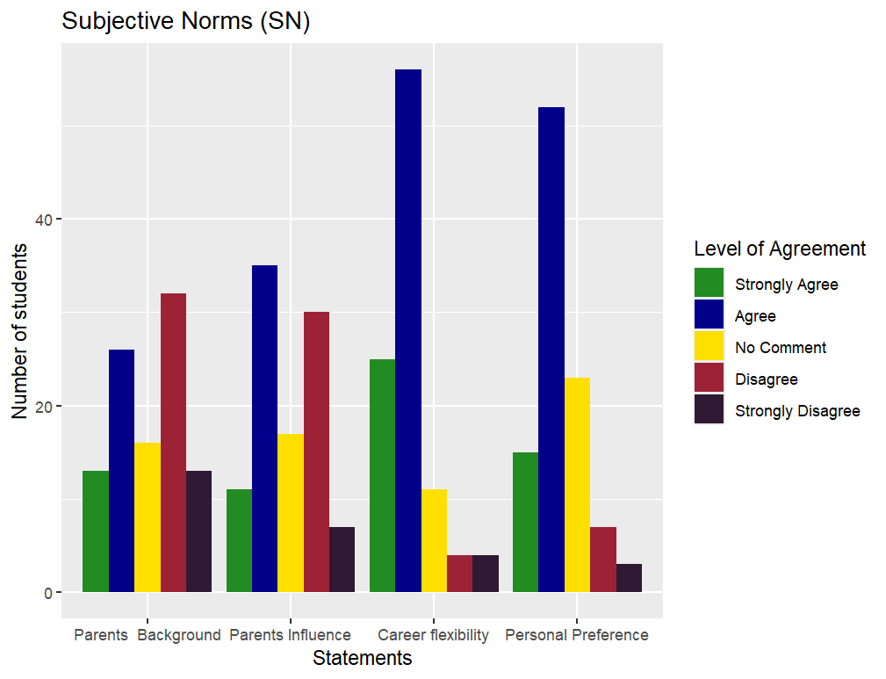

Figure 2: Distribution of students’ responses regarding Subjective Norms (SN)

The data revealed that parents’ background was more evenly distributed, with a considerable number of students (32 and 13 students) disagreeing or selecting “no comment.” This implies that the socioeconomic or occupational background of parents may not significantly shape students’ perceptions. However, direct parental influence had more agreement (35 students) than disagreement (30 students), suggesting that while background alone may not be influential, parents’ attitudes and guidance still play a role in forming students’ educational preferences.

In contrast, responses to career flexibility perceived very positively, with the majority of respondents (56 and 25 students) opined that it influenced their views on Agricultural education. This suggests that many students perceived the subject as offering diverse professional opportunities, which enhanced its appeal. Similarly, personal preference received a high number of “agree” (52 students) and “strongly agree”(15 students) responses, indicating that students’ individual interest played a substantial role in shaping their attitudes toward the discipline.

**3.2.3 Perceived Behavioral Control (PBC)**

This dimension relates to the students’ confidence in their ability to succeed in Agricultural education and their perception of available opportunities.

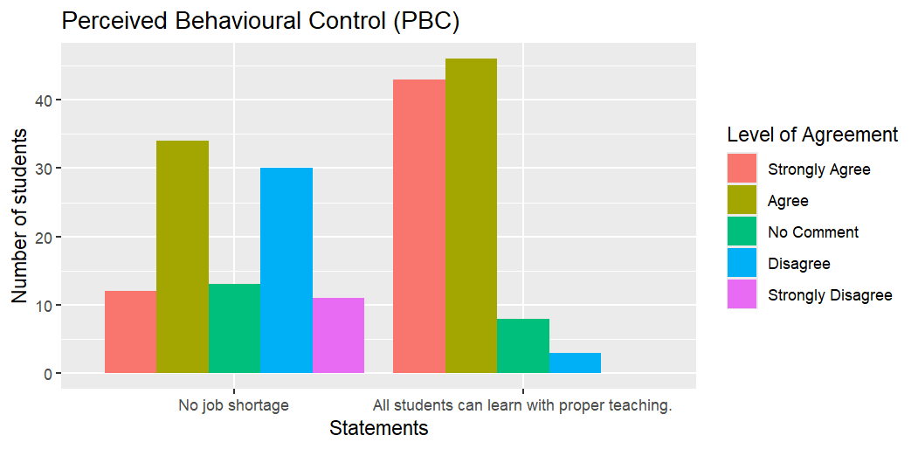

**Fig 3: Students opinion regarding perceived behavioural control**

Figure 3 illustrates students’ responses to two key statements: (1) “There is no lack of employment in the sector” and (2) “All students can learn complex Agricultural Science concepts if they are properly taught.”

Responses to the first statement showed that a significant number of students (34 students) agreed there are ample employment opportunities within the agricultural sector. This indicates that many students recognized agriculture as a field with viable career prospects.

Similarly, the majority of respondents agreed and strongly agreed (46 and 43 students) with the second statement, suggesting a strong belief in the learn ability of Agricultural Science when proper teaching support is provided. This reflects positive perceived academic control, indicating that students did not view the subject as inherently too difficult if instructional methods are effective.

**3.3. Ranking of Statements on the basis of mean**

**3.3.1. Factors influencing students’ attitude of agricultural education**

On the basis of mean score, the statements of students’ attitude toward agricultural education ranked.

Table 2: Rank order by mean of Students’ Attitude of Agricultural Education

| **Statement** | **Mean** | **Rank Order by mean** |
| --- | --- | --- |
| Limited future prospects | 1.46 | 10 |
| Easy to understand | 3.42 | 4 |
| Boring practical tasks | 4.07 | 1 |
| Considered a lucrative profession | 4.00 | 2 |
| Perceived as just farming | 2.05 | 8 |
| Lacks social respect | 2.59 | 6 |
| Easy to shift to other careers | 3.80 | 3 |
| Enjoyable subject matter | 3.01 | 5 |
| Uninterested in agricultural careers | 2.02 | 9 |
| Tend to skip agriculture classes | 2.44 | 7 |

The mean score of the statement *“Boring practical tasks”* was 4.07. Being highest mean, it ranked as first. The second highest ranked statement was “Considered a lucrative profession” (Mean = 4.00), following this, Easy to shift to other careers received a mean score of 3.80, ranking third, The statement “Easy to understand “ranked fourth (Mean = 3.42), “Enjoyable subject matter” came in fifth (Mean = 3.01 In contrast, statements such as “Limited future prospects” (Mean = 1.46), “Uninterested in agricultural careers” (Mean = 2.02), and “Perceived as just farming” (Mean = 2.05) received lower mean scores and were ranked towards the bottom (ranks 10, 9, and 8 respectively).

**3.3.2. Factors influencing students’ perception of subjective norm**

Table 3: **Subjective Norms (SN)** the perceived social pressure influencing their attitude toward Agricultural Science.

| **Statements** | **Mean** | **Rank Order by mean** |
| --- | --- | --- |
| Family background affects my ideas. | 2.94 | 4 |
| My parents’ influence affects my views about Agricultural Science | 3.13 | 3 |
| Career flexibility influenced my perception. | 3.94 | 1 |
| My decisions influence my thoughts on Agriculture. | 3.69 | 2 |

The highest mean score was observed for the statement “Career flexibility influenced my perception” (Mean = 3.94). The second highest ranked statement was “My decisions influence my thoughts on Agriculture” with a mean score of 3.69. “My parents’ influence affects my views about Agricultural Science” ranked third with a mean score of 3.13. The lowest ranked statement was “Family background affects my ideas” (Mean = 2.94).

**3.3.3. Factors influencing students’ opinion of perceived behavioural control**

“All students can learn Agricultural Science if well taught”, the statement ranked first on the basis of mean score of **4.29**.

**Table 4:** **Perceived Behavioural Control**

| **Statements** | **Mean** | **Rank Order by Mean** |
| --- | --- | --- |
| The sector offers ample jobs | 3.06 | 2 |
| All students can learn Agricultural Science if well taught | 4.29 | 1 |

On the otherhand, the second-ranked statement, “The sector offers ample jobs”, had a mean score of **3.06**.

**3.4. Students Perception (From open form question)**

Students were asked how they perceived about agriculture as subject. In response to the open-ended questions, students shared different thoughts about agriculture as a subject.

**Table 5: Students perception of agricultural education**

|  |  |
| --- | --- |
| **Students Perception** | **Frequency** |
| The education system is too focused on theory and not enough hands-on learning | **90%** |
| Agriculture offers many job opportunities | **80%** |
| Practical work is dull and boring | **75%** |
| Easier to switch to other careers | **70%** |
| Agriculture can help fight world hunger | **50%** |
| Agriculture encourages new ideas, like creating new crop varieties | **50%** |
| People often criticize those who study it. | **50%** |
| Agriculture is not just about farming | **45%** |
| Agriculture allows to stay connected with farmers | **45%** |
| A good subject to study in foreign countries. | **45%** |
| Agriculture is interesting if teachers teach well | **40%** |

From table 5, it could be observed that approximately 90% opined that the education system is based on theory and not enough hands-on learning. Some students commented: “*As practical requirements are very essential in agriculture, so the education system should focus more on practical rather than theoretical. But education system in our country is theoretical, it’s boring. That’s why my lack of interest grows as a student” (*Anonymous Student*).* They suggested making the lessons more practical and improving the learning facilities.

Many students (80%) said that agriculture offers many job opportunities both in government and private organizations and easier to switch to other careers. *“The job sector in agriculture is broad like one can work in government sectors like scientific officer, extension officer and private sectors like ACI, Syngenta, Agrotek. A student can also move to other sectors easily like working in banks or government offices” (*Anonymous student*)*. Half of the students (50%) said agriculture encourages new ideas, such as creating new crop varieties or working as a plant doctors. *Before taking agricultural science as a subject, I had not enough knowledge about it, I did not even go to the field. But after studying agriculture I can feel all the plants, fields, crops and their growing process, their physiological process. It feels like I am a plant doctor” (*Anonymous Student*).* People often have negative thinking about agriculture. “*Though agriculture assists us to think critically and change my conception about cultivation. But people don,t recognize it as a science and always criticize us as a student of agriculture”(*Anonymous Student*)*. Students also pointed out that agriculture not only about farming but also includes several topics like soil science, animal care and understanding farmers' behaviour. Some students believed agriculture can terminate world hunger. Many also believed, it is a good subject to study in foreign countries. In addition, students said their interest in the subject depends on how well the teachers teach. While some enjoyed how agricultural science helps with smart farming and stay connected to farmers, others found the practical work to be dull.

**4.Conclusion**

This study revealed undergraduate students' perceptions of Agricultural education in Bangladesh, particularly at Patuakhali Science and Technology University. Though, agriculture is an important sector in Bangladesh, students have mixed feelings about it.

Findings from Theory of Planned Behavior (TPB) proposed that though students acknowledged that the subject is highly demandable and have high probability for varied job opportunities, but opined that practical task is uninteresting.

Subjective norms showed that direct parental influence and personal interest significantly affected students’ choices, while family background played a lesser role. Furthermore, perceived behavioral control is generally positive, with students expressing confidence in their ability to learn agricultural concepts, if taught effectively and recognizing agriculture as a field with ample career opportunities.

This study provides significant information about students’ perception of agricultural education that will be useful for policy makers, who think about reforming education system in Bangladesh. Specially prioritizing more practical hands-on approach. The study was conducted at Patuakhali Science and Technology University and the respondents were 2nd year students. Therefore, future large-scale research encompassing all agricultural university in the country are recommendedto gain a more comprehensive understanding.

Authors’ contributions

This work was carried out in collaboration between both authors. Both authors read and approved the final manuscript.

DISCLAIMER (ARTIFICIAL INTELLIGENCE)

Author(s) hereby declares that NO generative AI technologies such as Large Language Models (ChatGPT, COPILOT, etc) and text-to-image generators have been used during writing or editing of this manuscript.

CONSENT

Before interviewing, agreement was collected from the respondents and no personally recognisable information was collected.

COMPETING INTERESTS

Authors have declared that no competing interests exist.

**References**

Adejoh, S. O., Edoka, M. H., & Shaibu, M. U. (2016). Assessment of students' attitude towards Agricultural Science subject in secondary schools in Olamaboro Local Government Area of Kogi State, Nigeria. International Journal of Agriculture and Veterinary Science, 2(1), 18–27.

Agbidi, S. S., Imobighe, M. I., & Emefia, I. (2022). Improvised instructional materials and improvement skills needed for teaching animal husbandry in Delta State, Nigeria. Delsu Journal of Educational Research and Development, 19(2), 52–60.

Bamidele, R., Femi, A., Arisukwu, P., et al. (2023). Factors influencing career choices in agriculture-related fields amongst secondary school students. Proceedings of SEB-SDG 2023, 1–9. https://doi.org/10.1109/SEB-SDG57117.2023.10124545

Bangladesh Bureau of Statistics (BBS). (2024). Labour Force Survey 2022: Final report. Statistics and Informatics Division, Ministry of Planning.

Leavy, J., & Hossain, N. (2014). Who wants to farm? Youth aspirations, opportunities and rising food prices. IDS Working Papers, 2014(439), 1–44.

Oduh, W. A., Agboola, J. O., & Eibhalemen, F. A. (n.d.). Influence of peer group on the career choice of secondary school students in South Senatorial District of Edo State, Nigeria. International Journal of Humanities, Social Sciences and Education.

Ojebiyi, W. G., Ashimolowo, O. R., Soetan, O. S., Aromiwura, O. A., & Adeoye, A. S. (2015). Willingness to venture into agriculture-related enterprises after graduation among final year agriculture students of Federal University of Agriculture, Abeokuta. International Journal of Applied Agriculture and Apiculture Research, 11(1–2), 103–114.

Rehman, A. B. (2022). Importance of agriculture in life. International Review of Agriculture World, 1(1). https://doi.org/10.15651/IRAW.22.1.03

Tafere, Y., & Woldehanna, T. (2012). Beyond food security: Transforming the productive safety net programme in Ethiopia for the well-being of children. Young Lives.

Ortega-Dela Cruz, R. (2020). Perceptions of higher agricultural education toward sustainable agricultural development. Higher Education, Skills and Work-Based Learning, 10(1), 187-202.

Kidane, T. T., & Worth, S. H. (2014). Student perceptions of agricultural education programme processes at selected high schools in KwaZulu-Natal Province, South Africa. The Journal of Agricultural Education and Extension, 20(4), 381-396.

Osborne, E. W., & Dyer, J. E. (2000). Attitudes of Illinois agriscience students and their parents toward agriculture and agricultural education programs. Journal of agricultural education, 41(3), 50-59.