*Original Research Article*

GROUNDWATER QUALITY ASSESSMENT OF BOREHOLES IN ONNA LOCAL GOVERNMENT AREA, AKWA IBOM STATE, NIGERIA

.

ABSTRACT

|  |
| --- |
| The study assessed aspect of water quality of groundwater from different boreholes in Onna Local Government Area, Akwa Ibom State. Water samples were collected from boreholes in the study sites using standard methods. Twenty (20) water quality parameters, in ten (10) study sites, were analysed using spectroscopic and titrimetric methods to determine the water quality index of groundwater in the study sites. Water quality parameters of interest include physicochemical, major ions, nutrients, heavy metals, and microbial indicators. Results indicate variations in pH (4.4–7.16), electrical conductivity (14–102 µS/cm), total dissolved solids (7 – 49 mg/L), Na (58.2 mg/L - 108 mg/L), K (56.4 mg/L - 74.3 mg/L), Ca (8 - 33.6 mg/L), Fe (BDL–4.753 mg/L), Zn (0.002 - 1.063 mg/L) and Mn (0.002–1.063 mg/L), Cl- (3.89 – 28.33), NO3- (1.342 – 2.541mg/L), PO43- (0.014 – 0.041 mg/L), SO42- (0.104 – 6.186 mg/L). Most water samples showed acidic pH and variable levels of salinity, hardness, and microbial contamination, suggesting the influence of geogenic and anthropogenic factors. Elevated Fe and Mn levels in some samples pose health risks, while microbial contamination indicates faecal pollution, necessitating urgent remediation. While some parameters complied with World Health Organisation and Nigerian safety regulatory standards, others exceeded permissible limits. Water Quality Index assessment of the study sites indicates that, with the exception of ONN 2, the water quality of all sample sites is suitable for drinking. However, there is need for continuous and improved groundwater monitoring, as well as point-of-use treatment strategies for contaminated groundwater in Onna LGA, Akwa Ibom State. |

*Keywords: Groundwater, Boreholes, Water Quality, Physicochemical parameters*

1. INTRODUCTION

Water is an abundant and essential resources of nature, which is regarded as a universal solvent that can dissolve several substances which are beneficial to man and its environment. It has been stated that groundwater has greater importance to civilization than surface water, because groundwater is the largest reserve of drinkable water in regions where humans can inhabit [1]. Ground water is found beneath the ground surface and fills the voids in the rocks and soil; it is a source of water for wells, boreholes and springs [2]. According to Indraja et al. [3], approximately 80% of Indian population is dependent on groundwater for household and agricultural purposes. Groundwater is a critical source of potable water for many rural and peri-urban communities worldwide, particularly in developing countries where surface water may be scarce or contaminated. In Nigeria, boreholes serve as a primary means of accessing groundwater for domestic, agricultural, and industrial use.

Groundwater characteristics vary spatially, depending on the type of rock, and where groundwater location is pervasive, flowing, accumulating, as well as environmental conditions and anthropogenic activities [4]. Therefore, the quality of groundwater is susceptible to degradation from natural geological processes and anthropogenic activities such as agricultural runoff, industrial discharge, and improper waste disposal. According to World Water Quality Alliance [5], the quality of groundwater is also determined by the initial quality of water infiltrating the subsurface and its interaction with the subsurface environment. Contaminated groundwater poses significant health risks, including exposure to toxic metals and pathogenic microorganisms. Sources of groundwater pollution range from anthropogenic to natural activities. The increased use of metal-based fertilizer in agriculture could result in continued rise in concentration of metal pollution in fresh water reservoir through water run-offs [6]. In the rainy season, faecal matter from pit latrines and open sources can leach into groundwater, thereby contaminating it [7]. Similarly, the garbage in a landfill can create groundwater pollution when rainwater percolates through the toxic garbage and sinks into the soil, contaminating the underlying groundwater to a depth of about 33m in tropical environments (low level of metal accumulation within the soil) [8]. The above listed anthropogenic activities pose serious threat to the groundwater users, with accompanying hazardous implications. Unfortunately, restoring the quality of groundwater after contamination is difficult and can be a lengthy process, due to their inaccessibility and slow movement [9]. It therefore becomes imperative to regularly monitor the quality of groundwater and to devise ways and means to protect it from contamination.

Onna Local Government Area (LGA) of Akwa Ibom State, Nigeria, is predominantly rural, relying heavily on borehole water for daily domestic water needs. This area is a representative of Niger Delta communities with shallow aquifers susceptible to contamination. Prior studies [10,11] have reported heavy metal pollution and microbial risks in similar environments. Despite its importance, there is limited comprehensive data on the physicochemical and microbiological quality of groundwater in this region. Understanding the water quality status is essential to inform public health interventions and sustainable water resource management. Accordingly, this study aims to assess the quality of groundwater obtained from boreholes in selected communities within Onna LGA by analysing key parameters such as pH, electrical conductivity, total dissolved solids, metal concentrations, anions, hardness, alkalinity, and microbial contamination. By identifying potential contaminants and comparing them against established standards, this research seeks to evaluate the suitability of borehole water for domestic consumption and highlight areas requiring remediation or further monitoring. The findings will contribute to safeguarding community health and guiding policy on groundwater utilization in Akwa Ibom State.

2. material and methods

**2.1 Study Area**

The study sampled ten (10) groundwater samples in nine (9) communities of Onna Local Government Area in southern region of Akwa Ibom State, Nigeria. Table 1 enlists the sample locations and description of each site; Fig. 1 shows the map of the study area and the sample sites.

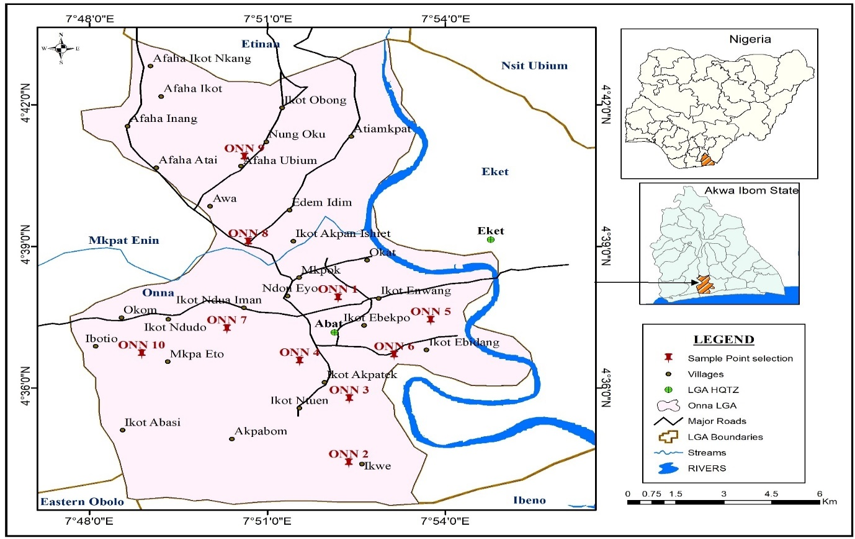

**Fig 1. Map of Onna LGA, indicating the sample sites**

**Table 1 Study Sites location and description**

|  |  |  |  |
| --- | --- | --- | --- |
| Site ID | GPS location | Village | Site Description |
| ONN 1 | 4.63171''7.869949 | Ndon Eyo | Residential Estate |
| ONN 2 | 4.573442"7.872895 | Ikwe | Primary Healthcare center |
| ONN 3 | 4.600624"7.865924 | Ikot Akpatek | Residential |
| ONN 4 | 4.616597"7.872367 | Ikot Ebekpo | Residential |
| ONN 5 | 4.618855"7.892927 | Ikot Ebidang | Residential |
| ONN 6 | 4.614201"7.881907 | Ikot Ebidang | Public water supply |
| ONN 7 | 4.620833"7.838662 | Ikot Edor | Residential |
| ONN 8 | 4.651388"7.844697 | Ikot Akpan Nsiet | Residential |
| ONN 9 | 4.681358"7.843605 | Afaha Ubium | Public School |
| ONN 10 | 4.611994"7.8147 | Ikot Eko Ibon | Public water supply |

**2.2 Methods**

**2.2.1 Determination of pH, Electrical Conductivity, Total dissolved solid, Oxygen reduction potential, salinity**

These parameters were measured at site electronically with the help of their corresponding handheld instrument (HANNA HI9813-51 & HI98190).

**2.2.2 Determination of Sulphate Concentrations**

SulfaVer 4 powder pillow was used in the determination of sulphate in the water sample. The concentration of sulphate was measured with HACH DR 3800 as follows; 10ml of the water sample was measured into a cuvette and the content of the pillow was also poured into the sample cuvette, shaken and measured in the Hach DR 3800 using the same sample of 10ml in a cuvette (without the reagent) as blank sample. The reading for the concentration was displayed on the screen and taken.

**2.2.3 Determination of Nitrate Concentration**

This parameter was determined using the spectrophotometric method after the addition of NitraVer 5 powder to 10ml of water sample in a cell. The mixture was shaken and an amber colour appeared, indicating the presence of nitrate, which was then measured in HACH DR 3800. Another cell was filled to the mark with 10ml of the same sample, without adding the reagent, and used as the blank sample. The result was shown on the screen.

**2.2.4 Determination of Calcium**

Titrimetric Method Using EDTA and Calgon indicator powder was utilized in the determination of Calcium ion concentration. 100mls of the water sample, 20mls of 20% KOH and 50ml of distilled water were placed into a 250mls conical flask. About 0.05g of Calgon indicator powder was added into the flask. The mixture was titrated against 1.2857mg concentration of EDTA [12].

${Ca}^{2+} \left(mg/100ml sample\right)= \frac{N × V_{1} ×100}{100}$ (1)

V1 = volume of EDTA used, N = normality of EDTA used

**2.2.5 Determination of Alkalinity as CO32-**

Titrimetric method was adopted and the reagents used for the determination of this parameter were methyl orange indicator and 0.01N H2SO4 titrant. Alkalinity as CO32- is calculated using the formula:

$Alkalinity as {CO}_{3}^{2-}= \frac{A ×N ×M ×1000}{vol. of sample used}$ (2)

Where A = volume of acid used, N = normality of acid used, M = molar mass of CO32-

**2.2.6 Total Hardness as CaCO3**

This was determined using EDTA titration method and ammonia buffer solution. 50mls of the water sample was measured into a 250ml conical flask, 2mls of ammonia buffer solution and a tablet of total hardness indicator was added; then titration with 0.01 N EDTA was carried out. A deep purple solution that changed to blue solution marks the titration end point. Total hardness was calculated thus,

$mg/l{CaCO}_{3}= \frac{V_{2}×E×N×1000}{Volume of sample used}$ (3)

V2 = volume of EDTA, E = Equivalent weight of CaCO3, N = Normality of EDTA

**2.2.7 Determination of Chloride (Argentometric titration)**

100mls of the water sample was titrated with 0.01N of AgNO3 using potassium chromate indicator. The chloride ions reacted preferentially with silver ions. Excess silver ions reacted with chromate ions to form silver chromate which indicated the end point of the titration [12]. Chloride concentration was determined using the formula;

$mg/l{Cl}^{-}= \frac{V_{2} ×E ×N ×1000}{volume of sample used}$ (4)

V2 = volume of AgNO3, E = Equivalent weight of Cl-, N = Normality of AgNO3

**2.2.8 Determination of Sodium and Potassium**

Sodium and Potassium were determined using the Flame Photometer (FP910), after preparation of standards to obtain the calibration curve on the instrument.

**2.2.9 Determination of Heavy metals**

Heavy metals were determined using the Atomic Absorption Spectrophotometer (Wincom AA320n)

**2.2.10 Microbial Analysis**

Plate count method was used to count gram negative bacteria such as E.coli, Escherichia, Enterobacter, Klebsiella and other coliforms present in the ground water samples. Endo medium, which was prepared following the manufacturer’s (Sigma-Aldrich) instruction and autoclaved was used to evaluate faecal coliform. After being plated in duplicate, each sample point was incubated for 24 hrs at 37oC. Following incubation, duplicate counts from specific sampling points were averaged and expressed as CFU/mL of water.

**2.3 Water Quality Index Estimation**

The WQI was calculated using standards of drinking water quality recommended by the World Health Organization [13] and the Nigeria Standard of drinking Water Quality [14]. The weighted Arithmetic index method [15], was used for the calculation of WQI. Furthermore, quality rating or sub index was calculated using the following expression

$WQI= \frac{∑Q_{i}W_{i}}{∑W_{i}}$ (5)

Where Qi is the water quality rating of the ith water quality parameter and Wi (∑Wi = 1) is the weight of the ith water quality parameter.

The quality rating Qi, can be calculated thus;

$Q_{i}= \frac{100(V_{i}- V_{0})}{∑W_{i}}$ (6)

Where Vi is the actual amount of the ith parameter, Vo represents the ideal value of the parameter (Vo = 0), except for the pH (Vo =7) and Si is the standard allowable value for the ith parameter.

The unit weight (Wi) is calculated using the equation below;

$W_{i}=\frac{K}{S_{i}};K=\frac{1}{∑(\frac{1}{S_{i}})}$ (7)

The term K is a proportional constant

3. results and discussion

The table below gives the values of twenty (20) water quality parameters in ten (10) sample locations in the study area

Table 2 Water Quality parameters in Groundwater Samples obtained from ten (10) sampling sites in Onna LGA, Akwa Ibom State

|  |  |  |  |  |  |  |  |  |  |  |
| --- | --- | --- | --- | --- | --- | --- | --- | --- | --- | --- |
|  | ONN 1 | ONN 2 | ONN 3 | ONN 4 | ONN 5 | ONN 6 | ONN 7 | ONN 8 | ONN 9 | ONN 10 |
| pH | 4.7 | 7.16 | 5 | 4.4 | 4.8 | 5 | 4.5 | 4.8 | 5 | 4.6 |
| EC (us/cm) | 40 | 36 | 32 | 32 | 50 | 14 | 34 | 18 | 28 | 102 |
| TDS (mg/l) | 20 | 18 | 16 | 16 | 25 | 7 | 17 | 9 | 14 | 49 |
| ORP (mV) | 375 | 280 | 358 | 420 | 416 | 362 | 444 | 415 | 428 | 399 |
| Salinity (ppm) | 17 | 20 | 14 | 18 | 28 | 7 | 18 | 9 | 15 | 51 |
| Zn (mg/L) | BDL | 2.234 | 0.005 | 0.008 | 0.01 | 0.057 | 0.004 | 1.112 | 0.034 | BDL |
| Fe (mg/L) | 0.01 | 4.753 | 0.011 | BDL | BDL | BDL | 0.046 | 0.021 | 0.012 | 0.005 |
| Mn (mg/L) | 0.002 | 0.699 | 0.555 | 0.04 | 0.364 | 0.277 | 0.257 | 0.832 | 0.578 | 1.063 |
| Na (mg/L) | 90.6 | 108 | 103 | 82 | 94 | 82.8 | 69.7 | 69.7 | 58.2 | 65.3 |
| K (mg/L) | 60.9 | 66.6 | 56.4 | 61.7 | 62.6 | 65.8 | 64 | 69.6 | 67.2 | 74.3 |
| NO3- (mg/L) | 1.782 | 2.046 | 2.541 | 2.005 | 2.097 | 2.168 | 1.342 | 1.832 | 1.986 | 1.756 |
| SO42- (mg/L) | 0.583 | 0.104 | 0.255 | 0.198 | 0.232 | 0.243 | 6.186 | 3.864 | 1.214 | 2.113 |
| PO43- (mg/L) | 0.014 | 0.018 | 0.027 | 0.041 | 0.039 | 0.024 | 0.019 | 0.031 | 0.041 | 0.039 |
| THC | 0.002 | <0.001 | 0.002 | 0.541 | 0.618 | 0.672 | 0.008 | 0.084 | 1.215 | 0.915 |
| Hardness (mg/L) | 28 | 84 | 64 | 80 | 44 | 20 | 32 | 48 | 36 | 64 |
| Alkalinity | 52 | 76 | 56 | 40 | 68 | 96 | 56 | 56 | 60 | 100 |
| Ca (mg/L) | 11.2 | 33.6 | 25.6 | 32 | 17.6 | 8 | 12.8 | 19.2 | 14.4 | 25.6 |
| Cl- (mg/L) | 9.44 | 11.11 | 7.78 | 10 | 15.56 | 3.89 | 10 | 5 | 8.33 | 28.33 |
| Total Heterotrophic count | 2680 | 690 | 1460 | 2750 | 510 | 185 | 850 | 1040 | 6090 | 310 |
| Total Coliform count (Cfu/mL) | 0 | 0 | 150 | 0 | 0 | 0 | 10 | 0 | 0 | 425 |

**3.1 Physicochemical parameters**

**3.1.1 pH and Acidity**

pH ranged from 4.4 (ONN 6) to 7.16 (ONN 2). It was observed that, with the exception of ONN 2 (7.16), groundwater from all sample sites were acidic (pH 4.4–5.0). Acidic groundwater, often due to CO2 dissolution or organic acids, can increase metal mobility and affect infrastructure [16]. Acidity is a key characteristic of groundwater. Acidity, measured as pH, in natural groundwater is controlled by the balance between carbonic acid (H2CO3) and buffering by dissolution of alkaline rocks. Besides controlling the precipitation and dissolution of minerals that may contain contaminants, the pH controls the mobility of a range of electrically charged contaminants by changing the surface charge of clays, oxides and organic matter (OM), solids whose surfaces promote sorption [5]. This implies that cationic contaminants like heavy metals (lead – Pb, zinc – Zn, cadmium – Cd, etc.) may be mobile at low pH values, while anionic contaminants, such as oxyanion forming elements (As, selenium – Se, etc.), may be mobile at neutral to high pH values. Similarly, organic contaminants may be adsorbed by naturally present organic matter, slowing the rate of contaminant transport in the groundwater (retardation) [5].

**3.1.2 Electrical Conductivity and TDS**

Electrical conductivity ranged from 14 µS/cm (ONN 6) to 102 µS/cm (ONN 10) while Total dissolved solids ranged from 7 mg/L (ONN 6) – 49 mg/L (ONN 10); these values were low, indicating fresh water status. The results are consistent with findings by Essien & Edet [17] in nearby areas, suggesting low mineralization from short residence time. Generally, a strong positive correlation was observed between EC and TDS, which has been supported by several studies [6,18,19]. High total dissolved solids are associated with processes such as saltwater intrusion; dissolution of salts from highly soluble rocks and evaporites; high rates of evaporation in arid and semi-arid environments; or highly mineralised (old or deep) groundwater [20]. High TDS are linked to high concentrations of major ions and sometimes geogenic contaminants (*e.g.* As, F, uranium – U). High TDS result in a high ionic strength and formation of soluble complexes that may lead to increased mobility for some ionic contaminants [5].

**3.1.3 Heavy Metals**

Concentration of heavy metals in the study sites were presented as follows: Zn (BDL – 2.234 mg/L); Fe (BDL - 4.753 mg/L); Mn (0.002 – 1.063 mg/L). Iron concentrations exceeded the WHO limit (0.3 mg/L) in ONN 2 (4.753 mg/L) and ONN 7 (0.046 mg/L). Similarly, Mn levels surpassed the 0.4 mg/L limit in ONN 2, ONN 8, ONN 10. High Mn and Fe are often linked to reducing environments or ferruginous sandstone aquifers [21]. Iron in concentrations greater than 0.3 mg/l may cause black and brown stains on laundry, plumbing, fixtures and sinks [18]; however, high concentration of iron does not appear to present health hazard but it may affect the taste of beverages made from the water

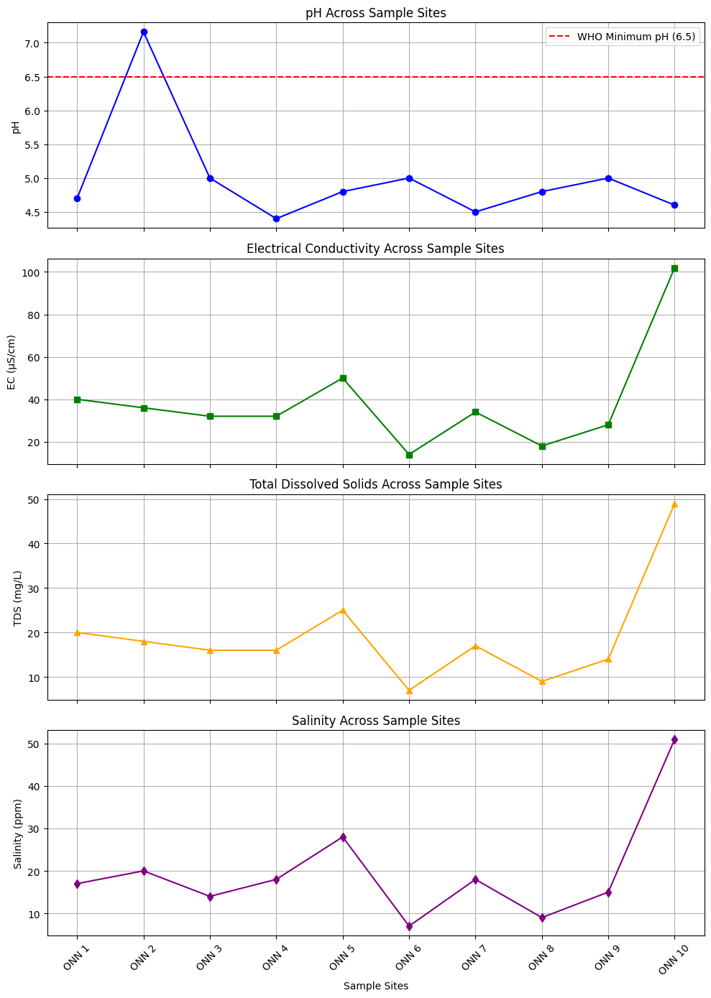

**Fig 2. Physicochemical parameters across sample sites**

**3.2 Cations and Anions**

Sodium in samples ranged from 58.2 mg/L (ONN 9) to 108 mg/L (ONN 2), which were below within the WHO safe limit of 200 mg/L [13]. It was observed that samples obtained from sites closer to the coast recorded higher Na+ concentration that other samples, which implies saline intrusion effect

Potassium ranged from 56.4 mg/L (ONN 3) to 74.3 mg/L (ONN 10). These values exceed the maximum EU directive of Potassium in drinking water of 12 mg/L [22]. Potassium in groundwater originates from various natural and anthropogenic sources, such as agricultural activities (fertilizer usage) and industrial activities. While potassium is an essential nutrient, high concentrations in drinking water can pose health risks, particularly for individuals with kidney problems [23].

The highest calcium concentration was found in ONN 2 (33.6 mg/L) while the lowest was 8 mg/L (ONN 6). Calcium is a common component of groundwater, and its concentration can vary significantly depending on the surrounding geology and water source [24]. Impact of calcium in groundwater include water hardness (which can cause scaling in pipes, water heaters and other appliances) and noticeable water taste

NO3⁻ levels were below 50 mg/L in all samples, indicating minimal nitrate pollution unlike other studies in Uyo LGA, Akwa Ibom State [18,25]. Nitrate is a common groundwater contaminant in drinking water sources and at high concentrations can cause health problems in infants and animals [26,27,28]. This is particularly important in peri-urban areas where untreated wastewater is used for irrigation and where groundwater is pumped for drinking purposes.

Phosphate was lowest in ONN 1 (0.014 mg/L) and highest in ONN 4 & 9 (0.041 mg/L), potentially from detergents or decaying organic matter. When phosphate rich groundwater enters surface water bodies (lakes, streams etc.), it can stimulate excessive growth of algae and aquatic plants, leading to eutrophication. Yu et al. [29] has stated that phosphate concentrations observed in groundwater may be due to human activities, such as the use of chemical phosphorus fertilizer for agriculture, industrial and domestic effluents or human sewage [29].

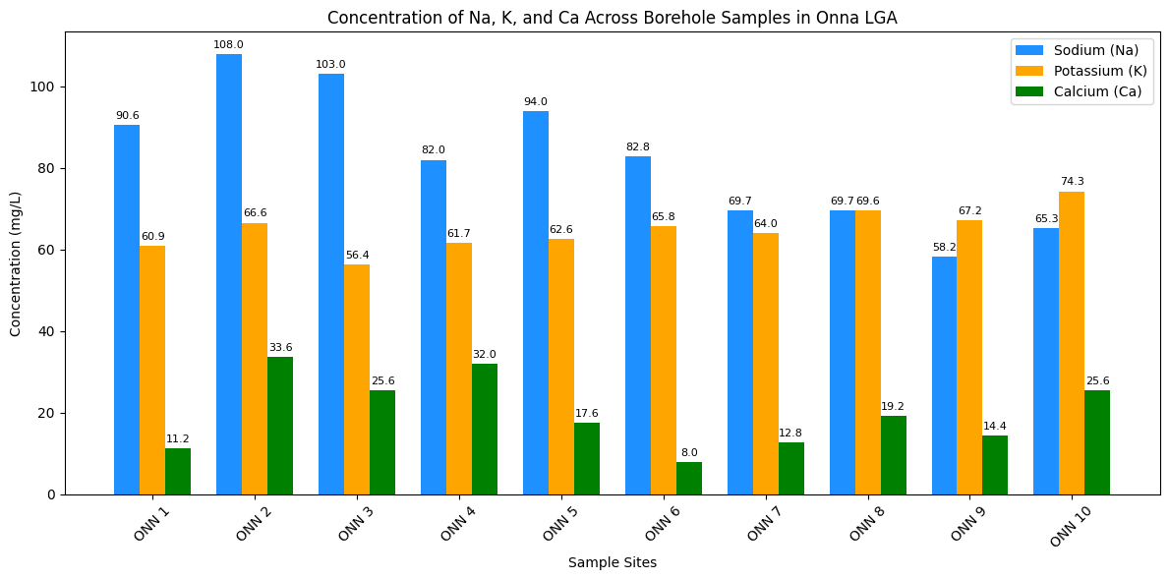

**Fig 3 Cations (Na, K, Ca) concentration across sample sites**

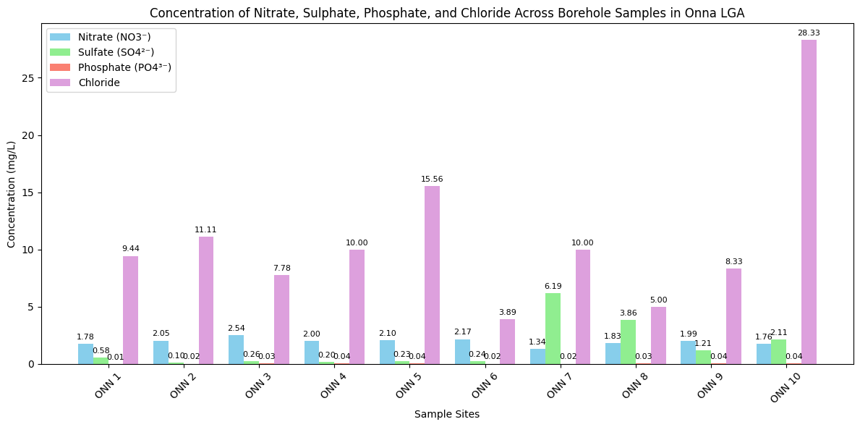

**Fig 4. Anions concentration (NO3-, SO42-, PO43-) across sample sites**

**3.3 Water Hardness and Alkalinity**

Hardness ranged from 20 mg/L (ONN 6) – 84 mg/L (ONN 2), which classifies the water samples as soft to moderately hard. A very strong correlation was observed between the calcium concentration of the samples with their hardness. As stated earlier, water hardness is not desirable for domestic use due to its scaling effect on materials and giving drinking water a noticeable taste.

Alkalinity is a measure of the capacity of water to neutralize acids. The predominant chemicals present in natural waters are carbonates, bicarbonates, and hydroxides [18]. Alkalinity in the present study varied from 40 mg/L (ONN 4) to 100 mg/L (ONN 10), showing varying buffering capacities. The buffering capacity of water is crucial for maintaining stable pH levels, which is important for aquatic life and preventing corrosion in pipes [30].

**3.4 Chloride and Salinity**

Chloride (3.89 – 28.33 mg/L) and salinity (7 –51 ppm) were within permissible limits. The lowest values were obtained in ONN 6 and the highest in ONN 10. These values align with low anthropogenic salt intrusion, due to the distance of the sample sites from the Atlantic coast. Elevated groundwater salinitycan result from a range of processes, including natural water-rock interactions and recharge in areas dominated by evaporation [20]. However, many groundwater salinization processes are exacerbated by anthropogenic activities; these include salinization from irrigated agriculture, over-pumping mobilising geologically old saline water, seawater intrusion into coastal aquifers and hydrocarbon production [31,32]. Groundwater salinization can be exacerbated by excessive irrigation and shallow groundwater levels due to salt accumulation which is subsequently leached to groundwater [33,34]. In certain cases, leaching of agricultural drainage water to groundwater increases concentrations of specific ions such as sodium and magnesium with deleterious effects to crops irrigated with sodium- and magnesium-rich groundwater. This issue is intensified in arid

and semi-arid regions where there is inadequate flushing of ions due to limited rainfall recharge [35].

**3.5 Microbiological Quality**

Total Heterotrophic Count (THC) was high across many sites (up to 6.09 × 10³ CFU/mL). Total Coliform Count exceeded zero in ONN 3, ONN 7, ONN 10, suggesting possible faecal contamination. According to WHO [36], any presence of coliforms indicates potential faecal contamination, rendering the water unsafe for consumption without treatment. The presence of faecal contamination is a health risk because it signifies the presence of various pathogens in the sampled water supply. They are associated with diseases such as diarrhoea, dysentery, typhoid fever, and cholera [37].

**3.6 Correlation Analysis**

This analysis was carried out to identify linear relationships among variables using Pearson correlation. The correlation heatmap (Fig. 5) indicate the relationships between various water quality parameters; a significant positive correlation was observed between TDS, EC, and Salinity (these are expected as they often co-vary). This agrees with several studies [6,18,19] which have stated that these three parameters often co-vary in aquatic environment. A strong positive correlation was seen between calcium and hardness, which is expected since calcium contributes to water hardness. Others include Total Heterotrophic Count and Chloride, THC, and NO₃⁻.

Some negative or weak correlations are visible as well, especially involving trace elements like Zn, Fe, and Mn, which aligns with Oluyemi *et al.* [38].

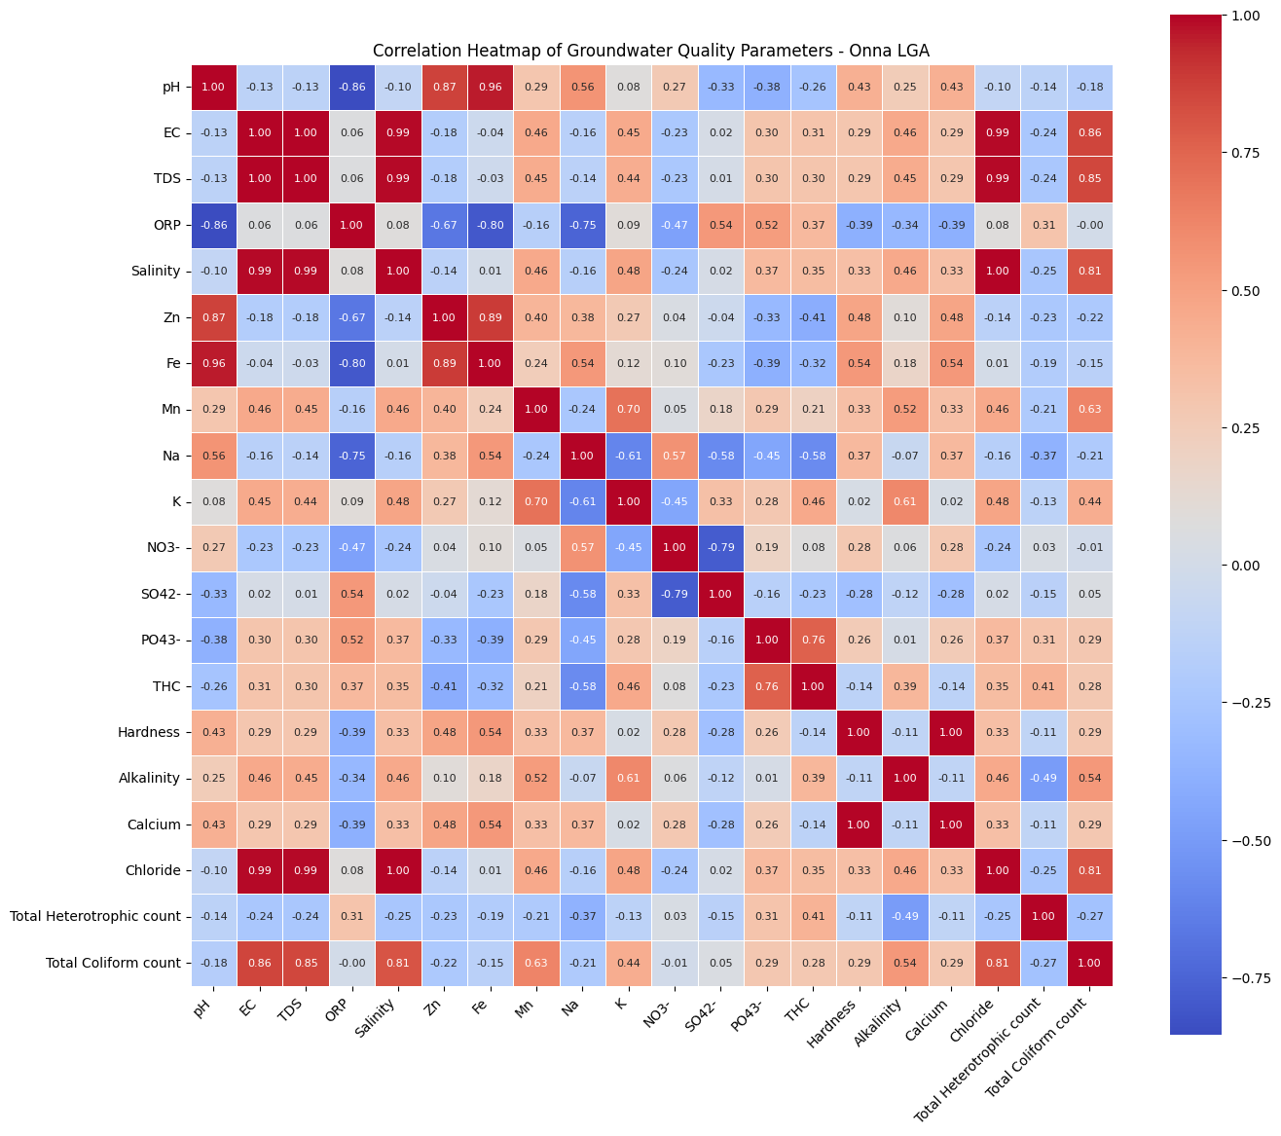

**Fig. 5 Correlation Heatmap of Groundwater Quality Parameters in sample sites**

**3.7 Water Quality Index**

Table 3 depicts the water quality index of the 10 sample sites, as well as their respective water quality status. The table reveal that, with the exception of ONN 2, the water quality of all sample sites is suitable for drinking. ONN 2 has a WQI of 620, which categorizes it an being unsuitable for human consumption. It is therefore necessary to inform the relevant stakeholders on the dangers posed by the bad quality of the groundwater in ONN 2 and the need for adequate water treatment before consumption.

**Table 3 Water Quality Index (WQI) and Water Quality Status (WQS) of the sample sites**

|  |  |  |  |
| --- | --- | --- | --- |
| Site ID | ∑QiWi | WQI | WQS |
| ONN 1 | 2.884043 | 2.884033 | Excellent |
| ONN 2 | 620.1018 | 620.0996 | Unsuitable for drinking |
| ONN 3 | 3.119621 | 3.119609 | Excellent |
| ONN 4 | 1.261843 | 1.261839 | Excellent |
| ONN 5 | 1.889609 | 1.889602 | Excellent |
| ONN 6 | 2.416248 | 2.41624 | Excellent |
| ONN 7 | 7.49843 | 7.498403 | Excellent |
| ONN 8 | 5.167864 | 5.167845 | Excellent |
| ONN 9 | 4.093674 | 4.093659 | Excellent |
| ONN 10 | 3.205834 | 3.205823 | Excellent |

4. Conclusion

The groundwater in ONNA LGA is generally fresh and low in TDS, but shows concerning acidity, heavy metal presence (Fe, Mn), and microbial contamination in certain locations. Intervention strategies such as filtration, disinfection, and improved borehole construction are recommended. However, the Water Quality Index of the sample sites indicate good water quality, with the exception of ONN 2. Therefore, relevant authorities need to take measures to safeguard the exposed populace in ONN 2 from attendant health hazards on consuming the groundwater.

AcknowledgEments

Authors acknowledge the financial support from Nigeria’s TERTFUND Institutional Based Research (IBR) Grant in the facilitation of this research.

Competing interests

Authors have declared that no competing interests exist.

Authors’ Contributions

Author IOE designed the study, performed the statistical analysis, wrote the protocol, and wrote the first draft of the manuscript. Author IOE, Author NEB and Author AOO managed the analyses of the study. Author IOE, Author COO and Author ODA managed the literature searches. All authors read and approved the final manuscript.

Disclaimer (Artificial intelligence)

Authors hereby declare that generative AI technologies such as CHATGPT and AI assisted Python programing have been used during the writing of manuscripts. This explanation will include the name, version, model, and source of the generative AI technology and as well as all input prompts provided to the generative AI technology

Details of the AI usage are given below:

1. CHATGPT-3.5 was used to generate some plots in the manuscript; however, the output from the AI chatbox was scrutinized to ensure its accuracy in the manuscript

2. Python 3.12 programming software was also used to generate some plots of the research result data

References

1. Abanyie, S. K., Apea, O. B., Abagale, S. A., Amuah, E. Y., & Sunkari, E. D. (2023). Sources and factors influencing groundwater quality and associated health implications: A review. Emerging Contaminants, 9(2), 100207
2. Devic, G. D., Djordjevic, D., & Sakan, S. (2014). Natural and anthropogenic factors affecting the groundwater quality in Serbia. Science of the Total Environment, 468, 933-942.
3. Indraja, P., Kumar, H. V. H., Mani , A., Reddy, K. V. S. R., & Rao, C. S. (2023). Estimation of Ground Water Recharge in the Command Area of Krishna Central Delta. International Journal of Environment and Climate Change, 13(12), 1317–1324. <https://doi.org/10.9734/ijecc/2023/v13i123798>
4. Yani, R. W. E., Palupi, R., Bramantoro, T., & Setijanto, D. (2019). Analysis of Calcium Levels in Groundwater and Dental Caries in the Coastal Population of an Archipelago Country. Open Access Marcedonian Journal of Medical Sciences, 14(7):134-138. doi: 10.3889/oamjms.2019.013
5. World Water Quality Alliance (2021). Assessing Groundwater Quality: A Global Perspective: Importance, Methods and Potential Data Sources. A report by the Friends of Groundwater in the World Water Quality Alliance. Information Document Annex for display at the 5th Session of the United Nations Environment Assembly, Nairobi 2021
6. Ubong, U. U., Ekwere, I. O., Ikpe, E. E., & Obadimu, C. O. (2021). Assessment of physicochemical properties and water quality index of borehole water in Mkpat Enin Local Government Area, Akwa Ibom State. International Journal of Chemistry Studies, 5 (2), 49-58
7. Dzwairo, B., Hoko, Z., Love, D., & Guzha, E. (2006). Assessment of the impacts of pit latrines on groundwater quality in rural areas: A case study from Marondera district, Zimbabwe. Physics and Chemistry of the Earth, Parts A/B/C,31(15-16):779-788
8. Essien, O. E., & Bassey, E. D. (2012). Spatial variation of borehole water quality with depth in Uyo Municipality, Nigeria. In 21st Century Watershed Technology: Improving Water Quality and Environment Conference Proceedings, May 27-June 1, 2012, Bari, Italy. 2012. American Society of Agricultural and Biological Engineers, 2012
9. Li, P., Karunanidhi, D., Subramani, T., & Srinivasamoorthy, K. (2021). Sources and Consequences of Groundwater Contamination. Arch. Environ. Contam. Toxicol. 80(1): 1-10. doi: 10.1007/s00244-020-00805-z
10. Ikpe, E. E., Etesin, U. M., Ubuo, E. E., & Ekwere, I. O. (2023). Bioaccumulation of Heavy Metals and Hydrocarbons in Sediment, Shell and Flesh of the Faunas in Qua-Iboe River at Ibeno, Akwa Ibom State, Nigeria. Asian Journal of Chemical Sciences, 13(6): 71-93.
11. Nwankwoala, H. O., & Udom, G. J. (2011). Hydrochemical Evaluation of Groundwater in Parts of Niger Delta. J. Acad. Ind. Res., 1(1), 48–58.
12. Carranzo, I. V. (2012). Standard Methods for examination of water and wastewater. in Anales De Hidrología Médica. Universidad Complutense de Madrid, 2012.
13. WHO (2011). Guidelines for drinking-water quality, World Health Organization Chronicle, 4(38): 104-108.
14. Standard Organisation of Nigeria (2015). Nigerian Standard for Drinking Water Quality, S.O.O. NIGERIA, Editor, NIGERIAN Industrial Standard: Abuja, Nigeria, 2015
15. Fataei, E., Seyyedsharifi, A., Seiiedsafaviyan, T., & Nasrollahzadeh, S. (2013). Water quality assessment based on WQI and CWQI Indexes in Balikhlou River, Iran. Journal of Basic Applied Sciences Research, 3(3): 263-269.
16. Jolaosho, T. L., Mustapha, A. A., & Hundeyin, S. T. (2024). Hydrogeochemical evolution and heavy metal characterization of groundwater from southwestern, Nigeria: An integrated assessment using spatial, indexical, irrigation, chemometric, and health risk models. Heliyon, 10(19), e38364
17. Wali, S. U., Dankani, I. M., Abubakar, S. D., Gada, M. A., Umar, K. J., Usman, A. A., & Shera, I. M. (2020). Re-examination of Hydrochemistry and Groundwater Potentials of Cross River and Imo-Kwa-Ibo Intersecting Tropical Basins of SouthSouth Nigeria. Journal of Geological Research, 2(3), 25–42. <https://doi.org/10.30564/jgr.v2i3.2142>
18. Nsi, E. W., Uwanta, E. J., Akpakpan, A. E., & Ekwere, I. O. (2020). Analytical Assessment of Borehole Water in Some Local Government Areas of Akwa Ibom State, South-South Nigeria. European Scientific Journal, 16(12):122-136.
19. Antai, H. R., Udom, G. J., & Nwankwoala, H. O. (2023). The Physico-Chemical Characteristics of Groundwater Quality in Some Coastal Areas of Akwa Ibom State, Nigeria. International Journal of Environment and Climate Change, 13(11), 1149-1160
20. Benmerabet, N., Sedrati, N., & Djabri, L. (2025). Hydrogeochemical processes, water–rock interactions, and the suitability of groundwater in a semi-arid region, Northeastern Algeria. Water Supply, 25(3), 404-423.
21. Guo, X., Lu, Y., Zhang, Q., Ren, J., & Cai, W. (2024). The Geological Characteristics, Resource Potential, and Development Status of Manganese Deposits in Africa. Minerals, 14(11), 1088. <https://doi.org/10.3390/min14111088>
22. OECD SIDS (2001). Potassium Hydroxide, SIDS Initial Assessment Report for SIAM 13, UNEP Publications. Bern, Switzerland, 6-9 November, 2001
23. WHO (2009) Potassium in drinking water. Background document for development of WHO Guidelines for Drinking water Quality WHO/HSE/WSH/09.01/7
24. Yani, R. W. E., Palupi, R., Bramantoro, T., & Setijanto, D. (2019). Analysis of Calcium Levels in Groundwater and Dental Caries in the Coastal Population of an Archipelago Country. Open Access Marcedonian Journal of Medical Sciences, 14(7):134-138. doi: 10.3889/oamjms.2019.013
25. Udo, A., Igboekwe, M., Chukwu, G, W., & Dedan, N. (2020). An Assessment of Nitrate Groundwater Pollution in an Agricultural Area in Akwa Ibom State, Nigeria. International Journal of Scientific and Engineering Research 11(2):89-99
26. Boy-Roura, M., Nolan, B. T., Menció, A., & Mas-Pla, J. (2013). Regression model for aquifer vulnerability assessment of nitrate pollution in the Osona region (NE Spain). Journal of Hydrology, 505, 150–162. https://doi.org/https://doi.org/10.1016/j.jhydrol.2013.09.048
27. Fennessy, M. S., & Cronk, J. K. (1997). The effectiveness and restoration potential of riparian ecotones for the management of nonpoint source pollution, particularly nitrate. Critical Reviews in Environmental Science and Technology, 27(4), 285–317. https://doi.org/10.1080/10643389709388502
28. Knobeloch, L., Salna, B., Hogan, A., Postle, J., & Anderson, H. (2000). Blue babies and nitrate-contaminated well water. Environmental Health Perspectives, 108(7), 675–678. https://doi.org/10.1289/ehp.00108675
29. Yu, G., Wang, J., Liu, L., Li, Y., Zhang, Y., & Wang, S. (2020). The analysis of groundwater nitrate pollution and health risk assessment in rural areas of Yantai, China. BMC Public Health, 20:437. https://doi.org/10.1186/s12889-020-08583-y
30. Trick, J. K., Stuart, M., & Reeder, S. (2018). Contaminated Groundwater Sampling and Quality Control of Water Analyses. In Vivo, B., Belkin, H. E & Lima, A (eds) Environmental Geochemistry: Site Characterization, Data Analysis and Case Histories (2nd ed) Elsevier, 25-45
31. Nogueira, G., T. Y., Stigter, Y., Zhou, F., & Mussa, D. (2019). Understanding groundwater salinization mechanisms to secure freshwater resources in the water-scarce city of Maputo, Mozambique. Science of The Total Environment, 661, 723-736
32. Chen X., Jiang, C., Zheng, L., Zhang, L., Fu, X., Chen, S. et al. (2021). Evaluating the genesis and dominant processes of groundwater salinization by using hydrochemistry and multiple isotopes in a mining city. Environmental Pollution, 283, 117381
33. McDonough, L. K., Santos, I. R., Andersen, M. S., O’Carroll, D. M., Rutlidge, H., Meredith, K., et al. (2020). Changes in global groundwater organic carbon driven by climate change and urbanization. Nature Communications, 11(1), 1279. https://doi.org/10.1038/s41467-020-14946-1
34. Zhang, Z., Hu, H., Tian, F., Yao, X., & Sivapalan, M. (2014). Groundwater dynamics under water-saving irrigation and implications for sustainable water management in an oasis: Tarim River basin of western China. Hydrol. Earth Syst. Sci., 18(10), 3951–3967. https://doi.org/10.5194/hess-18-3951-2014
35. Foster, S., Pulido-Bosch, A., Vallejos, Á., Molina, L., Llop, A., & MacDonald, A. M. (2018). Impact of irrigated agriculture on groundwater-recharge salinity: a major sustainability concern in semi-arid regions. Hydrogeology Journal, 26(8), 2781–2791. https://doi.org/10.1007/s10040-018-1830-2
36. World Health Organization (WHO). (2017). Guidelines for drinking-water quality: Fourth edition incorporating the first addendum. Geneva: WHO.
37. Gebremedhn, G., Berhe, A. A., Desta, A. A., & Legesse, L. (2019). Is Drinking Water Sources Safe for Drink? A Multicenter Assessment of Fecal Contamination of Drinking Water Sources in Tigray Region, Ethiopia. Springer Science and Business Media LLC. https://doi.org/10.21203/rs.2.9449/v1
38. Olufemi, A. (2010). Assessment of Groundwater Quality and Saline Intrusions in Coastal Aquifers of Lagos Metropolis. Nigeria. Journal of Water Resource and Protection, 2, 849-853. https://doi.org/10.4236/jwarp.2010.210100