**Theoretical investigation on mechanism and kinetics of M2CAA initiated by Cl atom in the atmosphere**

**ABSTRACT**

Methyl 2-chloroacetoacetate (M2CAA) is a class of volatile organic compound which finds their place in atmosphere by anthropogenic sources. The present study focused on the hydrogen abstraction reaction of M2CAA by Cl atom. The fate of these M2CAA is however poorly understood and scarcely taken into account in atmospheric chemistry modeling. The objective of this study was to explore the mechanistic and kinetic data relative to Cl oxidation in the atmospheric degradation of M2CAA. A comprehensive theoretical investigation was conducted to elucidate the mechanism, kinetics, and thermochemistry of the gas-phase reactions between Methyl 2-chloroacetoacetate (CH₃C(O)CHClC(O)OCH₃, M2CAA) and Chlorine atoms using the M06-2X functional. The most thermodynamically stable conformer of M2CAA was identified at ambient temperature. Three primary hydrogen abstraction pathways were characterized, each proceeding through the formation of a pre-reactive complex, indicating that the reactions follow an indirect hydrogen abstraction mechanism. Rate coefficients for these pathways were calculated for the first time over a temperature range of 250–450 K using Canonical Transition State Theory (CTST). Based on these kinetic results, the atmospheric lifetime of M2CAA was estimated to be approximately 1.85 days. From these results, it can be emphasize that the hydrogen abstraction from the −CHCl group is kinetically more advantageous than the other two reaction pathways i.e. abstraction from –CH3 and – COOCH3 group.

**Keywords:** Chloroacetoacetate, DFT, IRC calculation, Rate constant, Atmospheric lifetime

1. **INTRODUCTION**

“In recent decades, it has been stated that volatile organic compounds (VOCs), most likely hydrofluoroethers (HFEs), are widely acknowledged and recommended as a third-generation alternative to hydrofluorocarbons (HFCs), hydrochlorofluorocarbons (HCFCs), and chlorofluorocarbons (CFCs). These substances are used in refrigerator heat transfer fluid, foam blowing agents, lubricant deposition, and electronic equipment cleaning” (Devotta et al., 1994., sekiya and Misaki., 2000, Powell., 2002). The primary mechanisms for HFE degradation in the atmosphere may be initiated in coastal locations by reactions with OH radicals and Cl atoms, as well as possibly with aerosols containing chloride from highly mechanized metropolitan areas.

Solvents, fuel additives, and cleaning and disinfection chemicals are all made with oxygenated volatile organic compounds, (OVOCs.) These substances can primarily undergo chemical transformations when released into the atmosphere, producing reaction products that may be more dangerous than the precursors (Zhou et al., 2006; Christensen et al., 2000). OH radical-initiated photo oxidation processes are the primary pathway for OVOC oxidation in the troposphere (han et al., 2018; Bouzidi et al., 2015). The family of Oxygenated Volatile Organic Compounds (OVOCs) known as carbonyl esters includes methyl 2-chloroacetoacetate (M2CAA) and ethyl 2-chloroacetoacetate (E2CAA) as reported by DeMore et al., 1997. These VOCs have an oxygen bond that increases the reactivity of the molecule's neighboring hydrogen atoms to tropospheric oxidants like photolysis or OH or Cl radicals. Acetates have been widely released into the atmosphere as a result of industrial activity; these oxygenated volatile organic compounds will react with the primary tropospheric oxidants (Blanco et al., 2016; Bravo et al., 2011).

Chemical transformation is the primary determinant of these chemicals' destiny in the atmosphere. The primary cleaner in the marine boundary layer, chlorine atoms are crucial to the breakdown of OVOCs-initiated photo oxidation processes, which are brought on by the addition of a double bond or by mechanisms of hydrogen atom abstraction (Atkinson et al., 1997). Similarly, larger concentrations of Cl atoms, which can reach 1×105 atoms cm−3 or more, in marine or heavily industrialized (Blanco et al., 2012) environments may result in competitive interactions with the OH radical that triggered the breakdown of these VOCs (Blanco et al., 2009).

“Certain OVOCs, such as chloroacetoacetates, which are commonly employed as anti-slime antimicrobial and pesticide agents to eradicate slime-producing microorganisms such algae, fungi, and slime molds on pools, are released by the paper industry. These substances can be transmitted to water reservoirs or evaporate into the atmosphere if they are often used as insecticides. Instead of dry and wet deposition, chemical transformation is the primary determinant of the sink of OVOCs, such as esters and haloesteres. Methyl 2-chloroacetoacetate was used in one-pot synthesis of 2-arylimidazole-4-carboxylic acidsand 3,5-disubstituted 1,2,4-triazoles” (Yoburn and Baskaran, 2005; Tseng et al., 2011). To ascertain their environmental impact on the quality of air and other matrices, kinetic and mechanistic analyses of the degradation of chloroacetoacetates triggered by interaction with Cl radicals are pertinent. A well-defined theoretical study is very desirable in order to identify the feasible mechanism and gain a better grasp of the kinetics of the title reaction. In order to gain a more thorough knowledge of the title reaction, we presented a thorough theoretical analysis of the hydrogen abstraction reaction between M2CAA and Cl radical as an addition to the experiments.



However, there has only been one experimental research project on kinetic of M2CAA + Cl reaction as far as we know. Recently, Straccia et al., (2023) reported the Rate coefficients for the gas-phase reactions of Cl radical with M2CAA using the relative technique with different reference compounds. They reported a rate constant value as (2.54 ± 0.81) ×10-10 cm3 molecule−1 s−1at (298 ± 2) K. It has been also reported that by employing structure activity relationship (SAR) method, Aschmann and Atkinson, (1995) estimated rate coefficients for the reactions of M2CAA with Cl atoms. The SAR value for the reaction of M2CAA with chlorine atoms is established to be 3.68×10-11 cm3 molecule−1 s−1. As far as we are aware, this is the first thorough theoretical investigation of M2CAA's H-abstraction interactions with Cl radical. We think that our work will be helpful for a better understanding of this significant reaction, since experimental study mainly provides just the overall rate constant.



**2. COMPUTATIONAL METHODS**

We performed all the computational quantum calculations work using Gaussian 09 program package (Frisch et al., 2009). The electronic structures of the reactants (Rs), reaction complexes (RCs), product complexes (PCs), transition states (TSs) and products (Ps) were optimized using hybrid density functional M06-2X (Zhao and Truhlar, 2008) along with 6-31+G(d,p) basis set. Further, we were carried out frequency calculations of all the optimized species using the same M06-2X /6-31+G(d,p) method. From frequency analysis, we found that for stable species, these were no imaginary frequencies which ensure these molecules to have either local or global minima energies while for the TSs, we found one imaginary frequency to ensure it has maxima along the reaction coordinate. Previous reports (Gour et al., 2020; Lily et al., 2014; Rao et al., 2018; Baidya et al., 2020; Paul et al., 2020; Gour et al., 2017) have demonstrated that this hybrid density functional, M06-2X, produces satisfactory results for thermochemistry and kinetics for the hydrogen abstraction reactions for the volatile organic compounds. In order to validate to correct TSs which was really connecting the reactant and product species, we performed IRC calculation (Gonzalez and Schegel, 1989) throughout the reaction channels.

**3. RESULTS AND DISCUSSION**

We first identified the most stable M2CAA conformers using scan calculations, and we then chose the most stable conformer for further study. For the hydrogen abstraction reactions, we have considered three reaction routes (1-3), mainly hydrogen abstraction from the −CH3 group, −CHCl group, and −COOCH3 group. It can be seen from the geometrical parameters and stereographical orientation, the hydrogen atoms in the –CH3 group and −COOCH3 groups are not equivalent. The stereographic environment of one H-atom (C7-H8) is different from the other two (C7-H9 and C7-H10) in the –CH3 group as shown in Fig.1. Therefore, two transition states should be located for reaction channels 1 and 3. However, only one transition state could be located for hydrogen abstraction from the –CH3 group and −COOCH3 groups. Therefore, we have presented only one reaction channel each for reactions 1 and 3. Thus, we have located three transition states namely TS1, TS2 and TS3, respectively for three reaction channels (1 – 3). Pre-reactive complexes (RC1, RC2, and RC3) have been found in the entrance channel for reactions (1-3) in the current investigation. The exit channel also contains product complexes, referred to as PC1, PC2 and PC3. These product complexes have energies lower than the corresponding products before the final product is distributed. Therefore, it is clear that the reaction channels (1-3) may employ indirect procedures. The least energy path was used to find stationary spots on a relaxed potential energy surface. Figs. 1 and 2 show the electronic structure of the optimized geometry of the reactant, products, reaction complexes, product complexes, and transition states that were produced at the M06-2X/6-31+G(d,p) level. Regarding thermochemistry, the thermocchemical properties such as reaction enthalpies (ΔrH°) and free energies (ΔrG°) were derived to determine the nature of reaction channels (1-3). At the M06-2X/6-31+G(d,p) level, the precise thermodynamic calculations for reaction enthalpies (ΔrH°) and free energies (ΔrG°) at 298 K for loss processes (1−3) are documented in Table 1. These thermodynamic functions were determined with thermal corrections to the energy at 298 K. The calculated ΔrH° and ΔrG° values at 298 K indicate that the decomposition pathways taken into consideration in this investigation are feasible and spontaneous. The results reported in Table 1 clearly suggests that the reaction channel 2 is more thermodynamically viable. Because ΔrH°298 >0, the results also show that reaction channels 1& 2 are exothermic in nature while reaction channel 3 is endothermic in nature.

“The C−H bond of the departing hydrogen and the newly generated bond between the H and Cl atom are crucial structural characteristics that must be monitored throughout the development of transition states. The breaking C−H bond length is 25.87% greater than the observed C−H bond length in the isolated M2CAA molecule, while the forming H...Cl bond length is 19.5% longer than the H−Cl bond length in isolated HCl molecule, according to a visualization of the optimized structures of TS1 for reaction 1. This implies that the barrier of the reaction 1 is closer to the product. It is emphasized that the reactions with Cl atoms proceed via late transition state which is in consonance with Hammond’s postulate” (Hammond, 1995). Similarly, for transition state TS2 for reaction 2, the length of the breaking C-H bond (C15-H12) is found to be longer by 17.56% than the observed C-H bond length in isolated M2CAA molecule whereas the forming H...Cl bond length is longer by 21.48% than the H-Cl bond length in isolated HCl molecule. This implies that the barrier of the reaction 2 is closer to the reactant, and that the reactions with Cl atoms proceed via early transition state. Visualization of the optimized structures of TS3 for reaction 3 reveals that the length of the broken C-H bond (C3 −H6) is 29.77% longer than the C−H bond length that was determined in the isolated M2CAA molecule.

Table 2 presents the results of the harmonic vibrational frequency calculation at the M06-2X/6-31+G(d,p) level. Each transition state has one imaginary frequency due to its first order saddle point character. The minima species like reactants, reactant complexes (RCs), product complexes (PCs), and products were optimized with no imaginary frequency (NIMAG = 0). The Cl7–H8 and C7–H8 stretching modes are represented by the imaginary frequency of TS1 for reaction channel (1), which is 1115 cm−1. This also shows a considerable curvature in the potential energy surface (PES) surrounding the transition state.‬ The imaginary frequency for the hydrogen abstraction from the −CHCl group involving TS2 is determined to be −1010 cm

“The representation of the normal-mode corresponding to the calculated imaginary frequencies shows a clear transition state geometry connecting reactants and products during transition. To further ascertain whether a transition state exists on the potential energy surface, the intrinsic reaction coordinate (IRC) calculation” (Gonzalez and Schlegel, 1989) is performed at the same theoretical level using the Gonzalez-Schlegel steepest descent path in the mass-weighted Cartesian coordinates with a step size of 0.01(amu1/2- bohr). “Additional proof that the transition state truly connects the intended reactant and product along the corresponding potential energy surface is given by the results of IRC calculations, which are shown in Fig. 3. Table 3 summarizes the energy of each optimized geometry used in this study, which was determined using the M06-2X/6-311++G(d,p) method. We employed the species' optimal geometries, M06-2X/6-31+G(d,p), for the energetic computation. Using frequency calculation data at the M06-2X/6-31+G(d,p) level of theory, optimization was carried out to find each species' zero-point energy. Zero-point energy (ZPE) corrected total energies were calculated with a scale factor of 0.967” (Alecu et al., 2010). The total energy of the reactants R + Cl, (M2CAA + Cl) is set to be zero for reference, and the values in parentheses are relative energies in kcal mol−1 with reference to reactants.Fig. 4 shows a schematic potential energy profile of M2CAA reactivity with Cl atom that was acquired at the M06-2X level using zero-point energy (ZPE) adjustments. Zero-point energy corrected total energy has been used in the energy diagram's development. For TS1, TS2, and TS3, the energy barrier determined at the M06-2X/6-31+G(d,p) level is 1.65, −0.78, and 0.62 kcal mol−1, respectively. The barrier height values suggest that hydrogen abstraction by Cl atom from the −CHCl group of M2CAA is more facile than that from the –CH3 or –COOCH3 group.

**3.1 KINETICS CALCULATION**

The conventional transition state theory (CTST) (Laidler, 2004) and Eckart's tunneling correction (Xiao et al., 2014) were used to calculate the rate coefficient values for various reaction channels spanning the 250–450 K temperature range using the following formula.



The σ represents symmetry factor whereas tunneling correction factor at temperature T is represented by the symbol Γ(T). The total partition functions (per unit volume) for the reactants and transition states are denoted by QR and ,, respectively. R stands for the universal gas constant, kB for the Boltzmann constant, h for Planck's constant, and ΔE for the barrier height incorporating zero point energy correction. In present work, the kinetic rate coefficients for reaction pathways (1−3) were performed by means of the Kinetic and Statistical Thermodynamical Package (KiSThelP) programme (Canneaux et al., 2014). The obtained rate coefficients in the temperature range of 250 – 450 K for reaction pathways (1–3) are recorded in Table 4. At 298 K, our calculated rate constants for TS1, TS2, and TS3 were found to be 7.83×10−13 , 1.17×10−11 and 6.40×10−12 cm3 molecule−1 s-1 respectively at M06-2X/6-31+G(d,p) level of theory. The computed overall kCl value for M2CAA with Cl atom reaction using the M06-2X barrier height is found to be 1.90×10−11 cm3 molecule−1 s−1 at 298 K. Our calculated rate constant for the reaction of M2CAA with Cl atom is in good agreement with the reported SAR value of 3.68 × 10−11 cm3 molecule−1 s−1 (Aschmann and Atkinson, (1995). However, our calculated value is slightly lower than the value of rate constant (2.16 ± 0.85) ×10-10 cm3 molecule−1 s−1 at (298 ± 2) K by Straccia et al., (2023). The percentage branching ratios for each of the reaction channels determined at 298 K are found to be 4.14, 62.10 and 3376 %, respectively. From these results, it can be emphasize that the hydrogen abstraction from the −CHCl group is kinetically more advantageous than the other two reaction pathways i.e. abstraction from –CH3 and – COOCH3 group.



**3.2 ATMOSPHERIC LIFETIME**

In general, tropospheric lifetime (τeff) of M2CAA can be estimated by assuming that its removal from troposphere occurs only through the reactions with Cl atoms. Then (τeff) can be expressed as (Kurylo and Orkin, 2003),

τeff = τCl(4)

where, τCl = (kCl × [Cl])-1. Using the 298 K value of kCl = 1.90×10-11 cm3 molecule−1 s−1 and the global average atmospheric Cl concentrations of 3.3 ×104 molecule cm−3 (Wingenter et al., 1996), the estimated atmospheric lifetime of M2CAA is found to be 1.85 days which is in good agreement with the reported value of 1.57 days by Straccia et al., (2023).

**4. CONCLUSIONS**

In this study we have explored the atmospheric and environmental consequence of M2CAA molecule initiated by Cl atom by employing M06-2X/6-31+G(d,p) level of theory. We have done various inquires involving the optimization of structural parameters, energy profiles, thermochemistry and kinetics of the M2CAA with Cl radical. For that, we have identified three reaction channels which follow an indirect path through the formation of pre- and post- reaction complexes on the potential energy surface. In this manuscript, we applied an effective as well as reliable computational strategy for predicting accurately the tropospheric reactivity of the titled molecule and atmospheric implications. All rate constants, computed by canonical transition state theory. The rate coefficients for the M2CAA with Cl atom, manifests positive temperature influence at 250–450 K and the rate constant at 298 K is found to be 3.68×10−11 cm3 molecule−1 s−1 which is in reasonable agreement with the limited experimental data. The atmospheric lifetime for M2CAA molecule is estimated to be 1.85 days. From our theoretical study along with experimental evidence it can be concluded that hydrogen abstraction from –CHCl group is more facile than that from methyl group.

Authors Contributions  
Nabam Tayum and Nand Kishor Gour have performed theoretical calculations. Arumugam Murugan and Bhupesh Kumar Mishra have supervised, reviewed and drafted the manuscript. All authors read and approved the final manuscript.

**CONFLICTS OF INTEREST**

The authors declare no conflicts of interest.

**ACKNOWLEDGMENTS**

The authors acknowledge financial support from the Department of Science and Technology, New Delhi in the form of project under DST-SERB CRG scheme (CRG/2023/002561). BKM is also thankful to Directorate of Higher and Technical Education, Government of Arunachal Pradesh for providing research grant. Nabam Tayum is thankful to Ministry of Tribal Affairs, Govt. of India for providing national Fellowship & Scholarship for Higher Studies (Award No: 202122-NFST-ARU-00279).

**DISCLAIMER (ARTIFICIAL INTELLIGENCE)**

Author(s) hereby declare that NO generative AI technologies such as Large Language Models (ChatGPT, COPILOT, etc.) and text-to-image generators have been used during the writing or editing of this manuscript.

**DISCLOSURE STATEMENT**

No potential conflict of interest was reported by the author(s).

**REFERENCES**

Alecu, I. M., Zheng, J., Zhao. Y., & Truhlar, D. G. (2010). Computational Thermochemistry:

Scale Factor Databases and Scale Factors for Vibrational Frequencies Obtained from

Electronic Model Chemistries. *Journal of Chemical Theory and Computation, 6*, 2872-

2887. <https://pubs.acs.org/doi/10.1021/ct100326h>

Aschmann, S. M., & Atkinson, R. (1995). Rate constants for the gas-phase reactions of

alkanes with Cl atoms at 296±2 K. *International Journal of Chemical Kinetics, 27,*

613–622. <https://onlinelibrary.wiley.com/doi/abs/10.1002/kin.550270611>

Atkinson, R., Baulch, D. L., Cox, R. A., Hampson, R. F. J., Kerr, J. A., Rossi, M. J., & Troe,

J. (1997). Evaluated Kinetic and Photochemical Data for Atmospheric Chemistry:

Supplement VI. IUPAC Subcommittee on Gas Kinetic Data Evaluation for

Atmospheric Chemistry. *Journal of Physical Chemical Reference Data, 26,* 521–

1011. <https://doi.org/10.1063/1.556010>

Baidya, B., Lily, M., Patgiri, D., Hynniewta, S., & Chandra, A. K. (2020).

CHF2CF2OCHF2: conformational analysis and direct dynamics study of its reaction

with Cl atoms and atmospheric fate. *New Journal of Chemistry, 44,* 4276-4284.

<https://doi.org/10.1039/C9NJ06069C>

Blanco, M. B., Barnes, I., Wiesen, P., & Teruel, M. A. (2016). Atmospheric sink of methyl

chlorodifluoroacetate and ethyl chlorodifluoroacetate: temperature dependent rate coefficients, product distribution of their reactions with Cl atoms and CF2ClC(O)OH formation. *RSC Advances 6,* 51834-51844. <https://doi.org/10.1039/C6RA03454C>

Blanco, M. B., Bejan, I., Barnes, I., Wiesen, P., & Teruel, M. A. (2012). Atmospheric

Oxidation of Vinyl and Allyl Acetate: Product Distribution and Mechanisms of the

OH-Initiated Degradation in the Presence and Absence of NOx. *Environmental*

*Science & Technology, 46,* 8817-8825.

<https://pubs.acs.org/doi/abs/10.1021/es3015869>

Blanco, M. B., Bejan, I., Barnes, I., Wiesen, P., & Teruel, M. A. (2009). OH-Initiated

Degradation of Unsaturated Esters in the Atmosphere: Kinetics in the Temperature

Range of 287−313 K. *The Journal of Physical Chemistry A, 113(20),* 5958–5965.

<https://pubs.acs.org/doi/abs/10.1021/jp901755x>

Bouzidi, H., Aslan, L., Dib, G. E., Coddeville, P., Fittschen, C., & Tomas, A, (2015),

Investigation of the Gas-Phase Photolysis and Temperature-Dependent OH Reaction

Kinetics of 4-Hydroxy-2-butanone. *Environmental Science & Technology, 49,* 12178-

12186. <https://pubs.acs.org/doi/10.1021/acs.est.5b02721>

Bravo, I., Diaz-de-Mera, Y., Aranda, A., Moren,o E., Nutt, D. R., & Marston, G. (2011).

Radiative efficiencies for fluorinated esters: indirect global warming potentials of

hydrofluoroethers. *Physical Chemistry Chemical Physics 13,* 17185-17193.

<https://pubs.rsc.org/en/content/articlelanding/2011/cp/c1cp21874c>

Canneaux, S., Boh, F., & Henon, E. (2014). KiSThelP: a program to predict thermodynamic

properties and rate constants from quantum chemistry results. *Journal of*

*Computational Chemistry, 35,* 82-93.

<https://onlinelibrary.wiley.com/doi/10.1002/jcc.23470>

Christensen, L. K., Ball, J. C., & Wallington, T. J. (2000) Atmospheric Oxidation Mechanism

of Methyl Acetate. *The Journal of Physical Chemistry A, 104,* 345-351.

<https://pubs.acs.org/doi/abs/10.1021/jp993127n>

DeMore, W. B., Howard, C. J., Sander, S. P., Ravishankara, A. R., Golden, D. M,, Kolb, C.

E., Hampson, R. F., Molina, M. J., & Kurylo, M. J. (1997). Chemical Kinetics and

Photochemical Data for Use in Stratospheric Modeling Evaluation, Vol. 4. NASA. JPL

Publication.

<https://jpldataeval.jpl.nasa.gov/pdf/Atmos97_Anotated.pdf>

Devotta, S., Gopichand, S., & Pendyala, V. R. (1994). Comparative assessment of some

HCFCs, HFCs and HFEs as alternatives to CFC11. International Journal of

Refrigeration, 17, 32–39. <https://doi.org/10.1016/0140-7007(94)90084-1>

Frisch, M. J. *et al*. (2009). Gaussian 09 (Revision B.01); Gaussian Inc.; Wallingford, CT.

Gonzalez, C., Schlegel, H. B. (1989). An improved algorithm for reaction path following

*Journal of Chemical Physics, 90,* 2154-2161. <https://doi.org/10.1063/1.456010>

Gour, N. K., Borthakur, K., Paul, S., & Deka, R. C. (2020). Degradation of 2-fluoropropene

(CH3CF=CH2) initiated by hydroxyl radical: reaction mechanisms, kinetics and

atmospheric implications from DFT study. *Chemosphere 238,* 124556.

<https://www.sciencedirect.com/science/article/abs/pii/S0045653519317801>

Gour, N. K., Mishra, B. K., Sarma, P. J., Begum, P., & Deka, R. C. (2017). Tropospheric

degradation of HFE-7500[n-C3F7CF(OCH2CH3)CF(CF3)2] initiated by OH radicals

and Fate of alkoxy radical [n-C3F7CF(OCH(O)CH3)CF(CF3)2]: A DFT

investigation. *Journal of Fluorine Chemistry, 204,* 11–17.

<https://www.sciencedirect.com/science/article/abs/pii/S0022113917303822>

Hammond, G. S. (1955). A Correlation of Reaction Rates, *Journal of the American Chemical*

*Society, 77*, 334-338.

<https://pubs.acs.org/doi/10.1021/ja01607a027>

Han, L., Siekmann. F., & Zetzsch, C. (2018). Rate Constants for the Reaction of OH

Radicals with Hydrocarbons in a Smog Chamber at Low Atmospheric Temperatures.

*Atmosphere, 9,* 320.

<https://www.mdpi.com/2073-4433/9/8/320#metrics>

Kurylo, M. J., & Orkin, V. L. (2003). Determination of Atmospheric Lifetimes via the

Measurement of OH Radical Kinetics, *Chemical Reviews, 103,* 5049-5076.

<https://pubs.acs.org/doi/abs/10.1021/cr020524c>

Lily, M., Mishra, B. K., & Chandra. A. K. (2014). Kinetics, mechanism and thermochemistry

of the gas phase reactions of CF3CH2OCH2CF3 with OH radicals: A theoretical

study. *Journal of Fluorine Chemistry, 161,* 51-59.

<https://www.sciencedirect.com/science/article/abs/pii/S0022113914000621>

Paul, S., Mishra, B. K., Baruah, S. D., & Deka, R. C. (2020). Atmospheric oxidation of HFE-

7300 [n-C2F5CF(OCH3)CF(CF3)2] initiated by •OH/Cl oxidants and subsequent degradation of its product radical: a DFT approach. *Environmental Science and Pollution Research 27,* 907-920. <https://link.springer.com/article/10.1007/s11356-019-06975-1>

Powell, R. L. (2002). CFC phase-out: have we met the challenge? *Journal of Fluorine*

*Chemistry, 114,* 237-250.

<https://www.sciencedirect.com/science/article/abs/pii/S0022113902000301>

Rao, P. K., Deka, R. C., Gour, N. K., & Gejji, S. P. (2018). Understanding the Atmospheric

Oxidation of HFE-7500 (C3F7CF(OC2H5)CF(CF3)2) Initiated by Cl Atom and NO3

Radical from Theory. *The Journal of Physical Chemistry A, 122*, 6799–6808 .

<https://pubs.acs.org/doi/abs/10.1021/acs.jpca.8b04225>

Sekiya, A., & Misaki, S. (2000). The potential of hydrofluoroethers to replace CFCs, HCFCs

and PFCs. *Journal of Fluorine Chemistry,*101, 215–221.

<https://doi.org/10.1016/S0022-1139(99)00162-1>

Straccia, V. G. C., Lugo, P. L., Rivela, C. B., Blanc, M. B., & Teruel, M. (2023).

Atmospheric degradation of chloroacetoacetates by Cl atoms: Reactivity, products and

mechanism in coastal and industrialized areas. *Atmospheric Environment, 309*, 119925.

<https://www.sciencedirect.com/science/article/abs/pii/S1352231023003515>

Tseng, W. C., Wang, L. Y., Wu, T. S., & Wong, F. F. (2011). One-flask’ synthesis to 3,5-

disubstituted 1,2,4-triazoles from aldehydes with hydrazonoyl hydrochlorides via 1,3-dipolar cycloaddition. *Tetrahedron, 67,* 5339-5345.

<https://doi.org/10.1016/j.tet.2011.05.003>

Wingenter, O. W., Kubo, M. K., Blake, N. J., Smith, T. W., Blake, D. R., & Rowland, F. S.

(1996). Hydrocarbon and halocarbon measurements as photochemical and dynamical indicators of atmospheric hydroxyl, atomic chlorine, and vertical mixing obtained during Lagrangian flights, *Journal of Geophysical Research, 101,* 4331-4340. <https://agupubs.onlinelibrary.wiley.com/doi/abs/10.1029/95JD02457>

Xiao, R., Noerpel, M., Luk, H. L., Wei, Z., & Spinney, R. (2014). Thermodynamic and

kinetic study of ibuprofen with hydroxyl radical: A density functional theory approach. *International Journal of Quantum Chemistry, 114,* 74–83.

<https://onlinelibrary.wiley.com/doi/10.1002/qua.24518>

Yoburn, J. C.,& Baskaran, S. (2005). Chemoselective Arylamidine Cyclizations:  Mild

Formation of 2-Arylimidazole-4-carboxylic Acids. *Organic letters, 7,* 3801-3803.

<https://pubs.acs.org/doi/10.1021/ol0514855>

Zhao, Y., & Truhlar, D. G. (2008). The M06 suite of density functionals for main group

thermochemistry, thermochemical kinetics, noncovalent interactions, excited states, and

transition elements: two new functionals and systematic testing of four M06-class

functionals and 12 other functional. *Theoretical Chemistry Accounts, 120,* 215-241.

<https://link.springer.com/article/10.1007/s00214-007-0310-x>

Zhou, S., Barnes. I., Zhu, T., Klotz, B., Albu, M., Bejan, I., & Benter, T. (2006). Product

Study of the OH, NO3, and O3 Initiated Atmospheric Photooxidation of Propyl Vinyl

Ether. *Environmental Science & Technology, 40,* 5415-5421.

<https://pubs.acs.org/doi/10.1021/es0605422>

**Table 1** Thermochemical data (kcal mol−1.) for reaction channels (1−3) calculated at M06-2X/6-31+G(d,p) level of theory at 298 K.

|  |  |  |
| --- | --- | --- |
| Reaction channels | **ΔrH°298** | **ΔrG°298** |
| Reaction 1 | −4.54 | −36.29 |
| Reaction 2 | −11.72 | −44.07 |
| Reaction 3 | 0.17 | −32.58 |

**Table 2** Harmonic vibrational frequencies of reactants, transition states and products at M06-2X/6-31+G(d,p) level of theory.

|  |  |
| --- | --- |
| **Species** | **Vibrational Frequencies (cm-1)** |
| CH3C(O)CHClC(O)OCH3  (M2CAA) | 32, 64, 88, 104, 170, 182, 205, 243, 313, 343, 408, 498, 568, 681, 766, 798, 906, 942, 1015, 1034, 1079, 1182, 1184, 1214, 1236, 1281, 1366, 1403, 1470, 1479, 1486, 1499, 1508, 1866, 1898, 3079, 3092, 3131, 3155, 3179, 3195, 3211 |
| TS1 | 1115i, 14, 35, 62, 86, 90, 143, 181, 201, 242, 313, 330, 372, 400, 437, 524, 577, 685, 775, 803, 896, 925, 950, 979, 1027, 1076, 1138, 1185, 1203, 1219, 1240, 1296, 1368, 1451, 1488, 1501, 1505, 1805, 1900, 3095, 3142, 3154, 3181, 3222, 3263 |
| TS2 | 1010i, 28, 65, 73, 82, 111, 121, 158, 166, 194, 229, 277, 336, 359, 430, 510, 562, 690, 775, 809, 896, 941, 988, 1019, 1055, 1084, 1114, 1187, 1220, 1235, 1345, 1409, 1471, 1479, 1488, 1501, 1506, 1852, 1885, 3085, 3097, 3163, 3188, 3199, 3216, |
| TS3 | 816i, 14, 34, 44, 70, 118, 160, 189, 220, 244, 338, 357, 387, 417, 491, 521, 568, 706, 734, 772, 879, 912, 955, 981, 999, 1043, 1190, 1203, 1225, 1243, 1254, 1303, 1308, 1405, 1467, 1471, 1479, 1874, 1907, 3079, 3145, 3154, 3155, 3197, 3288 |
| RC1 | 26, 32, 66, 76, 101, 123, 159, 173, 186, 213, 244, 324, 355, 414, 496, 567, 705, 742, 777, 897, 925, 999, 1044, 1107, 1186, 1200, 1225, 1252, 1308, 1359, 1405, 1471, 1481, 1489, 1497, 1507, 1868, 1883, 3075, 3094, 3144, 3150, 3182, 3194, 3212, |
| RC2 | 29, 37, 57, 72, 99, 117, 141, 160, 189, 208, 242, 314, 343, 406, 502, 568, 677, 766, 798, 905, 942, 1014, 1037, 1078, 1183, 1185, 1214, 1238, 1286, 1371, 1404, 1470, 1480, 1487, 1497, 1506, 1871, 1897, 3085, 3096, 3130, 3159, 3182, 3202, 3218 |
| RC3 | 18, 28, 60, 81, 111, 127, 154, 176, 189,219, 250, 315, 345, 411, 498, 572, 680, 767, 801, 910, 946, 1015, 1038, 1077, 1183, 1185, 1217, 1241, 1283, 1377, 1406, 1472, 1484, 1487, 1495, 1508, 1848, 1872, 3080, 3096,3133, 3154, 3186, 3201, 3214 |
| PC1 | 34, 44, 52, 93, 103, 132, 186, 189, 213, 244, 314, 368, 407, 420, 427, 502, 565, 568, 735, 763, 803, 845, 932, 962, 1023, 1068, 1188, 1210, 1241, 1262, 1320, 1398, 1483, 1495, 1503, 1506, 1632, 1844, 2699, 3103, 3162, 3191, 3213, 3227, 3334 |
| PC2 | 16, 41, 63, 101, 118, 146, 167, 178, 197, 240, 269, 320, 363, 402, 427, 466, 500, 563, 607, 746, 799, 962, 1003, 1029, 1053, 1140, 1185, 1226, 1304, 1341, 1405, 1471, 1479, 1487, 1496, 1501, 1738, 1829, 2785, 3085, 3096, 3158, 3183, 3205, 3223 |
| PC3 | 16, 44, 47, 75, 96, 133, 156, 171, 208, 242, 312, 342, 355, 400, 419, 433, 500, 569, 672, 701, 746, 776, 885, 923, 1002, 1044, 1190, 1206, 1225, 1250, 1306, 1323, 1405, 1471, 1472, 1483, 1864, 1892, 2819, 3081, 3143, 3155, 3199, 3210, 3362 |
| CH2C(O)CHClC(O)OCH3 (P1) | 42, 81, 101, 168, 185, 200, 241, 315, 353, 410, 432, 523, 589, 687, 776, 784, 856, 918, 956, 1035, 1078, 1180, 1196, 1217, 1237, 1319, 1369, 1484, 1490, 1499, 1507, 1676, 1898, 3090, 3136, 3177, 3209, 3225, 3346 |
| CH3C(O)CClC(O)OCH3 (P2) | 22, 55, 127, 175, 182, 227, 253, 284, 325, 363, 408, 464, 569, 620, 741, 807, 955, 1007, 1033, 1050, 1156, 1187, 1231, 1277, 1359, 1405, 1467, 1481, 1487, 1495, 1509, 1746, 1822, 3087, 3095, 3168, 3182, 3195, 3213 |
| CH3C(O)CHClC(O)OCH2 (P3) | 29, 62, 84, 118, 186, 203, 239, 316, 328, 355, 419, 485, 496, 567, 672, 757, 794, 903, 934, 1017, 1034, 1133, 1192, 1209, 1248, 1282, 1352, 1402, 1469, 1471, 1478, 1868, 1903, 3079, 3133, 3155, 3197, 3233, 3390 |
| HCl | 3033 |

**Table 3** Relative energies (in kcal mol−1) with zero-point energy correction for the reactants, reaction complexes, transition states, product complexes and products at M06-2X/6-31+G(d,p) level of theory.

|  |  |
| --- | --- |
| **Species** | **M06-2X/6-31+G(d,p)** |
| M2CAA+ Cl | 0.00 |
| RC1 | −5.29 |
| RC2 | −4.67 |
| RC3 | −3.77 |
| TS1 | 1.65 |
| TS2 | −0.78 |
| TS3 | 0.62 |
| PC1 | -9.84 |
| PC2 | -18.67 |
| PC3 | -2.51 |
| P1 + HCl | -4.92 |
| P2 + HCl | -10.46 |
| P3 + HCl | -0.19 |

**Table 4:** Rate constants of different reaction channels and overall rate constant (in cm3 molecule−1 s−1) within the temperature range of 250−450 K at M06-2X/6-31+G(d,p) level of theory.

|  |  |  |  |  |  |  |
| --- | --- | --- | --- | --- | --- | --- |
| **Rate constant** | **250 K** | **298.15 K** | **300 K** | **350 K** | **400 K** | **450 K** |
| k1a | 3.84 ×10−13 | 7.83×10−13 | 8.02×10−13 | 1.39×10−12 | 2.14×10−12 | 3.03×10−12 |
| k2 | 1.27×10−11 | 1.17×10−11 | 1.17×10−11 | 1.13×10−11 | 1.12×10−11 | 1.13×10−11 |
| k3a | 4.37×10−12 | 6.40×10−12 | 6.48×10−12 | 8.54×10−12 | 1.12×10−12 | 1.38×10−11 |
| Ktotal | 1.75×10−11 | **1.90×10−11** | 1.9×10−11 | 2.16×10−11 | 2.47×10−11 | 2.82×10−11 |

**M2CAA**

**TS1**

**TS2**

**TS3**

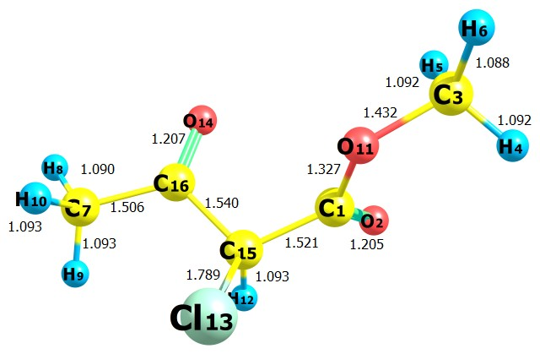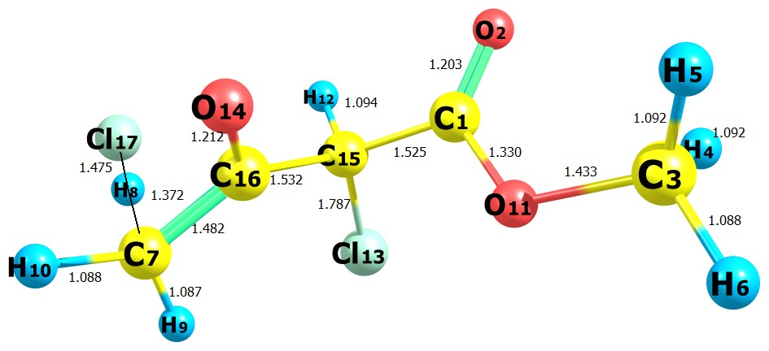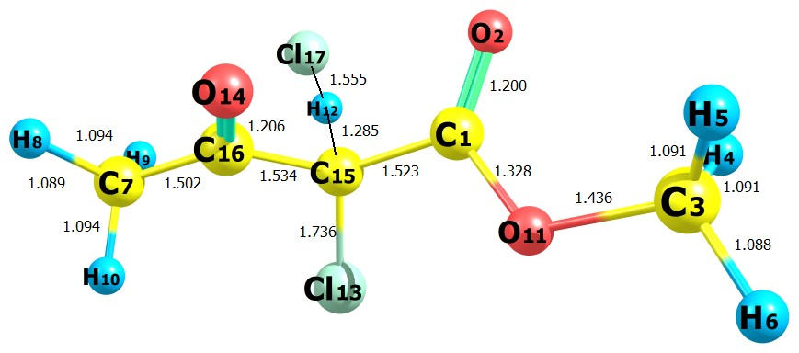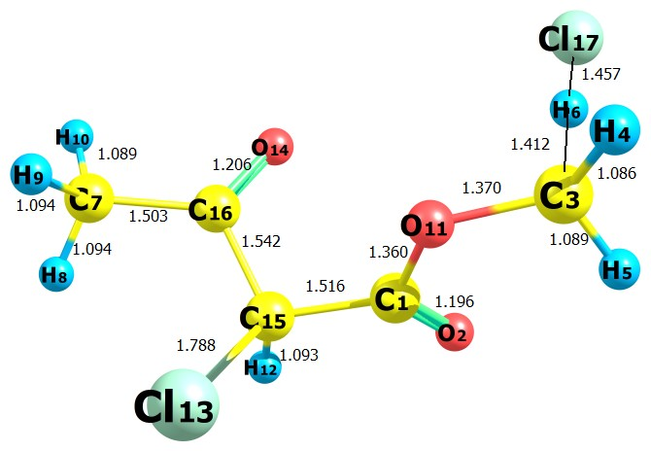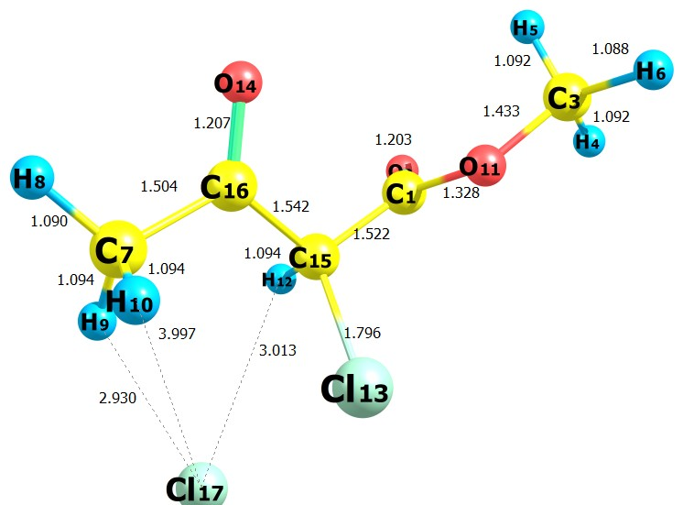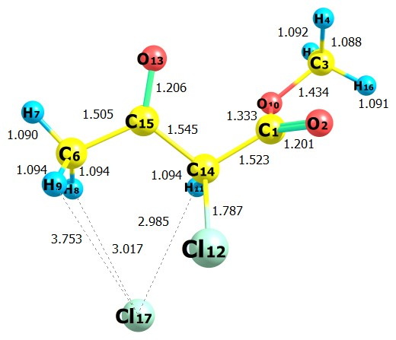

**RC1**

**RC2**

**Fig. 1:** Optimized geometries of M2CAA, transition states and reactive complexes at M06-2X/6-31+G(d,p)level.Bond lengths are in Angstroms.

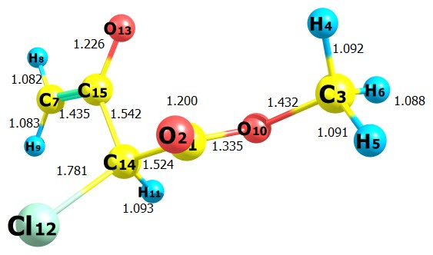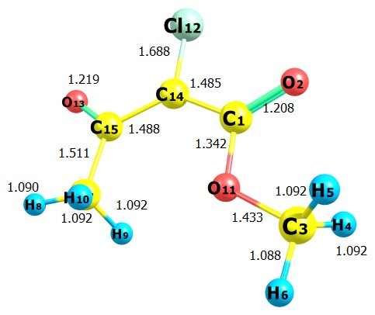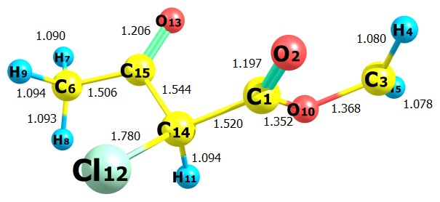

**RC3**

**P3**

**P2**

**P1**

**PC1**

**PC3**

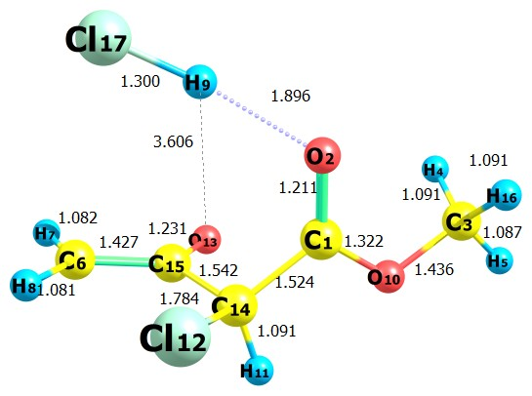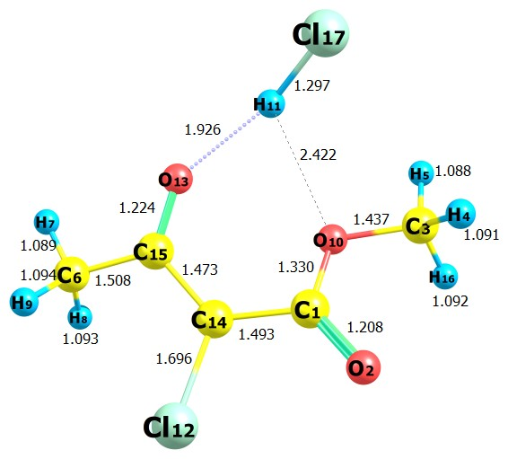

**PC2**

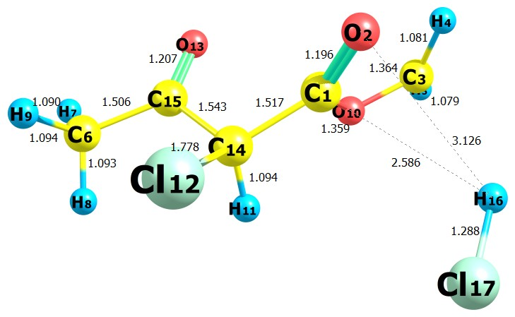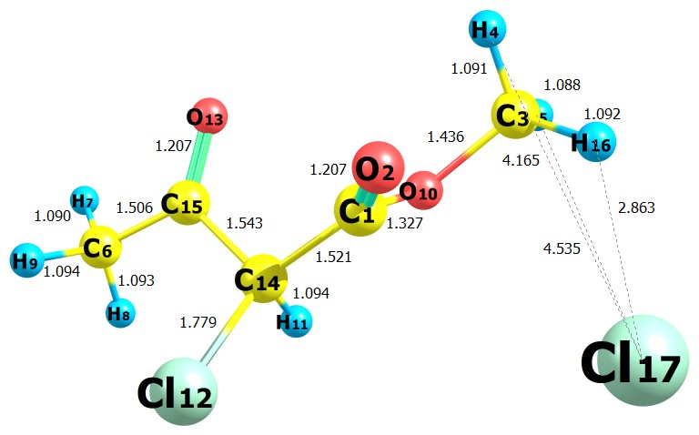

**Fig. 2:** Optimized geometries of product complexes and products at M06-2X/6-31+G(d,p) level.Bond lengths are in Angstroms.



**Fig. 3:** IRC plot performed for transition states TS1, TS2 and TS3 for reaction channels (1-3) at M06-2X/6-31+G(d,p) level of theory.



**Fig. 4:** Schematic potential energy diagram for the M2CAA + Cl reactions. Relative energies (in kcal mol−1) with ZPE at M06-2X/6-31+G(d,p) level.