**Chinese Tea: An overview on Culture, Commerce and Globalization**

**Abstract**

Tea (*Camellia sinensis*) holds prominent position as most consumed beverage globally after water, deeply woven into cultural traditions and economic dynamics. Through this paper we aimed to provide insights into multifaceted significance of Chinese tea, from its ancient medicinal origins and historical evolution to its current role in global trade and economic development in 21st century with its significance on country economy. Furthermore, it highlights China's dominance in tea production and export, the classification of tea types by regional and ecological factors. We also bring insights how the Belt and Road Initiative has expanded international cooperation and tea market. The review also underscores tea’s health benefits, its impact on rural livelihoods, and the importance of conserving wild tea resources, with strategic breeding approaches to support sustainable development.

**Key words:** Chinese tea, tea history and culture, tea economy, economic dynamics

**1. Introduction**

Tea (*Camellia sinensis)* is the most popular and affordable beverage in the world. It is consumed and enjoyed by a wide range of age groups of the society. Tea is also perceived as a cultural product along with a fast-growing beverage in different cultures across nations. The cultural, medicinal perspectives of tea also played vital role in human civilization. Globally, three billion cups of tea are consumed daily (Hicks, 2001; Tong et al., 2021). Moreover, it is an important high-value cash crop, generating an estimated $42 billion annually worldwide (Akanmu et al., 2021).

The tea industry is the major source of income for the rural population of 30 million tea farmers in China (C. Liu et al., 2011; Qin & Zhou, 2024). The Chinese tea industry is a multibillion-dollar sector, which is a significant asset, driving economic transformation and employment while deeply enriching daily life and culture worldwide. Additionally, tea in China boasts a millennia-long history, evolving from simple origins into a major industry (Alveus Blog Team, 2024). In 2023, China's tea market reached a significant milestone, projected to exceed one trillion yuan in value with over 500 million consumers. Fueled by globalization and economic development, Chinese tea has become a vital export commodity, leveraging China's abundant tea resources to drive economic growth. Furthermore, the "Belt and Road" initiative enhances the tea export trade and strengthens international collaboration (Qin & Zhou, 2024).

Besides economic and cultural values tea consumption offers numerous health benefits, including antioxidant, anti-inflammatory, immune-regulating, anticancer, cardiovascular-protective, anti-diabetic, and anti-obesity effects. During the COVID-19 pandemic, tea has shown significant effects in enhancing immune responses and inhibiting viral replication. Beyond its physical benefits, tea promotes mental well-being by inducing relaxation, clarity, and a sense of peace (Pan et al., 2022). Additionally, it is very crucial for developing and preserving tea cultivars for ensuring ample production for meeting increasing demand. So, tea breeding and cultivation technologies and recent innovation and enhancement, leading to steady improvements in both tea quality and yield. Efforts been concentrated in conserving and utilizing wild tea tree resources, for the sustainable development of tea production and boosting the tea economy and livelihood of the people (C. Liu, 2023).

This review aims to provide a comprehensive overview of Chinese tea, encompassing its cultural significance, historical evolution, regional distribution, economic impacts, and role in global trade and business. It also explores the impact of the tea industry on livelihoods of farming communities, as well as recent developments and technological advancements in tea cultivation and production.

**2. Historical Development of Tea in China**

China is the origin place of tea, tea trees, tea drinking, and tea culture. It holds the world’s oldest wild and cultivated tea trees, a 35.4-million-year-old tea leaf fossil, and a rich legacy of tea-related literature and art. Tea is also believed to be one of the earliest Chinese herbal medicines used in ancient times (Pan et al., 2022). Similarly, the tea plant existed before human civilization, with its origin widely traced to southwest China. The region spanning Yunnan, Guangxi, and Guizhou, extending into northern Southeast Asia, was minimally affected by the Quaternary Glaciation, making it a refugium for Neogene-period flora, including tea's ancestral species (Yiqing & Protection, 2021).

Initially Tea was collected as a medicinal herb ( Figure 1) with its valuable benefits , over the period of time, it evolved into a popular beverage among the nobility during the Han Dynasty (206 BC–AD 220) and the Three Kingdoms period (220–280) (T. Liu, 2012). Tea culture starts to influence Chinese elite society during the Tang Dynasty (618–907), marking its transformation into a daily necessity for the people. The tea production which initially centered in the hilly regions of southern China, gradually expanded to other Han-inhabited areas, such as Zhejiang Province, especially during the rule of Tang and Song dynasties (Benn, 2015; Chaffee, 2017; Tong et al., 2021).

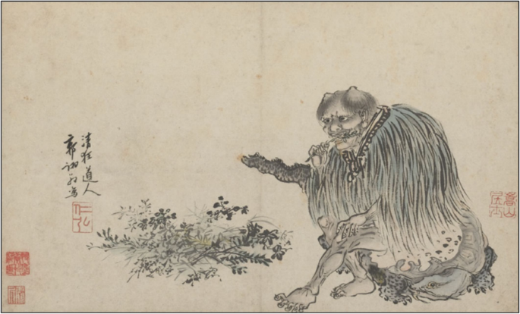

Figure 1: Guo Xu depicted Shen Nung, the legendary emperor who invented medicine and discovered tea, as a fashionable "wild man" in a portrait.

Fig 1 reflecting the tea's which further, resulting into a refreshing and mind-clearing beverage, leading to tea's initial use as an herbal medicine (Sigley, 2015).

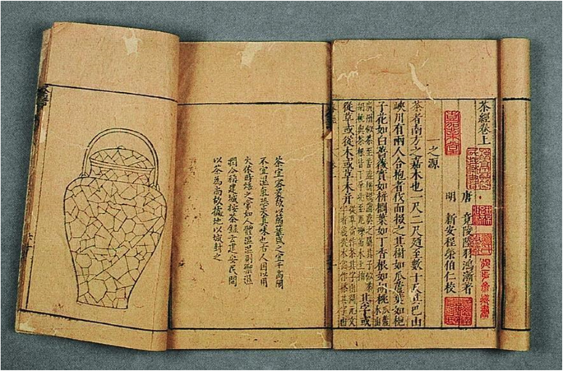

Figure 2: The historical book written by Lu Yu (733–804) around CE 760

Fig 2 introduces the history and geography of the tea plant in China. Moreover, it describes the characteristics of the tea plant, tea leaves, brew, and serve tea. Moreover, the book helps to establish tea as a respected beverage and legitimize tea drinking as a cultural and elegant activity suitable for the elites (Chen, 1992; Tong et al., 2021).

Since the medieval period, tea has gained political and commercial significance, traded alongside silk and porcelain for horses during the Tang and Song dynasties. The Tea Horse Road, later part of the Silk Road, facilitated this trade, with the Chinese government establishing “Tea and Horse Bureaus” to manage it. Over time, tea customs spread globally, enriching world civilization (Benn, 2015; Sigley, 2015). Since the beginning of 21st century, as China emerges as a major enriched country in tea production and it’s tea culture more revitalizing national identity and cultural pride globally, by exploring the rise of tea nationalism and its role in shaping modern Chinese identity (Sigley, 2015).

**3. Classification and characteristics of Chinese tea**

Tea is a perennial crop, and climatic and environmental factors have vital role tea yield and quality across different tea types according to agro-ecological regions (New et al., 2024). Chinese tea is classified into: white, yellow, green, oolong, black, and dark each characterized by their unique color, aroma, flavor, and appearance (Xu et al., 2021). Black tea is primarily produced in central and southern China, such as Fujian, Guangdong, Hunan, Yunnan, and Sichuan. Oolong tea predominantly found in Fujian, Guangdong, and Taiwan. Similarly, dark tea is produced in Yunnan, Hunan, and Sichuan. White tea, known for its fresh and delicate flavor, is mainly produced in Fujian and Yunnan. Yellow tea is especially cultivated in Anhui and Hunan as shown in figure 3 (C. Liu, 2023).

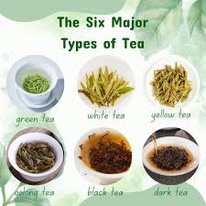

Figure 3 : Six Major types of Chinese tea

**4. Tea crop Improvement and breeding progress**

Tea cultivation represents a significant agro-based and environmentally sustainable sector that contributes to employment. Nevertheless, the long-term sustainability of the tea industry relies on the development of high-yielding, superior-quality tea cultivars with enhanced resistance to pests, diseases, and various environmental stresses. Genetic improvement is crucial for sustainable tea production. So, the identification, characterization, evaluation, domestication, conservation, and efficient use of germplasm to produce improved planting material. However, conventional breeding in tea is constrained by factors such as its lengthy juvenile phase, cross-pollinating nature, and inherent self-incompatibility (Kumar et al., 2016). As of now, over 350 species of *Camellia* genus have been identified, out of which the two primary cultivated varieties are *Camellia sinensis* var. *sinensis* (CSS; Chinese variety) and *Camellia sinensis* var. *assamica* (CSA; Assam variety). These are predominantely utilized in the production of various tea types, including green, black, dark, Oolong, white, and yellow tea (Li et al., 2022; Rawal et al., 2021).

Molecular markers have been used to improve the crop in tea-growing countries. The progress and significant achievements of marker-assisted selection for trait improvement. The recent advancements in functional genomic research and the progress of the *omics* approaches in tea played vital roles in desired trait enhancement and sustainable tea production. The progress of transgenic research in tea during the last two decades also showed remarkable improvement in tea breeding. The first genome sequence of tea identified in 2017 was a milestone in genome research. Additionally, mutation breeding has the potential to be used as an alternative tool to develop new cultivars of tea. The progress in controlled hybridization can be a strategy for tea crop improvement enhancing current tea production and future potential addressing global climate change (Ranatunga, 2019).

**5. Economics of Chinese Tea**

Tea is a key agricultural product for China, which have huge export potential. Using trade data and Autoregressive Distributive Lag (ARDL) analysis, the study identified 39 potential export destinations and found that tea exports significantly contribute in China's economic transformation (Suroso et al., 2025). Additionally, expanding production and trade ties can further enhance this growth. China is the world's leading producer, consumer, and exporter of tea. According to the statistics of the Food and Agriculture Organization (FAO, 2018), among the 60 tea-producing countries in the world, China holds first rank in tea production, with 2.616 million tons, accounting for 44% of the world's total production (2,119,000 tons). Moreover, the tea plantation area accounts for over 62.1% (Wu et al., 2020). China’s tea plantation area from 1978 to 2018 experienced an overall upward trend, expanding from 1.048 million hectares to 2.28 million hectares an increase of 1.18 times. During the same period, tea production exhibited significant growth, rising from 268,000 tons to 2.616 million tons, which represents an 876.1% increase (Zheng & Xu, 2017). Since the initiation of the "Belt and Road" initiative in 2013, China's tea trade has increasingly boosted investment and consumption in partners countries and other part of the world, while enriching the cultural exchange. Which further amplify the significance of the Belt and Road in China’s modern tea export market and contributing for the sustainable tea production and notable economic returns among the tea growers (Liang, 2024).

China's tea industry, encompassing 302 companies and employing 83,509 people, generated $26.4 billion in revenue in 2024, reflecting a 10.2% average annual growth rate. Changing consumer drinking habits is estimated to drive 7.5% annual growth in the industry, reaching $37.8 billion by 2029 (IBISWorld, 2024). China’s tea industry is geographically divided into four major regions: South China, Southwest China, Jiangnan, and Jiangbei. The leading provinces by comprehensive tea industry output are Fujian (¥140 billion), Yunnan (¥107.1 billion), Hunan (¥101.2 billion), Sichuan (¥100 billion), Hubei (¥71.5 billion), Anhui (¥61.5 billion), and Guizhou (¥57 billion) (Qin & Zhou, 2024).

**6. Conclusions**

Chinese tea has transformed traditional herbal remedy into a globally traded crop and significantly important economic commodity. Its historical depth, regional diversity, and health-promoting qualities further amplifying its values. With significant advancements in cultivation techniques, export expansion through initiatives like the Belt and Road, and a growing domestic and global consumer base, the Chinese tea industry continues to emerges and the economy has been expanding. Since tea becomes a symbol of national pride and cultural heritage. So, ensuring sustainability through resource conservation and innovation is crucial for sustainable tea production, import and export leading to further boosting to economy and creating more employment and income generating opportunities for the people.

**Disclaimer (Artificial intelligence)**

Author(s) hereby declares that NO generative AI technologies such as Large Language Models (ChatGPT, COPILOT, etc.) and text-to-image generators have been used during the writing or editing of this manuscript.

**References**

1. Akanmu, A. O., Babalola, O. O., Venturi, V., Ayilara, M. S., Adeleke, B. S., Amoo, A. E., Sobowale, A. A., Fadiji, A. E., & Glick, B. R. (2021). Plant Disease Management: Leveraging on the Plant-Microbe-Soil Interface in the Biorational Use of Organic Amendments. *Frontiers in Plant Science*, *12*, 700507. https://doi.org/10.3389/fpls.2021.700507
2. Alveus Blog Team. (2024). *Chinese Teas: Evolution, Diversity, and Producing Regions*. https://www.alveus.eu/blog/chinese-teas
3. Benn, J. A. (2015). *Tea in China: A Religious and Cultural History*. University of Hawai’i Press. https://doi.org/10.21313/hawaii/9780824839635.001.0001
4. Chaffee, J. W. (2017). Tea in China: A Religious and Cultural History by James A. Benn, and: The Rise of Tea Culture in China: The Invention of the Individual by Bret Hinsch. *Harvard Journal of Asiatic Studies*, *77*(2), 493–502. https://doi.org/10.1353/jas.2017.0036
5. Chen, Z. (1992). *Zhongguo Chajing. Shanghai*.
6. Hicks, A. (2001). Review of global tea production and the impact on industry of the Asian economic situation. *AU Journal of Technology*, *5*(2).
7. IBISWorld. (2024). *Tea Production in China—Market Research Report (2014-2029)*. https://www.ibisworld.com/china/industry/tea-production/163/
8. Kumar, R., Kuldip, Ahuja, P. S., & Sharma, R. K. (2016). Status and Opportunities of Molecular Breeding Approaches for Genetic Improvement of Tea. In V. R. Rajpal, S. R. Rao, & S. N. Raina (Eds.), *Molecular Breeding for Sustainable Crop Improvement* (Vol. 11, pp. 101–125). Springer International Publishing. https://doi.org/10.1007/978-3-319-27090-6_5
9. Li, J., Xiao, Y., Zhou, X., Liao, Y., Wu, S., Chen, J., Qian, J., Yan, Y., Tang, J., & Zeng, L. (2022). Characterizing the cultivar-specific mechanisms underlying the accumulation of quality-related metabolites in specific Chinese tea (Camellia sinensis) germplasms to diversify tea products. *Food Research International*, *161*, 111824. https://doi.org/10.1016/j.foodres.2022.111824
10. Liang, Z. (2024). Analysis of the Development of Chinese Tea Trade in Five Central Asian Countries (2017–2022). In P. Dou & K. Zhang (Eds.), *Proceedings of the 2023 International Conference on Economic Management, Financial Innovation and Public Service (EMFIPS 2023)* (Vol. 287, pp. 855–866). Atlantis Press International BV. https://doi.org/10.2991/978-94-6463-441-9_72
11. Liu, C. (2023). The Origin and Distribution of Tea Trees and Tea in China. *Journal of Tea Science Research*. https://doi.org/10.5376/jtsr.2023.13.0002
12. Liu, C., Xu, M., & Liu, P. (2011). Path analysis on the development and cultivation of the tea industry in China. *Resources Science*, *33*(12), 2376–2385.
13. Liu, T. (2012). *Chinese tea*. Cambridge University Press.
14. New, S., Li, S., Zhao, T., Thompson, E., Bown, N., Mitchell, T., Waterson, A., Weeks, J. H., Yang, J., Oakes, R., Zhou, T., & Golding, N. (2024). Towards a Climate Service for the Tea Industry: A Collaborative Approach between the UK and China. *Advances in Atmospheric Sciences*, *41*(12), 2289–2299. https://doi.org/10.1007/s00376-024-4302-8
15. Pan, S.-Y., Nie, Q., Tai, H.-C., Song, X.-L., Tong, Y.-F., Zhang, L.-J.-F., Wu, X.-W., Lin, Z.-H., Zhang, Y.-Y., Ye, D.-Y., Zhang, Y., Wang, X.-Y., Zhu, P.-L., Chu, Z.-S., Yu, Z.-L., & Liang, C. (2022). Tea and tea drinking: China’s outstanding contributions to the mankind. *Chinese Medicine*, *17*(1), 27. https://doi.org/10.1186/s13020-022-00571-1
16. Qin, K., & Zhou, L. (2024). Analysis of the high-quality development path of China’s tea export. *PLOS ONE*, *19*(11), e0311629. https://doi.org/10.1371/journal.pone.0311629
17. Ranatunga, M. A. B. (2019). Advances in Tea [Camellia sinensis (L.) O. Kuntze] Breeding. In J. M. Al-Khayri, S. M. Jain, & D. V. Johnson (Eds.), *Advances in Plant Breeding Strategies: Nut and Beverage Crops* (pp. 517–565). Springer International Publishing. https://doi.org/10.1007/978-3-030-23112-5_13
18. Rawal, H. C., Borchetia, S., Bera, B., Soundararajan, S., Ilango, R. V. J., Barooah, A. K., Sharma, T. R., Singh, N. K., & Mondal, T. K. (2021). Comparative analysis of chloroplast genomes indicated different origin for Indian tea (Camellia assamica cv TV1) as compared to Chinese tea. *Scientific Reports*, *11*(1), 110. https://doi.org/10.1038/s41598-020-80431-w
19. Sigley, G. (2015). Tea and China’s rise: Tea, nationalism and culture in the 21st century. *International Communication of Chinese Culture*, *2*(3), 319–341. https://doi.org/10.1007/s40636-015-0037-7
20. Suroso, A. I., Abdullah, A., Haryono, A., & Tandra, H. (2025). The potential of China’s tea trade and how it affects China’s economic growth. *The Journal of International Trade & Economic Development*, *34*(3), 428–449. https://doi.org/10.1080/09638199.2024.2313613
21. Tong, L., Toppinen, A., & Wang, L. (2021). Cultural motives affecting tea purchase behavior under two usage situations in China: A study of renqing, mianzi, collectivism, and man-nature unity culture. *Journal of Ethnic Foods*, *8*(1), 15. https://doi.org/10.1186/s42779-021-00092-6
22. Wu, Q., Sun, C., & Yang, J. (2020). Economic analysis of the change of tea production layout in China. *Journal of Physics: Conference Series*, *1629*(1), 012048. https://doi.org/10.1088/1742-6596/1629/1/012048
23. Xu, Q., Yang, Y., Hu, K., Chen, J., Djomo, S. N., Yang, X., & Knudsen, M. T. (2021). Economic, environmental, and emergy analysis of China’s green tea production. *Sustainable Production and Consumption*, *28*, 269–280. https://doi.org/10.1016/j.spc.2021.04.019
24. Yiqing, Z., & Protection, B. (2021). Overview of Chinese Tea Culture Landscape. *Int. Counc. Monum. Sites*, *11*, 31.
25. Zheng, X., & Xu, Z. (2017). Resource endowment constraint, factor substitution and induced technological change—A case study of mechanization of grain production in China. *Economics (Quarterly)*, *16*(01), 45–66.