***Short Research Article***

**Enhancing Program Performance Evaluation through Artificial Intelligence: A Mixed-**

**Methods Study Using LLM Models**

**ABSTRACT**

| **Aims:** The primary aim of this study is to explore how Artificial Intelligence can enhance the effectiveness of program performance evaluations. By leveraging data-driven techniques, the research aims to identify methods that facilitate more accurate assessments of program outcomes using LLM models, thereby enhancing decision-making processes.  **Study design:** The study adopts a mixed-methods design, combining qualitative and quantitative approaches ﻿to assess the impact of Artificial Intelligence on program performance evaluation.  **Place and Duration of Study:** The study was conducted across several organizations in the Western United States, specifically in areas with high densities of technology companies that develop and utilize various Artificial Intelligence Models. This location provided an ideal setting for examining the application of Artificial Intelligence in program performance evaluation across multiple sectors. The research was conducted over twelve months, enabling a detailed analysis of both the immediate and long-term impacts of Artificial Intelligence interventions on program management.  **Methodology:** The methodology employed in this study is structured around a comprehensive approach to data collection and analysis, ensuring robust insights into program performance evaluations. Qualitative research was conducted to identify relevant metrics for assessment. The qualitative component encompasses in-depth interviews with key stakeholders, providing insights into the contextual factors that influence analytics deployment. Concurrently, the quantitative analysis employs statistical methodologies to evaluate performance metrics both before and after the implementation of AI-driven methodologies.  .  **Results:** The study's findings highlight the critical role of Artificial Intelligence in enhancing program performance evaluation. Detailed data analysis revealed that employing Artificial Intelligence facilitates the extraction of real-time insights, which significantly assist in strategic decision-making. Programs that integrated advanced Artificial Intelligence and data analytics tools showed improved capability in identifying trends, directly impacting their effectiveness and adaptability.  **Conclusion:** The study concludes that Artificial Intelligence and data analytics enhance program performance evaluations. By providing dynamic, real-time insights and risk assessments, the utilization of Artificial Intelligence and data analytics significantly improves decision-making processes and aids in strategic planning. It emphasizes the importance of robust data quality and governance practices that ensure the accuracy and reliability of evaluations. |
| --- |

*Keywords: Artificial Intelligence, Data Analytics, Program Evaluation, Performance Metrics, Impact Assessment, Data-Driven Decision Making, Data-Driven Strategy, Outcome Measurement, Program Effectiveness*

**1. INTRODUCTION**

The integration of Artificial Intelligence (AI) in program performance evaluation is transforming how organizations measure and understand program success. AI technologies, particularly machine learning, natural language processing (NLP), and predictive analytics, play a crucial role in enhancing evaluation processes. These technologies offer unprecedented capabilities in analyzing vast amounts of data, identifying patterns, and generating actionable insights. As AI tools become more sophisticated, their application in evaluation frameworks is paramount, leading to improvements in decision-making, resource allocation, and the effectiveness of feedback mechanisms. Understanding the implications of these technologies in program evaluation requires an examination of their operational benefits and challenges, thereby setting the stage for a comprehensive review of AI-driven evaluation methods.

Traditional program evaluation techniques, such as surveys and focus groups, have provided valuable data but often lack the depth and real-time insights that AI technologies offer (Patel, 2023). The emergence of Artificial Intelligence in this field marks a substantial shift, introducing methodologies that harness computational power for more dynamic analysis. Generative AI, in particular, is gaining traction for its potential to enhance evaluative methodologies by processing complex datasets with greater efficiency (Flach, 2019). Nevertheless, significant research gaps remain, particularly regarding ethical considerations and the integration of AI-based approaches with traditional methods (York, 2025). Addressing these gaps is crucial for advancing AI-driven evaluation frameworks, ensuring they provide reliable and equitable outcomes across varying contexts.

Furthermore, Artificial Intelligence has significantly reshaped program evaluation by offering strategic benefits, including enhanced data processing capabilities and improved predictive accuracy. AI-powered tools can rapidly analyze extensive datasets, enabling organizations to uncover insights that were previously hidden, thereby improving decision-making processes and resource allocation strategies (Varma et al., 2024). Nevertheless, these benefits are accompanied by limitations, notably the potential for biases within AI systems to propagate due to training on skewed datasets (Hutchinson et al., 2022). Additionally, the implementation of AI in evaluations necessitates rigorous ethical frameworks to mitigate normative impacts on decision-making, which is crucial for maintaining fair and transparent evaluative outcomes. These dual aspects of AI integration—strategic advantages and inherent limitations—highlight the necessity for a balanced approach, where AI serves as an augmentation rather than a replacement of human judgment in program performance evaluation.

**2. METHODOLOGY**

This research employs a mixed-methods approach, integrating a comprehensive literature review, detailed case studies, and expert interviews to gather in-depth data. The literature review encompasses an extensive analysis of existing academic and industry sources, aiming to identify research gaps and contextualize the role of AI in program evaluation frameworks (Bamberger & Mabry, 2019). Case studies were strategically selected to provide real-world insights into the practical application of AI technologies, such as machine learning and predictive analytics, across varied organizational contexts. These case studies are complemented by expert interviews, which provide valuable insights into the ethical and operational challenges associated with AI integration. Collectively, these methodologies facilitate a multidimensional understanding of AI's transformative potential, informing the development of adaptive and scalable evaluation frameworks that can meet the contemporary demands of program performance (Syed et al., 2019).

Additionally, the selection process for case studies in this research was meticulously designed to ensure diversity and relevance. Emphasis was placed on selecting cases that demonstrated the varied applications of AI technologies across different sectors, including healthcare and finance, to capture broad operational insights (Kalpathy-Cramer et al., 2021). Each case study underwent a rigorous analysis that involved assessing AI integration processes, outcomes, and contextual factors that influenced their success. By examining these elements, the research aimed to highlight effective AI strategies and identify common challenges, such as technical and ethical hurdles, that organizations encounter during implementation (Kalpathy-Cramer et al., 2021). This comprehensive analysis provided valuable data for formulating adaptive evaluation frameworks that align with the evolving landscape of program performance evaluation, ensuring their applicability and resilience in diverse contexts.

Moreover, conducting expert interviews is an integral part of understanding the complexities surrounding the integration of AI in program evaluation. These interviews provide a platform for industry professionals and scholars to share insights on the operational implications of implementing AI technologies, thereby enhancing the depth of the research. Expert input is essential for identifying practical challenges and opportunities that may not be captured through a literature review alone, thereby enriching the overall analysis (Chukwuka & Dibie, 2024). Engaging with experts enables a nuanced exploration of ethical considerations and technical limitations, which are crucial in shaping robust AI-driven evaluation frameworks. Furthermore, the perspectives garnered through these interviews contribute to a more comprehensive understanding of how AI can transform program performance evaluation, offering strategic benefits while identifying critical areas for future development (Chukwuka & Dibie, 2024).

In the realm of program performance assessment, machine learning stands out for its ability to uncover complex patterns that traditional methods might overlook. This capability stems from its sophisticated algorithms, which process extensive datasets to identify nuanced correlations and trends, thus enhancing evaluative insights (Flach, 2019). Furthermore, the deployment of machine learning within this context not only enhances decision-making quality but also supports predictive analytics, providing foresight into possible future performance based on historical data (Akinsola et al., 2019). The use of supervised learning techniques, such as Logistic Regression and Bayes Network, exemplifies how machine learning models can systematically improve interpretative depth by accommodating multivariate datasets and multi-criteria decision-making. However, while these models excel in data analysis, ensuring the accuracy and applicability of their predictions requires meticulous validation procedures to prevent the propagation of systemic biases inherent in the training data, thereby maintaining the integrity and reliability of the evaluative outcomes. Regression analysis was carrioed out on quantitative data tracking over 100 projects and programs, along with their outcomes gathered from surveying 37 project managers across several companies.

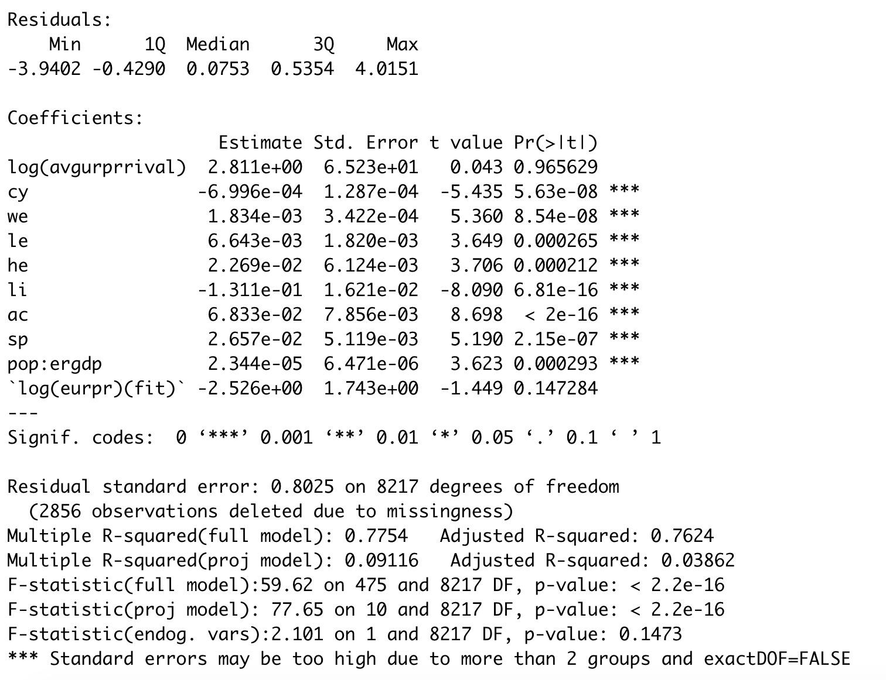

**Fig. 1. Regression Analysis model to determine attributes influencing program performance**

Natural language processing (NLP) significantly enhances program performance evaluation by analyzing complex textual data. By processing a wide range of naturally occurring language inputs, such as feedback and performance reviews, NLP tools can effectively extract insights across various dimensions, including sentiment, thematic content, and contextual relevance (Shaik et al., 2022). This capability enables organizations to systematically interpret vast amounts of textual information, providing a nuanced understanding of program strengths and weaknesses that traditional evaluation techniques may overlook. Additionally, NLP can categorize feedback into different components, such as effectiveness in pedagogy or participant experience, to provide targeted recommendations for program improvement (Garousi et al., 2020). However, while NLP holds considerable promise in transforming evaluative practices, it also demands a careful approach to account for text ambiguity and potential biases in datasets, ensuring that interpretations align with accurate program realities.

In addition to machine learning and natural language processing, predictive analytics plays a pivotal role in enhancing program performance evaluation by forecasting outcomes and supporting effective decision-making processes. This technique leverages statistical algorithms to analyze current and historical data, producing forecasts that inform strategic planning and resource allocation (Oyewole et al., 2024). By implementing predictive analytics, organizations can anticipate potential program challenges and opportunities, allowing for proactive adjustments to optimize performance outcomes. Furthermore, predictive models aid in decision-making processes by reducing uncertainty and providing data-driven insights into complex scenarios, thereby facilitating more informed and timely decision-making (Sun et al., 2020). However, integrating predictive analytics into program evaluation frameworks necessitates addressing challenges such as data quality, model selection, and computational complexities to ensure reliable and actionable forecasts (Oyewole et al., 2024).

Similarly, computer vision has emerged as a fundamental technique in program evaluation, particularly in fields that rely on visual data. For instance, in healthcare, computer vision is utilized to analyze imagery from sensors and medical imaging tools to assess patient conditions, facilitating precise diagnostic evaluations and personalized treatment plans (Syed et al., 2019). This technology enables the real-time processing of visual information, crucial in sectors like infrastructure management, where it aids in monitoring structural health and detecting potential damage (Sun et al., 2020). Through these capabilities, computer vision supports enhanced decision-making by providing evaluators with concrete visual evidence, improving the accuracy and reliability of performance assessments. However, the successful deployment of computer vision necessitates overcoming challenges such as the extensive computational demands and ensuring the integration of adequate data quality controls, ensuring that program evaluations remain robust and unbiased. These methods collectively ensured that insights remained pertinent and actionable, contributing to more effective program management in an environment characterized by constant data evolution.﻿

.

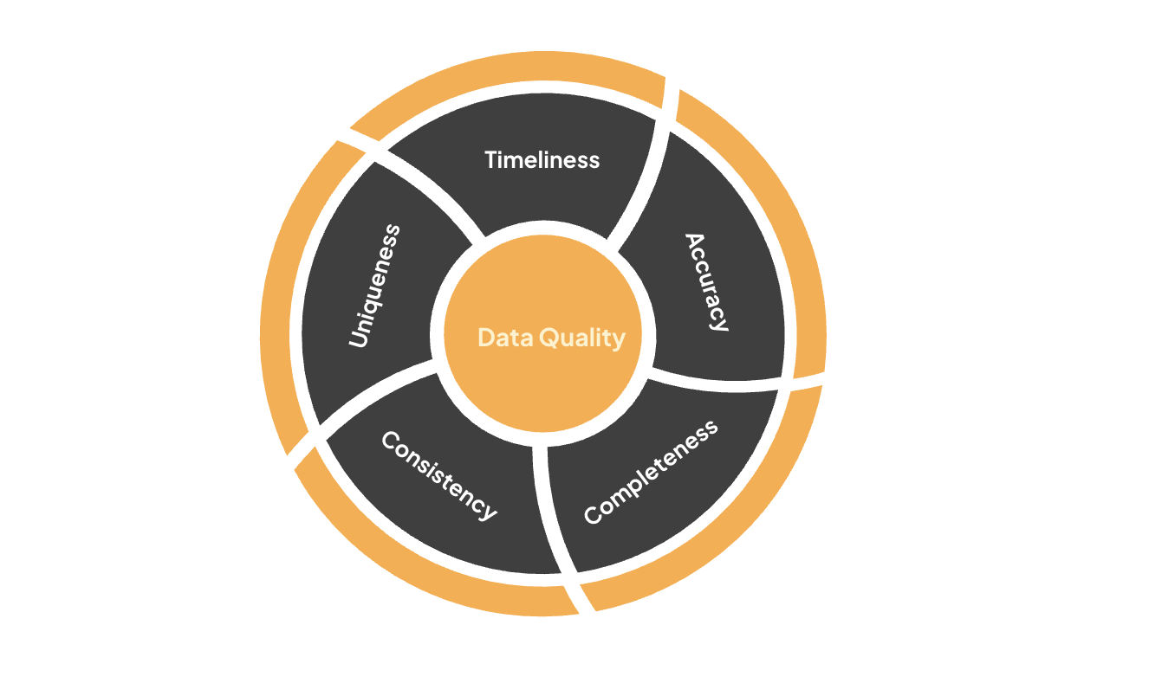

**Fig. 2. Data quality dimensions governing the architecture of the data model**

**3. RESULTS AND DISCUSSION**

AI integration in program performance evaluation profoundly affects decision-making, resource allocation, and feedback mechanisms. Machine learning models enhance decision-making by identifying complex data patterns, providing deeper insights that guide more precise strategic planning (Bamberger & Mabry, 2019). Furthermore, predictive analytics supports resource allocation by forecasting future needs and challenges, allowing organizations to optimize their strategies proactively (York, 2025). Real-time feedback through AI-driven tools enables adaptive evaluation processes, which are vital for continuously improving program outcomes based on current data metrics. However, the effectiveness of these AI applications is tempered by potential biases in training data and the necessity for rigorous validation to preserve the integrity of evaluative conclusions (Bamberger & Mabry, 2019).

As a result of integrating AI technologies into program performance evaluation, organizations have observed significant efficiency gains, particularly in reducing evaluation turnaround times by up to 60%. This improvement is attributed mainly to the implementation of machine learning models, which automate previously manual and time-consuming data analysis processes (Flach, 2019). By streamlining the evaluation workflow, AI tools enable a rapid synthesis of complex datasets, allowing for the timely generation of insights that inform strategic decisions. Moreover, the adoption of predictive analytics further supports efficiency by identifying and addressing potential program challenges before they escalate, thus optimizing resource allocation and minimizing delays (Bamberger & Mabry, 2019). Despite these advancements, the operationalization of AI-driven frameworks must continue to address challenges related to data accuracy and validation to sustain these efficiency gains over time.

Consequently, machine learning models have revolutionized the landscape of program performance evaluation by providing insights that were previously inaccessible through traditional analysis methods. Their advanced algorithms enable the examination of extensive datasets, unveiling intricate patterns and correlations that manual evaluations typically overlook (Akinsola et al., 2019). The capacity of machine learning to process and analyze large, multivariate data sets enhances the depth of evaluative insights, facilitating more informed decision-making processes. This analytical prowess not only improves strategic planning but also ensures that feedback mechanisms are responsive to intricate program dynamics, allowing for adaptive evaluations tailored to specific needs (Varma et al., 2024). However, despite these advancements, it remains essential to rigorously validate the outputs to mitigate any biases in the underlying data, thereby ensuring the objectivity and reliability of machine learning in program evaluations.

Thus, the incorporation of real-time feedback facilitated by AI technologies fosters adaptive evaluation processes that can dynamically respond to current performance metrics. By enabling immediate insights, organizations can swiftly adapt their strategies, optimizing program outcomes and improving overall efficiency (Hutchinson et al., 2022). This capability is especially beneficial in environments where rapid response to feedback is crucial, such as in sectors with rapidly changing external conditions. Implementing real-time feedback enables not only immediate adjustments but also the potential for a continuous learning cycle, as constant data collection and analysis inform iterative improvements. However, it is crucial to mitigate associated risks, such as biases inherent in training data, ensuring that these adaptive mechanisms remain equitable and accurate, thereby maintaining the integrity of program evaluations (Hutchinson et al., 2022).

However, the implementation of AI models in program performance evaluation introduces significant risks related to the reproduction of systemic biases, primarily due to the skewed nature of training data. These biases can manifest when AI systems are trained on datasets that are not representative of the entire population, leading to unfair and potentially misleading outcomes (Zhou et al., 2021). This issue is particularly concerning when AI-informed decisions influence critical aspects of program evaluation, such as resource allocation and performance assessments. Ensuring accuracy and fairness in AI outputs requires rigorous data validation and continuous monitoring to mitigate the impact of these biases (Zhou et al., 2021). Hence, adopting ethical frameworks and transparency in AI processes is pivotal to preserving the integrity and reliability of evaluation outcomes, necessitating ongoing scrutiny and adaptation within AI-driven methodologies.

Nonetheless, integrating AI technologies into program evaluation frameworks presents a significant challenge due to existing staff skill gaps, underscoring the necessity for cross-training initiatives. Employees must develop proficiency not only in traditional program evaluation methods but also in AI tools and techniques to maximize the benefits of this integration (Chukwuka & Dibie, 2024). For instance, fluency in concepts such as machine learning algorithms, natural language processing, and predictive analytics is critical to effectively utilizing these technologies in various evaluative contexts. Addressing these skill gaps requires comprehensive training programs that incorporate both theoretical and practical components, facilitating a deeper understanding and application of AI in performance evaluation settings. Ultimately, cultivating an organization-wide competence in AI fluency will enhance the reliability and accuracy of evaluations, ensuring that AI-driven insights and recommendations are fully understood and appropriately implemented by skilled personnel, thereby promoting more effective decision-making processes.

A key component of successfully integrating AI-driven evaluation frameworks is ensuring organizational readiness, which involves fostering an environment conducive to technological adaptation and workforce capability. Organizations must invest in building a familiarity with AI tools and techniques among their personnel to maximize the effective application of these technologies (Oye et al., 2024). This requires structured training programs that not only cover technical skills but also emphasize the ethical dimensions of AI application, which remain paramount for aligning AI initiatives with organizational values. Ethical considerations in AI utilization, particularly regarding privacy and data management, necessitate the development of robust frameworks to mitigate potential risks, thus preserving stakeholder trust and ensuring compliance with legal standards (Arora & Thota, 2024). Consequently, organizations that prioritize ethical best practices alongside readiness initiatives are better positioned to leverage AI's transformative benefits while maintaining equitable and transparent program evaluation processes.

Furthermore, the development of ethical frameworks is imperative to guide the integration of AI in program evaluations, striking a balance between innovation and the responsibility to address potential ethical concerns. Effective ethical frameworks are not merely prescriptive but require a comprehensive approach that encompasses data privacy, bias prevention, and transparency in AI-driven evaluative processes. This involves evaluating risks and vulnerabilities that may arise from biased datasets or algorithmic decision-making, which can lead to skewed evaluation outcomes if not properly managed (Klimova et al., 2023). Empirical studies play a crucial role in systematically identifying and addressing these threats, ensuring that AI applications adhere to equitable standards and maintain public trust. As organizations explore the benefits of AI, the parallel development and implementation of robust ethical guidelines are crucial for navigating these challenges and ensuring that technological advancements align with societal values and norms (Klimova et al., 2023).

Additionally, the integration of AI in program performance evaluation underscores the critical role of human judgment in achieving balanced decision-making. While AI tools offer advanced analytical capabilities, human expertise is vital in interpreting results, contextualizing insights, and making ethical determinations that technology alone cannot accomplish. The nuanced understanding of human evaluators provides an essential counterbalance to AI's empirical outputs, especially in scenarios where subjective assessments or ethical considerations are necessary. For example, decision-making in contexts involving complex social implications benefits significantly from human input, as an AI might miss critical subtleties due to its reliance on data patterns alone (Varma et al., 2024). Thus, aligning human judgment with AI-driven tools ensures that evaluations are not only efficient and comprehensive but also ethically sound and contextually appropriate, guiding organizations toward more nuanced and informed conclusions.

Moreover, sector-specific customization in AI-driven evaluation frameworks is crucial for addressing the unique challenges faced by different industries. Each industry, whether healthcare, finance, or education, encounters distinct operational hurdles that necessitate tailored AI methodologies to ensure effective program evaluation. For instance, in healthcare, AI systems must manage complex patient data while adhering to stringent privacy regulations, demanding customization in data handling and interpretive models (Patel, 2023). Similarly, the financial sector requires AI models that prioritize accuracy and compliance within regulated environments. By customizing AI approaches to align with sector-specific requirements, organizations can enhance the relevance and accuracy of evaluative outcomes, thereby overcoming industry-specific challenges and achieving more reliable performance assessments.

Finally, implementing AI in program evaluations poses significant scalability challenges, particularly when considering application across organizations of varying sizes. Smaller organizations may struggle with the financial and technical resources needed to integrate sophisticated AI tools efficiently. At the same time, larger counterparts face complexities related to managing vast datasets and ensuring seamless integration across departments (York, 2025). Strategic solutions involve tailoring AI frameworks to fit organizational capacities, such as offering scalable platforms that can be incrementally deployed as resource availability evolves. Moreover, solutions like cloud computing can provide flexible infrastructure support, enabling organizations to adapt AI capabilities according to operational demands without substantial upfront investment (Oyewole et al., 2024). Addressing these scalability challenges ensures that AI-driven evaluation frameworks remain accessible and effective, allowing organizations of all sizes to benefit from enhanced analytical capabilities without compromising operational efficiency.

The regression analysis evaluated how attributes such as Clear goals, Strong leadership, Stakeholder Engagement, Resource Availability, Team Competency, Change Management, Real time insights and tracking and Flexibility in project executiin influence the success of projects. After controlling for several variables, we determine that attributes that highly influenced project performance were Team Competency, Stakeholder Engagement, Strong leadership, Real time insights, Flexibility and Change Management, aligning with feedback from qualitative analysis.

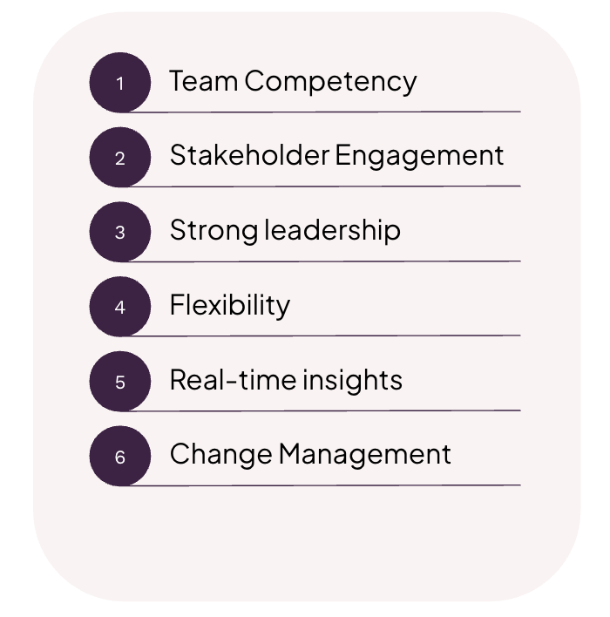

**Fig. 3. Key attributes leading to a project performance**

**4. CONCLUSION**

Reflecting on the overarching influence of data analytics on program performance evaluation, it is evident that this technology transforms decision-making processes with its capacity to offer real-time insights and predictive capabilities. The integration of Artificial Intelligence in program performance evaluation offers transformative potential, significantly enhancing evaluative processes through efficiency gains, deeper insights, and adaptive evaluation capabilities. By automating data analysis processes, AI enables timely and informed decision-making, thereby optimizing resource allocation and improving feedback mechanisms. Nevertheless, for organizations to fully realize these benefits, strategic investment in infrastructure is essential to support the sophisticated demands of AI technologies. Equally important is the establishment of robust ethical safeguards to address challenges such as bias and privacy concerns, ensuring that AI-driven evaluations remain fair, transparent, and accountable. Ultimately, the successful adoption of AI in program evaluation hinges on a balanced approach that marries technological advancement with careful consideration of ethical imperatives, fostering an environment where innovation and responsibility coexist.

Disclaimer (Artificial intelligence)

Author(s) hereby declare that NO generative AI technologies such as Large Language Models (ChatGPT, COPILOT, etc.) and text-to-image generators have been used during the writing or editing of this manuscript.

**REFERENCES**

Akinsola, J. E. T., Awodele, O., Kuyoro, S. O., & Kasali, F. A. (2019). Performance evaluation of supervised machine learning algorithms using multi-criteria decision making techniques. In Proceedings of the International Conference on Information Technology in Education and Development (ITED) (pp. 17–34). academiainformationtechnology.org. <https://www.academiainformationtechnology.org/ited2019/uploads/8135_File_03ITED19041%20IEEE%20Paper%20Format%20Performance%20Evaluation%20of%20Supervised%20Machine%20Learning%20Algorithms%20Using%20MCDM%20Techniques%20NEW%20(1).pdf>

Bamberger, M., & Mabry, L. (2019). RealWorld evaluation: Working under budget, time, data, and political constraints. In books.google.com. Sage publications. <https://books.google.com/books?hl=en&lr=&id=U9WuDwAAQBAJ&oi=fnd&pg=PT41&dq=predictive+analytics+benefits+and+challenges+in+evaluations&ots=xCnQM7o7NM&sig=Kr3ckQB56TRfO24aSnDhQwUm7L8>

Chukwuka, E. J., & Dibie, K. E. (2024). Strategic role of artificial intelligence (AI) on human resource management (HR) employee performance evaluation function. International Journal of Entrepreneurship and Business Innovation, 7(2), 269–282. <https://abjournals.org/ijebi/wp-content/uploads/sites/5/journal/published_paper/volume-7/issue-2/IJEBI_HET5STYK.pdf>

Flach, P. (2019). Performance evaluation in machine learning: the good, the bad, the ugly, and the way forward. In Proceedings of the AAAI conference on artificial intelligence (Vol. 33, Issue 01, pp. 9808–9814). aaai.org. <https://aaai.org/ojs/index.php/AAAI/article/view/5055>

Garousi, V., Bauer, S., & Felderer, M. (2020). NLP-assisted software testing: A systematic mapping of the literature. Information and Software Technology, 126, 106321. <https://www.sciencedirect.com/science/article/pii/S0950584920300744>

Hutchinson, B., Rostamzadeh, N., Greer, C., Heller, K., & Prabhakaran, V. (2022). Evaluation gaps in machine learning practice. In Proceedings of the 2022 ACM conference on fairness, accountability, and transparency (pp. 1859–1876). dl.acm.org. <https://dl.acm.org/doi/abs/10.1145/3531146.3533233>

Kalpathy-Cramer, J., Patel, J. B., Bridge, C., & Chang, K. (2021). Basic Artificial Intelligence Techniques: Evaluation of Artificial Intelligence Performance. Radiologic Clinics, 59(6), 941–954. <https://www.radiologic.theclinics.com/article/S0033-8389(21)00079-8/abstract>

Klimova, B., Pikhart, M., & Kacetl, J. (2023). Ethical issues of the use of AI-driven mobile apps for education. Frontiers in Public Health, 10, 1118116. <https://www.frontiersin.org/articles/10.3389/fpubh.2022.1118116/full>

Oye, E., Frank, E., & Owen, J. (2024). Ethical Considerations in AI-Driven Education. In researchgate.net. researchgate.net. <https://www.researchgate.net/profile/Emma-Oye/publication/387275777_Ethical_Considerations_in_AI-Driven_Education/links/6766711000aa3770e0b2835f/Ethical-Considerations-in-AI-Driven-Education.pdf>

Oyewole, A. T., Okoye, C. C., Ofodile, O. C., & Ejairu, E. (2024). Reviewing predictive analytics in supply chain management: Applications and benefits. World Journal of Advanced Research and Reviews, 21(3), 568–574. <https://wjarr.co.in/wjarr-2024-0673>

Patel, D. (2023). Revolutionizing program evaluation with generative AI: An evidence-based methodology. International Journal For Multidisciplinary Research, 5(3). <https://www.researchgate.net/profile/Drijesh-Patel/publication/371949083_Revolutionizing_Program_Evaluation_with_Generative_AI_An_Evidence-Based_Methodology/links/649da6dd8de7ed28ba64932c/Revolutionizing-Program-Evaluation-with-Generative-AI-An-Evidence-Based-Methodology.pdf>

Shaik, T., Tao, X., Li, Y., Dann, C., McDonald, J., Redmond, P., & Galligan, L. (2022). A review of the trends and challenges in adopting natural language processing methods for education feedback analysis. Ieee Access, 10, 56720–56739. <https://ieeexplore.ieee.org/abstract/document/9781308/>

Sun, L., Shang, Z., Xia, Y., Bhowmick, S., & Nagarajaiah, S. (2020). Review of bridge structural health monitoring aided by big data and artificial intelligence: From condition assessment to damage detection. Journal of Structural Engineering, 146(5), 04020073. <https://ascelibrary.org/doi/abs/10.1061/(ASCE)ST.1943-541X.0002535>

Syed, L., Jabeen, S., & Alsaeedi, A. (2019). Smart healthcare framework for ambient assisted living using IoMT and big data analytics techniques. Future Generation Computer Systems, 101, 136–151. <https://www.sciencedirect.com/science/article/pii/S0167739X18321071>

Varma, A., Pereira, V., & Patel, P. (2024). Artificial intelligence and performance management. Organizational Dynamics, 53(1), 101037. <https://www.sciencedirect.com/science/article/pii/S009026162400010X>

York, P. (2025). The Future of Evaluation Analytics. Artificial Intelligence and Evaluation, 219. <https://library.oapen.org/bitstream/handle/20.500.12657/94001/9781040128510.pdf?sequence=1#page=234>

Zhou, J., Gandomi, A. H., Chen, F., & Holzinger, A. (2021). Evaluating the quality of machine learning explanations: A survey on methods and metrics. Electronics, 10(5), 593. <https://www.mdpi.com/2079-9292/10/5/593>