**Original Research Article**

**Assessing Land Cover Shifts and Fire Impact in Uttarakhand (2018-2024): A Cloud-Based Geospatial Solution Using GEE and Dynamic World Data**

**ABSTRACT:**

In Uttarakhand, the 2024 forest fire season has seen a dramatic rise in outbreaks, marking one of the most severe incidents in recent years. Effective environmental management in ecologically fragile areas like Uttarakhand depends on analysing land cover changes and fire intensity. This article introduces a web-based tool that leverages cloud geospatial analytics to evaluate forest fire severity and land cover shifts in Uttarakhand, India. The application, built on Google Earth Engine (GEE), combines multi-temporal Sentinel-2 satellite imagery, Dynamic World land cover probability data, and FIRMS active fire alerts to provide near-real-time monitoring. The platform utilizes probabilistic land cover change detection and an enhanced Difference Normalized Burn Ratio (dNBR) method, specifically adapted for Himalayan Forest conditions. Four distinct goals are addressed by this study's automated cloud-based platform for environmental monitoring in Uttarakhand, India: (1) To examine changes in land cover in Uttarakhand between 2018 and 2024, (2) map and evaluate yearly fire incidents in Uttarakhand between 2018 and 2024, (3) use spectral indices to assess burn severity within 10 km of a user-selected point, and (4) create a time series analysis of changes in land cover for a user-selected pixel between 2018 and 2024.

The study uses Google Earth Engine to combine FIRMS active fire records, Dynamic World land cover data, and multi-temporal Sentinel-2 imagery. The increase of built-up areas by 28%, the stability of forest cover (27,000–29,500 km2) with fire-induced oscillations, and the notable variability in climate-sensitive classes are some of the main results. Using enhanced dNBR algorithms, users can visualize burn severity within a 10 km radius of a selected point. It also offers interactive visualization features via a dedicated dashboard.

At user-specified sites, this framework provides tool for land cover change detection, fire impact assessment, and temporal analysis, providing a solution for near-real-time environmental monitoring. The findings offer important new information for the sustainable management of Himalayan ecosystems in the face of mounting environmental stress.

**Keywords**: Dynamic World land cover, Forest fires, cloud computing, remote sensing, dNBR optimization, interactive geo-visualization, Google Earth Engine, FIRMS

**1. Introduction**

The Himalayan state of Uttarakhand in northern India stands out for its ecological significance, abundant biodiversity, and remarkable topographic variation. Dense woods, glacial rivers, alpine meadows, cultivated valleys, and growing metropolitan areas are among the diverse landscapes that make up the state, which spans a broad altitudinal range from lowland plains to high-elevation snow-covered summits. In addition to helping local residents, these landscapes offer vital ecosystem services to a large portion of northern India. The forests of Uttarakhand maintain a diverse range of indigenous plant and animal species, act as significant carbon sinks, control hydrological systems, and prevent soil erosion monitoring (Biaou et al., 2022)(ISFR, 2019);(Negi, 2019) ; (S. Singh & Suresh Babu, 2021) . In the meantime, rural populations rely on its agricultural areas for food security and livelihoods (Halder Oliviaand Sarkar, 2025).

However, a complicated interplay between human activity and climate change is putting this environmentally delicate Himalayan region in greater danger. Mass tourism, agricultural encroachment, infrastructure growth, and rapid urbanization have all expedited changes at the landscape level. At the same time, natural processes are changing and ecological fragility is growing due to stressors brought on by climate change(F. and C. Change. Ministry of Environment, 2021; H. Singh & Kumar, 2022), such as rising temperatures(Dhankar et al., 2024), unpredictable precipitation patterns, and glacial retreat. The increasing frequency and intensity of forest fires (S. Singh & Suresh Babu, 2021) is one of the most obvious and damaging effects. Forest fire incidences in Uttarakhand increased by 42% between 2015 and 2022, seriously impairing biodiversity, environmental stability, and human well-being, according to Forest Survey of India (2022)(F. and C. C. , G. of India. Ministry of Environment, 2022).

Understanding these continuous changes and creating plans for the preservation of forest

s, farmland, and other natural resources depend on precise land cover mapping. Land cover and fire impacts have historically been evaluated using field surveys and manual mapping; however, these approaches(Pragya et al., 2023) are costly, time-consuming, and difficult to use in vast and geographically complicated areas (I. Volke et al., 2024). Numerous present techniques inadequately account for variations in land cover, spatial scale, and time. variations, even though the Differenced Normalized Burn Ratio (dNBR) has often been employed to assess fire intensity(Miller & Thode, 2007). This highlights the necessity for reliable, adaptable, and scalable methods to accurately monitor changes in land cover and disturbance patterns. Traditionally, land cover(Sales et al., 2022) and disturbances were mapped using manual surveys and ground-based methods; however, these techniques often face limitations due to subjectivity, significant labor requirements, and accessibility challenges (Rogan & Chen, 2004). The complexity of the Himalayan region, characterized by its diverse landscapes(Potapov et al., 2017), assorted flora, and significant elevation changes, is frequently neglected by satellite-derived indices such as dNBR, even though these are commonly employed in assessing burn severity (Miller & Thode, 2007). Consequently, these methods are poorly equipped for dynamic land cover(I. Volke et al., 2024) studies and often miss small yet ecologically important changes in fragmented alpine ecosystems. Recent advancements in Earth observation technology and cloud-based geospatial platforms have revolutionized environmental monitoring, providing new opportunities for more precise and efficient assessments

Users can access, analyse, and visualize large amounts of satellite data with high spatial and temporal resolution using Google Earth Engine (GEE), a cloud-native geospatial(Patley et al., 2024; Rawat et al., 2013) processing platform(Gorelick et al., 2017). GEE is especially well-suited for hilly and data-sparse areas like Uttarakhand because of its processing capability, which allows for multi-sensor integration, large-scale time series analysis, and user-defined interactivity.

The Dynamic World(Brown et al., 2022) (DW) dataset, a joint product of Google and the World Resources Institute, which is based on Sentinel-2 imagery and deep learning algorithms, enhances GEE's capabilities. Water, trees, grass, flooded vegetation(Das et al., 2017), crops, shrub and scrub, developed area, bare ground, snow and ice, and flooded vegetation are among the nine categories for which DW offers near real-time, 10-meter resolution probabilistic land cover categorization (Brown et al., 2022). The dataset is very useful for tracking transitional landscapes because of its high spatial resolution and regular updates, particularly in situations where traditional land cover products are not as accurate or timely.

This study expands on these technologies by presenting an extensive and automated framework intended to track changes in land cover and the effects of forest (Schneibel et al., 2017)fires throughout Uttarakhand from 2018 to 2024.

**Objective of the Framework**   
**1. Examination of Land Cover Throughout the Years (2018–2024):**  
We analyse shifts in key land cover(Mondal & Zhang, 2018; Sales et al., 2022) categories through Sentinel-2 and Dynamic World data to identify trends linked to deforestation, urban development, agricultural expansion, and climate fluctuations.   
**2. Forest Fire Incidence Mapping:**

By utilizing active fire data from the FIRMS (Fire Information for Resource Management System), yearly fire events are tracked to recognize temporal and spatial trends in fire occurrence and propagation.

**3. Assessing the Intensity of Burns**   
A tailored dNBR algorithm specifically designed for Himalayan ecosystems evaluates burn severity within ten kilometres of user-defined locations. To enhance precision, the model considers regional fire dynamics, vegetation types, and altitude.

**4. Pixel-Level Analysis of Time Series Land Cover**:  
We detect both noticeable and subtle alterations in land cover (Biaou et al., 2022; I. Volke et al., 2024)over time through the analysis of pixel-level time series data, providing insights into gradual ecological shifts and sudden disturbances.

One of its key breakthroughs is the integration of this framework into a customized, interactive GEE application. By enabling real-time analysis, user-defined spatial searches, and clear visualization, the tool enables researchers, policymakers, and forest officials to investigate and decipher intricate geospatial patterns. This dynamic platform enables stakeholders to track land change processes on demand and within particular local settings, in contrast to static map products or standalone indices. This study makes a direct contribution to regional and global environmental goals. By encouraging data-driven environmental stewardship, the research advances the United Nations Sustainable Development Goals (SDGs), particularly SDG 13 (Climate Action) and SDG 15 (Life on Land). Additionally, it strengthens institutional capacity for evidence-based decision-making in areas such as climate resilience, land use(Rawat et al., 2013) planning, and forest conservation (Frantzeskaki et al., 2019).

Scaling such monitoring frameworks is urgently needed, given the growing dangers of biodiversity loss, glacial melt, and forest degradation (Hamunyela et al., 2020; Zhuravleva et al., 2013)in Himalayan nations. As seen below, the combination of cloud computing, machine learning, and satellite remote sensing provides a replicable model for Uttarakhand as well as other hilly and ecologically delicate areas in South Asia and the rest of the world

**2. Study Area and Data Acquisition**

**2.1 Study Area**

The study focuses on Uttarakhand which is a Himalayan state situated in northern India, extending from 28.7°N to 31.5°N latitude and 77.6°E to 81.0°E longitude a mountainous state located in the northern part of India, situated within the ecologically fragile and geologically young Himalayan range. Covering an area of approximately 53,483 km², Uttarakhand is characterized by significant elevational gradients ranging from the Terai plains (~200 m) to the snow-covered peaks of the Greater Himalayas (~7,000 m). The state's complex topography supports diverse ecological zones, including tropical forests, temperate coniferous forests, alpine meadows, glacial regions, and high-altitude wetlands(Bargali et al., 2022).

Uttarakhand is divided into 13 districts, each with unique land use (Batar et al., 2017; Rogan & Chen, 2004)dynamics and fire vulnerability. The state is a critical contributor to India's hydrological system, acting as the origin for major rivers such as the Ganges and Yamuna, and serves as a carbon sink and biodiversity hotspot (Negi, 2019; S. Singh & Suresh Babu, 2021).However, it is increasingly impacted by climate variability, unplanned urbanization, and recurring forest fires, especially in districts like Pauri Garhwal, Almora, Nainital, Tehri, and Chamoli (Patley et al., 2024).

The study area was selected due to:

* High ecological and socio-economic value.
* Increasing frequency of land use transformation and wildfires.
* Limited accessibility for ground-based monitoring, making it ideal for remote sensing applications.

This research aims to assess multi-temporal land cover change and fire impact severity over Uttarakhand from 2018 to 2024 through a collaborative, cloud-based geospatial framework using remote sensing, machine learning, and participatory tools.

**2.2 Data Acquisition**

2.2.1 Primary Datasets

|  |  |  |  |  |
| --- | --- | --- | --- | --- |
| Sr No. | Dataset | Resolution | Temporal Coverage | Key Parameters |
| 1. | Sentinel-2 MSI | 10–60 m | 2018–Present | B8 (NIR), B12 (SWIR) |
| 2. | Dynamic World (DW) | 10 m | 2017–present | 9 land cover classes |
| 3. | FIRMS (Fire Radiative Power) | 1 km | Daily | Active fire detections (thermal) |

Table 1 Data Set used

**2.2.2 Ancillary Data**

* FAO GAUL Administrative Boundaries (Level 2) — for clipping and masking to study area.
* ALOS PALSAR DEM (30 m) — for topography and slope analysis.

To perform multiyear land cover and burn severity analysis, we sourced two key datasets(Berrick et al., 2009) from Google Earth Engine:

* Dynamic World (DW)(Brown et al., 2022):

This is a near-real-time land cover product with 10 m resolution. The collection comprises daily, pixel-wise land cover classifications(Congalton, 1991; Gad, 2015) into nine classes — water, trees, grass, flooded vegetation, crops, scrub, built-up, bare, and snow — along with associated confidence scores.

* Landsat 8/9 (Miller & Thode, 2007);(Gorelick et al., 2017):

To compute the Normalized Burn Ratio (NBR) and subsequent dNBR, we used Landsat 8/9 optical data. The near-infrared (NIR) and short-wave infrared (SWIR) bands were particularly useful in identifying burned areas.

**3. Methodology**

This study followed a systematic approach to quantify land cover change and assess burn severity in the Himalayan state of Uttarakhand from 2018 to 2024. The workflow comprises six main components, starting from data collection and preparation, through processing and analysis, to validation and visualization(Berrick et al., 2009). The entire procedure was implemented within Google Earth Engine (GEE) -a scalable, cloud-native geospatial platform -allowing multitemporal analysis at 10 m resolution across large geographic areas. GEE efficiently handles vast amounts of satellite data and performs large-scale geospatial operations without having extensive computing resources on the local machine (Gorelick et al., 2017). The workflow comprises:

1. Data collection and preparation: Acquisition of multitemporal satellite products, administrative boundaries, and ancillary data.
2. Preprocessing: Cloud masking, clipping to study area, and annual composite generation.
3. Analysis: Quantification of land cover change, dNBR computation for burn severity, and land cover transitions.
4. Validation: Accuracy assessment against ground points and high-resolution data.
5. Visualization: Generation of maps, charts, and an interactive GEE application for stakeholders.
6. Interpretation: Drawing policy implications and understanding drivers of change.

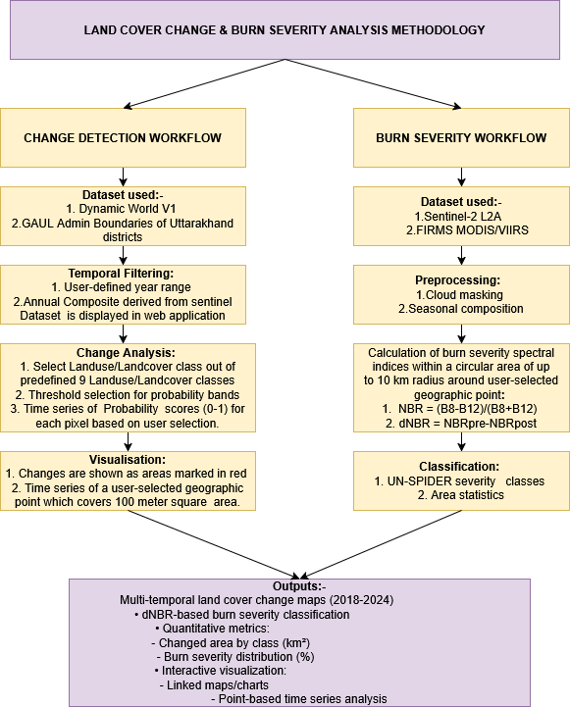

Figure 1 Workflow of the proposed methodology

**1. Land Cover Change Detection Workflow**

**1.1 Data Inputs**

* Dynamic World V1: land cover dataset provides 10-meter resolution, near real-time classification into nine land cover classes using Sentinel-2 imagery(Brown et al., 2022).
* GAUL (Global Administrative Unit Layers) district boundaries: are used to geographically filter the analysis to Uttarakhand.
* User-defined parameters: allow customization of the spatial area and time range via the GEE interface.

**1.2 Temporal and Spatial Filtering**

* Annual composite images**:** are derived from Sentinel-2(Wright et al., 2024) data using median values after cloud masking and seasonal filtering, following best practices in time-series satellite analysis (Zhou et al., 2020).
* Probability values (0–1) for each land cover class are filtered using user-defined thresholds to improve classification confidence(Sales et al., 2022).

**1.3 Change Detection and Analysis**

* Changes are detected by comparing land cover class probabilities across years, highlighting transitions (e.g., forest to built-up)(Lu et al., 2004).
* Time-series trends for selected pixels are generated to show class-specific fluctuations, especially for vulnerable categories like forest, agriculture, and barren land(Verma et al., 2022).

**1.4 Visualization and Decision Support**

* Spatial changes are visualized as red overlays in 100 m² tiles for affected zones.
* Interactive, point-based time series (Hamunyela et al., 2020; Schneibel et al., 2017)plots help identify transition patterns, improving clarity for policymakers and local stakeholders.

**2. Burn Severity Assessment Workflow**

**2.1 Data Inputs**

* Sentinel-2(Zhou et al., 2020) L2A imagery (10-meter resolution) provides pre- and post-fire spectral data.
* FIRMS (MODIS/VIIRS) active fire data(Congalton, 1991; Schneider et al., 2009) is used to identify fire-prone zones(Coskuner, 2022).
* User-defined geographic points enable site-specific severity analysis.

**2.2 Preprocessing**

* Cloud and shadow masking is applied using Sentinel-2’s Scene Classification Layer(Wright et al., 2024).
* Seasonal(Bargali et al., 2024) composites are created for pre-fire and post-fire dates to standardize conditions(Miller & Thode, 2007) .

**2.3 Spectral Indices Calculation**

* Normalized Burn Ratio (NBR) is calculated using near-infrared (B8) and shortwave infrared (B12) bands:

NBR= B8−B12

B8+B12

* Differenced Normalized Burn Ratio (dNBR) is computed as:

dNBR=NBRpre​−NBRpost

* These indices are widely used for mapping vegetation(Peng Gong et al., 2003) stress and burn severity(Miller & Thode, 2007) .

**2.4 Severity Classification**

* dNBR values are classified according to UN-SPIDER burn severity thresholds:
  + Unburned: < 0.1
  + Low severity: 0.1–0.27
  + Moderate severity: 0.27–0.44
  + High severity: > 0.44  
    (UN-SPIDER, 2021)

**2.5 Area Statistics**

* Each severity class’s area (in km²) is calculated within 10 km radius buffers surrounding fire-impacted points.
* These are aggregated to assess the spatial extent and intensity of forest fires at district and regional levels.

**3. Integration and Outputs**

The land cover and burn severity modules converge to produce:

* Multi-temporal land cover maps (2017–2024)
* dNBR-based fire severity(Sivakumar et al., 2024) maps
* Quantitative indicators: Changed area per land cover class, burn area per severity level
* Interactive decision tools:
  + Linked charts and maps
  + Pixel-level probability trends
  + Exportable visuals and data summaries

All processes are embedded in a user-interactive GEE application for visualization, temporal queries, and decision-making support by forest managers, researchers, and planners (Gorelick et al., 2017).

**4. Workflow of web application**

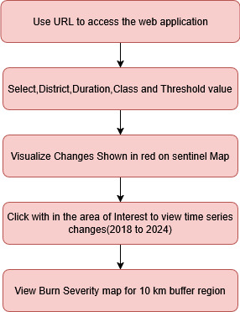

Figure 2 web application Functionality

Steps to access Web application are as follows and is also shown in fig 1 to 5

**Web Application Functionality**

1. Accessing the Application:  
   The web application can be accessed via the following URL:  
   <https://ee-shikhaitdwork.projects.earthengine.app/view/ukdcdbs>
2. User Inputs and Controls:  
   Users can interact with a panel on the right-hand side of the interface, where they can select a district, time duration, land cover class, and a threshold value. These inputs dynamically control the data visualization and analysis outputs for the selected region.
3. RGB Map Visualization with Change Detection:  
   Once the parameters are set, the application displays an RGB Sentinel-2 composite for the selected year and region. Changes in land cover during the specified duration are highlighted in red, allowing users to easily identify transformation zones.
4. Interactive Time-Series Analysis:  
   By clicking on any location within the selected area of interest, the application provides a time-series plot that displays the changes experienced by the selected pixel from 2018 to 2024, offering insight into its temporal land cover transition.
5. Burn Severity Mapping:  
   In addition to land cover analysis, the application also generates a burn severity map for fire-affected regions. This is displayed for a 10 km buffer zone around identified fire locations, enabling spatial analysis of wildfire impacts within the vicinity.

|  |  |
| --- | --- |
| C:\Users\Dell\AppData\Local\Packages\Microsoft.Windows.Photos_8wekyb3d8bbwe\TempState\ShareServiceTempFolder\1600.jpeg  Figure 3 Layer depicting the spatial distribution of FIIRMS in Dehradun | C:\Users\Dell\AppData\Local\Packages\Microsoft.Windows.Photos_8wekyb3d8bbwe\TempState\ShareServiceTempFolder\2600.jpeg  Figure 4 Sentinel Layer depicting the spatial distribution of Dehradun |
| C:\Users\Dell\AppData\Local\Packages\Microsoft.Windows.Photos_8wekyb3d8bbwe\TempState\ShareServiceTempFolder\4600.jpeg  Figure 5 Built-up Changes in Dehradun shown in red | C:\Users\Dell\AppData\Local\Packages\Microsoft.Windows.Photos_8wekyb3d8bbwe\TempState\ShareServiceTempFolder\5_6600.jpeg  Figure 6 Burn Severity map for a user selected point |
| C:\Users\Dell\AppData\Local\Packages\Microsoft.Windows.Photos_8wekyb3d8bbwe\TempState\ShareServiceTempFolder\ee-chart (1)600.jpeg  Figure 7 Histogram of NDVI before and after of forest fire | |

**5. Results and Discussion**

**Results**  
Using high-resolution satellite data, remote sensing indices, and an interactive web-based application developed on Google Earth Engine (GEE), the study thoroughly examines the dynamics of land cover and the intensity of fires in Uttarakhand between 2018 and 2024. The outcomes combine two main elements:

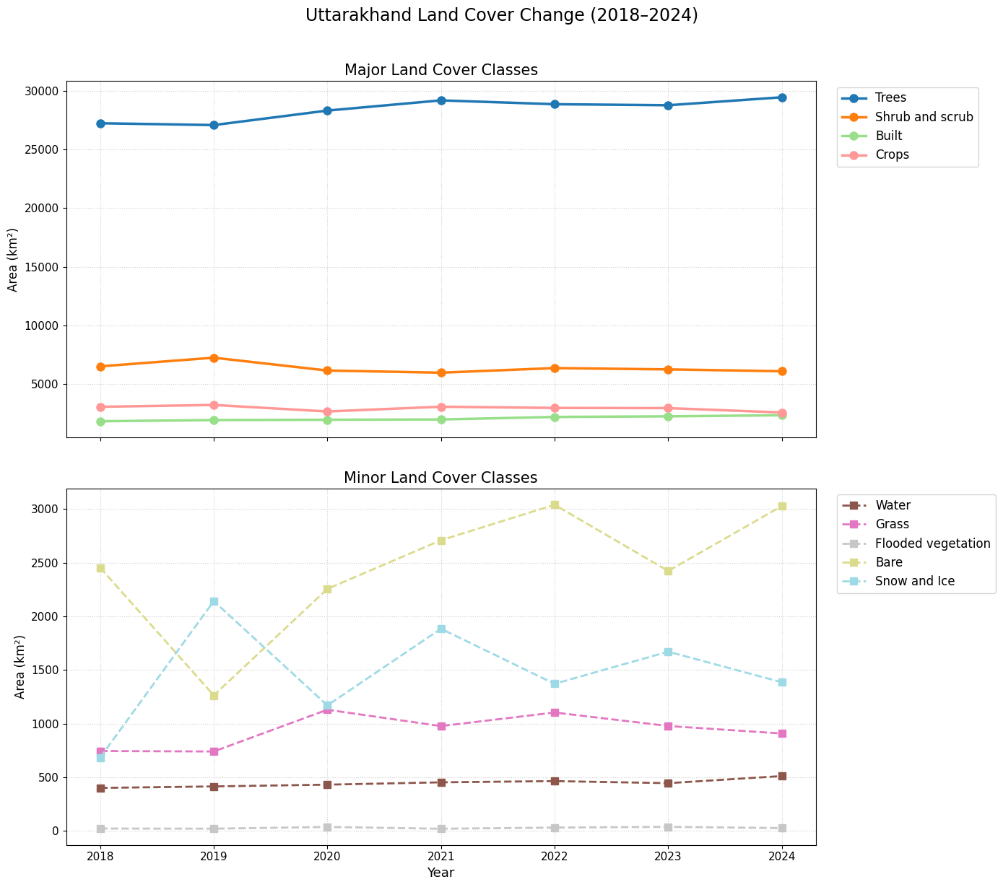

Figure 8 land use land cover change analysis (2018-2024)

**1. Land Cover Change Analysis (2018–2024)  
Major Land Cover Classes:** **Trees:** The most dominant land cover, increasing from 27,247.14 km² in 2018 to 29,462.06 km² in 2024 (+8.1%), likely reflecting afforestation and reforestation efforts.  
 **Built-up Area:** Expanded from 1,822.07 km² to 2,334.50 km² (+28.1%), indicative of urban sprawl especially in southern regions.  
 **Crops**: Declined from 3,053.78 km² to 2,569.06 km² (-15.9%), possibly due to urban encroachment or shifting agricultural practices.  
 **Shrub and Scrub:** Decreased moderately by 417.79 km² (-6.4%), perhaps replaced by urban infrastructure or reclassified due to vegetation(Bargali et al., 2024) changes.

**Minor Land Cover Classes:**  
 **Water Bodies:** Increased by 110.41 km² (+27.5%), potentially due to improved satellite detection and/or new reservoirs.  
 **Grasslands:** Expanded by 163.04 km² (+21.9%), indicating land-use transformation from fallow or degraded zones.  
 **Bare Land:** Increased significantly by 573.77 km² (+23.4%), possibly due to glacial retreat, deforestation, or construction activity.  
 **Flooded Vegetation:** Grew slightly (+17.7%), signalling local wetland changes.  
 **Snow and Ice:** Witnessed a marked increase of 700.88 km² (+102.4%), though such variation may be seasonally or methodologically influenced.  
 **Temporal Visualization and Trends:**  
 Annual land cover maps and time-series graphs provide district-level insights into land transformation. Users can observe location-specific changes (e.g., forest-to-urban transitions) with 100 m² resolution using the web application.

**Uttarakhand Land Cover Change (2018–2024 (Area in km²))**

|  |  |  |  |  |  |  |  |  |  |  |
| --- | --- | --- | --- | --- | --- | --- | --- | --- | --- | --- |
| Class | Class Name | 2018 | 2019 | 2020 | 2021 | 2022 | 2023 | 2024 | Change (2018–2024) | % Change |
| 0 | Water | 401.17 | 415.16 | 431.52 | 453.25 | 464.71 | 445.52 | 511.58 | +110.41 | +27.5% |
| 1 | Trees | 27,247.14 | 27,090.07 | 28,327.00 | 29,197.19 | 28,870.67 | 28,781.92 | 29,462.06 | +2,214.92 | +8.1% |
| 2 | grass | 745.23 | 740.71 | 1,129.64 | 977.09 | 1,103.83 | 977.85 | 908.27 | +163.04 | +21.9% |
| 3 | Flooded vegetation | 22.89 | 21.49 | 37.65 | 20.86 | 31.51 | 38.81 | 26.94 | +4.05 | +17.7% |
| 4 | crops | 3,053.78 | 3,212.56 | 2,654.35 | 3,060.75 | 2,957.28 | 2,941.34 | 2,569.06 | -484.72 | -15.9% |
| 5 | Shrub and scrub | 6,504.95 | 7,243.50 | 6,148.21 | 5,965.03 | 6,357.65 | 6,245.61 | 6,087.16 | -417.79 | -6.4% |
| 6 | Built | 1,822.07 | 1,922.09 | 1,948.12 | 1,973.24 | 2,188.63 | 2,239.78 | 2,334.50 | +512.43 | +28.1% |
| 7 | Bare | 2,452.82 | 1,263.10 | 2,255.18 | 2,708.39 | 3,038.68 | 2,422.08 | 3,026.59 | +573.77 | +23.4% |
| 8 | Snow and Ice | 684.56 | 2,141.44 | 1,169.95 | 1,884.00 | 1,370.89 | 1,670.55 | 1,385.44 | +700.88 | +102.4% |

Table 2 Land use Land cover of Uttarakhand (2018-2024)

**Spatial Interpretation (From Maps)**

* The 2018 map shows widespread forest (green) coverage in the central and eastern districts, with high snow and ice concentration in the northern Himalayan ranges.
* In 2024, there is a visible expansion of built-up areas (red) and a slight retreat of croplands (orange) in the southern and southwestern regions.
* Snow and ice regions (purple) appear more distinctly demarcated in 2024, consistent with observed increases in the quantitative data, although interpretation should account for seasonal image variations.

|  |
| --- |
|  |
|  |
| Figure 9 Classified maps of 2018 and 2024 |

1. **Methodological Advancements:**

* High-resolution mapping (10 m) using **Dynamic World**(Brown et al., 2022) **V1** and **Sentinel-2** imagery enabled precise detection of nine land cover classes.
* Interactive tools allowed users to visualize changes (highlighted in red) and explore time-series data (2014–2024) for specific locations.

**2. Burn Severity Assessment**

* **Pre- and Post-Fire Analysis:** Utilized Sentinel-2 L2A imagery(I. Volke et al., 2024) to compute Normalized Burn Ratio (NBR) and differenced NBR (dNBR) for fire-impacted areas.
* **Severity Classification:** Applied UN-SPIDER thresholds to categorize burn severity into unburned, low, moderate, and high severity.
* Severity maps around active fire zones (e.g., Dehradun) revealed substantial areas under moderate-to-high severity.
* **Burned Area Quantification:** Generated burn severity
* maps within a 10 km radius of selected locations, quantifying affected areas (km²).
* **FIRMS Fire Data Integration:**  
  MODIS/VIIRS FIRMS data provided fire point overlays, enabling real-time detection(Hamunyela et al., 2020; Schneibel et al., 2017) of fire-prone zones and hotspot visualization.

**Interactive Outputs:** **Visualization and Outputs:**

* Interactive maps displayed RGB Sentinel layers, built-up changes, burn severity(SHIKHA GOSWAMI & ALAKNANDA ASHOK, 2024), and NDVI histograms.
* Users could download customized reports, facilitating localized analysis and decision-making(Frantzeskaki et al., 2019).
* The application offers maps of built-up expansion, burn severity, NDVI histograms (pre- and post-fire), and downloadable analytics for decision support.

**Conclusion**

The land cover analysis of Uttarakhand from 2018 to 2024 reveals dynamic environmental and anthropogenic shifts across the Himalayan landscape. Notable trends include a substantial rise in built-up area (+28.1%), indicating urban expansion, and an unexpected increase in snow and ice cover (+102.4%), potentially reflecting improved remote sensing detection or seasonal accumulation patterns. Tree cover has modestly increased (+8.1%), showcasing positive ecological restoration trends, likely driven by afforestation programs or natural regrowth in abandoned agricultural lands. Conversely, agricultural land decreased by 15.9%, which may be symptomatic of rural-to-urban migration, abandonment of marginal lands, or encroachment by infrastructure. Shrubland and grassland fluctuations further reflect transitional zones responding to climate, human activity, and conservation efforts. Technologically, this study underscores the power of Google Earth Engine (GEE) and Dynamic World datasets in enabling high-frequency, cloud-based, and accurate land classification using satellite data like Sentinel-2. These tools facilitate scalable environmental monitoring in remote mountainous terrains like Uttarakhand.

The future scope of this research includes applying time series analysis to detect seasonal and long-term trends in land cover changes. Deep learning models can enhance classification accuracy and automate feature extraction. Integration of SAR data can improve analysis in cloud-prone or snow-covered regions. Comparative studies with other remote sensing products can validate results and refine land cover mapping.

COMPETING INTERESTS DISCLAIMER:

Authors have declared that they have no known competing financial interests OR non-financial interests OR personal relationships that could have appeared to influence the work reported in this paper.

Disclaimer (Artificial intelligence)

Option 1: No

Author(s) hereby declare that NO generative AI technologies such as Large Language Models (ChatGPT, COPILOT, etc.) and text-to-image generators have been used during the writing or editing of this manuscript.

Option 2: No

Author(s) hereby declare that generative AI technologies such as Large Language Models, etc. have been used during the writing or editing of manuscripts. This explanation will include the name, version, model, and source of the generative AI technology and as well as all input prompts provided to the generative AI technology

Details of the AI usage are given below:

1. Ai2 Paper Finder

2. Research Rabbit

3.

**References:**

Bargali, H., Bhatt, D., Sundriyal, R. C., & Uniyal, V. P. (2024). Mapping and impact of seasonal forest fires on vegetation types, soil dynamics, and tree mortality in the forest ecosystem of Uttarakhand Himalaya. *Landscape Online*, 1128. https://doi.org/10.3097/LO.2024.1128

Bargali, H., Kumar, A., & Singh, P. (2022). Plant studies in Uttarakhand, Western Himalaya–A comprehensive review. *Trees, Forests and People*, *8*. https://doi.org/10.1016/j.tfp.2022.100203

Batar, A., Watanabe, T., & Kumar, A. (2017). Assessment of Land-Use/Land-Cover Change and Forest Fragmentation in the Garhwal Himalayan Region of India. *Environments*, *4*(2), 34. https://doi.org/10.3390/environments4020034

Berrick, S. W., Leptoukh, G., Farley, J. D., & Rui, H. (2009). Giovanni: A web service workflow-based data visualization and analysis System. *IEEE Transactions on Geoscience and Remote Sensing*, *47*(1). https://doi.org/10.1109/TGRS.2008.2003183

Biaou, S., Gouwakinnou, G. N., Biaou, H. S. S., Tovihessi, M. S., Awessou, B. K., Ahononga, F. C., & Houéto, F. O. (2022). Identifying the land use and land cover change drivers: methods and case studies of two forest reserves in Northern Benin. *Environment, Development and Sustainability*, *24*(8). https://doi.org/10.1007/s10668-021-01849-4

Brown, C. F., Brumby, S. P., Guzder-Williams, B., Birch, T., Hyde, S. B., Mazzariello, J., Czerwinski, W., Pasquarella, V. J., Haertel, R., Ilyushchenko, S., Schwehr, K., Weisse, M., Stolle, F., Hanson, C., Guinan, O., Moore, R., & Tait, A. M. (2022). Dynamic World, Near real-time global 10 m land use land cover mapping. *Scientific Data*, *9*(1), 251. https://doi.org/10.1038/s41597-022-01307-4

Congalton, R. G. (1991). A review of assessing the accuracy of classifications of remotely sensed data. *Remote Sensing of Environment*, *37*(1), 35–46. https://doi.org/10.1016/0034-4257(91)90048-B

Coskuner, K. A. (2022). Assessing the performance of MODIS and VIIRS active fire products in the monitoring of wildfires: a case study in Turkey. *IForest*, *15*(2). https://doi.org/10.3832/ifor3754-015

Das, M., Chattopadhyay, A., & Basu, R. (2017). Spatial Flood Potential Mapping (SFPM) with Flood Probability and Exposure Indicators of Flood Vulnerability: Case Study Former Jalpaiguri District, West Bengal, India. *Journal of Geography & Natural Disasters*, *7*(3). https://doi.org/10.4172/2167-0587.1000210

Dhankar, S., Singh, G., & Kumar, K. (2024). Impacts of urbanization on land use, air quality, and temperature dynamics in Dehradun district of Uttarakhand, India: a comprehensive analysis. *Frontiers in Environmental Science*, *12*. https://doi.org/10.3389/fenvs.2024.1324186

Frantzeskaki, N., McPhearson, T., Collier, M. J., Kendal, D., Bulkeley, H., Dumitru, A., Walsh, C., Noble, K., Van Wyk, E., Ordóñez, C., Oke, C., & Pintér, L. (2019). Nature-based solutions for urban climate change adaptation: Linking science, policy, and practice communities for evidence-based decision-making. *BioScience*, *69*(6). https://doi.org/10.1093/biosci/biz042

Gad, A.-A. (2015). Land capability classification of some western desert Oases, Egypt, using remote sensing and GIS. *The Egyptian Journal of Remote Sensing and Space Science*, *18*(1), S9–S18. https://doi.org/10.1016/j.ejrs.2015.06.002

Gorelick, N., Hancher, M., Dixon, M., Ilyushchenko, S., Thau, D., & Moore, R. (2017). Google Earth Engine: Planetary-scale geospatial analysis for everyone. *Remote Sensing of Environment*, *202*, 18–27. https://doi.org/10.1016/j.rse.2017.06.031

Halder Olivia and Sarkar, A. and S. A. and M. L. (2025). Interconnection Between Agriculture and Livelihoods in Har-ki-Dun Valley, Uttarakhand, Indian Himalaya. In P. Borthakur Anwesha and Singh (Ed.), *People and Mountain Environments: Interconnectedness for Sustainable Development in the Himalayas* (pp. 149–175). Springer Nature Switzerland. https://doi.org/10.1007/978-3-031-83553-7\_4

Hamunyela, E., Brandt, P., Shirima, D., Do, H. T. T., Herold, M., & Roman-Cuesta, R. M. (2020). Space-time detection of deforestation, forest degradation and regeneration in montane forests of Eastern Tanzania. *International Journal of Applied Earth Observation and Geoinformation*, *88*, 102063. https://doi.org/10.1016/j.jag.2020.102063

I. Volke, M., Abarca-Del-Rio, R., & A. Warner, T. (2024). Cost-effective disaster-induced land cover analysis: a semi-automatic methodology Using machine learning and satellite imagery. *International Journal of Remote Sensing*, *45*(2). https://doi.org/10.1080/01431161.2023.2292015

ISFR. (2019). *Indian state of forests report, vol. II. Forest Survey of India*. (Ministry of Environment Forest and Climate Change) Kaulagarh Road, P.O. IPE Dehradun - 248195.

Lu, D., Mausel, P., Brondízio, E., & Moran, E. (2004). Change detection techniques. *International Journal of Remote Sensing*, *25*(12), 2365–2401. https://doi.org/10.1080/0143116031000139863

Miller, J. D., & Thode, A. E. (2007). Quantifying burn severity in a heterogeneous landscape with a relative version of the delta Normalized Burn Ratio (dNBR). *Remote Sensing of Environment*, *109*(1), 66–80. https://doi.org/10.1016/j.rse.2006.12.006

Ministry of Environment, F. and C. C. , G. of India. (2022). *Forest Survey of India (FSI). (2022). India State of Forest Report 2021.* .

Ministry of Environment, F. and C. Change. (2021). *Forest Survey of India. (2021). India State of Forest Report 2021. Dehradun*.

Mondal, P. P., & Zhang, Y. (2018). Research Progress on Changes in Land Use and Land Cover in the Western Himalayas (India) and Effects on Ecosystem Services. *Sustainability*, *10*(12), 4504. https://doi.org/10.3390/su10124504

Negi, G. C. S. (2019). Forest Fire in Uttarakhand: Causes, Consequences and Remedial Measure. *International Journal of Ecology and Environmental Sciences*, *45*(1).

Patley, M. K., Tiwari, A., Kumar, K., Arumugam, T., Kinattinkara, S., & Arumugam, M. (2024). Study of mountain ecosystem accounting in lower Himalaya range in Uttarkhand, India using geospatial technology. *Results in Engineering*, *21*. https://doi.org/10.1016/j.rineng.2024.101811

Peng Gong, Ruiliang Pu, Biging, G. S., & Larrieu, M. R. (2003). Estimation of forest leaf area index using vegetation indices derived from hyperion hyperspectral data. *IEEE Transactions on Geoscience and Remote Sensing*, *41*(6), 1355–1362. https://doi.org/10.1109/TGRS.2003.812910

Potapov, P., Hansen, M. C., Laestadius, L., Turubanova, S., Yaroshenko, A., Thies, C., Smith, W., Zhuravleva, I., Komarova, A., Minnemeyer, S., & Esipova, E. (2017). The last frontiers of wilderness: Tracking loss of intact forest landscapes from 2000 to 2013. *Science Advances*, *3*(1). https://doi.org/10.1126/sciadv.1600821

Pragya, Kumar, M., Tiwari, A., Majid, S. I., Bhadwal, S., Sahu, N., Verma, N. K., Tripathi, D. K., & Avtar, R. (2023). Integrated Spatial Analysis of Forest Fire Susceptibility in the Indian Western Himalayas (IWH) Using Remote Sensing and GIS-Based Fuzzy AHP Approach. *Remote Sensing*, *15*(19), 4701. https://doi.org/10.3390/rs15194701

Rawat, J. S., Biswas, V., & Kumar, M. (2013). Changes in land use/cover using geospatial techniques: A case study of Ramnagar town area, district Nainital, Uttarakhand, India. *The Egyptian Journal of Remote Sensing and Space Science*, *16*(1), 111–117. https://doi.org/10.1016/j.ejrs.2013.04.002

Rogan, J., & Chen, D. M. (2004). Remote sensing technology for mapping and monitoring land-cover and land-use change. In *Progress in Planning* (Vol. 61, Issue 4). https://doi.org/10.1016/S0305-9006(03)00066-7

Sales, M. H. R., De Bruin, S., Souza, C., & Herold, M. (2022). Land Use and Land Cover Area Estimates from Class Membership Probability of a Random Forest Classification. *IEEE Transactions on Geoscience and Remote Sensing*, *60*. https://doi.org/10.1109/TGRS.2021.3080083

Schneibel, A., Frantz, D., Röder, A., Stellmes, M., Fischer, K., & Hill, J. (2017). Using Annual Landsat Time Series for the Detection of Dry Forest Degradation Processes in South-Central Angola. *Remote Sensing*, *9*(9), 905. https://doi.org/10.3390/rs9090905

Schneider, A., Friedl, M. A., & Potere, D. (2009). A new map of global urban extent from MODIS satellite data. *Environmental Research Letters*, *4*(4), 044003. https://doi.org/10.1088/1748-9326/4/4/044003

SHIKHA GOSWAMI, & ALAKNANDA ASHOK. (2024). BURN SEVERITY ASSESSMENT IN UTTARKASHI DISTRICT, UTTARAKHAND USING SATELLITE IMAGERY AND REMOTE SENSING TECHNIQUES. *Jilin Daxue Xuebao (Gongxueban)/Journal of Jilin University (Engineering and Technology Edition)*, *43*(10–2024), 62–82.

Singh, H., & Kumar, M. (2022). *Climate Change and Its Impact on Indian Himalayan Forests: Current Status and Research Needs* (pp. 223–242). https://doi.org/10.1007/978-3-030-92782-0\_11

Singh, S., & Suresh Babu, K. V. (2021). *Forest Fire Susceptibility Mapping for Uttarakhand State by Using Geospatial Techniques* (pp. 173–188). https://doi.org/10.1007/978-3-030-76116-5\_11

Sivakumar, V. L., Raju, A., & Sundaram, A. V. (2024). Study of Forest Fire Severity through Normalized Burn Ratio Analysis using Remote Sensing. *E3S Web of Conferences*, *491*. https://doi.org/10.1051/e3sconf/202449101027

Verma, G., Mehta, A., & Goswami, S. (2022). Trend and Time Series Analysis of Vegetation Dynamics Using Satellite Data: A Case Study of Uttarakhand, India. *Current Journal of Applied Science and Technology*, *41*(33), 14–26. https://doi.org/https://doi.org/10.9734/cjast/2022/v41i333947

Wright, N., Duncan, J. M. A., Callow, J. N., Thompson, S. E., & George, R. J. (2024). CloudS2Mask: A novel deep learning approach for improved cloud and cloud shadow masking in Sentinel-2 imagery. *Remote Sensing of Environment*, *306*. https://doi.org/10.1016/j.rse.2024.114122

Zhou, F., Zhong, D., & Peiman, R. (2020). Reconstruction of cloud-free sentinel-2 image time-series using an extended spatiotemporal image fusion approach. *Remote Sensing*, *12*(16). https://doi.org/10.36745/IJCA.341

Zhuravleva, I., Turubanova, S., Potapov, P., Hansen, M., Tyukavina, A., Minnemeyer, S., Laporte, N., Goetz, S., Verbelen, F., & Thies, C. (2013). Satellite-based primary forest degradation assessment in the Democratic Republic of the Congo, 2000–2010. *Environmental Research Letters*, *8*(2), 024034. https://doi.org/10.1088/1748-9326/8/2/024034