Toward a Legislative Framework for Traditional and Complementary Medicine in Africa: A Legal Commentary on Ghana and the Gambia

**ABSTRACT**

**Background**  
Africa’s healthcare systems are inherently pluralistic, with Traditional and Complementary Medicine (TCAM) playing a central role in public health. However, despite constitutional recognition of indigenous healing systems in countries such as Ghana and The Gambia, regulatory frameworks remain narrow, outdated, or entirely absent—failing to reflect the evolving role of Complementary and Alternative Medicine (CAM) modalities such as naturopathy, homeopathy, and Ayurveda.

**Aim of the Study**  
This study aims to examine the constitutional and legal foundations of TCAM in Ghana and The Gambia, identify existing regulatory gaps, and propose a harmonized and inclusive legislative framework that ensures professional recognition and governance autonomy for both traditional and CAM practitioners.

**Methodology and Methods**  
This study employed a doctrinal and comparative legal research approach. It involved critical analysis of key constitutional provisions, including Articles 11(3) and 26(2) of the 1992 Constitution of Ghana and Section 7 of the 1997 Constitution of The Gambia. Relevant statutory instruments and policy documents were also examined, such as Ghana’s Traditional Medicine Practice Act 575 and The Gambia’s Draft Traditional Health Practitioners Bill, 2025. Additionally, international frameworks—particularly the WHO Traditional Medicine Strategy 2014–2023—and national policy drafts like The Gambia’s 2020 Draft Constitution were reviewed to contextualize the legal positioning of traditional medicine within broader global and regional governance structures.

**Results and Findings**  
The study found that both Ghana and The Gambia have constitutional backing for traditional medicine, yet existing laws—such as Ghana’s Traditional Medicine Practice Act (Act 575)—are limited in scope, excluding CAM systems that are increasingly relevant. The Gambia lacks a comprehensive TCAM statute entirely. The findings support the need for a dual regulatory mechanism that separates but equally legitimizes traditional and CAM practitioners. Furthermore, the study advocates for autonomous TCAM governance structures composed exclusively of TCAM stakeholders.

**Conclusion and Recommendations:**  
The integration of TCAM through constitutional and legislative reform is both a legal imperative and a public health necessity. The study concludes that renaming existing legislation to explicitly include complementary medicine, developing dual licensure pathways, and institutionalizing TCAM-led governance bodies are critical for regulatory legitimacy. It is recommended that Ghana and The Gambia adopt a unified 'Traditional and Complementary Medicine Bill' aligned with WHO and indigenous rights frameworks to ensure cultural inclusion, healthcare equity, and legal sustainability across African health systems.

# Keywords

Traditional Medicine, Complementary Medicine, Legal Pluralism, Ghana, The Gambia

# INTRODUCTION

Africa’s healthcare history is deeply interwoven with traditional medicine, a system rooted in centuries of indigenous knowledge, cultural belief systems, and therapeutic practices. Traditional medicine remains a cornerstone of healthcare for many African communities due to its accessibility, affordability, cultural resonance, and perceived effectiveness. Traditional, Complementary, and Alternative Medicine (TCAM) comprises a broad spectrum of products, therapies, and practices that differ from conventional allopathic medicine (Denu et al., 2024). Previous research by Lee et al. (2022) indicates that the prevalence of TCAM use is notably high, though actual usage may be underestimated. Furthermore, both individual and contextual factors significantly influence the choice to utilize TCAM, as highlighted by Molemans et al. (2023).

According to the World Health Organization (WHO), nearly 80% of the population in African countries rely on traditional medicine for primary healthcare needs (WHO, 2013). This statistic not only highlights the significance of indigenous healing systems in African societies but also indicates the potential role that traditional and complementary medicine (TCAM) can play in future healthcare development.

Despite its relevance, traditional medicine has struggled to find its rightful place in formal national healthcare systems. Most African countries—including Ghana and The Gambia—have historically focused their health sector regulations on biomedicine, often under frameworks inherited from colonial legacies.

Post-independence legislation has attempted to accommodate traditional medicine, but the efforts have largely centered around herbalism, leaving out a broad spectrum of Complementary and Alternative Medicine (CAM) practices such as naturopathy, homeopathy, Ayurveda, chiropractic, and acupuncture. The result is a fragmented policy and legal environment that marginalizes CAM practitioners and deprives populations of integrative healthcare solutions that blend indigenous and global therapeutic knowledge.

The WHO defines ***traditional medicine*** as “the sum total of the knowledge, skills, and practices based on the theories, beliefs, and experiences indigenous to different cultures used in the maintenance of health as well as in the prevention, diagnosis, improvement or treatment of physical and mental illness” (WHO, 2000).

***Complementary medicine***, by contrast, includes practices that are not part of a country’s own tradition or conventional medicine and are used interchangeably or alongside biomedical treatments. Together, these systems form what is now termed Traditional and Complementary Medicine (TCAM).

Globally, there is increasing recognition of TCAM's value. Countries such as India, China, Germany, Canada, and even the United States have incorporated various CAM disciplines into their healthcare policies and licensing regimes. Africa, however, remains behind in developing inclusive and legally robust frameworks that reflect both traditional and complementary medical practices.

In Ghana, the Traditional Medicine Practice Act, Act 575 (2000), represents a milestone in efforts to formalize traditional medicine. However, the Act’s focus is narrowly confined to herbal medicine, with little or no provision for non-herbal CAM modalities. The Traditional Medicine Council under the Ministry of Health oversees the regulation, yet it lacks the mandate to license naturopaths, homeopaths, or other CAM professionals. This exclusion not only limits the spectrum of health services legally available to Ghanaians but also fails to capitalize on the benefits that regulated CAM systems have brought to healthcare delivery in other regions of the world (Gyasi et al., 2017).

Similarly, The Gambia recognizes the relevance of traditional medicine within its constitutional and customary law frameworks. Section 7 of the 1997 Constitution affirms that common law and customary law are integral parts of the country’s legal system. Section 17 safeguards the right of every person to enjoy their cultural heritage, while provisions in the 2020 Draft Constitution go further by advocating the protection and promotion of traditional knowledge systems, including healthcare.

However, The Gambia still lacks a dedicated statutory instrument to regulate either traditional or complementary medicine. This absence of regulation leaves practitioners in a grey legal area, exposing both practitioners and patients to potential risks, while stifling innovation and growth in the natural health sector.

From a legal perspective, the failure to integrate TCAM reflects a broader issue of legislative inertia in recognizing the pluralistic nature of African societies. Legal pluralism—the coexistence of multiple legal systems such as statutory law, common law, and customary law—is already a hallmark of African constitutionalism (Merry, 1988). Yet, this pluralism is inconsistently applied in the health sector, where statutory biomedical frameworks dominate, often to the exclusion of other valid systems of care. This disparity stands in contrast to the constitutional provisions in countries like Ghana and The Gambia, which recognize the legitimacy of customary and common law, both of which have historically accommodated and supported traditional medicine practices.

Moreover, the marginalization of TCAM systems has implications beyond healthcare access. It affects education, professional development, intellectual property protection, and economic empowerment, particularly for rural and indigenous communities who depend on traditional healing for livelihoods. It also hinders Africa's ability to contribute to global innovation in holistic health and limits opportunities for collaboration in research and training with international CAM institutions.

The World Health Organization’s Traditional Medicine Strategy 2014–2023 calls on member states to integrate TCAM into national health systems through appropriate regulation, research, and education. As WHO member states, both Ghana and The Gambia have endorsed this framework. However, implementation has been patchy, with CAM still sidelined in national health strategies. The time has come for African countries to adopt legislative frameworks that are constitutionally grounded, globally informed, and locally relevant.

This paper seeks to address this gap by offering a legal critique and reform proposal for the development of a Traditional and Complementary Medicine Bill—one that unites indigenous and complementary health systems under a coherent, constitutionally-backed legal framework. The proposed model draws on principles of legal pluralism, indigenous knowledge jurisprudence, and international best practices. It also builds on constitutional analysis from Ghana and The Gambia to demonstrate that legislative reform is not only feasible but constitutionally warranted and socially necessary.

By addressing the legal void surrounding TCAM, this commentary seeks to promote healthcare equity, protect indigenous knowledge, and catalyze innovation in Africa’s health sector. The future of healthcare in Africa depends not only on biomedical advances but also on the ability to integrate time-tested traditional and complementary practices into national health systems.

# STATEMENT OF THE PROBLEM

Traditional medicine forms an integral part of Africa’s healthcare systems. According to the World Health Organization (WHO), approximately 80% of the population in developing countries rely on traditional medicine for their primary healthcare needs (WHO, 2013). This reliance underscores the critical role indigenous health systems play in the cultural and practical lives of African communities. However, despite the significant societal reliance on traditional and complementary healing systems, legal and regulatory frameworks in many African countries—including Ghana and The Gambia—remain underdeveloped and poorly integrated into national health policy. This regulatory gap is especially pronounced in the treatment of Complementary and Alternative Medicine (CAM) disciplines, such as naturopathy, homeopathy, Ayurveda, chiropractic, and traditional Chinese medicine.

In Ghana, the 1992 Constitution recognizes the importance of cultural practices through Article 26(2), which mandates the State to foster the development of appropriate customary practices. Additionally, Article 11(3) affirms the relevance of common law, customary law, and statutory law, thereby creating space for legal pluralism. These provisions establish a constitutional basis for recognizing traditional medicine systems (Constitution of Ghana, 1992). However, the legislative enactment that governs the field—the Traditional Medicine Practice Act, 2000 (Act 575)—is narrowly focused on herbal medicine and the licensing of herbalists, without extending its scope to include CAM modalities such as naturopathy and homeopathy. This limited scope has resulted in a fragmented regulatory environment where CAM practitioners operate without formal recognition, standardization, or legal protection.

Similarly, The Gambia’s 1997 Constitution provides for legal pluralism through Section 7, which includes customary law and common law as part of the country's legal system. Section 17 further guarantees the fundamental rights and freedoms of individuals, including participation in cultural life. These provisions could be interpreted as allowing for the inclusion of traditional and CAM systems. Furthermore, the 2020 Draft Constitution expands the space for cultural and indigenous practices by affirming community rights to preserve and promote traditional knowledge and health systems. However, The Gambia lacks a comprehensive legislative instrument that explicitly regulates either traditional medicine or CAM disciplines. As a result, CAM practitioners, despite often being professionally trained in reputable institutions abroad, face ambiguity in practice recognition, lack of licensing protocols, and absence from official health strategies.

The problem is exacerbated by the increasing use and acceptance of CAM disciplines globally, including in Africa. Studies have shown that CAM practices are not only growing in popularity but are also supported by an expanding body of scientific literature that confirms their efficacy in areas such as chronic disease management, preventive health, and patient-centered care (Ernst, 2000; Tilburt & Kaptchuk, 2008). Yet, despite this global evolution, African regulatory systems remain largely fixated on the herbalist model, failing to embrace the integrative potential of CAM. This oversight marginalizes qualified CAM practitioners, inhibits public access to diverse therapeutic options, and weakens quality assurance mechanisms.

This regulatory shortfall has real implications for public health, education, and professional development. CAM practitioners lack access to formal accreditation systems and are often excluded from national health insurance schemes and public health initiatives. Additionally, the lack of legal recognition undermines the development of structured educational programs in CAM disciplines within African institutions, hindering efforts to build local capacity and reducing Africa’s ability to contribute to global CAM research and innovation.

The marginalization of CAM also undermines efforts to protect and promote indigenous knowledge systems. Many CAM modalities—such as naturopathy and Ayurveda—share philosophical and therapeutic similarities with African traditional medicine. However, without legal frameworks to support their inclusion, these systems remain informally practiced and poorly documented. This not only limits their contribution to health service delivery but also jeopardizes the preservation and intergenerational transmission of valuable therapeutic knowledge.

Furthermore, the inclusion of CAM within the national legal framework is essential to safeguard public safety. Unregulated CAM practice may lead to the proliferation of quackery, misuse of therapies, and erosion of public trust. Establishing clear professional standards, licensing procedures, and scopes of practice—within a formal legal structure—would mitigate such risks and contribute to the delivery of safe, effective, and ethical healthcare services.

The WHO Traditional Medicine Strategy 2014–2023 emphasizes the importance of integrating traditional and complementary medicine into national health systems through regulation, research, and education. Both Ghana and The Gambia are member states of the WHO and have endorsed this strategy, yet neither country has taken significant legislative steps toward fulfilling these commitments in relation to CAM (WHO, 2013). This disjunction between international obligation and national implementation reveals the urgent need for legislative reform.

In conclusion, while constitutional provisions in Ghana and The Gambia provide a strong foundation for the recognition of TCAM, current legal frameworks are narrow, outdated, and fail to reflect the evolving realities of healthcare demand and practice. The absence of inclusive legislation results in professional marginalization, regulatory ambiguity, and underutilization of Africa’s rich repository of indigenous and complementary health systems. Addressing this problem through a revised, inclusive, and pluralistic legal framework is crucial for achieving health equity and advancing the role of traditional and CAM practices in Africa’s healthcare systems.

# OBJECTIVES OF THE STUDY

**RO1.** To examine constitutional provisions in Ghana and The Gambia that support TCAM.  
**RO2.**To assess gaps in the current traditional medicine regulatory frameworks.  
**RO3.**To propose a harmonized legislative model for regulating TCAM.  
**RO4.**To advocate for inclusive governance structures that ensure TCAM autonomy.

# RESEARCH QUESTIONS

**RQ1**: What constitutional and legal provisions support TCAM in Ghana and The Gambia?  
**RQ2:** What are the limitations of the current traditional medicine laws in recognizing CAM?  
**RQ3:** How can TCAM be integrated within the broader public health legal framework?  
**RQ4:** What should a governance model for regulating TCAM look like?

# CONCEPTUAL FRAMEWORK

The paper employs the concept of legal pluralism, which posits the coexistence of statutory, customary, and common law traditions in African legal systems. This conceptual model supports the idea that TCAM—rooted in indigenous knowledge and global CAM disciplines—can coexist and be formalized within national legal systems.

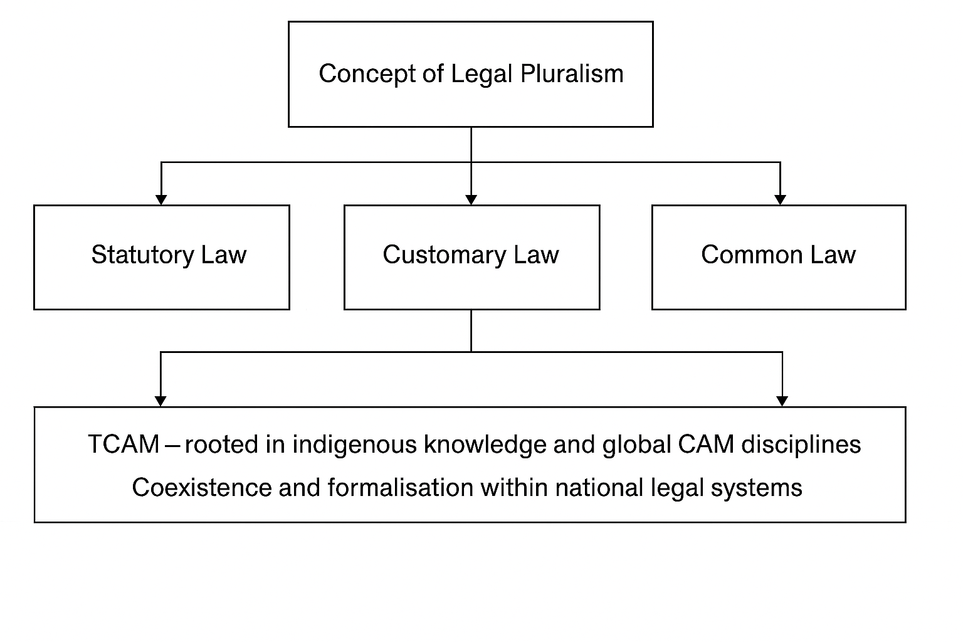

*Fig 1.Author’s Construct- The conceptual framework illustrates how legal pluralism—comprising statutory, customary, and common law—provides a basis for integrating Traditional and Complementary Medicine (TCAM) into national legal systems, supporting its coexistence and formalization.*

# THEORETICAL FRAMEWORK

This study is anchored in a composite theoretical framework that draws from four interrelated perspectives: (1) the decolonization of health systems, (2) indigenous knowledge jurisprudence, (3) legal pluralism, and (4) postcolonial legal theory. Together, these theories provide a rich foundation for analyzing the constitutional and statutory positioning of Traditional and Complementary Medicine (TCAM) within African legal systems, particularly in Ghana and The Gambia.

***Decolonization of Health Systems***

The decolonization of health systems theory critiques the historical imposition of Western biomedical models on colonized societies and calls for the reclamation of indigenous health knowledge and practices. Decolonization, in this context, involves dismantling the dominance of biomedical epistemologies and restoring legitimacy to traditional and culturally specific healing systems (Ndlovu-Gatsheni, 2013; Tangwa, 2000). The colonial health agenda often classified indigenous medical systems as inferior or unscientific, leading to their marginalization within formal legal and health institutions (Langwick, 2011). Postcolonial African states, including Ghana and The Gambia, have constitutional obligations to reverse these hierarchies and reintegrate indigenous health systems into mainstream governance.

Incorporating CAM systems—many of which share epistemological roots with traditional African healing—is part of the broader decolonial agenda. For example, naturopathy and Ayurveda emphasize holistic healing and harmony with nature, principles that closely align with African cosmologies of health (Asante & Gyimah-Boadi, 2004). The decolonization theory thus supports the legal recognition of diverse medical traditions that reflect the lived realities and health-seeking behaviors of African populations.

***Indigenous Knowledge Jurisprudence***

Indigenous knowledge jurisprudence refers to the body of legal thought that upholds the legitimacy, value, and protection of community-based knowledge systems, including those used in healing and medicine. This framework argues that indigenous knowledge is not merely cultural but is a legitimate form of intellectual property and legal authority deserving of formal recognition (Nnadozie, 2003). The African Union’s *Model Law on the Protection of the Rights of Local Communities* (2000) and the United Nations’ *Nagoya Protocol* (2010) affirm the legal relevance of indigenous knowledge and call on nation-states to incorporate these systems into statutory frameworks.

In the context of TCAM, indigenous jurisprudence demands that traditional healing practices be given equal legal standing with Western medical systems. It supports legislation that is culturally grounded and responsive to local health ecologies. This theory also provides the normative justification for the dual recognition of traditional and CAM systems within national health laws.

***Legal Pluralism***

Legal pluralism is the recognition that multiple legal systems—statutory, customary, common law, and religious law—can coexist within a single political community (Merry, 1988). In Africa, legal pluralism is not merely theoretical but a constitutional reality. For example, Article 11(3) of the 1992 Constitution of Ghana and Section 7 of the 1997 Constitution of The Gambia both affirm the role of customary and common law in national jurisprudence. This legal environment creates space for the recognition of traditional medicine practices, which are often governed by customary norms rather than statutory codes.

By invoking legal pluralism, this study affirms that TCAM can be regulated through innovative legal models that incorporate both formal state mechanisms and community-based regulatory systems. This theory provides a constitutional and jurisprudential bridge between biomedical law and the culturally situated governance of health.

***Postcolonial Legal Theory***

Postcolonial legal theory interrogates how colonial legacies continue to shape post-independence legal institutions and their treatment of non-Western systems of knowledge. Scholars such as Mamdani (1996) and Achiume (2019) argue that many African legal systems, though formally independent, continue to exhibit structural biases against indigenous institutions. Health law is no exception. The privileging of biomedical standards over traditional or CAM systems in regulatory frameworks is a manifestation of these colonial residues.

Postcolonial legal theory thus reinforces the need to critique and reform national health laws that exclude or marginalize TCAM systems. It supports a legislative reorientation that moves from assimilationist models—where traditional medicine must conform to biomedical criteria—towards integrative and pluralistic legal systems that recognize the distinctiveness and value of multiple healing traditions.

Together, these four theoretical lenses—decolonization of health systems, indigenous knowledge jurisprudence, legal pluralism, and postcolonial legal theory—provide a robust foundation for analyzing and reimagining TCAM regulation in Africa. They collectively affirm that pluralistic, inclusive, and decolonized legal frameworks are both constitutionally grounded and morally justified. These theories not only support the coexistence of diverse healing systems but also call for their co-regulation through culturally legitimate, legally enforceable, and institutionally autonomous mechanisms.

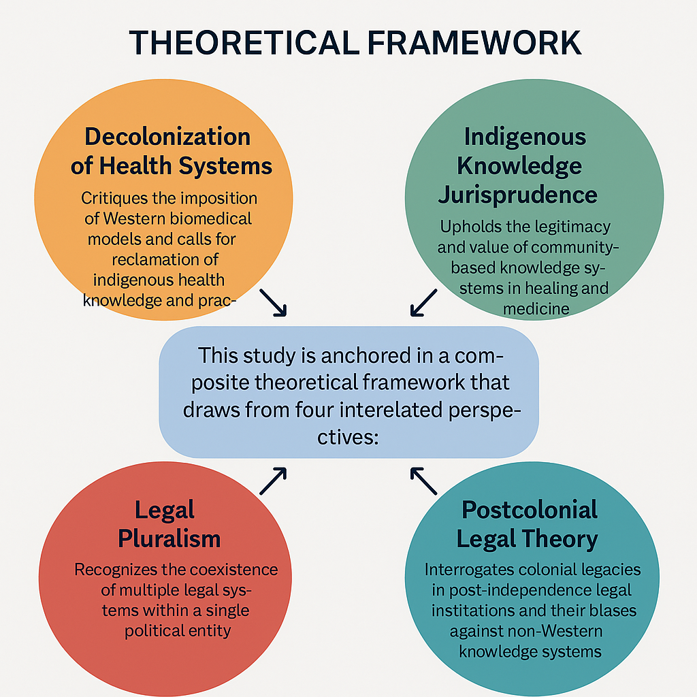

*Fig 2. Author’s Construct- The theoretical framework illustrates how the decolonization of health systems and indigenous knowledge jurisprudence, supported by legal pluralism and postcolonial theory, justify the coexistence and co-regulation of diverse healing practices within African legal systems.*

**LITERATURE REVIEW**

The evolving landscape of healthcare in Africa has necessitated a re-evaluation of how traditional medicine and Complementary and Alternative Medicine (CAM) systems are recognized, regulated, and integrated into national health policies. The World Health Organization (WHO) has been a critical voice in this conversation, advocating for the formal incorporation of traditional and complementary medical systems into national healthcare strategies. The *WHO Traditional Medicine Strategy 2014–2023* encourages member states to implement policies that support the safe, effective, and equitable use of traditional medicine (TM) and CAM by strengthening research, regulatory oversight, education, and integration into healthcare systems (WHO, 2013). This strategy reflects a global paradigm shift toward pluralistic and integrative health models and challenges countries to embrace broader systems of care beyond biomedicine.

***WHO’s Strategy and Africa’s Response***

In Africa, the uptake of WHO’s guidance has been uneven. Countries like South Africa, Nigeria, and Ethiopia have made varying degrees of progress in formalizing traditional medicine, with South Africa’s Traditional Health Practitioners Act (2007) offering a relatively inclusive framework. Ghana and The Gambia, however, present a dichotomy. While both nations constitutionally acknowledge the relevance of traditional healing systems, their statutory frameworks remain narrowly focused and underdeveloped with respect to CAM modalities.

Ghana’s Traditional Medicine Practice Act, Act 575 (2000) was a milestone in the country’s journey to formalize traditional medicine regulation. The Act established the Traditional Medicine Council under the Ministry of Health to regulate and license traditional medical practitioners. However, its scope is overwhelmingly centered on herbalism. The Act does not include modalities such as naturopathy, homeopathy, chiropractic, or acupuncture, despite the increasing practice and demand for these disciplines within Ghana. Gyasi et al. (2015) observed that this exclusion contributes to a “regulatory vacuum” that places CAM practitioners outside formal health and legal structures, exposing patients to unregulated services and practitioners to professional marginalization.

The omission of CAM systems in Ghanaian legislation contradicts the pluralistic ethos enshrined in the 1992 Constitution, particularly Articles 11(3) and 26(2), which affirm the importance of common law, customary law, and cultural values, including healing practices. As Bazzano et (2018) argue, the failure to translate these constitutional principles into inclusive statutory frameworks has contributed to the stagnation of holistic health development in Ghana.

In The Gambia, the 1997 Constitution recognizes customary law and common law under Section 7, which provides the foundation for embracing non-statutory legal systems. This provision legitimizes the coexistence of diverse knowledge systems, including traditional healing practices. Moreover, the 2020 Draft Constitution strengthens the position of indigenous knowledge, particularly in the promotion of cultural rights and traditional knowledge systems. Section 39(2) of the Draft Constitution, for instance, protects the rights of communities to preserve their cultural heritage, which can be interpreted to include traditional healing practices.

However, despite these promising legal provisions, The Gambia has yet to enact a comprehensive statutory framework for traditional medicine or CAM. This gap, as noted by (Obu, 2023), contributes to uncertainty in health governance and limits the capacity of CAM professionals to contribute effectively to national health goals. The current absence of a regulatory structure also weakens the protection of intellectual property rights and community-held knowledge systems—a key issue highlighted in the Nagoya Protocol on Access and Benefit-sharing (2010).

***Scholarly Perspectives on Integration***

Scholars have long advocated the integration of traditional and modern health systems as a path toward inclusive, culturally appropriate, and resilient healthcare models. Twumasi (2005), in his seminal work on medical pluralism in Ghana, argues that a true African health system cannot be divorced from its socio-cultural context. He criticizes the Western-centric approach to health regulation in post-colonial Africa and supports the development of hybrid systems that combine the strengths of both biomedical and traditional practices.

Similarly, Tangwa (2000) emphasizes the moral and philosophical justifications for integrating traditional and complementary systems. He posits that many CAM disciplines—such as naturopathy and homeopathy—share holistic health philosophies with African traditional medicine. Tangwa’s argument supports the idea that excluding these systems from legal recognition contradicts African cultural values and perpetuates colonial health hierarchies.

From a policy perspective, scholars such as Hughes et al. (2013) and Bodeker and Kronenberg (2002) have called for multi-tiered governance models that recognize the distinct knowledge bases of CAM and traditional medicine practitioners. They advocate for regulation that is context-sensitive, respects community-based epistemologies, and includes stakeholder-driven certification and training systems. This model is particularly relevant in Africa, where many traditional health systems operate outside formal medical institutions.

The issue of practitioner education and certification has also attracted scholarly attention. In Ghana, for example, Gyasi et al. (2015) found that many CAM practitioners operate informally due to the lack of standardized training or recognized certification pathways. This contributes to both professional insecurity and challenges in quality assurance. A similar scenario is seen in The Gambia, where CAM practitioners often depend on foreign training and remain unregulated domestically.

***Legal Pluralism and Indigenous Knowledge***

The concept of legal pluralism underpins much of the discourse surrounding TCAM integration. As explained by Merry (1988), legal pluralism is the recognition that multiple legal systems—statutory, customary, religious, and informal—can coexist within a single nation-state. In Africa, this pluralism has been particularly pronounced due to colonial legacies and the resilience of indigenous governance structures. Therefore, the exclusion of TCAM from statutory law is not only a legal gap but a contradiction of the broader pluralistic legal ethos that characterizes African legal systems.

The recognition of indigenous knowledge systems (IKS) is also gaining traction in international law and African scholarship. The African Union's Model Law on the Protection of the Rights of Local Communities (2000) advocates for the protection of traditional knowledge, including medicinal practices, as part of Africa’s intellectual heritage. Incorporating CAM systems within national legislation not only enhances healthcare delivery but also aligns with continental and global efforts to safeguard cultural heritage and promote community-based development.

In sum, the literature strongly supports the inclusion of traditional and CAM systems within national legal and policy frameworks in Africa. While WHO and other international bodies have provided guidance, countries like Ghana and The Gambia have not fully implemented comprehensive legislation to regulate and integrate CAM. Scholarly work from Twumasi, Tangwa, and others reinforces the cultural, ethical, and practical justifications for legislative reform. The continued exclusion of CAM from statutory recognition undermines Africa’s potential for holistic healthcare, violates the principles of legal pluralism, and fails to protect the rich troves of indigenous knowledge.

# METHODOLOGY

This research adopts a **doctrinal legal methodology** combined with a **comparative legal approach** to explore the legal and constitutional basis for integrating Traditional and Complementary Medicine (TCAM) into national health regulatory frameworks in Africa, particularly in Ghana and The Gambia.

The **doctrinal method,** also known as library-based legal research, involves a systematic analysis of legal texts, statutes, constitutional provisions, policy instruments, and judicial interpretations relevant to traditional medicine and CAM. This method allows the researcher to interpret, critique, and propose reforms to existing legal frameworks based on authoritative legal materials (Hutchinson & Duncan, 2012). In this study, **primary sources** include the draft Traditional Health Practitioners Act, Gambia, the 1992 Constitution of Ghana, the Traditional Medicine Practice Act, 2000 (Act 575), the 1997 Constitution of The Gambia, and the 2020 Draft Constitution of The Gambia. These legal instruments were selected because they provide the foundational legal recognition for traditional and customary practices, including indigenous health systems.

**Secondary sources** used in this research include WHO publications such as the WHO Traditional Medicine Strategy 2014–2023, General Guidelines for Methodologies on Research and Evaluation of Traditional Medicine (WHO, 2000), peer-reviewed journal articles, reports from the African Union, and relevant scholarly books. These sources offer policy insights, global perspectives, and theoretical grounding on the regulation and integration of traditional and complementary medicine.

The research further employs a **comparative legal methodology** to examine how the legislative and constitutional structures of Ghana and The Gambia treat TCAM systems. This comparative lens facilitates the identification of both best practices and regulatory gaps in the two countries’ approaches. The selection of Ghana and The Gambia is justified on the basis of their shared post-colonial legal heritage, the researcher’s legal background in both Ghana and the Gambia, legal pluralism, and constitutional provisions that recognize customary law and indigenous practices. However, despite these similarities, the countries differ significantly in their implementation of TCAM legislation—Ghana having enacted a traditional medicine statute (though limited in scope), and The Gambia yet to establish a dedicated legal framework.

This methodological framework allows for a holistic understanding of how statutory, customary, and common law interact to shape the space for TCAM in Africa. Legal pluralism—acknowledging the coexistence of multiple legal systems—is central to this analysis. The research also integrates insights from **postcolonial legal theory,** which critiques the dominance of Western biomedical paradigms and calls for the decolonization of African health systems (Tangwa, 2000; Merry, 1988).

Where necessary, the study also references **international instruments,** *such as the* Nagoya Protocol on Access to Genetic Resources and the Fair and Equitable Sharing of Benefits(2010), and the **African Union’s Model Law on the Protection of the Rights of Local Communities** (2000), to frame the global legal context within which African states are expected to safeguard indigenous knowledge systems and regulate their use.

The combination of doctrinal and comparative methodologies is appropriate for this research because it allows not only for a legal analysis of textual materials but also for a cross-jurisdictional examination of policy coherence, gaps, and legislative opportunities. Through this dual approach, the study provides practical recommendations for the development of a harmonized TCAM legal framework that is rooted in African constitutional values and responsive to global health governance trends.

**FINDINGS AND DISCUSSION**

This study set out to examine the constitutional and statutory foundations for Traditional and Complementary Medicine (TCAM) in Ghana and The Gambia, assess the limitations of current regulatory frameworks, and propose legal and policy reforms for the inclusion of Complementary and Alternative Medicine (CAM) modalities. The findings provide compelling evidence that while both countries constitutionally acknowledge traditional and customary health systems, their legislative and institutional responses remain incomplete, fragmented, and biomedical-centric.

***Research Question 1:*** *Do the constitutions of Ghana and The Gambia support the recognition of TCAM practices, including CAM modalities?*

The findings confirm that both countries constitutionally validate traditional and customary health systems. In Ghana, Article 11(3) incorporates customary law and common law into the sources of Ghanaian law, while Article 26(2) mandates the State to foster appropriate customary practices, including those relating to health. These provisions legitimize the inclusion of indigenous healing systems and support the integration of TCAM into the legal framework (Constitution of Ghana, 1992).

Similarly, in The Gambia, Section 7 of the 1997 Constitution identifies customary law and common law as components of the national legal system. Section 17 protects cultural rights, which includes the freedom to engage in traditional healing. Moreover, the 2020 Draft Constitution expands the recognition of indigenous knowledge systems by affirming community rights to preserve traditional health practices (Draft Constitution of The Gambia, 2020).

Despite this strong constitutional support, there is a disconnect between constitutional principles and statutory implementation. The recognition of TCAM at the constitutional level has not been translated into comprehensive legal or policy frameworks that govern CAM disciplines such as naturopathy, Ayurveda, chiropractic, or homeopathy. This finding directly addresses Research Question 1 and validates the first objective.

***Research Question 2:*** *To what extent do current laws regulate CAM practices such as naturopathy, homeopathy, and Ayurveda?*

Ghana’s Traditional Medicine Practice Act, 2000 (Act 575) focuses primarily on herbal medicine, with licensing and regulatory responsibilities vested in the Traditional Medicine Practice Council. However, the Act does not mention or provide registration criteria for CAM practitioners trained in modalities such as naturopathy or Ayurveda, despite their growing presence in the country. This narrow regulatory focus leaves CAM disciplines unregulated and their practitioners operating without legal recognition or professional safeguards (Gyasi et al., 2015).

In The Gambia, there is no existing legislative instrument regulating either traditional medicine or CAM. This legal vacuum means that all practitioners, regardless of training or professional standards, operate outside any formal licensing or accreditation framework. This finding directly addresses Research Question 2 and confirms the need for comprehensive legislative reform as outlined in the second objective.

**Research Question 3:** What legal reforms can be proposed to incorporate CAM systems into existing national regulatory structures?

Based on doctrinal analysis and comparative legal evaluation, the study proposes that the name of existing regulatory frameworks be changed from the “Traditional Medicine Practice Act” to the “Traditional and Complementary Medicine Bill.” This new title would broaden the legislative scope to include both indigenous and globally recognized CAM systems, thereby aligning with WHO’s 2014–2023 Traditional Medicine Strategy, which encourages the integration of TCAM into national health laws (WHO, 2013).

The study recommends the establishment of a dual registration and licensing pathway, where one stream covers traditional herbalists and another recognizes professionally trained CAM practitioners. For CAM, criteria should include a minimum of a diploma in the specific modality, evidence of clinical training, and a Professional Qualifying Examination (PQE). Titles such as "Naturopath" and "Naturopathic Doctor (ND)" should be awarded based on the number of hours trained—e.g., under or above 4,000 hours—to ensure alignment with international best practices (Bodeker & Kronenberg, 2002). These findings respond directly to Research Question 3 and fulfil Objective 3 by outlining clear legislative and policy recommendations.

***Research Question 4:*** *How can governance structures be redesigned to support inclusive and culturally grounded TCAM regulation?*

The study finds that existing governance structures—particularly in Ghana—suffer from biomedical dominance. The inclusion of medical doctors, nurses, and pharmacists in TCAM regulatory councils dilutes the autonomy and epistemological identity of traditional and CAM systems. This structure contradicts the WHO’s principle of non-biomedical interference in the governance of traditional and complementary medicine, which calls for councils composed of practitioners, educators, researchers, and legal experts within the TCAM domain (WHO, 2000).

To address this, the study recommends the exclusive composition of TCAM councils with members drawn from:

* Traditional healers
* Naturopaths
* Homeopaths
* CAM educators
* Health law experts
* Pharmacognosists

This would ensure that the regulatory framework is grounded in the philosophies and practices of TCAM, promote autonomy, and enhance policy relevance. The need for TCAM-specific councils and policy boards is a response to both Research Question 4 and Objective 4.

**Synthesis of Key Findings**

* Both Ghana and The Gambia constitutionally support legal pluralism and traditional medicine practices, offering a legal foundation for TCAM integration.
* However, statutory instruments lag behind constitutional principles, failing to account for CAM disciplines in scope, registration, or licensing.
* CAM practitioners are professionally marginalized, lacking clear titles, pathways for legal recognition, or participation in national health systems.
* Governance structures are dominated by biomedical professionals, which undermines the cultural and professional autonomy of TCAM systems.

# CONCLUSION

This study set out with four core objectives aimed at exploring, evaluating, and reimagining the legal landscape of Traditional and Complementary Medicine (TCAM) in Ghana and The Gambia. The conclusion demonstrates that these objectives were effectively addressed through both doctrinal and policy analysis, and provides a solid foundation for actionable reform in TCAM regulation and governance.

***Objective 1: To examine constitutional provisions in Ghana and The Gambia that support TCAM.***  
This objective has been fully met. The study established that both Ghana and The Gambia have strong constitutional bases that uphold customary law, indigenous knowledge systems, and cultural rights—all of which implicitly validate TCAM practices. Ghana’s Constitution (Articles 11(3) and 26(2)) and The Gambia’s recognition of customary law support this assertion. These provisions underscore that TCAM is not alien to African jurisprudence, and any integration into national health law is constitutionally justified.

***Objective 2: To assess gaps in the current traditional medicine regulatory frameworks.***  
The study critically assessed existing statutes—such as Ghana’s Traditional Medicine Practice Act (Act 575)—and highlighted key limitations, including the law’s narrow focus on herbal medicine and its exclusion of broader CAM systems like naturopathy and Ayurveda. The analysis also pointed out The Gambia’s complete lack of a dedicated TCAM statute despite its constitutional support for customary healing practices. Thus, this objective has also been achieved by identifying both structural and policy-level gaps that hinder effective regulation.

***Objective 3: To propose a harmonized legislative model for regulating TCAM.***  
This objective is substantially met through the study’s proposed legal reforms. These include renaming existing laws to encompass TCAM in its entirety, establishing dual registration and licensure regimes (for both traditional and complementary modalities), and adopting the WHO Traditional Medicine Strategy 2014–2023 as a guiding framework. The emphasis on harmonization aligns with global best practices while preserving local health sovereignty and indigenous traditions. These proposals address the fragmentation in current legal instruments and offer a clear pathway toward a unified, inclusive legal model.

***Objective 4: To advocate for inclusive governance structures that ensure TCAM autonomy.***  
This objective has been met by the recommendation that TCAM governance should not merely fall under biomedical regulatory bodies but instead be managed by autonomous councils or boards led by TCAM professionals. The study argues for structural reforms that empower TCAM practitioners, enhance self-regulation, and reduce the epistemic injustice historically imposed by colonial and biomedical paradigms. This includes the call for legal pluralism and culturally informed policy design as part of a decolonized healthcare model.

In conclusion, the findings of the study align strongly with its original objectives. Each objective has been effectively addressed through comprehensive legal analysis, case comparison, and strategic policy proposals. The research confirms that the constitutional and cultural foundations for TCAM integration already exist in Ghana and The Gambia. What remains is the political and legislative will to enact inclusive, decolonized, and harmonized legal frameworks that ensure professional recognition, regulatory clarity, and governance autonomy for TCAM systems.

This study therefore not only meets its objectives but also contributes to the broader discourse on legal reform, indigenous knowledge rights, and health pluralism in Africa. It calls for a transformative shift—where TCAM is no longer treated as peripheral, but rather as an essential, constitutionally protected component of Africa’s healthcare future.

**RECOMMENDATIONS**

1. **Rename or Enact Separate Legislation:**  
   Existing statutory instruments should be renamed to reflect the broader scope of practice, such as the Traditional and Complementary Medicine Bill. Alternatively, distinct legislative frameworks should be enacted—one for Traditional Medicine and another for Complementary and Alternative Medicine (CAM)—to provide legal clarity and regulatory precision.
2. **Establish Dual Registration Pathways:**  
   A dual-track system should be introduced to allow separate but parallel registration and licensing processes for traditional healers and CAM practitioners. This will ensure inclusivity while respecting the distinct epistemologies and practice scopes of both sectors.
3. **Reform Council Composition for Autonomy:**  
   Governance structures, including regulatory councils and boards, should be composed exclusively of TCAM practitioners and stakeholders, in alignment with the World Health Organization’s recommendation to prevent biomedical dominance and ensure self-regulation within the sector.
4. **Standardize Titles and Qualifications:**  
   CAM practitioner titles should be formally recognized and regulated based on defined training hours and in accordance with internationally accepted standards. This would enhance professional identity, public trust, and cross-border mobility of practitioners.

These recommendations collectively address the current disconnect between constitutional recognition and statutory implementation of TCAM. They operationalize the study’s objectives and offer clear, actionable responses to the research questions, promoting legal certainty, practitioner autonomy, and equitable healthcare delivery across Africa.

Disclaimer (Artificial intelligence)

Author(s) hereby declare that generative AI technologies such as Large Language Models, etc. have been used during the writing or editing of manuscripts. This explanation will include the name, version, model, and source of the generative AI technology and as well as all input prompts provided to the generative AI technology

Details of the AI usage are given below:

1. (ChatGPT, 4.0) personalized Prof. DKB- AI Holistic Health Assistant assisted to in conducting the research and brainstorming the manuscript.

# CONSENT

# It is not applicable.

# ETHICAL APPROVAL

# It is not applicable.

# COMPETING INTERESTS

# Author has declared that no competing interests exist.

# REFERENCES

1. WHO (2013). WHO Traditional Medicine Strategy: 2014–2023. Geneva: World Health Organization.
2. Constitution of the Republic of Ghana, 1992.
3. Constitution of the Republic of The Gambia, 1997.
4. Draft Constitution of The Gambia, 2020.
5. Tangwa GB. The traditional African perception of a person. Some implications for bioethics. Hastings Cent Rep. 2000 Sep-Oct;30(5):39-43. PMID: 11057387.
6. Twumasi, P. A. (2005). Medical Systems in Ghana: A Study in Medical Sociology. Ghana Publishing Corporation.
7. Traditional Medicine Practice Act, Act 575 of Ghana (2000).
8. Draft Traditional Health Practitioners Act, The Gambia(2025)
9. Nagoya Protocol on Access and Benefit-sharing, 2010.
10. Ernst, E. (2000). Prevalence of use of complementary/alternative medicine: A systematic review. Bulletin of the World Health Organization, 78(2), 252–257.
11. Tilburt, J. C., & Kaptchuk, T. J. (2008). Herbal medicine research and global health: An ethical analysis. Bulletin of the World Health Organization, 86(8), 594–599.
12. WHO. (2000). General Guidelines for Methodologies on Research and Evaluation of Traditional Medicine. Geneva: World Health Organization.
13. Gyasi, R. M., Siaw, L. P., & Mensah, C. M. (2015). Prevalence and pattern of traditional medical therapy utilisation in Kumasi metropolis and Sekyere South district, Ghana. Journal of Ethnopharmacology, 195, 216–224.
14. Merry, S. E. (1988). Legal pluralism. Law & Society Review, 22(5), 869–896.
15. Bazzano, A. N., Kirkwood, B. R., Tawiah-Agyemang, C., Owusu-Agyei, S., & Adongo, P. B. (2008). Beyond symptom recognition: Care-seeking for ill newborns in rural Ghana. Tropical Medicine and International Health, 13(1), 123-128. https://doi.org/10.1111/j.1365-3156.2007.01981.x
16. Obu , Raphael Nyarkotey. (2023). “The Gambia and the Right to Traditional, Complementary, and Alternative Health Care: A Legal Commentary”. Journal of Complementary and Alternative Medical Research 21 (4):25-32. https://doi.org/10.9734/jocamr/2023/v21i4445.
17. Hughes, G.D., Aboyade, O.M., Clark, B.L. et al. The prevalence of traditional herbal medicine use among hypertensives living in South African communities. BMC Complement Altern Med **13**, 38 (2013). https://doi.org/10.1186/1472-6882-13-38
18. Bodeker, G., & Kronenberg, F. (2002). A public health agenda for traditional, complementary, and alternative medicine. American Journal of Public Health, 92(10), 1582–1591.
19. African Union (2000). Model Law on the Protection of the Rights of Local Communities, Farmers, and Breeders, and for the Regulation of Access to Biological Resources. Addis Ababa: AU.
20. Hutchinson, T., & Duncan, N. (2012). Defining and describing what we do: Doctrinal legal research. Deakin Law Review, 17(1), 83–119.
21. United Nations. (2010). Nagoya Protocol on Access and Benefit-sharing. Montreal: Convention on Biological Diversity.
22. Denu, M.K., Buadu, M.A.E., Adrah, F. *et al.* Traditional complementary and alternative medicine (TCAM) use among PLHIV on antiretroviral medication. *AIDS Res Ther* **21**, 84 (2024). <https://doi.org/10.1186/s12981-024-00673-w>
23. Lee EL, Richards N, Harrison J, Barnes J. Prevalence of Use of Traditional, Complementary and Alternative Medicine by the General Population: A Systematic Review of National Studies Published from 2010 to 2019. Drug Saf. 2022 Jul;45(7):713-735. doi: 10.1007/s40264-022-01189-w. Epub 2022 Jul 5. PMID: 35788539; PMCID: PMC9296440.
24. Molemans, M., Reis, R., Shabalala, F. *et al.* Reasons for using traditional and complementary care by people living with HIV on antiretroviral therapy and association with interrupted care: a mixed methods study in Eswatini. *BMC Complement Med Ther* **23**, 350 (2023). https://doi.org/10.1186/s12906-023-04184-5