**Livelihood Diversification and Adaptation Strategies among Internally Displaced Persons in Urban Bamenda, Cameroon**

Abstract

In the extensive literature on migration and displacements, the source and spatio-temporal evolution of internally displaced persons (IDPs) are well documented. While much has been written, about the causes and patterns of IDPs in several parts of the world, context specific studies on livelihood strategies of displaced persons particularly in urban settings remains insufficient. This forestalls policy interventions aimed at addressing the plight of the IDPs. Using Bamenda as a Cameroonian case, this study (a) analyses the origins of the IDPs and their displacement drivers (b) assesses the livelihood diversification strategies of the IDPs, and (c) evaluates the level of satisfaction of the IDPs with the livelihood diversification activities. A structured questionnaire was developed and administered using a convenient and a snowball non probability sampling techniques to 150 households(n=150) in Bamenda I, II and III municipalities. Data from structured interviews(n=5) and focus group discussions(n=2) was used to complement information from questionnaire. The quantitative data set was analysed descriptively with the aid of the Statistical Package for Social Sciences (SPSS Version 25.0). Frequencies and percentages were calculated and the results presented using tables and bar charts. The finding of the study revealed the following conclusions: Firstly, IDPs originate from all the six divisions of the northwest region. The highest number of IDPs (26%) come from Boyo Division and the least (8%) come from Menchum Division. Amongst other reasons, 85% of the respondents indicated that the main reason for their displacement is the ongoing conflict between the separatist fighters and government forces. Secondly, the IDPs are involved in diverse on farm (46.7%), off farm (35.3%) and non-farm activities (58.7%). Thirdly, over 90% of the IDPs are not satisfied with the livelihood diversification activities. This study contributes to the theoretical debate on forced migration and livelihood diversification in the context of an urban setting. These findings provide a framework for the development of a policy instrument that can guide assistance to IDPs as a means of improving their living livelihood and living standards. Further studies could focus on a comparative analysis of the livelihood adaptation strategies of IDPs in some selected neighborhoods in Bamenda.

.

**Key** words: on-farm, off-farm, non-farm diversification, forced migration, Cameroon

**Introduction**

The history of humanity has for long been defined by varied forms of migration. Internally Displaced Persons (IDPs) which is one of such movements, have shaped societies and economies across the globe.The concept of Internally Displaced Persons (IDPs) involves two core facts; One, the involuntary nature of the movements; Two, the fact that the movements take place within national borders (Mooney,2005). In 1992, the United Nations Secretary General defined IDPs as “Persons or groups who have been forced to flee their homes suddenly or unexpectedly in large numbers, as a result of armed conflict, internal strife, systematic violations of human rights or natural or man-made disaster, and who are within the territory of their own country” (UNCHR 1992). This definition went further to include persons uprooted by natural and man-made disasters. In the context of this study, IDPs refer to all involuntary displaced persons within the national borders. The internal displacement could result either from political, socioeconomic or natural factors.

Globally, the number of IDPs are increasing even though with spatial variations ((UNHCR, 2021). By the end of 2021,59.1million people were displaced from their homes (Internal Displacement Monitoring Center (IDMC),2022). By the end of 2021, Sub Saharan Africa played host to over14,112,000 (37.1%) (IDMC, 2022). The U.S. Committee for refugee estimated that by the end of 1999, there were over 20million IDPs in the world. Over 10 million were in Sub-Saharan Africa, and 1.9 million were in South America, mainly in Colombia Norwegian Refugee Council,1999. Countries with significantly high numbers of IDP include; Iraq (1 million), Afghanistan (750,000-1 million), and the Russian Federation (1 million) (Norwegian Refugee Council,1999) (NRC).

Sub Saharan Africa is reported to be one of the most affected regions of the world with internally Displaced Persons resulting from armed conflicts, jihadist attacks, and communal violence being the leading causes of displacement (Internal Displacement Monitoring Centre (IDMC,2020). Ethiopia is reported to be one of the top 10 countries with the highest number of IDPs, estimated at over 1.4 million by 2019 (World Bank, 2021), The IFRC & RCS, (2019) noted that Syria alone registered,3.19 million people displaced from their habitual residence because of conflict Human Rights Watch (HRW) (2023), reported that, since the outbreak of the armed conflict in the English-speaking Regions of Cameroon, 6000 people have been killed and 562,807 internally displaced. The International Organization for Migration (IOM), (2022) and the (NRC,2019) revealed that the armed conflict in the North and South West Regions of Cameroon, is the most under reported in the world.

In the extensive literature on migration and displacements, the source and spatio-temporal evolution of internally displaced persons (IDPs) are well documented (Davis et al2013) However, recent evidence on the livelihood diversification of IDPs remains scanty, thus forestalling policy interventions aimed at addressing the plight of the IDPs in SSA, including Cameroon. Existing literature on IDPs in Cameroon have focused on specific aspects such as, security concerns (Mafany & Budi, 2019), access to education, (Safotso, 2020), healthcare (Omam et al., 2021) disaster management (Bang & Balgah, 2022) and human rights (Acha-Anyi,2024). Using Bamenda as a Cameroonian case, this study (a) analyses the origins of the IDPs and their displacement drivers (b) assesses the livelihood diversification strategies of the IDPs, and (c) evaluates the level of satisfaction of the IDPs with the livelihood diversification activities. The study is motivated by the fact that, although humanitarian organization, such as NGO may have desire to support the IDPs through poverty alleviation schemes, they are most often limited by the absence of reliable field data.

The concept of livelihood has been theorized differently by several authors Chambers& Conway (1992) defined livelihood as capabilities, assets (including both material and social assets), and activities required for a means of living. Krantz (2001) defined livelihoods as resources that households combine to choose between available options of living for positive outcomes. Livelihood diversification in the context of this study is process by which rural households make a more diverse range of activities to survive and advance their standard of living

**Study area and Methods**

Bamenda is the regional capital of the North West Region of Cameroon. It is administratively subdivided into three municipalities, Bamenda I, II and III. (Figure 1). It is located on latitudes 50o56’ and 50o58’ north of the equator and at longitudes 10o09’ and 10o11’ east of the Greenwich meridian. It is bounded to the north by Bafut Sub-Division, to south by Santa Sub-Division, northeast by Tubah Sub-Division and to the northwest by Momo and Bali Sub-Divisions

Bamenda, like other urban areas of Cameroon is home to IDPs from the different divisions and subdivision of the northwest and from other regions of Cameroon. Given the socio-economic opportunities for livelihood, such as business opportunities, informal and formal jobs and the heavy military surveyance are some of the motivating factors pull factors of IDPs in study area.

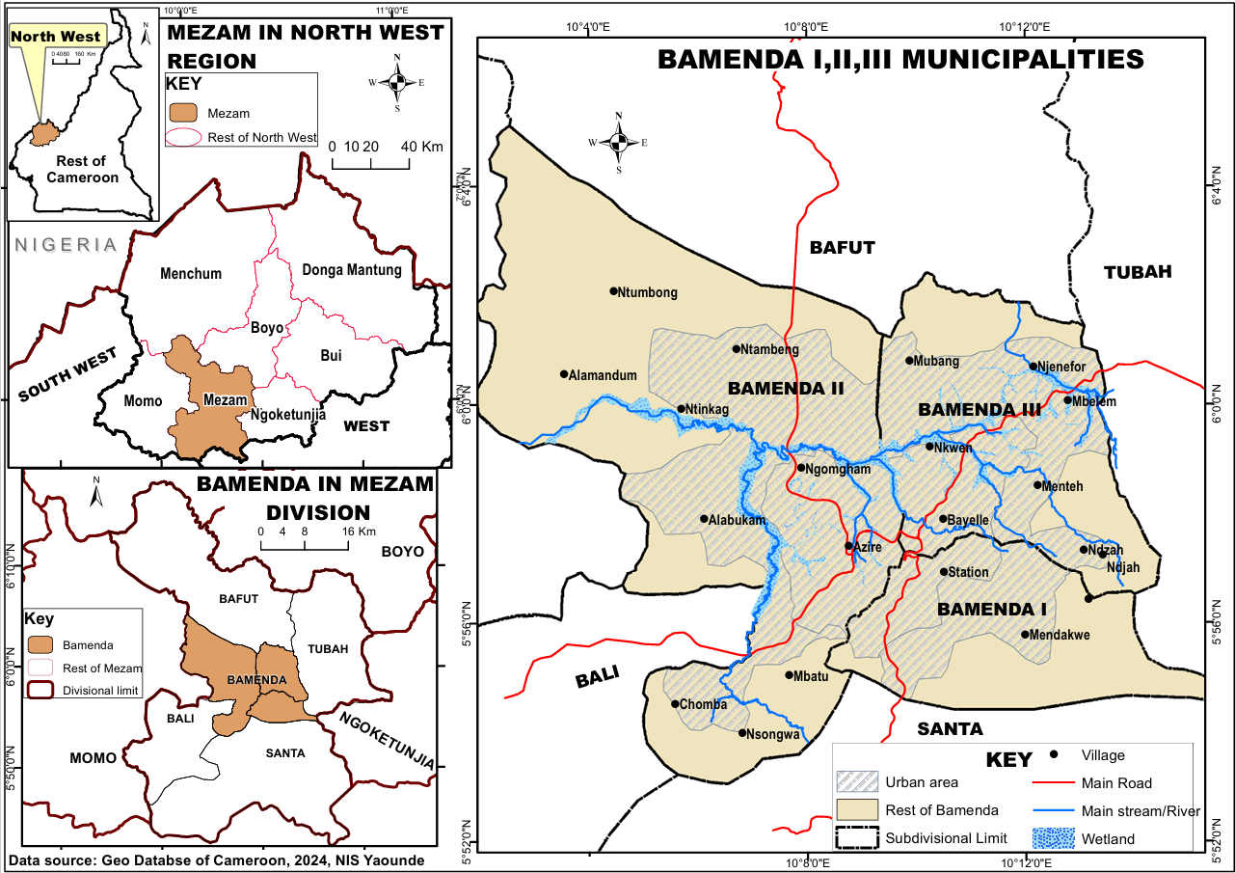

**Figure 1: Location of Bamenda, in the North West Region of Cameroon**

**Methods**

Data for this study was collected through a structured questionnaire. The questionnaire was subdivided into five sections. Section A was structured to capture demographic information. This section was comprised of ten closed ended questions that required respondents to select options that best describe their demographic characteristics. Section B was comprised of nine questions aimed at probing into the origins of the IDP, the reasons for their displacement and the choice of Bamenda as their destination. The questions in this section were dominantly open ended, to give the respondents the opportunity to fully express themselves. Section C, was structured to capture information on the livelihood diversification strategies of the IDPs. This section was subdivided into, on farm activities, off farm activities and non-farm activities. The objective of this section was to collect information on the specific livelihood activities of the IDPs and to identify the challenges they face. The questions in this section were structured as closed and open ended to give the respondent the opportunity to select or indicate the activity or activities they were engaged in before displaced and after being displaced. Such responses were required to analyze the extent of diversification. In order to capture information on the livelihood diversification challenges the question were structured in the form a 5-point Likert scale, giving the respondent the opportunity to rate their level of satisfaction with the activities they are engaged in. The 5point Likert scaled was described as (a)Not satisfied (b) satisfied) (c)moderately (d)satisfied (e)Very satisfied.

After developing, the survey instrument, the questionnaire was pre tested to avoid any language ambiguity and ensure clarity. In this regard, 30 IDPs, in Bayele one of the neighbourhoods of Bamenda III municipality with a high concentration of IDPs was identified through a snow ball sampling technique. The IDPs were invited to complete the questionnaire. The results of this pilot test indicted, that there were some few ambiguities with regards to the phraseology of some questions. This was immediately addressed and the correct version of the questions were printed and handed to the trained field assistants for administration.

A convenient sampling technique was adopted for this study. It was easy to identify the IDPs, since they live in groups. IDPs were served with a consent form to indicate their willingness to participate in the study. Respondents who could not read and write in English had the questionnaire read and explained to them by the field assistants. The field assistants made sure they marked or indicted just the responses given by the respondents.

Data collection ran from June to July 2024 with the use of structured questionnaires. Prior to the actual data collection, the Bamenda City council records were consulted to identify neighbourhoods in Bamenda where IDPs were concentrated.

Data from the Bamenda City Council Report for (2020) revealed that there were 231,281 were in Bamenda by the end of 2020 distributed across several neighborhoods in Bamenda I, II &III municipalities. 15 neighborhoods were purposely selected,5 in each municipality. From this we proceeded to carry out raffle draws to randomly select numbers corresponding to 150 households. The selected numbers guided us to located the precise households for data collection A sampling fraction of. Of 8 -10% was assured for all the 15 communities under study, with the level of analysis being the households.

The Kobbo Collect Tool((Version2023) was used to capture data. The spreadsheets were subsequently downloaded and exported to the statistical Package for Social Sciences (SPSS Version 25.0) where the data was analysed quantitively and qualitatively. Frequencies and percentages were calculated and the results presented using tables and bar charts. The Global Earth and Global Facility Mapper version 15were used to download Land Sat Imagery. These were subsequently digitised using ArcGIS Version 10.2 to show the spatial distribution of IDPs and to identify their livelihood activities

**Results**

**The Origin and reasons for displacement of IDPs**

Table 1 shows that IDPs originate from six administrative divisions of the north west region. Field statistics revealed that (26%) of the IDPs originated from Boyo Division, Bui (23%) Ngunga Mantung (19.2%), Ngokentungia (19.2), Momo (10%) and Menchum (8.6%).

**Table 1 Division of Origin of the IDPs**

|  |  |  |
| --- | --- | --- |
| Division of Origin of IDP | Frequency | Percentage |
| Boyo | 39 | 26 |
| Bui | 35 | 23 |
| Menchum | 12 | 8.6 |
| Momo | 15 | 10 |
| Ndonga Mantung | 29 | 19.2 |
| Ngoketungia | 20 | 13.2 |
| Total | 150 | 100 |

**Source: field work 2025**

Respondents indicated that, the main trigger of their displacement is the on-going crisis between the separatist fighters and the government forces that has claimed thousands of lives since it started in 2016. The political conflict, characterized, by killing and kidnapping for ransom has forced many out of their usual residents to seek for refuge in the urban areas where they consider to be “safer” given the heavy military surveillance in these urban areas.

While the socio-political conflict that has rendered many homeless, was reported as the leading cause for the displacement. Other triggers for the displacement included, loss of livelihood as reported by (25%) of the study population, homelessness (15%), sexual harassment (15%), desire to continue schooling (10% and search for medical care 8% (Figure 2)

**Figure 2 Triggers for internally Displaced Persons**

It therefore holds that political and socio-economic factors are the main factors that trigger the displacement of IDPs from their usual places of residence to urban areas.

**Spatial distribution of the IDPS in Bamenda**

Field data revealed that, although, IDPs are found in all three municipalities of (Bamenda I, II and III). However, they are concentrated in the following neighborhoods that were selected for this study (Ntarikon, Ntahmulung, Azire Nitop,Ntambag,GRA,Ntaafi,Sisia,Bayele,Bangshiem,Ntaghem,Manda Ntahkekaho,Menteh and Futru (Figure 3)

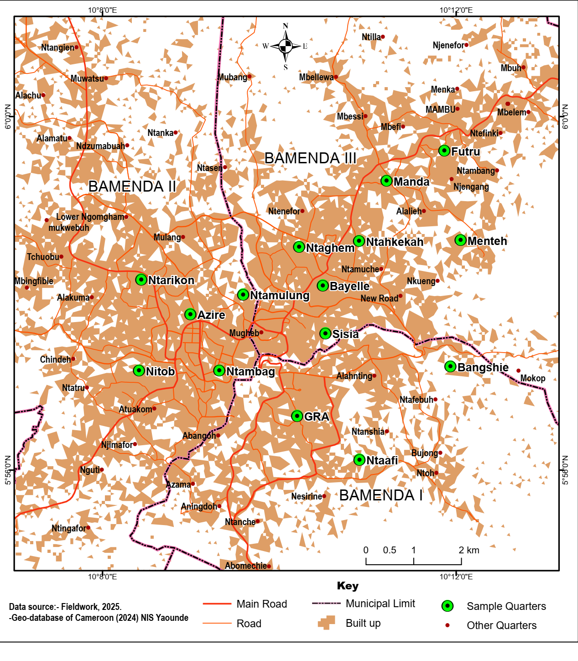

Figure 3 Spatial Distribution of IDPs in some neighborhoods in Bamenda

The IDPs surveyed for this study, advanced diverse reasons for choosing to settle in Bamenda. Some of the reasons reported by the respondents included security (88%), Family ties (50%) cultural affiliation (87.3), health facilities (83.3) job availability (75.3%) opportunities in the informal sector80.7% Figure 4

Figure 4 Reasons for choosing Bamenda as a destination

**Assistance to the IDPs**

The findings of this study revealed that some of the IDPs have received aid in diverse forms from both state and non-state organizations (Table 2) For instance, financial support from government (17.6%) close relatives (95.3%), NGOs 42.4%. Aid in the form of food items from the government (18.8%), Close relatives 96.2%, NGOs (45%). Farm inputs from the government (27.7%). Close relatives (95.7%) NGOs (47%). Healthcare assistance from the government (27.8%) close relatives (96.3%) and from NGOs (50%)

Table 2 Source of Aid to IDP households (p = 0.000)

|  |  |  |  |
| --- | --- | --- | --- |
| Support received | Government | Close relation | NGOs |
| Financial support | 17.6% | 95.3% | 42.4% |
| Food items | 18.8% | 96.2% | 45% |
| Farm inputs | 27.7% | 95.7% | 47% |
| Health care | 27.8% | 96.3% | 50% |

Table 2 also shows that, some of the IDPs have received help in the form of medical care from the government (27.8%), close relations (96.3%) and NGOs (50%)This statistic imply that there is a heavy burden on close relations, mostly because, government and social welfare institutions are do not have accurate statistics and locations of the IDPs

**Livelihood Diversification Strategies**

The livelihood diversification strategies adopted by the IPD households were captured in terms of, on farm strategies, off farm strategies and non-farm strategies (Figure 5)

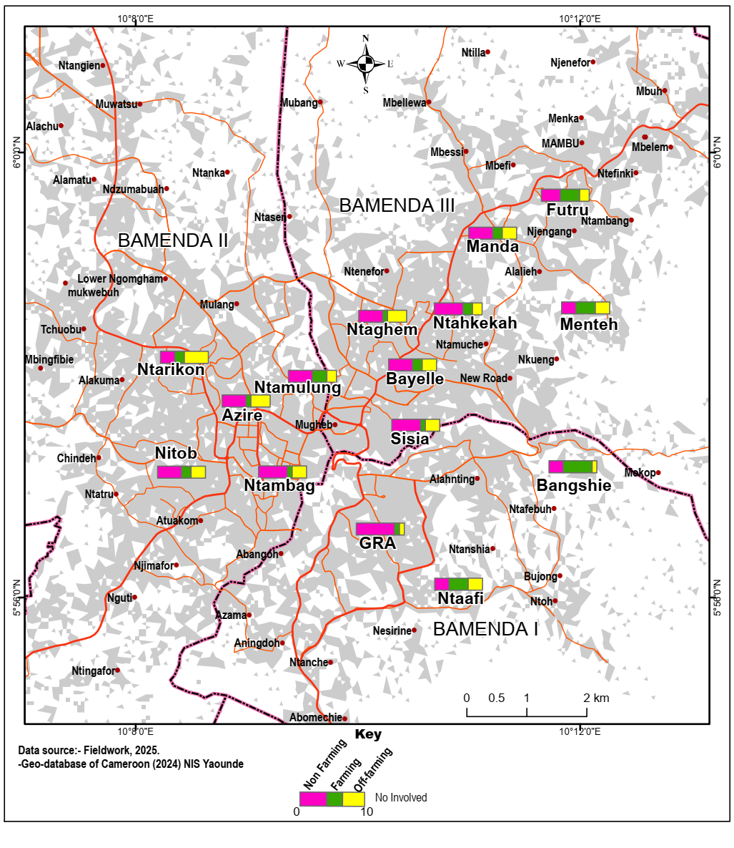

Figure 5 **Livelihood Diversification Strategies**

Figure 5 shows that, in nearly all the neighborhoods where IDPs are found, a majority of the IDPs are into non-farm activities. Such non farming activities include: petty trading, bike-riding, motor mechanics, taxi drivers, street hawkers. The IDPs have adapted to the urban realities in order to survive given that they have lost the main source of livelihoods in their places of origin, The number of IDPs depending on farming activities as a source of livelihood are significantly small given the unavailability of farmlands. However, at the urban periphery, some IDPs have engage in the cultivation of food crops. Some the IDPs are also engaged in nonfarming activities particularly the off loading of farm produce and in transporting this produce for commercialization in other regions of Cameroon like Douala and Yaoundé.

**On farm activities**

For the on-farm strategies, statistical results indicate that, before displacement 93.3% of the IDPs were engaged in the cultivation of food crops and after displacement, only (46.7%) indicated that they are still involved in the cultivation of crop. As concerns, animal rearing, before displacement, 78.7% of the IDPs were involved in animal rearing but after displacement the percentage dropped to 18.0%.With regards to clearing, before displacement,(79.3% )were involved in farm clearing and after displacement the percentage dropped to (28.0.%) As concerns weeding, before displacement , (84.7%) of the IDPs were involved in farm weeding and after displacement, the percentage dropped to(31.3%) (Figure 6)The reasons advanced for the sharp decline include the fact, that cultivable land is scarce in their new settled urban areas.

.

Figure.6: Change in on farm strategies by IDP households

**Off farm activities**

There has been a significant change in off farm activities before and after displacement as reported by the respondents Figure7. For instance, results show that before displacement, 87.3% of the IDPs depended on the loading of farm produce as a source of livelihood but after displacement, the percentage involved in this activity dropped to 35.3%.

Fig.7: Change in off farm strategies by IDP households

Figure 7 shows that with regards to the assembly of farm produce, before displacement, 90% of the respondents were engaged in this activity but after displacement, the percentage dropped to 39,3%.As concerns the transportation of farm produce, before displacement, 84.7 of the respondents indicated that they were engaged in this activity but after displacement only 35.5% are still involved in this activity. With regards to the storage of farm produce, before displacement 88.7% of the respondent indicted that they were engaged in this activity as a source of livelihood but after displacement, the percentage involved in this activity dropped to 42.0%

**non-farming livelihood activities**

The non-farming livelihood activities of the IDPs in Bamenda show that there has been significant diversification before and after displacements Table3. The respondents indicated that before displacement, (46.7%) were involved in petty business and after displacement the percentage involved in this activity increased to (58.7%). For Bike riding, (46.7%) were engaged in this activity and after displacement the numbers of IDPs involved in this activity increased to (9.3%). With regards to Hawking (11.3%) of the respondents reported that before displacement they were engaged in this activity but after displacement the percentage of respondents involved in this activity increased to (14%.). As concerns call box operators, (3.3%) of the respondents depended on this activity for a livelihood before displacement but after displacement, the percentages of those involved in this activity increased to (6.7%). The is therefore a significant increase in the densification of non-farming activities, compared to the on farm and off farm activities which have rather witnessed significant decline in terms of the percentages involved. The main determinant of this non farming activities include: the high demand for these services by the urban population.

Table 3: Diversification of livelihoods in to non-farm activities

|  |  |  |  |
| --- | --- | --- | --- |
| Activity | Before | Now | Chi-square |
| Petty business | 46.7% | 58.7% | X2 = 4.332, p = 0.037 |
| Bike riding | 7.3% | 9.3% | X2 = 0.393, p = 0.677 |
| Security guard | 2.7% | 2% | X2 = 0.146, p = 1 |
| Fish roasting | 0.7% | 2.7% | X2 = 1.831, p = 0.371 |
| Hawking | 11.3% | 14% | X2 = 0.482, p = 0.603 |
| Shoe mending | 1.3% | 2.7% | X2 = 0.68, p = 0.684 |
| Call box operator | 3.3% | 6.7% | X2 = 1.754, p = 0.289 |
| Carpenter | 4% | 6.7% | X2 = 1.056, p = 0.442 |
| Brick layer | 2% | 5.3% | X2 = 2.359, p = 0.218 |
| Salary earner | 8% | 12.7% | X2 = 1.763, p = 0.255 |

**Livelihood demands**

In order to assess the ability of the respondents to meet up with the livelihood demands, to pay rents, the respondents were asked to rate their ability to pay for some social facilities. For example, as concerns house rents, (87.3%) of the respondents reported that it is not easy for them to pay their house rents due to low incomes (0.7%) indicated that it is moderately easy and 9.3% indicated it was easy. However, a negligeable (2.7%) indicated that it is easy very easy. With regards to the payment of water bills, 79.3% said, it is not easy for them to pay, (6.7 %) reported that it is moderately easy. While some (14%) indicted that it is easy, none of the respondent indicated that it is very easy Table 4.

Table 4: Livelihood demands

|  |  |  |  |  |
| --- | --- | --- | --- | --- |
| Activity | Not easy | Moderately easy | Easy | Very easy |
| Payment of house rents | 87.3% | 0.7% | 9.3% | 2.7% |
| Payment of water bills | 79.3% | 6.7% | 14% | 0% |
| Payment of electricity bills | 84.7% | 0% | 15.3% | 0% |
| Payment of hospital bills | 95.3% | 0.7% | 4% | 0% |
| Payment of school fees | 96% | 0% | 3.3% | 0.7% |

**Rate of satisfaction with livelihood activities**

In order to assess the level of satisfaction with the practice of livelihood diversification activities, the respondents were asked to rate their level of satisfaction. Over 93% of the IDPs reported that they were not satisfied with the on-farm activities of crop cultivation, animal rearing, clearing and weeding. The results show similar trends with respect to off farm activities as over 91% of the IDPs also reported no satisfaction with respect to the various off farm and non-farm activities they are now engaged in as a livelihood strategy. However, close to 41% of the IDPs were moderately satisfied while close to 33% reported satisfaction with their petty business involvement. The respondents reported that, they were not satisfied because, despite their energy inputs in terms of labour, there were still unable to pay for livelihood demands such as house rents, water and electricity bills, quality health care and improved education for their children.

Table 5 Level of Satisfaction with livelihood diversification activities.

|  |  |  |  |  |  |
| --- | --- | --- | --- | --- | --- |
| Category | Activity | Not satisfied | Moderately satisfied | Satisfied | Very satisfied |
| On farm activities | Cultivation of crops | 92% | 1.3% | 6.7% | 0% |
| Rearing of animals | 94.6% | 0.7% | 4% | 0.7% |
| Cultivation of fruit crops | 97.3% | 0.7% | 2% | 0% |
| Clearing | 93.3% | 0.7% | 6% | 0% |
| Weeding | 92% | 1.3% | 6.7% | 0% |
| Off farm activities | Loading of farm produce | 92% | 2% | 5.3% | 0.7% |
| Assembly of farm produce | 90.7% | 0.7% | 8% | 0.7% |
| Transport of farm produce | 90.7% | 2% | 7.3% | 0% |
| Storage of farm produce | 91.3% | 2% | 6.7% | 0% |
| Non-farm activities | Petty business | 6% | 40.7% | 32.6% | 0.7% |
| Bike riding | 92% | 0.7% | 7.3% | 0% |
| Security guard | 98.7% | 0% | 1.3% | 0% |
| Fish roasting | 98.7% | 0% | 1.3% | 0% |
| Hawking | 94.6% | 0.7% | 4.7% | 0% |
| Shoe mending | 99.3% | 0% | 0.7% | 0% |
| Call box operator | 98.7% | 0% | 1.3% | 0% |
| Carpenter | 96.7% | 2% | 1.3% | 0% |
| Brick layer | 98% | 0.7% | 1.3% | 0% |
| Salary earner | 96.7% | 1.3% | 2% | 0% |

**Livelihood diversification outcomes**

In order to assess the livelihood diversification outcomes, the respondents were to compare their average monthly incomes, savings and expenditure before and after displacement Table6. The respondents indicated that they have witnessed a significant drop in their average monthly income since displace and livelihood diversification (from an average of FCFA80,785 to FCFA70,340, t 0 2.2067, p = 0.04). drop in household monthly savings (from about FCFA15,650 to FCFA8,475, an 84.7% drop in savings, t = 3.914, p = 0.000). Despite the drop in income and savings, the average monthly expenditures for these households showed no significant difference (on average FCFA67,310 before and FCFA64,530 now, t = 0.649, p = 0.517).

Table 6 Impact on financial capital/FCFA

|  |  |  |  |  |
| --- | --- | --- | --- | --- |
|  | State | Mean | Std. Deviation | t-distribution |
| Average monthly Income | Before | 80,785 | 45,520 | t = 2.067  p = 0.04 |
| After | 70,340 | 41,475 |
| Average monthly Savings | Before | 15,650 | 16,170 | t = 3.914  p = 0.000 |
| After | 8,475 | 9,690 |
| Average monthly Expenditure | Before | 67,310 | 38,220 | t = 0.649  p = 0.517 |
| After | 64,530 | 33,250 |
| Average monthly Group reliance | Before | 52,640 | 62,470 | t = -0.567  p = 0.572 |
| After | 60,760 | 75,090 |

With respect to impact on productive assets, the findings showed a significant drop in productive assets for these IDP households Table7. For example, it was observed that there has been a significant drop in the number of sheep owned by IDP households (from an average of 29 before displacement and 20 now, t = 3.686, p = 0.000). also, there has been a significant drop in the number of goats owned by IDP households (from an average of 37 before displacement and 27 now, t = 2.968, p = 0.003).

Table7: Impact on productive assets

|  |  |  |  |  |
| --- | --- | --- | --- | --- |
|  | State | Mean | Std. Deviation | t-distribution |
| Number of Cows | Before | 15 | 11 | t = 1.761  p = 0.079 |
| After | 11 | 22 |
| Number of Sheep | Before | 29 | 22 | t = 3.686  p = 0.000 |
| After | 20 | 20 |
| Number of Goats | Before | 37 | 28 | t = 2.968  p = 0.003 |
| After | 27 | 29 |
| Number of Poultry | Before | 490 | 790 | t = 2.003  p = 0.046 |
| After | 326 | 595 |

With respect to changes in physical assets results show a significant drop in the ownership of electronics (Table 8) For instance, ownership of TV sets (from an average of 28 before displacement to 19 now, p = 0.022), computers (from an average of 34 before displacement to 22 now, p = 0.019) as well as number of moto bikes owned by the IDP households (from an average of 7 before displacement to 5 now, p = 0.005).

Table8: Impacts on physical Assets

|  |  |  |  |  |
| --- | --- | --- | --- | --- |
|  | State | Mean | Std. Deviation | t-distribution |
| Number of Smart phones | Before | 31 | 28 | t = 0.331  p = 0.741 |
| After | 29 | 87 |
| Number of Satellite TV sets | Before | 28 | 26 | t = 3.08  p = 0.022 |
| After | 19 | 22 |
| Number of Computers | Before | 34 | 52 | t = 2.35  p = 0.019 |
| After | 22 | 28 |
| Number of Cars | Before | 2 | 4 | t = 1.445  p = 0.150 |
| After | 2 | 1 |
| Number of Houses | Before | 1 | 1 | t = -1.356  p = 0.180 |
| After | 2 | 2 |
| Number of Moto Bikes | Before | 7 | 6 | t = 2.840  p = 0.005 |
| After | 5 | 5 |
| Number of Landed properties | Before | 2 | 2 | t = -0.025  p = 0.980 |
| After | 2 | 1 |

**Discussions**

**Origins of IDPs and Reasons for Displacement**

This study examined, the origins of IDPs and the reasons for their displacement. Finding, revealed that with reference to the of division of origin, (26%) of the IDPs originated from Boyo Division, Bui (23.2%) Ngunga Mantung (19.3%), Ngokentungia (19.30), Momo (10%) and Menchum (8%). The study further reveals that the main cause for the displacement of IDPs is the ongoing political conflict between the government forces even though economic and environmental factors have also contributed to displacements of the IDPs .This finding, concur with earlier studies conducted by (Mafany & Budi, 2019, Afotso, 2020, Omam et al., 2021, Bang & Balgah, 2022, Acha-Anyi,2024, Alan et al., 2023; UNHCR, 2023) who identified the armed conflict in the English-speaking regions of north west and south west regions of Cameroon as the main cause displacements of IDPs in the North West and South West Regions of Cameroon. These studies also argued that displacement is caused principally by persecution, violence/conflict, and human rights violations The findings also align with those of (Lamino et al, 2024, Hatton,1998) where they found out that in Rural Ecuador, migration was triggered by community conflicts

**Livelihood Diversification Strategies**

The aim of this study was to explore the livelihood diversification strategies of IDPs in Bamenda. The findings revealed, the IDPs are involved in diverse livelihood activities which include on farming such as the cultivation of food crops and the rearing of animals, off farm activities such as the assembly and transportation of farm produce to urban areas and non-farm activities such as petty trading, bike riding, fish roasting amongst others. These findings contradict previous studies conducted by Kassegn & Endris (2021) where they found out that in Ethiopia, the country policy framework has focused only on on-farm agricultural development strategy and has not given adequate attention for non-farm and off farm livelihood diversification The livelihood challenges faced by the IDPs include, limited access to finances, jobs, training opportunities, health care, shelter, potable water. They equally face constraints in managing micro-businesses, such as competition with established businesses, food-aid dependency, lack of a support network. These finding are consistent with the results of previous studies by Bang (2024) who argued that, IDPs in Cameroon have limited access to financial aid, training opportunities, potable water. These findings are also in line with earlier studies conducted by ( Mandishekwa & Mutenhehri 2020), who noted that limited financial credit access, and displacement results to food insecurity and this affects the mental health of the IDPs (Getanda et al., 2015). Furthermore, these findings are similar correspond to the findings of previous studies by Acha-Anyi (2024), Bang & Balgah (2022), and the World Bank (2021).

**Conclusion** The triggers of IDPs in several parts of the world has been well documented. However, context specific studies on the livelihood diversifications strategies of IDPs for countries in sub-Saharan Africa are still very limited. The objective of this paper therefor was to bridge this gap using Bamenda as a Cameroonian case, to (a) analyses the origins of the IDPs and their displacement drivers (b) assesses the livelihood diversification strategies of the IDPs, and (c) evaluates the level of satisfaction of the IDPs with the livelihood diversification activities, The analysis of this study led to the following conclusions: The highest number of IDPs (26%) come from Boyo-Division and the least (8%) come from Menchum-Division. Amongst other reasons, the main reason for the displacement is the ongoing conflict between the separatist fighters and government forces that started in 2016. Secondly, the IDPs are involved in diverse on farm, off farm and non-farm activities. Thirdly, over 90% of the IDPs are not satisfied with the livelihood diversification activities since they cannot easily satisfy their livelihood demands of feeding and access to safe drinking water, health and educational facilities.

Disclaimer (Artificial intelligence)

Option 1:

Author(s) hereby declare that NO generative AI technologies such as Large Language Models (ChatGPT, COPILOT, etc.) and text-to-image generators have been used during the writing or editing of this manuscript.

Option 2:

Author(s) hereby declare that generative AI technologies such as Large Language Models, etc. have been used during the writing or editing of manuscripts. This explanation will include the name, version, model, and source of the generative AI technology and as well as all input prompts provided to the generative AI technology

Details of the AI usage are given below:

1. Author(s) hereby declare that NO generative AI technologies such as Large Language Models (ChatGPT, COPILOT, etc.) and text-to-image generators have been used during the writing or editing of this manuscript

2.

3.

References

1)Acha-Anyi, P. N. (2024). Analysis of human rights needs of internally displaced persons and the role of social work practice: the case of the northwest, southwest, and littoral regions of Cameroon. *Journal of Human Rights and Social Work*, *9*(2), 210-224.

Alan, S., Annan, J., Behaghel, l., Mobarak, M., Steinen, t., Merner, S., & Kenny, n. (2023). *New displaced livelihoods initiative will help advance sustainable livelihoods for displaced and host communities*. https://poverty-action.org/ blog/new-displaced-livelihoods-initiative-will-help-advance-sustainable-livelihoods-displaced-and

2)Bang, H. N. (2024). Displacement-induced destitution in Cameroon: seeking durable livelihood solutions for internally displaced persons from the Anglophone crisis. *Cogent Social Sciences*, *10*(1). <https://doi.org/10.1080/23311886.2024.2411861>

3)Bamenda council. Bamenda City Council Development Plan, PNDP, Cameroon,P.152

4)Chambers, R., & Conway, R. (1992). Sustainable rural livelihoods: Practical concepts for the 21st century. IDS Discussion Paper, 296, 127–130. https://www.ids. ac.uk/publications/sustainable-rural-livelihoods-practical-concepts-for-the-21st-century/

5)Davis KF, D’Odorico P, Laio F, Ridolfi L (2013) Global Spatio-Temporal Patterns in Human Migration: A Complex Network Perspective. PLoS ONE 8(1): e53723.: 10.1371/journal.pone.0053723

6)Getanda, e., Papadopoulos, c., & evans, h. (2015). the mental health, quality of life and life satisfaction of internally displaced persons living in nakuru county, Kenya. *BMC Public Health*, *15*(1), 755. https://doi.org/10.1186/ s12889-015-2085-7

7)Human Rights Watch (HRW). (2023). World report: Cameroon. https:// [www.hrw.org/world-report/2022/country-chapters/cameroon](http://www.hrw.org/world-report/2022/country-chapters/cameroon)

8)Internal Displacement Monitoring Centre (IDMC). (2022). Global report on internal displacement

2022https://www.internaldisplacement.org/sites/default/files/publications/documents/ IDMC_GRID_2022_LR.pdf

9))International Federation of Red cross and Red crescent Societies. (2019). *Emergency appeal Ethiopia: Population movement*. international Red cross and Red crescent Societies. <https://adore.ifrc.org/Download.aspx?Fileid=236989>

10)International Organization for Migration (IOM). (2022). *Displacement tracking matrix: Cameroon Northwest and Southwest crisis*. https:// reliefweb.int/report/cameroon/cameroon-north-west-and-southwest-crisis-displacement-tracking-matrix-monthly-dashboard-2-26-october-2022#:~:text=Sixty%2Dsix%20per%20cent%20of, to% 20West%20and%20Littoral%20regions

11)Jafer, E., Imana, G., Doda, Z., & Lemessa, A. (2022). Post conflict-induced displacement: Human security challenges of internally displaced persons in Oromia Special Zone Surrounding Finfinne, Ethiopia. *Cogent Social Sciences*, *8*(1). <https://doi.org/10.1080/23311886.2022.2103252>

12)Krantz, S. (2001). The sustainable livelihood approach to poverty reduction: An introduction. Swedish International Development Cooperation Agency (SIDA), Division for Policy and Socio-Economic Analysis

13)Kassegn, A & Endris, E | (2021) Review on livelihood diversification and food security situations in Ethiopia, Cogent Food & Agriculture, 7:1, 1882135, DOI: 10.1080/23311932.2021.1882135

14)Lamino P, Forno CM, Landaverde R, Boren-Alpízar AE. (2024) Rural youth migration intentions in Ecuador: The role of agricultural education

programs. Adv Agric Dev. 2024;5(3):25–38. https://doi.org/10.37433/aad.v5i3.433.

15)Mafany, C. N., & Budi, R. N. (2019). The protection and integration of displaced persons within the Kadey Division of the East Region of Cameroon: Measures, challenges and impact. American Journal of Humanities and Social Sciences Research, 3(9), 24–40. e-ISSN: 2378-703X.

16)Mandishekwa, r., & Mutenhehri, e. (2020). the economic activities among mining induced displacees in Arda transau, Zimbabwe. *Mineral Economics*. <https://doi.org/10.1007/s13563-019-00215-1>

17)Mooney, E. (2005). The concept of internal displacement and the case for internally displaced persons as a category of concern. *Refugee survey quarterly*, *24*(3), 9-26.

18)Norwegian Refugee Council (NRC). (2019). Cameroon tops list of most neglected crises. https://www.nrc.no/news/2019/june/ cameroon-tops-list-of-most-neglected-crises

19)Omam, L. A., Jarman, E., & Ekokobe, W. (2021). Mobile clinics in conflict-affected communities of Northwest and Southwest regions of Cameroon: An alternative option for differentiated delivery service for internally displaced persons during COVID19. Conflict and Health, 15(90), 90. https://doi.org/10.1186/ s13031-021-00427-9

20)Safotso, G. T. (2020). Internally displaced and refugee students in Cameroon: Some pedagogical proposals. English Language Teaching, 13(11), 140–144. <https://doi.org/10.5539/elt.v13n11p140>

21)Stites, e., Anyew, A., eniyew, A., & robillard, S. (2018). *Those who scattered: Understanding internal displacement in Ethiopia’s Feinstein International Centre*. <https://fletcher.tufts.edu/faculty-research/research-publications/those-whoscattered-understanding-internal-displacement-ethiopia-0>

22)UNHCR. (2023). *Mid-year trends 2023: Key displacement and solutions trends in the first half of 2023*. https://www.unhcr. org/mid-year-trends-report-2023

23)United Nations Commission on Human Rights, *Analytical Report of the Secretary-General on Internally Displaced Persons,* UN Doc. E/CN.4/1992/23 (14 February 1992), para. 17

24)United Nations High Commission on Refugees (UNHCR). (2021). Refugee data finder. <https://www.unhcr.org/refugee-statistics>

25)United Nations High Commission on Refugees (UNHCR). (2021). *Refugee data finder*. <https://www.unhcr.org/refugee-statistics>

26)World Bank. (2021). *A development approach to conflict-induced internal displacement*. World Bank.

27)Zewude, B., & Siraw, G. (2024). Sustainable integration of internally displaced persons (IDPs) in Ethiopia: exploring intentions about post-conflict resettlement choices. *Cogent Social Sciences*, *10*(1). <https://doi.org/10.1080/23311886.2024.2350116>