**Analysing University Students’ Coping Mechanisms for Academic Anxiety: A Structural Equation Modelling Approach**

ABSTRACT

|  |
| --- |
| **Aim:** Globally, a major contributing factor to students’ poor performance is academic anxiety, which is fueled by psychological, emotional and social pressures. It results from a fear of being criticized by peers, parents or teachers. This study investigated the primary causes of students’ academic anxiety as well as the coping mechanisms they employ to deal with it.  **Place and Duration of Study:** The study was conducted among final year undergraduate students (n=240) of Tamil Nadu Agricultural University, Coimbatore during 2024.  **Methodology:** Data were subjected to descriptive statistics and Partial Least Squares Structural Equation Modeling (PLS-SEM) method was employed to identify the most commonly used coping strategy by the university students in managing academic anxiety.  **Results:** The study findings revealed that the academic factors were the most influential contributors to academic anxiety among students, which resulted in low academic performance, where only 13% of the total respondents had higher OGPA (Overall Grade Point Average). Problem-solving emerged as a statistically significant coping strategy (*P = .038*) adopted by students in response to academic anxiety. The model exhibited good fit (SRMR = 0.056; R² for coping strategy = 0.47), indicating substantial explanatory power.  **Conclusion:** Recognizing academic pressures as key drivers of student anxiety is crucial for safeguarding educational outcomes. Equipping students with robust problem-solving skills emerges as an essential intervention to alleviate anxiety and encourage long-term academic success. This study offers practical implications for developing support programs for improving students’ mental well-being. |

Key words: Academic anxiety, university students, OGPA, PLS-SEM, Coping strategies

**1. INTRODUCTION**

Education offers the possibility of overall growth and development. A person’s behavior shifts from instinctive conduct to human behavior through both a process and an action. An undeveloped personality is transformed into a developed personality. (Nancy and Gichohi, 2019) It enhances one’s ability to reason and argue. It is responsible for developing a sufficient number of moral people who can contribute to the advancement of the country (Shakir, 2014). As the advancement of a country is determined by its pupils’ academic performance, academic success is valued globally. People who struggle to achieve their demands due to a range of psychological, emotional, and societal factors experience anxiety (Sindhu and Basha, 2017; Rahaman and Rana, 2018). Academic anxiety stems from a fear of being judged by peers, parents, and teachers for failing to fulfill one’s academic responsibilities adequately (Mahajan, 2015). Academic anxiety affects the student’s performance as well as their capacity to acquire and retain information (Afolayan *et al.,* 2014; Banga, 2014). Additionally, it may affect their sense of drive, self-worth and general well-being (Acharya, 2019).

Throughout the world, prevalent mental illnesses are on the rise. From the year of 1990 to 2013, the total number of people experiencing depression and anxiety grew from 416 million to 615 million, a fifty percent rise. Around 10% of the world’s population suffers from mental problems, which make up 30% of all non-fatal diseases. There is an even greater demand for more treatment choices because of ongoing violence and humanitarian problems. According to the WHO (World Health Organization, 2019) estimates that up to 1 in 5 people struggle with anxiety and hopelessness.

According to a poll by UNICEF and Gallup at the beginning of 2021, among 20,000 children and adults from 21 different nations, individuals between the ages of 15 and 24 gave support for mental health issues positive ratings ranging from 56 to 95%. The study also found that one in seven Indians in this age group frequently felt depressed or lacked drive. The ability to investigate choices deliberately and solve problems peacefully is enhanced by developing a better awareness about factors causing anxiety. These skills might enhance both mental and emotional intelligence among individuals. The current study’s objectives are to determine what factors affect academic anxiety the most and to look at the coping strategies used by university students.

**2. METHODOLOGY**

In the current study, 240 respondents were randomly selected from final-year undergraduate students at the Tamil Nadu Agricultural University (TNAU) in Coimbatore, representing various disciplines including agriculture, horticulture, agricultural engineering, biotechnology and Agri-business management. A well-structured questionnaire was formulated using already developed scales, with necessary modifications made in accordance with the demands of the study. A google form was created and given to the students as a questionnaire to compile data for the investigation.

The Academic Anxiety Questionnaire, developed by Hooda and Saini (2017) was employed as a first tool to gather data on the factors that have the greatest influence on students’ academic anxiety. There are a total of 39 statements covering personal, competitive environment, physiological issues, and academic components that induce academic anxiety, which compose the questionnaire. A 5-point scale was used to rate the responses. A second instrument, based on a scale developed by Nasir and Iqbal (2012) with some minor modifications, was used to gather data about the different coping mechanisms that students employ to manage their academic anxiety. The questionnaire contained 16 statements about emotion control, problem solving, avoiding situations, and cognitive coping mechanisms. The data were analyzed using percentage analysis, mean score ranking and Smart PLS 3 software to test the study’s hypothesis.

**3. RESULTS AND DISCUSSION**

**3.1. Demographic profile of the respondents**

Table 1 displays the respondents’ demographic characteristics. Among the total respondents, 55% of the students were female and 45% were male, based on their medium of instruction where 94% of the respondents have medium of instruction as English and the remaining 6% have as Tamil for whom language problem causes anxiety among students. The respondents of the study were from various disciplines in that 45% (Agriculture), 12.09% (Horticulture), 13.33% (Agri. Business Management), 6.25% (Agri. Engineering) and 23.33% (Biotechnology). Regarding their OGPA (Overall Grade Point Average), only 13% of respondents have an OGPA higher than 8.5, while the majority attained an OGPA between 7 and 8. More academically anxious students perform poorly in their academic activities.

**Table 1. Demographic profile of the respondents (n=240)**

|  |  |  |  |
| --- | --- | --- | --- |
| Variable | Label | Frequency (n) | Percentage (%) |
| Gender | Male | 108 | 45.00 |
| Female | 132 | 55.00 |
| Medium of Instruction | Tamil | 14 | 6.00 |
| English | 226 | 94.00 |
| Discipline of the Study | Agriculture | 108 | 45.00 |
| Horticulture | 29 | 12.09 |
| Agri. Business Management | 32 | 13.33 |
| Agri. Engineering | 15 | 6.25 |
| Bio-technology | 56 | 23.33 |
| OGPA (overall Grade Point Average) | Less than 7.3 | 48 | 20.00 |
| Between 7.3 – 8.5 | 161 | 67.00 |
| More than 8.5 | 31 | 13.00 |

**3.2. Contribution of four different components to Academic anxiety**

Four categories were used to group the various causes of academic anxiety: personal, competitive environment and worry about the future, physiological & health concerns, and academic reasons. To evaluate the contribution of each factor, several statements were given under each section. Most of the respondents felt that they had a lot of personal work to do but little free time, which increased their anxiety and upset them; when necessary, tasks were put off. The pupils are mainly concerned about the high expense of coaching and the growing number of competitions because of the competitive climate. Students who experience physiological and physical issues tend to forget information they already know as a result of anxiety. Concerning academic factors, most of the students feel pressure to get good grades and also and they also worry about meeting the expectations of their parents.

According to Table 2, academic reasons account for the majority of academic anxiety, followed by the competitive environment, while physiological difficulties account for the least amount of it.

**Table 2. Assessing the extent of different factors causing Academic anxiety (n=240)**

|  |  |  |
| --- | --- | --- |
| **Components** | **Total mean score** | **Rank** |
| Personal life | 3.06 | III |
| Competitive environment  & worry about the future | 3.13 | II |
| Physiological & Health problems | 2.80 | IV |
| Academic factors | **3.21** | **I** |

Academically anxious students have a lax attitude towards their studies, with little excitement for learning and subpar performance on examinations and assignments (Son *et al.,* 2020). Anxious students may experience anxiety before tutorial lessons, panic before tests, lose concentration when doing their assignments, or lose interest in difficult subjects (Vitasari, 2010). According to Figure 1, there is a negative correlation between anxiety levels and academic performance and vice versa (Thomas *et al.,* 2017).

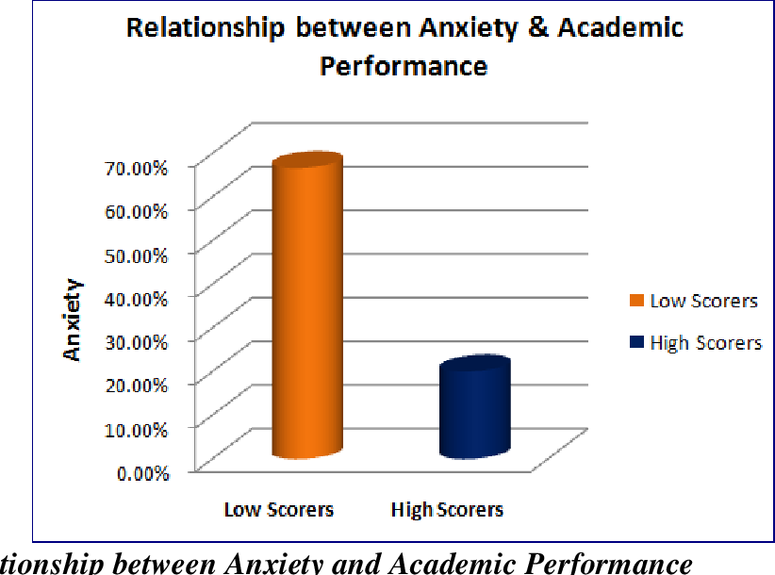

**Figure 1: Relationship between Anxiety and Academic Performance**

**3.3. Significant strategy for coping with Academic anxiety**

Respondents were given four alternative strategies, each with several statements and their responses were recorded to determine the coping mechanisms that students most frequently employ when experiencing anxiety. PLS-SEM was employed to accomplish the study’s second goal, which was to determine which coping mechanisms students most frequently employ in anxious situations.

**3.3.1. PLS SEM modelling**

A two-step procedure was used to assess the PLS SEM model. The claimed causal relationship was then investigated using the structural model (the inner model), after which the measurement model (the outer model) was used to test for construct validity and reliability. The model included four exogenous latent variables (constructs), including (a) avoidance tactics, (b) cognitive strategies, (c) emotional management strategies and (d) problem-solving strategies, as well as one endogenous latent variable, academic anxiety. Table 3 shows the indicators under each construct that have been used in the questionnaire.

**Table 3. Constructs used for PLS SEM modelling**

|  |  |  |
| --- | --- | --- |
| **Constructs** | **Indicators** | **Source** |
| **Emotion Management Strategies (E)**  Students attempt to control their emotions by recognising their emotional condition. | E1 - I discuss it with a close friend whenever I encounter a challenging circumstance. | Adapted from  Iqbal, S. & Nasir , M. (2015) |
| E2 - I engage in doing relaxing exercises, whenever I feel anxious. |
| E3 - I take deep breaths to calm myself down before a presentation to keep my nerves relaxed. |
| E4 - I recognize my emotional condition in anxiety-provoking situations and make an effort to control it. |
| **Problem Solving Strategies (F)**  Students make an effort to analyse the challenging situation and identify potential solutions. | F1 - I try to come up with solutions, whenever I face an anxiety provoking situation |
| F2 - I try to plan my work, when a deadline is coming up. |
| F3 - I raise questions during lectures if I don't understand. |
| F4 - I employ different strategies when preparing for tests to comprehend and retain the material. |
| **Avoidance Strategies (G)**  Students stay away from circumstances that can make them feel anxious. Studies have looked at how worry affects students’ performance in a variety of ways. | G1 - I pay special attention to keeping my study desk clean during tests. |
| G2 - I refuse to listen when someone reminds me of a deadline. |
| G3 - I frequently leave classes in challenging subjects. |
| G4 - I prefer the easiest one when selecting an assignment topic. |
| **Cognitive Strategies (H)**  Students understand and interpret the situation, which typically manifests as judgement and negative thinking. | H1 - Reading books other than the subject books |
| H2 - Develop positive thinking styles |
| H3 - Deal with what I have to deal with and not worry about the rest |
| H4 – Attending to any counselling class |

**3.3.2. Conceptual framework and hypothesis development**

Using the constructs adapted from Iqbal, S. & Nasir, M. (2015), the conceptual model has been developed for the study and Table 4 shows the hypotheses being developed for the study.

**Table 4. Hypothesis set for PLS-SEM Modelling**

|  |  |  |
| --- | --- | --- |
| **Hypothesis** | **Relations** | **Hypothesis development** |
| H1 | AS → AA | Avoidance Strategies will have a significant effect on the coping with Academic Anxiety of the students. |
| H2 | CS → AA | Cognitive Strategies will have a significant effect on the coping with Academic Anxiety of the students. |
| H3 | EM → AA | Emotional Management will have a significant effect on the coping with Academic Anxiety of the students. |
| H4 | PS → AA | Problem solving will have a significant effect on coping with the Academic Anxiety of students. |

**3.3.3. Measurement model assessment**

The measurement model was tested using the PLS algorithm in the smart PLS programme. Using composite reliability and average variance extracted (AVE) scores, the constructs validity and reliability were evaluated. How regularly an item measures a concept is referred to as reliability. According to Hair et al. (2017), the composite dependability score should be higher than 0.7. The AVE score was used to gauge the constructs’ convergent and divergent validity. According to Hock et al., (2010), AVE must be more than 0. Since the values are higher than the threshold value, it can be deduced from Table 5 that the constructs’ reliability, convergent validity, and divergent validity were established.

**Table 5. Assessment for Composite Reliability and Average Variance Extracted**

|  |  |  |  |
| --- | --- | --- | --- |
| **Construct** | **Cronbach’s alpha**  **(>0.7)** | **Composite reliability (>0.7)** | **Average Variance Extracted (AVE)**  **(>0.5)** |
| **Avoidance strategies** | 0.787 | 0.757 | 0.521 |
| **Cognitive strategies** | 0.834 | 0.885 | 0.659 |
| **Emotional management strategies** | 0.87 | 0.911 | 0.718 |
| **Problem solving strategies** | 0.802 | 0.865 | 0.616 |

*Source: Calculated through PLS-SEM analysis for 240 students*

Table 6 shows the discriminant validity which investigates the problem of multicollinearity. This validity asserts that all constructs are independent of one another, which means that there is no multicollinearity among independent variables. In the study, the discriminant validity shows that the square root of Average Variance Extracted values of all the latent constructs were greater than the inter-construct correlation. Thus, establishing Discriminant Validity.

**Table 6. Assessment for discriminant validity**

|  |  |  |  |  |  |
| --- | --- | --- | --- | --- | --- |
|  | **Academic anxiety** | **Avoidance strategies** | **Cognitive strategies** | **Emotional management strategies** | **Problem-solving strategies** |
| **Academic anxiety** |  |  |  |  |  |
| **Avoidance strategies** | 0.183 |  |  |  |  |
| **Cognitive strategies** | 0.169 | 0.157 |  |  |  |
| **Emotional management strategies** | 0.153 | 0.162 | 0.128 |  |  |
| **Problem-solving strategies** | 0.24 | 0.141 | 0.171 | 0.165 |  |

**3.3.4. Structural model assessment**

In Smart PLS, using the bootstrapping test, the structural model was assessed. Using the t-statistic and the associated p-values, each of the paths and their associated hypotheses were examined. Table 7 shows the hypotheses and associated inferences based on the bootstrapping test. The path coefficient was significant for problem-solving strategies (hypothesis H4) and was found to be the most commonly used strategy by the students. The findings were in accordance with Lazaro-Quilang and Palattao-Dayawon, (2024).

**Table 7. Key findings for the structural model assessment**

|  |  |  |  |  |  |  |
| --- | --- | --- | --- | --- | --- | --- |
| **Path** | **Original sample(O)** | **Sample Mean(M)** | **Standard**  **deviation (STDEV)** | **T Statistics**  **(|O/STDEV|)**  **(>1.96)** | **P values**  **(<0.05)** | **Result** |
| AS →AA | -0.286 | -0.224 | 0.232 | 1.232 | 0.218 | Rejected |
| CS →AA | 0.184 | 0.193 | 0.116 | 1.587 | 0.113 | Rejected |
| EM→AA | -0.188 | -0.185 | 0.125 | 1.504 | 0.133 | Rejected |
| PS → AA | 0.217 | 0.229 | 0.104 | 2.079 | 0.038 | Accepted |

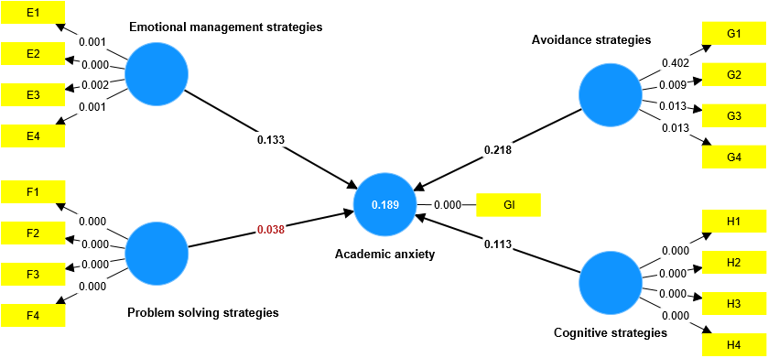Figure 2 demonstrates how coping mechanisms for academic anxiety were found to have a good and significant influence. Even though there are various ways, people choose to employ problem-solving techniques to deal with their anxiety.

**Figure 2 Structural model calculated through PLS-SEM analysis**

As problem-solving strategy is a significant coping strategy, activities such as workshops, training on life skills, personalized counselling sessions and rewards for resilient individuals can be done to improve the students’ problem-solving abilities. Academic counsellors and curriculum designers can consider integrating interventions related to stress management, emotional resilience and mental well-being activities in the academic courses can create a motivating learning environment that addresses academic anxiety.

**4. LIMITATIONS OF THE STUDY**

While the results provided insightful information, some limitations should be noted. The study was limited to final-year undergraduate students from a single state agricultural university. This may not apply to the wider student population or institutions with different academic backgrounds. Following this, the utilization of self-reported data may sometimes lead to response bias. Longitudinal or cross-sectional studies can be done in the future to improve applicability and a deeper understanding of academic anxiety prevailing among the student community.

**5. CONCLUSION**

The study reveals that anxiety triggered by both the academic environment and fears surrounding performance substantially undermines students’ academic success, with emotional and cognitive dimensions playing a particularly influential role. Encouragingly, most students actively adopt constructive problem-solving approaches to navigate these challenges, reflecting their resilience and adaptive capacity. This highlights the critical need for universities to foster supportive learning climates and strengthen students’ problem-solving competencies, ensuring they are better equipped to manage academic pressures and thrive in their educational pursuits.

**CONSENT**

Every individual participant participating in the study gave informed consent. The approval of the participants has been obtained for the submission of the paper, which includes excerpts from their journal diaries.

**ETHICAL APPROVAL**

This study was conducted by ethical guidelines for research involving human participants, as outlined by American Psychological Association (APA).

Disclaimer (Artificial intelligence)

Author(s) hereby declare that NO generative AI technologies such as Large Language Models (ChatGPT, manuscript.

**REFERENCES**

1. Nancy and Gichohi, W.M. (2019). Influence of Anxiety on Academic Performance among Students at The Technical University of Kenya. *International Journal of Scientific and Research Publications,*9(5): 850-865.
2. Shakir, M. (2014). Academic anxiety as a correlate of academic achievement. *Journal of Education and Practice,* 5(10): 29-36.
3. Sindhu, P., & Basha, L. D. S. A. (2017). Impact of depression, anxiety and stress on academic achievement among engineering students. *The International Journal of Indian Psychology,* 5(1): 202-208. 10.25215/0501.058
4. Rahaman, M., & Rana, S. (2018). Academic anxiety of secondary school students in Murshidabad District, West Bengal, India. *International Journal of Research in Social Sciences*, 8(2): 118-122.
5. Mahajan, G. (2015). Academic anxiety of secondary school students in relation to their parental encouragement. *International Journal of Research in Humanities and Social Sciences,* 3(4): 23-29.
6. Afolayan, Donald, B., J.A., Onasoga, J.A., Babafemi, A., & Juan A. (2014). Relationship between anxiety and academic performance of nursing students, Niger Delta University, Bayelsa State, Nigeria. *Advances in Applied Science Research,* 4(5):25-33.
7. Banga, C. L. (2014). A study of academic anxiety level of high school students. *International Journal of Behavioral Social and Movement Sciences*, 3(3): 40-48.
8. Acharya, S. (2019). Development of an anxiety scale for under graduate students of Delhi. *International Journal of Advanced Research in Management and Social Sciences*, 8(2): 72-119.
9. Hooda and Saini. (2017). Academic Anxiety: An Overview. *Journal of Education and Applied Social Science,* 8 (3): 807-810. 10.5958/2230-7311.2017.00139.8
10. Son, C., Hegde, S., Smith, A., Wang, X., & Sasangohar, F. (2020). *Effects of COVID-19 on college students' mental health in the United States: Interview survey study.* Journal of Medical Internet Research, 22(9), e21279.
11. Vitasari, P. Wahab, M.N.A., Othman, A., Herawan, T., & Sinnadurai, S.K. (2010). The Relationship between Study Anxiety and Academic Performance among Engineering Students. *Procedia Social and Behavioral Sciences,* 8: 490–497. <https://doi.org/10.1016/j.sbspro.2010.12.067>
12. Thomas, C. L., Cassady, J. C., & Heller, M. L. (2017). The influence of emotional intelligence, cognitive test anxiety, and coping strategies on undergraduate academic performance. Learning and Individual Differences, 55, 40-48. <https://doi.org/10.1016/j.lindif.2017.03.001>
13. Iqbal, S. and Nasir, M. (2015). Strategies of University Students to Cope with Academic Anxiety. *Journal of Arts and Social Sciences,* 2(2): 13-20.
14. Hair, J. F., Hult, G. T. M., Ringle, C., & Sarstedt, M. (2017). A primer on partial least squares structural equation modeling (PLS-SEM), Thousand Oaks: Sage Publications.
15. Höck, C., Ringle, C. M., & Sarstedt, M. (2010). Management of multi-purpose stadiums: Importance and performance measurement of service interfaces. *International Journal of Services, Technology and Management*, 14(2/3): 188–207. <https://doi.org/10.1504/IJSTM.2010.034327>
16. Lazaro-Quilang, L. J., & Palattao-Dayawon, M. (2024). Academic rope to cope: Teachers’ coping strategy to academic anxiety. Journal of Human Behavior in the Social Environment, 34(5), 684-692. <https://doi.org/10.1080/10911359.2023.2215271>