**REVIEW ARTICLE**

**Mulberry (Morus spp.): A Comprehensive Review of Its Medicinal and Functional Properties**

**ABSTRACT**:

Mulberry (*Morus* spp.), a multipurpose medicinal plant, exhibits a wide array of pharmacological activities across its various parts—leaves, fruits, twigs and roots—making it a promising candidate for functional foods and therapeutic applications. Rich in bioactive compounds such as flavonoids, anthocyanins, alkaloids and polyphenols, mulberry demonstrates significant potential in managing metabolic, inflammatory, neurodegenerative, gastrointestinal and oncological disorders. Leaf extracts show anti-ulcer and antidiabetic effects by modulating gastric and glycemic parameters. Fruits improve mental health, joint function, and enhance ovarian cancer treatment via flavonoids like morin. Twigs aid in diabetes and Alzheimer's through enzyme inhibition and liver protection. Roots reduce prostate enlargement by downregulating androgen pathways, showcasing mulberry as a potent multi-targeted nutraceutical

**Key words**: Mulberry, Antidiabetic, Antioxidant, Neuroprotection, Cancer therapy

**INTRODUCTION:**

Herbshave quite a crucial part to play in the rehabilitation of various diseases. Development of herbal medicine cultivation is required, along with establishment of a connection between traditional and modern treatment techniques. About (70%) of germ doctors recommended herbal medicines for the treatment of various diseases that are widely used to treat mild to moderate depression than any chemical medication. According to the survey conducted by World Health organization, there are almost (80%) developing countries whose population believed on the natural medicines, which assure the safety of patients. According to the pharmacological reviews the medicinal plants are potential source for the major antioxidants and bioactive compounds (Afzal *et al*., 2021)

Plants play an important role in well-being of human that has been witnessed by their mention in the Rigveda and Ayurveda. Among those plants, *Morus* spp. is the one having versatile nature because of the presence of secondary metaboliteslike phenols, flavonoids and anthocyanins play a pivotal role as scavengers for free radicals present in body. Mulberry (*Morus* spp*.*) belongs to family Moraceae and is widely distributed in Asia. *Morus* spp. - silkworm, *Bombyx mori* L. widely grown for rearing of silkworm. Mulberryhas potent chemical constituents which provide homeo-therapies for various ailments in human beings. Ancient Chinese herbal Medicine describes many medicinal benefits of mulberry,the nutritional and medicinal values of mulberry have attracted increasing research interest. A wide range of the phytochemicals are present in different parts of *Morus* because of which they possess biological functions. The bioactive compounds of mulberry often exhibit a wide range of physiological activities. Therefore, mulberry represents a medicinal and edible plant source that poses no health risk to consumers. (Manzoor and Qayoom, 2023)

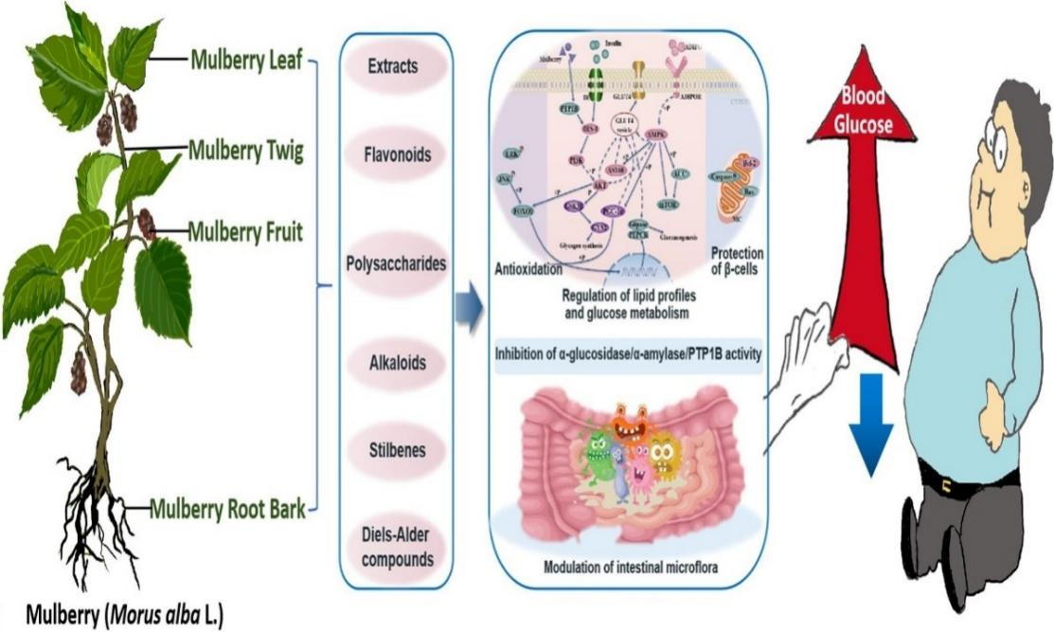

**Fig. 1: Bioactive compounds of mulberry**

* The Fig.1 illustrates the various bioactive compounds found in different parts of the mulberry plant (*Morus alba L*.) and highlights their potential health benefits. Specifically, it shows that the mulberry leaf, twig, fruit, and root bark contain extracts, flavonoids, polysaccharides, alkaloids, stilbenes, and Diels-Alder compounds. These compounds offer several health benefits, such as antioxidation, regulation of lipid profiles and glucose metabolism, inhibition of α-glucosidase and PTP1B activity, protection of pancreatic β-cells, and modulation of intestinal microflora. The mulberry plant thus represents a medicinal and edible source that can contribute to overall health without posing risks to consumers.

**FIG 2. MULBERRY LEAF**

* 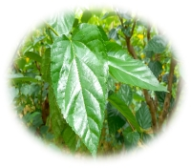
* The mulberry leaf consists of minerals, vitamins, dietary fiber, amino acids, phytosterols, flavonoids and other functional components. It contains mainly 1-DNJ (1-Deoxynojirimycin) which acts as an anti-diabetic drug, maintains blood pressure, reduces cholesterol, prevents liver cancer and prevents oxidation.
* The primary class of flavonoids found in mulberry leaves are flavonols, whose amounts vary by region. Neochlorogenic acid, chlorogenic acid, cryptochlorogenic acid, caffeoylquinic acid isomer, and caffeoylquinic acid glucoside were found in the leaves of Morus as caffeoylquinic acid derivatives (Manzoor and Qayoom, 2023). Rutin and quercetin 3 (6- malonylglucoside), which are flavonol glycosides primarily responsible for the antioxidant capacity of the leaves and have properties that lessen oxidative stress in the liver and improve hyperglycemia, were also discovered to be the predominant flavonol glycosides in mulberry leaves. Mornigrol E, Mornigrol F, and morusin, a prenylated phenolic found in all parts of the mulberry plant with the highest concentration in the bark of the root, are other flavonoids that have been found in mulberry leaves.

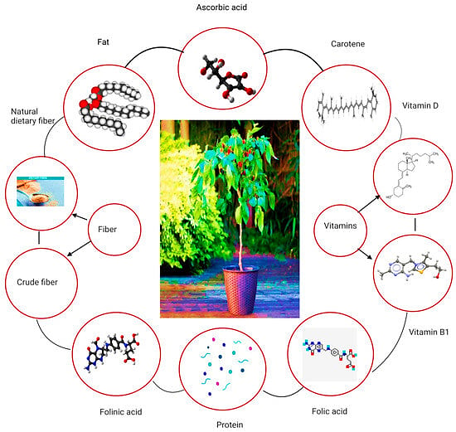

**Fig. 3: An overview of the nutritional content of the mulberry leaves**

Figure 3 highlights the rich nutritional value of mulberry leaves, which are packed with essential vitamins and minerals. They contain Vitamin C, carotene (a precursor to Vitamin A), Vitamin D, Vitamin B1, and folic acid, all of which support immune function, vision, bone health, energy metabolism, and brain function. In addition, mulberry leaves are rich in protein, fiber and a small amount of fat, contributing to muscle repair, digestive health, and energy supply. This nutrient profile makes mulberry leaves a valuable natural source for promoting overall health and well-being

**MULBERRY FRUIT**

*M. nigra* fruits contain anthocyanins, water-soluble colours. Many research revealed that anthocyanins are potent flavonoids and antioxidants, and that the structure, presence, and amount of copigments as well as the environment's acidity all affect the colour of anthocyanins. Anthocyanins are responsible for giving black mulberries their colour. Since anthocyanins are present, *M. nigra* L. generally has higher bioactive chemical levels than *M. alba* L. (Zheng *et al*., 2016) . Nevertheless, anthocyanins were found in some species of white mulberries because they accumulate as fruit ripens, changing the fruit's colour from green (unripe) to white and light purple (at maturity).

The amount of polyphenolic compounds and their functions in mulberry fruits have been recorded in a number of studies, and it varies greatly depending on the variety as well as the climate, soil, agronomic, and processing conditions. Cyanidin-3-Oglucoside is the primary pigment among the four main anthocyanins found in *M. nigra* (Qin *et al*.,2009).

There were found to be four pelargonidin and cyanidin anthocyanins in *M. nigra*, each conjugated with one, two, or three hexose sugars. Both white and black mulberries include the flavonol compounds quercetin and kampferol, which are esterified with one to three sugars or one to two sugars and one malonyl group. Dihydroquercetin (taxifolin) hexoside and dihydrokaempferol hexoside, which are precursors of the biosynthesis of anthocyanidins like cyaniding and pelargonidin, respectively, were shown to be two flavanonols in black mulberries

* Mulberry fruit with high nutritious value, contains flavonoids, vitamin C and anthocyanin that can fight against many diseases. These components have direct or indirect curative activity on diabetes, inflammation, tumor, hepatic diseases, immunomodulation, neural damage and chronic diseases. (Ramappa *et al*., 2020)

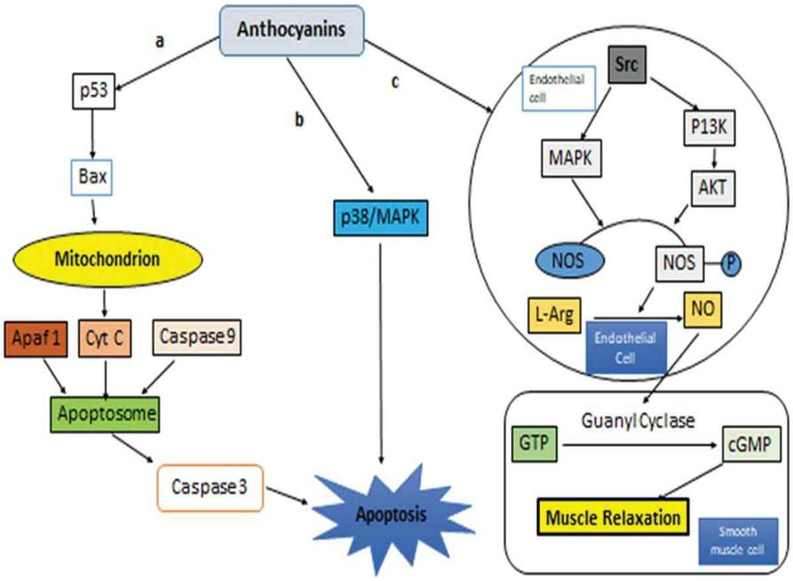

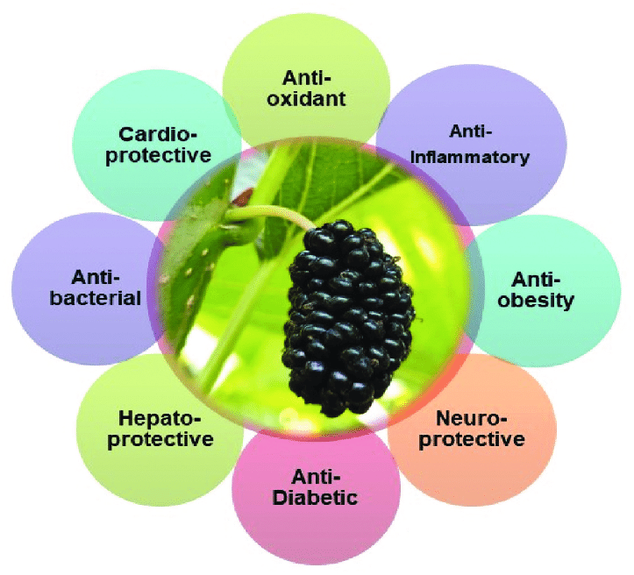

**Fig. 4: Anthocyanins induce apoptosis through a) p53/MAPK b) p38/MAPK, c) NO pathway leading to muscle contraction**

Figure 4 illustrates the molecular mechanisms by which anthocyanins, a class of flavonoids, exert therapeutic effects through apoptosis induction and muscle relaxation. Anthocyanins activate the p53/Bax pathway, where p53 upregulates Bax, triggering mitochondrial release of cytochrome c, formation of the apoptosome, and activation of caspases-9 and -3, ultimately leading to apoptosis. They also stimulate the p38/MAPK pathway, promoting stress-induced apoptosis. For muscle relaxation, anthocyanins enhance nitric oxide (NO) production by stimulating endothelial nitric oxide synthase (via L-arginine), leading to activation of guanylyl cyclase, increased cGMP levels, and smooth muscle relaxation. Additionally, the Src/PI3K/AKT pathway contributes to NO production and vascular relaxation. Overall, anthocyanins support cancer cell apoptosis and cardiovascular health through these interconnected signaling pathways

**Table 1: Polyphenol, anthocyanin, and flavonoid levels in mulberry fruits and leaves**

|  |  |  |  |  |  |
| --- | --- | --- | --- | --- | --- |
| **Species** | **Organs** | **Total Polyphenols** | **Anthocyanins** | **Flavonoids** | **References** |
| *Morus nigra* | Fruits | 502.43±5.10 mg GAE/ 100 g fw | 81.36±2.05 mg C3GE/ 100 g fw | 219.12±4.45 mg QE/ 100 g fw | [9] |
| *Morus alba* | Fruits | 5.68 to 40.46 mg GAE/g dw | 0.51 to 28.61 mg/g dw | 0.65 to 3.70 mg QE/g dw | [11] |
| *Morus rubra* | Fruits | 1035 mg GAE/ 100 g dw | Not recorded | 219 QE/ 100 g dw | [6] |

GAE—gallic acid equivalent, C3GE—cyanidin-3-glucoside equivalent, QE—quercetin equivalent, fw—fresh weight, dw—dry weight

**FIG 5 MULBERRY TWIG**

* 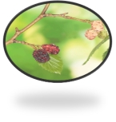Mulberry twig has been used in herbal medicine as anti-diabetic, anti-inflammatory, neuro-protective and hepato-protective agent.

**FIG 6 MULBERRY ROOT BARK**

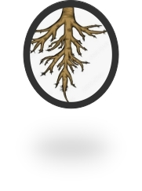

Root bark of mulberry has been used in herbal medicine as anti-phlogistic, liver protective, kidney protective, hypotensive, diuretic, anti-cough and analgesic agent

In Chinese herbal medicine, the root barks of mulberries, particularly *M. alba* L., were frequently used to cure a variety of illnesses. Prenylated flavonoids including morusin, kuwanon C (also called mulberrin), and kuwanon G are the primary components of root barks (Morante *et al*., 2024). Diels Alder-type adducts are another form of polyphenol that can be discovered in mulberries. The majority of these adducts contain flavonoid groups, while prenyls and their analogues can substitute for the flavonoid unit's C-2 and C-3. Kuk *et al*. (2017) examined the anti-disease Alzheimer's activity of the root bark of M. alba (Korea) by phytochemical analysis (Kuk *et al*., 2017). Oxyresveratrol, resveratrol p-coumaric acid, chrysin, catechin, vanillic acid, ferulic acid, chlorogenic acid, mulberroside A, maclurin, and moracins were discovered to be abundant in the phenolic phytochemicals in mulberry bark.

**Why mulberry as medicinal value????**

**Broad-Spectrum Activity**: Mulberry provides multi-system health benefits, including anti-diabetic, antioxidant, cardiovascular, and anti-cancer effects.

**Fewer Side Effects:** It causes minimal adverse effects compared to synthetic drugs, making it safer for long-term use.

**HolisticEffects:**  
Mulberry supports overall wellness by improving multiple bodily functions simultaneously.

**CulturalAcceptance:**  
It is widely used and trusted in traditional medicine systems like Ayurveda and Traditional Chinese Medicine.

**NaturalComposition:**  
Rich in nutrients and phytochemicals, mulberry offers a plant-based, chemical-free approach to health care.

**HEALTH BENEFITS:**

**Mulberry leaves**

"Ethanol-induced gastric ulcer models in rats demonstrated significant increases in ulcer index, gastric volume, and total acidity, along with decreased pH (p < 0.01). Treatment with Mulberry leaf extract-loaded microspheres (MEM) significantly improved these parameters (p < 0.05), comparable to Omeprazole. The anti-ulcer effects of MEM are attributed to its rich rutin and quercetin content, which enhance prostaglandin production, inhibit *H. pylori*, scavenge free radicals, exhibit antibacterial properties, and reduce IL-16 and TNF-α levels."(Garg *et al*.,2022)

FIG 7 **Mulberry leaf extract-loaded microspheres**

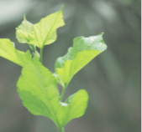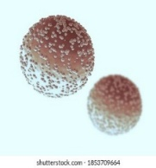 Floating microspheres:
 In floating types the bulk density is less than
the gastric fluid and so remains buoyant in
stomach.
10
TYPES OF MICROSPHERES
  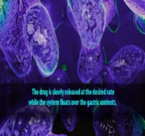

"In a study of 30 participants, the mulberry leaf extract (MLE)-based blend significantly reduced postprandial glucose iAUC by 19.5% and early insulin iAUC (0–60 min) by 23.7% (p = 0.0236) compared to the blend without MLE. While 2- and 3-hour insulin levels showed non-significant reductions, Cmax and Tmax remained unaffected. The inclusion of fiber, vitamin D, and chromium with MLE enhanced glucose regulation by slowing digestion and improving insulin sensitivity, offering superior glycemic control over MLE alone." (Mohammed *et al*., 2023)

Mulberry leaf polysaccharide (MLP), extracted through an optimized low-temperature ultrasonic-assisted method, exhibits strong antioxidant properties and effectively scavenges DPPH free radicals. In vitro studies revealed that MLP significantly inhibits the viability, migration, and invasion of breast cancer cells. These findings highlight MLP's potential as a natural antioxidant supplement or functional health food to support breast cancer therapy. (Feng *et al*., 2022)

**MULBERRY FRUIT:**

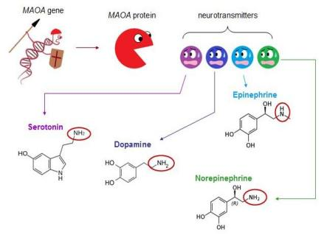

Fig 8: **The MAOA gene controls the analysis of neurotransmitters like serotonin, dopamine, and norepinephrine**.

"Daily consumption of anthocyanin-rich mulberry milk for 6 weeks significantly reduced cortisol (P < 0.001) and MAO-A/B activity (P < 0.05 in the double-serving group), correlating with improvements in anxiety, depression, somatic symptoms and social dysfunction. These effects are attributed to anthocyanins downregulating HPA axis activity and MAO expression, thereby enhancing monoamine neurotransmitter levels and supporting mental health." (Rangseekajee *et al*., 2024)

"In an MIA-induced knee osteoarthritis (KOA) rat model, oral administration of mulberry protein (Mup) at 100 and 200 mg/kg significantly improved gait parameters—stride length, foot width and gait irregularity—and reduced joint swelling. These effects are attributed to Mup’s anti-inflammatory action, likely via downregulation of TNF-α and IL-6, leading to reduced joint inflammation and pain."(Zheng *et al*., 2024)

Micro-CT and X-ray imaging revealed that KOA induces bone damage and osteophyte formation. Crude Mup (200 mg/kg) partially restored trabecular bone and reduced cortical degeneration. It also suppressed MMP-3 and MMP-13 while upregulating aggrecan, protecting 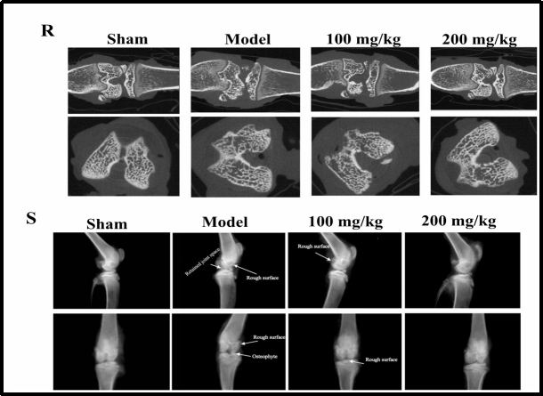cartilage integrity. (Zheng *et al*., 2024)

**Fig. 9: Crude Mup improved the clinically relevant diagnostic phenotypes of KOA rats.** (J) Schematic of micro-CT. (K) Schematic of X-ray.

**Mulberry fruit – ovarian cancer**

Morin (100–250 µM) significantly reduced galectin-3 expression at both mRNA and protein levels in TOV-21G and SK-OV-3 ovarian cancer cells, even in the presence of cisplatin. While cisplatin alone increased galectin-3 expression, it did not interfere with morin's suppressive effect. This suggests that morin enhances cisplatin sensitivity through galectin-3 depletion, likely via inhibition of the NF-κB pathway. (Beig *et al*., 2019)

**MULBERRY ROOT**

Flavonoid-rich Igsu(cultivar of *Morus* spp) extract significantly reduced prostate weight in BPH (Benign prostatic hyperplasia) models by downregulating 5α-reductase and androgen receptor signaling. It restored prostate tissue structure and decreased expression of 5AR-2, AR, SRC-1 and PSA, indicating inhibition of DHT synthesis. Igsu thus shows potential in alleviating BPH symptoms, comparable to finasteride (Fi). (Antiandrogenic compound**)** (**Choi *et al*., 2020)**

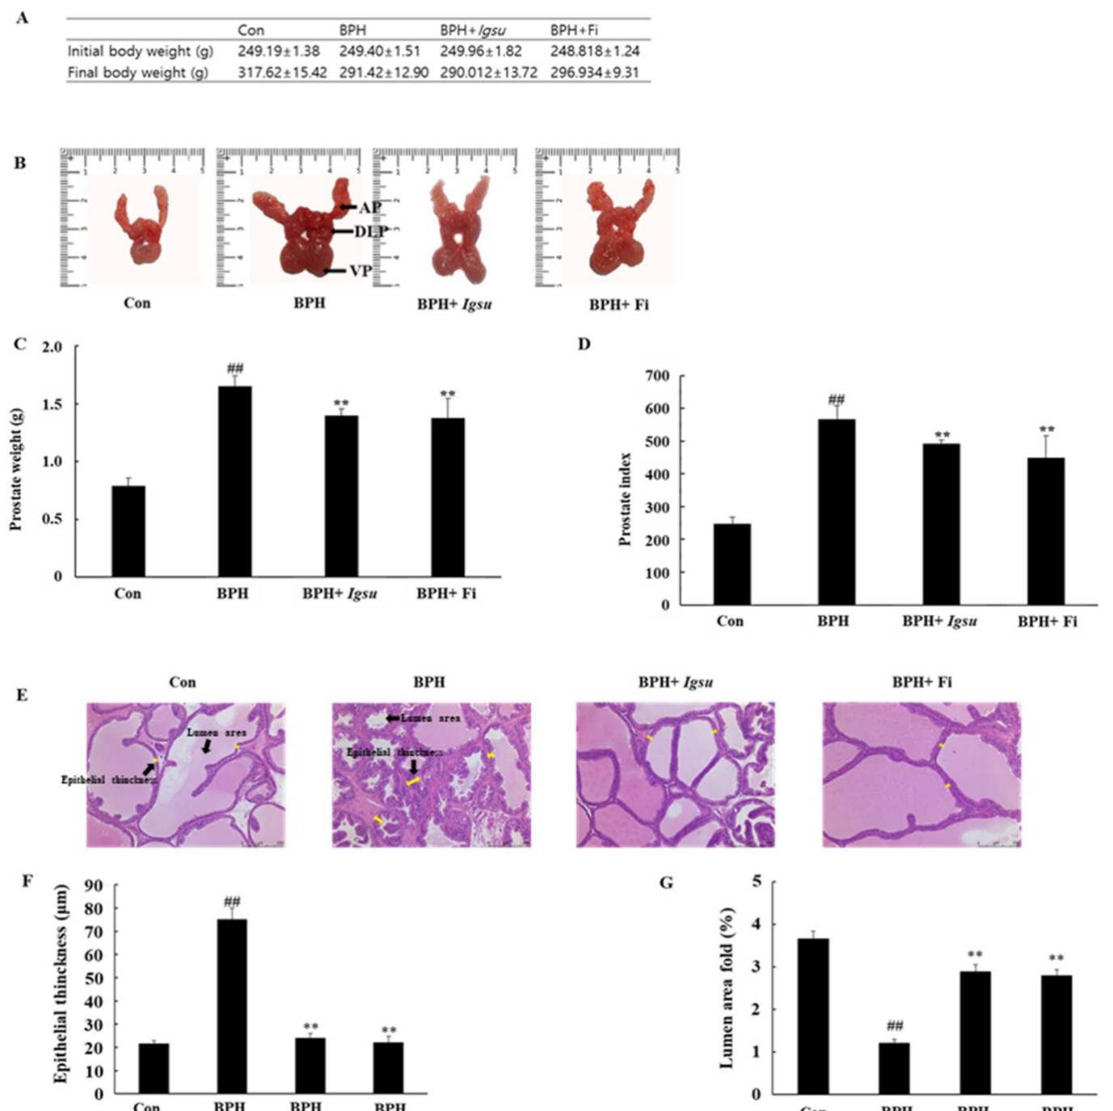

**Fig. 10: Evaluation of prostate weight and toxicity according to administration of *Igsu* in benign prostatic hyperplasia (BPH).**

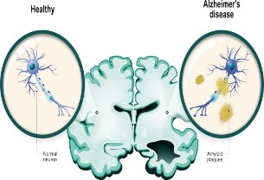

**Fig :11. Comparison of a healthy and a neuron-affected Alzheimer's disease brain**

**Mulberry twig – Alzheimer's disease**

Isopentenyl flavonoids isolated from mulberry twigs, particularly Kuwanon H, exhibited strong BChE inhibitory activity, suggesting their potential neuroprotective role in managing neurodegenerative diseases like Alzheimer’s. (Zhu *et al*., 2022)

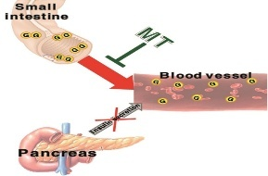

**Fig 12:.** **Isopentenyl flavonoids isolated from mulberry twigs**

Mulberry twig extract reduced liver enlargement, weight loss, and blood glucose levels in diabetic mice, showing selective organ protection.  
It modestly improved insulin levels, likely due to (Mulberry twig alkaloids) Sangzhi alkaloids inhibiting α-glucosidase activity. By suppressing disaccharidase enzymes in the intestine, it effectively reduced glucose absorption, supporting its role as a natural antidiabetic agent. (Zhu *et al*., 2022)

**Special Precautions & Warnings:**

**Pregnancy and breast-feeding**: There is not enough reliable information about the safety of taking mulberry if you are pregnant or breast-feeding. Stay on the safe side and avoid use.

**Allergies**: People who are allergic to black mulberry might also be allergic.

**Diabetes**: Mulberry might lower blood sugar. If you have [diabetes](https://www.rxlist.com/diabetes/definition.htm), monitor your blood sugar levels closely. The dose of your diabetes medication might need to be changed.

**Surgery**: Mulberry seems to lower blood sugar levels. It might interfere with blood sugar control during and after surgery. Stop using mulberry at least 2 weeks before a scheduled surgery.

(Negra *et al*.,2021)

**CONCLUSION**

Due to the global trend towards enhancing quality of life, there is a growing demand for plant-based supplements that are free from synthetic chemicals and associated with fewer side effects. Mulberry has attracted considerable attention in this context, as it is rich in bioactive constituents such as flavonoids, which exhibit notable antimicrobial and antioxidant properties. Various parts of the mulberry plant, including its leaves, fruits, and twigs, are known to offer a range of medicinal benefits that support both human and animal health. Despite its promising phytochemical profile and traditional use in herbal medicine, scientific evidence from human intervention studies on the pharmacological activities of mulberry remains limited. Therefore, more in-depth clinical research is essential to fully understand and validate its therapeutic potential

**DISCLAIMER (ARTIFICIAL INTELLIGENCE)**

Author hereby declares that NO generative AI technologies such as Large Language Models (ChatGPT, COPILOT, etc.) and text-to-image generators have been used during writing or editing of manuscripts.

**COMPETING INTERESTS**

Authors have declared that no competing interests exist

COMPETING INTERESTS DISCLAIMER:

Authors have declared that they have no known competing financial interests OR non-financial interests OR personal relationships that could have appeared to influence the work reported in this paper.

**REFRENCES:**

1. Afzal, F., Khalid, W., Asif, M.N., Jabeen, A., Jha, R.P., Khalid, M.Z., Fizza, C., Aziz, A., Akram, R., Bashir, A. And Younas, S., 2021. Role of mulberry leaves in human nutrition: A review. *Act. Sci. Nutr. Health,* **5** (3):43-50
2. Ahn, E., Shin, S., Choi, S.W. And Kim, E., 2023. Antidiabetic effects of water extracts of mulberry (Morus alba L.) twig by inhibition of disaccharidase activity in streptozotocin-induced diabetic mice. *J Nutr*, **56**(1): 24-34
3. Bieg, D., Sypniewski, D., Nowak, E. And Bednarek, I., 2019, Morin decreases galectin-3 expression and sensitizes ovarian cancer cells to cisplatin. *Arch. Gynaecol. Obstet*., 298: 1181-1194.
4. Bora, S., Narzary, P. R., & Ahmed, M. H. (2025). Mulberry (Morus spp.): Nature’s Medicine for Modern Health and Industry. Journal of Advances in Biology & Biotechnology, 28(6), 928–943
5. Chen W, Li Y, Bao T, Gowd V. Mulberry Fruit Extract Affords Protection against Ethyl Carbamate-Induced Cytotoxicity and Oxidative Stress. Oxid. Med. Cell. Longev. 2017;2017:1594963.
6. Choi, Y.J., Lee, J.I., Fan, M., Tang, Y., Yoon, E.J., Ryu, Y.B. And Kim, E.K., 2020, Metabolomic analysis of *Morus* cultivar root extracts and their ameliorative effect on testosterone-induced prostate enlargement in Sprague-Dawley rats. *Int. J. Mol. Sci*., 21 (4):1435-1453.
7. Feng, F., Hu, P. And Tao, X., 2022. Mulberry leaf polysaccharide extracted by response surface methodolog suppresses the proliferation, invasion and migration of MCF-7 breast cancer cells. *Food Sci. Technol*, **42**, p.e05122.
8. Garg, S., Singla, R. K., Rahman, M. M., Sharma, R. And Mittal, V., 2022, Evaluation of ulcer protective activity of *Morus alba* L. extract‐loaded chitosan microspheres in ethanol‐induced ulcer in rat model. *Evid. Based Complement. Alternat. Med*., 53 (2): 282-295.
9. Kim I, Lee J, 2020. Variations in Anthocyanin Profiles and Antioxidant Activity of 12 Genotypes of Mulberry (*Morus* spp.) Fruits and Their Changes during Processing. Antioxidants. **9**(3):242.
10. Kim, G.N., Kwon, Y.I. And Jang, H.D., 2011. Mulberry leaf extract reduces postprandial hyperglycemia with few side effects by inhibiting α-glucosidase in normal rats. *J.Med. Food*, **14** (7-8):712-717.
11. Kuk EB, Jo AR, Oh SI, Sohn HS, Seong SH, Roy A., 2017. Anti-Alzheimer’s Disease Activity of Compounds from the Root Bark of *Morus alba* L. *Arch. Pharm. Res.***40**(3):338-349.
12. Manzoor, S. And Qayoom. K., 2023, Medicinal values of mulberry (*Morus* spp.): A review. *J. Curr. Res. Food Sci.*, 4(1): 95-99.

1. Mohamed, M., Zagury, R.L., Bhaskaran, K., Neutel, J., Mohd Yusof, B. N., Mooney, L., Yeo, L., Kirwan, B. A., Aprikian, O., Von Eynatten, M. And Johansen, O. E., 2023, A randomized, placebo-controlled crossover study to evaluate postprandial glucometabolic effects of mulberry leaf extract, vitamin D, chromium and fiber in people with type-2 diabetes. *Diabetes Ther.,* **14** (4): 749-766.
2. Morante-Carriel, J., Živković, S., Nájera, H., Sellés-Marchart, S., Martínez-Márquez, A., Martínez-Esteso, M.J., Obrebska, A., Samper-Herrero, A. And Bru-Martínez, R., 2024. Prenylated flavonoids of the moraceae family: a comprehensive review of their biological activities. *Plants*, **13**(9):1211.
3. Qin, C., Li, Y., Niu, W., Ding, Y., Zhang, R. and Shang, X., 2010. Analysis and characterisation of anthocyanins in mulberry fruit. *Czech Journal of Food Sciences*, **28**(2):117-126.
4. Ramappa, V.K., Srivastava, D., Singh, P., Kumar, U., Kumar, D., Gosipatala, S.B., Saha, S., Kumar, D. And Raj, R., 2020. Mulberries: a promising fruit for phytochemicals, nutraceuticals, and biological activities. *Int. J. Fruit Sci*, **20** (sup3): 1254-S1279.
5. Rangseekajee, P., Piyavhatkul, N., Wattanathorn, J., Thukham-Mee, W. And Paholpak, P., 2024. Positive effects of anthocyanin-rich mulberry milk on mental health problems in the working population: an open-label study. *Nutrition Research and Practice*, **18**(1): 110-118
6. Rodrigues, E.L., Marcelino, G., Silva, G.T., Figueiredo, P.S., Garcez, W.S., Corsino, J., Guimarães, R.D.C.A. and Freitas, K.D.C., 2019. Nutraceutical and medicinal potential of the Morus species in metabolic dysfunctions. *Int. J. mo. Sci,*, **20**(2): 301.
7. Zeng, Q.W., Zhang, C., Chen, H.Y., Ding, T.L., Zhao, A.C., Xiang, Z.H. and He, N.J., 2016. Introduction trial of medicine mulberry (*Morus nigra*) in Chongqing. *Zhongguo Zhong yao za zhi= Zhongguo Zhongyao Zazhi= China J. Chinese Materia Medica*, **41**(8):1450-1455.
8. Zheng, Y.Z., Chen, Q.R., Yang, H.M., Zhao, J.A., Ren, L.Z., Wu, Y.Q., Long, Y.L., Li, T.M. And Yu, Y., 2024, Modulation of gut microbiota by crude mulberry polysaccharide attenuates knee osteoarthritis progression in rats. *Int. J. Biol*. *Macromol*., 262:129936-129948.
9. Choi, Y.J., Lee, J.I., Fan, M., Tang, Y., Yoon, E.J., Ryu, Y.B. And Kim, E.K., 2020, Metabolomic analysis of *Morus* cultivar root extracts and their ameliorative effect on testosterone-induced prostate enlargement in Sprague-Dawley rats. *Int. J. Mol. Sci*., **21** (4):1435-1453.