**Esthetic and functional restorative management with composite resin veneers in a patient with bruxism: a case report**

.

**ABSTRACT**

|  |
| --- |
| A 38-year-old male patient presented with multiple fractures and failures in direct composite restorations on his maxillary anterior teeth, associated with nocturnal bruxism. He sought care at the clinical training facility of the Professional Master’s Program in Dentistry at the University of Fortaleza. Clinical examination, patient interview, and photographic documentation confirmed esthetic compromise and functional instability due to failed restorations. These were removed and replaced with direct composite resin veneers, following strict adhesive, insertion, polymerization, and polishing protocols. To manage the underlying parafunctional habit, a 2 mm-thick acrylic stabilizing occlusal splint was fabricated and delivered, along with occlusal adjustments on the teeth, restorations, and splint. In this case, nocturnal bruxism was considered the primary contributing factor to the repeated restorative failure, emphasizing the need for a multidisciplinary approach. Based on the treatment strategy applied and its outcomes, a clinical management suggestion is presented to support conservative esthetic and functional rehabilitation in similar cases. |

**Keywords: resin veneers, polymerization, anterior teeth, restorations, and splint.**

**1. INTRODUCTION**

Bruxism is a pathological condition characterized by clenching or grinding of teeth due to mandibular muscle hyperactivity. It is classified as awake or sleep bruxism, both leading to significant tooth wear, sensitivity, headaches, and otalgia if unmanaged. Its presence must be considered when planning restorative procedures (1-2).

The advancement of light-cured composite resins, particularly through reduced filler particle size, has improved their physical and optical properties. Consequently, composites are ideal for complex restorative procedures, offering strength, versatility, minimal invasiveness, and natural esthetics, thereby enhancing patient satisfaction (3).

Although adhesive techniques are technique-sensitive and require effective isolation and strict protocol adherence, direct veneers present a viable alternative to indirect ceramic restorations. While ceramics provide esthetic and functional benefits, they entail higher costs, longer procedures, and more invasive tooth preparation. Conversely, composite veneers offer lower costs, predictability, and easier repairability (4-5).

Composite restorations are particularly appropriate for patients with bruxism, where a multidisciplinary approach is key to achieving successful outcomes (2). Consequently, combining composite resin restorations with management of masticatory parafunction represents a promising treatment strategy.

Bruxist patients often present with tooth wear, compromising function, esthetics, and oral health. Management is often challenging due to the inherent complexities of each case. Due to the complex challenges posed by bruxism, this report presents a clinical case alongside a table of suggestions for esthetic and functional rehabilitation using composite veneers in patients with nocturnal bruxism.

**2. PRESENTATION OF CASE**

***Anamnesis***

A 40-year-old male non-smoker, non-drinker, with no comorbidities or systemic conditions, and not engaged in physical activities sought care at the dental service with the following complaint: “I sought care because the previous restorations either fell out or fractured.” The patient reported grinding his teeth at night, which characterized a case of nocturnal bruxism, and stated that he did not use a stabilization splint. After conducting a thorough investigation and collecting the health history, the patient signed the Informed Consent Form authorizing the treatment and case documentation.

***Clinical Examination***

Fractures were observed on the incisal edges of teeth Upper Right Lateral Incisor (12) and Upper Left Lateral Incisor (22), along with wear and displacement on the buccal surfaces of Upper Right Central Incisor (11) and Upper Left Central Incisor (21). Additionally, canine guidance was absent on Upper Right Canine (13) and Upper Left Canine (23), supporting the diagnosis of nocturnal bruxism. These findings support the patient’s report of nocturnal teeth grinding. The gingival appearance was healthy, with no pathological signs (**Figures 1 and 2**).

**Figure 1.** Initial condition.

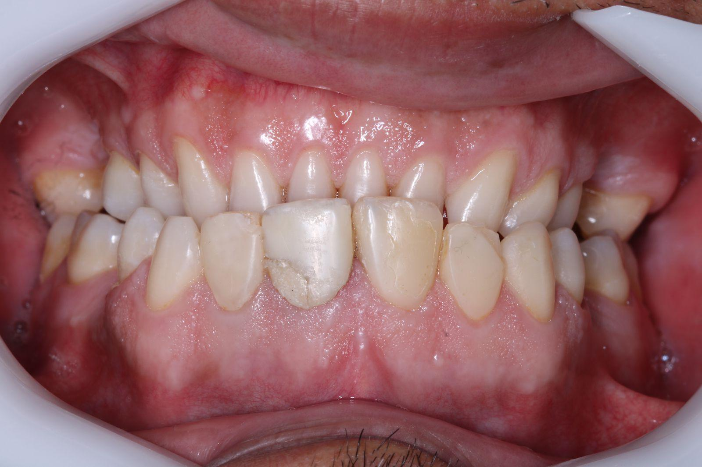

**Figure 2.** Initial condition upper arch.

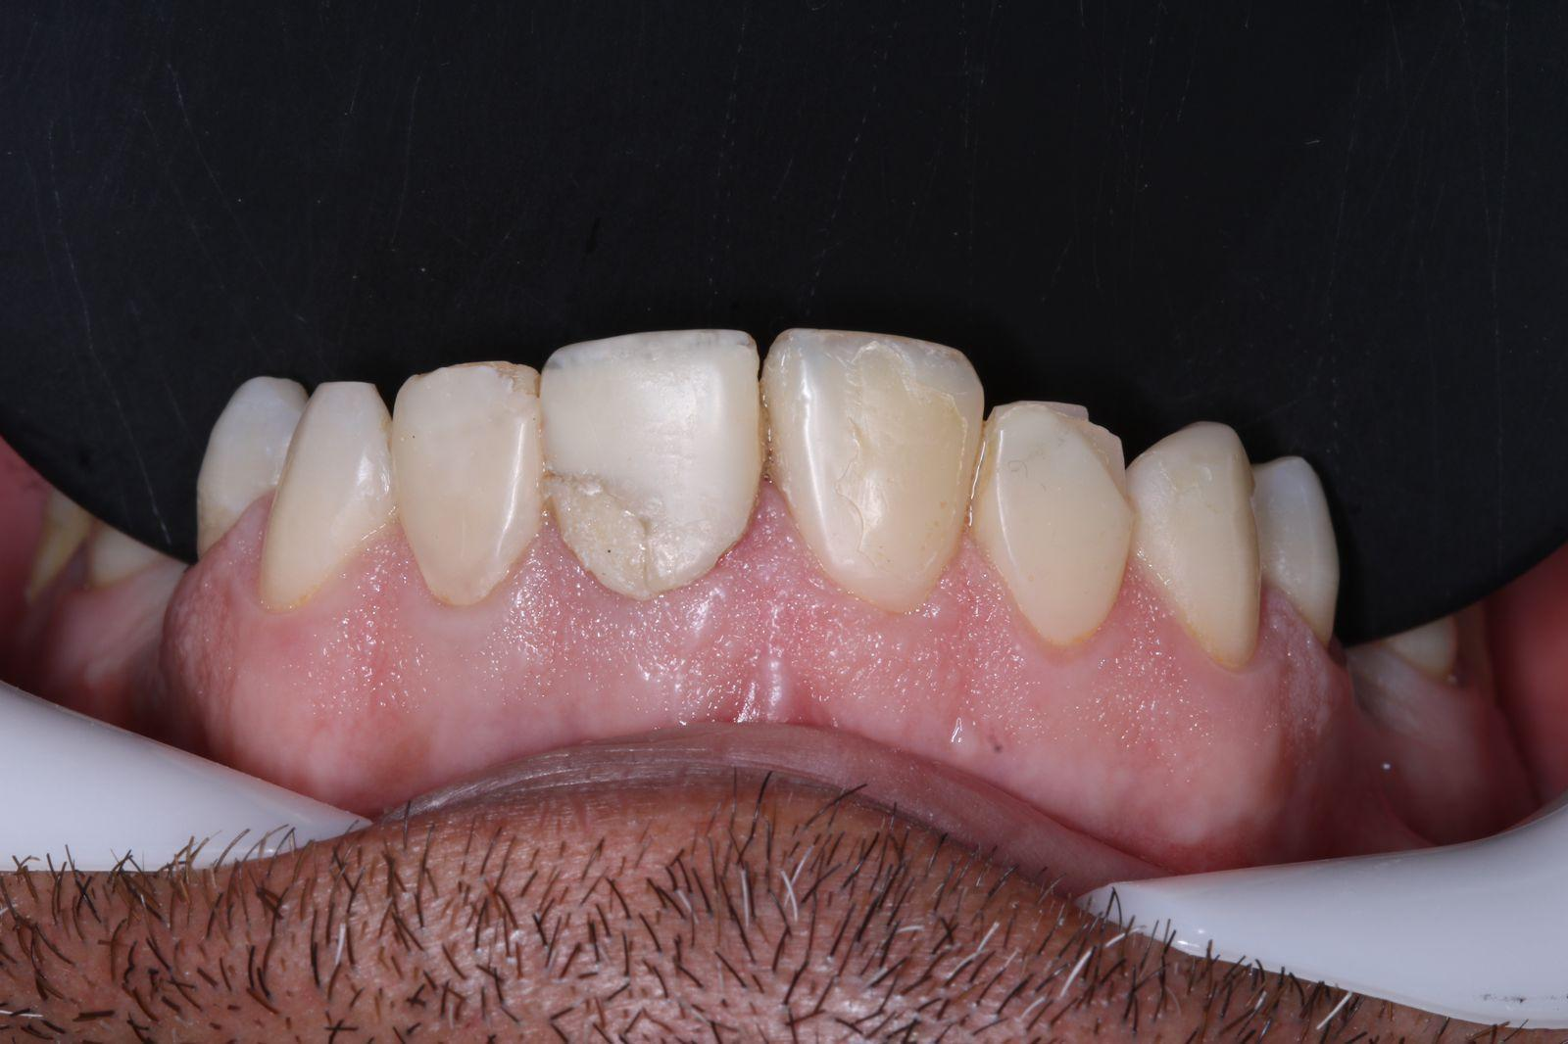

***Clinical Procedures***

Initially, the patient was informed about the importance of a multidisciplinary approach in managing bruxism. Subsequently, the dental surfaces were cleaned using a Robson brush, pumice stone, and Herjos prophylactic paste (Coltene, Altstätten, Switzerland).

The treatment plan included the removal of the anterior veneers from teeth 12, 11, 21, and 22, and the fabrication of new veneers from teeth 13 to 23, followed by the fabrication and installation of an occlusal stabilization splint. The following restorative materials were selected: for tooth 11, A2D and A2E Empress Direct composite resins (Ivoclar Vivadent, Zurich, Switzerland) and translucent resin Trans 30 (Ivoclar Vivadent, Zurich, Switzerland); for tooth 21, A1D Filtek Z350 XT (3M ESPE, St. Paul, United States), A2D and A2E (Ivoclar Vivadent, Zurich, Switzerland), and translucent resin (Ivoclar Vivadent, Zurich, Switzerland); for teeth 12 and 22, A2D and A2E (Ivoclar Vivadent, Zurich, Switzerland) and translucent resin (Ivoclar Vivadent, Zurich, Switzerland). For teeth 13 and 23, only translucent resin (Ivoclar Vivadent, Zurich, Switzerland) was used.

After shade selection, relative isolation was performed, and the previous veneers were removed with fine and extra-fine diamond burs KG Sorensen (Cotia, São Paulo, Brasil). The preparations were then refined and finished using a set of fine and extra-fine diamond burs and coarse-grit Sof-Lex Pop-On discs (3M ESPE, St. Paul, United States).

Acid etching was performed with 37% phosphoric acid (FGM, Joinville, Brazil), applied for 30 seconds on enamel and 15 seconds on dentin, followed by rinsing for 60 seconds. The area was dried with indirect air spray for 10 seconds, keeping the dentin cavity dry and without shine. Then, Single Bond Universal adhesive (3M ESPE, St. Paul, United States) was applied and light-cured with Valo Cordless Grand 3200 light-curing unit (Ultradent, South Jordan, United States) for 20 seconds. For the restorative procedure, after careful evaluation and proportion measurements of height and width, modified absolute isolation was applied along with a gingival retraction cord to control sulcular moisture. The incremental freehand technique with polyester strips was used, following esthetic principles and the golden proportion for composite resin veneers (**Figures 3 and 4**).

**Figure 3.** Modified isolation performed for incremental insertion of composite resin.

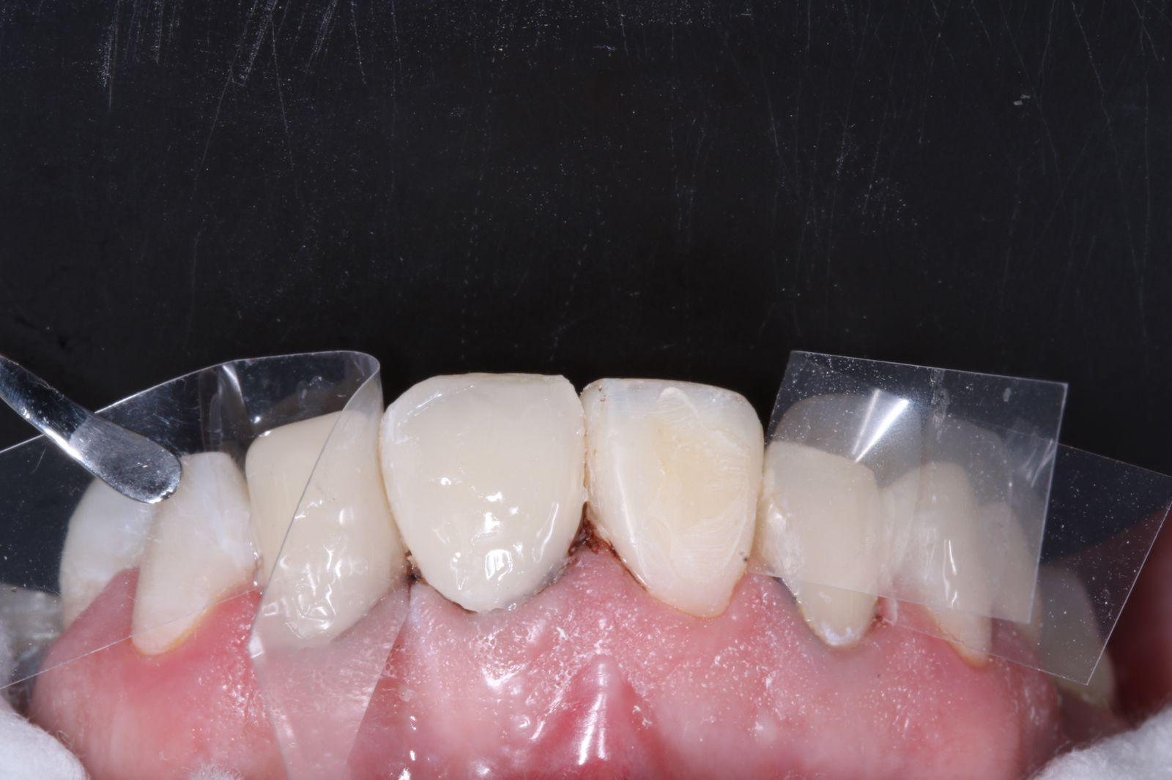

**Figure 4.** Incremental insertion of composite resin for veneer fabrication on tooth 12.

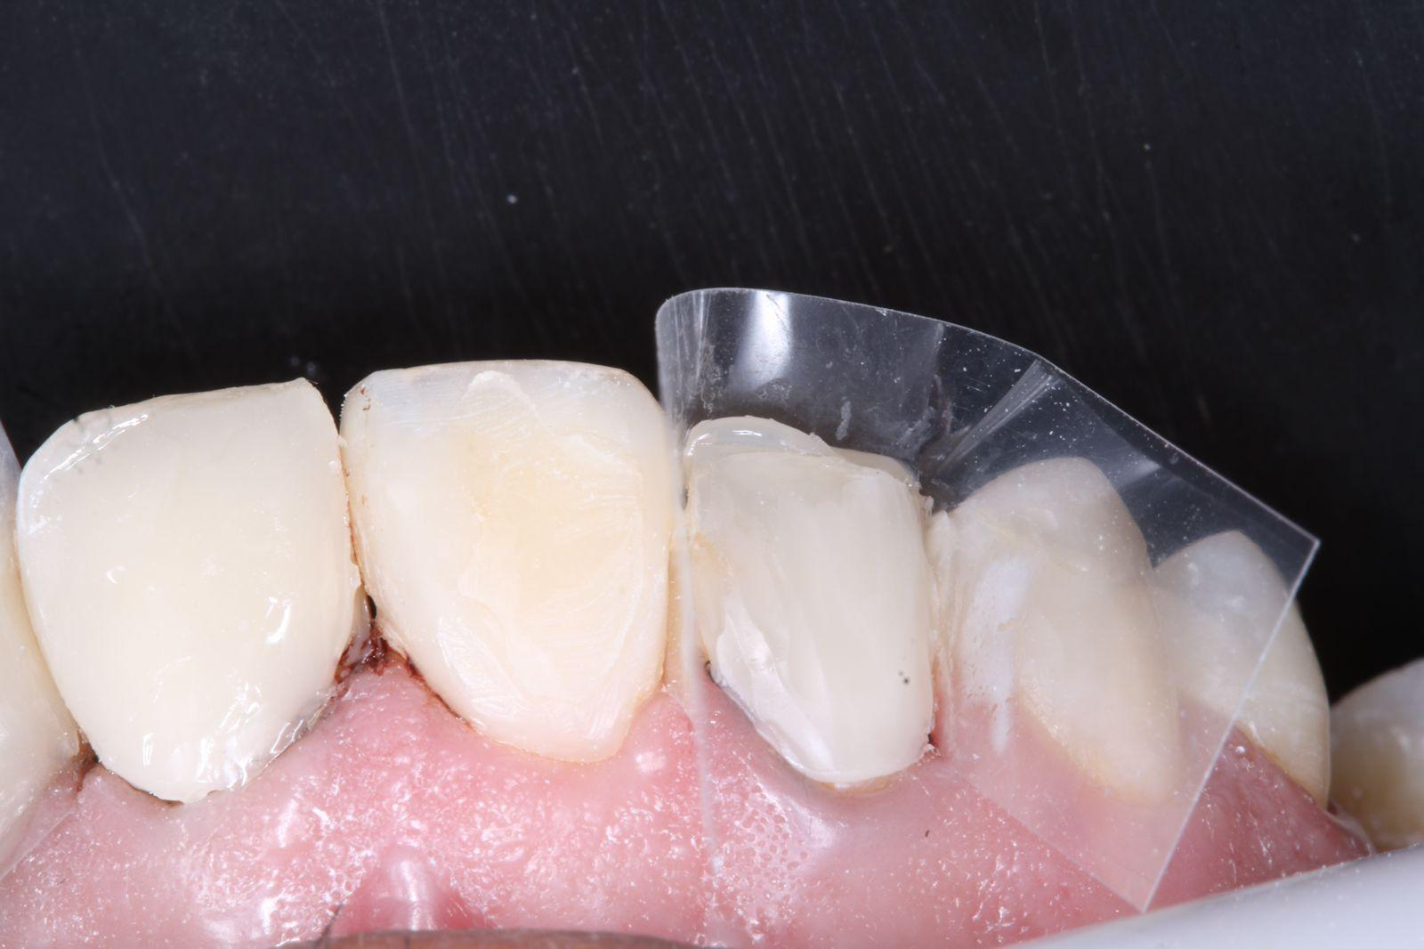

Finishing and polishing of the veneers were performed using fine and extra-fine diamond burs (Microdont), Diamond Excel polishing paste (FGM, Joinville, Brazil), felt discs, an abrasive rubber kit (Microdent, São Paulo, Brazil) at low speed, Sof-Lex Pop-On discs (3M ESPE, St. Paul, United States), metal abrasive strips for removing interproximal excesses, and no. 12 scalpel blades for removing cervical excesses under controlled moisture (**Figure 5**).

**Figure 5.** Finishing performed with fine and extra-fine diamond burs.

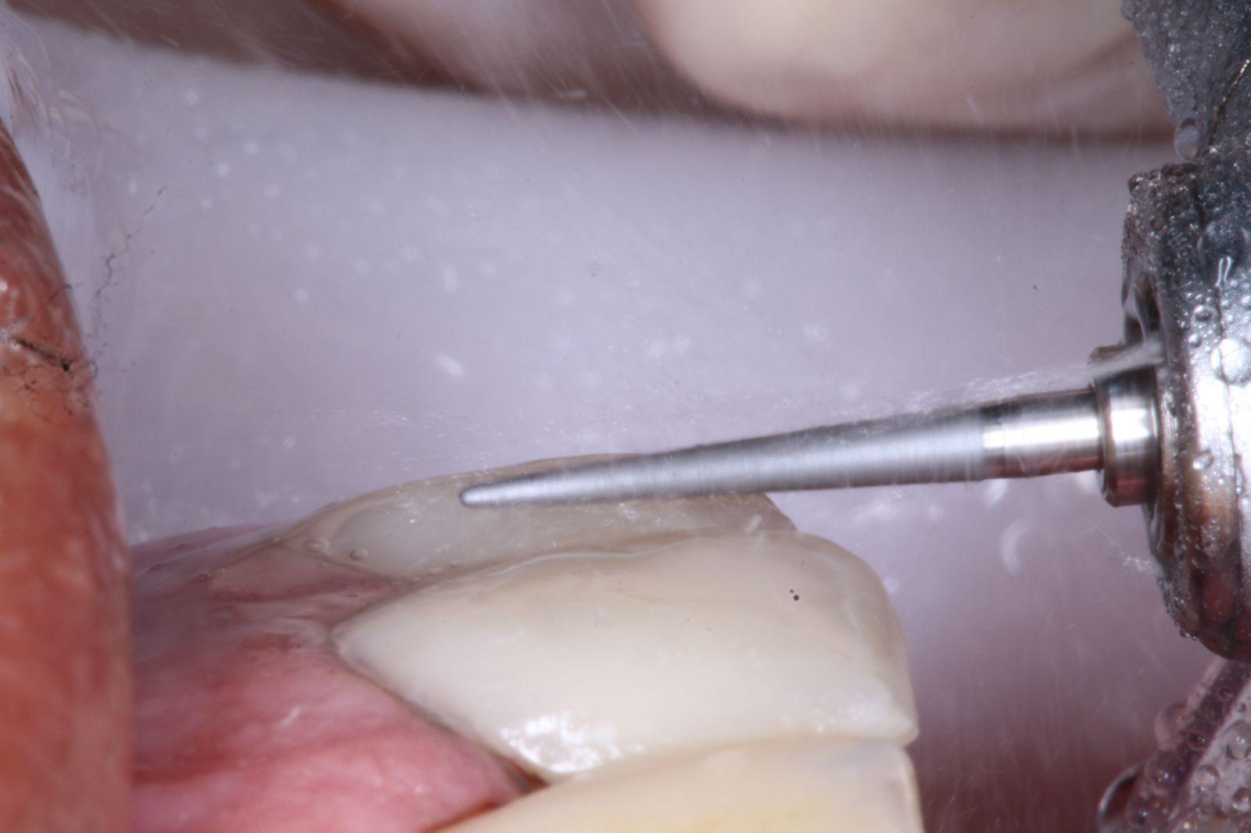

After completing the restorations (**Figures 6 and 7**), upper and lower impressions were taken, as well as a bite registration, and the materials were sent to the laboratory for fabrication of a rigid stabilization splint with 2 mm thickness, smooth surface, and made of acrylic resin.

**Figure 6.** Immediate final result.

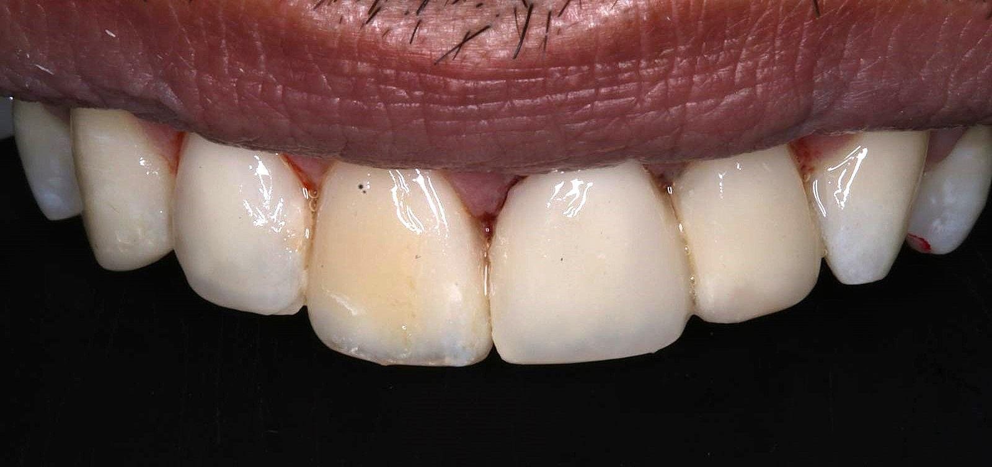

**Figure 7.** Final result view of the upper and lower arches.

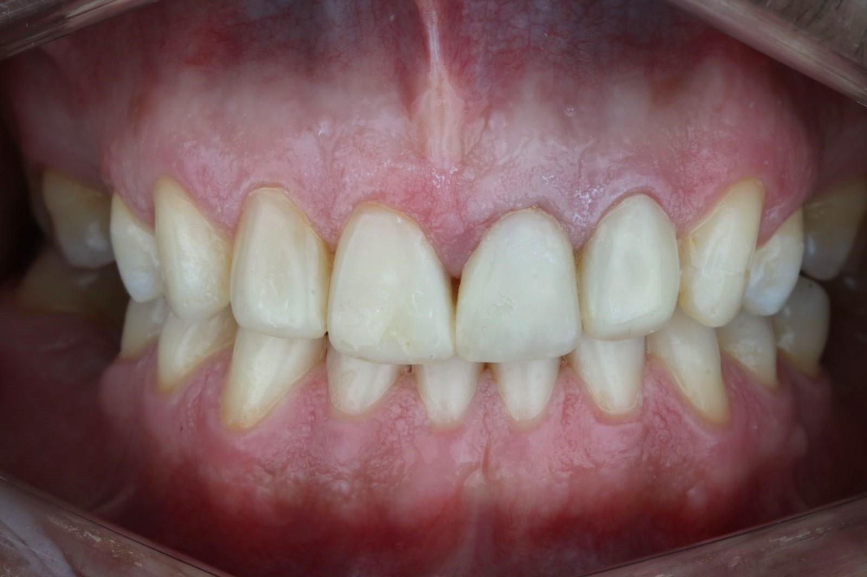

Subsequently, the smooth occlusal device was installed and adjusted according to the patient’s occlusal needs (**Figures 8 and 9**). Two follow-up visits were conducted for occlusal splint adjustment, using a straight handpiece and tungsten carbide bur (KG Sorensen, Barueri, Brazil), guided by articulating paper to ensure at least three balanced bilateral contacts. The device was then polished with the PM Ultra-technique kit (American Burrs, Santa Catarina, Brazil).

**Figure 8.** Final aspect of the upper arch.

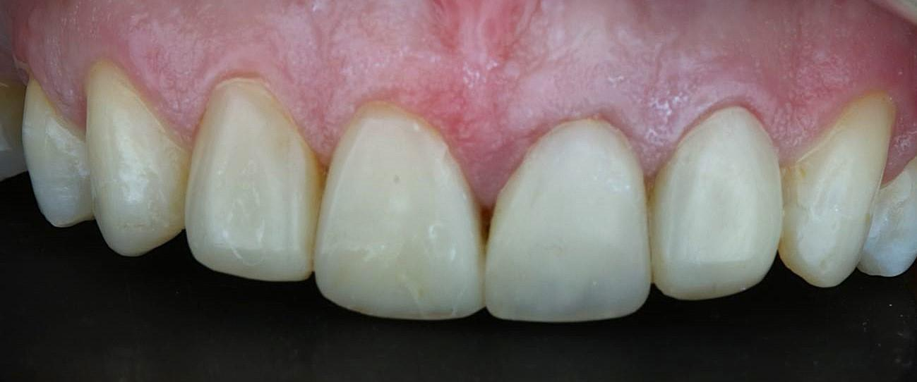

**Figure 9.** Fabricated splint.

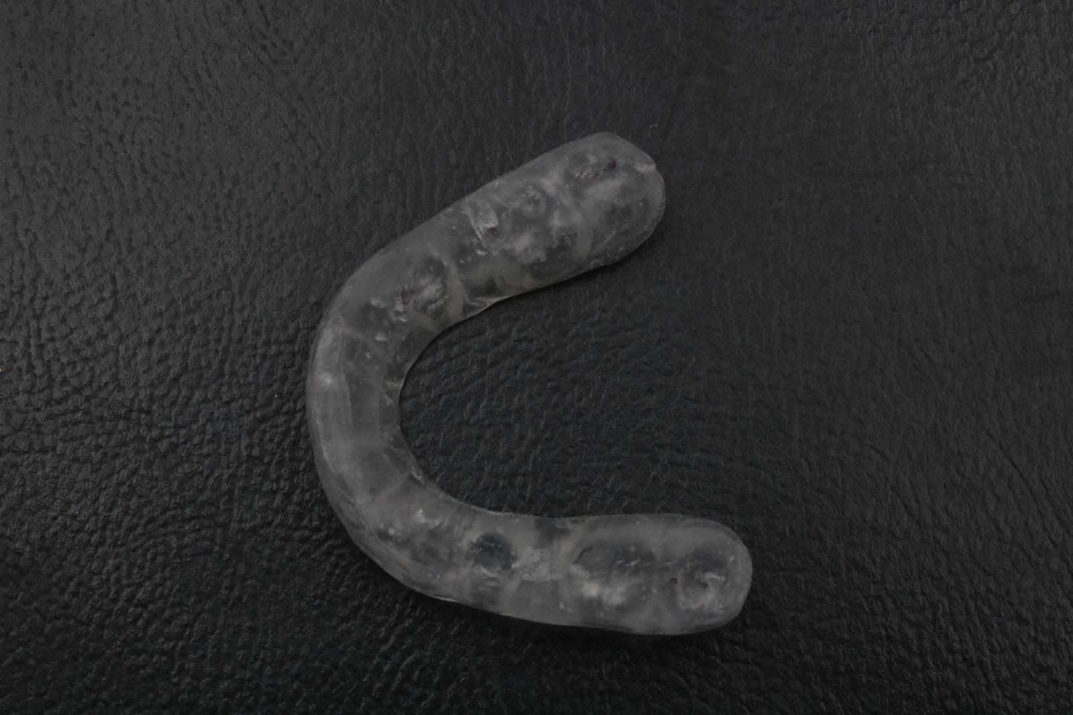

The case was concluded with clinical reevaluation, control, and monthly follow-up to ensure treatment success (**Figures 10 and 11**). The patient was reassessed after three months, and the veneers remained intact, in contrast to the previous treatment, where the restorations fractured in less than 24 hours due to the absence of a splint, which was fabricated and delivered in the current case.

**Figure 10.** Final result.

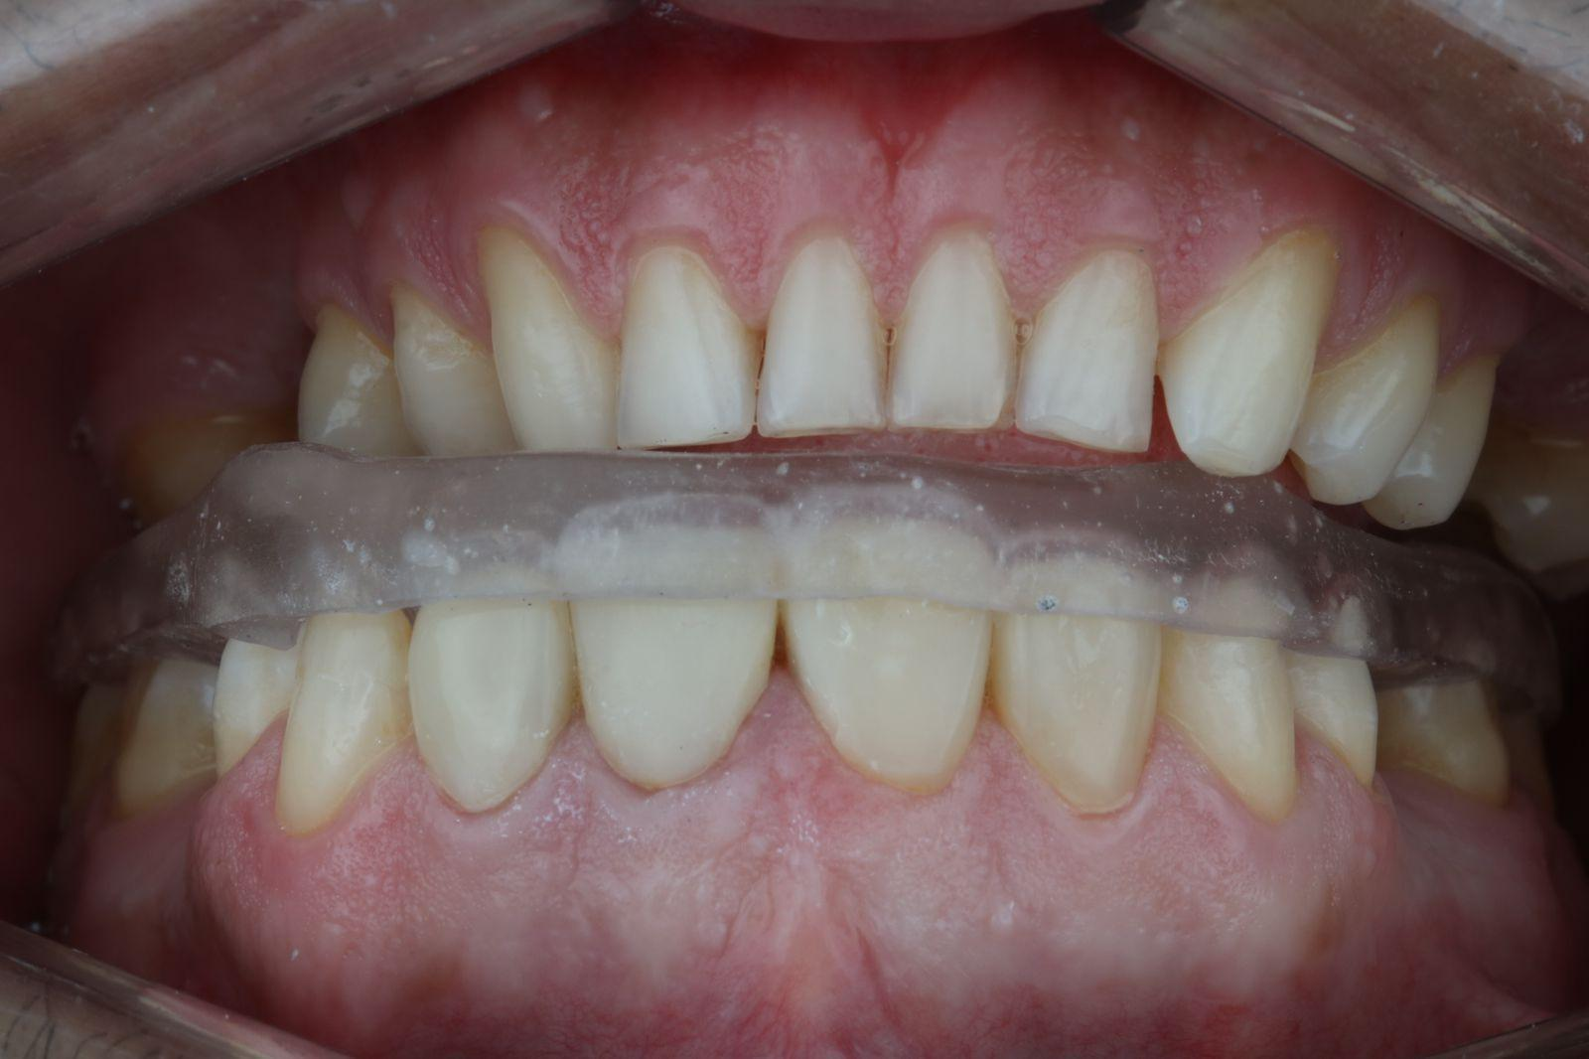

**Figure 11.** Occlusal stabilization device in the oral cavity.

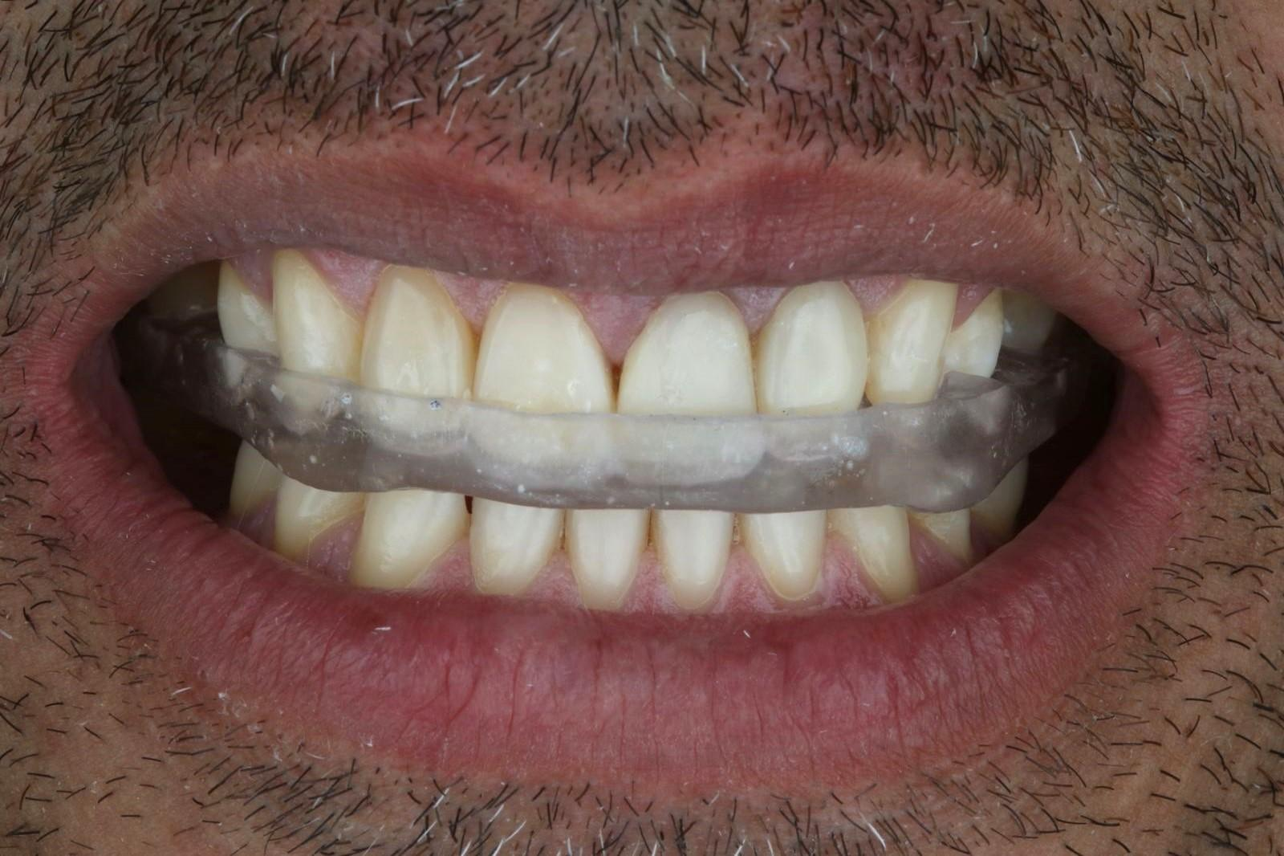

**3. DISCUSSION**

Bruxism presents significant challenges to restorative dentistry, requiring materials that balance durability and esthetics. Advances in composite resin formulations, including reinforcing particles, have enhanced mechanical properties and optical outcomes (3). However, success depends not only on the material but also on adhesion and photopolymerization, which are critical to prevent micropermeability and nanoleakage, particularly in bruxist patients (6). Wysokińska-Miszczuk et al. (7) demonstrated the importance of proper finishing and polishing, emphasizing that both technical skill and polishing paste quality are relevant. The paste’s efficiency may also be influenced by force and temperature.

The rehabilitation described by Floriani et al. (8), using semi-direct composite veneers, supports a conservative, esthetic, and functional alternative. The report underscores the need for individualized planning and occlusal assessment to ensure proper balance. Granell-Ruíz et al. (9) evaluated the impact of bruxism on porcelain laminate veneers, a material known for its esthetic and functional performance. Bruxism was a key factor in treatment failure, though stabilizing devices significantly reduced fracture risk.

In this case, direct freehand resin composites were used, consistent with the literature. Incremental insertion reduced stress, followed by appropriate photopolymerization and occlusal adjustment to prevent imbalance. Despite the susceptibility to failure even in porcelain restorations, composites offer lower cost, easier repair, and simpler maintenance (3; 8; 9-10).

Bruxism is driven by various triggers, often linked to the patient’s routine. The use of a stabilization splint to control bruxism-induced movement and protect the veneers aligns with Faus-Matoses et al. (10), who found that regular use of the device over eight years reduced complications in bruxist patients. Thus, occlusal devices alone are insufficient; multidisciplinary management is essential (1). Accordingly, the patient was advised to seek psychological support and adopt regular physical activity.

The literature remains limited regarding optimal restorative strategies for bruxist patients, especially in balancing esthetics, durability, and cost. This case shows promising short-term outcomes with composite veneers and occlusal splints, but generalizability is limited. Future clinical studies comparing materials in bruxist patients, with long-term follow-up and patient-centered outcomes, are essential. In vivo research should be prioritized, as in vitro models fail to replicate the biomechanical and biological complexities of oral parafunctions.

Although follow-up was limited to three months, this case offers valuable preliminary evidence in a field lacking long-term data. It highlights the necessity for extended clinical studies to validate and expand upon these promising outcomes, particularly concerning the durability of composite veneers under parafunctional stress.

Rehabilitation of bruxist patients requires specialized care and presents challenges even for experienced clinicians. Based on this case, the reviewed literature, and clinical experience, a table of suggestions is provided to support the esthetic management of bruxist patients and aid clinical decision-making (**Table 1**).

**Table 1.** Suggestions for esthetic and functional management of bruxist patients

|  |  |
| --- | --- |
| **Education** | Educate the patient about the condition, the need for control, regular follow-up, potential repairs, and oral hygiene care. |
| Request complementary examinations when necessary to better understand the condition. |
| Emphasize the importance of a multidisciplinary team for successful treatment. |
| **Assessment** | Conduct a comprehensive anamnesis, focusing on parafunctional habits, medical history, lifestyle, stress levels, and musculoskeletal symptoms. |
| Evaluate occlusal wear patterns, self-reported clenching or grinding, tooth mobility, sensitivity, and masticatory muscle fatigue. |
| Perform imaging of the temporomandibular joint, such as Computed Tomography and Magnetic Resonance Imaging, when indicated. |
| Obtain informed consent and photographic documentation for monitoring. |
| **Planning** | Select appropriate restorative materials and techniques, considering composite or ceramic systems and high-strength cements compatible with occlusal overload. |
| Define adhesive protocol and etching procedure according to the substrate and adhesive system. |
| Ensure controlled and efficient light-curing to achieve proper polymerization and minimize internal stresses. |
| Select restorative options that are durable, cost-effective, and feasible, taking into account the patient’s financial situation and overall social background. |
| Plan for the fabrication of a stabilization splint in cases where necessary. |
| **Treatment** | Prefer minimally invasive adhesive techniques to preserve remaining tooth structure. |
| Perform selective and planned tooth reduction, ensuring precise occlusal adjustment for optimal force distribution. |
| Refer the patient to other specialists, such as psychologists, orofacial physiotherapists, psychiatrists, or oral surgeons when necessary. |
| **Maintenance** | Schedule short-term recall intervals (3–6 months) to monitor wear and restoration integrity. |
| Periodically reassess the effectiveness of the occlusal splint and make adjustments as needed. |
| Recommend multidisciplinary support for stress management and sleep disorder control. |

**4. Conclusion**

Bruxism challenges restorative dentistry by demanding materials that combine strength, durability, and esthetics. Composite resin restorations, when combined with individualized planning, meticulous finishing and polishing, occlusal adjustment, and stabilization splints, represent a conservative and effective treatment option. Treatment success also relies on patient adherence to behavioral modifications and psychological support.

**Consent**

All authors declare that written informed consent was obtained from the patient for publication of this case report and accompanying images. A copy of the written consent is available for review by the Editorial office/Chief Editor/Editorial Board members of this journal.

**Ethical approval**

All authors hereby declare that all have been performed in accordance with the ethical standards laid down in the 1964 Declaration of Helsinki.

**Disclaimer (Artificial intelligence)**

Option 1:

Author(s) hereby declare that NO generative AI technologies such as Large Language Models (ChatGPT, COPILOT, etc.) and text-to-image generators have been used during the writing or editing of this manuscript.

Option 2:

Author(s) hereby declare that generative AI technologies such as Large Language Models, etc. have been used during the writing or editing of manuscripts. This explanation will include the name, version, model, and source of the generative AI technology and as well as all input prompts provided to the generative AI technology

Details of the AI usage are given below:

1.

2.

3.

**References**

1. Matusz K, Maciejewska-Szaniec Z, Gredes T, Pobudek-Radzikowska M, Glapiński M, Górna N, Przystańska A. Common therapeutic approaches in sleep and awake bruxism - an overview. Neurol Neurochir Pol. 2022;56(6):455-463. doi: 10.5603/PJNNS.a2022.0073.
2. Thomas DC, Manfredini D, Patel J, George A, Chanamolu B, Pitchumani PK, Sangalli L. Sleep bruxism: The past, the present, and the future-evolution of a concept. J Am Dent Assoc. 2024;155(4):329-343. doi: 10.1016/j.adaj.2023.12.004.
3. Anusavice KJ, Shen C, Rawls HR. Phillips' Science of Dental Materials. 12th ed. St. Louis: Elsevier; 2013.
4. Bastos NA, Scotti CK, Zabeu GS, Bueno LS, Ferrairo BM, Bombonatti JFS. Clinical performance of the composite resin veneers: the minimally invasive approach. Arch Health Invest. 2018;7(9):392-396, doi:10.21270/archi.v7i9.3151.
5. Gresnigt MMM, Sugii MM, Johanns KBFW, van der Made SAM. Comparison of conventional ceramic laminate veneers, partial laminate veneers and direct composite resin restorations in fracture strength after aging. J Mech Behav Biomed Mater. 2021;114:104172. doi: 10.1016/j.jmbbm.2020.104172.
6. Toledano M, Osorio E, Cabello I, Aguilera FS, López-López MT, Toledano-Osorio M, Osorio R. Nanoscopic dynamic mechanical analysis of resin-infiltrated dentine, under in vitro chewing and bruxism events. J Mech Behav Biomed Mater. 2016;54:33-47. doi: 10.1016/j.jmbbm.2015.09.003.
7. Wysokińska-Miszczuk J, Piotrowska K, Paulo M, Madej M. Composite Materials Used for Dental Fillings. Materials (Basel). 2024;17(19):4936. doi: 10.3390/ma17194936.
8. Floriani F, Coelho NF, de Azevedo Linhares L, Stolf SC, Lopes GC. Semidirect Resin Composite Veneers in a Patient with Bruxism. Case Rep Dent. 2024;2024:5572481. doi: 10.1155/2024/5572481.
9. Granell-Ruíz M, Agustín-Panadero R, Fons-Font A, Román-Rodríguez JL, Solá-Ruíz MF. Influence of bruxism on survival of porcelain laminate veneers. Med Oral Patol Oral Cir Bucal. 2014 Sep;19(5):e426-32. doi: 10.4317/medoral.19097.
10. Faus-Matoses V, Ruiz-Bell E, Faus-Matoses I, Özcan M, Salvatore S, Faus-Llácer VJ. An 8-year prospective clinical investigation on the survival rate of feldspathic veneers: Influence of occlusal splint in patients with bruxism. J Dent. 2020;99:103352. doi: 10.1016/j.jdent.2020.103352.