***Original Research Article***

**Evaluation of different bio-control agents and fungicides against *Alternaria* *brassicae* causing Alternaria blight of mustard**

**Abstract**

The present investigation was carried out *in vitro* to check the efficacy of different bio-control agents and fungicides to inhibit the growth of *Alternaria brassicae* causingAlternaria blight of mustard*.* All the tested bio-control agents and fungicides significantly inhibited the growth of pathogen compared to control. Of all bio-control agents, *Trichoderma harzianum* (77.04%)was found to be highly effective in mycelial growth inhibition of *A. brassicae* followed by *T. viride* (67.77%). However, least inhibition (60.00%) was observed with *T. hamatum.* Among the tested fungicides, Propiconazole, Hexaconazole and Azoxystrobin were found to be most effective at all four tested concentrations of 50, 100, 150 and 200 ppm, thereby causing complete growth inhibition. While as, Propineb was found to be least effective at all concentrations in comparison to other fungicides.

**Keywords:** Fungicides, Alternaria blight, *Alternaria brassicae*, bio-control agents, mustard

**Introduction**

Oilseed crops play a significant role in Indian agricultural economy next to food grains. India is one of the leading oilseeds producing country among the overall world’s rapeseed-mustard production and rank third in the world next to China and Canada (Singh *et al.*, 2020). In our country, rapeseed-mustard is the second largest oilseed crop after groundnut, covering an area of 6.12 m ha with an annual production of 9.26 mt and an average yields of 1511 kg/ha (Singh and Khan, 2022; Hemalatha *et al.*, 2023). The crop is chiefly used as edible oil, vegetables, and also as a cake (organic amendment) and fodder (Nain *et al*., 2023). It contains an adequate amount of erucic acid (38-57%), linolenic acid (4.7-13%), and linoleic acid (27%)(Singh *et al.*, 2020). The oil is also used in making soaps, paints and varnishes. The crop is mainly cultivated in Rajasthan, Uttar Pradesh, Madhya Pradesh, Haryana, Assam, West Bengal, Gujarat, Jharkhand, Bihar, and Punjab. Among these states, Rajasthan (46.49%) is the largest producer of rapeseed-mustard followed by Haryana (12.44%), Madhya Pradesh (11.32%), and Uttar Pradesh (10.60%)(Hemalatha *et al.*, 2023).

In India, rapeseed and mustard crop suffer from different diseases which not only deteriorate the quality of the seed but also reduce the oil content considerably. The crop is known to attack by more than thirty diseases in India (Saharan *et al.,* 2005). Among them, Alternaria blight is one of the important diseases that affects the quality of produce and reduces the oil content in different oil-yielding *Brassica* species. This disease reduces the photosynthetic area of leaves and causes the formation of the small, discolored, and shrivelled seeds which affects the quality by decreasing the oil content in seed (Singh *et al.*, 2020). It usually causes 17-22% yield losses in this crop but in favorable conditions, it can reach up to 47%(Saharan *et al.,* 2016; Singh and Khan, 2022).

Alternaria blight caused by *Alternaria* *brassicae* is seed-borne as well as soil-borne pathogen in nature. It affects all plant parts like leaves, stem, siliquae and produce light to dark brown prominent round spots on the leaves with concentric rings inside the spot. Later, these circular spots become coalesce to form large patches resulting in blighted appearance (Singh and Khan, 2018). The pathogen has no sexual stage and survive asmycelium or conidia on the decaying debris of previous year’s crop(Humpherson-Jones and Maude, 1982), or in susceptible weeds or perennial crops or in the infected seeds for at least one year at roomtemperature (Shrestha *et al.,* 2003).

So it is the need of the hour to manage this disease due to its wide host range and survival as mycelium or conidia in decaying plant debris. The management of Alternaria blight needs a proper understanding of pathogen etiology and epidemiology. Hence, keeping in mind the polyphagous and destructive nature of disease, there is a crucial need to manage this disease. Therefore, the present study was aimed to check the efficacy of various fungicides and bio-control agents against *Alternaria brassicae*.

**Material and methods**

***In-vitro* efficacy of bio-control agents on radial growth of *A. brassicae***

Three bio-control agents (*Trichoderma harzianum, T. hamatum,* and *T. viride*) were evaluated to test the antagonistic activity against *A. brassicae* by employing dual culture technique (Dennis and Webster, 1971). About 20 ml of PDA was poured into sterile Petri plate and allowed to solidify. A 5 mm mycelial disc of pathogen were taken and placed near the periphery of the plate having PDA (Singh *et al*., 2018). Likewise, bio-control agents were placed on opposite side of pathogen. Petri plates without antagonist treated as control for the pathogen (Nain *et al*., 2023). Three replicates were maintained for each bio-control agent and kept at 25±2°C for 7 days. The antagonistic effect of bio-control agents was observed after 7 days of incubation by checking the fungal growth in treated and control plates. The per cent fungal growth inhibition was calculated by using method suggested by Vincent (1927).

Per cent inhibition (%) = C-T/C × 100

Where,

C= fungal growth in control plates

T= fungal growth in treated plates

***In vitro* efficacy of fungicides on mycelial growth of *A. brassicae***

Efficacy of five systemic fungicides *viz.,* Carbendazim, Propiconazole, Hexaconazole, Azoxystrobin, CM-75 (Carbendazim 12%+ Mancozeb 63% WP) and two non-systemic fungicides *viz.,* Mancozeb and Propineb @ 50, 100, 150 and 200 ppm were evaluated *in vitro* against *A. brassicae,* by poisoned food technique (Dubey and Patel, 2001).

Based on active ingredient the adequate quantity of each fungicide was calculated and mixed thoroughly with autoclaved at 121°C for 15-20 minutes and cooled Potato Dextrose Agar medium in conical flasks to obtain desired concentrations of 50, 100, 150 and 200 ppm. The PDA medium without fungicide served as untreated control. Fungicide mixed PDA medium was then poured aseptically in Petri plates (90 mm) and allowed to solidify at room temperature. After solidification of the medium, all the plates were inoculated aseptically with 5 mm culture disc obtained from a week old actively growing pure culture of *A. brassicae.* The disc was placed on PDA in inverted position in the centre of the Petri plate and plates were incubated at 25±2°C. Each treatment was replicated thrice with suitable control (Singh *et al*., 2018). The observation, thus, recorded on the mycelial growth of fungus at all concentrations until the growth of test pathogen fully covered the un-poisoned Petri plates (check). The percent inhibition in radial growth (T) over control (check) was calculated by using following formula prescribed by Vincent (1947).

Per cent inhibition (%) = C-T/C × 100

Where,

C= fungal growth in control plates

T= fungal growth in treated plates

**Results and discussion**

**I. *In-vitro* efficacy of bio-control agents on radial growth of *A. brassicae***

All bio-control agents significantly inhibited the mycelial growth of pathogen over control. Of all, *T. harzianum* (77.04%)was found to be most efficient in mycelial growth inhibition of *A. brassicae* followed by *T. viride* (67.77%) which showed significant differences with one another. However, the least inhibition of pathogen (60.00%) was observed with *T. hamatum* (Figure 1).

It is evident from current findings that among all *Trichoderma* spp., *T. harzianum* showed superiority in growth inhibition of pathogen followed by *T. viride.* While, *T. hamatum* was less effective in this study (Figure 1). The present study was in accordance with findings of many other workers (Meena *et al.,* 2004; Ganie *et al*., 2013). In a study, Bharti *et al*. (2016) also tested the efficacy of two bio-control agents *viz*., *Trichoderma viride* and *T. harzianum* to inhibit growth of *A. brassicae* and found that *T. harzianum* was most effective in inhibiting the mycelial growth of pathogen. In another study, Singh *et al*. (2018) evaluated the bio-efficacy of seven *Trichoderma* spp. against *A. solani* and found that *T. harzianum* showed maximum growth inhibition (80.37%) of pathogen followed by *T. viride* (71.48%) and *T. koningii* (77.41%).

**Figure 1. Efficacy of different *Trichoderma* spp. on growth inhibition of *A. brassicae***

*Trichoderma* spp. are known to produce some plant growth promoting substances which increase seed germination, root and shoot length and enhance plant nutrition or production of some growth-regulating substances. For parasitizing the pathogen, various enzymes like glucanases, chitinases, cellulases and proteases are produced by *Trichoderma* spp. which results in disintegration of fungal cell wall (López-Mondéjar *et al*., 2011; Nain *et al*., 2023).

**II. *In-vitro* efficacy of fungicides on mycelial growth of *A. brassicae***

It is evident from Table 1 that all fungicides significantly inhibited the colony growth of fungus at four different tested concentrations over control. Among all fungicides, Propiconazole, Hexaconazole and Azoxystrobin were found to be most effective at their all four tested concentrations of 50, 100, 150 and 200 ppm, thereby registering cent per cent radial growth inhibition. However, other fungicides namely, Propineb, Carbendazim, CM-75 and Mancozeb caused a gradual decrease in mycelial growth at their increasing concentrations. Of all these fungicides, Mancozeb showed maximum growth inhibition of 72.22, 78.15, 84.07 and 90 per cent followed by CM-75 67.77, 71.48, 79.63 and 87.77 per cent and Carbendazim 63.33, 74.08, 82.60 and 86.30 per cent at 50, 100, 150 and 200 ppm, respectively. Propineb was found to be least effective at all concentrations in comparison to other fungicides and resulted 58.15, 62.60, 70.00 and 81.85 per cent growth inhibition at 50, 100, 150 and 200 ppm, respectively.

The results, thus, obtained in the present study are in conformity with findings of other workers, who have also noted the efficacy of Propiconazole, Hexaconazole and Azoxystrobin and Carbendazim for inhibition of mycelial growth of *A. brassicae* (Hassan *et al*., 2022; Singh *et al*., 2022). In a study, Valvi *et al.* (2019) tested efficacy of seven fungicides under *in- vitro* conditions against *A. brassicae* and found thatMancozeb 75% WP (0.25 %) completely inhibited the growth of the test fungus. It was followed by Propiconazole 25% EC (0.1%) which showed 96.29 percent inhibition of the test fungus and was at par with Mancozeb.

Use of fungicides provide higher plant growth during initial application but due to their side effects on the soil microflora and non-target microorganism, it became a threat to sustainable agriculture (Singh *et al*., 2020). The judicious use of fungicides plays an important role in sustainable agriculture. In sustainable agriculture, biological controls are often combined with judicious fungicide use which reduces reliance on chemicals and promotes ecological balance. They protect the crops from a number of diseases while minimizing negative environmental impacts by maintaining soil and plant health. So, proper application of fungicides becomes a key component of integrated disease management.

**Table 1. Efficacy of different fungicides on mycelial growth of *A. brassicae***

*Each value is an average of three replicates. Values within a column followed by different alphabets are significant and some alphabets are non-significant according to Tukey’s Test at P≤0.05

|  |  |  |  |  |  |  |  |  |
| --- | --- | --- | --- | --- | --- | --- | --- | --- |
| **Fungicides** | **Concentration (mm)** | | | | | | | |
| **50 ppm** | | **100 ppm** | | **150 ppm** | | **200 ppm** | |
| **Mycelial growth (mm)** | **% inhibition** | **Mycelial growth (mm)** | **% inhibition** | **Mycelial growth (mm)** | **% inhibition** | **Mycelial growth (mm)** | **% inhibition** |
| **Hexaconazole** | 00.00 | 100.00a | 00.00 | 100.00a | 00.00 | 100.00a | 00.00 | 100.00a |
| **CM-75** | 29.00 | 67.77c | 25.66 | 71.48d | 18.33 | 79.63d | 11.00 | 87.77c |
| **Carbendazim** | 33.00 | 63.33d | 23.33 | 74.08c | 15.66 | 82.60c | 12.33 | 86.30d |
| **Propineb** | 37.66 | 58.15e | 33.66 | 62.60e | 27.00 | 70.00e | 16.33 | 81.85e |
| **Azoxystrobin** | 00.00 | 100.00a | 00.00 | 100.00a | 00.00 | 100.00a | 00.00 | 100.00a |
| **Mancozeb** | 25.00 | 72.22b | 19.66 | 78.15b | 14.33 | 84.07b | 9.00 | 90.00b |
| **Propiconazole** | 00.00 | 100.00a | 00.00 | 100.00a | 00.00 | 100.00a | 0.00 | 100.00a |
| **Control** | 90.00 | - | 90.00 | - | 90.00 | - | 90.00 | - |
| **L.S.D. (P≤0.05)** | 0.49 | 0.55 | 0.99 | 1.10 | 1.22 | 1.36 | 1.11 | 1.24 |
| **SE(m)±** | 0.16 | 0.18 | 0.33 | 0.37 | 0.40 | 0.45 | 0.37 | 0.41 |

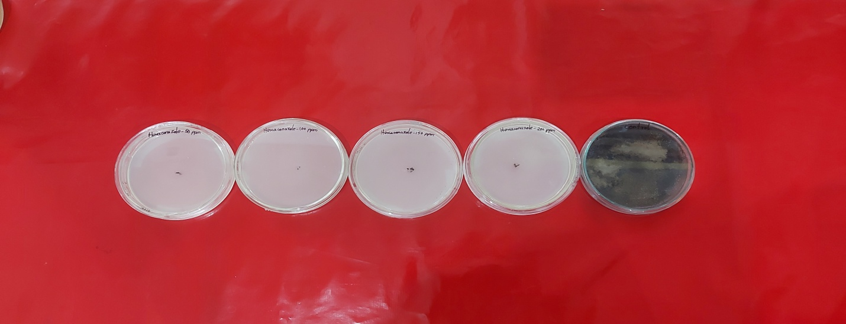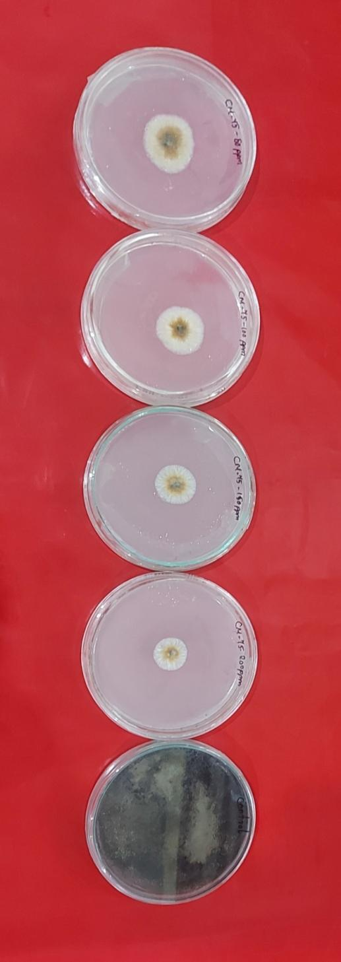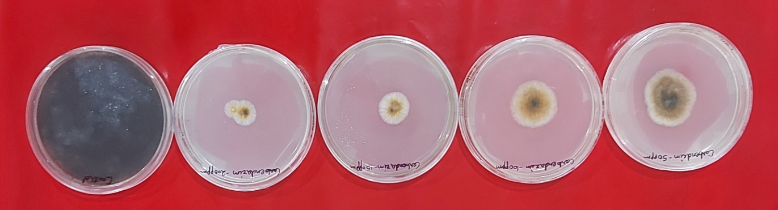

**Hexaconazole**

**CM-75CM-75Hexaconazole**

**Carbendazim**

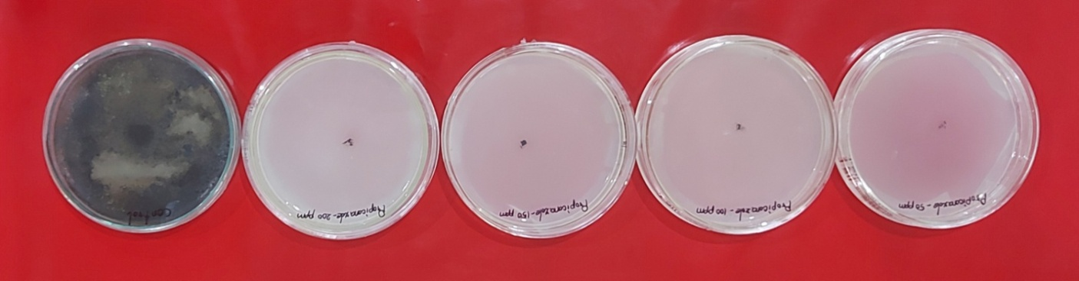

**Propiconazole**

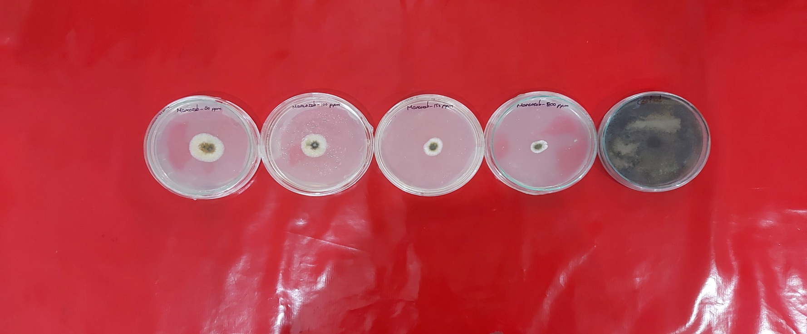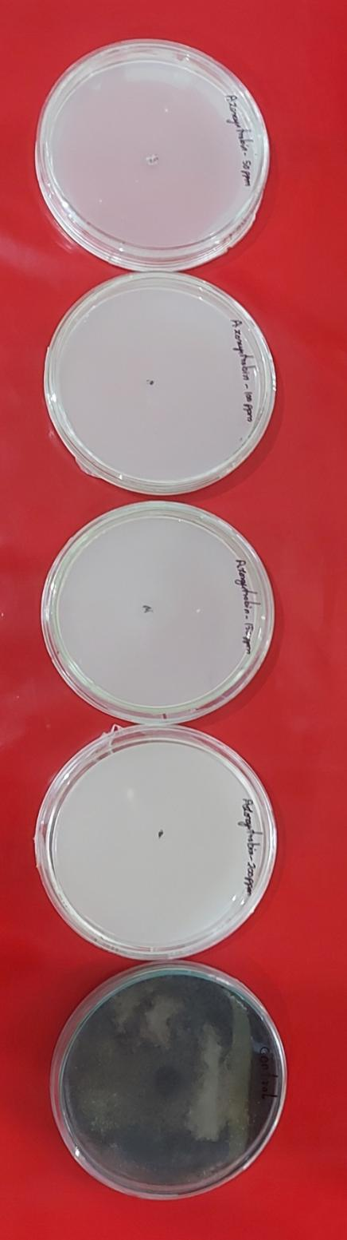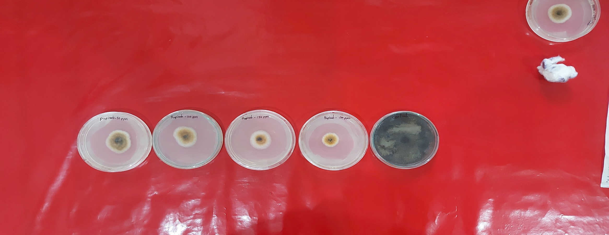

**Azoxystrobin**

**Propineb**

**Mancozeb**

**Plate 1. Efficacy of different fungicides on mycelial growth of *A. brassicae***

**Plate 3. Efficacy of different fungicides on mycelial growth of *A.brassicae***

**Carbendazim**

**Plate 3. Efficacy of different fungicides on mycelial growth of *A.brassicae***

**Plate 3. Efficacy of different fungicides on mycelial growth of *A.brassicae***

**Plate 3. Efficacy of different fungicides on mycelial growth of *A.brassicae***

**Conclusion**

It is concluded from the study that all *Trichoderma* spp. significantly minimized the growth of *A. brassicae*. But *T. harzianum* was most efficient in reducing the growth of pathogen followed by *T. viride*. Among all fungicides, Propiconazole, Hexaconazole and Azoxystrobin had better inhibitory effect at all four concentrations. However, Mancozeb was also effective followed by CM-75 and Carbendazim at increasing levels of concentrations, being more effective at 200 ppm. While as, Propineb was least effective in the study. The farmers are encouraged to integrate biopesticides into their agricultural practices due to their eco-friendly nature. Although, biopesticides offer environmentally sustainable solutions, they may exhibit slower action compare to chemical fungicides. Therefore, a judicious approach of combining biopesticides with chemical fungicides through proper method to ensure effective disease management should be implemented.

Disclaimer (Artificial intelligence)

Option 1:

Author(s) hereby declare that NO generative AI technologies such as Large Language Models (ChatGPT, COPILOT, etc.) and text-to-image generators have been used during the writing or editing of this manuscript.

Option 2:

Author(s) hereby declare that generative AI technologies such as Large Language Models, etc. have been used during the writing or editing of manuscripts. This explanation will include the name, version, model, and source of the generative AI technology and as well as all input prompts provided to the generative AI technology

Details of the AI usage are given below:

1.

2.

3.

**References**

**Dennis, C. and Webster, J. (1971).** Antagonistic properties of species groups of *Trichoderma* I. Production of non-volatile antibiotics. *Trans. Br. Mycol. Soc.,* 57: 25-39.

**Dubey S. C, Patel B. (2001).** Evaluation of fungal antagonists against *Thanatephorus* *cucumeris* causing web blight of urd and mung bean. *Indian Phytopathology,* 54(2): 206-209.

**Ganie, S. A., Ghani, M. Y., Nissar, Q. and Rehman, S. U. (2013).** Bioefficacy of plant extracts and biocontrol agents against *Alternaria solani. African Journal of Microbiology*, 7(34): 4397-4402.

**Hassan, R. A., Ali, S., Zaheer, M. S., Ali, H.H., Iqbal, J., Habib, A. and Mumtaz, M. Z. (2022).** *In-vitro* and *in-vivo* evaluation of different fungicides against leaf blight causing fungus *Alternaria cucumerina* in bitter gourd. *Journal of the Saudi Society of Agricultural Sciences,* 21(3), 208-215.

**Hemalatha, S., Khan, R. U., Sayyeda, S. and Singh, V. P. (2023).** Influence of different temperature regimes and culture media on the growth and sporulation of *Alternaria brassicae* causing Alternaria blight of mustard. *International Journal of Environment and Climate Change,* Volume 13, Issue 8: 1232-1239.

**Humpherson-Jones, F.M. and Maude, R.B. (1982).** Studies on the epidemiology of *Alternaria brassicicola* in *Brassica oleracea* seed production crops. *Annals Appl. Biol.,* 100: 61-71.

**López-Mondéjar, R., Ros, M. and Antonio Pascual, J. (2011).** Added-value of Trichoderma amended compost as biopesticide organic substrates: Alternative to traditional organic substrates. [*Acta Horticulturae*](https://www.researchgate.net/journal/Acta-Horticulturae-2406-6168?_tp=eyJjb250ZXh0Ijp7ImZpcnN0UGFnZSI6InB1YmxpY2F0aW9uIiwicGFnZSI6InB1YmxpY2F0aW9uIiwicG9zaXRpb24iOiJwYWdlSGVhZGVyIn19)*,*898: 189-196.

**Meena, P. D., Meena, R. L., Chattopadhyay, C. and Kumar, A. (2004).** Identification of critical stage for disease development and bio-control of Alternariablight of Indian mustard (*Brassica Juncea*). *Journal of Phytopathology*, 152: 204-209.

**Nain, M. Z., Khan, R. U., Singh, V. P. and Sayyeda, S. (2023).**  *In vitro* evaluation of antifungal activity of different *Trichoderma* spp. and plant extracts against *Sclerotinia sclerotiorum* (Lib.) de Bary causing stem rot of mustard. *International Journal of Plant & Soil Science*, Volume 35, 15: 40-47.

**Saharan, G. S., Mehta, N. and Meena, P. D. (2016).** Alternaria diseases of Crucifers: biology, ecology and disease management. Springer Science + Business Media Singapore Pvt Ltd, pp. 17-51.

**Saharan, G. S., Mehta, N. and Sangwan, M. S. (2005).** Diseases of oilseed crops*. Indus Publication Co., New Delhi,* 643p.

**Shrestha, S. K., Munk, L. and Mathur, S. B. (2005).** Role of weather on Alternaria leaf blight disease and it’s effect on yield and yield components of mustard. *Nepal Agricultural Research Journal,* 6, 62-72.

**Singh, P., Bhanwar, R. R. and Mehar, N. (2022).** *In-vitro* evaluation of new fungicide combinations against *Alternaria brassicae* causes leaf blight of rapeseed. *The Pharma Innovation Journal*, 11(4S): 1787-1792.

**Singh, V. P. and Khan, R. U. (2018).** Effect of different nutrient media on radial growth of *Alternaria brassicae* (Berk.) Sacc. infecting different *Brassica* host crops. *International Journal of Agricultural Invention*, 3(2): 137-140.

**Singh, V. P. and Khan, R. U. (2022).** Prevalence of Alternaria blight of rapeseed-mustard in different districts of Uttar Pradesh. *Research Journal of Agricultural Sciences*, 13(4): 1140-1144.

**Singh, V. P., Khan, R. U. and Pathak, D. (2018).** *In-vitro* evaluation of fungicides, bio-control agents and plant extracts against early blight of tomato caused by *Alternaria solani* (Ellis and Martin) Jones and Grout. *International Journal of Plant Protection,* 11(1): 102-108.

**Singh, V. P., Pathak, D. and Sayyeda, S. (2020).** Alternaria blight: A problem of rapeseed-mustard. *Agriculture & Food: e- Newsletter*, 2(1): 504-507..

**Singh, V. P., Pathak, D. and Sayyeda, S. (2020).** Use of pesticides and its effect on environment. *Agriculture & Food: e- Newsletter*, 2(5): 834-836.

**Valvi, H. T., Saykar, A. D. and Bangar, V. R. (2019).** *In-vitro* and *in-vivo* field efficacy of different fungicides against *Alternaria brassicae* (Berk.) sacc. causing Alternaria leaf spot of cauliflower. *Journal of Pharmacognosy and Phytochemistry*, 8(2), 1333-1337.

**Vincent, J. M. (1974).** Distortion of fungal hyphae in the presence of certain inhibitors. *Nature,* 159: 239-241.