Original Research Article

Impact of Antibiotic Exposure Duration on Bacterial Resistance in Chicken Farm Drinking Water

**ABSTRACT**

|  |
| --- |
| The selection of resistance traits within the microbial world represents a major scientific concern for healthcare systems across the globe. This worry develops in connection with the management policies that are holistically enacted to control infectious diseases from the onset to aggravation, alleged to drive species evolution and exacerbate metabolic disorders in humans. The present pilot investigation aimed at determining the length of time that drinking water specimens containing antibiotics should be kept on a chicken farm with minimal risk of selecting resistant bacterial strains. The present pilot experience was an experimental study conducted in poultry farms and in the Laboratory of Microbiology of the Université des Montagnes Teaching Hospital. Different steps were performed between July 1st and September 20th, 2024. All required administrative requirements were fulfilled prior to the first steps through the process, which began with a questionnaire, then isolation of *Escherichia coli*, *Morganella morganii* and *Proteus mirabilis* from animal drinking water (> 72 h) and initial susceptibility tests. These isolates first underwent subculture over 15 days in antibiotic-free environments to appreciate susceptibility patterns based on the inhibition diameters. Secondly, the subcultures obtained from the 15th subcultures were exposed to antibiotic suspensions made according to the manufacturer's instructions regarding their use on farms. Several findings were expected from this second step: a– the time between the suspension preparation and development of the first population on agar plates, and b– the susceptibility tests on the first populations and on the one observed at 24 h. These tests were repeated 15 times. All identifications and susceptibility testing were conducted according to standard guidelines. All recovered data were recorded and analysed with the tools provided by Microsoft Office Excel 2016 and GraphPad Prism version 9.4.1. Doxycycline (42%), Colistin (39%), and Oxytetracycline (13%) were identified as the most commonly used antibacterial agents. Overall, 64% of the population renewed the water after 24 or 48 hours, while 36% kept it for 12-24 hours on average. Gradual increased susceptibility was invariably observed in bacteria in population growth serially in antibiotic-free environments. Exposed to antibiotics, it was observed that the average time for minimal risk of resistance selection was species-dependent and antibiotic-dependent, and that susceptibility gradually decreased as exposure time extended. Overall, the time recommended to keep antibiotic solutions on farms depends on the bacterial types and the antibiotic used, imposing the necessity to know, at least the major bacterial types targeted, before any intervention regarding antibiotics in animal drinking water is undertaken. This management pattern will thereby associate biosafety and biosecurity in addressing the selection of resistance traits in bacteria. |

*Keywords:* Animal farm,Antibiotic-resistant bacteria, Drinking water, Resistance selection, Antibiotic exposure

1. INTRODUCTION

Antibiotic-resistant bacteria have increased as a result of antibiotic abuse in recent years, endangering the health of many people worldwide. The majority of research on antibiotic resistance takes place in the medical field, but there is rising concern over the spread of antibiotics into the environment (Wilcox et al., 2023). The selection of resistance traits within the microbial world represents a major scientific concern for healthcare systems across the globe. This worry develops in connection with the management policies that are holistically enacted to control infectious diseases [1] from the onset to aggravation, alleged to drive species evolution and exacerbate metabolic disorders in humans [2,3].

The phenomenon of antimicrobial resistance refers to the potential of microorganisms, including bacteria, viruses, fungi, and parasites, to thrive and continue to grow in the midst of drugs designed to kill them (Salam et al., 2023). Known and controllable drivers on which this phenomenon builds include the misuse and overuse of antimicrobials in preventing and managing microbial diseases in healthcare settings, on animal farms and in plant production [1,4,5]. Within the microbial world and the sets of stochastic overlaps with human and animal conditions, resistant bacterial diseases are amongst the most important threats, regardless of living standards or geographic determinants globally. According to some authors, they are responsible for mortality rates higher than those attributable to famine, wars, accidents and other crimes combined [6]. In 2018, the WHO estimated that infectious diseases were responsible for 32% of deaths worldwide, with 68% in Africa and 83.7% in South-East Asia. In 2001, the WHO and the UN recognised bacterial resistance as a major public health problem [7]. It is currently estimated that bacterial resistance to antibiotics causes 700,000 deaths every year worldwide, and that this number could rise to rise to 10 million by 2050 if effective policies are not developed and implemented to bring this threat under control [8].

In particular, populations in resource-limited countries share a common set of daily life challenges, which are poverty and infectious diseases (IDs). The WHO estimates that the cost of IDs in Africa is more than 2.4 trillion dollars, and that about $796 trillion of these losses could be saved by 2030 if the sustainable development goals related to IDs are met.

Despite admirable technological advances towards controlling IDs globally, contextual policies implemented to manage drivers of selection that vary with resource availability and affordability, no nation is spared from the challenges imposed by microbial resistance [2,5]. This situation will be exacerbated with increased life expectancy, which will require additional tools to prevent the resurgence of drug-resistant opportunistic infections [5]. It is also estimated that the quantities of antibiotics used in animal production are several times greater than those used in human medicine [9]. Otherwise, other sectors than human medicine likely contribute a larger but overlooked share in microbial resistance and deserve special attention. One means to address this issue would be to identify as precisely as possible the levers on which resistance selection and dissemination on animal farms are rooted. It is undeniable that the antibiotic concentrations that best favour the selection of resistant strains are those used for prophylaxis (that is, at lower doses) [6] in animal farms. In poultry, for instance, antibiotics used for prophylaxis are generally administered *via* animal drinking water [10], commonly at sub-lethal doses [11]. Based on findings from previous investigations, it was alleged that, in addition to antibiotic residues, drug effectiveness likely decreases with time in water [10]. No one knows with accuracy how this process takes place, nor how it persists and evolves. In this vein, developing evidence-based contextual intervention strategies emerges as a priority.

The aim of the present pilot investigation was to determine the length of time that a drinking water specimen containing antibiotics could spend on a chicken farm with minimal risk of selecting resistant bacterial strains. Conventional antibacterial agents used in animal drinking water on farms were primarily identified, alongside initial susceptibility profiles of recovered Gram-negative rod bacterial isolates. Thereafter, these isolates were regrown with and without these antibiotics to appreciate the susceptibility/resistance profile evolution based on the inhibition diameters. Overall findings revealed a set of considerations regarding both the time and the microbial populations subjected, which could guide contextual interventions in controlling antimicrobial resistance (AMR), in line with Biosafety and Biosecurity according to the One Health principles.

2. material and methods

**2.1 Study design and ethical/administrative considerations**

The present pilot experience was an experimental study conducted in poultry farms and in the Laboratory of Microbiology of the Université des Montagnes Teaching Hospital. Different steps were performed between July 1st and September 20th, 2024. It was conducted under research authorization Reference N° 2024/102/CUM/AND_GEN provide by the Université des Montages Teaching Hospital Head.

**2.2 Specimen collection and laboratory screening**

On farms, a questionnaire was used. It is intended to collect necessary pieces of information on the use of antibacterial from stakeholders, observance of the manufacturer's recommended dilutions, and the length of time water containing antibiotics should be kept for animal use.

The biological material consisted of resistant bacterial strains recovered from specimens of drinking water collected from a farm. Subjected chicken’s drinking water was collected from farms where it was found to be renewed after 72 h; and bacterial species of interest, those that are often associated with infections in humans and animals.

To isolate, identify and perform susceptibility tests on bacteria, standard procedures were used [12-16]. Drinking water specimens (72 h and above) were then collected and conveyed to the laboratory in refrigerated containers (≈ 4°C) and then plated on McConkey agar. The plated preparations were, thereafter, incubated aerobically at 37°C for 24 h. Upon completion of incubation, the bacterial identification was conducted according to the recommended standards [12,13].

**2.3 Primary/initial susceptibility testing**

Bacterial susceptibility tests were performed by agar diffusion [14-16]. Antibacterial agents used in this step were : Imipenem (10 µg), Gentamicin (15 µg), Erythromycin (15 µg), Amoxicillin (25 µg), Ceftriaxone (30 µg), Ceftazidime (30 µg), Rifampicin (5 µg), Cefoxitine (30 µg), Azithromycin (15 µg), Trimethoprim/Sulfamethoxazole (25 µg), Levofloxacin (5 µg), Amoxicillin/Clavulanic acid (20/10 µg), Colistin (50 µg), Doxycycline (15 µg) and Enrofloxacin (5 µg).

**2.4 Repeating growth tests in antibiotic-free environments**

Bacterial populations from the same isolates underwent 15 consecutive cultures over 15 days on Muller Hinton agar. Each of the resulting fresh populations was tested for susceptibility profile through assessment of the trend in inhibition diameter variation, according to the same guidelines (agar diffusion).

**2.5 Exposing bacteria to antibiotics, appreciating growth, and performing secondary susceptibility testing**

The bacterial populations recovered at the end of 15 tests in antibiotic-free environments with known original susceptibility profiles were exposed to recommended dilutions of four antibiotics that are used in chicken drinking water by farmers. They consisted of Doxycycline, Colistin, Oxytetracycline, and Enrofloxacin. These antibiotics were diluted in sterile water. For Doxycycline and Colistin, the recommended dilution was 100 g of antibiotic in 200-300 L of clean water. Concerning Oxytetracycline, the manufacturer recommended 100 g of antibiotic powder in 250 L of clean water. For Enrofloxacin, it was 100 mL in 400 L of clean water. For all the tests, 0.5 L of water was used. Accordingly, the required quantities were 250 µL for Enrofloxacin, 0.25 g for Doxycycline and Colistin, and 0.2 g for Oxytetracycline. In each of these suspensions, 500 µL of the 0.5 McFarland fresh (24 h on Muller Hinton) bacterial inoculum was dispensed and thoroughly mixed.

All well-mixed bacterial suspensions were immediately plated (10 µL per 90 mm diameter Muller Hinton agar plate) in triplicate. This plating step, done in the same conditions, was repeated after 2 h, 4 h, 8 h, 12 h, and 24 h, followed by aerobic incubation for 18 to 24 h at 37°C as recommended for non-stringent bacteria. Overall, therefore, 0 hx3, 2 hx3, 4 hx3, 8 hx3, 12 hx3, and 24 hx3, for each of the populations subjected (all suspensions used once). After completion of incubation, bacterial enumeration was conducted on a plate, for which bacterial growth was observed on two out of the three plates. Then, susceptibility tests were carried out on one of the first pure cultures in the series, where this bacterial growth was recorded. Each preparation was renewed after 24 h, and the triplicate protocol was repeated 15 times. *Escherichia coli* ATCC 25922 was the reference bacterial strain used for quality control throughout the process of identification and susceptibility tests.

**2.6 Data analysis**

All recovered data were recorded and analysed with the tools provided by Microsoft Office Excel 2016 and GraphPad Prism version 9.4.1.

3. results

**3.1 Data from farmers**

Overall, 100 participants were enrolled. They consisted of 48 farmers, 19 veterinary doctors, and 33 veterinary technicians. Each of these participants followed his or her own routine protocol regarding the duration that water containing antibiotics in the farm would be kept on the farm. However, 64% renewed it after 24h or 48h on average, because it was in fact the time for clearing the container and refilling; 36% left it for an average of 12-24h. This time coincided with the cleaning throughout the farm. About 20% of the 36% have completed secondary education, why 13% who have attended higher education were found to renew drinking water after 72 h and above. The 13% justified this attitude with the lack of time, the availability and affordability of antibiotics. The antibiotics most frequently used were Doxycycline (42%), Colistin (39%), Oxytetracycline (13%), and Enrofloxacin (3%).

Namely, the Gram-negative rod isolates recovered from the 72h-old water specimens and used in the subsequent steps were Escherichia coli, Morganella morganii and Proteus mirabilis.

**3.2 Susceptibility tests on repeated subcultures in antibiotic-free media**

Susceptibility tests conducted on fresh bacterial populations from fifteen consecutive subcultures generated sets of findings that were summarised and displayed in Figure 1. The overall picture reveals increased inhibition diameter with time for all the tests performed. However, with imipenem, if the values recorded on Morganella morganii and Proteus mirabilis steadily increased, wider fluctuations are observed with the inhibition diameters in *E. coli*. Similar results are recorded when Erythromycin and Amoxicillin are used. Additional details indicate a slight fluctuation after day 11th with the inhibition diameters for *E. coli.* With Ceftriaxone and Ceftazidime, the trend is similar to the one recorded when Imipenem is tested, though the inhibition diameters for *E. coli* appear to fluctuate relatively more. On day 14th, a drop in the inhibition diameters is frequently observed with *E. coli*. Further insight reveals increased effectiveness with Amoxicillin/Clavulanic acid compared to Amoxicillin alone.

**Figure 1: Susceptibility tests summary on 15 subcultures (antibiotic-free media)**

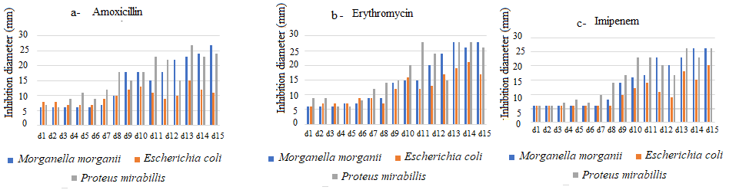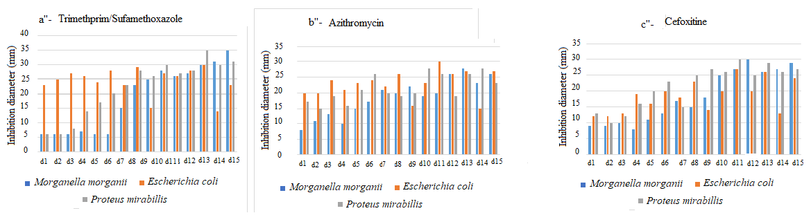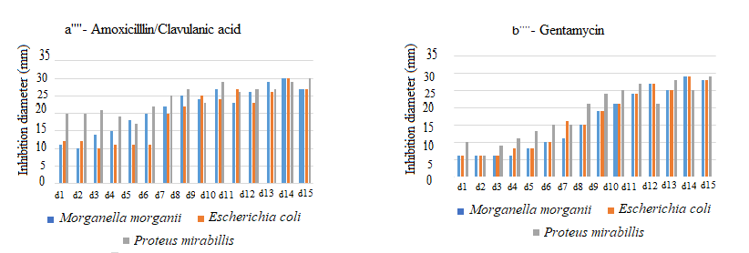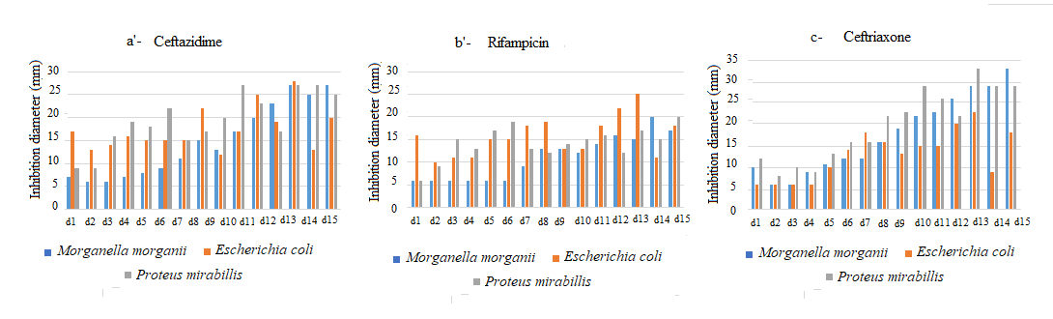

**3.3 Exposed bacterial growth in antibiotic-enriched media and colony count as a function of time**

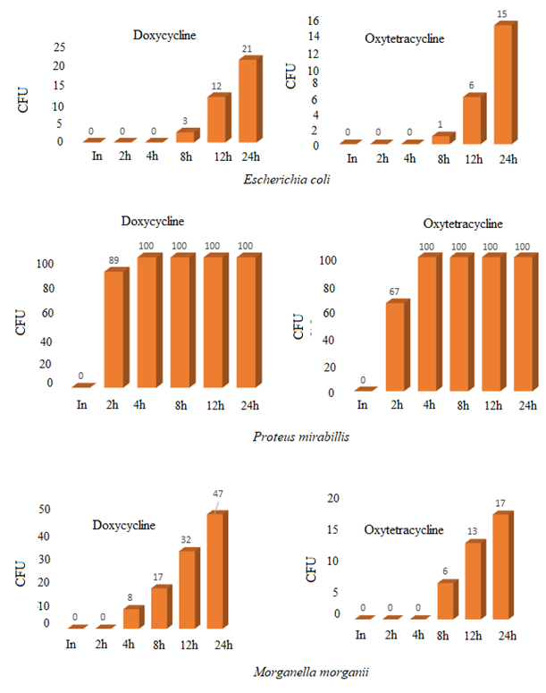Figure 2 illustrates colony count values that were plotted after bacterial cultures were exposed to Oxytetracycline and Doxycycline. The general trend is the bacterial growth and increased population that are recorded over the length of exposure time. More insight, however, highlights isolate-dependent differences that are obvious with the antibacterial agent used. Doxycycline and Oxytetracycline inhibit *E. coli* growth for longer times (8 h for the first count), Morganella morganii (4 h and 8 h for Doxycycline and Oxytetracycline, respectively), then *Proteus mirabilis*, 2 h each, for the respective antibiotics. Otherwise, *Proteus mirabilis* resumes steady growth earlier than Morganella morganii and E. coli in animal drinking water. This general trend is associated with the population densities, which increase rapidly after the first growth is recorded.

**Figure 2: Time-related exposed bacterial growth and counting (antibiotic-enriched media)**

**3.4 Resistance re-expression subsequent to exposure in antibiotic-rich environments**

The overall picture indicates decreased inhibition diameters upon exposure of bacteria to recommended antibiotic concentrations. Illustrations and related further details are summarised and plotted in Figure 3. Following exposure of E. coli to Doxycycline and Oxytetracycline, the first culture is observed after the 8th h for both antibiotics. Figure 3 reveals that the average inhibition diameter values gradually decrease for all the antibiotics used, from the beginning through the 24th h. This decline is much more obvious with Amoxicillin, Oxytetracycline, Ceftazidime, Cefoxitin, Azithromycin, Trimethoprim/Sulfamethoxazole, Colistin and Doxycycline. The experiment conducted with P. mirabilis reveals the first visible culture after the 2nd h. Further details related to the average inhibition diameters indicate that these diameters decrease for all the antibiotics tested as the time of exposure elapses. A similar trend is observed with Amoxicillin, Oxytetracycline, Ceftazidime, Cefoxitin, Azithromycin and Colistin.

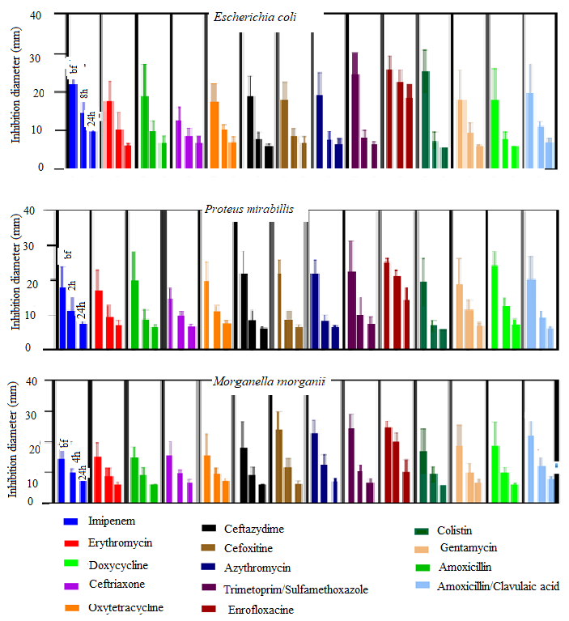About *M. morgannii*, the first culture is seen after the 4th h. This population exhibits similar behaviour in the presence of Oxytetracycline and Doxycycline. Average inhibition diameters reveal a gradual decline with all the antibiotics tested, however. This reduction is, however, more obvious in the first culture exposed to Trimethoprim/Sulfamethoxazole, Cefoxitin and Gentamycin.

**Figure 3: Susceptibility tests summary on bacteria after exposure to antibiotics**

bf: before antibiotic exposition

4. discussion

The present investigation into bacterial resistance selection in chicken drinking water revealed subtle relevant findings.

The farmer survey indicated that the antibiotics which are most commonly used by farmers included Doxycycline (42%), Colistin (39%), Oxytetracycline (13%) and Enrofloxacin (3%). This list is almost identical to the one reported by previous authors in Douala (Wouri division, Littoral-Cameroon) [17], though the proportions differ. These authors observed Enrofloxacin (55.5%), Oxytetracycline (30.2%), Doxycycline, Colistin, Tylosin and Tetracolivite combined (14.3%).

In the course of the present work, it was observed that 64% of participating farmers kept animal drinking water containing antibiotics for above 24 h. They justified their attitude by the lack of time and/or the financial resources required for antibiotics. These results are similar to the findings by André *et al.* in 2023 [18], who observed that 35% of their populations had poor practices with regard to antibiotic use and pointed out similar reasons. Mir *et al.* (2018) [19] concluded at the end of their study on bovines that 12-24 h would be suitable for animal drinking water containing antibiotics for optimal action, regardless of specific bacterial types or time-specific growth. Data analysis further revealed that about 36% of farmers kept these solutions between 12 h and 24 h, and renewed it for its high turbidity due to debris, generally coinciding with the routine farm cleaning times.

This dimension draws attention to the hygiene practices that should be observed to mitigate the phenomenon addressed by the present pilot study. In fact, debris in drinking water plays at least two roles in the selection of resistant bacterial strains. Firstly, they serve as support for the development of bacterial biofilms, which are highly effective in maintaining microbial populations and negatively affect antibacterial action. Secondly, their presence dilutes the antibacterial concentration due to the increased inoculum size that ensues. This reduction in concentrations is one of the best-known factors that are responsible for the selection of resistant organisms [11,20]. These couple of determinants are likely to work together in promoting selection and dissemination of resistant bacteria traits in the environment [1,11,21].

It should also be pointed out that about 20% of those who followed this routine had attended secondary education. According to the set of findings recorded, the educational background appeared, however not associated with practices. In fact, 13% of those who kept antibiotic solutions above 72 h were university graduates. This practice was justified by the purchasing power, the time, the availability and affordability of antibiotics. Otherwise, trained people or potentially trained people could do better if they were provided the minimal conveniences for their activity. In a recent investigation (unpublished), it was also observed that several stakeholders in hospital hygiene were unable to provide the expected quality of job because adequate incentive policies were not enacted.

Repeated subcultures of original isolates over 15 days revealed a gradual increase in susceptibility of the subjected strains, despite relative fluctuations with some drugs like Amoxicillin and Imipenem. This global trend implies likely inactivation and/or deletion of resistance genes and is consistent with the hypothesis of resistance phenotype inactivation throughout bacterial generations grown in drug-free environments. This unstable expression over time is characteristic of acquired traits, theoretically developed due to selection pressures associated with antimicrobial agents like antibiotics and pesticides in farms [2,21].

When *Escherichia coli*, *Morganella morganii* and *Proteus mirabilis* were exposed to Doxycycline, Oxytetracycline, and Enrofloxacin for 24 h, the primary visible growth of *Proteus mirabilis* was recorded after 2 h in Doxycycline and Oxytetracycline. These two antibacterial agents have similar modes of action. Osvald *et al.* (2023) [22] observed that in *P. mirabilis*, these acquired resistances could durably resist deselection. Accordingly, and based on the current findings, resistance trait inactivation and/or deletion might occur as time-dependent and species-dependent (that is it does not evolve at similar rates in all bacteria and for all antibiotics), further consistent with Baquero (2015) on the need for multiple parameters to understand microbial ecology and evolution [2,21]. With reference to this author, the biology of microbes cannot be studied in the absence of explicitly detailed studies of their microenvironments, since every biological entity represents at the same time an ‘environment’ and a ‘signal’ for the neighbor biological and abiotic entities**.** For *Escherichia coli* and *Morganella morganii*, the first cultures were observed on plates from the 8th h post-exposure to Oxytetracycline. With Doxycycline, they were observed after 8 h for *E. coli* and 4 h for *M. morganii*. Bacteria belonging to these two species are naturally susceptible to Tetracycline and Doxycycline, but can acquire resistance with prolonged and repeated exposure. This view justified the acquired resistance anticipated above. Similar findings were reported by Rasamoelisoa *et al.* (1999) [23] during an investigation on the evaluation of antibiotic use in pediatric hospitals, when they concluded that patients receiving Doxycycline eventually developed resistance to this antibiotic, in line with Arifatun *et al.* (2014) on multidrug-resistant *Proteus mirabilis* isolated from commercial chicken farms [24]. In addition, Arifatun *et al.* (2014) observed that resistance acquisition was associated with gene selection through the overuse of antibiotics as food supplements. The three bacterial strains subjected to the present study did not express resistance to Enrofloxacin after 48 h. This result could be understood from the fact that this broad-spectrum antibiotic remains highly effective even at low concentrations, thanks to its reduced molecular size and its bactericidal mode of action (characteristic of quinolones). Only 3% of participating farmers used Enrofloxacin on their farms as a therapeutic alternative when infection control with other drugs failed. This figure is well below the one described by Ngandjui Yonga *et al.* (2021), where 55.5% of the population of Douala (Littoral-Cameroon) used Enrofloxacin on their farms [17]. The difference in the use might reflect the purchasing power and attachment to their profession. In fact, in Douala, where Ngandjui Yonga *et al.'s* study was conducted, most farmers had animal husbandry as their major income-generating activity, unlike the case in the present investigation. These conclusions could help understand the lack of time, the cost of antibiotics, and the time between two consecutive farm premises-cleaning and animal drinking water renewal in Bangangté, which is a typical semi-urban area.

Data analysis related to inhibition diameters before and after exposure to antibiotics revealed a gradual reduction in the recorded values for all the antibiotics tested. Invariably, the longer the bacteria were in contact with Doxycycline and Oxytetracycline, the more the inhibition diameter reduced, implying resistance selection, like Sanders *et al.* (2011) observed when they investigated the use of antibiotics in livestock farming and the public health risks involved [25]. These authors concluded, therefore, that one of the factors responsible for bacterial resistance was the prolonged contact of germs with antibiotics, since susceptibility tests performed on strains before and after exposure revealed that resistance evolves over time. This is also consistent with the above hypothesis on time-dependent changes. Overall, it could be pointed out several depending variables (the time and the species), suggesting the need to describe the microbial ecology prior to the use of antibiotic on the farms, in line with Baquero (2015) [2] about the genetic modifications that could only be clearly understood when the local environments’ parameters are well defined. He built this conclusion on the correspondence between the genetic map, which is associated with the prevailing environment [2]. It could, therefore, be reasonably anticipated that upon exposure to antibiotics, acquired resistance intensifies with time of exposure, guided by species variations. Future essays should provide additional pieces of information at least three levels: how the concentration of the selective agents evolves over time, the number of resistance mechanisms involved and the advents with mixed bacterial populations, in line with biosafety and biosecurity as key arguments useful to addressing microbial resistance.

5. Conclusion

This research on the selection of bacterial resistance in chicken drinking water revealed that most commonly used antibiotics included Doxycycline (42%), Colistin (39%), Oxytetracycline (13%), and Enrofloxacin (3%). The education standard did not influence the use of these drugs, and the majority (64%) of participating farmers renewed antibiotic solutions after 24 or 48 hours. Successive subculturing in antibiotic-free and in drug-enriched environments revealed time-dependent and species-dependent increased and reduced susceptibility patterns, respectively. Otherwise, the time recommended to keep antibiotic solutions on farms depends on bacterial types and the antibiotic used, imposing the necessity to know, at least the major bacterial types targeted, before any intervention regarding antibiotics in animal drinking water.

Data availability

Data associated with this work were not deposited into a publicly available repository. All the data of this work are present in this paper.

**DISCLAIMER (ARTIFICIAL INTELLIGENCE)**

Author(s) hereby declare that NO generative AI technologies such as Large Language Models (ChatGPT, COPILOT, etc) and text-to-image generators have been used during writing or editing of this manuscript.

References

1. Resende JA, da Silva VL and Diniz CG. Aquatic environments in the One Health context: modulating the antimicrobial resistance phenomenon. Acta Limnologica Brasiliensia. 2020; 32:e102.

2. Baquero F. Causes and interventions: need of a multiparametric analysis of microbial ecobiology. Environ Microbiol Rep. 2015; 7(1):13-4. https://doi.org/10.1111/1758-2229.12242

3. Baquero F. Threats of antibiotic resistance: an obligatory reappraisal. Int Microbiol. 2021; 24(4):499-506. https://doi.org/10.1007/s10123-021-00184-y

4. Taylor P and Reeder R. Antibiotic use on crops in low and middle-income countries based on recommendations made by agricultural advisors. CABI Agric Biosci. 2020; 1:1.

5. Hernando-Amado S, Coque TM, Baquero F and Martínez JL. Antibiotic Resistance: Moving From Individual Health Norms to Social Norms in One Health and Global Health. Front Microbiol. 2020; 11:1914. https://doi.org/10.3389/fmicb.2020.01914

6. Davies J, Spiegelman GB and Yim G. The world of subinhibitory antibiotic concentrations. Curr Opin Microbiol. 2006; 9(5):445-453. https://doi.org/10.1016/j.mib.2006.08.006

7. Petit F. Antibiotic resistance in aquatic environments: a microbial ecology and public health issue. Environment, Risks & Health. 2018; 17:40-46. https://doi.org/10.1684/ers.2017.1098

8. Dauvergne E. Detection of antibiotic resistance genes in bacteria isolated from seafood products. Microbiology and Parasitology. 2018. https://hal.univ-lorraine.fr/hal-02010604v1

9. Andersson DI, Balaban NQ, Baquero F, Courvalin P, Glaser P, Gophna U et al. Antibiotic resistance: turning evolutionary principles into clinical reality. FEMS Microbiol Rev. 2020; 44(2):171-188. https://doi.org/10.1093/femsre/fuaa001

10. Done HY, Venkatesan AK and Halden RU. Does the Recent Growth of Aquaculture Create Antibiotic Resistance Threats Different from those Associated with Land Animal Production in Agriculture? AAPS J. 2015; 17(3):513-524. https://doi.org/10.1208/s12248-015-9722-z

11. Stanton IC, Murray AK, Zhang L, Snape J and Gaze WH. Evolution of antibiotic resistance at low antibiotic concentrations including selection below the minimal selective concentration. Common Biol. 2020; 3(1):467. <https://doi.org/10.1038/s42003-020-01176-w>

12. REMIC/SFM. Reference Guide in Medical Microbiology Volumes 1 and 2. 6th ed. French Society of Microbiology, 2018.

13. Denis F, Ploy MC, Martin C, Bingen E and Quentin R. Medical Bacteriology, Usual Techniques. 2nd edition. Paris: Elsevier Masson SAS, 2011.

14. Antibiogram Committee of the French Society of Microbiology, CASFM / EUCAST, 2024. Recommendations 2024 V1.0 June. French Society of Microbiology. 177p.

15. Antibiogram Committee of the French Society of Microbiology. Recommendations 2013. French Society of Microbiology. 2013. 60p.

16. Antibiogram Committee of the French Society of Microbiology. Veterinary Recommendations 2023. French Society of Microbiology. 2023. 15p

17. Ngandjui Yonga C, Nankam Chimi R, Fotsing Kwetché PR, Kouengoua Kouengoua PA, Njayou Ngapagna A, Yawat Djogang AM, et al. Antibacterial resistance: Trend in a few poultry farms of the Wouri division, coastal Cameroon. World J Pharm Pharm Sci. 2021. 10(4):275-288.

18. André M. Antibiotic resistance in pig breeding: causes and consequences of its emergence and presentation of alternatives to the use of antibiotics. [Master's thesis] University of Liège, Liège, Belgium, 2023. https://matheo.uliege.be/handle/2268.2/18019

19. Mir, Y and Sadki I. Evaluation of milk electrical conductivity as a means of early detection of bovine mastitis on different farms in southern Morocco. Rev Mar Sci Agron Vét. 2018;6(3):308-313.

20. Jutkina J, Marathe NP, Flach CF and Larsson DGJ. Antibiotics and common antibacterial biocides stimulate horizontal transfer of resistance at low concentrations. Sci Total Environ. 2018;616-617:172-178. https://doi.org/10.1016/j.scitotenv.2017.10.312

21. Davies J and Davies D. Origins and evolution of antibiotic resistance. Microbiol Mol Biol Rev. 2010 Sep;74(3):417-33. https://doi.org/10.1128/mmbr.00016-10

22. Oswald E, Bertrand X, Chubilleau C, Collineau L, Colomb-Cotinat M, Filippitzi M-E, et al. Drawing up a list of “bacterial/antibiotic family” pairs of priority interest in controlling the spread of antibiotic resistance from animals to humans, and proposing technical measures to support the manager. Handles; 2023. https://anses.hal.science/anses-04342509v1

23. Rasamoelisoa JM, Tovone XG, Andriamady C and Rakotoarimanana DR. Evaluation of the use of antibiotics in the hospital pediatric environment. Arch Inst Pasteur Madagascar. 1999; 65(1-2):124-6.

24. Arifatun Nahar, Mashuk Siddiquee, Shamsun Nahar, Kazi Selim Anwar, Sk Imran Ali, Salequl Islam. Multidrug resistant- Proteus mirabilis isolated from chicken droppings in commercial poultry farms: bio-security concern and emerging public health threat in Bangladesh. Biosafety and Health Education. 2014; 2:2:1-5.

25. Sanders P, Bousquet-mélou A, Chauvin C and Toutain P-L. Antibiotic use in livestock farming and public health issues. INRA Productions Animales. 2011; 24 (2) 199-204. <https://hal.science/hal-01191161v1>.

26. Wilcox, I. M., Sokari, T. G., Akani, N. P., & Amadi, L. O. (2023). Antimicrobial profiling of resistant genes in bacteria isolated from drinking water sources in bonny island, rivers state, nigeria. *Journal of advances in microbiology*, *23*(10), 146–157.

27. Salam, M. A., Al-Amin, M. Y., Salam, M. T., Pawar, J. S., Akhter, N., Rabaan, A. A., & Alqumber, M. A. (2023, January). Antimicrobial resistance: a growing serious threat for global public health. In *healthcare* (Vol. 11, No. 13, p. 1946). Multidisciplinary Digital Publishing Institute.