**APPRAISING CRUMB TIRE ASH AS A PARTIAL CEMENT SUBSTITUTE IN CONCRETE FOR SUSTAINABLE CONSTRUCTION.**

**ABSTRACT**

The increasing demand for sustainable construction materials has driven research into alternative cementitious materials. This study investigates the use of Crumb Tire Ash (CTA) as a partial cement replacement in Concrete to evaluate its effects on workability and compressive strength. CTA was produced by burning and milling waste tire rubber into fine ash. Laboratory tests, including specific gravity, sieve analysis, slump flow, V-funnel, and L-box tests, were conducted to assess the physical and rheological properties of the concrete. The mix design included cement replacement levels of 0%, 5%, 10%, and 15% CTA, with samples cured for 7, 21, and 28 days. The results showed that CTA-modified Concrete met fresh concrete requirements, but an increase in CTA content negatively impacted filling and passing ability. The density of the concrete increased with age and replacement percentage, remaining within the range for normal-weight concrete. Compressive strength results at 7 days for 0%, 5%, 10%, and 15% CTA were 11.04 N/mm², 11.47 N/mm², 12.67 N/mm², and 12.46 N/mm², respectively. At 21 days, the strengths were 15.09 N/mm², 16.03 N/mm², 17.07 N/mm², and 16.63 N/mm², while at 28 days, they were 21.18 N/mm², 21.33 N/mm², 21.57 N/mm², and 20.04 N/mm², respectively. For splitting tensile strength, results at 7 days were 13.30 N/mm², 14.19 N/mm², 14.49 N/mm², and 14.17 N/mm², while at 28 days, they were 22.98 N/mm², 22.83 N/mm², 23.57 N/mm², and 22.54 N/mm², respectively. The study found that 10% CTA replacement yielded the highest compressive and tensile strengths, demonstrating an optimum blend for improved mechanical properties. This research contributes to sustainable construction by repurposing waste tires as a cement substitute, reducing cement consumption, and mitigating environmental hazards. However, higher CTA replacement negatively affected workability and strength, indicating a limit to its usage in structural applications.

***Keywords:*** *Crumb Tire Ash (CTA), Concrete, Workability, Compressive Strength, Sustainable Construction.*

**1.0 INTRODUCTION**

Concrete production relies heavily on cement, which is expensive and contributes significantly to environmental pollution due to high carbon emissions during its manufacture. To reduce dependence on cement while maintaining concrete’s strength, alternative materials such as industrial and agricultural wastes have been studied (Oyelami and Olaniyi, 2025).

Waste tires present a serious environmental challenge because they are non-biodegradable. Millions of used tires are discarded each year, causing land pollution, fire risks, and breeding grounds for disease vectors (Olaniyi et al., 2025). Given the rising global waste generation, which reached 1.3 billion tonnes in 2015 and is projected to increase, recycling waste tires has become crucial, (Junior et al. 2022).

This study explores partial replacement of cement with crumb tire rubber in concrete to evaluate its impact on workability and compressive strength. Crumb rubber, produced by grinding scrap tires into fine particles, serves as a partial substitute for fine aggregates. Previous research indicates that crumb rubber enhances concrete’s impact resistance, reduces density, and improves flexibility (Olaniyi et al., 2025). However, its effect on strength and durability requires more detailed investigation.

**2.0 MATERIALS METHODOLOGY**

**2.1 Materials Used**

In this research study, Portland cement of grade 42.5, free from lumps and conforming to the standard requirements of BS EN 197-1:2011, was used as the binder. It was sourced from an open market in Ibadan. Fine aggregate (sand) with a maximum size of 4.75 mm, conforming to BS EN 12620:2013, was used. The sand, obtained within the Ibadan metropolis, had a fineness modulus ranging between 2.4 and 2.6, in line with the recommendation of Raheem et al., 2012. Coarse aggregate (granite) was obtained from Takol quarry site, located at Shokuro village off Lagos-Ibadan expressway. The granite, with a maximum size of 20 mm, also complied with BS EN 12620:2013. Clean and potable water, free from impurities, salts, and chlorides, was used throughout the concrete production process to avoid adverse effects on both fresh and hardened concrete. The water met the requirements of BS EN 1008:2002. The crumb tire, used as a partial replacement for cement, was obtained from discarded waste tires collected from local vulcanizers and recycling centers, as shown in Figure 1.

**2.2 Production of Crumb Tires Ash (CTA)**

Discarded waste tires were collected from local vulcanizers and recycling centers. The tires were thoroughly cleaned and sorted to remove foreign materials such as metal wires and fabric reinforcements. The cleaned tires were then stored in a dry environment before processing.

To produce crumb tire powder, the tires were first burned as shown in (Figure 2a) and then shredded into smaller pieces as shown in (Figure 2b). The shredded pieces were mechanically ground into granules powdered material and was calcined at varying temperatures ranging from 400°C to 1000°C to determine the optimum temperature at which it reacts with cement to achieve maximum strength. Finally, the processed material was sent to the Ministry of Works in Ibadan for chemical analysis to determine the percentage composition of iron, alumina, and silica, ensuring its suitability as a pozzolanic material for sustainable concrete production.

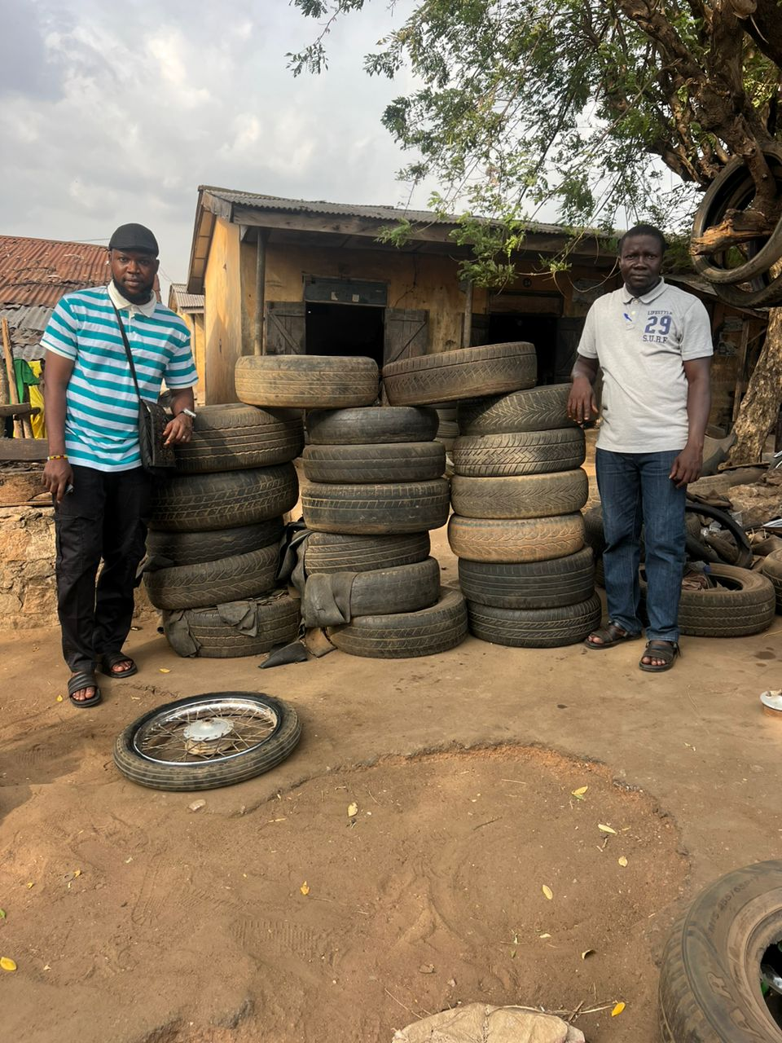

**Figure 1: Discarded waste tires**

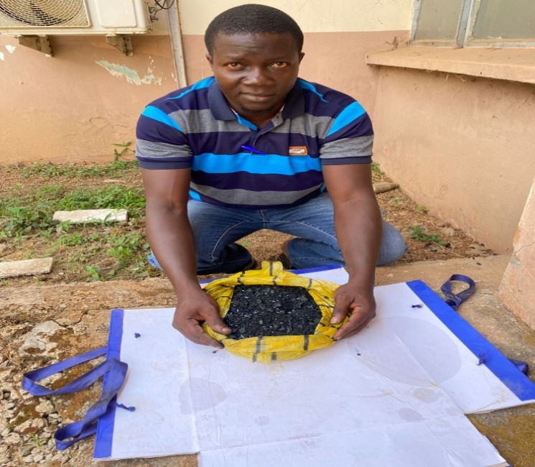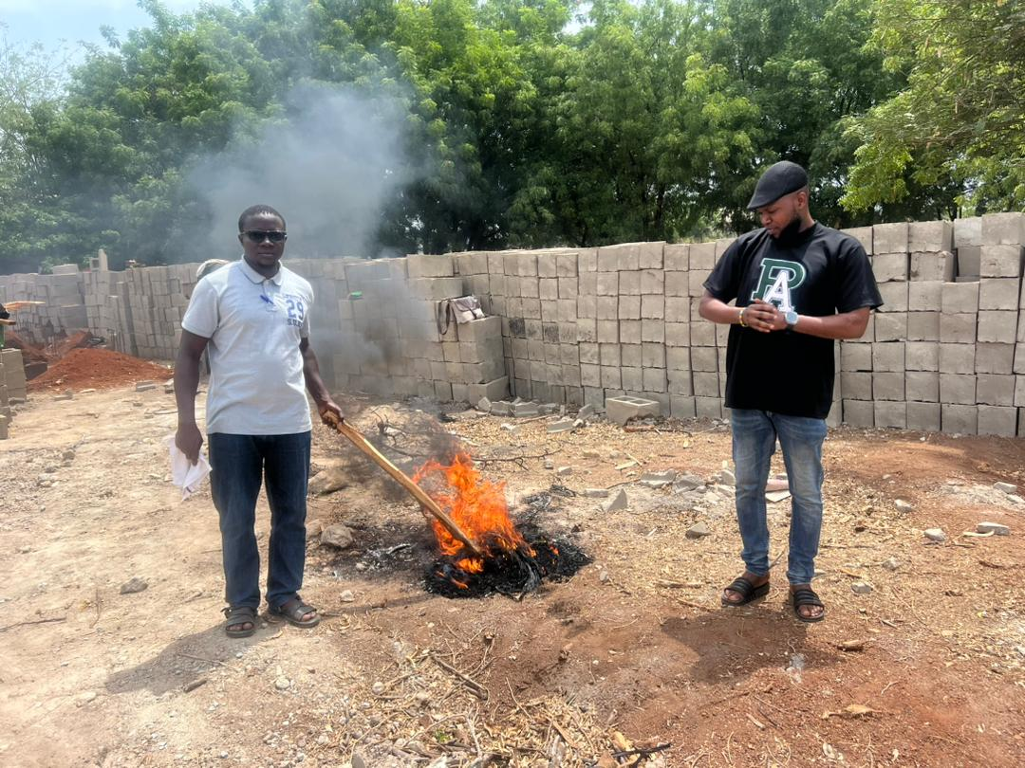

**2.3 Sieve Analysis**

**Figure 2a: Burning of Tires Figure 2b: Shredded burnt Tires.**

**2.3 Pozzolanic Reactivity Test of Crumb Tire Ash (CTA) Using Chappelle Method**

The pozzolanic reactivity of crumb tire ash (CTA) was evaluated using the Chappelle test, following the guidelines of NF P 18-513. This test is essential for determining the optimal calcination temperature of the crumb tire ash for its effective reactivity with cement.

For this test, two samples were used:

1. A blank sample, which contained 2 g of calcium oxide (CaO).
2. A pozzolanic mixture, which consisted of 2 g of CaO combined with 1 g of CTA.

The test was conducted at varying calcination temperatures, ranging from 400°C to 800°C at 100°C intervals, with additional temperatures at 850°C, 870°C, and 900°C.

Procedure

* Each sample was dissolved in 250 ml of distilled water inside a plastic Erlenmeyer flask.
* The samples were placed in a water bath at 85°C and continuously stirred for 16 hours.
* After the reaction period, the samples were cooled to room temperature, and a saccharose solution was added.
* The saccharose solution was freshly prepared by dissolving 60 g of saccharose in 250 ml of distilled water and stirring for 15 minutes.
* 75 ml of the combined sample mixture was filtered and divided into three equal portions before being titrated with 0.1M hydrochloric acid (HCl).

Pozzolanic Reactivity Calculation. The pozzolanic reactivity was determined using the formula:

$MgCaO=\frac{ 2(V1 – V2) x 74 x 1000}{V1 x 56}$………………. Equation 1

Where:

* MgCaO = Amount of calcium consumed by the pozzolanic material.
* V1 = Volume of HCl used to titrate the control mixture (CaO only).
* V2 = Volume of HCl used to titrate the pozzolanic mixture (CaO + CTA).

**2.4 Particle Size Distribution of Fine Aggregates**

This test was conducted to determine the gradation of the fine aggregate. The sample was first oven-dried for 24 hours and then weighed. Before use, all sieves were thoroughly cleaned. The sieves were arranged in a sieve shaker machine, with the largest sieve placed at the top. The machine was operated for five minutes to ensure proper separation of particles.

After sieving, the mass of material retained on each sieve was weighed and recorded. The cumulative weight retained on each sieve was used to calculate the fineness modulus (FM) by dividing the total cumulative weight by 100. A graph of percentage passing versus sieve size was plotted to analyze the gradation properties of the fine aggregate. The test was performed following BS 812: Part 103.1:1985.

**2.5 Mix Proportions**

The concrete mix for this study was designed using the same constituent materials as conventional concrete but with modified proportions to accommodate crumb tire ash (CTA) as a partial cement replacement. A trial mix was conducted to ensure a workable mix with acceptable strength. The table 1 below presents the trial mix proportions and final adopted mix design for this study.

**Table 1: Trial Mix Composition**

|  |  |  |  |
| --- | --- | --- | --- |
| S/No |  | Material | Proportion in kg/m3 |
| 1 |  | Cement | 450 |
| 2 |  | Fine Aggregate | 990 |
| 3 |  | Coarse Aggregate | 843 |
| 4 |  | Water | 170 |

**2.6 Batching and Mixing**

Concrete mixtures were prepared based on the adopted mix design for this research. The batching process followed a systematic approach to ensure uniform mixing and consistency in all samples.

**2.7 Slump flow Test**

To conduct the test, the slump cone and base plate were positioned on a clean, stable, and level surface, as shown in Figure 3. The cone was then filled with the fresh concrete mix without any agitation, and excess material was leveled off. The filled cone remained undisturbed for a maximum of 30 seconds to ensure stability. During this time, any spilled concrete was removed, and the base plate was evenly dampened without excess water.

Next, the cone was lifted vertically in a single motion, allowing the concrete to spread freely. For the T500 time measurement, a stopwatch was started the moment the cone was removed, and the time taken for the concrete to reach a 500 mm spread was recorded to the nearest 0.1 seconds. Without disturbing the concrete or base plate, the largest diameter of the spread was measured at right angles and recorded. A higher slump flow (SF) value indicates better flow ability and formwork-filling capacity. The test procedure followed the standard guidelines outlined in BS EN 12350-2.

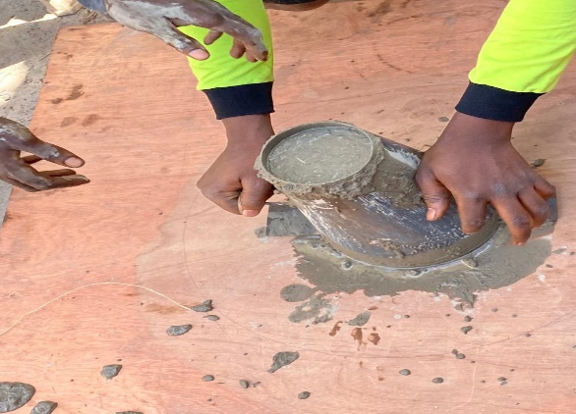

**Figure 3: Slump Flow Test**

**2.8 L-Box Test**

The L-box test evaluates the flowability and passing ability of the concrete mix, ensuring that it can move freely through reinforcements without segregation. This test was conducted following the EFNARC (2002) guidelines.

To perform the test, the L-box apparatus was placed on a stable, level surface, ensuring the sliding gate could open and close smoothly. The inner surfaces of the apparatus were moistened to prevent absorption, and any excess water was removed. The vertical section of the box was then filled with the fresh concrete mix and left undisturbed for about one minute. Afterward, the sliding gate was lifted, allowing the concrete to flow into the horizontal section. A stopwatch was started immediately when the gate was opened, and the time taken for the concrete to reach the 200 mm and 400 mm marks was recorded.

**2.9 Casting and Curing of Concrete**

Before casting, the concrete moulds were properly oiled to ensure easy removal of the hardened specimens. The fresh concrete mix was then poured into cube moulds (150 × 150 × 150 mm) and cylindrical moulds (150 mm diameter × 300 mm height). After casting, the specimens were left to set for 24 hours before being demoulded. Once removed from the moulds, they were immersed in water for curing at different ages of 7, 14, 21 and 28days to ensure proper hydration and strength development.

**2.10 Tests on Hardened Concrete**

Once the concrete has hardened, various tests are conducted to evaluate its mechanical properties and ensure it meets design specifications. The compressive strength test is the most commonly used method for assessing concrete's load-bearing capacity and is essential for quality control.

**2.11 Compressive Strength Test**

The compressive strength test was performed on 150 × 150 × 150 mm cube specimens after curing for 7, 21 and 28 days before testing, the compression testing machine was inspected to ensure proper calibration. The bearing surface of the machine was cleaned, and each concrete cube was placed with its smooth face in contact with the loading plate. The cube was carefully aligned with the center of the compression machine’s pressure plate to ensure uniform loading. A gradual load was applied until the specimen failed, and the ultimate load was recorded. The compressive strength (MPa) was calculated using the formula:

$Compressive Strength =\frac{Ultimate Load (N)}{Cross sectional area (mm2)}$………………. Equation 2

For each curing period, three specimens were tested, and the average strength was recorded. This test was performed following the procedures outlined in BS EN 12390-3:2019.

**2.12 Splitting Tensile Strength Test**

The splitting tensile strength test was conducted on cylindrical concrete specimens (150 mm × 300 mm) after 28 days of curing. This test evaluates the concrete’s tensile strength, which is crucial for understanding its resistance to cracking under tensile loads. Before testing, the loading and supporting rollers of the compression testing machine were cleaned to ensure accurate results. Two bearing strips of 3.175 mm thick plywood, free from defects, and measuring 25 mm wide with a length slightly exceeding that of the specimen were prepared.

**3.0 RESULTS AND DISCUSSION**

**3.1 Chemical Composition of Calcined Crumb Tire Ash (CTA)**

The chemical composition of calcined crumb tire ash (CTA) is a critical factor in determining its suitability as a pozzolanic material for partial cement replacement. The composition was analyzed using X-ray Fluorescence (XRF) spectroscopy, which identifies the major and minor oxides present in the ash. The primary oxides found in CTA include: Silicon Dioxide (SiO₂), Aluminum Oxide (Al₂O₃), Iron Oxide (Fe₂O₃), Calcium Oxide (CaO), Magnesium Oxide (MgO), Sulfur Oxide (SO₃), Zinc Oxide (ZnO), Potassium Oxide (K₂O) and Sodium Oxide (Na₂O)

The result of chemical composition of calcined kaolin when compared with that of the cement is presented in Table 2 below

**Table 2: Chemical Composition of Calcined Crumb Tire Ash**

|  |  |  |
| --- | --- | --- |
| Oxide | Content Cement | Calcined Crumb Tire (CTA) % |
| Al2O3 | 4.9 | 38.54 |
| SiO2 | 20.1 | 43.20 |
| TiO2 | 0.2 | 0.091 |
| K2O | 0.4 | - |
| CaO | 65 | 0.772 |
| Na2O | 0.2 | - |
| MgO | 3.1 | 0.027 |
| MnO | 0.02 | - |
| Fe2O3 | 2.5 | 0.083 |
| Loss on ignition | 8.8 | 12 |

**3.2 Pozzolanic Reactivity Results**

The pozzolanic reactivity test was conducted on crumb tire ash at different calcination temperatures of 400°C, 500°C, 600°C, 700°C, 800°C, 850°C, 870°C, and 900°C to evaluate its suitability as a pozzolanic material. The results in the figure 4 below showed that crumb tire ash calcined at 850°C exhibited the highest pozzolanic reactivity, with a fixation capacity of 1358 mg/g of Ca(OH)₂, confirming its potential as a cementitious replacement material in concrete applications.To evaluate the pozzolanic potential of calcined crumb tire ash (CTA), its oxide composition was compared with the ASTM C618 standard for pozzolanic materials. According to this standard, the combined percentage of silicon dioxide (SiO₂), aluminum oxide (Al₂O₃), and iron oxide (Fe₂O₃) must exceed 70% for a material to be considered pozzolanic.The chemical analysis of CTA showed the following oxide composition: Al₂O₃ = 38.54%, SiO₂ = 43.20%, Fe₂O₃ = 0.083%

The total sum of these oxides is 81.82%, which exceeds the 70% requirement of ASTM C618, confirming that CTA is suitable as a pozzolanic material for partial cement replacement.

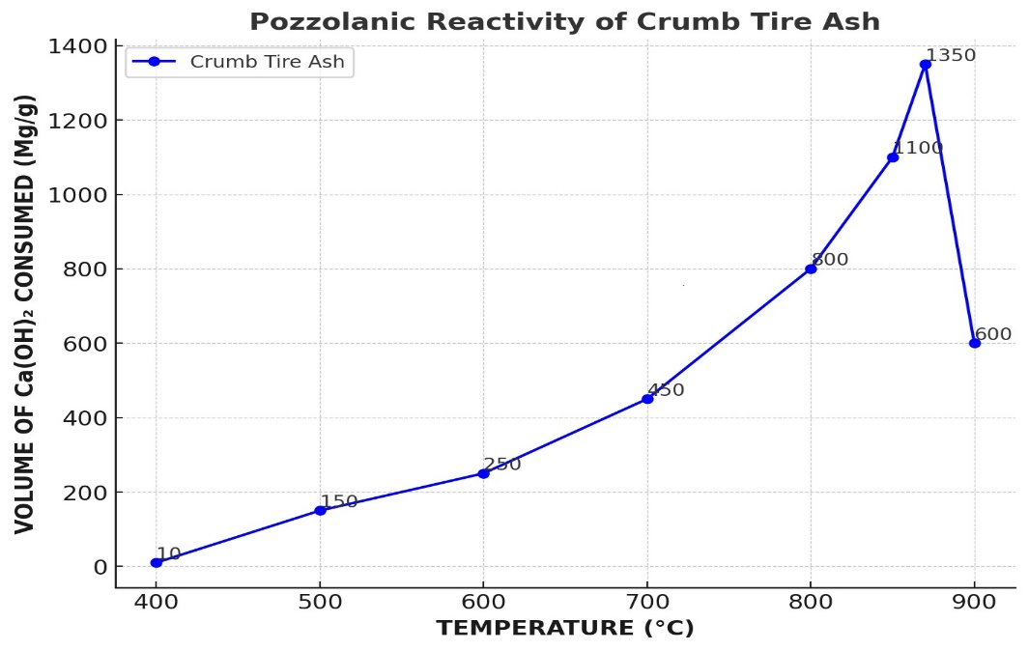

**Figure 4: Pozzolanic reactivity (Chappelle’s test) for Crumb Tire Ash (CTA)**

**3.3** **Particle Size Distribution of Fine Aggregates**

The particle size distribution curves are shown in Figure 5 below. From the obtained results, the fineness modulus of sand was 2.57. This falls within the acceptable range for producing self-compacting concrete (SCC), as recommended by Zheng et al. (2024) confirming its suitability.

Additionally, the coefficients of uniformity (Cu) and curvature (Cc) were 1.45 and 0.96 for sand, while for coarse aggregate, they were 1.2 and 1.1, respectively, as shown in figure 5. These values indicate that all aggregates used in this study were uniformly graded since their Cu values are below 4, as specified by ASTM D2487 (2022).

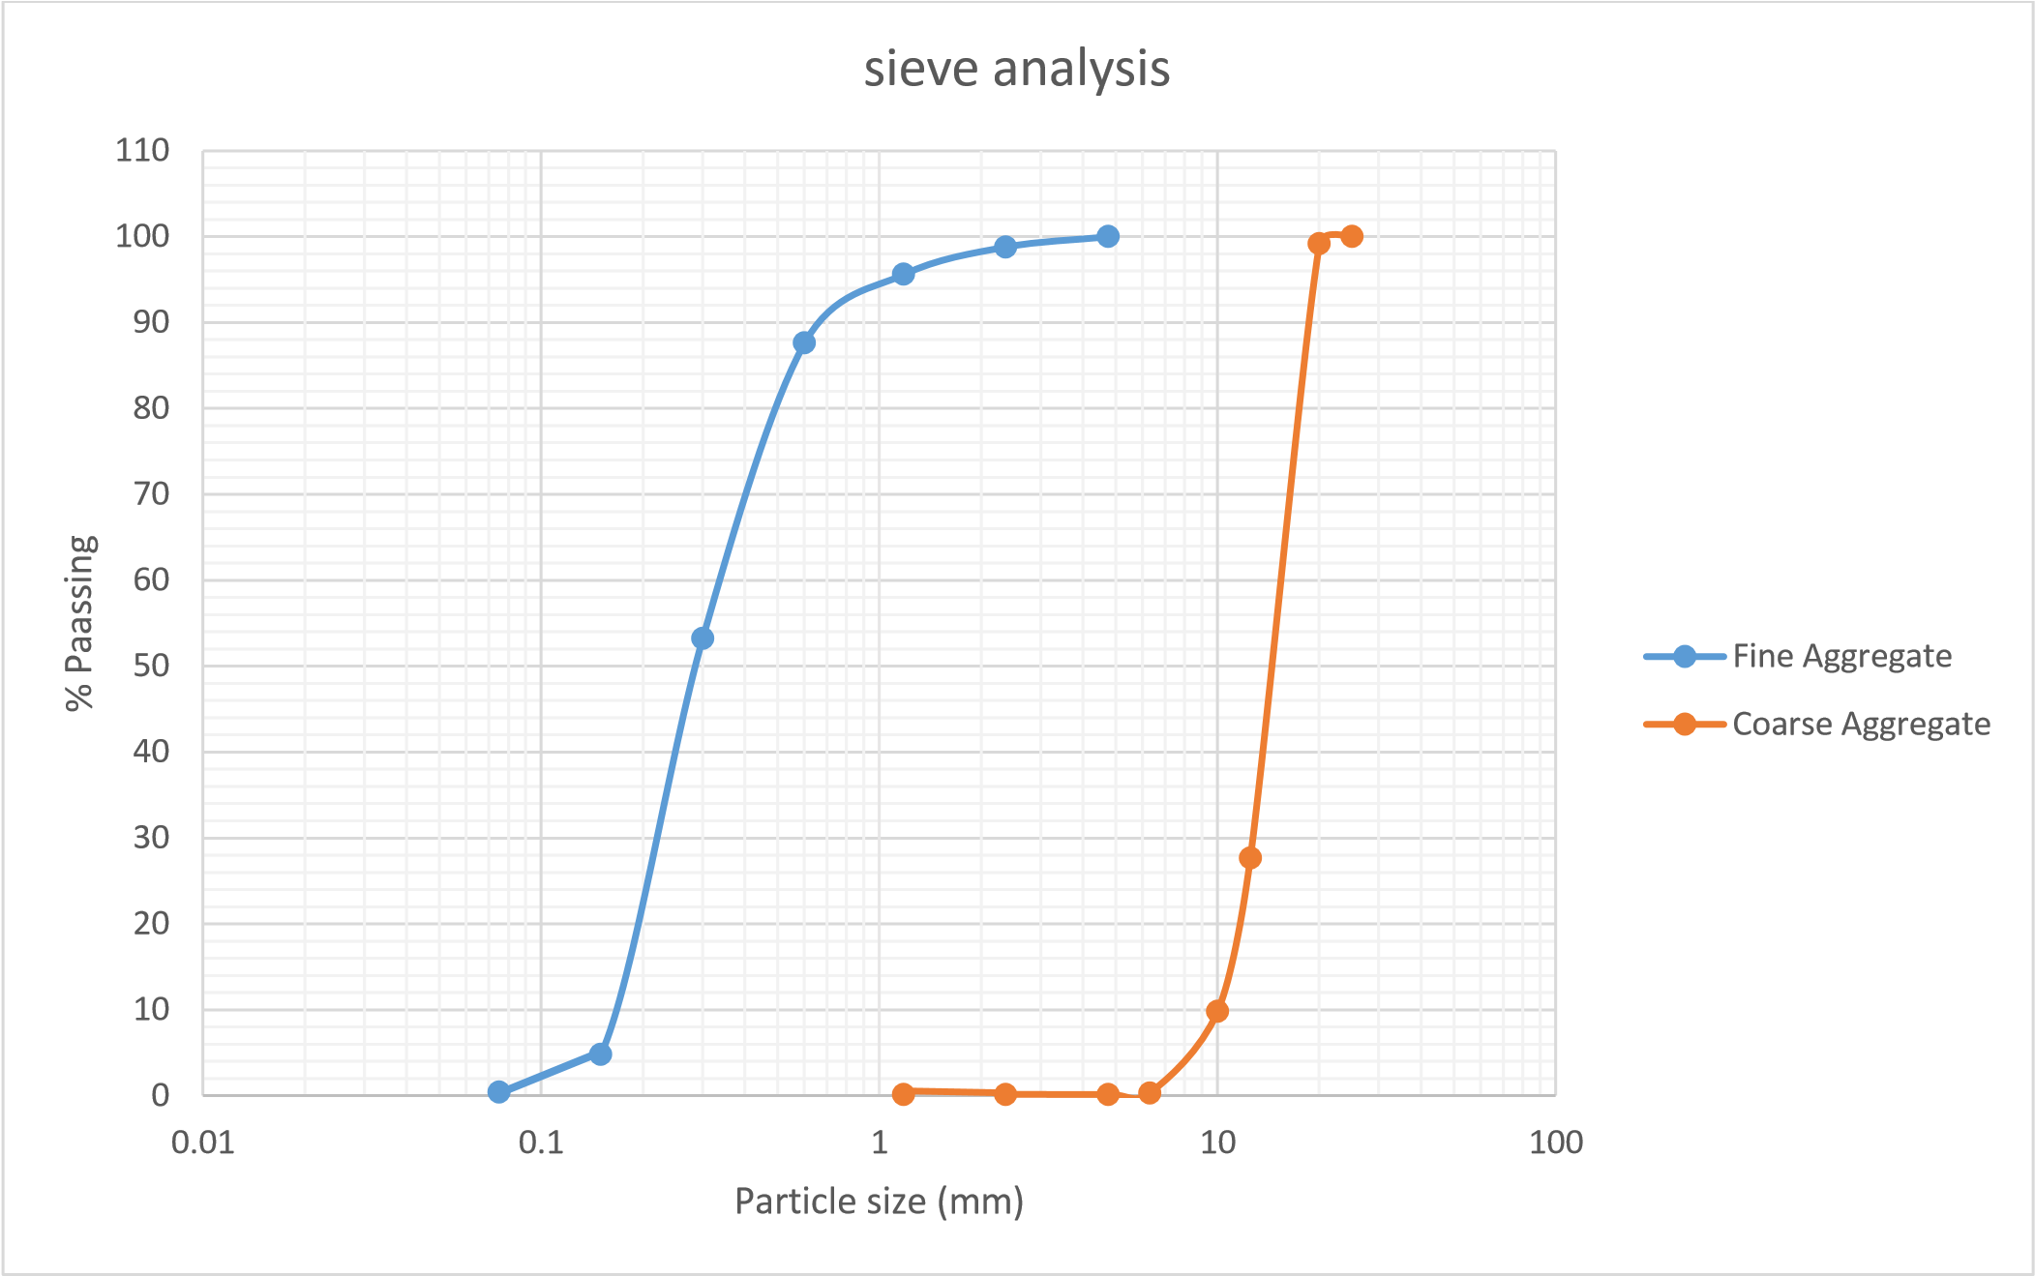

**Figure 5: Particle size Distribution Curve for Aggregates**

**3.4 Slump flow**

The results of the slump flow at varying proportions of crumb tire ash (CTA) as a partial cement substitute in concrete are presented in Table 3. From the table, it was observed that as the percentage of CTA increased, there was a reduction in slump flow diameter along with an increase in flow time. This indicates that the flowability of the concrete decreased with higher CTA dosage. However, the slump flow diameters remained within the range of 653–684 mm, demonstrating that the concrete mix conformed to the specification range (660–750 mm for class SLF2) outlined by BS EN 206-9 (2010) and EFNARC (2002).

|  |  |  |  |  |
| --- | --- | --- | --- | --- |
| Mixes | Slump flow for SCC | | | |
|  | Dia(mm) |  |  | T50(Sec) |
| CTA 0% | 684 |  |  | 3.7 |
| CTA 5% | 677 |  |  | 3.43 |
| CTA 10% | 661 |  |  | 4.78 |
| CTA 15% | 654 |  |  | 4.92 |

**Table 3: Slump flow results**

**3.5 L- Box test results for CTA**

The results for the different concrete mixes are presented in Table 4. The data indicate that all mixes met the requirements for Passing Ability Class 2 (PL2), as the values exceeded 0.8 with 3 rebars, in accordance with BS EN 206-9 (2010). This confirms that the concrete containing crumb tire ash (CTA) exhibited sufficient passing ability to flow through dense reinforcement without blockage.

**Table 4: L-Box test results**

| **Mixes** | **L-Box h₂/h₁ (mm) (SCC)** |
| --- | --- |
| CTA 0% | 0.90 |
| CTA 5% | 0.87 |
| CTA 10% | 0.83 |
| CTA 15% | 0.81 |

**3.6 Compressive Strength Test Results**

The results of the compressive strength tests conducted on the concrete with crumb tire ash (CTA) are presented in Tables 5, 6 and 7. From the results obtained, the compressive strength of CTA-modified concrete ranged from 11.04–12.67 N/mm², 15.59–17.07 N/mm², and 21.18–21.57 N/mm² at 7, 21, and 28 days, respectively. Generally, the strength increased with curing age for all the prepared mixes. The specific compressive strength values for CTA-modified concrete at different replacement levels were:

* 0% CTA: 11.04 N/mm² (7 days), 15.09 N/mm² (21 days), and 21.18 N/mm² (28 days).
* 5% CTA: 11.47 N/mm² (7 days), 16.03 N/mm² (21 days), and 21.33 N/mm² (28 days).
* 10% CTA: 12.67 N/mm² (7 days), 17.07 N/mm² (21 days), and 21.57 N/mm² (28 days).
* 15% CTA: 12.46 N/mm² (7 days), 16.63 N/mm² (21 days), and 20.04 N/mm² (28 days).

The percentage variation in compressive strength of CTA-modified concrete compared to the control mix (0% CTA) was:

* 7 days: +3.8% (5% CTA), +5.2% (10% CTA), +3.5% (15% CTA).
* 21 days: +2.7% (5% CTA), +8.9% (10% CTA), +6.3% (15% CTA).
* 28 days: -0.7% (5% CTA), +2.7% (10% CTA), -2.0% (15% CTA)1

These results indicate that 10% CTA replacement produced better compressive strength than other replacement levels (5% and 15%) across all curing ages. However, mixes with CTA beyond 10% exhibited lower strength compared to the control mix (0% CTA) at all ages. This study contrasts with previous research (Onyechere, 2022) that reported a decrease in strength with increasing saw dust ash content. The difference in findings may be attributed to the non-calcination of saw dust ash in previous studies and the lack of reactivity testing to determine the optimum calcination temperature before use. However, this study aligns with (Oba et al., 2020) who found that 10% replacement of cement with saw dust ash improved strength properties.

**Table 5: 7-Days Compressive Strength of Concrete with CTA**

| **Mix ID** | **Sample** | **Weight (Kg)** | **Density (Kg/m³)** | **Crushing Load (KN)** | **Compressive Strength (N/mm²)** | **Average Strength (N/mm²)** |
| --- | --- | --- | --- | --- | --- | --- |
| **CTA 0%** | 1 | 7.0 | 2074 | 265 | 10.8 | **11.04** |
|  | 2 | 7.2 | 2133 | 275.4 | 11.24 |  |
|  | 3 | 7.7 | 2281 | 271.8 | 11.08 |  |
| **CTA 5%** | 1 | 8.1 | 2162 | 285.5 | 11.69 | **11.47** |
|  | 2 | 7.2 | 2400 | 279 | 11.4 |  |
|  | 3 | 8.0 | 2133 | 277 | 11.31 |  |
| **CTA 10%** | 1 | 8.0 | 2370 | 280.2 | 12.45 | **12.67** |
|  | 2 | 7.7 | 2301 | 289.58 | 12.87 |  |
|  | 3 | 7.6 | 2370 | 285.5 | 12.69 |  |
| **CTA 15%** | 1 | 7.9 | 2281 | 281.93 | 12.53 | **12.46** |
|  | 2 | 8.0 | 2251 | 281.03 | 12.49 |  |
|  | 3 | 7.5 | 2300 | 278.10 | 12.36 |  |

**Table 6: 21-Days Compressive Strength of Concrete with CTA**

| **Mix ID** | **Sample** | **Weight (Kg)** | **Density (Kg/m³)** | **Crushing Load (KN)** | **Compressive Strength (N/mm²)** | **Average Strength (N/mm²)** |
| --- | --- | --- | --- | --- | --- | --- |
| **CTA 0%** | 1 | 7.6 | 2252 | 380 | 15.89 | **15.59** |
|  | 2 | 7.9 | 2340 | 370 | 15.44 |  |
|  | 3 | 7.8 | 2311 | 370 | 15.44 |  |
| **CTA 5%** | 1 | 7.6 | 2252 | 390 | 16.33 | **16.03** |
|  | 2 | 7.9 | 2340 | 380 | 15.44 |  |
|  | 3 | 8.1 | 2400 | 390 | 16.33 |  |
| **CTA 10%** | 1 | 7.8 | 2311 | 410 | 17.22 | **17.07** |
|  | 2 | 8.1 | 2400 | 410 | 17.22 |  |
|  | 3 | 7.8 | 2311 | 400 | 16.78 |  |
| **CTA 15%** | 1 | 8.3 | 2459 | 390 | 16.33 | **16.63** |
|  | 2 | 7.7 | 2281 | 400 | 16.78 |  |
|  | 3 | 7.9 | 2341 | 400 | 16.78 |  |

**Table 7: 28-Days Compressive Strength of Concrete with CTA**

| **Mix ID** | **Sample** | **Weight (Kg)** | **Density (Kg/m³)** | **Crushing Load (KN)** | **Compressive Strength (N/mm²)** | **Average Strength (N/mm²)** |
| --- | --- | --- | --- | --- | --- | --- |
| **CTA 0%** | 1 | 8.2 | 2430 | 490 | 20.78 | **21.18** |
|  | 2 | 7.6 | 2311 | 490 | 21.78 |  |
|  | 3 | 8.1 | 2400 | 470 | 19.89 |  |
| **CTA 5%** | 1 | 8.2 | 2430 | 470 | 19.89 | **20.63** |
|  | 2 | 7.9 | 2341 | 480 | 20.33 |  |
|  | 3 | 8.3 | 2459 | 490 | 21.78 |  |
| **CTA 10%** | 1 | 8.1 | 2400 | 500 | 21.22 | **21.57** |
|  | 2 | 7.9 | 2341 | 490 | 20.78 |  |
|  | 3 | 8.1 | 2400 | 500 | 22.22 |  |
| **CTA 15%** | 1 | 8.2 | 2430 | 480 | 20.33 | **20.64** |
|  | 2 | 8.0 | 2370 | 470 | 19.89 |  |
|  | 3 | 7.9 | 2380 | 470 | 21.89 |  |

**3.7 Splits Tensile Strength Results**

The results of the split tensile strength test obtained at 28 days are displayed in Tables 8, the split tensile strength for CTA-modified concrete at different replacement levels was:

* 28 days: 22.98N/mm² (0% CTA), 22.83 N/mm² (5% CTA), 23.57 N/mm² (10% CTA), 22.54 N/mm² (15% CTA).

From the results, the split tensile strength of the concrete increased with curing age, and mixes containing CTA performed better than the control (0% CTA) at all ages. The 10% CTA mix consistently produced the highest tensile strength, reinforcing its suitability for improving tensile performance in self-compacting concrete.

The improvement in strength of SCC incorporating 10% CTA was 3.9% at 28 days compared to the control mix.

These findings align with the study by Oba et al., (2020) which reported that 10% SDA replacement resulted in improved split tensile strength.

**Table 8: 28 Days Split Tensile Strength**

| **Mix ID** | **Sample** | **Weight (Kg)** | **Density (Kg/m³)** | **Crushing Load (KN)** | **Split Tensile Strength (N/mm²)** |
| --- | --- | --- | --- | --- | --- |
| **CTA 0%** | 1 | 8.2 | 2430 | 490 | 23.28 |
|  | 2 | 7.6 | 2311 | 490 | 23.28 |
|  | 3 | 8.1 | 2400 | 470 | 22.39 |
| **Average** |  |  | **2380** |  | **22.98** |
| **CTA 5%** | 1 | 8.2 | 2430 | 470 | 22.39 |
|  | 2 | 7.9 | 2341 | 480 | 22.83 |
|  | 3 | 8.3 | 2459 | 490 | 23.28 |
| **Average** |  |  | **2410** |  | **22.83** |
| **CTA 10%** | 1 | 8.1 | 2400 | 500 | 23.72 |
|  | 2 | 7.9 | 2341 | 490 | 23.28 |
|  | 3 | 8.1 | 2400 | 500 | 23.72 |
| **Average** |  |  | **2380** |  | **23.57** |
| **CTA 15%** | 1 | 8.2 | 2430 | 480 | 22.83 |
|  | 2 | 8.0 | 2370 | 470 | 22.39 |
|  | 3 | 7.9 | 2380 | 470 | 22.39 |
| **Average** |  |  | **2393** |  | **22.54** |

**4.0 Conclusions**

Based on the laboratory results, Cement-Tire Ash (CTA) showed optimum pozzolanic activity at 850°C, with 10% replacement yielding the best strength performance—improving compressive and tensile strength across all curing ages. While fresh concrete met standard workability, higher CTA levels reduced flow properties. Concrete density increased with curing age and CTA content but remained within normal ranges.

**Disclaimer (Artificial intelligence)**

Authors hereby declare that NO generative AI technologies such as Large Language Models (ChatGPT, COPILOT, etc.) and text-to-image generators have been used during the writing or editing of this manuscript.

**REFERENCES**

ACI Committee 325. (2016). *Guide for Construction of Concrete Pavements* (ACI 325.9R-15). American Concrete Institute.

Adeyokunnu A.T and Oyelami A.K. (2024) Rheological Study on Strength Characteristics of Concrete Partially Replaced with Calcined Kaolin in Concrete Production*, International journal of Advances in Engineering and Management, volume 6, issue 11. page 438-444*

Agunwamba, J. C., and Adagba, T. (2021). A comparative analysis of the rebound hammer and ultrasonic pulse velocity in testing concrete. *Nigerian Journal of Technology*, *40*(2), 234-240.

American Association of State Highway and Transportation Officials. (2013). *AASHTO LRFD Bridge Design Specifications* (6th ed.). Washington, D.C.: AASHTO.

Avcular, N., and Aköz, F. (2023). *Fresh and hardened properties of waste rubber tires based concrete*. SN Applied Sciences, 5(1), 123–135.

British Standards Institution (BSI). (2011). *BS EN 197-1: Cement – Part 1: Composition, specifications and conformity criteria for common cements.* BSI Standards Publication.

British Standards Institution (BSI). (2013). *BS EN 12620:2013 – Aggregates for concrete.* BSI Standards Publication.

British Standards Institution. (2021). *BS 1881-124:2015+A1:2021 Testing concrete—Methods for analysis of hardened concrete*. BSI Standards Limited.

Domone, P., and Illston, J. (Eds.). (2010). *Construction Materials: Their Nature and Behaviour* (4th ed.). CRC Press. ISBN: 978-0-415-46516-8.

European Committee for Standardization (CEN). (2010). *Testing fresh concrete – Part 2: Slump test (EN 12350-2:2010).* CEN.

European Federation for Specialist Construction Chemicals and Concrete Systems (EFNARC). (2005). *Specification and guidelines for self-compacting concrete*. EFNARC.

Junior, J. K. Q., Kankam, C. K., Dzivenu, C. K., & Akortia, V. K. (2022). Strength Characteristics of Concrete Partially Replaced with Glass Powder and Palm Kernel Shells. Journal of Engineering Research and Reports, 23(12), 24–38. <https://doi.org/10.9734/jerr/2022/v23i12760>

Kumari, K. S., and Jaysawal, D. (2024). *Crumb rubber as a sustainable construction material*. International Journal of Current Innovations in Interdisciplinary Scientific Studies, 8(1), 15–21.

Oba, K. M., Ugwu, O. O., and Okafor, F. O. (2020). Predicting the split tensile strength of Saw Dust Ash - Fine aggregate concrete. *Nigerian Journal of Technology, 39*(1). https://doi.org/10.4314/njt.v39i1.9

Okafor, C., Ajaero, C., Madu, C., Agomuo, K., and Abu, E. (2020). *Implementation of circular economy principles in management of end-of-life tyres in a developing country (Nigeria).* AIMS Environmental Science, 7(5), 406–433. <https://doi.org/10.3934/environsci.2020027>

Olaniyi O. A, Abraham. B, Adeyemi, F. O and Oyelami, A. K (2025) Compressive Behaviour of Tyre Fibre in Light Weight Concrete using Higher Grade of Cement. *Journal of Engineering Research and Reports, volume 27, issue 5. page 100-109*

Olaniyi O. A, Adewuyi. A.P, Adeyemi, F. O and Oyelami, A. K (2025) Mechanical and Microstructural Properties of Steel Reinforcing Bars Produced from Different Manufacturing Industries as Available in Nigeria Market. *Engineering and Technology Journal, volume 10, issue 5. page 4977-4985*

Olaniyi O.A., Oyelami A.K and Adeyemi F.O (2025) Assessment of crumb rubber as a partial substitute with quarry dust for the production interlocking paving stone*, World Journal of Advanced Engineering Technology and Sciences, volume 15, issue 2. page 231-239*

Onuaguluchi, O., and Banthia, N. (2019). Sustainability of self-consolidating concrete containing crumb rubber. *Journal of Sustainable Cement-Based Materials, 8*(1), 42–57. https://doi.org/10.1080/21650373.2019.1587859

Oyelami A.K and Olaniyi O.A (2025) Strength Characteristics of Concrete Produce with Partial Replacement of Cement with Calcined Halloysite*, Journal of Scientific and Engineering Research, volume 12, issue 4. page 133-139*

Oyelami A.K and Olaniyi O.A (2025) Strength properties of self-compacting concrete (scc) produced with opepe saw dust ash (sda) addictive. *International journal of Advances in Engineering and Management, volume 7, issue 4. page 1167-1177*

Xu, J., Yao, Z., Yang, G., and Han, Q. (2020). *Research on crumb rubber concrete: From a multi-scale review.* Construction and Building Materials, 232, 117282. <https://doi.org/10.1016/j.conbuildmat.2019.117282>

Yaroslavov, A. A., Panova, I. G., Arzhakov, M. S., and Khokhlov, A. R. (2022). *Interpolymer complexes and problem of polymer waste management.* Russian Journal of Applied Chemistry, 95(4), 472–485. <https://doi.org/10.1134/S1070427222040024>.