**Enhancing Value and Agricultural Use of Shiitake Mushroom Byproducts: Investigating Biodegradable Active Compounds**

**ABSTRACT:**

The edible fungus Shiitake mushroom the most significant edible fungi that has been *Lentinus edodes* is one of extensively cultivated globally and retains very high economic value as well as nutritional value and continues to maintain particular significance in Asia such as Japan, China and Korea because Shiitake mushrooms have been used as an the ingredient in food and medicine for centuries. China produces the 22% of world's mushroom production, and most mushrooms are produced in the world. Shiitake is gaining popularity in India and its post-market is also growing due to its high-value nutrient content and health benefits. Enormous cultivation methodology such as by-products are generated through mushroom spent mushroom substrate (SMS) and stipes along with non-commercial mushrooms. Each kilogram of fungi produces 5kg of waste stream, and this waste stream is hemicellulose and lignin. Edible mushroom production rich in cellulose, generates by-product materials that includes polysaccharides, proteins, and and immunomodulatory bioactive substances. SMS is antimicrobial, antioxidant the key for sustainable mushroom cultivation. When SMS is integrated into nutritional waste supplements by the food industry and thereby provides a valuable management system. Spent mushroom substrate (SMS) has a mixture of organic and inorganic matter, which is used to produce biogas and biochar products that enhance soil quality and sequester atmospheric carbon dioxide. Shiittake Mushroom Waste Materials their Characteristics, Storage, nutrition and Its Different Sustainable Utility explores how Shiitake mushroom waste may be used in a variety of agricultural and mechanical applications while maintaining its environmental benefits as a waste management and recovery material.

**Key words:** Shiitake mushroom, mushroom cultivation, waste materials, SMS.

1. **Introduction:**

*L. edodes* often known as shiitake mushroom is the most popular edible macrofungus in the Basidiomycota family that grows naturally in dead wood of broad-leaved trees (Gaitan et al., 2019). Shiitake is one of the most significant edible mushrooms in the world in terms of production, as well as one of the most popular fungi grown (Chang et al., 2017). *L. edodes*, also known as the flower mushroom, Shiitake, winter mushroom, golden oak mushroom, emperor mushroom, and Chinese black mushroom (Ponnusamy et al., 2022). In Japan, *L. edodes* has been traditionally used in folk medicine to treat several diseases and disorders, including fever, tumors, high blood pressure, cardiovascular problems, obesity, sexual dysfunction, aging, respiratory ailments, and diabetes. Shiitake is a Japanese term derived from” shii” the common name of the *Castanopsis cuspidata* tree, whose wood is used to cultivate the species (Wasser and Weis 1999). *L. edodes* thrives on decaying deciduous trees, including *Castanopsis cuspidata, Aesculus, Quercus, Acer, Fagus, Eucalyptus, Populus, Carpinus*, and *Morus.spp* grows abundantly in Southeast Asia's warm, humid conditions (Casaril et al., 2011). These mushrooms have been utilized as food and medicine in East Asian countries such as China, Korea, and Japan for millennia. Shiitake mushrooms are popular due to their interesting nutritional profile and can be found in either raw or dried form. Shiitake mushrooms' alluring scent, distinctive culinary qualities, and rough texture are making them more and more well-liked by local customers. Depending on the consumer's preference, shiitake can be eaten fresh or dried (Sud et al., 2024) Strong antibacterial and antifungal properties have been demonstrated by several shiitake extracts. Due to its medicinal value, flavoring agents, bio-active compounds Shiitake mushroom is gaining popularity worldwide among consumers.

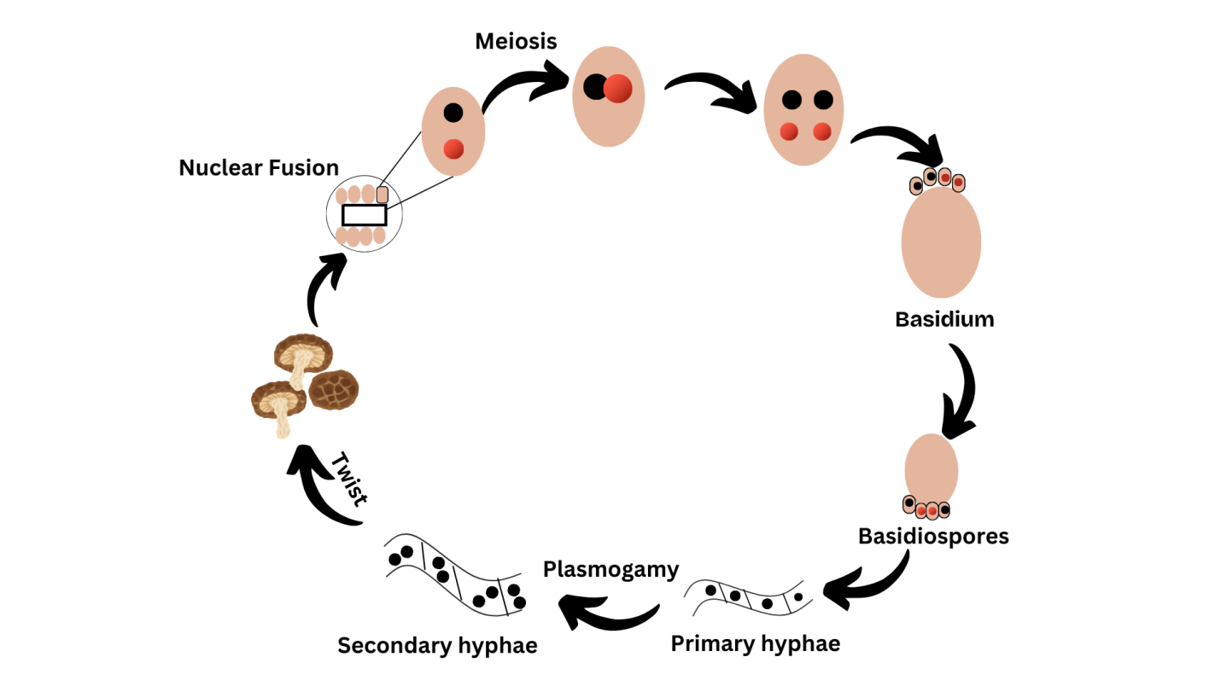  
**Fig.1. Life cycle of Shiitake Mushroom**

* 1. **Global Market:**

Particularly since the middle of the 1990s, the amount of mushrooms produced and consumed worldwide has grown rapidly. Along with the growth in the global population, there has also been a rise in the amount of mushrooms consumed per person. Five primary genera provide approx. 85% of the world’s, mushroom supply in which *L. edodes* contributes 17%. Japan was the world's largest producer of *L. edodes* until the late 1980s, China emerged as the primary shiitake producer by 1990 (Royse, 2014). China now produces more than 90% of the world's shiitake, with an estimated 4 million tons produced in 2012. Growing shiitake has given entire towns in China economic opportunities that have pulled them out of poverty. In 2009, Japan produced 101,392 t of *L. edodes* (based on fresh *L. edodes* and dried *L. edodes* adjusted to fresh weight), ranking third with 22% of all edible mushroom output (Royse, 2014) FAOSTAT data shows that Asia, Europe, and the Americas are responsible for 99% of global mushroom production. This also makes up 76% of total, with Asia leading the pack. China and Japan have always been the lead mushroom nations in Asia  (FAOSTAT). In 1970, these two nations accounted for 98% of Asia's total mushroom output. In 2016, China and Japan collectively provided 96% of the production (FAOSTAT) (Singh et al., 2018). China is by far the biggest producer of farmed, edible mushrooms.Japan's share was and has now declined from 15% to merely 1% of the mushroom production in Asia (FAOSTAT data for 1970-2016). Mushroom production has grown in a number of Asian countries, including Taiwan, Vietnam, Korea, Indonesia, and India. *L. edodes* is grown commercially in approximately 80 countries, including Japan, South Korea, Taiwan, China, and others. Production data of (8983, 9865, 10432 thousand tones Up to year 2016-18) were taken from Chinese Edible Fungi Association (CEFA) (Singh et al., 2021) shiitake are on the inroads on Europe, America, Canada and Australia. Shiitake mushrooms (26%) Button (11%) Flammulina (7%) paddy straw mushroom (1%) oyster mushroom (21%) black earmushroom (21%) eight kinds of mushroom (13%) six kinds of mushrooms in the world's production and sale between the 6 kinds of mushrooms.

* 1. **Indian Market:**

In India, where the mushroom industry is primarily centered on white button mushrooms, shiitake mushrooms are gaining popularity. The total mushroom production in India stands at only 0.13 million tons (Sharma et al., 2017). Shiitake, also known as golden oak mushroom, is the most widely consumed edible fungus globally and is extensively cultivated in India due to its unique flavor and nutritional benefits (Singh et al., 2021). Recent figures show shiitakes account for more than 1 percent of all mushrooms produced in the country. In some areas of North East states, the cultivation of shiitake mushrooms has turned out to be a major income source, and even have proved to be a good livelihood in the Himalayan region (Sharma et al., 2020). The short duration cultivation technology of shiitake under indoor conditions was standardized at ICAR-DMR, Solan (Sharma et al., 2017), but still this valued mushroom has so far not been exploited at commercial scale in India. Few of the growers in Uttharakhand and Himachal Pradesh successfully cultivated the shiitake mushroom using the technology developed by ICAR-DMR, Solan (Sharma et al., 2017). Nonetheless, Taiwanese and Chinese-imported dried mushrooms are controlling the marketplace.Urban consumers are increasingly seeking mushrooms for their high protein content and health benefits, says a 2020 study by the Federation of Indian Chambers of Commerce and Industry. Shiitake mushrooms, in particular, are praised for their antioxidants and immune-boosting properties.

1. **By-products of shiitake mushrooms**:

The mushroom production process generates a lot of by-products that negatively affect the environment while also increasing the production cost for the industry. By-products include such as spent mushroom substrate (SMS), caps, and stipes, and mushrooms that are not commercially sized, shaped, or calipered. SMS consists of residual lignocellulosic substrates,  and extragenic enzymes secreted by mushrooms for constituent decomposition fungi- produce mycelium (Antunes et al., 2020). Shiitake mushrooms may degrade substrates and release elements. Harvesting reduces carbon percentage and C: N ratio, while increasing nitrogen, phosphorous, and potassium levels. This substrate can be used to produce several types of mushrooms, soil fertilizer, or to grow plants with soil (Abdullah et al., 2022). Leftover wastes are often neglected without any prior treatment and are recklessly dumped. Holo-cellulose in spent mushroom substrate is plentiful, as shiitake mushrooms usually consume Starting substrates range from 15% the hemicellulose, cellulose, and lignin contents to 56% and 23%, respectively. Researchers have suggested the use of SMS to produce biofuels especially biogas as SMS is rich in carbohydrates and protein (Kumar et al., 2020). Shiitake mycelium is 25-30% protein, Shiitake mycelium has linoleic acid; an essential fatty acid. Typically, the substrate composition for shiitake grows is 80% hardwood sawdust and 20% additive mixture (Atila et al., 2019). Among fresh shiitake mushrooms, gills contain the most ergosterol, followed by cap, and stalk, with ergosterol in the gills being approximately double that of the cap. Under UV-B irradiation, the gills produce more vitamin D2 as well—four times the amount of the cap, 22.8 μg/g DM in the gills versus 5.2 μg/g DM in the cap (Cardwell et al., 2018). Nutrition results indicate that the stipes of shiitake fungi (which are the stems left after the process has been completed) have a good nutritional content. This stipes is rich in fiber (82.94 g/kg) and carbohydrates (439.56 g/kg) and can be indicated in functional foods. This shows that the plant material has high fiber rates, and carbohydrates can be used to increase the nutritional value of food products in foods (Li et al., 2018). L. edodes' mycelia had a low mannitol content (about 1% in dry mass), while the fruiting body had 20–30% in the pileus and stripes (Tan and Moore, 1994). The shiitake stipes was rich in widely studied bioactive compounds with strong antioxidant activity. SMS primarily consists of fiber, including remnants of cellulose, lignin and hemicelluloses that make up the plant cell walls along with the leftover fungal mycelium. It also consists of minerals, proteins, and carbohydrates that are not a part of the cell wall. Shiitake byproducts are rich in organic content, which makes them suitable for anaerobic digestion and biogas production. This process is a great way to generate energy from waste, therefore reducing waste and producing renewable energy.

1. **Agriculture and industry use of Byproducts**:

Mushroom culture is a potential way to transform vast amounts of ligno-cellulosic waste into a variety of edible products or functional food products, contributing to environmental conservation and restoration. Moreover, mushroom farming can foster equitable economic growth, as seen already benefiting communities, countries, and regions. Edible mushrooms are the easiest and cheapest class of mushrooms to grow commercially, as they are renowned for their ability to synthesize agricultural waste into edible food protein s.The considerable amount of nitrates in SMS could leach into the environment, causing surface and underground water contamination. This alarming situation led the European Union (EU) to implement the “Nitrate Directive” back in 1991 to protect this essential life resource. (EEA, 2022). The shiitake mushroom *L. edodes* mushroom industry produces a vast number of spent mushroom substrate (SMS), which is thought of as a solid waste generated that requires appropriate management. Reincorporating SMS into new mushroom crops with nutritional supplements is one of the proposed ways of applying it  (Carrasco et al., 2018). Mushrooms can produce numerous hydrolytic and oxidative enzymes. The reuse of spent mushroom substrate (SMS) used in one cycle of mushroom cultivation in the subsequent cycles rests on the different enzyme activities of different species of mushrooms, thus reiterating the importance of their order of introduction. After the production of Shitake mushroom, the substrate has been reused, sterilized and used, in the cultivation of *P. ostreatus, P. eryngii and Grifola frondosa* (Stamets et al., 2016). Provitamin D2 ergosterol determination in *L. edodes* SMS shows 151.6 mg/100 g (Wang et al., 2018). It has a high nutritional value that is preferred in the meals of monogastric animals, ruminants, poultry, fish and edible insects. Likewise, weaned pigs have improved intestinal barriers, immunity, and gut bacterial diversity when provided *L. edodes* SMS. (Qi and Peng et al., 2020). During the cultivation of edible mushrooms, the mycelium of white-rot fungus secretes active enzymes that perform continuous lignin degradation on the substrate, which can result in an increased content of nutritious elements such as crude protein and improve the in vivo dry matter digestibility (IVDMD) of lignocellulosic materials (Leong et al.,2022). The Micoshelf (MS) application of *L. edodes as* SMS-based biocontrol agents shown excellent positive effects through using this fungus to facilitates major changes in plant growth and significantly decrease of symptoms of some diseases affecting plants. A polysaccharide extracted from *P. ostreatus* and *L. edodes* wastes can effectively reduces the severity of bacterial spot. *Xanthomonas gardneri* in tomatoes by 50% (Martin et al., 2023). Spent mushroom substrate (SMS) from shiitake cultivation, abundant in organic and inorganic matter, is a promising feedstock for biogas production. The highest biogas (8834 mL, 61% methane) was produced from 50:50 SMS and cow dung mix and it resulted in maximum reduction of slurry parameters after 21 days. The resultant digestate also enhanced the soil nutrient content which benefitted tomato cultivation (Kumar et al., 2022). Due to its unique properties, the lignocellulosic structure, rich nutrients, and organic matter (40-45%) content make spent mushroom substrate (SMS) an ideal candidate for biochar biochar manufacture. The use of biochar derived from SMS as a soil additive increases soil fertility, promotes water retention, supports beneficial microorganisms, and facilitates carbon sequestration, making it a sustainable alternative to improve agricultural systems and combat climate change (Aiduang et al., 2025) Bioactive compounds from SMS have great potential for utilization in several sectors, including pharmaceuticals, biomedicine, animal feed, and the food industry. Using these molecules opens up new dimensions of product performance and safety in these industries.

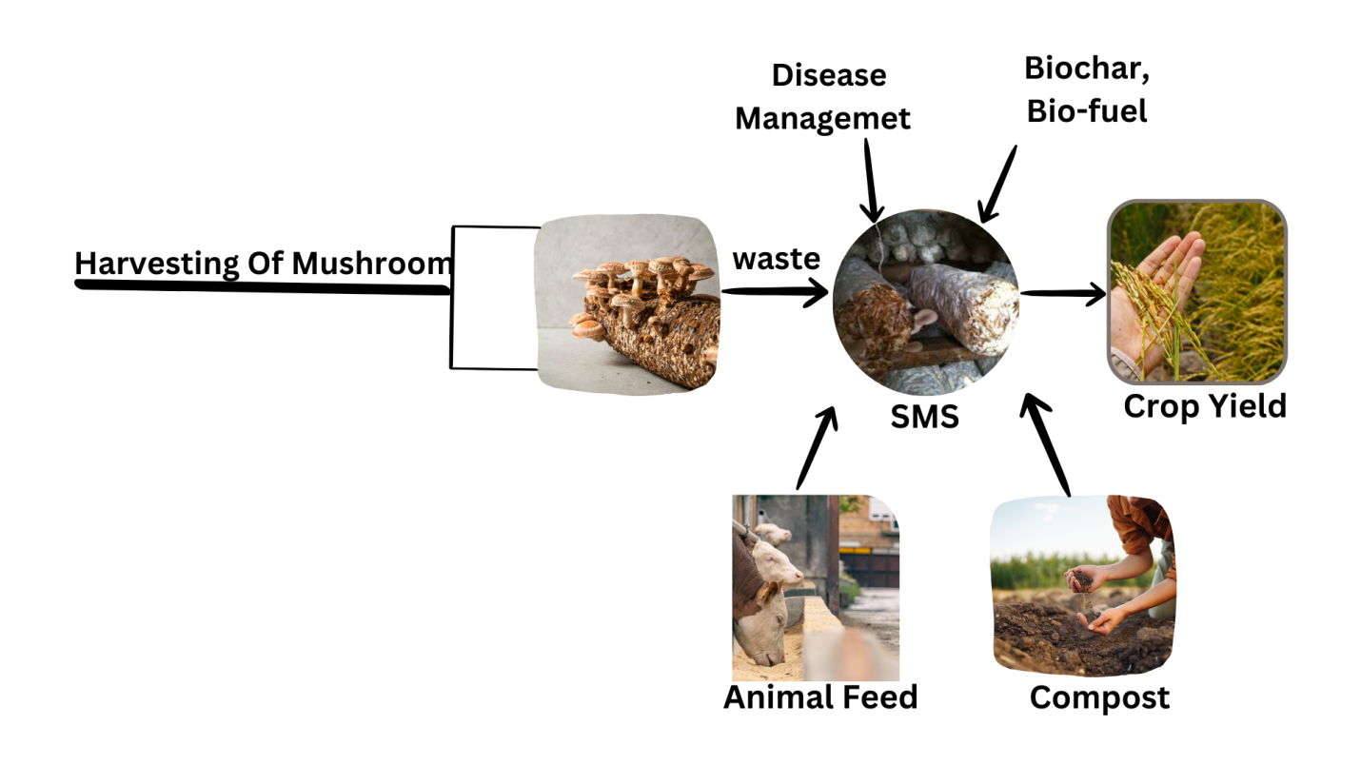 **Fig.2. Potential applications of SMW in various fields of agriculture and others**

1. **Bio-active compound in Shiitake mushroom:**

High molecular weight molecules including polysaccharides and oligopeptides, secondary metabolites are bioactive substances. Certain bioactive compounds in mushrooms display potential for treatment and prevention of numerous diseases. Its composition includes physiologically active compounds such as proteins, peptides, terpenoids, polyphenols, polysaccharides, vitamins, and minerals, which effects are assumed to act as immunomodulatory, anti-inflammatory, antioxidant, hypocholesterolemic, and hypoglycemic (Zang et al., 2020). In terms of functional characteristics and chemical composition, wood-cultured Shiitake *L. edodes* had higher levels of terpenoids and phenolic compounds, and higher hypoglycemic and antioxidant activities than sack cultures (Sobota et al., 2020). As with other types of mushrooms, edible fruit bodies of shiitake, especially group B, are an excellent source of vitamins. The fruiting bodies had low amounts of lipids (4.8–8.0% dry weight) The fats detected are fatty acids, mono-, di- and triglycerides, phospholipids and sterols (Muszyńska et al., 2017). The basic repeating units of β-glucan polysaccharides from edible shiitake mushrooms include two branch structures of 1-6-β-glucopyranoside and a linear chain of five (1→3)-β glucose units. The concentrations of β-glucan varied significantly across cultivars and the stipe of the fruiting bodies contained greater amounts compared to the pileus. The detected levels of β-glucans varied between the piles with values from 20.06 to 44.21%, and stipe section ranged from 29.74 to 56.47% (Friedman, 2016). All of the exogenous amino acids are present in this species' fruiting bodies. Essential amino acids account for 39% of all amino acids. Shiitake mushrooms are high in nutritional content, ranking after meat and ahead of dairy products (Wasser , 2005). Scientific studies show that eritadenine from *L. edodes* can lower LDL cholesterol levels in the body and blood.In just one week, it reduces blood cholesterol levels by 25% (Wasser ,1997).This mushroom extract is high in diverse bioactive components with the well-recognized antimicrobic effect. These species comprise the 1,2- and 3,4-butanetetrol isomers, erythritol, sesquiterpenes, steroids, anthraquinones, benzoic acid derivatives, and quinolones. In addition, it includes bathing acid, a sesquiterpene metabolite, and carvacrol, an aromatic monoterpene found in shiitake oil extract (Avinash et al., 2016). Mushrooms' protein is rich in the basic amino acids glutamic acid, aspartic acid, and arginine (PUIA et al., 2018). Shiitake mushrooms have over 20% protein (Chaturvedi et al., 2018). Such host-derived proteins are lectins, immunomodulatory proteins, and several enzymes (e.g., nucleases, ribonucleases, laccase, and ergotionein). Lectins promote insulin secretion, modulate blood glucose homeostasis, boost the immune response, and confer chemopreventive activity against selected cancers, such as hepatocellular carcinoma (Sousa et al., 2023). Also, shiitake mushrooms contain antioxidant-rich phenolic compounds (p-hydroxybenzoic acid, protocatechuic acid, and trans-cinnamic acid). But they are also rich in offer higher calcium concentrations than most mushroom varieties, along with notable amounts of potassium, magnesium, sodium, copper, zinc, and phosphorus. Shiitake are one of many mushrooms containing phenolic compounds with potent antioxidant activity. *L. edodes* in particular, have a total phenolic concentration of 13 µmol GAE/mg (Sharpe et al., 2021). In 1972, anti-atherosclerotic compounds like lentysine were discovered in the fruiting bodies of *L. edodes*. Eritadenine (2 (R), 3 (R)-dihydroxy-4-(9-adanyl) butyric acid) is a key component found in *L. edodes* fruiting bodies that helps lower blood lipid levels (Kamiya et al.,1969).Shiitake Mushromm waste consists mainly of cellulose, hemicellulose, lignin, proteins, amino acids and trace minerals, providing it with the potential for recycling or utilization.

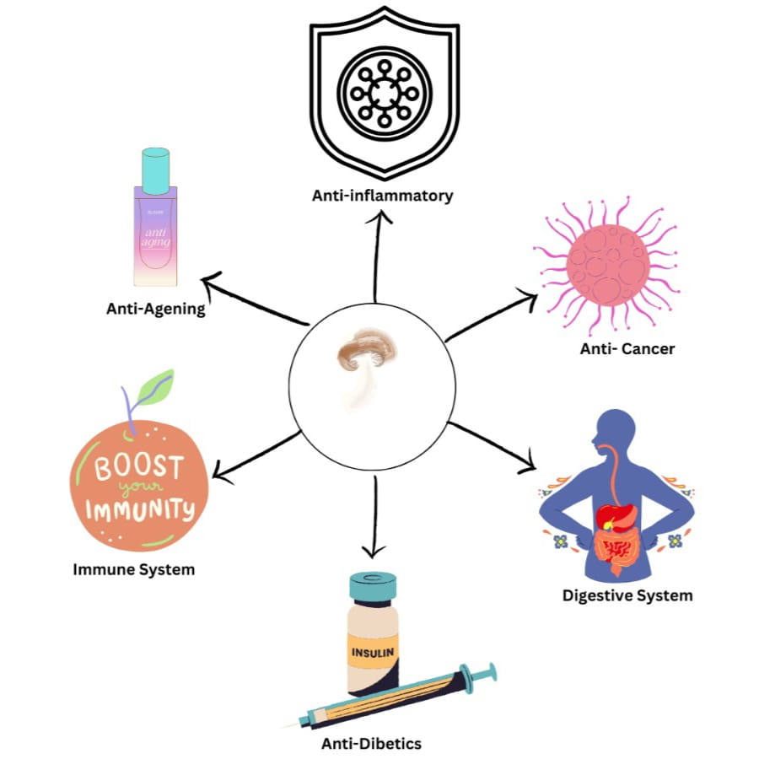

**Fig.3. Bio-activity of Shiitake mushroom byproducts**

1. **Bioloical activity and different bio-active compounds of shiitake mushroom byproducts:**

|  |  |  |
| --- | --- | --- |
| **Bioactive Compound** | **Biological Activity** | **Reference** |
| Polysaccharides (e.g., Î²-glucans, lentinan) | Anticancer, immunomodulatory, antioxidant, antitumor and cholesterol-lowering activities | (Chaipoot et al., 2023; Łysakowska et al., 2023) |
| Phenolic compounds | Antioxidant, antimicrobial and anti-inflammatory properties | (Chaipoot et al., 2023; Kumar et al., 2022) |
| Ergosterol | Antioxidant and precursor to vitamin D synthesis | (Chaipoot et al., 2023; Antunes et al., 2020) |
| Triterpenoids | Antitumor and anti-inflammatory effects | (Antunes et al., 2020; Łysakowska et al., 2023) |
| Proteins and peptides | Antimicrobial and immunomodulatory effects | (Antunes et al., 2020) |
| Polysaccharide-protein complexes | Enhances immunity and exhibits antitumor activity | (Antunes et al., 2023; Łysakowska et al., 2023) |
| Flavonoids | Antioxidant and protective effects | (Antunes et al., 2023; Kumar et al., 2020) |
| Trace elements (e.g., Fe, Zn, Mg) | Supports enzymatic functions and antioxidant defense systems | (Kumar et al., 2020) |

**Table.1. Biocompounds of shiitake mushroom byproducts and its biological activity**

1. **Medicinal and Nutritional Value of Shiitake Byproducts:**

Shiitake mushrooms contain a considerable amount of bioactive components, such as (1,3)(1,6)-β-D-glucans (a kind of dietary fiber), triterpenes, phenolic compounds and sterols. They are low in calories so can be a low-calorie addition to your menu and they are classified as a functional food. These mushrooms have proved capable of enhancing wellness and nutritional level and having benefits in the human body (Łysakowska et al., 2023). Shiitake mushrooms have attracted much attention to the world due to their various health benefits and high body absorption rates. They have been a significant element of traditional Chinese medicine for millennia and are valued for their health and medicinal properties (Wang et al., 2019). Shiitake are an excellent source of B vitamins. *Lentinus edodes* waste consists mainly of cellulose, hemicellulose, lignin, proteins, amino acids and trace minerals, providing it with the potential for recycling or utilization.

It consists approximately 58-60% carbohydrates, 20-23% protein, 9-10% fiber, 3-4% fat and 4-5% ash (Sheng et al., 2021). For these reasons the lentin capsules have been used to promote vigor, improve libido and reverse senescence, while lentinan sulfate from these types of mushrooms was found to inhibit an HIV. Moreover, polysaccharides derived from *L. edodes* potentiate the immune system and reduce the effects of radiation and chemotherapy while simultaneously displaying potent antiviral, anticancer and antibacterial activities. The anti-inflammatory properties of *L. edodes* have been effective when administered in association with Cu, Zn or Se (Muszyńska et al, 2020).Mycelium could be a beneficial component of natural anti-inflammatory dietary supplements. Some specific strains of *Lentinula edodes*, especially Shenxiang 18, are characterized by favorable amino acid structure and high-quality protein. This amino acid represents 0.06 to 730 μmol/g dry matter in 113 kinds of mushrooms *L. edodes* contains 128 μmol/g (Antunes et al., 2020). Dietary supplementation for four weeks with *L. edodes* significantly promoted the ex vivo proliferation of γδ-T cells (increase of 60%, p < 0.0001) and NK-T cells (two-times increase, p < 0.0001) (Antunes et al., 2020). The types of immune cells mentioned showed greater expression of activation receptors, confirming that eating mushrooms enhanced their effector functions (Dai et al., 2015). Some specfic types of mycelium processed with tree bark, such as shiitake mycelium and elm tree *Ulmus parvifolia* bark, may also help prevent and/or treat allergic asthma (Kim et al., 2016). Drying M1 dried mushrooms, in contrast, has a compelling fungistatic effect due to a lower total acid of fresh mushrooms (0.16%), compared to 0.48% dry variant source. On the contrary, the water extract has less antibacterial potential than the acetone extract from shiitake mushrooms. In addition, the acetone extract was non-cytotoxic at the antimicrobial concentrations. Shiitake mushrooms may aid in the prevention and management of periodontitis, as suggested by these findings (Jeon et al., 2022). The fresh fruiting bodies of *L. edodes* contains 88-92% water. They are also notable for their energy, containing 387–392 kcal/100 g dry matter. health benefits Shiitake waste is rich in dietary fiber, which can improve digestive health and possibly aid in the regulation of blood glucose levels. Shiitake stems are reported to be very fibrous, containing both soluble and insoluble fibers.

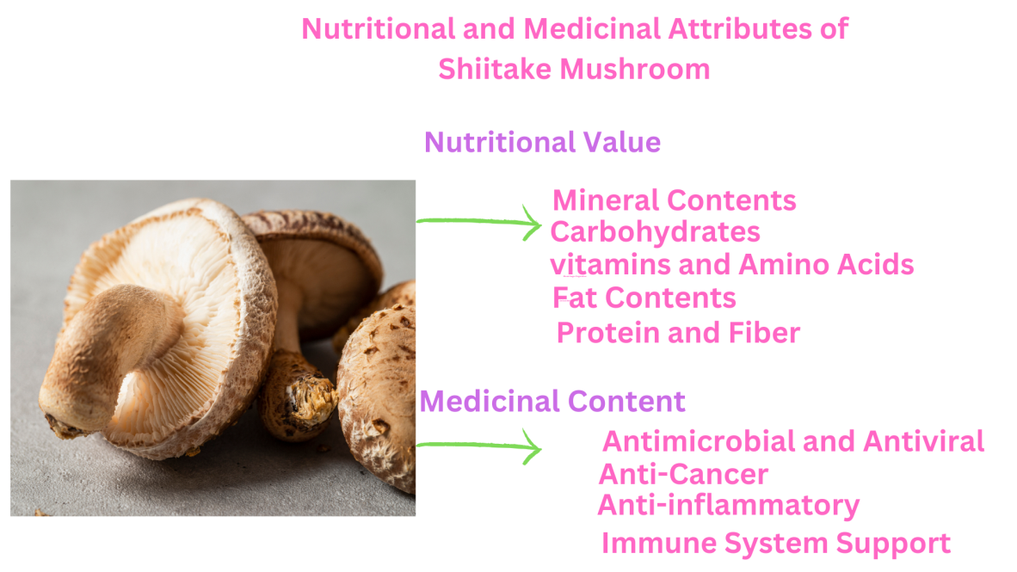

**Fig.4. Medicinal and Nutritional content in Shiitake Mushroom.**

**Nutritional Value of Shiitake Mushrooms (Per 100g Dried):**

|  |  |
| --- | --- |
| **Nutrient** | **Amount per 100g** |
| **Energy** | 296 kcal |
| **Carbohydrates** | 75.4 g |
| **Dietary Fiber** | 11.5 g |
| **Sugars** | 2.2 g |
| **Protein** | 9.6 g |
| **Total Fat** | 1.0 g |
| **Saturated Fat** | 0.2 g |
| **Monounsaturated Fat** | 0.2 g |
| **Polyunsaturated Fat** | 0.4 g |
| **Vitamin D** | 3.9 µg |
| **Vitamin B2 (Riboflavin)** | 1.27 mg |
| **Vitamin B3 (Niacin)** | 14.1 mg |
| **Vitamin B5 (Pantothenic Acid)** | 3.6 mg |
| **Vitamin B6** | 0.29 mg |
| **Folate** | 163 µg |
| **Vitamin C** | 3.5 mg |
| **Vitamin A** | 2 µg |
| **Vitamin E** | 0.5 mg |
| **Vitamin K** | 1.7 µg |
| **Calcium** | 11 mg |
| **Iron** | 1.7 mg |
| **Magnesium** | 60 mg |
| **Phosphorus** | 294 mg |
| **Potassium** | 1534 mg |
| **Sodium** | 13 mg |
| **Zinc** | 2.0 mg |
| **Copper** | 5.2 mg |
| **Manganese** | 0.5 mg |
| **Selenium** | 46.1 µg |

*Percent Daily Values are based on a 2,000-calorie diet* (Smith, 2023)

**Table. 2**. **Nutrient composition of dry Shiitake mushroom per 100g.**

**7. Biodegradation mechanisms of shiitake mushroom byproducts:**

*L. edodes* forms lignins degrading enzymes. Consequently, they can straightforwardly develop on straw, tree trunks, and so on. It is worth mentioning that they can be amended to a variety of commercial substrates, in particular wastes from forestry, agro-industry, and agriculture, employing biodegradation and biotransformation to transmute them into protein-rich biomass. Thus, SMS has phytotoxic components which need maturation duration in the range of 1 to 2 years before they can be applied into commercial soil (Hu et al., 2019). *L. edodes* mycelium synthesizes oxidative enzymes that may potentially aid in the degradation of xenobiotics. Polycyclic aromatic hydrocarbons are persistent pollutants that can be transformed by white rot fungi. These features may also be employed for the bioremediation of soil polluted with petroleum (Muszyńska et al., 2018). Fungi secrete various types of extracellular enzymes, such as peroxidases, ligninases, cellulases, pectinases, xylanases and oxidases. Biochemical characterization was performed on multiple hemi-cellulolytic enzymes such as xylanase, endoglucanases (GH12) and cellobiohydrolases (GH6 and GH7) and lignin degrading enzymes (laccases and MnP) in L. edodes (Cai Y, et al., 2017). Ligninolytic, cellulolytic, and hemicellulolytic are examples of different enzymes used for lignocellulosic material decomposition (Vasco et al., 2016). These enzymes can degrade resistant, non-polymeric pollutants such as nitrotoluenes, many dyes, both organic and synthetic, and pentachlorophenol. Dead mushroom biomass has many advantages over living cells in terms of biosorption: This biomass can be harvested from industrial processes as a fermentation operations byproduct (Kulshreshtha et al., 2014). White-rot fungi are well known for degrading lignocellulosic material but can also degrade waste from the shiitake mushrooms. Shiitake mycelium also degrades lignocellulose. These fungi rapidly degrade lignin which is present in shiitake waste into a humus-like substance that acts as a soil conditioner (Zhang et al., 2017). Bacteria are major cellulase producers that excrete cellulase in huge amounts. Cellulolytic enzymes are crucial in the decomposition of lignocellulose by specifically hydrolyzing the β-1,4 glycosidic bonds in cellulose (Malik et al., 2021). Chitin is found inside the mycelium of shiitake mushrooms, and is digested by chitinases. Hydrolysis of chitin is crucial for the digestion and recycling of mycelial waste. The degradation rate, which is controlled by the chemical components of shiitake byproducts, such as the cellulose, hemicellulose, lignin, and chitin ratios. Lignocellulose-rich materials usually decompose more slowly than plant-based mycelium materials.

**8. Shitake byproduct as composting and organic fertilizers:**

Composting is the transformation of organic matter into a more decomposed enzyme. Composting helps you get more nutrients out of straw and additives. These nutrients are converted into a mold-friendly form that makes for superior food for mushrooms. Spent mushroom compost (SMC) is a residue from the mushroom industry, and its proper “handling and disposal” poses significant environmental challenges, since about 5% of the SMC in the permanent storage is released into the atmosphere as greenhouse gases through natural anaerobic decomposition as it piles up. Additionally, this process may generate foul odors and leachate that can perspire and enrich water bodies, resulting in lowered levels of dissolved oxygen (Martín et al., 2023). The bulk density is highest for pure SMC (no compost) and decreases with the addition of other materials. Therefore, an ideal growth substrate should be (0.4 g/cm3) optimal bulk density which can serve as a reliable indicator of the porosity that permits free gas exchange in the medium. Meaning both properties; preferred water-holding capacity and total pore space, should range from 50–60% and 70–90% (Thakur et al., 2020). SMC is usually 1.9:0.4:2.4% NPK, but after 8-16 months spent outside it normalizes to 1.9:0.6:1.0% NPK. Potassium, despite being more soluble than nitrogen and phosphorus, tends to be leached out during weathering. Spent Mushroom Substrate (SMS) is less hazardous than sewage sludge, having much lower concentrations of heavy metals (Becher et al., 2021). SMS has also low moisture and weakly acidic pH 12. The substrate of *L. edodes* is used as mulch. SMC was assessed for efficacy against the pathogen *F. oxysporum ,f. sp cepae* which causes basal rot disease of shallots, and limited success was observed. The results showed that SMC reduced the severity of 44–76.8% (Yusidah et al., 2018). This is used to supply 50% of the nitrogen in this study, while the other 50% were supplied by Chemical fertilizer in ABR50 (Tang et al., 2024). Shiitake mushroom waste (SMW) improves ground aeration, supporting plant growth. Apart from calcium (0.2–0.4%) and sodium (0.05–0.2%), it has important minerals like nitrogen (1.3–4.2%), phosphorus (0.1–0.4%), and potassium (0.5–1.8%). Additionally, it includes minute amounts of copper, iron, manganese, zinc, and boron in uneven proportions and is vital for good growth of plants (Jasinska et al., 2018). *Lentinus edodes* spent mushroom waste can be used as an effective mulching material because of its better physicochemical properties and its positive effect on the degradation of pesticides (Gaoаet al. 2015).

**9. Innovative Biotechnological Approaches for Enhancing Byproduct Utilization**:

Shiitake mushrooms *L. edodes* rank among the most widely cultivated edible fungi globally, appreciated for both their taste and health benefits. Besides being consumed directly, they serve as a crucial resource in the biotechnology field, as their cultivation generates substantial byproducts, mainly in the form of spent mushroom substrate (SMS), which is frequently discarded or used for animal feed. Nevertheless, recent advancements in biotechnological methods have unveiled new avenues for using these byproducts, resulting in the creation of value

* 1. **Biodegradable Packaging from Shiitake Mushroom Byproducts**

Sales Force recently reported that from second quarter of 2020, digital sales had a 71% increase over 2019, and  they experienced a 55% year-over-year increase. As a result, this massive surge has resulted in a corresponding demand for packages and packaging materials that can most probably be destined to the garbage, incineration plants or, worst of all, into the water bodies of soil and nature. Packaging materials like polystyrene and polypropylene are often described as recyclable, but ex­perts say less than 14 percent of the nearly 86 million tons of plastic packaging created annually is ever recycled. Much of the waste packaging that is generated goes to landfill or is incinerated instead of being recycled. Moreover, some of it also might end up in the environment, specifically in our water bodies and oceans which endanger marine life (Ellen MacArthur Foundation, 2017). Mycelium-based materials have been studied for packaging food as an environmentally friendly substitute to polystyrene (Abhijith et al., 2018) Research on mushrooms based packaging created from mycelia fungi has been appropriately conducted and reported over the past decade. Foams made from agricultural waste products or materials like sawdust can form mycelium foams, which are essentially a low-cost alternative with many similar properties to Styrofoam. Mycelium grows around substrates like sawdust and coir pith, binding it into a material that can replace expanded polystyrene and other plastics in cushioning for packaged goods and is also compostable, whether or not they can compete with synthetic materials as a cost-effective and high-performance protective packaging solution, however, remains to be seen. (Ellen MacArthur Foundation, 2017). Three alternative mixing techniques were used with various substrate materials, including wood pulp, millet grain, wheat bran, a natural fiber, and calcium sulfate, as well as two packing conditions, to produce a fungal mycelium-based biofoam. The results revealed a high potential for application as an alternative insulating material for building and infrastructure development, particularly in cold climates as a lightweight backfill material for geoengineering applications (Yang et al., 2017).Ecovative Design is a New York-based biotech company that creates mushroom-based foam products. They are now able to optimize the manufacturing process and retain the key characteristics of the material. Dell and other companies have been early adopters, declaring their decision to use green foam from fungal mycelium to ship their servers in their packaging. They continue to test these materials in their laboratories to ensure that the same protection is provided as with the traditional expanded polystyrene foam (Rajendran, 2022). In the 1980s, Japanese scientist Shigeru Yamanka observed that the adhesive properties of mycelium could be advantageous in the paper industry and for making construction materials. (Mojumdar et al., 2021).

* 1. **Development of Functional Foods and Nutraceuticals:**

Shiitake mushrooms *L. edodes* are well-known for their culinary applications and health benefits. More recently, however, research has begun to focus on functional food and nutraceutical development from shiitake mushroom cultivation byproducts, the mainly utilized being the spent substrate, stems, and mycelium. These byproducts, often discarded, are enriched with bioactive compounds with significant potential for the development of health-promoting food products. Shiitake mushroom could be a fresh and gentle umami flavor material to develop natural seasonings and also can gave variety of strong non-volatile flavor compounds. According to studies, shiitake byproducts may return them to a flavoring agent and help formulate low sodium meat products (França et al., 2022). These umami-rich elements include available soluble sugars, free amino acids, 5'–nucleotides, organic acids and small compounds such as flavor peptides, which are central to our sense of taste (Sun et al., 2020).Umami component derived from shiitake stalks was identified and suggested as a possible substitute for monosodium glutamate in lower-sodium extruded corn snacks (Harada et al., 2020) The broths yielded from shiitake that is blanched and centrifuged are rich in polysaccharides, total phenols, ergothioneine, essential minerals, and flavor compounds, while being low in fat and sodium. It was shown that the blanching water of shiitake mushrooms has not only good taste, but also beneficial for health (Chen et al., 2023). During the conversion of acetaldehyde into ethanol, *L. edodes* have shown that NADPH levels were found to be the highest  (Takemoto et al., 2024). They are an easy source of nitrogen during alcoholic fermentation because they are rich in protein, which can be converted into nitrogen (Chen et al., 2022). Different doses of *L. edodes* powder, famous for its strong umami taste and health benefits, were added to the fermentation of Huangjiu, a traditional Chinese rice wine. Shiitake mushroom powder was blended with Jiuku wheat and water for the initiation of the fermentation and during the fermentation period the effect of the mushrooms on the microbial dynamics and also the volatile compounds was studied (Geng et al., 2024). Under heterogeneous solid-state conditions, potato tubers were mixed with *L. edodes* powder, a common ingredient of Japanese food, and a rapid saccharide release was observed (Tatsumi et al., 2016). The incorporation of mushroom by-products into food formulations could provide extra nutritional, sensory, and quality attributes that are significant for creating food products.

* 1. **Extraction of bio-active compounds from shiitake mushroom byproducts** **using biotechnological approaches.**

Shiitake by-products serve as a promising functional ingredient that exhibits strong effects against lipid oxidation and the growth of undesirable bacteria in fermented sausages throughout storage (Van et al., 2017).The extract derived from shiitake mushroom by-products was prepared and incorporated into the formulations of fermented sausages. The fermented sausages enhanced with the shiitake stipes extract demonstrated increased shelf-life stability by reducing the final pH value, preventing lipid oxidation, and slowing the proliferation of spoilage bacteria in the products during a storage period of up to 30 days at 15 °C (Van et al., 2016). The SMS of shiitake mushroom has cellulose that is very prone to enzymatic saccharification (Xiong et al., 2019).The used substrate from the cultivation of *L.edodes* has been shown to be a naturally abundant source of enzymes for the transformation of lignocellulosic biomass (Schimpf et al., 2016). Chitin extracted from leftover mushroom stipes transformed into chitosan for the purpose of creating edible coatings. A layer-by-layer (LbL) electrostatic deposition technique was employed to apply the polycation chitosan and the polyanion alginate onto fruit bars that were enhanced with ascorbic acid. The fruit bars coated with alginate-chitosan LbL exhibited higher levels of ascorbic acid, improved antioxidant properties, greater firmness, and reduced fungal growth during storage (Bilbao et al., 2018). Shiitake powder macerated in water at 98°C for 1 hour at a pilot scale (30 L) produced up to 80 L of β-glucan-rich extracts with concentrations of 1.9-4.2% total soluble components (Morales et al., 2018). The technique utilized in the (Ultrasound-Assisted Extraction) UAE for obtaining bioactive polysaccharides from both the fruit body and fungal mycelium of *L.edodes* mushrooms involves an extraction period of 60 minutes. The extraction yield from *L.edodes* was found to be 0.13% (Cheung et al., 2013). Another technique for gathering functional mushroom bioactives without changing their functions for future use as high-value mycoextracts or nutraceuticals is enzyme-assisted extraction. In order to help consumers with dysphagia patterns, 3D printing technology has recently produced customized nutritious gums made of arabic, xanthan, and k-carrageenan with *L. edodes.* The protein fraction and bioactive substances found in mushrooms may help to lessen nutritional deficiencies brought on by chewing and swallowing difficulties (Liu et al., 2021)

**Conclusion:**

Three types of byproducts are generated from shiitake mushroom farms, which include stipes and spent mushroom substrate (SMS) containing non-commercial mushrooms, which are generally troublesome to manage, but contain potential economic value. Yet, the SMS was used for growing nutritional supplements and, therefore, caused an efficient waste management process, which helps to identify mushroom cultivation scaling. SMS contains organic and inorganic components which allow for efficient biogas production and the resulting biochar is beneficial to soil quality and contributes to atmospheric carbon capture. Bioactive compounds from SMS have significant practical applications in the pharmaceuticals, biomedicine, animal feed, and food industries. The versatility of these molecules offers a unique opportunity to increase the efficiency and safety of products in these industries. Ergosterol, a provitamin D2, is recorded in *L. edodes* SMS (151.6 mg per 100 g); thus, animal feed quality improves. White-rot fungus mycelial active lignin-degrading enzymes work throughout the growth period of edible mushrooms to enhance nutritional protein, contributing to the digestion of lignocellulosic materials by livestock. The following three key features of SMS such as lignocellulosic structure combined nutritional utility and biochemical remaining content render it as an optimal feed-stock for biochar synthesis. SMS's biochar also fortifies soil nutrients while locking in moisture, encourages microbial communities, and captures carbon, all of which are environmentally friendly solutions for developing farming systems and mitigating climate change. Future research should establish optimal protocols for extracting bioactive compounds, while the viable use of SMS as a bioresource for sustainable economics should be well established.

**Disclaimer (Artificial intelligence)**

**Option 1:**

**Author(s) hereby declare that NO generative AI technologies such as Large Language Models (ChatGPT, COPILOT, etc.) and text-to-image generators have been used during the writing or editing of this manuscript.**

**Option 2:**

**Author(s) hereby declare that generative AI technologies such as Large Language Models, etc. have been used during the writing or editing of manuscripts. This explanation will include the name, version, model, and source of the generative AI technology and as well as all input prompts provided to the generative AI technology**

**Details of the AI usage are given below:**

**1.**

**2.**

**3.**

**References:**

Abdullah, M. B., Abed, I. A., & Alkobaisy, J. S. (2022). Changes of some chemical elements of agrowaste after shiitake cultivation. *NeuroQuantology*, *20*(5), 1195-1202.

Abhijith, R., Ashok, A., & Rejeesh, C. R. (2018). Sustainable packaging applications from mycelium to substitute polystyrene: a review. *Materials today: proceedings*, *5*(1), 2139-2145

**Aiduang, W., Jatuwong, K., Kiatsiriroat, T., Kamopas, W., Tiyayon, P., et al. (2025).** Spent mushroom substrate-derived biochar and its applications in modern agricultural systems: An extensive overview. Life, 15(2), 317. <https://doi.org/10.3390/life15020317>

Antunes, F., Marçal, S., Taofiq, O., M. M. B. Morais, A., Freitas, A. C., Ferreira, I.C.F.R., et al., (2020). Valorization of Mushroom By-Products as a Source of Value-Added Compounds and Potential Applications. Molecules, 25(11), 2672. <https://doi.org/10.3390/molecules25112672>

Atila, F. Compositional changes in lignocellulosic content of some agro-wastes during the production cycle of shiitake mushroom. *Sci. Hortic.* 2019, *245*, 263–268.

**Avinash, J., Vinay, S., Jha, K., Das, D., Goutham, B. S., et al. (2016).** The unexplored anticaries potential of shiitake mushroom. Pharmacognosy Reviews, 10(20), 100-104. https://doi.org/10.4103/0973-7847.194039 PMID: 28082791;

**Becher, M., Banach-Szott, M., Godlewska, A., et al. (2021).** Organic matter properties of spent button mushroom substrate in the context of soil organic matter reproduction. Agronomy, 11(2), 204. <https://doi.org/10.3390/agronomy11020204>

Bilbao‐Sainz, C., Chiou, B. S., Punotai, K., Olson, D., Williams, T., Wood, D., et al. (2018). Layer‐by‐layer alginate and fungal chitosan based edible coatings applied to fruit bars. Journal of Food Science, 83(7), 1880-1887. <https://doi.org/10.1111/1750-3841.14186>. PMID: 29846934.

**Cai, Y., Gong, Y., Liu, W., Hu, Y., Chen, L., et al. (2017).** Comparative secretomic analysis of lignocellulose degradation by L. edodes grown on microcrystalline cellulose, lignosulfonate, and glucose. Journal of Proteomics, 163, 92–101.

Cardwell, G., Bornman, J. F., James, A. P., & Black, L. J. (2018). A Review of Mushrooms as a Potential Source of Dietary Vitamin D. Nutrients, 10(10), 1498. https://doi.org/10.3390/nu10101498

**Carrasco, J., Zied, D. C., Pardo, J. E., Preston, G. M., & Pardo-Giménez, A., et al. (2018).** Supplementation in mushroom crops and its impact on yield and quality. AMB Express, 8, 1-9.

Casaril, K. B. P. B., Kasuya, M. C. M., & Vanetti, M. C. D. (2011). Antimicrobial activity and mineral composition of shiitake mushrooms cultivated on agricultural waste. *Brazilian Archives of Biology and Technology*, *54*, 991-1002.

Chaipoot, S., Wiriyacharee, P., Phongphisutthinant, R., Buadoktoom, S., Srisuwun, A., Somjai, C., & Srinuanpan, S. (2023). Changes in physicochemical characteristics and antioxidant activities of dried shiitake mushroom in dry-moist-heat aging process. Foods, 12(14), 2714. <https://doi.org/10.3390/foods12142714>

Chang, S., & Wasser, S.  (2017, March 29). The Cultivation and Environmental Impact of Mushrooms. Oxford Research Encyclopedia of Environmental Science. Retrieved 5 Apr. 2025, <https://oxfordre.com/environmentalscience/view/10.1093/acrefore/9780199389414.001.0001/acrefore-9780199389414-e-231>.

**Chaturvedi, V. K., Agarwal, S., Gupta, K. K., Ramteke, P. W., Singh, M. P., et al. (2018).** Medicinal mushroom: Boon for therapeutic applications. 3 Biotech, 8, 1-20.

**Chen, F., Xiong, S., Gandla, M. L., Stagge, S., & Martín, C. (2022).** Spent mushroom substrates for ethanol production—Effect of chemical and structural factors on enzymatic saccharification and ethanolic fermentation of Lentinula edodes-pretreated hardwood. Bioresource Technology, 347, 126381

**Chen, S.-Y., Tseng, J., Wu, C.-R., & Lin, S.-D. (2023).** Quality evaluation of shiitake blanched and centrifuged broths as functional instant drinks. Foods, 12(15), 2925. <https://doi.org/10.3390/foods12152925>

Cheung, Y. C., Siu, K. C., & Wu, J. Y. (2013). Kinetic models for ultrasound-assisted extraction of water-soluble components and polysaccharides from medicinal fungi. *Food and Bioprocess Technology*, *6*, 2659-2665.

**Dai, X., Stanilka, J. M., Rowe, C. A., Esteves, E. A., Nieves, C., Jr., et al. (2015).** Consuming L. edodes (shiitake) mushrooms daily improves human immunity: A randomized dietary intervention in healthy young adults. Journal of the American College of Nutrition, 34(6), 478–487. <https://doi.org/10.1080/07315724.2014.950391>

dos Santos Harada-Padermo, S., Dias-Faceto, L. S., Selani, M. M., Alvim, I. D., Floh, E. I. S., Macedo, A. F., et al. (2020). Umami Ingredient: Flavor enhancer from shiitake (Lentinula edodes) byproducts. Food Research International, 137, 109540. https://doi.org/10.1016/j.foodres.2020.109540. PMID: 33233168

Ellen MacArthur Foundation (2017) The new plastics economy: Rethinking the future of plasticsand catalysing action. <http://www.ellenmacarthurfoundation.org/publications>

**European Environment Agency (EEA).** (2022). Nitrate Directive. Available at: <https://www.eea.europa.eu/archived/archived-content-water-topic/water-pollution/prevention-strategies/nitrate-directive> (Accessed: May 3, 2022).

**França, F., dos Santos Harada-Padermo, S., Frasceto, R. A., Saldana, E., Lorenzo, J. M., de Souza Vieira, T. M. F., Selani, M. M., et al. (2022).** Umami ingredient from shiitake (Lentinula edodes) by-products as a flavor enhancer in low-salt beef burgers: Effects on physicochemical and technological properties. LWT, 154, 112724.

**Friedman, M., et al. (2016).** Mushroom polysaccharides: Chemistry and antiobesity, antidiabetes, anticancer, and antibiotic properties in cells, rodents, and humans. Foods, 5(4), 80. <https://doi.org/10.3390/foods5040080>

friendly alternative to synthetic packaging. In: Vaishnav A, Choudhary DK (eds) Microbial

Gaitán-Hernández, R., López-Peña, D., Esqueda, M., & Gutiérrez, A. (2019). Review of bioactive molecules production, biomass, and basidiomata of shiitake culinary-medicinal mushrooms, Lentinus edodes (Agaricomycetes). *International journal of medicinal mushrooms*, *21*(9).

**Gao, W., Liang, J., Pizzul, L., Feng, X. M., Zhang, K., del Pilar Castillo, M., et al. (2015).** Evaluation of spent mushroom substrate as a substitute for peat in Chinese biobeds. International Biodeterioration & Biodegradation, 98, 107–112

**Geng, J., He, S., Zhang, S., Tian, H., & Jin, W. (2024).** Impact of incorporating shiitake mushrooms (Lentinula edodes) on microbial community and flavor volatiles in traditional Jiuqu. Foods, 13(1019).

**Hu, T., Wang, X., Zhen, L., Gu, J., Zhang, K., et al. (2019).** Effects of inoculating with lignocellulose-degrading consortium on cellulose-degrading genes and fungal community during co-composting of spent mushroom substrate with swine manure. Bioresource Technology, 291, 121876.

**Jasinska, A., et al. (2018).** Spent mushroom compost (SMC)—retrieved added value product closing loop in agricultural production. Acta Agraria Debreceniensis, 150, 185–2020. <https://doi.org/10.341010/actaagrar/150/171>

**Jeon, Y. M., et al. (2022).** Effects of shiitake mushroom extract on antimicrobial activity against periodontopathogens and inflammatory condition of human gingival fibroblast. Journal of Dental Rehabilitation and Applied Science, 38(2), 90-96.

Kamiya, T.; Saito, Y.; Hashimoto, M.; Seki, H. Tetrahedron Lett. 1969, 10 (53), 4729–4732

**Kim, S. P., Lee, S. J., Nam, S. H., Friedman, M., et al. (2016).** Turmeric (Curcuma longa) bioprocessed with mycelia of shiitake (Lentinus edodes) mushrooms: Composition and mechanism of protection against salmonellosis in mice. International Journal of Medicinal Mushrooms.

**Kulshreshtha, S., Mathur, N., Bhatnagar, P., et al. (2014).** Mushroom as a product and their role in mycoremediation. AMB Express, 4, 29. <https://doi.org/10.1186/s13568-014-0029-8>.

Kumar, P., Eid, E. M., Taher, M. A., El-Morsy, M. H. E., Osman, H. E. M., Al-Bakre, D. A., et al.,(2022). Biotransforming the Spent Substrate of Shiitake Mushroom (*L. edodes* Berk.): A Synergistic Approach to Biogas Production and Tomato (*Solanum lycopersicum* L.) Fertilization. Horticulturae, 8(6), 479. <https://doi.org/10.3390/horticulturae8060479>

**Leong, Y. K., Ma, T. W., Chang, J. S., Yang, F. C., et al. (2022).** Recent advances and future directions on the valorization of spent mushroom substrate (SMS): A review. Bioresource Technology, 344, 126157.

Li, S., Wang, A., Liu, L., *et al.,*(2018).Evaluation of nutritional values of shiitake mushroom (*Lentinus edodes*) stipes. *Food Measure* 12, 2012–2019.https://doi.org/10.1007/s11694-018-9816-2

Liu, Z., Bhandari, B., Guo, C., Zheng, W., Cao, S., Lu, H., Mo, H., & Li, H. (2021). 3D Printing of Shiitake Mushroom Incorporated with Gums as Dysphagia Diet. Foods, 10(9), 2189. <https://doi.org/10.3390/foods10092189>.

**Łysakowska, P., Sobota, A., Wirkijowska, A., et al. (2023).** Medicinal mushrooms: Their bioactive components, nutritional value, and application in functional food production—A review. Molecules, 28(14), 5393. <https://doi.org/10.3390/molecules28145393>

**Malik, W. A., Javed, S., et al. (2021).** Biochemical characterization of cellulase from Bacillus subtilis strain and its effect on digestibility and structural modifications of lignocellulose-rich biomass. Frontiers in Bioengineering and Biotechnology, 9, 800265. <https://doi.org/10.3389/fbioe.2021.800265>

**Martín, C., Zervakis, G. I., Xiong, S., Koutrotsios, G., & Strætkvern, K. O., et al. (2023).** Spent substrate from mushroom cultivation: Exploitation potential toward various applications and value-added products. Bioengineered, 14(1). <https://doi.org/10.1080/21655979.2023.2252138>

**Martín, C., Zervakis, G. I., Xiong, S., Koutrotsios, G., & Strætkvern, K. O., et al. (2023).** Spent substrate from mushroom cultivation: exploitation potential toward various applications and value-added products. Bioengineered, 14(1). <https://doi.org/10.1080/21655979.2023.2252138>

Mojumdar A, Behera HT, Ray L (2021) Mushroom mycelia-based material: an environmental

**Mojumdar, A., Behera, H. T., Ray, L., et al. (2021).** Mushroom mycelia-based material: an environmentally friendly alternative to synthetic packaging. In Vaishnav, A., Choudhary, D. K. (Eds.), Microbial Polymers (pp. 131–141). Springer, Singapore. <https://doi.org/10.1007/978-981-16-0045-6_6>.

Morales, D., Smiderle, F. R., Piris, A. J., Soler-Rivas, C., & Prodanov, M. (2019). Production of a β-D-glucan-rich extract from Shiitake mushrooms (Lentinula edodes) by an extraction/microfiltration/reverse osmosis (nanofiltration) process. *Innovative food science & emerging technologies*, *51*, 80-90..

**Muszyńska, B., Kała, K., Włodarczyk, A., Krakowska, A., Ostachowicz, B., et al. (2020).** L. edodes as a source of bioelements released into artificial digestive juices and potential anti-inflammatory material. Biological Trace Element Research, 194(2), 603–613. <https://doi.org/10.1007/s12011-019-01782-8>

**Muszyńska, B., Pazdur, P., Lazur, J., Sułkowska-Ziaja, K., et al. (2017).** L. edodes (Shiitake)–biological activity. Medicina Internacia Revuo, 28(108), 189-195.

**Muszyńska, B., Żmudzki, P., Lazur, J., et al. (2018).** Analysis of the biodegradation of synthetic testosterone and 17α-ethynylestradiol using the edible mushroom Lentinula edodes. 3 Biotech, 8, 424. <https://doi.org/10.1007/s13205-018-1458-x>

**Mwangi, R. W., Mustafa, M., Kappel, N., et al. (2024).** Practical applications of spent mushroom compost in cultivation and disease control of selected vegetable species. Journal of Material Cycles and Waste Management, 26, 1918–1933. <https://doi.org/10.1007/s10163-024-01969-9>

Olsson S (1995) Mycelial density proﬁles of fungi on heterogeneous media and their interpretation

polymers. Springer, Singapore, pp 131–141

Ponnusamy C, Uddandrao V. V. S, Pudhupalayam S. P, Singaravel S, Periyasamy T, Ponnusamy P, (2022) L. edodes (Edible Mushroom) as a Nutraceutical: A Review. Biosci Biotech Res Asia 19(1)

**Puia, I. C., Puia, A., Chedea, V. S., Leopold, N., Bocsan, I. C., et al. (2018).** Characterization of Trametes versicolor: Medicinal mushroom with important health benefits. Notulae Botanicae Horti Agrobotanici Cluj-Napoca, 46(2), 343-349.

**Qi, Q., Peng, Q., Tang, M., et al. (2020).** Microbiome analysis investigating the impacts of fermented spent mushroom substrates on the composition of microbiota in weaned piglets’ hindgut. Frontiers in Veterinary Science, 7, 584243. <https://doi.org/10.3389/fvets.2020.584243>

**Raghoonundon, B., Gonkhom, D., Phonemany, M., Luangharn, T., & Thongklang, N. (2021).** Nutritional content, nutraceutical properties, cultivation methods, and economic importance of Lentinula: A review. Fungal Biotec, 1, 88-100.

**Rajendran, R. C., et al. (2022).** Packaging applications of fungal mycelium-based biodegradable composites. In Fungal Biopolymers and Biocomposites: Prospects and Avenues (pp. 189-208). Singapore: Springer Nature Singapore.

Royse, D. J. (2014). A global perspective on the high five: Agaricus, Pleurotus, Lentinula, Auricularia & Flammulina.

Royse, D. J., Baars, J., & Tan, Q. (2017). Current overview of mushroom production in the world. *Edible and medicinal mushrooms: technology and applications*, 5-13.

Schimpf, U.; Schulz, R. Industrial by-products from white-rot fungi production. Part I: Generation of enzyme preparations and chemical, protein biochemical and molecular biological characterization. *Process Biochem.* **2016**, *51*, 2034–2046

Sharma, V. P., Annepu, S. K., Barh, A., & Kumar, S. (2020). Adoption and competitiveness of new strains of shiitake mushroom in India. *Mushroom Research*, *29*(1),31-35. https://doi.org/10.36036/MR.29.1.2020.108712.

**Sharpe, E., Farragher-Gnadt, A. P., Igbanugo, M., Huber, T., Michelotti, J. C., et al. (2021).** Comparison of antioxidant activity and extraction techniques for commercially and laboratory-prepared extracts from six mushroom species. Journal of Agriculture and Food Research, 4, 100130.

**Sheng, K., Wang, C., Chen, B., Kang, M., Wang, M., et al. (2021).** Recent advances in polysaccharides from Lentinus edodes (Berk.): Isolation, structures, and bioactivities. Food Chemistry, 358, 129883..

Singh, M., Kamal, S. and Sharma, V.P. 2021. Status and trends in world mushroom production-III-World Production of Different Mushroom Species in 21st Century. Mushroom Res., 29(2): 75-111.

Singh, M., Kamal, S., & Sharma, V. P. (2018). Status and trends in world mushroom production-II -Mushroom production in Japan and China. *Mushroom Research*, *27*(1).1-25.

**Smith, J., Brown, R., et al. (2023).** Nutritional and medicinal properties of shiitake mushrooms: A comprehensive review. Journal of Food Science and Nutrition, 12(4), 567-582.

**Song, T., Zhang, Z., Liu, S., Chen, J., Cai, W., et al. (2020).** Effect of cultured substrates on the chemical composition and biological activities of Lingzhi or Reishi medicinal mushroom, Ganoderma lucidum (Agaricomycetes). International Journal of Medicinal Mushrooms, 22, 1183–1190.

**Sousa, A. S., Araújo-Rodrigues, H., Pintado, M. E., et al. (2023).** The health-promoting potential of edible mushroom proteins. Current Pharmaceutical Design, 29(11), 804-823.

Stamets, P. (2011). *Growing gourmet and medicinal mushrooms*. Ten speed press.

Sud, D., Sharma, S., & Dhiman, R. (2024). Significance and cultivation techniques of shiitake mushroom (L. edodes (Berk.) Pegler). *Indian Phytopathology*, 1-21.

**Sun, L. B., Zhang, Z. Y., Xin, G., Sun, B. X., Bao, X. J., Wei, Y. Y., et al. (2020).** Advances in umami taste and aroma of edible mushrooms. Trends in Food Science & Technology, 96, 176-187.

**Takemoto, N., Sameshima, Y., & Matsui, T. (2024).** Study of alcohol dehydrogenase involved in alcohol fermentation by Basidiomycetes. Journal of Nutritional Science, 12, 7–12.

Tan, Y. H., & Moore, D. (1994). High concentrations of mannitol in the shiitake mushroom Lentinula edodes. *Microbios*, *79*(318), 31-35.

**Tang, Q., Liu, W., Huang, H., Peng, Z., Deng, L., et al. (2024).** Responses of crop yield, soil fertility, and heavy metals to spent mushroom residues application. Plants, 13(5), 663. <https://doi.org/10.3390/plants13050663>

**Tatsumi, E., Konishi, Y., & Tsujiyama, S. (2016).** Application of residual polysaccharide-degrading enzymes in dried shiitake mushrooms as an enzyme preparation in food processing. Biotechnology Letters, 38, 1923–1928.

**Thakur, M. P., et al. (2020).** Advances in mushroom production: key to food, nutritional and employment security: A review. Indian Phytopathology, 73, 377–395. <https://doi.org/10.1007/s42360-020-00244-9>

Van Ba, H., Seo, H. W., Cho, S. H., Kim, Y. S., Kim, J. H., Ham, J. S., Park, B. Y., & Nam, S. P. (2016). Antioxidant and anti-foodborne bacteria activities of shiitake by-product extract in fermented sausages. Food Control, 70, 201-209. <https://doi.org/10.1016/j.foodcont.2016.05.053>

Van Ba, H., Seo, H. W., Cho, S. H., Kim, Y. S., Kim, J. H., Ham, J. S., Park, B. Y., & Pil-Nam, S. (2017). Effects of extraction methods of shiitake by-products on their antioxidant and antimicrobial activities in fermented sausages during storage. Food Control, 79, 109-118. <https://doi.org/10.1016/j.foodcont.2017.03.034>

**Vasco-Correa, J., Ge, X., Li, Y., et al. (2016).** Biological pretreatment of lignocellulosic biomass. In Biomass Fractionation Technologies for a Lignocellulosic Feedstock-Based Biorefinery (pp. 561–585). Elsevier: Amsterdam, The Netherlands.

**Wang, Q., Cheng, J., Wang, L., et al. (2018).** Valorization of spent shiitake substrate for recovery of antitumor fungal sterols by ultrasound-assisted extraction. Journal of Food Biochemistry, 42(5), e12602.

**Wang, T., He, H., Liu, X., Liu, C., Liang, Y., et al. (2019).** Mycelial polysaccharides of Lentinus edodes (shiitake mushroom) in submerged culture exert immunoenhancing effect on macrophage cells via MAPK pathway. International Journal of Biological Macromolecules, 130, 745-754

Wasser, S. P. (2005). Shiitake (Lentinus edodes). *Encyclopedia of dietary supplements*, 653-664.

Wasser, S. P., & Weis, A. L. (1999). Medicinal properties of substances occurring in higher basidiomycetes mushrooms: current perspectives. *International Journal of medicinal mushrooms*, *1*(1

Wasser, S. P., & Weiss, A. L. (1997). Medicinal mushrooms Lentinus edodes (Berk.) Sing. Shiitake mushroom/Ed. Nevo E. *Peledfus Publ. House: Haifa, Israel*.

Xiong, S., Martín, C., Eilertsen, L., Wei, M., Myronycheva, O., Larsson, S. H., et al. (2019). Energy-efficient substrate pasteurisation for combined production of shiitake mushroom (Lentinula edodes) and bioethanol. Bioresource Technology, 274, 65-72. https://doi.org/10.1016/j.biortech.2018.11.071. PMID: 30500765.

Yang, Z., Zhang, F., Still, B., White, M., & Amstislavski, P. (2017). Physical and mechanical properties of fungal mycelium-based biofoam. Journal of Materials in Civil Engineering, 29(7), 04017030. <https://doi.org/10.1061/(ASCE)MT.1943-5533.0001866>..

**Yusidah, I., Istifadah, N., et al. (2018).** The abilities of spent mushroom substrate to suppress basal rot disease (Fusarium oxysporum f. sp. cepae) in shallot. International Journal of Biosciences, 13, 440–448. <https://doi.org/10.12692/ijb/13.1.440-448>

**Zhang, Y., Yang, Z., Wang, Q., et al. (2017).** Degradation of lignocellulosic compounds from shiitake mushroom byproducts by white-rot fungi. Fungal Ecology, 27, 65-73.