***Review Article***

**Leveraging Mobile Technology to Enhance Agricultural Extension Services: A Review**

**Abstract**

The accelerated growth of mobile technology and digital applications has initiated a revolutionary shift in agricultural extension services, especially in developing countries where agriculture is the pillar of rural economies. The conventional extension services, characterized by field visits and on-site consultations, were mostly hampered by time, distance, and resource limitations. This review examines the impact of mobile apps on Agriculture Extension Services.Mobile applications have become a game-changer by giving farmers real-time access to critical agricultural information directly on their smartphones. Mobile apps provide weather forecasts, pest and disease identification, market price information, expert advisory, and even financial services, all of which lead to enhanced farm productivity and better decision-making. By means of mobile-based advisory platforms such as Kisan Call Center in India and M-Kilimo in Kenya, farmers can access the advice of experts without having to wait for physical visits by extension officers. The inclusion of mobile banking services within agriculture apps has strengthened the financial inclusion of farmers further, enabling them to obtain credit, receive secure payments, and invest in quality inputs. Through the closure of the information gap, mobile apps enable smallholder farmers to make effective plans, avoid wastage of inputs, increase yields, and get better access to markets, thereby increasing their incomes and livelihoods. Poor internet coverage, low digital literacy, the exorbitant price of smartphones, and limited localized content are some of the significant hindrances that bar many farmers from enjoying the full benefits of these technologies. The overcoming of these obstacles demands combined inputs from governments, private tech companies, and agriculture organizations to facilitate rural connectivity, offer subsidized devices, and conduct inclusive training packages to raise the digital capacities of farmers. All in all, the expanding interface of mobile applications with extension services in agriculture promises enormous opportunities for transforming farm management, improving the sustainability of agriculture, and enriching smallholder farmers' livelihoods through access to more affordable, effective, and farmer-centered extension services. Overall, mobile apps have great potential to make agriculture more modern, efficient, and sustainable. By giving farmers quick access to the right information, these apps help them make better decisions, improve their crops, and earn more money. With the right support, mobile apps can play a big role in improving the lives of farmers and making agriculture better for the future.

Keywords: Mobile applications, Agricultural extension services, Smart farming, Digital advisory platforms, Real-time agricultural information

**Introduction**

The development of mobile technology and digital tools has brought big changes to farming, especially in countries where agriculture is the main source of income. The integration of digital technologies in agriculture not only enhances efficiency within agricultural value chains but also supports the three pillars of Industry 5.0: human-centricity, resilience, and sustainability (Abioye et al., 2024). Over the past few years, mobile apps, smartphones and smart devices like sensors have helped farmers get better access to important information (Jayaraman et al., 2016). This is particularly helpful because most farmers are often poor in terms of resources, and there are not enough extension workers to reach out to them (Ibe et al., 2023). These digital tools help farmers improve their work, get better yields and make better decisions about their farms. Mobile phones, especially, have facilitated farmers address common issues such as accessing market prices, expert advice, weather reports and money management. For instance, in Niger, farmers employed mobile phones to access crop prices and farming advice, which enabled them to produce various crops and earn more income (Aker & Ksoll, 2015). Elsewhere, internet-connected devices assist farmers in tracking their crops and soil health so that they can utilize water and fertilizers optimally (Jayaraman et al., 2016). For example, an internet-connected [soil water content](https://www.sciencedirect.com/topics/agricultural-and-biological-sciences/soil-water-content) (SWC) sensor network measures the plant water deficit and uploads data to a cloud-based data analysis platform. The analysis will find the trend of [soil water deficit](https://www.sciencedirect.com/topics/earth-and-planetary-sciences/soil-water-deficit) to determine the best time and quantity to apply irrigation water (Chamara et al., 2022). Special mobile services to help farmers have begun in several countries. India has the Kisan Call Centers, through which farmers can call and seek advice (Bhattacharjee & Raj, 2014). Kenya has the M-Kilimo app, through which farmers are given real-time information. These applications provide farmers instant access to specialists, weather and market prices, which allows them to lower risk and make better farming decisions (Ananda et al.,2024). However, there are still some challenges. Not all farmers know how to use smartphones or mobile apps, and, in some areas, internet connections are poor. Some farmers may not trust digital tools or may not afford them. Because of this, mobile technology works better in some places than in others (Aker, 2011). The common problems in the adoption of digital tools in rural areas are ICT illiteracy, availability of relevant and localized content in their own languages, easy and affordable access and other issues as awareness and willingness for the adoption of new agricultural technologies among the rural peoples (Jena et al., 2023).

New technology, including Artificial Intelligence (AI) and intelligent farm appliances, is also being popularized. These devices make it possible for farmers to predict weather, determine crop diseases early and operate farms more effectively. These devices have the ability to help farmers save money, reduce losses of their crops and improve their yield (Jayaraman et al.,2016). The future of mobile technology in farming will depend on teamwork. Governments, companies and farming experts need to work together to create apps that meet the needs of farmers. Training programs should also teach farmers how to use these tools. This will help farmers get the most from mobile technology and improve their farming practices (Ananda et al., 2024). To address these problems, new technologies are slowly being integrated into agriculture, giving rise to a phenomenon called smart farming. This enables farmers to make more informed decisions regarding when to irrigate crops, use fertilizers, or defend against pests. A prime example is the SmartFarmNet platform created in Australia, which enables farmers to link various sensors and devices to track their crops and soil, providing them with precise recommendations to enhance productivity (Jayaraman et al., 2016). Likewise, in Asia, mobile-based offerings such as India's IFFCO Kisan Sanchar Limited (IKSL) and Dialog Tradenet of Sri Lanka furnish farmers with instant information on agriculture techniques and market prices (FAO, 2012). It is not always simple, though, to adopt these solutions. Farmers in rural areas are primarily beset by the high cost of devices, poor internet connectivity and insufficient technical know-how. Therefore, governments, researchers and private sector institutions need to work together to make the technologies available and easy to use (FAO, 2012; Jayaraman et al., 2016).

**Impact of mobile apps on Agriculture Extension Services**

1. Role of Mobile Applications in Agricultural Extension

Mobile applications have made it easier for farmers to get real-time information. M-Kilimo in Kenya and Kisan Call Center in India are applications that help farmers with weather, farm advice and information on managing pests (Ananda et al., 2024; Bhattacharjee & Raj, 2014). Farmers can fix problems more effectively and boost harvests with these gadgets. Farmers currently rely on mobile devices to gain advisory services without expecting the farm to be visited by agricultural officers. This has improved efficiency and made it possible for farmers to respond with speedy and informed decision-making (Singh et al.,2023; Kaundal et al., 2024). One of the biggest advantages of mobile applications in agriculture is that they help farmers make better decisions in a timely manner. For example, if a farmer notices signs of a pest infestation in their crops, they can use a mobile app to identify the problem and get recommendations on how to treat it (Ananda et al., 2024). This allows them to take action immediately rather than wait for an extension officer to visit their farm. As a result, mobile applications not only help prevent crop damage but also encourage the use of environmentally friendly farming practices by reducing unnecessary pesticide use (Raj & Bhattacharjee, 2014). Yet another significant benefit of mobile farming apps is that they are very affordable. Conventional extension services entail travel, hard copies and field visits, all of which are expensive and time-consuming. By contrast, mobile apps offer an inexpensive solution that reaches many farmers at the same time (Kumar & Singh, 2023). This has prompted governments and agricultural agencies to invest in mobile-based extension programs so that more farmers, particularly in rural areas, can access vital farming tips (Ananda et al., 2024).

**Table 1.** List of smartphone applications reviewed in this study

|  |  |  |  |  |  |  |
| --- | --- | --- | --- | --- | --- | --- |
| **S. No.** | **Name of**  **Application** | **Developed by (Organization)** | **Available Languages** | **Application Downloading Link**  **(All Applications Accessed on 15 March 2025)** | **Target Stakeholder** | References |
| 1. | Haritha Drishti | Indian Institute Of Information Technology and Management (IIITM),  Kazhakkoottam, Kerala | English | https://play.google.com/store/applications/detailsid=in.ac.iiitm k.hk&hl=en | Government officials | Ananda et al., 2024 |
| 2. | SPARK OnMobile | National Informatics Centre (NIC)  e-Gov Mobile Applications, New Delhi. | English | <https://play.google.com/store/applications/>details?id=in.gov.kerala.spark.onmobile&hl= en | Government officials | Raj & Bhattacharjee, 2014 |
| 3. | PANNAI App  (Pest-disease  advance notification  and need-based agriculture  Information) | MS Swaminathan Research Foundation  (MSSRF), Chennai, Tamil Nadu | Tamil and English | <https://play.google.com/store/applications/>details?id=org.mssrf.farmerapp&hl | Farmers and  Researchers | Singh et al.,2023 |
| 4. | FARMS (Farm  Machinery Solutions) | National Informatics Centre (NIC)  e-Gov Mobile Applications,  New Delhi | Hindi, English,  Bengali, Gujarati,  Kannada, Malayalam,  Marathi, Nepali,  Punjabi, Tamil, Telugu  & Urdu | <https://play.google.com/store/applications/>  Details?id=app.chcagrimachinery.comchcagrimachinery&hl=en_IN&gl=US | Farmers | Ananda et al., 2024 |
| 5. | Meghdoot | India Meteorological Department  (IMD)—Agricultural Meteorology  Division (AAS),  Ministry of Earth Sciences, Government  of India | English, Marathi,  Bengali, Gujarati, Odia,  Hindi, Malayalam,  Assamese, Telugu,  Tamil, Mizoram,  Bangla, Punjabi | <https://play.google.com/store/apps/details?>id=com.aas.meghdoot | Farmers | Kumar & Singh, 2023 |
| 6. | PM Kisan GoI | National Informatics Centre (NIC)  e-Gov Mobile Applications, New Delhi. | English, Hindi,  Gujarati, Malayalam,  Marathi, Tamil, Khasi,  Garo. | <https://play.google.com/store/applications/>  details?id=com.nic.project.pmkisan&hl=en | Farmers and  Government officials | Raj & Bhattacharjee, 2014 |
| 7. | Farmers and  Government officials | National Informatics Centre (NIC)  e-Gov Mobile Applications, New Delhi. | Malayalam and  English. | <https://play.google.com/store/applications/>  details?id=in.nic.aims&hl=en | Farmers and  Government official | Ananda et al., 2024 |

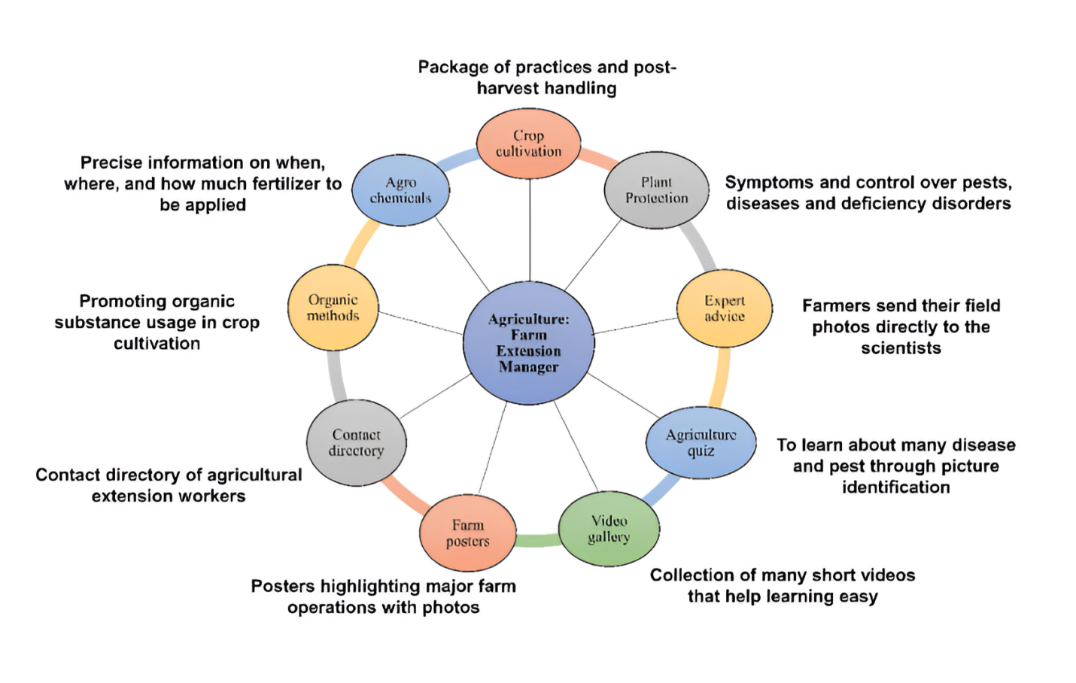

**Fig 1.** Salient features of Agriculture of Farm Extension Manager

1. Market Access and Price Information

Linking farmers to markets, mobile phones enable farmers to understand the market prices of their produce and link with consumers. This eliminates the risk of being cheated by middlemen. Applications such as Reuters Market Light in India provide farmers with real-time price information, which enables them to sell their produce for better prices (Aker, 2011; Mittal et al., 2010). In Africa, mobile phones have also empowered farmers to tap into better markets and save transport expenses by finding buyers within proximate locations. Farmers can obtain fair prices and reduce post-harvest losses by selling their produce promptly (Aker & Mbiti, 2010). Mobile phones have also made a significant impact in Africa. Platforms such as Esoko in Ghana and M-Farm in Kenya give farmers up-to-date market prices and link them to buyers in the surrounding areas. This not only enables farmers to earn higher prices but also saves them on transportation costs as they are able to find buyers locally. By selling their produce in a timely manner, farmers can also lower post-harvest losses, which is one of the main issues in most developing nations (Aker & Mbiti, 2010). For example, in sub-Saharan Africa, perishable crops post-harvest are lost to the tune of 30% due to lack of proper storage and procrastination in selling. Mobile platforms help farmers eliminate this problem by linking them to buyers sooner and even granting them access to cold storage (World Bank, 2019). These technologies are particularly beneficial for women farmers, who tend to encounter more difficulties in reaching markets. Mobile platforms provide them with the same information and access as men, enabling them to earn more and sustain their families (GSMA, 2020). Nevertheless, there are still some hurdles to be crossed. Not all farmers have smartphones or stable internet connections, and some might not possess the ability to utilize these technologies. Fixing these problems is important to provide all farmers with an opportunity to make use of these developments (FAO, 2021).

1. Financial Inclusion and Mobile Banking

Mobile Banking for farmers’ mobile banking apps such as M-Pesa in Kenya enable farmers to save, borrow and pay securely. The financial assistance enables farmers to purchase seeds and fertilizers on time (Kamal & Bablu, 2024). In India, mobile banking has also facilitated small farmers in increasing agricultural investment. Farmers are able to invest in quality seeds and equipment with the service of microloans, resulting in improved yields and income security (Mittal et al., 2010). Besides, electronic payment systems have minimized the use of cash payments, which is safer and quicker. In India, mobile banking has also transformed the existence of small farmers. Farmers can get microloans and invest in better seeds, new equipment and improved irrigation systems through mobile means. These investments lead to higher crop yields and constant revenues, allowing farmers to break out of poverty traps. Electronic payment systems have enhanced security and efficiency in transactions. Farmers no longer need to handle so much cash, reducing the chances of theft and receiving money for products and services is easier and faster (Mittal et al., 2010). Mobile banking has enabled greater access for women farmers and women in rural areas who encounter a deeper scope of barriers to financial services. These platforms have helped women save and borrow money in a secure environment, which allows them to invest more in their farms and help better their families’ livelihoods (GSMA,2020). However, problems such as lack of internet coverage, poor digital skills, and the cost of smartphones still need to be considered to guarantee that every farmer can benefit from these innovations (FAO,2021).

1. Weather Forecast and Disaster Alerts

Alerts and updates about the weather with weather applications like Agrimet in India, farmers are now aware of rainfall and thunderstorms earlier, which helps them take necessary measures to save their crops (Jayaraman et al., 2016). Timely notifications on mobile phones have helped farmers save their crops during floods and droughts. Farmers can also get recommendations on when to plant and harvest crops depending on the weather (Ananda et al., 2024; Mittal et al., 2010). Overall, farmers are better prepared, and with the right information, there are fewer chances of crops failing. Farmers are able to plan their activities ahead of time while minimizing the losses that may arise due to harsh weather because weather forecasts are accurate. Farmers living in remote areas are able to receive precise updates on the weather thanks to mobile phones (Mittal et al., 2010). For instance, in India, Reuters Market Light (RML) provides farmers with weather updates, guidelines on crops, and market prices through SMS on a daily basis. This enables farmers to make well-informed decisions about the best time to plant, water, and even harvest their crops, ensuring maximum success. These farmers are more prepared than the non-tech-enabled farmers for extreme weather like droughts or heavy rains that can potentially ruin their crops (Aker, 2011). Weather forecasts also help farmers reduce losses after harvesting. For instance, if farmers know rain is coming during the drying period, they can cover their crops or move them to a safe place. This is especially important in places like sub-Saharan Africa, where up to 30% of crops can be lost after harvest due to bad weather. By providing accurate and timely weather information, mobile platforms help farmers protect their crops and improve their overall productivity (FAO, 2021)

**Table 2.** Role of Weather Forecasts and Disaster Alerts in Agriculture

|  |  |  |  |
| --- | --- | --- | --- |
| **S. No.** | **Aspect** | **Benefits** | **References** |
| 1. | Early Warning Systems | Alerts for rainfall, thunderstorms, floods, and droughts help farmers prepare in advance | Jayaraman et al.,2016 |
| 2. | Crop Planning | Weather-based recommendations on planting and harvesting periods | Ananda et al., 2024; Mittal et al., 2010 |
| 3. | Real-time Notifications | Timely alerts via SMS or mobile apps ensure farmers are always updated | Jayaraman et al.,2016 |
| 4. | Remote Area Access | Farmers in remote areas receive accurate weather updates | Ananda et al., 2024; Mittal et al., 2010 |
| 5. | Integration with Market Information | Combined weather, crop, and market data helps in better decision-making | Aker, 2011 |
| 6. | Post-Harvest Loss Reduction | Alerts during drying and storage phases reduce weather-related post-harvest losses | Jayaraman et al.,2016 |
| 7. | Disaster Preparedness | Tech-enabled farmers better prepared for extreme weather events | Jayaraman et al.,2016 |
| 8. | Pest and Disease Management | Weather data helps forecast pest and disease outbreaks, allowing timely preventive measures | Ananda et al., 2024; Mittal et al., 2010 |
| 9. | Efficient Irrigation Scheduling | Accurate rainfall predictions help farmers optimize irrigation, saving water and reducing costs | FAO, 2021 |
| 10. | Crop Insurance Decisions | Reliable weather forecasts support claims assessment and risk evaluation for crop insurance | Ananda et al., 2024; Mittal et al., 2010 |
| 11. | Yield Prediction | Advanced weather data combined with crop models helps estimate potential yields | Aker, 2011 |
| 12. | Climate Adaptation Planning | Long-term weather trends help farmers adopt resilient crops and farming techniques | FAO, 2021 |
| 13. | Livestock Management | Weather alerts help livestock farmers protect animals from extreme heat, cold, or floods | Jayaraman et al.,2016 |
| 14. | Market Access and Price Planning | Weather-linked production forecasts support better price and supply chain planning | Ananda et al., 2024; Mittal et al., 2010 |
| 15. | Government Disaster Response | Aggregated weather data helps authorities coordinate disaster relief efforts efficiently | FAO, 2021 |

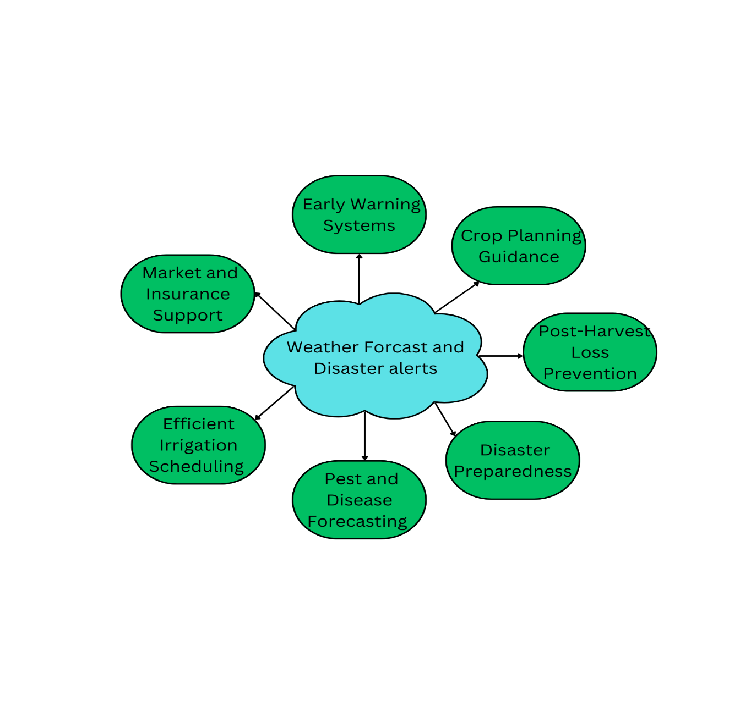

**Fig 2**. Role of Weather Forecasts and Disaster Alerts in Agriculture

1. Smart Farming and Use of Sensors

Precision Farming with Technology New technologies such as drones and sensors are assisting farmers in monitoring their fields through mobile apps. Microsoft FarmBeats and other such tools provide data on plants and soil, assisting farmers in conserving fertilizers and water. These techniques enhance crop yield and minimize wastage. Smart farming systems can also identify variations in soil health, assisting farmers in modifying their input usage accordingly. This leads to cost reduction and better crop quality, which makes farming more profitable and sustainable (Jayaraman et al., 2016; FAO, 2018). One of the greatest benefits of smart farming is that it can monitor soil health in real time. Field sensors can measure changes in soil nutrient levels, pH and moisture. This will enable farmers to change their practices quickly so that their crops receive exactly what they need in order to thrive. For example, when a sensor recognizes that a specific region of the field lacks nitrogen, the farmer will only add fertilizer to this area rather than the whole field. This specificity contributes to higher yields of crops and lower waste costs (World Bank, 2020). Nonetheless, there are a few challenges to the integration of smart farm technologies. It is beyond the reach of many small farmers to pay the exorbitant prices for drones, sensors, or sophisticated software. Moreover, improved internet penetration in rural areas is required to accommodate these technologies. Governments and agencies are planning to implement these challenges by making subsidies, training and infrastructure assistance available for farmers to adopt these technologies (IFAD, 2022).

**Table 3.** Role of Smart Farming and Use of Sensors in Modern Agriculture

|  |  |  |  |
| --- | --- | --- | --- |
| **S. No.** | Aspect | Description | References |
| 1. | Precision Farming | Use of sensors, drones, and smart devices to monitor crops and soil conditions in real time, ensuring accurate management of inputs. | Jayaraman et al., 2016; FAO, 2018 |
| 2. | Soil Health Monitoring | Sensors measure soil moisture, nutrient levels, and pH to help farmers adjust fertilizers and irrigation as needed. | World Bank, 2020 |
| 3. | Data-Driven Decision Making | Smart farming tools provide real-time data on crop health, enabling farmers to make timely, informed decisions to improve yield and quality. | IFAD, 2022 |
| 4. | Resource Efficiency | Targeted application of water, fertilizers, and pesticides reduces waste, lowers costs, and enhances sustainability. | Jayaraman et al., 2016; FAO, 2018 |
| 5. | Crop Yield Optimization | Real-time data helps farmers detect problems early, apply corrective measures, and maximize crop productivity. | IFAD, 2022 |
| 6. | Site-Specific Management | Farmers can apply fertilizers, water, or pest control only where needed instead of treating entire fields uniformly. | Jayaraman et al., 2016; FAO, 2018 |
| 7. | Cost Reduction | Reduced input costs (fertilizer, water, pesticides) through precise applications, lowering overall operational expenses. | IFAD, 2022 |
| 8. | Environmental Sustainability | Minimizes overuse of chemicals and water, reduces pollution, and supports eco-friendly farming practices. | World Bank, 2020 |
| 9. | Real-Time Alerts | Sensors and apps notify farmers of changes in weather, soil conditions, or crop health, allowing quick action to prevent losses. | Jayaraman et al., 2016; FAO, 2018 |
| 10. | Challenges in Adoption | High initial costs, lack of digital infrastructure in rural areas, and need for technical training limit widespread adoption. | IFAD, 2022 |
| 11. | Government Support | Subsidies, training programs, and improved rural internet connectivity are essential to help small farmers adopt smart farming technologies. | World Bank, 2020 |
| 12. | Market Access and Forecasting | Data from smart systems helps farmers predict harvest times, align with market demand, and plan sales strategies effectively. | Jayaraman et al., 2016; FAO, 2018 |
| 13. | Livestock Monitoring | In addition to crops, smart sensors monitor livestock health, feed intake, and environmental conditions, improving animal welfare and productivity. | IFAD, 2022 |

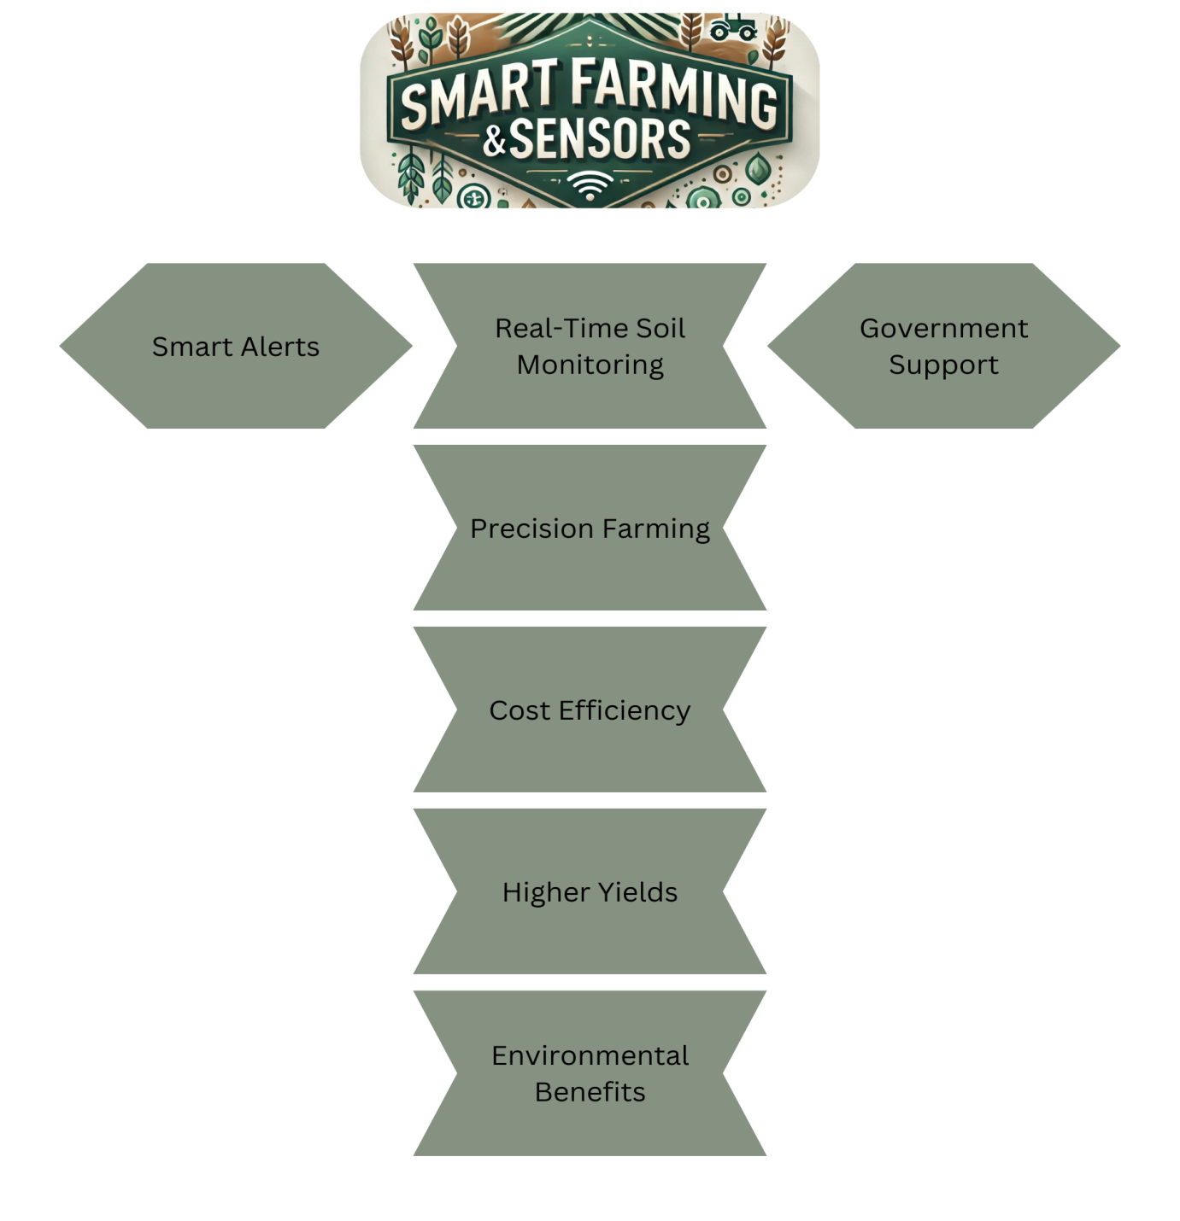

**Fig 3.** Role of Smart Farming and Use of Sensors in Modern Agriculture

1. Pest and Disease Control

Crops Management Apps such as Plantix enable farmers to capture images of their crops and detect pests or diseases. The app provides tips on how to safeguard the crops. This is an early detection that enables farmers to prevent the crops from being damaged. Mobile apps also advise farmers on how to apply pesticides correctly, which lowers the risk of crops being damaged and ensures food safety. Farmers have access to a community forum in such apps where they can post their problems and learn from other farmers' experiences (Sivakumar et al., 2022; Saikanth et al., 2023). One of the greatest advantages of these apps is that they instruct farmers on how to use pesticides. Rather than spraying indiscriminately, farmers can be given clear instructions on how much and where to spray and thereby minimize the risk of over-spraying or damage to crops. This not only protects the crops but also food safety by minimizing residue of toxic chemicals. Additionally, such applications can also contain information on organic or green alternatives to chemical pesticides, which are less harmful to the environment and human beings (FAO, 2021). But there are a few issues that need to be addressed. Not every farmer has a smartphone or internet connectivity, which restricts their use of these apps. More localized content is also required, as the pests and diseases may differ considerably from one location to another. Governments and NGOs are addressing these issues by making smartphones affordable, enhancing internet penetration and creating local condition-specific apps (IFAD, 2023).

1. Training and Knowledge Sharing

Learning From Mobile Platforms Farmers learn improved farming techniques through mobile videos and apps such as Digital Green. The platforms employ simple language and images in explaining farming practices, allowing the farmer to easily comprehend and implement the training (Bhattacharjee & Raj, 2014; Singh et al., 2023). Mobile platforms also provide interactive sessions where farmers can query and gain expert counsel. The training is often made accessible offline, allowing farmers to access the lessons even in areas with no internet. An excellent aspect of such platforms is that most of them provide offline access to learning materials. Farmers can download a video, a guide, or a tutorial and use it later, even if there is no internet connection available. This becomes particularly useful for rural areas where internet connectivity is poor or sporadic (FAO, 2021). For instance, a farmer in a rural village can download a video on seed choice and view it several times in order to have a complete idea of the procedure. Apart from personal learning, governments and NGOs are also utilizing these platforms to train groups of farmers. For instance, in Kenya, the WeFarm app links farmers to exchange tips and advice, establishing a knowledge network that benefits all (IFAD, 2023). Likewise, in India, the Kisan Suvidha app gives farmers weather forecasts, market prices and expert tips, enabling them to make informed choices regarding their crops.

1. Better Supply Chain

Enhancing Input and Output Systems Such applications as AgroStar in India enable farmers to place orders for seeds, fertilizers and other inputs directly from suppliers. This enables farmers to receive quality products at the right time. In Kenya, AgroManager enhances the buying and selling of crops in a transparent and efficient manner (Sivakumar et al., 2022; Qiang et al., 2012). These supply chain applications ensure that farmers receive equitable prices and are not exposed to counterfeit products. They also save the time and expense of going to physical markets, keeping the farmers engaged with more farm activities. These applications also provide financial inclusion through digital payments. Farmers can be paid or can pay for inputs using mobile wallets, thus minimizing the use of cash. It's not just safer but also more convenient, particularly in rural settings where bank access is poor (World Bank, 2022). For example, a Kenyan farmer can get paid for his maize directly into his M-Pesa account, which removes the possibility of carrying cash. Despite this, there still exist some hurdles. Not every farmer owns a smartphone or enjoys a stable internet connection, which hinders their usage of these apps. There should be greater awareness and training to enable farmers to learn how to effectively utilize these platforms (IFAD, 2023). The governments and organizations are attempting to tackle these problems by offering low-cost smartphones, enhancing internet connectivity, and providing training programs.

1. Women Empowerment

Empowering Women Farmers Mobile phones enabled women farmers to have improved access to agriculture information and financial services. For instance, India's Women Farmers App empowers women farmers to learn new methods and enhance their farms (Kamal & Bablu, 2024). They have earned more money and gained self-confidence (Mittal et al., 2010). Women farmers are also empowered by mobile groups through which they exchange experiences and collectively overcome farming issues, making informed decisions and become independent. Mobile phones have also enabled women farmers to network and learn from one another. Most applications and platforms also include community features, like group chats or forums, where women can share farming issues, exchange ideas and provide support. For instance, in Kenya, women farmers employ mobile groups to exchange advice on crop rotation, pest control and market prices. These networks assist women in making more informed decisions, problem-solving as a group and being more confident in their agricultural practices (World Bank, 2022). In addition to improving agricultural outcomes, mobile technology has also made women more independent and esteemed. With increased incomes and literacy, women farmers are able to contribute more to their families and society. For example, in Uganda, women using mobile farm apps have reported being treated with more respect and dignity at home and in their villages. This transformation is good not just for the women themselves but also for gender equality and social progress (IFAD, 2023).

1. Problems and Future Solutions

Challenges and Opportunities Although mobile technology is beneficial, poor network connectivity, lack of knowledge on the use of apps and high costs of internet are challenges that confront some farmers. In order to counter these setbacks, future innovations such as increased speed in 5G networks, easy-to-use apps with local languages, and artificial intelligence can enhance the utilization of mobile technology by farmers (Aker, 2011; Qiang et al., 2012). Governments and companies should collaborate in making smartphones and the internet affordable to farmers in rural areas. Digital literacy training programs can further increase technology uptake among farmers. Both the government and private sector firms also have a role to play in solving these problems. They can come together and provide affordable smartphones and subsidized internet bundles to rural farmers. For example, in India, the government has started initiatives to provide low-cost smartphones and improve internet connectivity in villages. Further, digital literacy courses can help farmers learn how to familiarize themselves with mobile applications and online tools (World Bank, 2022). The training sessions may be conducted through cooperatives, community centers, or even mobile vans that travel to rural regions. By surmounting these hurdles, mobile technology can be more useful to farmers, allowing them to increase their productivity, incomes and livelihoods. For example, in Kenya, farmers trained to use mobile apps saw higher crop yields and better market access (GSMA, 2020). Similarly, in Brazil, farmers using AI-based tools have been able to conserve water and increase profits. These success stories show that with the right hand-holding, mobile technology can transform agriculture and assist farmers worldwide (IFAD, 2023).

### **Conclusion**

Mobile applications have become very important tools in agriculture extension services, especially for farmers living in rural areas. In the past, farmers had to wait for agricultural officers to visit their farms to get advice. This process was slow, and sometimes, officers could not visit every farmer on time. Now, with mobile apps, farmers can get real-time information directly on their phones. They can check weather forecasts, learn about pest and disease control, see market prices, and even talk to agricultural experts without leaving their farms. Apps like Kisan Call Center in India and M-Kilimo in Kenya have helped farmers solve their problems faster by giving them instant expert advice. In addition to this, smart farming tools like sensors and drones can now connect to these mobile apps. These tools help farmers monitor soil health, check crop growth, and know exactly how much water, fertilizer, or pesticide to use. This helps farmers save money, reduce waste, and protect the environment. Another big advantage of mobile apps is that they also support mobile banking. This means farmers can receive payments, apply for loans, and buy farm inputs directly through their phones. This is very helpful for small farmers who may not have easy access to banks. However, there are still some challenges. Many farmers in rural areas do not have good internet or smartphones. Some farmers also don’t know how to use these apps properly because they have never used technology like this before. To fix these problems, governments, agricultural departments, and technology companies need to work together. They should provide affordable smartphones, better internet connections, and easy training programs to teach farmers how to use mobile apps. Overall, mobile apps have great potential to make agriculture more modern, efficient, and sustainable. By giving farmers quick access to the right information, these apps help them make better decisions, improve their crops, and earn more money. With the right support, mobile apps can play a big role in improving the lives of farmers and making agriculture better for the future.

Conflict of interest statement

The authors declare that they have no known competing financial interests or personal relationships that could have appeared to influence the work reported in this article.

Competing interests

Authors have declared that no competing interests exist.

**COMPETING INTERESTS DISCLAIMER:**

Authors have declared that they have no known competing financial interests OR non-financial interests OR personal relationships that could have appeared to influence the work reported in this paper.

Disclaimer (Artificial intelligence)

Option 1:

Author(s) hereby declare that NO generative AI technologies such as Large Language Models (ChatGPT, COPILOT, etc.) and text-to-image generators have been used during the writing or editing of this manuscript.

Option 2:

Author(s) hereby declare that generative AI technologies such as Large Language Models, etc. have been used during the writing or editing of manuscripts. This explanation will include the name, version, model, and source of the generative AI technology and as well as all input prompts provided to the generative AI technology

Details of the AI usage are given below:

1.

2.

3.

**References**

Aker, J. C. (2011). Dial “A” for Agriculture: A review of information and communication technologies for agricultural extension in developing countries. Agricultural Economics, 42(6), 631-647.

Aker, J. C., & Ksoll, C. (2015). Can mobile phones improve agricultural outcomes? Evidence from a randomized experiment in Niger. Food Policy, 60, 44-51.

Aker, J.C., & Mbiti, I.M. (2010). Mobile Phones and Economic Development in Africa. *Journal of Economic Perspectives*, *24*(3), 207-232.

Ananda, K. R., Saikanth, D. R. K., Chaudam, V., Sravani, S., Nayak, S. H., Dam, A., & Shukla, A. (2024). Impact of mobile technology on extension service delivery in remote farming communities: A review. Journal of Scientific Research and Reports, 30(3), 1-13.

Bhattacharjee, S., & Raj, S. (2014). Global review on mobile phone applications for agricultural extension.

FAO & ITU. (2018). E-agriculture in action: Drones for agriculture. Food and Agriculture Organization of the United Nations.

FAO. (2012). Mobile technologies for food security, agriculture and rural development: Role of the public sector. RAP Publication 2012/19.

FAO. (2021). Digital Technologies in Agriculture and Rural Areas: Status Report. Food and Agriculture Organization of the United Nations.

GSMA. (2020). Connected Women: The Mobile Gender Gap Report 2020. GSM Association.

GSMA. (2021). Smart Farming: How Mobile Technology is Transforming Agriculture. GSM Association.

IFAD. (2023). Supporting Smallholder Farmers with Digital Tools. International Fund for Agricultural Development.

Jayaraman, P. P., Yavari, A., Georgakopoulos, D., & Morshed, A. (2016). Internet of Things platform for smart farming: Experiences and lessons learnt. Sensors, 16(11), 1884.

Kamal, M., & Bablu, T. A. (2024). Mobile applications empowering smallholder farmers: An analysis of the impact on agricultural development. International Journal of Social Analytics, 8, 36-45.

Kamal, R., & Bablu, S. (2024). The Role of Mobile Banking in Agricultural Development: A Case Study of M-Pesa in Kenya. *Journal of Financial Inclusion, 12*(2), 45-60.

Kaundal, M., Seth, M., Singh, A., Sharma, K., Anand, H., Gantait, A., and Sharma, V. (2025). An Extensive Analysis of Unmanned Aerial Vehicle Technology and Its Effect on Agriculture. Ecology Environment and Conservation 30 (4), 1907-1912.

Mbiti, I., & Aker, J. C. (2010). Mobile phones and economic development in Africa. The Journal of Economic Perspectives, 24(3), 207-232.

Mittal, S., Gandhi, S., & Tripathi, G. (2010). Socio-economic impact of mobile phones on Indian agriculture. Working Paper No. 246. Indian Council for Research on International Economic Relations (ICRIER).

Qiang, C. Z., Kuek, S. C., Dymond, A., & Esselaar, S. (2012). Mobile applications for agriculture and rural development. World Bank.

Singh, N. K., Sunitha, N. H., Tripathi, G., Saikanth, D. R. K., Sharma, A., Jose, A. E., & Mary, M. V. K. J. (2023). Impact of digital technologies in agricultural extension. Asian Journal of Agricultural Extension, Economics & Sociology, 41(9), 963-970.

Sivakumar, S., Bijoshkumar, G., Rajasekharan, A., Panicker, V., Paramasivam, S., Manivasagam, V. S., & Manalil, S. (2022). Evaluating the expediency of smartphone applications for Indian farmers and other stakeholders. AgriEngineering, 4(3), 656-673.

Ugwoezuonu, L., & Ezike, C. C. (2024). Assessing the effectiveness of mobile apps in enhancing agricultural extension services delivery in Nigeria. African Journal of Sustainable Agricultural Development, 5(2), 13-31.

World Bank. (2012). Information and communication technology for agriculture. ICT in Agriculture e-Sourcebook. World Bank.

World Bank. (2019). ICT in Agriculture: Connecting Smallholders to Knowledge, Networks and Institutions. World Bank Group.

Ibe, M. N., Edet, A. I., Ajaero, J. O., & Godson-Ibeji, C. C. (2023). Agricultural Extension Workers' Use of Electronic Tools in Delivering Farm Information During Pandemics, Disasters and Emergencies in Imo State, Nigeria. *International Academy Journal of Agribusiness and Agricultural Science Annal*, *6*(3), 09-16.

Chamara, N., Islam, M. D., Bai, G. F., Shi, Y., & Ge, Y. (2022). Ag-IoT for crop and environment monitoring: Past, present, and future. *Agricultural systems*, *203*, 103497.

Abioye, D. O., Popoola, O., Akande, A., Fadare, D. A., Omitoyin, S. A., Yinusa, B., & Kolade, O. O. (2024). Farmers’ willingness to adopt digital application tools in Ogun State, Nigeria. *Journal of Strategy and Management*.

Jena, P., Chauhan , A. S., Tigga , A. S., Kumar , S., Kumari , M., Behera , S. K., Homa , F., & Saryam , M. (2023). Problems Faced by Farmers Using Digital Tools in Agriculture in Central Zone of India. *Asian Journal of Agricultural Extension, Economics & Sociology*, *41*(10), 311–316.