**Cover crops: Role in Agriculture Sustainability and Climate Change**

**Abstract**

This study explores the benefits of cover crops in climate change mitigation, highlights their role in sustainable agriculture, and discusses policy measures that can facilitate their broader integration into farming systems. Climate change significantly impacts global agricultural systems, necessitating the adoption of sustainable practices to mitigate its effects. Cover crops positively impact soil properties by reducing bulk density, improving soil structure, and enhancing water retention. They also increase soil nitrogen and organic carbon levels, making essential minerals such as phosphorus, potassium, calcium, iron, and magnesium more accessible for plant growth. They contribute to climate resilience by preventing soil erosion, increasing water retention, and sequestering carbon. Despite these advantages, challenges such as high implementation costs, regional climate variability, and knowledge gaps hinder their widespread adoption. Cover crops have the potential to enhance long-term sustainability, improve soil health, and increase the resilience of farming systems against climate change and other agricultural stressors. Addressing these challenges through research, incentives, and education can encourage more farmers to adopt cover cropping, ultimately promoting environmental sustainability and long-term food security.

**Keywords**: Cover crops, climate change mitigation, carbon sequestration, biodiversity, greenhouse gas reduction

# Introduction

Climate change has already endangered the soil-water resources and risked agricultural productivity in several regions worldwide. The cover cropping in the maize-soybean rotation proved to be one of the sustainable practices which can scavenge N from soil and reduce nitrate-nitrogen (NO3)–N loadings from subsurface drainage (Gupta et al., 2023; Fan et al., 2025). Cover crops, grown mostly to improve soil quality rather than for direct profit, are very important in sustainable farming. These crops preserve soil fertility, stop soil erosion, and help nutrients to be recycled. By lowering greenhouse gas emissions, increasing water conservation, and carbon sequestering in the ground, they also significantly help to slow down climate change (Thakrar et al., 2020; Sierra et al., 2024.The extensive acceptance of cover crops in agricultural systems as well as their contribution to climate resilience are investigated in this work.

Agriculture and food production contribute nearly one-third of global greenhouse gas (GHG) emissions, making them key drivers of climate change. Approximately 40% of these emissions stem from agricultural practices, while around 32% result from land-use changes (Nsabiyeze et al., 2024). However, agriculture also has immense potential to mitigate these emissions. Sustainable farming methods such as agroforestry can act as carbon sinks, significantly reducing net global emissions (Shukla et al., 2022). To achieve these benefits, farming practices must evolve. One of the most effective approaches for fostering climate-smart agriculture is integrating cover crops into conventional farming methods.

Addressing these pressing concerns requires collaboration between governments and citizens to implement effective policies that enhance agricultural sustainability. These initiatives could include the development of resilient crop varieties and advanced agricultural technologies that withstand environmental stressors. Additionally, reducing fossil fuel dependence and increasing the use of renewable resources are essential steps toward mitigating climate change effects. Promoting sustainable farming practices is critical to maintaining food security and ensuring agriculture's ability to support human populations. The rapid pace of climate change, biodiversity loss, and water scarcity underscores the urgency of transitioning to eco-friendly agricultural methods (Caesar, Abunga, Saa, & Nantui, 2018).

Cover crops, often referred to as "living mulch," "catch crops," or "green manures," serve as a protective layer over the soil. They are commonly incorporated into annual farming systems during fallow periods to reduce soil erosion. Globally, cover crops are categorized into two major types: broad-leaved (both leguminous and non-leguminous) and grasses. These crops decompose rapidly, forming a substantial soil cover that helps reduce groundwater contamination (Wendimu & Moral, 2021; Mondal, Veeck, & Yu, 2020). Additionally, they help minimize greenhouse gas emissions and improve the climate adaptability. Improve soil structure, increase nutrient efficiency, and reduce dependent on external fertilizer inputs, cover crops enhance both Soil health and agricultural yields.

Cover crops positively impact soil properties by reducing bulk density, improving soil structure, and enhancing water retention. They also increase soil nitrogen and organic carbon levels, making essential minerals such as phosphorus, potassium, calcium, iron, and magnesium more accessible for plant growth. Furthermore, cover crops create favorable conditions for microorganisms, promoting diverse and abundant soil microbial communities (Chaudhary, 2023). Under suitable conditions, these crops establish quickly, requiring adequate soil matter and efficiently transforming atmospheric nitrogen into usable forms. Furthermore, cover crops add organic matter with a low carbon/nitrogen (C/N) ratio and grow deep root systems, allowing nutrients to be absorbed from lower soil depths.

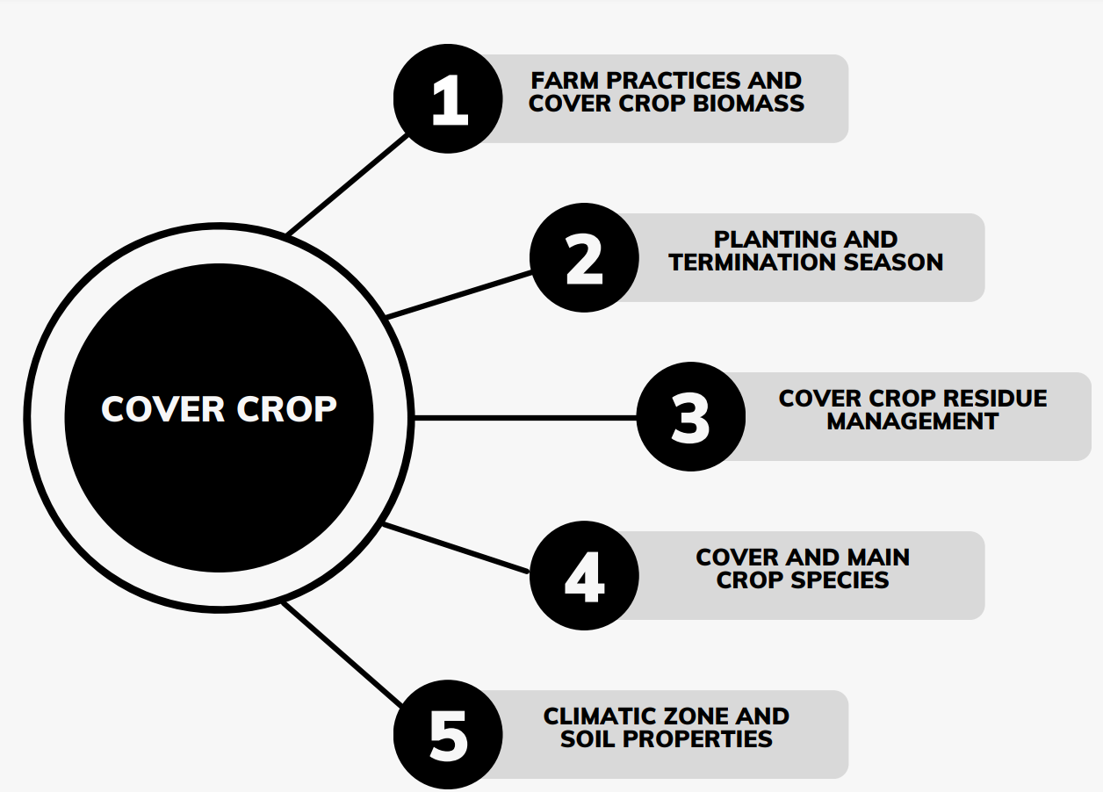

Figure 1: Effectiveness of cover cropping

**Role of Cover Crops in Climate Change Mitigation**

Long-term environmental shifts associated with climate change significantly affect agriculture, particularly through abiotic stressors that hinder plant growth, flowering, and productivity. Cover crops (CCs) offer a viable solution for mitigating these effects Cover crops (CCs) provide a feasible approach for minimizing these consequences by increasing soil carbon absorption, lowering greenhouse gas emissions, and improving soil health. By increasing soil organic matter and decreasing dependence on synthetic fertilizers, CCs contribute approximately 0.22 tonnes of carbon sequestration per hectare annually, aiding climate change mitigation. However, their impact on greenhouse gas emissions varies based on species, biomass quality, and termination methods.

Grass-based CCs, such as ryegrass and oats, release carbon more gradually, whereas leguminous CCs, including vetch and clover, decompose faster due to their lower carbon-to-nitrogen ratio, which may lead to increased nitrogen oxide emissions. The timing of CC termination also plays a crucial role in carbon and nitrogen dynamics—early suppression results in lower C:N ratios, potentially reducing emissions. Additionally, CCs enhance nitrogen cycling, reducing nitrate leaching and water pollution—especially in Mediterranean regions prone to heavy rainfall. They also improve precipitation storage efficiency, reducing irrigation demands and preventing soil erosion.

Certain CCs, such as milk vetch, help maintain rice production while simultaneously lowering methane emissions, a major contributor to global warming. Incorporating CCs into farming systems decreases the need for intensive agricultural operations, thereby reducing fuel consumption and overall carbon footprints. Furthermore, cover crop residues and mulching techniques, such as straw surface mulching and burial, effectively mitigate soil salinity in affected regions while sustaining crop productivity. These benefits highlight the role of CCs in fostering sustainable agricultural practices and enhancing climate resilience (Quintarelli, 2020).

|  |  |  |
| --- | --- | --- |
| **Role of Cover Crops** | **Description** | **References** |
| Carbon Sequestration | Enhances soil organic carbon storage through biomass and root matter integration. | Lal, R. (2015) |
| Reduction of Greenhouse Gas Emissions | Lowers nitrogenous oxide emissions by improving nitrogen efficiency and reducing fertilizer dependency. | Basche & DeLonge (2019) |
| Improved Soil Health | Enhances soil structure, microbial activity, and erosion resistance. | Blanco-Canqui & Ruis (2018) |
| Water Regulation | Increases water infiltration and retention, minimizing drought impacts and runoff. | Dabney et al. (2001) |
| Biodiversity Enhancement | Supports pollinators, beneficial insects, and microbial diversity. | Storkey et al. (2015) |
| Reduction in Chemical Inputs | Suppresses weeds, fixes nitrogen, and reduces synthetic fertilizer and herbicide use. | Teasdale et al. (2007) |

Table1: Role of Cover Crops in Climate Change Mitigation

**Soil Health and Resilience**

Cover crops (CCs) serve an important role in sustainable agriculture through enhancing soil health, increasing nutrient availability, and decreasing environmental consequences. Various CC types—including grains, legumes, root crops, and oil crops—offer distinct advantages. For example, Vicia sativa L. (common vetch) is known for its nitrogen-fixing ability, while Avena sativa L. (oats) and Secale cereale L. (rye) function as nutrient scavengers, capturing excess nitrogen and minimizing leaching risks (Vassilev, 2021). Additionally, brassicaceous cover crops like Raphanus raphanistrum subsp. sativus (radish) help break compacted soil, improving water infiltration and overall structure.

Leguminous CCs, such as subterranean clover, not only fix nitrogen but also enhance phosphorus uptake, reducing dependence on synthetic fertilizers. Mixed CC species, like rye and radish, offer synergistic benefits by reducing soil compaction, curbing erosion, and boosting biomass production. In Mediterranean regions, CCs have proven particularly effective in mitigating soil degradation caused by excessive tillage and chemical use, improving water-use efficiency, and regulating runoff (Mancinelli, 2019).

|  |  |  |  |
| --- | --- | --- | --- |
| Cover Crop | Soil Health Benefits | Resilience Benefits | References |
| Legumes | Nitrogen fixation, increased organic matter, improved microbial diversity | Enhances drought resistance, reduces erosion | Snapp et al. (2005), Blanco-Canqui et al. (2015) |
| Grasses | Enhances soil aggregation, carbon sequestration, reduces compaction | Suppresses weeds, improves water infiltration | Clark (2007), Kaspar & Singer (2011) |
| Brassicas | Breaks soil compaction, improves nutrient cycling, suppresses pathogens | Enhances water infiltration, prevents erosion | Weil & Kremen (2007), Williams & Weil (2004) |
| Mixed Cover Crops | Nitrogen fixation, carbon sequestration, boosts microbial activity | Enhances climate adaptability, improves biodiversity | Daryanto et al. (2018), Schipanski et al. (2014) |

Table 2: Soil Health and Resilience Benefits of Cover Crops

**Role of cover crops in Drought Resilience**

Changes in the water cycle have a significant impact on drought resistance by changing precipitation patterns, groundwater recharge, and surface water availability. Climate change and anthropogenic activities, such as deforestation and excessive water extraction, significantly disrupt the natural flow of water. These disruptions lead to prolonged dry periods, reduced soil moisture retention, and imbalances in hydrological processes. A disturbed water cycle often results in decreased precipitation and heightened evapotranspiration, further exacerbating drought conditions. Implementing effective water management strategies, such as sustainable irrigation, afforestation, and advanced conservation techniques, can enhance resilience by improving water conservation, soil retention, and storage capacity. Strengthening the natural water cycle is essential for mitigating drought risks and ensuring long-term water security.

|  |  |  |  |
| --- | --- | --- | --- |
| **Impact** | **Effect on Water Cycle** | **Effect on Drought Resilience** | **References** |
| Soil Moisture Retention | Reduces evaporation and enhances infiltration | Improves water availability during dry periods | Blanco-Canqui et al., 2013; Basche & DeLonge, 2019 |
| Infiltration Improvement | Enhances water absorption by reducing runoff | Stores more water in soil for sustained crop growth | Mitchell et al., 2017; Siller et al., 2021 |
| Soil Organic Matter Increase | Enhances the soil’s ability to retain moisture | Ensures long-term water availability | Lal, 2004; Basche & DeLonge, 2017 |
| Erosion Reduction | Reduces soil loss, preserving water-holding capacity | Maintains soil structure for better moisture retention | Montgomery, 2007; Blanco-Canqui et al., 2015 |
| Reduced Surface Runoff | Minimizes water loss and enhances groundwater recharge | Strengthens resilience against drought stress | Dabney et al., 2001; Basche, 2017 |
| Microbial Activity Boost | Improves soil structure, facilitating water movement | Enhances plant tolerance to drought stress | Six et al., 2002; Lupwayi et al., 2012 |

Table 3: Impact on Water Cycle and Drought Resilience

**Nitrogen Fixation and Reduction in Fertilizer Use**

Biological nitrogen fixation is critical for lowering reliance on synthetic fertilizers, promoting sustainable agriculture, and protecting the environment. Leguminous plants, in collaboration with nitrogen-fixing bacteria such as Rhizome, transform nitrogen from the atmosphere into physiologically accessible forms, organically improving soil fertility. This method reduces dependency on nitrogen-based fertilizers, which are energy-intensive to manufacture and can contribute to environmental problems such as water pollution, soil deterioration, and greenhouse gas emissions. Integrating nitrogen-fixing crops into crop rotations or inter-cropping systems improves soil health, increases biodiversity, or promotes long-term agricultural sustainability. This strategy not only lowers farmers' input costs, but it also lessens the environmental impact of conventional agricultural operations.

**Cover Crops and Carbon Sequestration**

Biodiversity is fundamental in maintaining ecosystem services essential for sustainable agriculture and food security. Agroforestry and diverse cropping systems rely on various organisms, including pollinators, soil microbes, and natural pest controllers, to enhance productivity and resilience. Biodiversity supports Important ecological services including nitrogen cycling, soil fertility, water regulation, and pest suppression, reducing the need for synthetic inputs while promoting environmental sustainability. Moreover, diverse cropping systems enhance resilience against climate change by improving soil health and reducing susceptibility to pests and diseases.(Kremen, & Miles et al., (2012))

The intricate interactions between species and their environment contribute to robust ecosystems capable of adapting to environmental shifts. However, biodiversity loss due to habitat destruction, climate change, and unsustainable agricultural practices threatens these essential services, potentially leading to ecosystem degradation and decreased functionality. Conservation efforts and sustainable management strategies are necessary to preserve biodiversity and ensure ecological balance, thereby maintaining the long-term stability of agricultural systems.(Dainese et al.,2019)

**Cover Crops and Sustainable Agriculture**

Cover crops are an essential component of sustainable agriculture, significantly enhancing soil health, preventing erosion, and improving overall biodiversity. These plants, such as legumes, rye, and clover, are primarily cultivated to protect the soil rather than for direct harvest. By covering the ground, they prevent nutrient leaching, suppress weed growth, and improve soil structure. Legume-based cover crops contribute additional benefits by naturally fixing nitrogen, reducing the need for synthetic fertilizers, and enriching soil fertility.

Furthermore, cover crops play a crucial role in carbon sequestration, helping to mitigate climate change effects by capturing atmospheric carbon and incorporating it into the soil. Integrating cover crops into crop rotation systems enhances resilience against extreme weather events, ensuring long-term agricultural productivity. Their ability to improve soil structure and fertility contributes to higher yields in subsequent crops, reducing dependency on chemical inputs. Although the initial adoption of cover crops may involve implementation costs, long-term economic benefits include improved crop performance, reduced fertilizer expenses, and enhanced farm sustainability. Thus, incorporating cover crops is a practical and effective strategy for promoting sustainable agriculture and ensuring global food security.

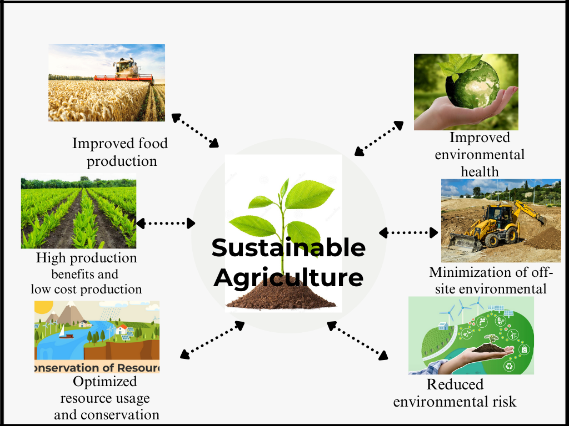

Figure 2: Cover crops and sustainable agriculture.

**Challenges and Limitations of Cover Crops**

Despite the numerous environmental and agricultural benefits of cover crops, their implementation comes with certain issues and constraints. One of the major difficulties is their varying effectiveness based on local soil conditions and climatic factors. In regions with extreme weather conditions, such as prolonged droughts or high temperatures, cover crops may struggle to establish, reducing their capacity to improve soil health and avoid erosion. For instance, in arid and semi-arid regions, inadequate moisture levels can hinder cover crop growth and limit microbial activity essential for nutrient cycling. Additionally, sandy soils, which have low water retention and limited nutrient-holding capacity, present challenges as they restrict cover crop growth and often require additional soil amendments to maintain fertility (Blanco-Canqui et al., 2012).

Another significant obstacle is the economic burden and logistical complexity involved in cover crop adoption. Farmers must invest in seeds, specialized equipment, and additional labor, which can be costly, especially for small-scale farmers or those already operating under financial constraints. In the short term, cover crops occupy land that could be used for commercial crop production, raising concerns about potential reductions in immediate profits. This issue is particularly pressing for tenant farmers who do not own the land they cultivate, as they may not perceive long-term soil health benefits as a sufficient incentive to offset the upfront costs. Additionally, inadequate access to technical knowledge and limited research on region-specific best practices for integrating cover crops into existing farming systems make successful implementation more challenging (Blanco-Canqui et al., 2012; Smith et al., 2015).

**Cover Crops in Regenerative and Conservation Agriculture**

Cover crops have become an essential component of conservation and regenerative agriculture due to their potential to increase biodiversity, improve soil health, and help to mitigate climate change. These farming approaches prioritize soil restoration, reducing erosion, and minimizing reliance on external inputs, fostering more resilient and sustainable agricultural systems (Lal, 2020).

One of the main benefits of cover crops in regenerative agriculture is the role in maintaining and improving soil health. By providing continuous ground cover, they enhance water infiltration, minimize soil erosion, and promote organic matter accumulation, ultimately increasing soil fertility (Kaye & Quemada, 2017). In conservation tillage systems, cover crops help reduce soil disturbance, which fosters beneficial microbial communities, suppresses weeds, and retains moisture (García-Ruiz et al., 2019).

Cover crops provide a substantial contribution to nutrient cycling, especially when paired with no-till or reduced-till farming practices. Leguminous cover crops, such as clover and vetch, fix atmospheric nitrogen, lowering the need for synthetic fertilizers while increasing soil fertility (Drinkwater and Snapp, 2007). Further, deep-rooted species such as radishes help break up compacted soil layers and mobilize nutrients, making them more available to future crops (Blanco-Canqui et al., 2015).

Moreover, cover crops support biodiversity by providing habitats for pollinators and beneficial insects, which naturally suppress pests and reduce the need for chemical pesticides (Storkey et al., 2015). Farms integrating cover crops within regenerative systems are better suited to handle adverse weather conditions, including high rainfall and lengthy drought, because to increased soil structure and moisture retention (Basche & DeLonge, 2019).

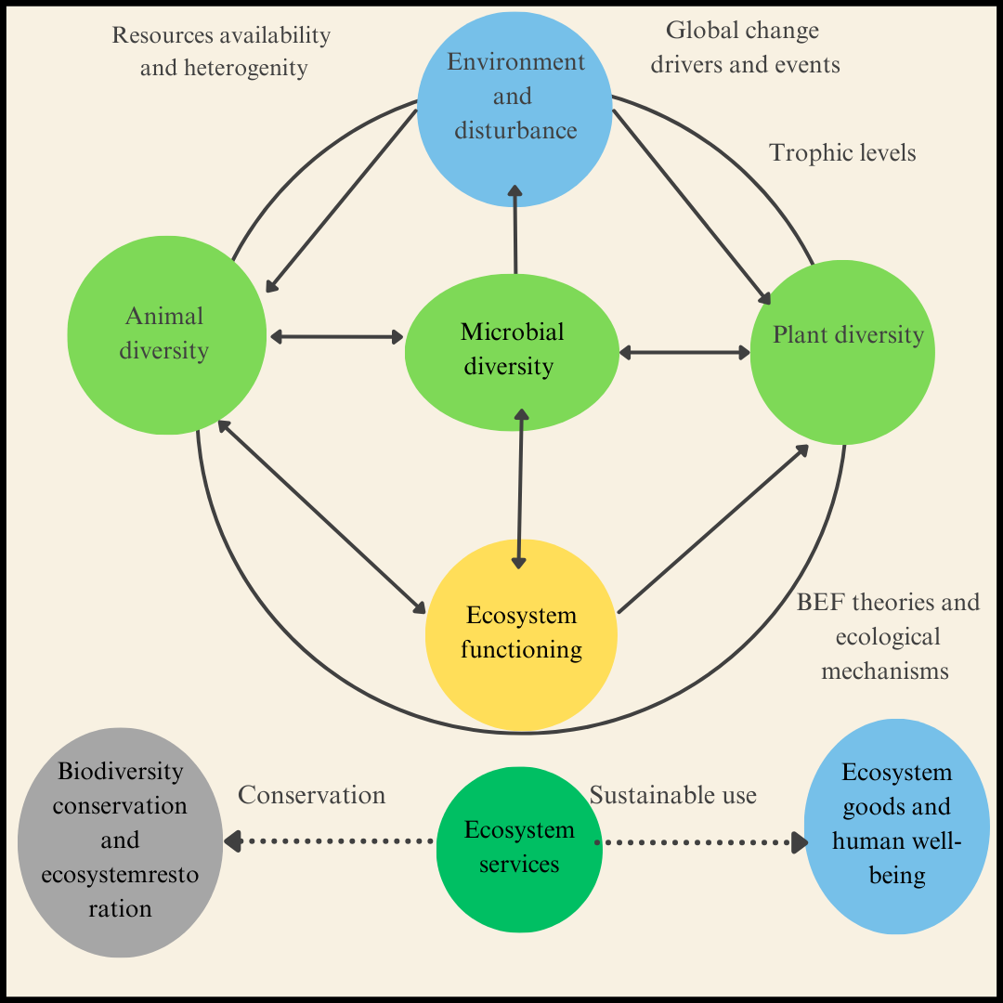

Figure 3: Conservation Agriculture and biodiversity

**Policy and Incentives for Cover Crop Adoption**

Effective policy frameworks play a critical role in promoting the widespread adoption of cover crops by offering financial incentives and technical assistance to farmers. Governments can introduce subsidies or grants to offset the initial costs of cover crop implementation, making the practice more financially viable. Additionally, education and training programs are essential in helping farmers understand the benefits and optimal management practices associated with cover crops.

Carbon sequestration incentives and soil health initiatives further encourage farmers to adopt cover cropping as a standard practice. By linking financial support to environmental conservation goals, policymakers can help mainstream sustainable agriculture practices that improve soil conservation, biodiversity, and climate change mitigation.

Cover crops, when integrated with no-till farming techniques, have gained significant traction in sustainable agriculture. Conservation agriculture (CA) increasingly recognizes cover crops as a vital component due to their ability to enhance soil structure and nutrient cycling while reducing the need for chemical inputs (Jacobs et al., 2022; Sakagami, 2021). In regions like California, cover crops promote microbial diversity, which improves plant nutrition and nutrient retention in soils, contributing to overall soil health (Lal et al., 2021).

A key principle of conservation agriculture is maintaining continuous soil cover, often with crop residues left on the surface. However, during periods between crop harvest and replanting, the absence of vegetative cover leaves soil exposed to erosion and weathering. Cover crops serve as a crucial bridge, protecting soil from degradation and enhancing agroecosystem stability. Beyond improving soil quality, they play a broader role in promoting biodiversity across the agricultural landscape.

**Future Perspectives and Research Gaps**

Despite growing interest in cover crops and sustainable agriculture, significant research gaps remain, particularly concerning the socioeconomic impacts of organic farming and diversified cropping systems. More comprehensive studies are needed to assess how these practices influence rural incomes and poverty alleviation (Das et al., 2023; Reardon et al., 2024). This data is essential for informing policymakers and encouraging farmers to adopt diversified agricultural methods that integrate organic inputs effectively.

Further research should also explore the long-term effects of crop rotation on soil fertility, nutrient availability, and water retention across different seasons and climatic conditions. Additionally, studies focusing on soil microbial biomass (SMB), soil organic carbon (SOC), and agroforestry sustainability are crucial for understanding the broader implications of organic farming. Investigating the interactions between different crops and organic amendments across diverse climate zones can provide valuable insights into optimizing soil health management.

Moreover, research into organic fertilization should examine its influence on weed and pest control, nutrient runoff prevention, and suppression of soil-borne diseases (Pervaiz et al., 2020). Addressing these research gaps will enable the development of more targeted agricultural policies and practical guidelines, ultimately supporting the widespread adoption of sustainable farming practices.

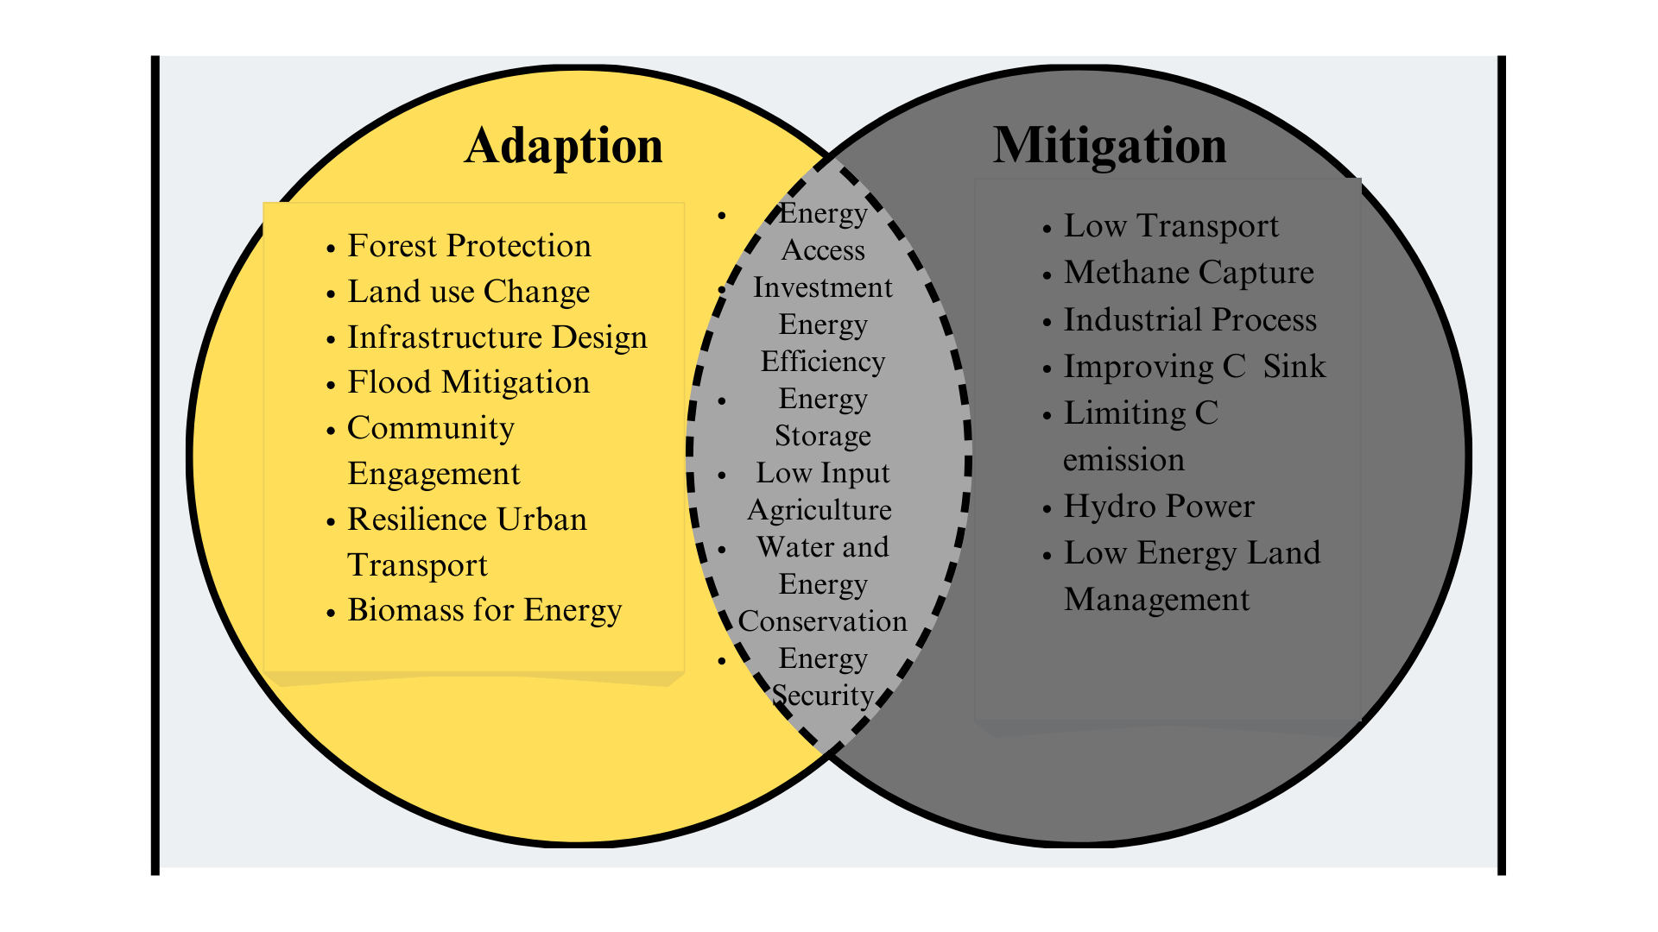

Figure 4 :Climate change adaptation and mitigation (Winkelman et al.[2017]

**Results**

The analysis of existing literature underscores both the advantages and challenges associated with the adoption of cover crops in agriculture. These crops play a crucial role in promoting soil fertility, enhancing biodiversity, and supporting sustainable farming practices. However, their efficiency and success depend on multiple factors, including environmental conditions, economic feasibility, and government policies.

**1. Impact on Soil Health and Water Retention**

Research consistently demonstrates that cover crops significantly contribute to soil structure improvement, increase in organic matter, and better moisture retention. According to Kaye & Quemada (2017), cover crops can enhance water infiltration by 20–50%, thereby minimizing runoff and effectively reducing soil erosion. Furthermore, studies by Basche & DeLonge (2019) reveal that farms incorporating cover crops exhibit increased resilience to drought, attributed to enhanced soil porosity and improved water-holding capacity. Additionally, cover crops suppress soil compaction, fostering root penetration and overall soil aeration, which further enhances plant health and productivity.

**2. Nutrient Cycling and Reduced Fertilizer Dependence**

Leguminous cover crops, such as clover and vetch, contribute to natural nitrogen fixation, thereby reducing dependency on synthetic fertilizers. Research conducted by Drinkwater & Snapp (2007) indicates that nitrogen-fixing cover crops can lower synthetic nitrogen fertilizer requirements by 30–60%, which not only cuts costs for farmers but also mitigates negative environmental effects. Similarly, deep-rooted species like radishes are highly effective in mobilizing essential nutrients from deeper soil layers, ensuring that subsequent crops benefit from improved nutrient availability (Blanco-Canqui et al., 2015). The integration of cover crops in crop rotation systems also aids in phosphorus retention and prevents nutrient leaching, thereby supporting long-term soil fertility.

**3. Biodiversity and Ecosystem Benefits**

Cover crops serve as crucial habitats for beneficial insects, pollinators, and essential soil microbes, which contribute to ecosystem balance. Storkey et al. (2015) observed that farms implementing cover cropping strategies experienced a 25% rise in pollinator activity and a 40% decline in pest populations due to improved biological control. Moreover, the enhancement of soil microbial diversity, facilitated by cover crops, promotes efficient nutrient cycling and organic matter decomposition, further strengthening soil health (Lal et al., 2021). Additionally, cover crops improve weed suppression through natural allelopathic effects, reducing reliance on herbicides and promoting environmentally friendly farming practices.

**4. Economic and Logistical Challenges**

Despite the numerous benefits of cover crops, their widespread adoption is hindered by economic and logistical constraints. High initial costs related to seed purchase, specialized equipment, and additional labor requirements pose significant barriers, particularly for small-scale farmers with limited financial resources. Research suggests that transitioning to a cover cropping system may lead to short-term yield reductions, which can be challenging for farmers who depend on immediate returns (Blanco-Canqui et al., 2012). Furthermore, tenant farmers often lack the motivation to invest in soil improvement strategies since they do not own the land they cultivate. The time required for cover crops to deliver substantial economic benefits further discourages adoption, as farmers may not be willing to wait multiple seasons for measurable financial gains.

**5. Policy Support and Incentives**

Government initiatives and financial incentives are pivotal in encouraging the integration of cover crops into conventional farming systems. Studies by Jacobs et al. (2022) and Sakagami (2021) highlight that subsidies, grants, and carbon credit programs have significantly boosted cover crop adoption in regions where such incentives are accessible. Policies promoting soil conservation and carbon sequestration have proven effective in motivating farmers to embrace cover cropping practices. Additionally, educational outreach programs and technical assistance play a crucial role in raising awareness about the long-term benefits of cover crops, helping farmers make informed decisions regarding their implementation. Collaborative efforts between government bodies, research institutions, and agricultural extension services can further facilitate the successful adoption of cover crops.

**6. Research Gaps and Future Directions**

Although existing studies confirm the environmental and agronomic advantages of cover crops, there are still gaps in understanding their long-term economic and social impacts. More comprehensive research is required to evaluate the profitability of cover cropping over extended periods and to assess its potential role in poverty reduction within rural agricultural communities (Das et al., 2023; Reardon et al., 2024). Additionally, further investigations are needed to refine cover crop selection based on diverse climatic conditions to ensure optimal performance across different farming systems. Advancements in precision agriculture and remote sensing technologies could also play a role in optimizing cover crop management, enabling more efficient and sustainable agricultural practices.

**Conclusion**

The findings emphasize that while cover crops offer substantial environmental and agronomic benefits, several challenges hinder their widespread adoption. Economic constraints, lack of technical knowledge, and inadequate policy support remain major obstacles. Addressing these challenges through well-structured financial incentives, farmer education programs, and targeted research efforts can facilitate the successful integration of cover crops into mainstream agriculture. By overcoming these barriers, cover crops have the potential to enhance long-term sustainability, improve soil health, and increase the resilience of farming systems against climate change and other agricultural stressors.

Conflict of interest statement

The authors declare that they have no known competing financial interests or personal relationships that could have appeared to influence the work reported in this article.

Disclaimer (Artificial intelligence)

Option 1:

Author(s) hereby declare that NO generative AI technologies such as Large Language Models (ChatGPT, COPILOT, etc.) and text-to-image generators have been used during the writing or editing of this manuscript.

Option 2:

Author(s) hereby declare that generative AI technologies such as Large Language Models, etc. have been used during the writing or editing of manuscripts. This explanation will include the name, version, model, and source of the generative AI technology and as well as all input prompts provided to the generative AI technology

Details of the AI usage are given below:

1.

2.

3.

# References:

1. Blanco‐Canqui H, Shaver TM, Lindquist JL, Shapiro CA, Elmore RW, Francis CA, Hergert GW. Cover crops and ecosystem services: Insights from studies in temperate soils. Agronomy journal. 2015 Nov;107(6):2449-74.
2. Smith E. The role of local knowledge in developing context sensitive agroforestry options for smallholder farmers. Bangor University (United Kingdom); 2018.
3. Lal R. Managing soils for negative feedback to climate change and positive impact on food and nutritional security. Soil Science and Plant Nutrition. 2020 Jan 2;66(1):1-9.
4. Agula C, Akudugu MA, Dittoh S, Mabe FN. Promoting sustainable agriculture in Africa through ecosystem-based farm management practices: evidence from Ghana. Agriculture & Food Security. 2018 Dec;7:1-1.
5. Yigezu Wendimu G. The challenges and prospects of Ethiopian agriculture. Cogent Food & Agriculture. 2021 Jan 1;7(1):1923619.
6. Rani M, Chaudhary BS, Jamal S. Towards Sustainable Natural Resources Monitoring and Managing Ecosystem Biodiversity. Remote sensing. 2024 Mar 14.
7. Adetunji AT, Ncube B, Mulidzi R, Lewu FB. Management impact and benefit of cover crops on soil quality: A review. Soil and Tillage Research. 2020 Oct 1;204:104717.
8. Vassilev N, Malusà E, Neri D, Xu X. Plant Root Interaction With Associated Microbiomes to Improve Plant Resiliency and Crop Biodiversity. Frontiers in Plant Science. 2021 Jul 2;12:715676.
9. Mancinelli R, Muleo R, Marinari S, Radicetti E. How soil ecological intensification by means of cover crops affects nitrogen use efficiency in pepper cultivation. Agriculture. 2019 Jul 7;9(7):145.
10. Change IP. Climate change 2007: the physical science basis. Agenda. 2007 May 31;6(07):333.
11. Rockström J, Falkenmark M, Folke C, Lannerstad M, Barron J, Enfors E, Gordon L, Heinke J, Hoff H, Pahl-Wostl C. Water resilience for human prosperity. Cambridge University Press; 2014 Mar 27.
12. Galloway JN, Townsend AR, Erisman JW, Bekunda M, Cai Z, Freney JR, Martinelli LA, Seitzinger SP, Sutton MA. Transformation of the nitrogen cycle: recent trends, questions, and potential solutions. Science. 2008 May 16;320(5878):889-92.
13. Van Groenigen KJ, Bloem J, Bååth E, Boeckx P, Rousk J, Bodé S, Forristal D, Jones MB. Abundance, production and stabilization of microbial biomass under conventional and reduced tillage. Soil Biology and Biochemistry. 2010 Jan 1;42(1):48-55.
14. Altieri MA. The ecological role of biodiversity in agroecosystems. InInvertebrate biodiversity as bioindicators of sustainable landscapes 1999 Jan 1 (pp. 19-31). Elsevier.
15. Altieri MA. The ecological role of biodiversity in agroecosystems. InInvertebrate biodiversity as bioindicators of sustainable landscapes 1999 Jan 1 (pp. 19-31). Elsevier.
16. Wulanningtyas HS, Gong Y, Li P, Sakagami N, Nishiwaki J, Komatsuzaki M. A cover crop and no-tillage system for enhancing soil health by increasing soil organic matter in soybean cultivation. Soil and Tillage Research. 2021 Jan 1;205:104749.
17. Lal R. Soil management for carbon sequestration. South African Journal of Plant and Soil. 2021 May 27;38(3):231-7.
18. Zhang Y, Wang Z, Lu Y, Zuo L. Biodiversity, ecosystem functions and services: Interrelationship with environmental and human health. Frontiers in Ecology and Evolution. 2022 Nov 29;10:1086408.
19. Takacs V, O’Brien CD. Trends and gaps in biodiversity and ecosystem services research: A text mining approach. Ambio. 2023 Jan;52(1):81-94..
20. Qiu J, Mitchell M. Understanding biodiversity–ecosystem service linkages in real landscapes. Landscape Ecology. 2024 Nov 4;39(11):188.
21. Das S, Patra S, Darshan NP. Agricultural diversification: necessity, drivers, and future pro-spects. Emerging Trends in Agricultural Extension Education. Bhubaneswar, Odisha. 2023:102-13.
22. Sharma P, Singh A, Kahlon CS, Brar AS, Grover KK, Dia M, Steiner RL. The role of cover crops towards sustainable soil health and agriculture—A review paper. American Journal of Plant Sciences. 2018 Aug 7;9(9):1935-51.
23. Bergtold JS, Ramsey S, Maddy L, Williams JR. A review of economic considerations for cover crops as a conservation practice. Renewable Agriculture and Food Systems. 2019 Feb;34(1):62-76..
24. Turk JK, Graham RC. Disturbance impacts on porosity and hydraulic properties of vesicular horizons. Soil Science Society of America Journal. 2020 Mar;84(2):543-55.
25. Reardon T, Timmer CP, Berdegue J. The rapid rise of supermarkets in developing countries: Induced organizational, institutional and technological change in agri-food systems. InThe Transformation of Agri-Food Systems 2012 May 23 (pp. 47-65). Routledge.
26. Pervaiz ZH, Iqbal J, Zhang Q, Chen D, Wei H, Saleem M. Continuous cropping alters multiple biotic and abiotic indicators of soil health. Soil Systems. 2020 Sep 23;4(4):59.
27. Kaye JP, Quemada M. Using cover crops to mitigate and adapt to climate change. A review. Agronomy for sustainable development. 2017 Feb;37:1-7.
28. Kim N, Zabaloy MC, Guan K, Villamil MB. Do cover crops benefit soil microbiome? A meta-analysis of current research. Soil biology and Biochemistry. 2020 Mar 1;142:107701.
29. Neher DA, Harris JM, Horner CE, Scarborough MJ, Badireddy AR, Faulkner JW, White AC, Darby HM, Farley JC, Bishop-von Wettberg EJ. Resilient soils for resilient farms: An integrative approach to assess, promote, and value soil health for small-and medium-size farms. Phytobiomes Journal. 2022 Sep;6(3):201-6.
30. Dainese M, Martin EA, Aizen MA, Albrecht M, Bartomeus I, Bommarco R, Carvalheiro LG, Chaplin-Kramer R, Gagic V, Garibaldi LA, Ghazoul J. A global synthesis reveals biodiversity-mediated benefits for crop production. Science advances. 2019 Oct 16;5(10):eaax0121.
31. Kremen C, Miles A. Ecosystem services in biologically diversified versus conventional farming systems: benefits, externalities, and trade-offs. Ecology and society. 2012 Dec 1;17(4).
32. Gupta, R., Bhattarai, R., Dokoohaki, H., Armstrong, S. D., Coppess, J. W., & Kalita, P. K. (2023). Sustainability of cover cropping practice with changing climate in Illinois. Journal of Environmental Management, 339, 117946.
33. Fan, Y., He, L., & Wang, S. (2025). Limited improvement of crop nitrogen management sustainability through optimal crop distributions in drylands. Journal of Environmental Management, 377, 124716.
34. Sierra, C. A., Ahrens, B., Bolinder, M. A., Braakhekke, M. C., von Fromm, S., Kätterer, T., ... & Wang, G. (2024). Carbon sequestration in the subsoil and the time required to stabilize carbon for climate change mitigation. Global Change Biology, 30(1), e17153.
35. Nsabiyeze, A., Ma, R., Li, J., Luo, H., Zhao, Q., Tomka, J., & Zhang, M. (2024). Tackling climate change in agriculture: A global evaluation of the effectiveness of carbon emission reduction policies. Journal of Cleaner Production, 142973.
36. Shukla, P. R., Skea, J., Slade, R., Al Khourdajie, A., van Diemen, R., McCollum, D., ... & Malley, J. (2022). Climate change 2022: Mitigation of climate change. Contribution of working group III to the sixth assessment report of the Intergovernmental Panel on Climate Change, 10, 9781009157926.