***Original Research Article***

**Parasites Affecting Native Freshwater Fishes in Punatsangchhu, Bhutan**

**Abstract**

Fish parasites play a crucial role in the health and ecology of freshwater fishes; however, they are often overlooked. This study aims to determine the diversity and distribution of parasites in native freshwater fishes of Punatsangchhu and its tributary, Toebrongchhu, and examine their relationship with eco-hydrological parameters. A total of 44 fish specimens of *Schizothorax richardsonii* and *Pseudecheneis sulcate* were collected through systematic random sampling. The specimens were dissected, and the parasites were examined under a stereomicroscope. Concurrently, water quality parameters were measured in the field. Two parasite genera, *Rhabdochona* spp. and *Ergasilus* spp., were identified. The low diversity (H’ = 0.05) may be attributed to low host diversity and data collection during winter. The parasite count showed strong positive correlations with fish weight (*p* < 0.001, *ρ* = 0.739) and length (*p* < 0.001, *ρ* = 0.773), suggesting increased susceptibility in older, larger fish. Logistic regression and the Mann-Whitney U test confirmed that infected fish were significantly larger and heavier. Parasite abundance also correlated positively with pH, temperature, TDS, EC, salinity, depth, and turbidity, indicating that elevated values of these parameters may impair fish immunity and increase the susceptibility of parasite infection. Principal Component Analysis revealed additional potential relationships between parasite prevalence and other eco-hydrological parameters. Furthermore, the spatial distribution of parasites indicated a higher prevalence in Punatsangchhu than in Toebrongchhu. This study provides baseline information on fish parasites, making such studies crucial for long-term aquatic biodiversity management. Future research must employ seasonal, multi-species sampling and improved diagnostic methods.

**Keywords:**  Distribution, Diversity, Fish, Parasites, Prevalence.

1. **Introduction**

Freshwater ecosystems, which comprise only 2.5% of the water on the planet, are essential for human life and support vast biodiversity, natural processes, and nutrient cycling (Apostolaki *et al.,* 2020). These ecosystems host complex interactions, including competition, predation, mutualism, and parasitism. Such interactions shape the dynamics of species populations and influence their overall health and survival. The interaction between two populations can often be affected by a third population of a different species. For instance, a parasite, virus, or predator can alter the outcome of competition between two species (Hasik *et al.,* 2023). Among these, parasites frequently cause a detrimental impact on the host species.

Fish are hosts to major groups of animal parasites. Fish living in natural environments are rarely found to be infection-free, as most fish species are intermediate hosts for many different types of parasites. Fish with parasitic infestations often have a slower development rate, lower productivity, impaired reproduction, weight loss, gill abnormalities, and other symptoms. Parasites can be broadly classified into two distinct groups as endoparasites and ectoparasites. The endoparasites are the internal fish parasites, which are found in the intestines, various internal organs, and the body cavity, and even in the flesh. Ectoparasites are generally found on the external surface of the fish, including skin or on scales, gills, oral cavity, and gill rakers (Tesfaye *et al.,* 2017).

Additionally, parasites serve as valuable indicators of ecosystem health and stability (Palm, 2011). Despite their vital roles, parasites are generally overlooked in many studies (Barber *et al.,* 2000). Furthermore, the free-living infectious stages of fish parasites can serve as excellent pollution indicators since they are susceptible to their surrounding environmental conditions. Several fish parasites have been reported and documented in other Himalayan regions (Debenedetti *et al.,* 2019; Devkota *et al.,* 2023; Gautam *et al.,* 2024), but there is no specific work on fish parasites in Bhutan. Despite the significant role of fish parasites in ecosystem health, no baseline data or detailed studies have been conducted in freshwater fish populations of Bhutan, particularly in the Punatsangchhu River. This study aims to characterise the parasites impacting the health of native freshwater fishes, to analyse the association between eco-hydrological parameters, fish morphometric characteristics, with parasite abundance and to determine the spatial distribution pattern of parasites in the study area.

1. **Materials and Methods**

**2.1. Study area**

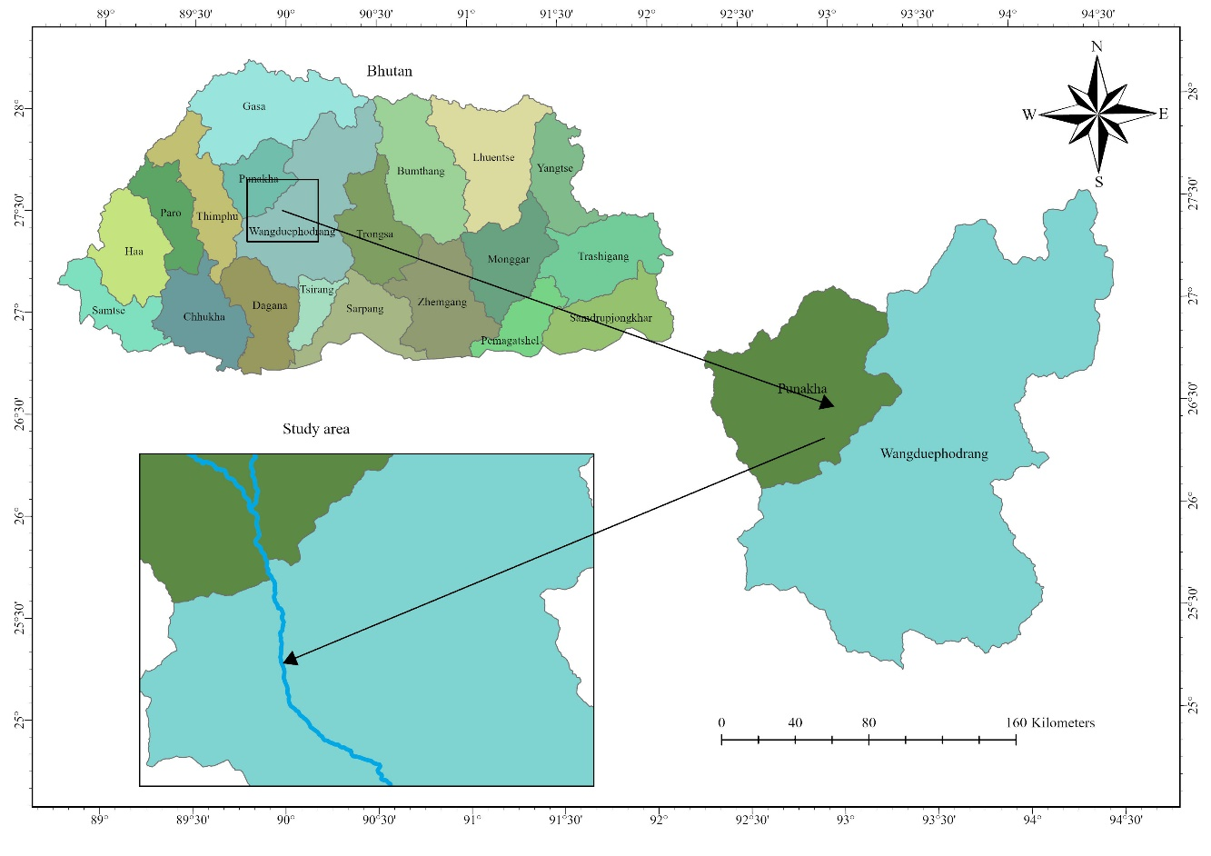The study was carried out in Punatsangchhu and its tributary, Toebrongchhu, which is located in Punakha and Wangdue Phodrang. Punatsangchhu flows through five districts of Gasa, Punakha, Wangdue Phodrang, Tsirang, and Dagana. The elevation extends from 200 to 6,500 meters above sea level (Subedi *et al.,* 2024). The river is approximately 320 km from the source till it meets the Brahmaputra and runs through Bhutan for around 250 km. The discharge of the river fluctuates seasonally, often due to monsoon rains and snowmelt. However, the natural flow of the river has been significantly altered by the construction of hydropower dams. The hydropower dams may impact fish migration, habitat availability (Khanal *et al.,* 2022), and parasite-host interactions.

Figure 1: Study area

**2.2. Research design**

A systematic random sampling method was used to collect data along the river transect. The study was conducted in the sampling area of Punatsangchhu and its tributary, Toebrongchhu. The study area transect extended 13 kilometers from Bajo to the confluence of Phochhu and Mochhu. Additionally, a transect of more than two kilometers was laid in Toebrongchhu. The study site was laid in the transect with a site-to-site distance of 1,000 m, and a 300 m sampling stretch was laid inside each sampling site (Dorji & Sagar, 2025). Within each site, three sample plots were laid randomly, making the overall sample size of 45 in 15 sites.

## 2.3. Data collection

## 2.3.1. Fish sample collection

The fish samples were collected from the plots along the river using a cast net in December of 2024. After the capture, the fish were carefully placed in containers and transported to the lab.

2.3.2. Water quality data collection

The data for water samples were collected in the field itself. Water parameters like pH, electrical conductivity (EC), salinity, TDS, and water temperature were measured on-site with the PCS testr and recorded in the datasheet. Other parameters like dissolved oxygen (DO), ammonium nitrogen, and turbidity were measured using a Pro DSS multiparameter digital probe. Velocity and depth was measured using velocity meter.

2.3.3. Lab analysis

Fish specimens were collected and inspected for both endoparasites and ectoparasites at the laboratory of the College of Natural Resources. The external surface (fins, skin, and gills) was examined for pathological signs and ectoparasites using a magnifying lens. Skin and gill scrapings were made using coverslip and saline water was added to prepare a wet mount, which was observed under a stereomicroscope (Ojwala *et al.,* 2018). After that, the fish specimens were dissected using a dissecting blade and the internal organs were carefully extracted. The visceral organs were placed in petri dishes with saline solution (0.85% Sodium Chloride) and examined for internal parasites using a dissecting microscope. Additionally, the body cavity, muscle tissues, and pericardial cavity were also examined for endoparasites (Ojwala *et al.,* 2018). When the parasites were found, they were counted and preserved in 70% ethanol. Standard identification keys and pictorial guidelines, such as Hoffman (2019) and Pouder *et al.* (2005), were used to identify the parasites. Additionally, images of the parasites were shared with experts from various institutions to assist in identification.

**2.4. Data analysis**

The species diversity of the parasites was assessed using multiple biodiversity indices, including the Shannon-Wiener Index, Pielou’s Evenness Index, Margalef’s Richness Index, Simpson’s Diversity Index, and Menhinick’s Index.

H’ = -Ʃ PiLnPi………………………………………………………..Equation 1

J’ = $\frac{H^{'}}{Hmax}$ or J’= $\frac{H}{Ln\left(S\right)}$………………………………………………...Equation 2

DMg = S-1/Ln (N)……………………………………………………..Equation 3

D = 1- ∑ $(\frac{n\left(n-1\right)}{N\left(N-1\right)}$)……………………………………………………..Equation 4

$D_{Mn}\frac{S_{R}}{\sqrt{n}}$………………………………………………………………..Equation 5

The parameters of infection were calculated according to Bush *et al.* (1997) as follows:

|  |  |
| --- | --- |
| Prevalence = $\frac{Infected number of hosts}{Total no. of hosts examined}$ × 100 | ………………………………….Equation 6 |
| Mean intensity = $\frac{Number of parasites collected}{Total number of infected hosts examined}$ ……….…………….Equation 7 | ………………………………….Equation 8 |
| Abundance = $\frac{Number of parasites collected}{Total number of host examined}$ |  |
| Index of Infection = $$\frac{Number of hosts infected ×Number of parasites collected}{Total number of hosts examined }$$ | ………………….Equation 9 |

**2.5. Statistical analysis**

R version 4.2.1 was used to interpret the result based on the data collected from the field. Before further analysis, the normality of the data was assessed using the Shapiro-Wilk test. The data had a non-normal distribution, so non-parametric tests were conducted for all subsequent analyses. Spearman’s rank correlation analysis was performed to analyze the correlation between parasite count and fish size and all the water quality parameters. Additionally, a logistic regression was carried out to test how the fish weight and length can predict the parasite presence. Furthermore, the Mann-Whitney U test was performed to compare the size of infected and uninfected fish. Principal component analysis was carried out to provide insights into the relationship between parasite count and various other environmental factors.

**2.6. Mapping of spatial distribution of parasites**

ArcGIS Pro was used to map the spatial distribution of parasites in the study area by employing the inverse distance weighting (IDW) interpolation technique.

**3. Result and Discussion**

**3.1. Parasite**

A total of two genera of fish parasites under two different families were recorded in the study, Rhabdochona spp. and *Ergasilus* spp. Rhabdochona spp. are parasitic nematodes that infect the intestines of freshwater fishes. *Rhabdochona* spp. belongs to the family Rhabdochonidae, order Rhabditida, and phylum Nematoda. *Ergasilus* spp. belongs to the family Ergasilidae, order Cyclopoida, subclass Copepoda, class Hexanauplia, and phylum Arthropoda. The parasitic copepods, *Ergasilus* spp. infect the gills of freshwater and marine fish, resulting in respiratory discomfort and gill damage.

Table 1:Parasite genera and counts recorded in the study

|  |  |  |  |
| --- | --- | --- | --- |
| **Species** | **Family** | **Parasite count** | **Proportion (%)** |
| Rhabdochona spp. | Rhabdochonidae | 977 | .... |
| *Ergasilus* spp. | Ergasilidae | 7 | .... |
| Total |  | .... | 100 |

**3.1.1. Biodiversity indices**

Multiple biodiversity indices were calculated for parasites. The Shannon diversity index (H') for the parasites was extremely low. H' of 0.05 indicates low diversity, which could be predominantly due to the dominance of *Rhabdochona* spp. (*n* = 977), which comprised 99.29% of total parasite individuals. Margalef's Richness Index (Dmg) of 0.15 indicates low richness. Pielou’s evenness index, calculated was 0.07, demonstrating a significant lack of evenness in the distribution of individuals between the two genera. The Simpson's Index of Diversity calculated was 0.01. Additionally, Menhinick's index, a measure of species richness, was calculated for the parasites to be 0.06.

The low parasite diversity of parasites may be attributed to the winter sampling period, as low temperatures can suppress parasite life cycles and reduce detection rates. A meta analyses by Poulin (2020), show that parasite diversity, particularly cestodes and acanthocephalans, increases in warmer months, while nematodes and copepods remain stable year-round. This aligns with the results, where only nematodes and copepods were recorded during the cold season. The low parasite diversity may also be due to the limited fish sample size and low host diversity, which reduces parasite detection. This aligns with Calhoun et al. (2018) that found a positive correlation between fish diversity and parasite richness in aquatic ecosystems.

Table 2: Prevalence, mean intensity, and mean abundance of each parasite

|  |  |  |  |  |
| --- | --- | --- | --- | --- |
| **Parasites** | **Organ infected** | **Prevalence** | **Mean intensity** | **Mean abundance** |
| *Rhabdochona* spp. | Intestine | 50 | 44.41 | 22.20 |
| *Ergasilus* spp. | Gills | 2.27 | 7 | 0.16 |

**3.1.2. Host fish species**

A total of 44 fish samples were collected from 45 plots. *Schizothorax richardsonii* (snow trout) and *Pseudecheneis sulcata* were the native fish species examined for parasites. *Schizothorax richardsonii* was the dominant fish species examined (97.72%, *n* = 43), followed by *Pseudecheneis sulcata* (2.27%, *n* = 1). Out of 44 hosts, 22 fish were infected. Abundance, prevalence (percentage of fish infested), mean intensity (number of parasites per host), and index of infection were 22.36, 50%, 44.72, and 492, respectively. From the 22 infected fish, a total of 984 parasites were collected.

Table 3:Descriptive statistics of fish

|  |  |  |  |  |
| --- | --- | --- | --- | --- |
|  | **Maximum** | **Minimum** | **Mean** | **Std. deviation** |
| Fish weight (g) | 1416.36 | 13.47 | 491.98 | 467.44 |
| Fish length (cm) | 53 | 11 | 31.98 | 14.69 |
| Black spot count | 413 | 0 | 95.02 | 123.218 |

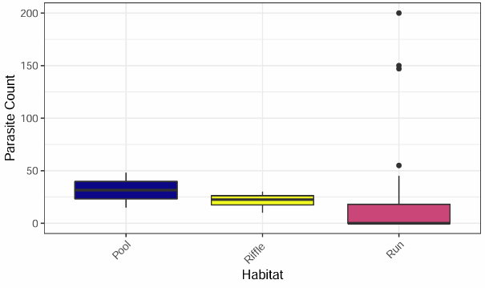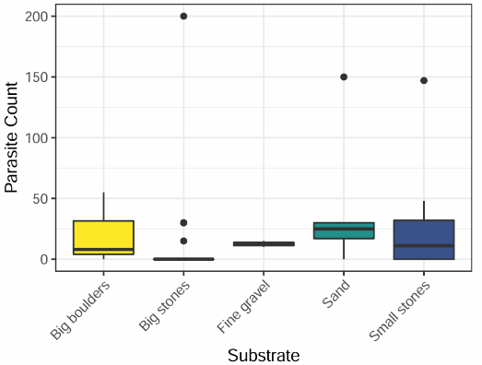**3.2. Association between eco-hydrological parameters, fish morphometric characteristics, with parasite abundance**

## Figure 3: Parasites in infected fish across different substrates

## Figure 2: Parasites in infected fish across different substrates

**3.2.1.** **Relationship between fish size and parasite count**

Spearman correlation analysis revealed a strong positive correlation between parasite count and fish weight (*P* < .001, *ρ* = 0.739) and length (*P* < .001, *ρ* = 0.773). This suggests that the parasite count tends to increase with an increase in fish size. A study conducted by Ojwala *et al.* (2018) reported a strong positive correlation between fish size and parasite infection levels. The findings are also consistent with the study conducted by Akoll *et al.* (2012). They studied the infection pattern of Nile tilapia by two helminth species with different lifestyles and found a positive correlation between fish size and the number of parasites.

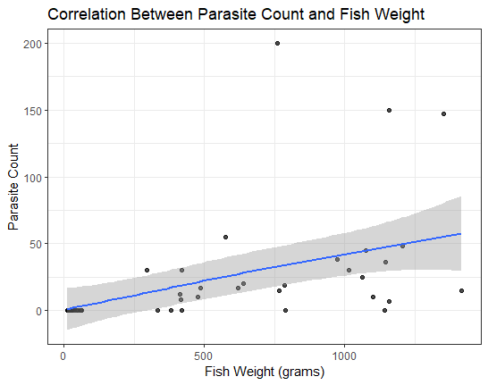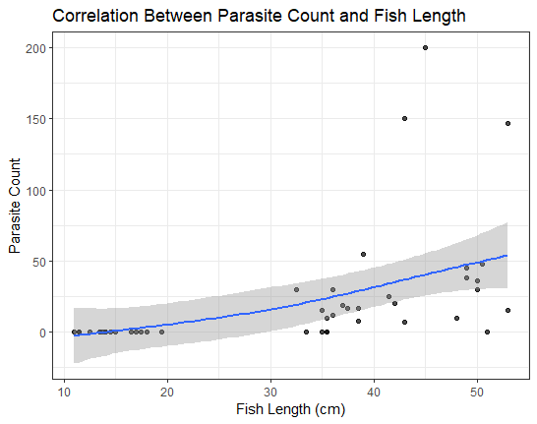

Figure 5: Correlation between parasite count and fish length

Figure 4: Correlation between parasite count and fish weight

**3.2.2. Relationship between fish size and parasite presence (“yes”, “no”)**

The association between fish size and parasite presence was investigated using a logistic regression model. It was conducted separately for fish length and fish weight. For fish length the overall model was statistically significant (*X*2= 37.91, *P* < .001). In particular, the probabilities of parasite presence increased by 1.252 (odds ratio = 1.252, *P* < .001) for every unit increase in fish length. For fish weight the model was also statistically significant (*X*2= 34.536, *P* < .001), indicating that fish weight is a significant predictor of parasite presence. The likelihood of parasite presence increased by 1.007 (odds ratio = 1.007, *P* < .001) for every unit increase in fish weight.

This dependence of parasite abundance on fish size could be that the larger fish are often older and may have had longer periods of exposure to parasites. It could have led to older fish accumulating more parasites and younger fish supporting fewer parasites. This aligns with a study by Lo *et al.* (1998) that observed that parasite diversity and abundance increase significantly with an increase in host age and size. The larger and older hosts tend to sustain more diverse and abundant parasite populations. Additionally Poulin (1993) also observed that younger fish were less affected by parasites than older fish.

**3.2.3. Comparison of size between infected and uninfected fish groups**

The Mann-Whitney U test was used to determine if there was a statistically significant difference between the fish size of the infected and the uninfected fish. There was a significant difference in the distribution of weight between the two groups as revealed by the Wilcoxon rank sum exact test results (*W* = 462, *P* < .001). The median weight of the uninfected fish was 26.26 g, significantly lower than the median weight of the infected fish, which was 775.9 g.

The distribution of lengths between the two groups had a significant difference (*W* = 459, *P* < .001). The median length of the infected fish was 41.75 cm, significantly higher than the median length of the uninfected fish, which was 14.25 cm. These results align with previous studies that found size-dependent parasitism in fishes (Walker *et al.,* 2017). It suggests that larger fish are often older, which gives them more time to accumulate parasites. The study also found that the fish infected with parasites were relatively larger than the uninfected fish.

**3.2.4. Relationship between fish size and black spot count**

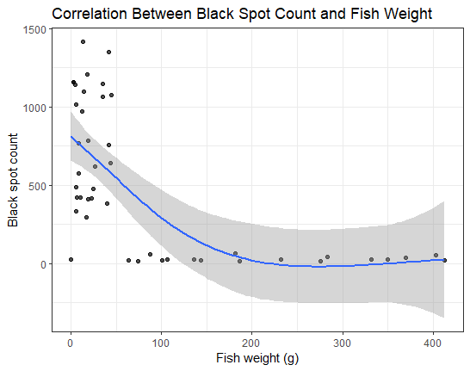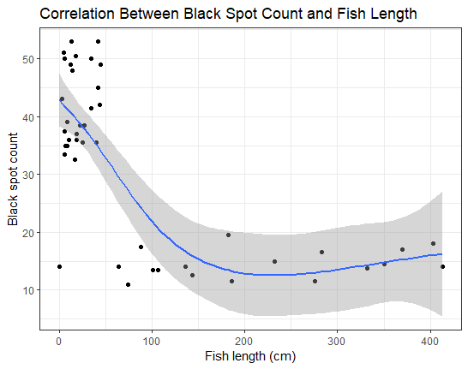In snow trout, black spot disease is common. It is caused by the Metacercariae Larva *Diplostomum minimum.* In this study, black spots were observed visually on the skin of fish; however, no actual parasitic larvae that are most frequently linked to black spot disease were identified.  Spearman’s rank correlation showed a significant negative relationship between black spot count and fish weight (ρ = -0.641, *P* < .001, *N* = 44) and length (*P* < .001, *ρ* = -0.598, *N* = 44). It indicates that black spot count decreases with increase in fish size. In contrast, Vashist (2011) reported a strong positive correlation between black spot count and fish size in *Schizothorax richardsonii*, where larger fish had more severe infections.

Figure 7: Correlation between fish weight and black spot count

Figure 6: Correlation between fish length and black spot count

Table 4: Descriptive statistics of water quality parameters

|  |  |  |  |  |  |  |
| --- | --- | --- | --- | --- | --- | --- |
| **Water parameters** | **Min** | **Max** | **Mean** | **Median** | **Mode** | **SD** |
| pH | 8.10 | 8.82 | 8.47 | 8.47 | 8.40 | 0.18 |
| TDS (mg/L) | 51.10 | 88 | 72.19 | 74.50 | 73.20 | 9.16 |
| EC (µS/cm) | 33.10 | 130.40 | 100.92 | 104.90 | 104.90 | 16.94 |
| Salinity (g/L) | 27.50 | 59 | 45.95 | 47.20 | 33.70 | 6.41 |
| Temperature (o C) | 9.90 | 14.9 | 12.14 | 12.10 | 11.6 | 1.04 |
| Velocity (m/s) | 0.40 | 1.20 | 0.75 | 0.80 | 0.70 | 0.18 |
| Depth (cm) | 28 | 160 | 83.93 | 89 | 85 | 26.88 |
| Turbidity (FNU) | 1.65 | 4.60 | 2.99 | 3.10 | 3.10 | 0.65 |
| D.O (mg/L) | 7.80 | 9.57 | 8.68 | 8.70 | 8.20 | 0.46 |

The measured water quality parameters were compared with standard values from AWQS, EPA, WHO, and BDWQS. Overall, the water quality was good, with most of the parameters falling within the acceptable range.

**3.2.5. Relationship between parasite count and water quality parameters**

Spearman’s rank correlation analysis revealed statistically significant positive correlations between parasite count and several water quality parameters such as pH, TDS, salinity, temperature, depth, turbidity, and EC.

Table 5: Correlation between water quality parameters and parasite abundance

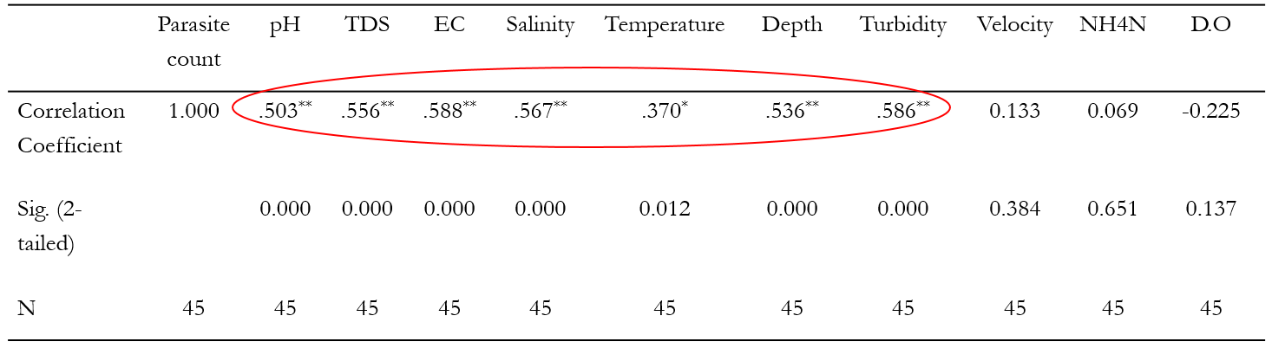

These parameters may influence parasite ecology by weakening host immune responses, enhancing parasite transmission, or supporting intermediate host survival. It aligns with previous studies that reported that elevated pH (Ashmawy *et al.,* 2018; Calhoun *et al.,* 2018), TDS (Zhang *et al.,* 2017; Obayemi *et al.,* 2023), temperature (Majdi *et al.,* 2020; George & Lakshmi, 2021), EC (Shah *et al.,* 2024; Koledoye *et al.,* 2022), salinity (Ahmed *et al.,* 2019), and turbidity (Radwan *et al.,* 2022; Ojwala *et al.,* 2018) were associated with increased parasite prevalence due to favorable conditions for parasite development or compromised host health.

**3.2.5. Association between parasite abundance and environmental variables**

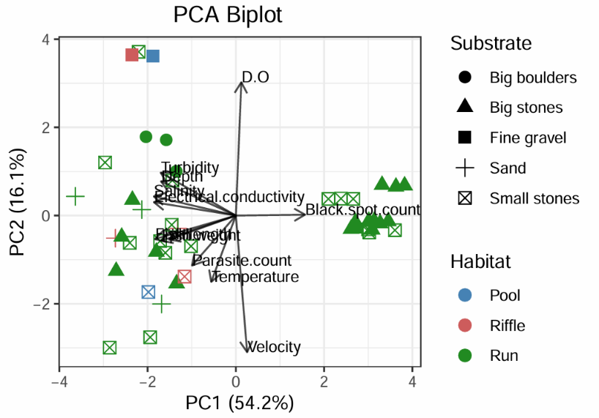The Principal Component Analysis was conducted to provide insights into the relationship between parasite and various other environmental factors, including water quality parameters, substrate, and habitat types. The first principal component (PC1) accounted for a significant 54.22% of variance with an eigenvalue of 6.50. The second principal component accounted for 16.1% with an eigenvalue of 1.93. Cumulatively, the first two components account for 70.3% of the total variance. It is commonly recommended to retain principal components that together explain around 70% of the total variance in the dataset (Kammoun *et al.,* 2024). A high total variance of 70.3 suggests a significant association between parasite abundance and environmental factors.

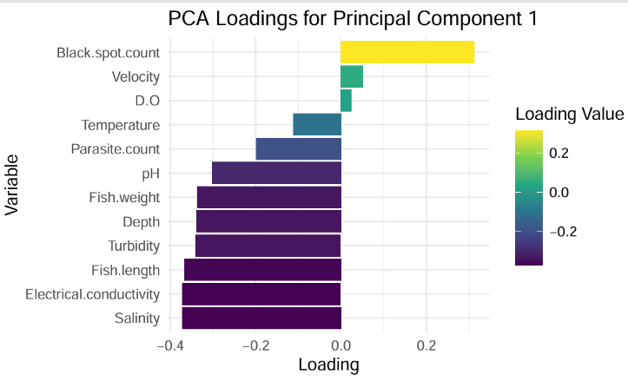

Figure 9: PCA loadings

Figure 8: PCA biplot

In PC1, parasite count clustered with fish morphometric factors and water quality parameters such as salinity, turbidity, pH, temperature, and depth, all showing negative loadings. This suggests that these variables share a common influence on parasite abundance indicating that the high values of these water quality parameters and larger fish size were associated with high parasite abundance. In PC2, dissolved oxygen showed a strong positive loading, while water velocity and temperature showed negative loadings. Black spot count had a minimal contribution. The overall PCA revealed an association between parasite abundance and other environmental variables. It aligns with Deflem *et al.* (2022) that reported that various environmental factors, such as water quality were associated with parasite presence and parasite abundance in fish.

**3.3. Spatial distribution of parasites in the study area**

The spatial analysis using IDW revealed a heterogeneous distribution of parasite count across the study area. The red areas on the map, representing the highest estimated parasite counts (IDW values ranging from 64.043 to 198.616), covered an area of 0.5 square kilometers, indicating high parasite counts in the neighboring sampling points. The orange areas indicate moderate parasite count estimation (IDW values ranging from 6.12 to 64.042), covering an area of 1.7 square kilometers. Progressively lower estimated parasite counts were observed in yellow and lighter regions (IDW values ranging from 0.007 to 6.119) with an area of 1.4 square kilometers. This spatial variation highlights an uneven distribution of parasite prevalence across the study area.

The areas with the highest parasite count were observed in the areas near the built-up and agricultural lands, indicating their impact on the parasite prevalence and diversity. The disturbed areas might have led to the weakened immune system of the host or created a favorable condition for parasite invasion due to the disturbance to the habitat of the fish. The findings align with the findings of the previous studies. A study by Chapman *et al.* (2015) found that the overall parasite abundance increased in streams in degraded ecosystems. In the degraded streams, parasite abundance was highest with the lowest diversity, and in the pristine streams, the parasite diversity was highest with the lowest abundance.

Spatial analysis of parasite distribution in the study area revealed a significant difference in parasite presence between the Punatsangchhu and Toebrongchhu rivers. As shown in the figure, parasites were detected in the Punatsangchhu, which displayed a diverse distribution pattern. However, no parasites were detected in Toebrongchhu. It could be because Punatsangchhu is characterized by the presence of wide human settlements, abundant agricultural land, and urban development. The results are consistent Öktener & Bănăduc (2023) that reported that fish can experience stress from these changed environmental conditions, which could impair their immunity and provide an environment that is more conducive to parasite growth. The stressors connected to human activities in Punatsangchhu may be the cause of the deterioration of host 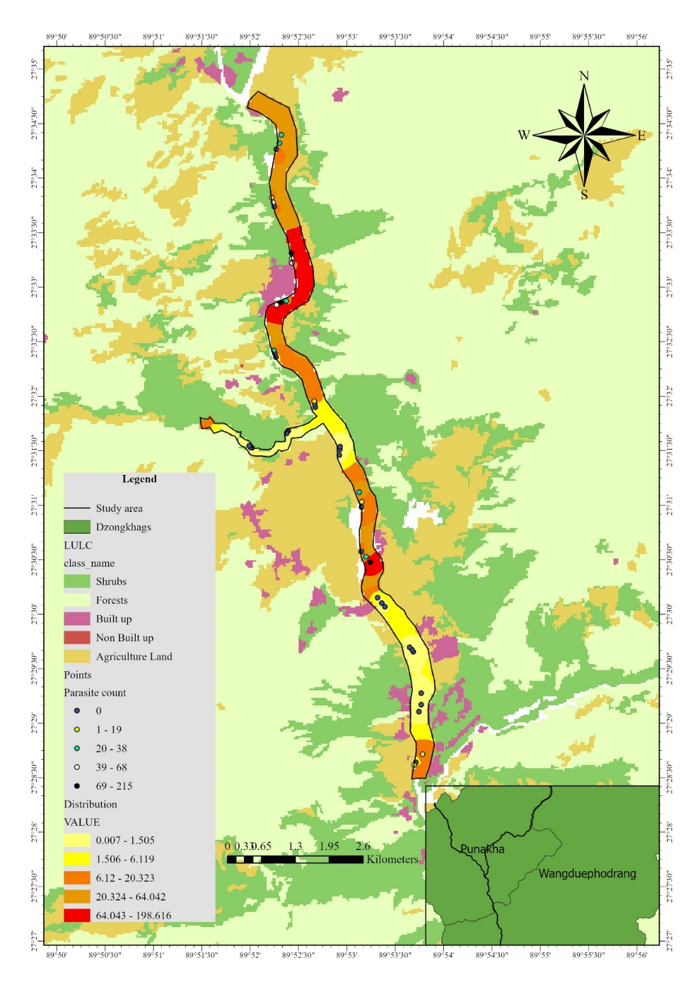immunity and parasite infection.

Figure 10: Spatial distribution of parasites in the study area

Figure 10: Spatial distribution of parasites in the study area

**4. Conclusion**

Based on the study findings, two genera of parasites, Rhabdochona spp. and *Ergasilus* spp., were recorded*.* The low diversity of parasites may be due to low host diversity and data collection during winter. Of 44 hosts, 22 were infected, accounting for a prevalence rate of 50%. Parasite abundance increased with an increase in fish weight and length, exhibiting a strong positive correlation with statistical significance. This relationship may be due to larger fish being older and may have had longer periods of exposure to parasites. In contrast to the result of other studies, the number of black spots on snow trout, which are considered a sign of trematode infestation, increased as fish length and weight decreased.

The study also provides insights into the relationships between eco-hydrological parameters and parasite prevalence. There was a positive correlation between parasite count and pH, TDS, water temperature, EC, salinity, depth, and turbidity. The increase in these parameters may affect the host by weakening their immune system and increasing their susceptibility to parasite invasion. In contrast, DO, velocity of water, and ammonium nitrogen showed weak and statistically insignificant correlation with parasite prevalence. PCA was also conducted to determine the relationship between parasite abundance and various environmental variables. Spatial interpolation of parasite distribution across the study area indicated a higher parasite prevalence in Punatsangchhu than in Toebrongchhu.

Overall, the study indicated that fish size and water quality parameters are interlinked factors influencing parasite prevalence in freshwater systems. This study provides baseline data on fish parasites and emphasizes the need for future researchers to study fish parasites. It provides significant insights into our knowledge of the relationships between freshwater parasites, their hosts, and the environment. Given Bhutan’s emphasis on environmental conservation, such findings are essential for sustainable freshwater resource use and long-term aquatic biodiversity management.

**References**

Ahmed, I. M., Shazili, N. A. M., & Jye, W. (2019). *Influence of water quality parameters on prevalence of nematodes in freshwater fish Barbonymus schwanenfeldii in Tasik Kenyir, Malaysia*.

Akoll, P., Konecny, R., Mwanja, W. W., & Schiemer, F. (2012). Infection patterns of Nile tilapia (Oreochromis niloticus L.) by two helminth species with contrasting life styles. *Parasitology Research*, *110*, 1461–1472.

Amer, O. S. (2014). The impact of fish parasites on human health. *Journal of the Egyptian Society of Parasitology*, *44*(1), 249–274.

Apostolaki, S., Akinsete, E., Koundouri, P., & Samartzis, P. (2020). Freshwater: The importance of freshwater for providing ecosystem services. *Encyclopedia of the World’s Biomes*, 71–79.

Barber, I., Hoare, D., & Krause, J. (2000). Effects of parasites on fish behaviour: A review and evolutionary perspective. *Reviews in Fish Biology and Fisheries*, *10*, 131–165.

Bush, A. O., Lafferty, K. D., Lotz, J. M., & Shostak, A. W. (1997). Parasitology meets ecology on its own terms: Margolis et al. revisited. *The Journal of Parasitology*, 575–583.

Calhoun, D. M., McDevitt-Galles, T., & Johnson, P. T. J. (2018). Parasites of invasive freshwater fishes and the factors affecting their richness. *Freshwater Science*, *37*(1), 134–146. DOI: https://doi.org/10.1086/696566

Chapman, J. M., Marcogliese, D. J., Suski, C. D., & Cooke, S. J. (2015). Variation in parasite communities and health indices of juvenile Lepomis gibbosus across a gradient of watershed land-use and habitat quality. *Ecological Indicators*, *57*, 564–572.

Debenedetti, Á. L., Madrid, E., Trelis, M., Codes, F. J., Gil-Gómez, F., Sáez-Durán, S., & Fuentes, M. V. (2019). Prevalence and Risk of Anisakid Larvae in Fresh Fish Frequently Consumed in Spain: An Overview. *Fishes*, *4*(1), Article 1. DOI: https://doi.org/10.3390/fishes4010013

Deflem, I. S., Van Den Eeckhaut, F., Vandevoorde, M., Calboli, F. C., Raeymaekers, J. A., & Volckaert, F. A. (2022). Environmental and spatial determinants of parasite communities in invasive and native freshwater fishes. *Hydrobiologia*, *849*(4), 913–928.

Devkota, S., Subedi, A., Singh, D. K., & Ghimire, R. P. (2023). Prevalence of Fish Tapeworm–Diphyllobothrium latum in Commercial Fish Farms of Chitwan District, Nepal. *Nepalese Veterinary Journal*, 68–75.

Dezfuli, B. S., & Scholz, T. (2022). Fish parasites. *Parasitology*, *149*(14), 1811–1814.

Dorji, U., & Sagar, L. (2025). Hydrological Dynamics and Brown Trout Habitat Selection in the Thimphu Chhu River, Bhutan. *Asian Journal of Environment & Ecology*, *24*(3), 51–63.

Gautam, J., Parajuli, R. P., & Pandey, K. (2024). Prevalence and associated factors of intestinal parasitic infections in the Badi indigenous communities of Western Nepal. *Journal of Health, Population and Nutrition*, *43*(1), 211. DOI: https://doi.org/10.1186/s41043-024-00694-1

George, P. R., & Lakshmi, B. B. (2021). Effect of environmental factors on the intensity of nematode infection in marine fishes of Visakhapatnam, AP, India. *J. Adv. Parasitol*, *8*(2), 20–25.

Hoffman, G. L. (2019). *Parasites of North American freshwater fishes*. Cornell University Press. https://books.google.com/ Hudson, P. J., Dobson, A. P., & Lafferty, K. D. (2006). Is a healthy ecosystem one that is rich in parasites? *Trends in Ecology & Evolution*, *21*(7), 381–385.

Koledoye, T. Y., Akinsanya, B., Adekoya, K. O., & Isibor, P. O. (2022). Physicochemical parameters of the Lekki Lagoon in relation to abundance of Wenyonia sp Woodland, 1923 (Cestoda: Caryophyllidae) in Synodontis clarias (Linnaeus, 1758). *Environmental Challenges*, *7*, 100453. DOI: https://doi.org/10.1016/j.envc.2022.100453

Lo, C. M., Morand, S., & Galzin, R. (1998). Parasite diversity, host age and size relationship in three coral-reef fishes from French Polynesia. *International Journal for Parasitology*, *28*(11), 1695–1708.

Majdi, N., Uthoff, J., Traunspurger, W., Laffaille, P., & Maire, A. (2020). Effect of water warming on the structure of biofilm-dwelling communities. *Ecological Indicators*, *117*, 106622. DOI: https://doi.org/10.1016/j.ecolind.2020.106622

Obayemi, O. E., Komolafe, O. O., & Onana, E. E. (2023). Limnological variables as a determinant of fish parasites abundance in the Esa-Odo reservoir, Esa-Odo Southwestern Nigeria. *Journal of Water and Health*, *21*(2), 271–285.

Ojwala, R. A., Otachi, E. O., & Kitaka, N. K. (2018). Effect of water quality on the parasite assemblages infecting Nile tilapia in selected fish farms in Nakuru County, Kenya. *Parasitology Research*, *117*, 3459–3471.

Öktener, A., & Bănăduc, D. (2023). Ecological interdependence of pollution, fish parasites, and fish in freshwater ecosystems of Turkey. *Water*, *15*(7), 1385.

Palm, H. W. (2011). Fish Parasites as Biological Indicators in a Changing World: Can We Monitor Environmental Impact and Climate Change? In H. Mehlhorn (Ed.), *Progress in Parasitology* (pp. 223–250). Springer Berlin Heidelberg. DOI: https://doi.org/10.1007/978-3-642-21396-0_12

Pouder, D. B., Curtis, E. W., & Yanong, R. P. E. (2005). *Common freshwater fish parasites pictorial guide: Digenean trematodes (FA112) and nematodes (FA113)* (Fact Sheet FA112/FA113). Florida Cooperative Extension Service, Institute of Food and Agricultural Sciences, University of Florida.

Poulin, R. (1993). Age-dependent effects of parasites on anti-predator responses in two New Zealand freshwater fish. *Oecologia*, *96*(3), 431–438.DOI: https://doi.org/10.1007/BF00317516

Poulin, R. (2020). Meta-analysis of seasonal dynamics of parasite infections in aquatic ecosystems. *International Journal for Parasitology*, *50*(6–7), 501–510.

Radwan, M., Abbas, M. M. M., Afifi, M. A. M., Mohammadein, A., & Al Malki, J. S. (2022). Fish parasites and heavy metals relationship in wild and cultivated fish as potential health risk assessment in Egypt. *Frontiers in Environmental Science*, *10*, 890039.

Shah, I. M., Khurshid, I., Maqbool, N., Ahmad, F., & Ahmad, S. M. (2024). Unveiling the potential of parasites as proxy bioindicators for water quality assessment in river Jhelum Kashmir, India. *Environmental Monitoring and Assessment*, *196*(12), 1156. DOI: https://doi.org/10.1007/s10661-024-13306-6

Sisay, B., Simiyu, J., Mendesil, E., Likhayo, P., Ayalew, G., Mohamed, S., Subramanian, S., & Tefera, T. (2019). Fall armyworm, Spodoptera frugiperda infestations in East Africa: Assessment of damage and parasitism. *Insects*, *10*(7), 195.

Subedi, R., Gurung, D. B., Namgay, K., Sagar, L., Dorji, R., Pem, T., & Gyeltshen, N. (2024). Distribution pattern and population dynamics of Brown trout (Salmo trutta) and Snow trout (Schizothorax richardsonii) in Punatsangchhu River, Bhutan. *Fisheries and Aquatic Sciences*, *27*(7), 421–433.

Tesfaye, A., Teklu, A., Bekelle, T., Tkue, T., Kebede, E., Gebretsadik, T., & Berhe, N. (2017). A survey on occurrence of internal and external fish parasites and causes of fish population reduction in Lake Hashenge, Tigray, Ethiopia. *Ethiopian Veterinary Journal*, *21*(2), 75–91.

Vashist, P. (2011). Incidence of black spot infection and growth patterns in *Schizothorax richardsonii* (Gray) and *Schizothorax plagiostomus* (Heckel) from Garhwal (West Himalaya). *Voyager*, 17, 70–78.

Zhang, C., Zhang, W., Huang, Y., & Gao, X. (2017). Analysing the correlations of long-term seasonal water quality parameters, suspended solids and total dissolved solids in a shallow reservoir with meteorological factors. *Environmental Science and Pollution Research*, *24*(7), 6746–6756. DOI: https://doi.org/10.1007/s11356-017-8402-1