***Review Article***

**HYDROPONICS: A SUSTAINABLE WAY OF FARMING**

**Abstract**

The increase in population growth is rapid, per capita land availability is decreasing day by day and in the near future, this will be one of the major global problems. The use of chemical pesticides and fertilizers also degrades our soil and produces unhealthy food, which is harmful to human lives. Soil-less cultivation is the solution to all these problems. Soil-less cultivation is the modern day technique of farming, in which three main techniques used, Hydroponics, Aeroponics and Aquaponics. Hydroponics is the practice of growing plants without soil using nutrient-rich water solutions and represents a transformative approach to modern agriculture, promising increased sustainability and efficiency. In the near future hydroponic technique will play a major role in sustainability and food security concerns. This paper mainly focuses on study of hydroponic farming, economic analysis for set up of hydroponic plant, how hydroponics is important in future, challenges like high initial cost, requirement of skilled labours, high energy consumption etc., and solutions like use of waste materials, better utilization of cheap source of energy like geothermal energy. The environmental benefits of hydroponics; highlight its potential to conserve water, reduce land usage, and minimize chemical runoff compared to traditional soil-based farming.

**Keywords:** Hydroponics, growing medium, soilless technique, nutrients, vertical farming, sustainable.

**Introduction**

In 1960, when the global population was around 3 billion, the per capita land availability was 0.5 hectares. Today, with a population of 6 billion, this has decreased to 0.25 hectares and by 2050, it is expected to drop further to just 0.16 hectares (Bhattacharya, 2017). Under such circumstances, it will become increasingly difficult to feed the growing population using traditional open field agricultural systems alone. In response to these challenges, soil-less cultivation methods are gaining relevance and importance. Soil-less culture refers to the practice of growing plants without the use of soil. These systems offer improved space and water efficiency and have demonstrated promising results globally. The main techniques under soil-less cultivation include Hydroponics,Aeroponics and Aquaponics. Hydroponics is a method of growing plants without soil, using a nutrient-rich water solutioninstead. The term hydroponics was derived from the Greek words ‘hydro’ means water and ‘ponos’means labour. In hydroponics, plants are grown in a controlled environment where the temperature, humidity and lighting can be carefully regulated. The word hydroponics was coined by Professor W.F. Gericke in the early 1930s; describe the growing of plants with their roots suspended in water containing mineral nutrients. The roots of the plants are placed in a growing medium, such as gravel, perlite or coconut coir and are continuously fed with a nutrient solution that contains all the essential minerals and nutrients that the plants need to grow (Sharma *et al*., 2018; Habeeba *et al.,* 2023). Aeroponics is the process of growing plants in an air or mist environment without the use of soil or an aggregate medium (known as geoponics). Aquaponics is a cooperation between plants and fish and the term originates from the two words aquaculture (the growing of fish in a closed environment) and hydroponics (the growing of plants usually in a soil-less environment).

**Sustainable Agriculture**

Sustainable Agriculture refers to ecological sustainability and addresses the negative impacts of conventional farming on natural resources. Sustainable agriculture involves the utilization of environment friendly energy sources such as hydropower, wind energy and solar power. These energy sources are considered preferable as they have minimal impact on the environment. While agricultural advancements have allowed us to meet the increasing demand for food, they have often overlooked the detrimental effects on natural resources. The need to prioritize agricultural sustainability has become evident due to the strain on resources caused by population growth and economic development. Sustainable agriculture aims to balance economic, environmental and social aspects of farming. Vertical farming, organic farming, Integrated Pest Management (IPM) and agroforestry are all part of sustainable agriculture (Arumugam & Manida, 2023).

**Vertical Farming: Part of sustainable agriculture**

Vertical farming is a modern agricultural practice of growing crops, stacked vertically in a protected indoor environment, which mainly utilises a hydroponic or aeroponic cultivation system. Vertical farming offers numerous potential benefits, including more efficient uses of space, reduced water usage, shorter growing times, reduced need for pesticides/herbicides and shelter from extreme weather. In addition, since vertical farms can be set up practically anywhere, even underground. They could enable hyper-localised production, thus shortening food supply chains and providing fresh and nutritious local foods all year round. The term vertical farming was first given by Gilbert Ellis Bailey. The classic and earliest example of vertical farming is the legendary Hanging Gardens of Babylon, built by KingNebuchadnezzar more than 2,500 years ago(Eldridge *et al.,* 2020; Shamshiri *et al*., 2018).

**Types of Vertical Farming**

There are three main types of vertical farming,

1. Hydroponics
2. Aeroponics
3. Aquaponics

**Hydroponics**

Hydroponics is a method of growing plants without soil, using a nutrient-rich water solution. In this method of farming, plants are grown in a controlled environment where temperature, humidity and light are carefully regulated. The roots of plants are dipped in a growing medium, which provides essential nutrients to the plant (Habeeba *et al*., 2023).

**Global Scenario of Hydroponics**

The global hydroponics market size was valued at USD 5.00 billion in 2023and is expected to grow at a compound annual growth rate (CAGR) of 12.4 per centfrom2024 to 2030 (*[grandviewresearch.com](http://www.grandviewresearch.com)*).According to the Mordor intelligence report in the U.S. and Canada 90 per centof the lettuce and tomatoesare being produced using hydroponic farming ([*mordorintelligence.com*](http://www.mordorintelligence.com)).They alsoreported that the hydroponics market size is estimated atUSD 5.06 billion in 2024,and is expected to reach USD 7.36 billion by 2029,growing at a CAGR of7.80 per centduring the forecast period (2024-2029)([*mordorintelligence.com*](http://www.mordorintelligence.com)).Also, owing to their controlled environmental conditions, the effect of climatic changes can be balanced with the help of these systems, thereby not affecting the annual crop production.

**Indian Scenario of Hydroponics**

In hydroponics, India is at a nascent stage various initiative are being taken for its advancement. Datam intelligence reported that the hydroponic market in India is projected to experience a compound annual growth rate (CAGR) of 13.53 per centfrom 2020 to 2027, which is significantly higher than the global hydroponicindustry’s estimated growth rate of6.8 per cent.According to Datam intelligence research, Southern India has the biggest share, with places like Hyderabad, Bangalore and Chennai having a vast number of farms and many new small and medium farms being developed.

**Plants/Crops suitable for hydroponics**

Accordig to Sonawane (2018) we can grow cereals like Rice, Maize *etc.,* fruits like strawberry, vegetables like tomato, chilli, brinjal, green bean, beet, winged bean, bell pepper, cabbage, cauliflower, cucumbers, radish, onion *etc.,* and also leafy vegetables like lettuce, kang kong, certain condiments like parsley, mint, sweet basil, oregano *etc.,* some flower crops like marigold, carnation, chrysanthemum, roses *etc.,* medicinal crops like Indian aloe, coleus and some of the fodder crops like sorghum, alfa alfa, barley, bermuda grass *etc.* Ashok & Sujitha, (2020) and Barman *et al*., (2016) also measure the same.

**Growing Media for Hydroponics**

**Rockwool**: Rockwool is one of the most common growing media used in hydroponics. Rockwool is a sterile, porous, non-degradable medium that is composed primarily of granite or limestone which is super-heated and melted, then spun into small threads like cotton candy. The Rockwool is then formed into blocks, sheets, cubes, slabs, or flocking. Rockwool should be pH balanced before use.

**Hydroton (LECA):** Hydroton is a Lightweight Expanded Clay Aggregate (L.E.C.A.) that is a type of clay which is super-fired to create a porous texture. It’s heavy enough to provide secure support for your plants, but still lightweight. Hydroton is a non-degradable, sterile growing medium that holds moisture, has a neutral pH, and also will pick up nutrient solution to the root systems of your plants. Hydroton grow media is re-usable; it can be cleaned, sterilized and then re-used again.

**Coco Fibre Coco Chips:** “Coco coir” (Coconut fibre) is made from the outer husk of coconuts. Although coco coir is an organic plant material. It breaks down and decomposes very slowly, so it won’t provide any nutrients to the plants growing and for making it perfect for hydroponics. Coco coir is also pH neutral, holds moisture very well, yet still allows for good aeration for the roots. Coco fibre comes in two forms, coco coir (fibre) and coco chips. They’re both made of coconut husks; the only difference is the particle size.

**Perlite:** Perlite is mainly composed of minerals that are subjected to very high heat, which then expand it like popcorn so it becomes very lightweight, porous and absorbent. Perlite has a neutral pH, excellent wicking action and is very porous. Perlite can be used by itself or mixed with other types of growing media.

**Vermiculite:** Vermiculite is a silicate mineral that like perlite expands when exposed to very high heat. As a growing medium, vermiculite is quite similar to perlite except that it has a relatively high cation exchange capacity, meaning it can hold nutrients for later use. Also like the perlite, vermiculite is very light and tends to float. The easiest way to be sure is to get it from a nursery.

**Floral foam:** Floral foam can be used as a growing medium in hydroponics as well, and is similar to the Oasis cubes, though the cell size is larger in the floral foam. Depending on the type of hydroponic system you’re using and how you designed it, you may notice a couple of problems with using floral foam. Floral foam absorbs water easily, so make sure it isn’t in constant contact with the water supply.

**River rock:** River rock is common and easy to find in home improvement stores, as well as even pet supply stores (with the fish and aquariums). River rock is fairly inexpensive (depending on where you get it from) and comes in many different sizes. River rock is rounded with smooth edges from tumbling down the river.

**Rice Hull:** Rice hulls are a by-product of the rice milling industry. Although these are extremely light in weight, rice hulls are very effective in improving drainage. The particle size and resistance to decomposition of rice hulls and sawdust are more or less similar. However, nitrogen depletion is not a serious problem in media amended with rice hulls (Ashok & Sujitha, 2020; Swain *et al*., 2021).

**Types of Hydroponics**

**Wick System**

The Wick system is by far the simplest type of hydroponics system. This is a passive system, which means there are no moving parts. The nutrients are stored in the reservoir and moved into the root system by capillary action often using a candle or wick. In simpler terms, the nutrient solution travels up the wick and into the root system of the plant. This system can use a variety of growing media. Perlite, vermiculite, pro-mix and coconut fibre are among the most popular.

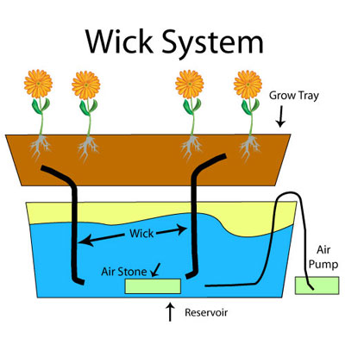

***Figure 1: Wick System***

**Water culture system**

This system is the simplest of all active hydroponics systems. The platform that holds the plants is usually made of Styrofoam and floats directly on the nutrient solution. An air pump supplies air to the air stone that bubbles the nutrient solution and supplies oxygen to the roots of the plants. Water culture is the system of choice for growing leaf lettuce, which are fast growing water loving plants, making them an ideal choice for this type of hydroponic system.

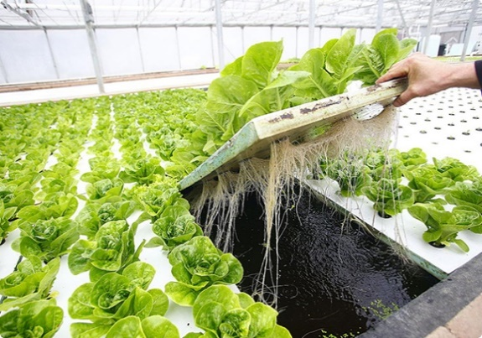

***Figure 2: Water culture system***

**EBB and Flow System (Flood and Drain)**

The ebb and flow hydroponic system is an active recovery type system. They work on a simple flood and drain theory. The ebb and flow system works by temporarily flooding the grow tray with nutrient solution and then draining the solution back into the reservoir. This action is normally done with a submerged pump that is connected to a timer.

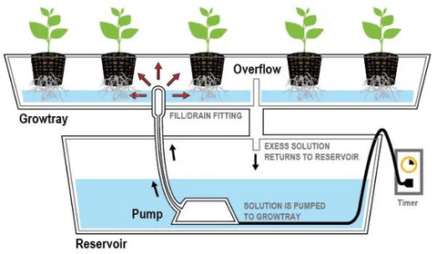

***Figure 3: EBB and Flow system***

**Nutrient Film Technique (NFT)**

The nutrient film technique or NFT system is an active recovery type hydroponic system. NFT systems have a constant flow of nutrient solution so no timer is required for the submersible pump. The nutrient solution is pumped into the growing tray (usually a tube) and flows over the roots of the plants and then drains back into the reservoir. The nutrient solution flows over the roots up to 24 hours per day. The plants are held up by a net pot and mostly hydroton (pebbles) is used.

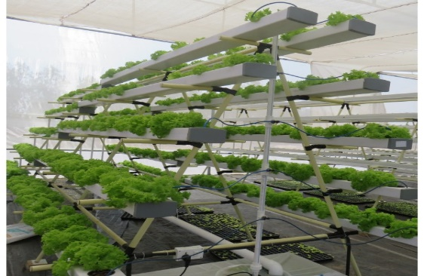

***Figure 4: Nutrient film technique***

**Drip System**

Drip systems are probably the most widely used type of hydroponics system in the world. The continuous drip system is an active recovery or non-recovery type system. This system uses a submersible pump in a reservoir with supply lines going to each plant. With a drip emitter for each plant the gardener can adjust the amount of solution per plant. A drip tray under each row of plants, sending the solution back to the reservoir, can easily make this system an active recovery type (Maiti & Saha, 2020; Bhattacharya, N., 2017 and Dubey & Nain, 2020 describe mainly this type of hydroponics).

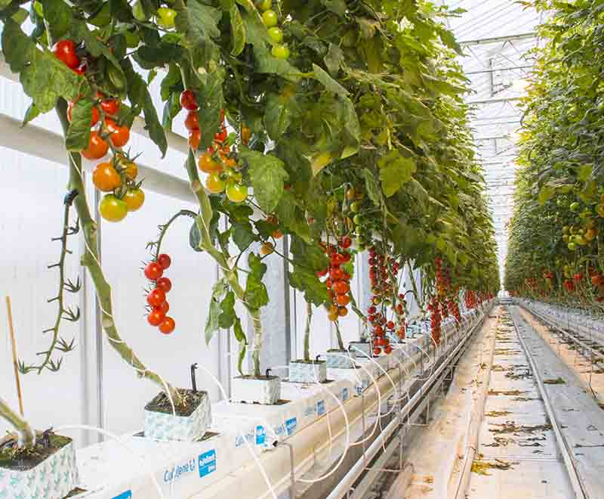

***Figure 5: Drip system***

**Environmental factors for hydroponic systems**

The environmental factors are important for the optimization of the hydroponic fodder growth and production. Ghorbel *et al.* (2022) reported that the standard level of environmental cues such as temperature (19 to 22ºC), humidity (average 60 per cent), light intensity (2000 lux), length (12-16 h) and aeration for 3 minutes at every 2 h interval should be maintained.

**Hydroponic for fodder purposes**

Only 5 per cent of cropped land area is utilized for cultivating fodder. According to Shit (2019) we facing a deficit of 35.6 per cent green fodder, 26 per cent of dry fodder and 41 per cent of concentrate feed ingredients. Yvonne Kamanga (2016) suggested that only 1.5-2.0 litres of water is enough for 1 kg of hydroponic fodder production compared to 73, 85 and 160 litres of water to produce 1 kg green fodder of barley, alfalfa and rhodes grass under conventional field conditions, respectively. Increase in the nutritive value of the fodder by using hydroponic technique (Jan *et al*., 2020). Malhi *et al.,* 2020 reported that more palatable and digestible fodder was produced by a hydroponic system. 13.7 per cent increase in the milk yield and higher net profit of Rs. 12.67/cow/day on feeding hydroponic maize fodder (Naik *et al*., 2014). According to Naik & Singh (2013) using hydroponics technology, up to 1000 kg of maize fodder can be produced daily from a 45-50 m area which is equivalent to the conventional fodder produced in 25 acres of cultivable land. Naik *et al*. (2014) reported that in the hydroponic fodder production system, the seed cost contributes 85-90 per cent of the total cost of production. Mainly maize, barley, sorghum, alfa-alfa, bermuda grass *etc.* are grown (Shit, 2019).

**Economic analysis of hydroponics**

Thanushree *et al*. (2024) conducted a study on hydroponic plants to analyze the cost-benefit ratio of the hydroponic plant and to ascertain various elements of costs in hydroponic farming.

***Table 1: Cost calculation of hydroponic plant as per NFT technique***

|  |  |
| --- | --- |
| **Various elements required** | **Cost for the element (in rupees)** |
| Poly house shelter | 600000 |
| Pipes (4 inches) | 700000 |
| Pipes (2 inches) | 12000 |
| Pipe connectors | 120000 |
| Stand platform (includes 40 Stands and 32 pipes for each) | 100000 |
| 20000 ltrs. Tank | 55000 |
| 1000 ltrs. Plastic tanks (2 no.) | 15000 |
| 5000 ltrs. Plastic tank | 22000 |
| Water pumps (1 hp) and 4 no. | 30000 |
| Water pumps (0.5 hp) and 2 no. | 10000 |
| Net cups | 100000 |
| Water cooler | 60000 |
| Reverse Osmosis system | 50000 |
| PH meter | 1200 |
| TDS (Total Dissolved Solids) meter | 2000 |
| Labour cost | 10000 |
| Total cost | 1887200 |

Source: Thanushree *et al*., 2024

***Table 2: Various elements and the cost incurred for each element***

|  |  |  |
| --- | --- | --- |
| **Sl. No.** | **Variables** | **Lettuce** |
| 1 | Initial investment / one time setup cost | Rs.18,87,200 |
| 2 | Total number of harvests p.a | 5 times |
| 3 | Net production capacity per harvest | 2200 kg |
| 4 | Total production per annum | 11,000kg |
| 5 | Price per kg | Rs.350 |
| 6 | Total revenue per annum | Rs.38,50,000 |
| 7 | Operating expenses per cycle | Rs.1,92,000 |
| 8 | Total operating expenses per annum | Rs.9,60,000 |
| 9 | Estimated life of the growing system | 5 years |
| 10 | Discount rate | 10 per cent |
| 11 | Depreciation | Rs.3,77,440 |

*Note: Depreciation is provided under straight line method.*

Source: Thanushree *et al.,* 2024

***Table 3: Cost- benefit analysis of hydroponic farming in India*.**

|  |  |
| --- | --- |
| **Various cost-benefits analysis techniques** | **Values** |
| Net Present Value (NPV) | Rs.8147057 |
| Benefit-cost ratio | 5.317 |
| Other econometrics are: | |
| Payback period | 9.43 months |
| Internal rate of return | 60.6 per cent |
| Profitability index | 4.31 |

Source: Thanushree *et al.,* 2024

This study was conducted for the area of 5000 sq.ft. The analysis shows that NPV was Rs. 81,47,057 for the duration of 5 years, benefit-cost ratio was 5.317, payback period (PBP) was less than 1 year (*i.e.,* 9.43 months), internal rate of return (IRR) was 60.6 per cent and profitability index (PI) was 4.31. The study shows that the investment required for hydroponic farming is high but still it can be recovered within one year and sometimes it may take 1.5 years. The high NPV and a BCR greater than 1 are positive indicators for adopting the Nutrient Film Technique (NFT) for growing lettuce. Internal rate of return was calculated using discount rates of 5 per cent and 20 per cent (Thanushree *et al*., 2024).

**Market Potential of hydroponics in Anand district**

According to Thanushree *et al*. (2024) for one hydroponic plant set-up, ideally 5000 sq.ft. area is required and cost incurred is Rs. 1887200. In Anand district, total 2337 hectare land is available for hydroponic farming which include cultivable as well as, barren land 5000 sq.ft. Means 0.046 hectare is for 1 plant set-up.

Market Potential = Total area in Anand district available for hydroponics × Number of plants / Ideal required area for 1 hydroponic plant × price

= 2337 hectare × 1 plant / 0.046 hectare × 1887200

= 50,804 Hydroponic plants can be set-up in Anand district.

= 95877308800 Rs.

(Data Source: Land use planning survey 2022-23).

**Advantages of Hydroponics:**

Solanki *et al.* (2017) found that the healthiest crops are produced with high yields per unit area. The conservation of water is the biggest advantage of hydroponics compared to the conventional technique. It is a water saving option as it uses 80-90 per cent less water as compared to a traditional system (Biswas & Das, 2022). The amount of nutrients that are to be given to plants can be controlled thereby reducing the cost of nutrition and saving money by recycling of nutrients and plants (Pandey *et al*., 2009). Less space is required (higher density planting) for growing plants in hydroponics (K.K.R. *et al.,* 2012). Farmers do not need to worry about exhausting their fields of certain nutrients through growing the same crop over and over, there is no need for crop rotation, so in-demand crops can be focused on (Shrestha and Dunn 2010). According to Sousa *et al*. (2024), less occurrence of pests and diseases in the hydroponic system of planting and it is much easier to treat them. Hydroponic crops are least affected by the environment and plants can therefore, be grown closer to consumers, reducing transport emissions. Weeding is also not required (Singh and Davidson, 2016). According to Ghorbel *et al.* (2022) minimum land required in this system is one of the best advantages and that too does not require fertile land. Continuous yield as compared to the conventional one. Reduced carbon footprint because hydroponics is more environment friendly as compared to traditional agriculture when it comes to the use of inorganic chemicals, less cost of labour and minimum manpower is needed to produce hydroponic fodder.

**Disadvantages of Hydroponics**

Solanki *et al.* (2017) revealed that due to high cost, only high value crops are grown in hydroponics for high net returns. The major disadvantage of this system is high initial investment and high maintenance costs (Solanki *et al.,* 2017; Khan *et al.,* 2018). Technical expertise and knowledge are required (Pomoni *et al*., 2023). Chances of dry matter loss, Hydroponic fodder is susceptible to be highly perishable in a hot climate and a lack of oxygen if it is not properly stored. High risk of fungus and microbial infection, Hydroponic fodder is too sensitive to room temperature and humidity, which is a major threat to fodder production technology. Failure to control temperature and humidity could lead to the growth mold, fungi and bacteria. The chance of waterborne diseases, sharing the same nutrient solution can be the cause of waterborne diseases to spread from one plant to another (Ghorbel *et al*., 2022).

**Challenges**

Sisodia *et al*. (2020) found that less interest of farmers because of the uncertainty of yield was also one of the major challenges. The TDS and pH range of the nutrient solutions need to be maintained. In this technique, the right temperature range, pH and proper TDS with growth must lie up to ~30°C. After 30°C, many plants did not grow and got damaged, but some vegetables and plants like capsicum, tomato, daisy and marigold grew at more above 30°C (Meric *et al*., 2011). A hydroponic greenhouse is influenced by power cuts**;** deficiency of some elements such as oxygen can result in low production, thus losses; and the fact that a failure of the system can result in rapid plant death since there is no soil to act as a buffer (Senel *et al.,* 2020). Optimizing nutritional needs for different leafy and fruit-bearing vegetable crops is one of the biggest difﬁculties in hydroponic systems (Sousa *et* *al*., 2024). It requires constant supervision and there is a chance to introduce water or soil borne microorganisms. If any problem arises in the culture, it might be fully loss of plant yield. Finally, it needs to supply light and energy to run the system (Barman *et al*., 2016).

**Possibilities**

Sardare and Admane (2013) reported that the water will be changed after 20-25 daysotherwise the growth of microorganisms and algae would affect the growth and production of the crops. This technique can use waste plastic bottles, tubs, glassand glass pots so that it helps in green chemistry (Sharma *et al*., 2018). Using PVC and timber for erecting a greenhouse frame rather than using aluminium and steel structures would significantly reduce the initial construction cost of a greenhouse. However, the structure is not likely to be rigid and durable as structures built using steel or aluminium. Use of a cheap source of energy is reducing the cost of maintenance and in some parts of the world experiments on this cheap source of energy are running like, geothermal energy is under experimentation in Holland. The problem of needing high level management skills can be obtained in a number of ways. The first and most vital technique is attending a course that offers specialized training on how to manage hydroponic greenhouses. The second strategy is the use of mobile apps as well as automating the whole system. Most of the modern hydroponic greenhouses are installed with control systems that have sensors, which are capable of sending their readings over the internet so that they can be viewed remotely and with immediate effect from a smart phone or a computer among other devices (Senel *et al*., 2020). The best approach for preventing an outbreak and spread of diseases in a hydroponic greenhouse is by maintaining a high level of sanitation (Nichols and Lennard, 2010).

**Conclusion**

In India prioritizing sustainable agriculture, could help in addressing environmental challenges to achieve food security, foster economic growth and contribute to global climate change mitigation efforts. Hydroponics is extending worldwideand such systems offer many new opportunitiesfor growers and consumers to have high production with high quality and better returns. In hydroponics India is at a nascent stagevarious initiatives are being taken for its advancement. At present the major challenges of the hydroponics system are high cost of implementation, lack of awareness, lack of knowledge and skill to grow crops *etc.* In India, the scope of hydroponicsis very highbecause the population size is increasingindiscriminately, so the size of the arable land is reducing in availability. In this regard by using hydroponics methods, the farmers can solve the problem of arable land availability leading to food securityand economic growth.

**References**

1. Arumugam, U., & Manida, M. (2023). Sustainable farming management in India. *Shanlax International Journal of Management*, 11(1), 54-60.
2. Ashok, A., & Sujitha, E. (2020). Hydroponic vegetable cultivation. *International Journal of Chemical Studies*, 8, 1207-1213.
3. Barman, N. C., Hasan, M. M., Islam, M. R., & Banu, N. A. (2016). A review on present status and future prospective of hydroponics technique. *Plant Environment Development*, 5(2), 1-7.
4. Bhattacharya, N. (2017). Hydroponics: Producing plants in-vitro on artificial support medium. *International Journal of Scientific and Engineering Research*, 8(4), 224-229.
5. Biswas, S., & Das, R. (2022) Hydroponics: A promising modern intervention in agriculture. *Agriculture & Food e-newsletter*, 4(1), 334-338.
6. Dubey, N., & Nain, V. (2020). Hydroponic - The future of farming. *International Journal of Environment, Agriculture and Biotechnology*, *5*(4).
7. Eldridge, D. J., Reed, S., Travers, S. K., Bowker, M. A., Maestre, F. T., Ding, J., Havrilla, C., Rodriguez-Caballero, E., Barger, N., Weber, B., Antoninka, A., Belnap, J., Chaudhary, B., Faist, A., Ferrenberg, S., Huber-Sannwald, E., Malam Issa, O., & Zhao, Y. (2020). The pervasive and multifaceted influence of biocrusts on water in the world’s drylands. Global Change Biology, 26(10), 6003-6014.
8. Ghorbel, R., Chakchak, J., Kosum, N., & Cetin, N. S. (2022). Hydroponic technology for green fodder production: concept, advantages, and limits. In *6th International Students Science Congress Proceedings,*1-10*.*
9. Habeeba, I., Vinothini, G., & Rajasekar, G. (2023). Hydroponics - The future farming. *Just Agriculture*, 3(7), 133-138.
10. Jan, S., Rashid, Z., Ahngar, T. A., Iqbal, S., Naikoo, M. A., Majeed, S., Bhat, T. A., Gul, R., & Nazir, I. (2020). Hydroponics - A review. *Int. J. Curr. Microbiol. App. Sci*, 9(8), 1779-1787.
11. KKR, L., Kasturi, K., & KRS, S. R. (2012). Role of hydroponics and aeroponics in soilless culture in commercial food production. *Journal of Agricultural Science and Technology*, 1(1), 26-35.
12. Maiti, M., & Saha, T. (2020). Understanding hydroponics and its scope in India. *Just Agriculture*, 1(2), 281-288.
13. Malhi, G. S., Kaur, M., Sharma, K., & Gupta, G. (2020). Hydroponics technology for green fodder production under resource deficit condition. *Vigyan Varta*, *1*(5), 65-68.
14. Meric, M. K., Tuzel, I. H., Tuzel, Y., & Oztekin, G. B. (2011). Effects of nutrition systems and irrigation programs on tomato in soilless culture. *Agricultural water management*, 99(1), 19-25.
15. Nichols, M., & Lennard, W. (2010). *Aquaponics in New Zealand. Practical Hydroponics and Greenhouses*, (115), 46-51.
16. Pandey, R., Jain, V., & Singh, K. P. (2009). Hydroponics agriculture: Its status, scope and limitations. *Division of Plant Physiology, Indian Agricultural Research Institute, New Delhi*, *20*.
17. Pomoni, D. I., Koukou, M. K., Vrachopoulos, M. G., & Vasiliadis, L. (2023). A review of hydroponics and conventional agriculture based on energy and water consumption, environmental impact, and land use. *Energies*, 16(4), 1690.
18. Quagrainie, K. K., Flores, R. M. V., Kim, H. J., & McClain, V. (2018). Economic analysis of aquaponics and hydroponics production in the US Midwest. *Journal of Applied Aquaculture*, 30(1), 1-14.
19. Shamshiri, R. R., Weltzien, C., Hameed, I. A., Yule, I. J., Grift, T. E., Balasundram, S. K., Pitonakova, L., Ahmad, D., & Chowdhary, G. (2018). Research and development in agricultural robotics: A perspective of digital farming, *International Journal of Agricultural and Biological Engineering,* 11(4), 1-14.
20. Sardare, M. D., & Admane, S. V. (2013). A review on plant without soil-hydroponics. *International Journal of Research in Engineering and Technology*, 2(3), 299-304.
21. Senel, U., Senel, I., Yildirim, R., Cemek, M., Isildak, I., & Agir, I. (2020). Hydroponic greenhouse - The common problems and solutions. *International Journal of Agriculture and Environmental Research,* 3(4), 10-18.
22. Sharma, N., Acharya, S., Kumar, K., Singh, N., & Chaurasia, O. P. (2018). Hydroponics as an advanced technique for vegetable production: An overview. *Journal of soil and water conservation*, 17(4), 364-371.
23. Shit, N. (2019). Hydroponic fodder production: An alternative technology for sustainable livestock production in India. *Exploratory animal & medical research*, 9(2), 108-119.
24. Shrestha, A., & Dunn, B. (2010). *Hydroponics*. Oklahoma Cooperative Extension Service. HLA- 6442,1-4.
25. Singh, D. J., & Davidson, J. (2016). *Introduction to Hydroponics-Growing Your Plants Without Any Soil*. Mendon Cottage Books.
26. Sisodia, G. S., Alshamsi, R., & Sergi, B. S. (2021). Business valuation strategy for new hydroponic farm development - A proposal towards sustainable agriculture development in United Arab Emirates. *British Food Journal*, 123(4), 1560-1577.
27. Solanki, S., Gaurav, N., Bhawani, G., & Kumar, A. (2017). Challenges and possibilities in hydroponics: An Indian perspective. *International journal of advanced research*, 5(11), 177-182.
28. Sonawane, M. S. (2018). Hydroponics: An upcoming and innovative way of future farming. *International archive of applied sciences and technology,* 9(10), 69-74.
29. Sousa, D. R., Braganca, L., Silva, M.V.D., & Oliveira, R. S. (2024). Challenges and solutions for sustainable food systems: The potential of home hydroponics. *MDPI, Sustainability*, 16(2), 817, DOI: 10.3390/su16020817
30. Swain, A., Chatterjee, S., & Vishwanath, M. (2021). Hydroponics in vegetable crops: A review. *The Pharma Innovation Journal*, *10*(6), 629-634.
31. Thanushree, B. V., & Kumar, H. (2024). Cost-Benefit analysis of hydroponic farming: Growing lettuce under nutrient film technique in India. *Educational Administration: Theory and Practice*, 30(5), 1623-1627.