Shrimp Farmers' Acceptance of Private Extension Services in Andhra Pradesh

ABSTRACT:

Andhra Pradesh is the one of the shrimp culture hub in India. In this present study, focus on private extension services to enhance aquaculture development in the Andhra Pradesh. Four major shrimp farming districts viz., Nellore, Guntur, Krishna, and West Godavari and the data was collected from 400 shrimp culture farmers using a structured interview schedule. Fifteen independent variables were examined to determine their relevance to shrimp farmers' attitudes. The study found that the average score across 30 statements was 3.5, indicating that most shrimp farmers agreed with the statements and held positive views towards private extension services. It also disclosed that private enterprises and their personnel predominate in the provision of inputs and services within prawn farming. Shrimp farming experience, exposure to mass media and training, source of shrimp seed, and awareness of Best Management Practices (BMPs) were found to have positive and significant correlations with farmers' attitudes towards private extension services. This private extension approach has proven more effective and also gaining rapid acceptance among farmers.

KEY WORDS: Attitude, Shrimp farmers, Private extension services, Andhra Pradesh.

1. INTRODUCTION
Of all shrimp species, Litopenaeus vannamei (Boone, 1931) dominates shrimp aquaculture in the Western Hemisphere, accounting for over 90% of production. India, with its extensive 8,118 km coastline and 1.24 million hectares of brackish water area, is the world's second-largest shrimp producer. Within India, Andhra Pradesh leads in shrimp production, boasting a 974 km coastline and 80,000 hectares of brackish water area. Despite the challenges posed by the COVID-19 pandemic, Andhra Pradesh, often referred to as India's "Aquaculture Hub," maintained its top position in shrimp production. In 2021, it produced 634,672 metric tons with productivity of 8.82 MT/Ha/Year, according to the Department of Fisheries (2021).
Shrimp farming is a capital-intensive industry requiring advanced technology and a constant supply of inputs such as high-quality seed, feed, and farm equipment. Historically, shrimp farmers relied on various sources for their needs, including experienced farmers, personal networks, extension workers, media, intermediaries, and financial institutions (Kunchala et al., 2012). Private extension services have emerged as a driving force in promoting sustainable aquaculture practices. In light of this development, the current study aimed to assess shrimp farmers' attitudes towards private extension services in Andhra Pradesh.

2. MATERIALS AND METHODS
This study focused on four districts in Andhra Pradesh that are major contributors to shrimp production. A total of 400 farmers were chosen from SPSR Nellore, Guntur, Krishna, and West Godavari districts, with the selection based on each district's shrimp production levels. The data was collected using the random sampling using the ex-post facto research design from November 2021 to May 2022. The primary focus of this study is to study the shrimp farmers' attitudes towards private extension services. Seventeen independent variables were identified and categorized into four groups: socio-personal, socio-economic, psychological, and communication with the through literature search, and many discussions held with the scientists, extension experts. These variable were measured using the existing scale was adopted.
The data was collected using a pre-tested, structured personal interview schedule and to measure the farmers attitude towards PES, a five-point Likert scale was used ranging from Strongly Agree to Strongly Disagree. The required statistical analysis was performed to check the variations in the analysis of percentage, mean, standard deviation, and chi-square tests.

3. RESULTS AND DISCUSSION
Shrimp Farmers' Perception of Private Extension Services
Attitude is either positive or negative emotions linked to the physiological object was defined by the Thurstone (1946). To study the effectiveness of an extension system can be partly evaluated by examining the attitudes of extension workers towards their roles. In this present study aimed to assess shrimp farmers' attitudes towards PES in their aquaculture farming systems. The data generated in this study was quantified to which shrimp farmers have positive or negative views about the private extension services which is available to them. This study provided significant insights into the perceived value and effectiveness of Private Extension Services (PES) in the shrimp farming sector, offering valuable guidance to the farming community for enhancing production and productivity.

Constructing an Attitude Scale
Many rating scales have been developed to specifically evaluate attitudes; the most often used one is the Likert scale (1932). This five-point system helps people express how closely they agree or disagree with a given statement. It offers five response choices, so enabling respondents to indicate, from positive to negative, the degree of their agreement or feelings about a statement.
The Likert scale holds that attitudes' intensity is linear, ranging from highly agree to highly disagree. The range of the 5-point scale is found by dividing the difference between the maximum and minimum values—5-1=4—by 5, the highest value on the scale—0.80. This value then finds application in establishing intervals for interpretation (Pandya, 2004). The interpretation of mean scores on the Likert scale is as follows: 1.00 to 1.80: Strongly Disagree; 1.81 to 2.60: Disagree; 2.61 to 3.40: Neutral; 3.41 to 4.20: Agree; and 4.21 to 5.00: Strongly Agree.
This approach provides a consistent means of measuring and interpreting attitudes, so enabling statistical analysis and comparison of responses between many statements or respondent groups. Respondents' attitudes were categorised by the mean values of thirty statements using a Five-Point Likert scale. The range of the categories was from great disagreement to great agreement. Statistical analysis used the overall scores.
Thirty attitude statements were used in the study to assess respondents' impressions of private extension services. Table 3 clarifies the statements. Table 3 and Figure 2 show that statement No. 1 received a mean score of 4.1, so attesting to consensus that private extension services have improved rural employment prospects. Andhra Pradesh's large prawn farming industry can help to explain this positive view since it creates financial possibilities for young people from rural areas. These findings line up with data reported by Kaur et al. (2015).
With a mean score of 2.8, Statement No. 2 came out as neutral about whether public extension services outperform private ones. This suggests that, without any clear inclination for either, respondents thought well of public and private extension services. This study clarifies farmers' opinions about several aspects of private extension services by stressing areas of agreement and objectivity. It shows a generally positive view of private extension services, particularly with regard to their impact on rural employment, while also underlining the ongoing value of public services.

The mean value for statement No.3 is 4.0, indicating that private extension service personnel are very flexible in executing policies, as agreed by the respondents. This indicates that the private extension personnel are positively encouraging the farmers to accept the change for higher productions. With a mean score of 2.6, the respondents have disagreed statement No. 4 the individual is always eager to know more about modern practices through private extension services. Farmers are profit- driven, thus respondents are ready to learn more about modern methods from private extension services.
The respondents disagreed that private extension services are not appropriate to persuade users to use technology, as indicated by the mean value (1.9) for statement No.5. The reason for this could be because respondents believed the technologies disseminated by private extension services were appropriate at the field level and that they were benefiting them in raising their total production.
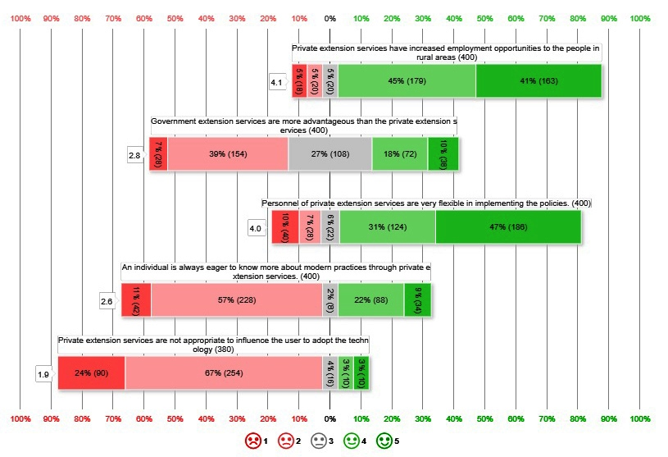
Fig.1. Likert scale chart for statements ranging from 1 to 5

The mean result for statement No.6 is 4.3, as per Fig.3, showing that respondents strongly agreed that the private extension services are quite inexpensive. This could be due to the fact that majority of the services provided by private services are low-cost or free. Statement No.7 has a mean value of 2.8, indicating that the framers were neutral that private extension services have failed to deliver financially viable technologies. This may be because most of the technologies transferred by the private sector are based on the needs of the farmers and are also economically viable. These results are supported by the findings of Ahmed et al., (2018).
The mean value for statement No.8 is 2.2, indicating that the respondents disagreed that required inputs are not supplied regularly to users by private extension services, as majority of respondents rely on private services for their input requirements. According to the mean value for statement No.9 is 3.1 indicating that the respondents were neutral that the personnel from private extension services visit the same users on a regular basis. This indicates that the private extension services are mostly intended towards the farmers who were in regular contact with them. The respondents agreed that private extension services meet the needs of small and marginal farmers, as evidenced by the mean value of 3.8 for statement No.10.
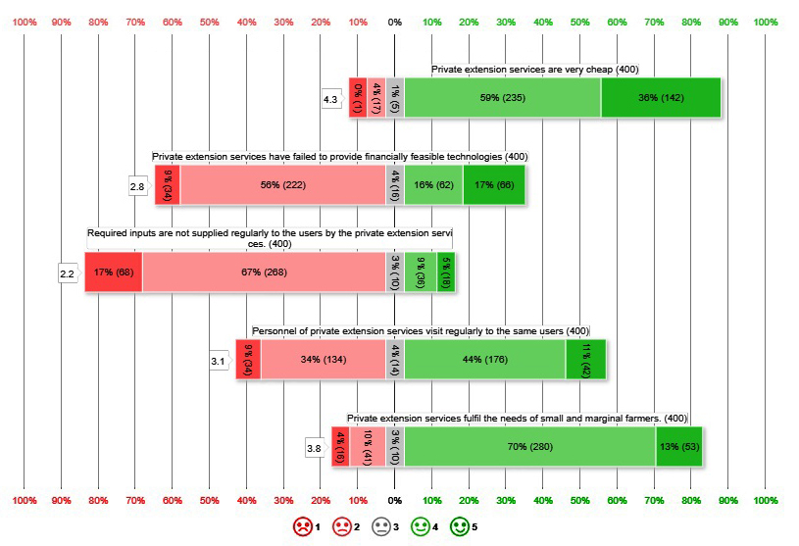
Fig.2. Likert scale chart for statements ranging from 6 to 10

As per the Fig. 4, the 11th statement’s mean value is 3.9, (personnel of private extension services are capable of solving the user's issues in a timely manner) and it was agreed. This suggests that private extension services are assisting in the reduction of huge losses during times of emergency. Similar results have been recorded by Kuncahala et al. (2012) and Kushawaha (2018). With an average score of 3.9, statement No. 12 shows that the respondents agreed private extension services are reliable for prawn farming. Prawn farming is a precarious endeavour, thus constant monitoring of the culture is vital. For prawn farming, the private extension services are dependable since they are always timely and available to farmers. Research of Ahmed et al., 2018 supports these findings.
With a 4.0 average score for statement No. 13, respondents agreed that private extension services help farmers increase their income. Their good experiences with private extension services most certainly help to explain this. Kaur et al. (2014) came at similar conclusions.With an average response of 3.4 for statement No. 14, farmers seem to be indifferent about the idea that only resource-rich farmers could gain from private extension agents' offered services. These findings are in line with Ahmed et al., 2018. For the statement No.15, the mean value is 3.7 indicating that farmers have agreed that extension services provided by them assist the farmers in planning and decision making in the farming activities.
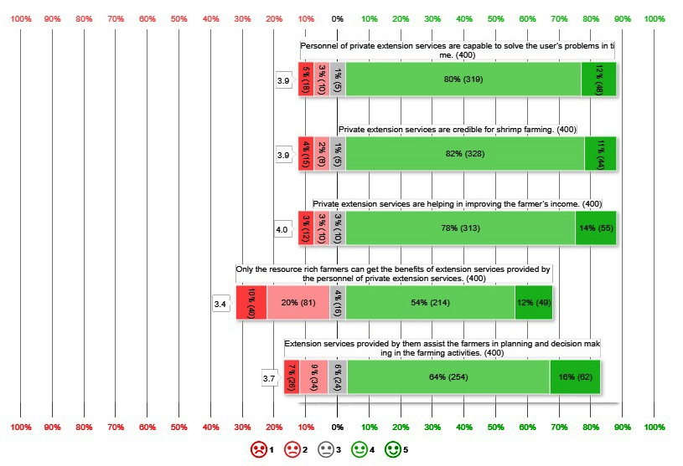
Fig.3. Likert scale chart for statements ranging from 11 to 15

The respondents disagreed that private extension services lack the technical manpower to conduct successful extension services as indicated by the mean result (2.2) of the statement No.16. (Fig.5). These results are in line with conclusions of Kaur et al., (2015). The mean score for statement No.17 is 1.7, indicating that the respondents strongly disagreed that existing infrastructure and facilities provided by private services were insufficient to meet farmers' information needs. As private extension services are working to the needs of the farmers this statement was disagreed.
As it could be seen from the mean value (2.1) of the statement No. 18, the respondents disagreed statement, private extension services cannot demonstrate improved technology to farmers. The mean result for statement No.19 is 4.3, indicating that respondents strongly agreed that private extension servicers are capable of efficiently disseminating shrimp culture technologies very effectively. These results indicate that the private extension personnel are motivating the farmers to adopt the technology which helps them to reduce the production cost. These findings are supported with the findings of Ahmed et al. (2018). The respondents have strongly agreed that the personnel of private extension services have good communication skills, as evidenced by the mean score of 4.3 for statement No 20. It is obvious that the private extension personnel must have a good communication skill in order to persuade the farmers to adopt new innovations. Similar results were reported by Kunchala et al., (2012).

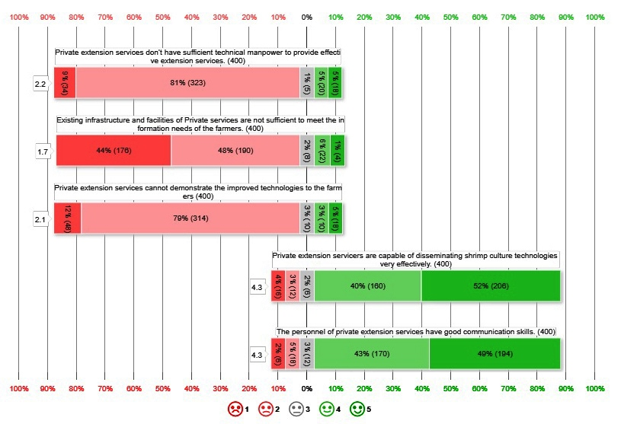
Fig.4. Likert scale chart for statements ranging from 16 to 20

The mean result for statement No. 21 is 4.1, indicating that the respondents agreed that private extension services use various extension teaching methods very effectively (Fig.6). This result indicates that the private extension personnel are encouraging the farmers through live demonstrations, videos and success stories. The respondents agreed that the personnel of private extension services are scientifically oriented, as evidenced by the mean score of 4.0 for statement No.22. It is evident by the mean value of 4.4 for statement No. 23, the respondents strongly agreed that private extension services motivated farmers to adopt new technology.
The mean score for statement No. 24 is 2.6, revealed that respondents disagreed on whether the visiting period of private extension service personnel is sufficient to solve day-to-day problems. The respondents agreed that as a recipient, they always received good guidance from private extension services as it could be seen from the mean value (4.0) of statement No.25. These results indicates that the private extension services are helping the farmers to reduce or minimize the risk and uncertainties in shrimp farming as they were in frequent contact with the farmers.
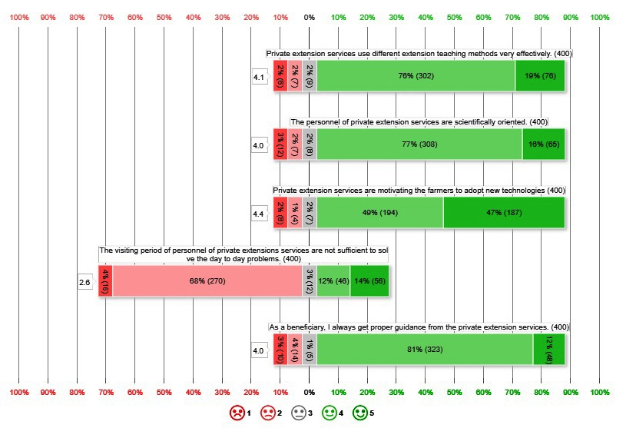
Fig.5. Likert scale chart for statements ranging from 21 to 25
The mean value for statement No.26 is 4.6, and according to the Fig.7, which indicating that respondents strongly agreed that private extension services increase awareness of current market information. The mean value for the statement No.27 is 3.8, where the respondents had agreed that timely availability of needed inputs like feed, seed, fertilizers, farm machineries etc, could be met by the private personnel. This may be because the respondents are getting the required inputs on time which will reduce the risk and uncertainties in shrimp farming.

For the statement No.28, the mean value is 3.5, where the respondents had agreed that private extension services provide finance facilities for the shrimp culture. The possible reason might be because of the availability of different sources of finance for the respondents. The mean value for the statement No.29 is 3.9, where the respondents had agreed that soil, water and health management can be done in the reliable time by private extension services. This may be because the above services were very important to reduce the economic loss in shrimp farming the respondents had a positive opinion that the private extension services are helping to minimizing the risk.
For the statement No.30, the mean value is 4.0, where the respondents had agreed that the personnel of private extension services are highly innovative. As shrimp farming requires high investment and updated technology, it is very important to be innovative according to the time and conditions in shrimp farming. The respondents felt that the personnel of private extension services are innovative and motivate them to adopt the innovative technologies. Similar results were reported by Sravanthi, (2011), Kushawaha, (2018).
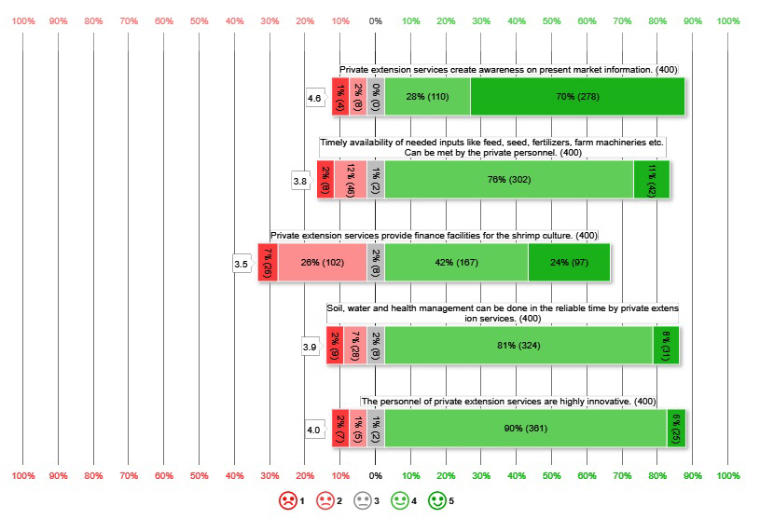
Fig.6. Likert scale chart for statements ranging from 26 to 30

Table.1 Attitude statements and its mean values
Sl. No | Statement | N | Min. | Max. | Mean | Std.  deviation
1. | Rural areas have seen a rise in job availability due to the implementation of private extension services. | 400 | 1 | 5 | 4.1 | 1.06
2. | The public sector's approach to extension services delivers more favorable outcomes than private sector alternatives. | 400 | 1 | 5 | 2.8 | 1.09
3. | The workforce in private extension services exhibits significant flexibility in executing policy directives. | 400 | 1 | 5 | 4.0 | 1.39
4. | Private extension services frequently attract those who are curious about learning the latest agricultural practices. | 400 | 1 | 5 | 2.6 | 1.14
5. | Private extension programs are ineffective in promoting the uptake of technological innovations among their clientele. | 400 | 1 | 5 | 1.9 | 1.05
6. | Private extension services are offered at highly affordable rates. | 400 | 1 | 5 | 4.3 | 0.83
7. | Private extension initiatives have not managed to deliver cost-effective technological solutions. | 400 | 1 | 5 | 2.8 | 1.25
8. | The private extension services do not consistently provide the necessary inputs to the users. | 400 | 1 | 5 | 2.2 | 0.94
9. | The personnel of private extension services make regular visits to the same users. | 400 | 1 | 5 | 3.1 | 1.21
10. | Private extension services meet the needs of small and marginal farmers. | 400 | 1 | 5 | 3.8 | 1.01
11. | The personnel of private extension services are capable of solving users' problems promptly. | 400 | 1 | 5 | 3.9 | 1.00
12. | Private extension services are credible for shrimp farming | 400 | 1 | 5 | 3.9 | 0.85
13. | Private extension services are helping in improving the farmer’s income | 400 | 1 | 5 | 4.0 | 1.07
14. | Only the resource rich farmers can get the benefits of extension services provided by the personnel of private extension services | 400 | 1 | 5 | 3.4 | 1.21
15. | Extension services provided by them assist the farmers in planning and decision making in the farming activities. | 400 | 1 | 5 | 3.7 | 1.03
16. | Private extension services do not have sufficient technical manpower to provide effective extension services | 400 | 1 | 5 | 2.2 | 0.83
17. | Existing infrastructure and facilities of private extension services are not sufficient to meet the information needs of the farmers. | 400 | 1 | 5 | 1.7 | 0.86
18. | Private extension services cannot demonstrate the improved technologies to the farmers | 400 | 1 | 5 | 2.1 | 0.85
19. | Private extension servicers are capable of disseminating shrimp culture technologies very effectively | 400 | 1 | 5 | 4.3 | 1.02
20. | The personnel of private extension services have good communication skills | 400 | 1 | 5 | 4.3 | 1.04
21. | Private extension services use different extension teaching methods very effectively. | 400 | 1 | 5 | 4.1 | 0.86
22. | The personnel of private extension services are scientifically oriented | 400 | 1 | 5 | 4.0 | 0.88
23. | Private extension services are motivating the farmers to adopt new technologies | 400 | 1 | 5 | 4.4 | 0.83
24. | The visit frequency of private extension service personnel is insufficient to address daily problems. | 400 | 1 | 5 | 2.6 | 1.17
25. | As a beneficiary, I consistently receive proper guidance from private extension services. | 400 | 1 | 5 | 4.0 | 0.90
26. | Private extension services create awareness on present market information | 400 | 1 | 5 | 4.6 | 0.99
27. | The timely availability of necessary inputs such as feed, seed, fertilizers, and farm machinery can be provided by private personnel. | 400 | 1 | 5 | 3.8 | 1.08
28. | Private extension services provide finance facilities for shrimp culture | 400 | 1 | 5 | 3.5 | 1.06
29. | Soil, water and health management can be done in the reliable time by the personnel of private extension | 400 | 1 | 5 | 3.9 | 0.87
30. | The personnel of private extension services are highly innovative | 400 | 1 | 5 | 4.0 | 0.58

Overall attitude level of the respondents towards private extension services

Figure 7 shows that the average value of all thirty statements is 3.5, meaning that most of the shrimp farmers agreed with the comments and showed a good and positive attitude about the several services provided by the private extension system. It also revealed that in most inputs and services used in shrimp aquaculture, private businesses and employees rule. Operating in a high-risk, high-investment industry, shrimp growers depend on input vendors for quick technical support and other resources. Comparable findings were reported by Kaur et al. (2014) and Tripathy and Dipak (2021).

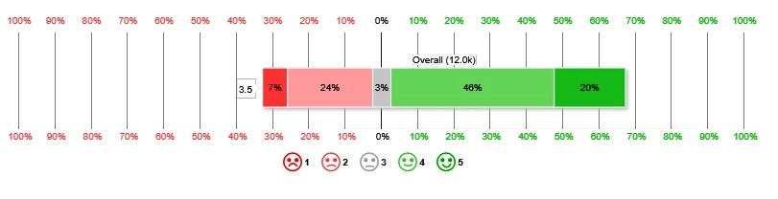
Fig.7. Overall attitude of the respondents towards private extension services

According to Kaur et al. (2014), the majority of farmers (57.5%) supported the idea of privatizing extension services. While a significant portion (32%) expressed even stronger support, a smaller group (10.5%) was less enthusiastic.
Tripathy and Dipak (2021) also found positive farmer attitudes towards private extension services. Nearly half of the farmers surveyed (45.83%) held a high opinion of these services, with the remaining participants demonstrating a generally positive outlook.

3.4. Relationship between independent and dependent variable (Y₃)
The relationship between different groups (independent variables) and attitudes was analyzed using chi-square statistics. From the results below it is evident that there is an significant association at 5% significance level of shrimp farming experience (χ²= 13.213, p = .041), Mass medias exposure (χ²= 9.804, p = .044), Training exposure (χ²= 21.756, p = .001), Source of shrimp seed (χ²= 14,115, p = .028) and Awareness on Best Management Practices (χ²= 19.790, p = .001) with the attitude of respondents.

TABLE 2. Crosstab
 |  | Attitude |  |  | Total | χ² | P (2-sided)
 |  | Low attitude | Medium attitude | High attitude | Total | χ² | P (2-sided)
Age | Old | 9_{a1} | 97_{b} | 8_{ab} | 114 | 8.341 | 0.080
Age | Old | 56.3% | 27.2% | 29.6% | 28.5% | 8.341 | 0.080
Age | Old | 7.9% | 85.1% | 7.0% | 100% | 8.341 | 0.080
Age | Middle | 5_{a2} | 196_{ab} | 17_{b} | 218 | 8.341 | 0.080
Age | Middle | 31.3% | 54.9% | 63.0% | 54.5% | 8.341 | 0.080
Age | Middle | 2.3% | 89.9% | 7.8% | 100% | 8.341 | 0.080
Age | Young | 2₁₂ | 64 | 2 | 68 | 8.341 | 0.080
Age | Young | 12.5% | 17.9% | 7.4% | 17.0% | 8.341 | 0.080
Age | Young | 2.9% | 94.1% | 2.9% | 100% | 8.341 | 0.080
Occupational status | Secondary occupation | 3_{a1} | 13_{b1} | 2_{ab} | 18 | 9.334 | 0.053
Occupational status | Secondary occupation | 18.8% | 3.6% | 7.4% | 4.5% | 9.334 | 0.053
Occupational status | Secondary occupation | 16.7% | 72.2% | 11.1% | 100% | 9.334 | 0.053
Occupational status | Primary occupation | 5_{a2} | 138_{a2} | 8_{a} | 151 | 9.334 | 0.053
Occupational status | Primary occupation | 31.2% | 38.7% | 29.6% | 37.8% | 9.334 | 0.053
Occupational status | Primary occupation | 3.3% | 91.4% | 5.3% | 100% | 9.334 | 0.053
Occupational status | Only occupation | 8_{a2} | 206_{a12} | 17_{a} | 231 | 9.334 | 0.053
Occupational status | Only occupation | 50.0% | 57.7% | 63.0% | 57.8% | 9.334 | 0.053
Occupational status | Only occupation | 3.5% | 89.2% | 7.4% | 100% | 9.334 | 0.053
Shrimp farming experience | Less than 6 years | 1₁ | 55 | 6₁ | 62 | 13.123 | 0.041
Shrimp farming experience | Less than 6 years | 6.3% | 15.4% | 22.2% | 15.5% | 13.123 | 0.041
Shrimp farming experience | Less than 6 years | 1.6% | 88.7% | 9.7% | 100% | 13.123 | 0.041
Shrimp farming experience | 6 - 10 | 3₁ | 122 | 13₁ | 138 | 13.123 | 0.041
Shrimp farming experience | 6 - 10 | 18.8% | 34.2% | 48.1% | 34.5% | 13.123 | 0.041
Shrimp farming experience | 6 - 10 | 2.2% | 88.4% | 9.4% | 100% | 13.123 | 0.041
Shrimp farming experience | 11 - 15 | 7₁₂ | 137 | 8₁₂ | 152 | 13.123 | 0.041
Shrimp farming experience | 11 - 15 | 43.8% | 38.4% | 29.6% | 38.0% | 13.123 | 0.041
Shrimp farming experience | 11 - 15 | 4.6% | 90.1% | 5.3% | 100% | 13.123 | 0.041
Shrimp farming experience | > 15 years | 5_{a2} | 43_{ab} | 0_{b2} | 48 | 13.123 | 0.041
Shrimp farming experience | > 15 years | 31.3% | 12.0% | 0.0% | 12.0% | 13.123 | 0.041
Shrimp farming experience | > 15 years | 10.4% | 89.6% | 0.0% | 100% | 13.123 | 0.041
Farm size | Marginal (< 0.50 ha) | 1 | 56₁ | 8₁ | 65 | 15.414 | 0.17
Farm size | Marginal (< 0.50 ha) | 6.3% | 15.7% | 29.6% | 16.3% | 15.414 | 0.17
Farm size | Marginal (< 0.50 ha) | 1.5% | 86.2% | 12.3% | 100% | 15.414 | 0.17
Farm size | Small (0.5 – 1.00 ha) | 6_{a} | 133_{a2} | 2_{b2} | 141 | 15.414 | 0.17
Farm size | Small (0.5 – 1.00 ha) | 37.5% | 37.3% | 7.4% | 35.3% | 15.414 | 0.17
Farm size | Small (0.5 – 1.00 ha) | 4.3% | 94.3% | 1.4% | 100% | 15.414 | 0.17
Farm size | Medium (1.0-3.0 ha) | 8 | 101₁ | 10₁ | 119 | 15.414 | 0.17
Farm size | Medium (1.0-3.0 ha) | 50.0% | 28.3% | 37.0% | 29.8% | 15.414 | 0.17
Farm size | Medium (1.0-3.0 ha) | 6.7% | 84.9% | 8.4% | 100% | 15.414 | 0.17
Farm size | Large (>3.0 ha) | 1 | 67₁₂ | 7₁ | 75 | 15.414 | 0.17
Farm size | Large (>3.0 ha) | 6.3% | 18.8% | 25.9% | 18.8% | 15.414 | 0.17
Farm size | Large (>3.0 ha) | 1.3% | 89.3% | 9.3% | 100% | 15.414 | 0.17
Farm size | Large (>3.0 ha) | 0.0% | 0.3% | 0.0% | 0.3% | 15.414 | 0.17
Farm size | Large (>3.0 ha) | 0.0% | 100% | 0.0% | 100% | 15.414 | 0.17
Farm size | Large (>3.0 ha) | 4.7% | 82.8% | 12.5% | 100% | 15.414 | 0.17
Farm size | Large (>3.0 ha) | 18.8% | 7.3% | 3.7% | 7.5% | 15.414 | 0.17
Farm size | Large (>3.0 ha) | 10% | 86.7% | 3.3% | 100% | 15.414 | 0.17
Annual income | <3 lakhs | 2 | 66 | 8₁ | 76 | 9.809 | 0.133
Annual income | <3 lakhs | 12.5% | 18.5% | 29.6% | 19.0% | 9.809 | 0.133
Annual income | <3 lakhs | 2.6% | 86.8% | 10.5% | 100% | 9.809 | 0.133
Annual income | 3 - 4 lakhs | 6_{ab} | 125_{b} | 3_{a2} | 134 | 9.809 | 0.133
Annual income | 3 - 4 lakhs | 37.5% | 35.0% | 11.1% | 33.5% | 9.809 | 0.133
Annual income | 3 - 4 lakhs | 4.5% | 93.3% | 2.2% | 100% | 9.809 | 0.133
Annual income | 4 - 5 lakhs | 7 | 105 | 9₁₂ | 121 | 9.809 | 0.133
Annual income | 4 - 5 lakhs | 43.8% | 29.4% | 33.3% | 30.3% | 9.809 | 0.133
Annual income | 4 - 5 lakhs | 5.8% | 86.8% | 7.4% | 100% | 9.809 | 0.133
Annual income | 5 – 6 lakhs | 1 | 61 | 7₁ | 69 | 9.809 | 0.133
Annual income | 5 – 6 lakhs | 6.3% | 17.1% | 25.9% | 17.3% | 9.809 | 0.133
Annual income | 5 – 6 lakhs | 1.4% | 88.4% | 10.4% | 100% | 9.809 | 0.133
Annual expenditure | <2 lakhs | 1 | 14 | 2₁ | 17 | 10.645 | 0.223
Annual expenditure | <2 lakhs | 6.3% | 3.9% | 7.4% | 4.3% | 10.645 | 0.223
Annual expenditure | <2 lakhs | 5.9% | 82.4% | 11.8% | 100% | 10.645 | 0.223
Annual expenditure | 2 - 3 lakhs | 1 | 62 | 6₁ | 69 | 10.645 | 0.223
Annual expenditure | 2 - 3 lakhs | 6.3% | 17.4% | 22.2% | 17.3% | 10.645 | 0.223
Annual expenditure | 2 - 3 lakhs | 1.4% | 89.9% | 8.7% | 100% | 10.645 | 0.223
Annual expenditure | 3 - 4 lakhs | 7_{a} | 127_{a} | 3_{b2} | 137 | 10.645 | 0.223
Annual expenditure | 3 - 4 lakhs | 43.8% | 35.6% | 11.1% | 34.3% | 10.645 | 0.223
Annual expenditure | 3 - 4 lakhs | 5.1% | 92.7% | 2.2% | 100% | 10.645 | 0.223
Annual expenditure | 4 - 5 lakhs | 6 | 96 | 9₁ | 111 | 10.645 | 0.223
Annual expenditure | 4 - 5 lakhs | 37.5% | 26.9% | 33.3% | 27.8% | 10.645 | 0.223
Annual expenditure | 4 - 5 lakhs | 5.4% | 86.5% | 8.1% | 100% | 10.645 | 0.223
Annual expenditure | >5 lakhs | 1 | 58 | 7₁ | 66 | 10.645 | 0.223
Annual expenditure | >5 lakhs | 6.3% | 16.2% | 25.9% | 16.5% | 10.645 | 0.223
Annual expenditure | >5 lakhs | 1.5% | 87.9% | 10.6% | 100% | 10.645 | 0.223
Contact with extension agencies | Low | 1_{a} | 53_{a} | 4_{a12} | 58 | 7.933 | 0.094
Contact with extension agencies | Low | 6.3% | 14.8% | 14.8% | 14.5% | 7.933 | 0.094
Contact with extension agencies | Low | 1.7% | 91.4% | 6.9% | 100% | 7.933 | 0.094
Contact with extension agencies | Medium | 14_{a} | 228_{ab} | 13_{b2} | 255 | 7.933 | 0.094
Contact with extension agencies | Medium | 87.5% | 63.9% | 48.1% | 63.7% | 7.933 | 0.094
Contact with extension agencies | Medium | 5.5% | 89.4% | 5.1% | 100% | 7.933 | 0.094
Contact with extension agencies | High | 1 | 76 | 10₁ | 87 | 7.933 | 0.094
Contact with extension agencies | High | 6.3% | 21.3% | 37.0% | 21.8% | 7.933 | 0.094
Contact with extension agencies | High | 1.1% | 87.4% | 11.5% | 100% | 7.933 | 0.094
Mass media exposure | Low | 5_{a1} | 51_{ab} | 1_{b1} | 57 | 9.804 | 0.044
Mass media exposure | Low | 31.3% | 14.3% | 3.7% | 14.2% | 9.804 | 0.044
Mass media exposure | Low | 8.8% | 89.5% | 1.8% | 100% | 9.804 | 0.044
Mass media exposure | Medium | 10₁₂ | 240 | 17₁₂ | 267 | 9.804 | 0.044
Mass media exposure | Medium | 62.5% | 67.2% | 63.0% | 66.8% | 9.804 | 0.044
Mass media exposure | Medium | 3.7% | 89.9% | 6.4% | 100% | 9.804 | 0.044
Mass media exposure | High | 1₂ | 66 | 9₂ | 76 | 9.804 | 0.044
Mass media exposure | High | 6.3% | 18.5% | 33.3% | 19.0% | 9.804 | 0.044
Mass media exposure | High | 1.3% | 89.3% | 6.8% | 100% | 9.804 | 0.044
Training exposure | No training | 0₂ | 22₁₂ | 2₁₂ | 24 | 21.756 | 0.001
Training exposure | No training | 0.0% | 6.2% | 7.4% | 6.0% | 21.756 | 0.001
Training exposure | No training | 0.0% | 91.7% | 8.3% | 100% | 21.756 | 0.001
Training exposure | 1 training | 5_{b2} | 118_{b2} | 17_{a2} | 140 | 21.756 | 0.001
Training exposure | 1 training | 31.3% | 33.1% | 63.0% | 35.0% | 21.756 | 0.001
Training exposure | 1 training | 3.6% | 84.3% | 12.1% | 100% | 21.756 | 0.001
Training exposure | 2 training | 3₂ | 147₁ | 7₁ | 157 | 21.756 | 0.001
Training exposure | 2 training | 18.8% | 41.2% | 25.9% | 39.3% | 21.756 | 0.001
Training exposure | 2 training | 1.9% | 93.6% | 4.5% | 100% | 21.756 | 0.001
Training exposure | =>3 trainings | 8_{a1} | 70_{b12} | 1_{b1} | 79 | 21.756 | 0.001
Training exposure | =>3 trainings | 50.0% | 19.6% | 3.7% | 19.8% | 21.756 | 0.001
Training exposure | =>3 trainings | 10.1% | 88.6% | 1.3% | 100% | 21.756 | 0.001
Scientific orientation | Low | 6₁ | 61 | 3 | 70 | 5.392 | 0.249
Scientific orientation | Low | 37.50% | 17.10% | 11.10% | 17.50% | 5.392 | 0.249
Scientific orientation | Low | 8.6% | 87.1% | 4.3% | 100% | 5.392 | 0.249
Scientific orientation | Medium | 8₂ | 226 | 19 | 253 | 5.392 | 0.249
Scientific orientation | Medium | 50.00% | 63.30% | 70.40% | 63.20% | 5.392 | 0.249
Scientific orientation | Medium | 3.2% | 89.3% | 7.5% | 100% | 5.392 | 0.249
Scientific orientation | High | 2₁₂ | 70 | 5 | 77 | 5.392 | 0.249
Scientific orientation | High | 12.50% | 19.60% | 18.50% | 19.30% | 5.392 | 0.249
Scientific orientation | High | 2.6% | 90.9% | 6.5% | 100% | 5.392 | 0.249
Source of shrimp seed | Government shrimp farms | 1_{ab12} | 69_{b1} | 0_{a1} | 70 | 14.115 | 0.028
Source of shrimp seed | Government shrimp farms | 6.3% | 19.3% | 0.0% | 17.5% | 14.115 | 0.028
Source of shrimp seed | Government shrimp farms | 1.4% | 98.6% | 0.0% | 100% | 14.115 | 0.028
Source of shrimp seed | Private shrimp farms | 1₂ | 70₁₂ | 5₂ | 76 | 14.115 | 0.028
Source of shrimp seed | Private shrimp farms | 6.3% | 19.6% | 18.5% | 19.0% | 14.115 | 0.028
Source of shrimp seed | Private shrimp farms | 1.3% | 92.1% | 6.6% | 100% | 14.115 | 0.028
Source of shrimp seed | From other shrimp farmers | 7₁₂ | 147₂ | 16₂ | 170 | 14.115 | 0.028
Source of shrimp seed | From other shrimp farmers | 43.8% | 41.2% | 59.3% | 42.5% | 14.115 | 0.028
Source of shrimp seed | From other shrimp farmers | 4.1% | 86.5% | 9.4% | 100% | 14.115 | 0.028
Source of shrimp seed | Own shrimp seeds produced by themselves | 7₁ | 71₂ | 6₂ | 84 | 14.115 | 0.028
Source of shrimp seed | Own shrimp seeds produced by themselves | 43.8% | 19.9% | 22.2% | 21.0% | 14.115 | 0.028
Source of shrimp seed | Own shrimp seeds produced by themselves | 8.3% | 84.5% | 7.1% | 100% | 14.115 | 0.028
Awareness on BMP | Somewhat Aware | 0_{ab} | 11_{b1} | 5_{a1} | 16 | 19.790 | 0.001
Awareness on BMP | Somewhat Aware | 0.0% | 3.1% | 18.5% | 4.0% | 19.790 | 0.001
Awareness on BMP | Somewhat Aware | 0.0% | 68.8% | 31.3% | 100% | 19.790 | 0.001
Awareness on BMP | Aware | 9 | 176₂ | 16₂ | 201 | 19.790 | 0.001
Awareness on BMP | Aware | 56.3% | 49.3% | 59.3% | 50.3% | 19.790 | 0.001
Awareness on BMP | Aware | 4.5% | 87.6% | 8.0% | 100% | 19.790 | 0.001
Awareness on BMP | Well aware | 7_{ab} | 170_{b2} | 6_{a3} | 183 | 19.790 | 0.001
Awareness on BMP | Well aware | 43.8% | 47.6% | 22.2% | 45.8% | 19.790 | 0.001
Awareness on BMP | Well aware | 3.8% | 92.9% | 3.3% | 100% | 19.790 | 0.001
*Identical alphabetical subscript letter: Categories with the same letter have similar proportions across different groups (attitudes) and are not significantly different from each other.
*Identical numerical subscript letter: Categories with the same number have similar proportions within the same group (experience) and are not significantly different from each other.

These results indicate that shrimp farmers had sufficient interaction with private extension service personnel regarding the shrimp farming activities and are incorporating new or updated technologies into their farming operations for higher production.
The above findings revealed that the farmers of Andhra Pradesh had a positive and favorable attitude toward private extension services who are mainly concerned with maximizing their profits.
4. CONCLUSION
Effective extension services are important for providing technical advices and for supply of necessary inputs to the farmers. There is a positive association with the socio personal characteristics and the attitude of the farmers indicating that farmers are in need of private extension services for improving their livelihood opportunities. The present available private extension services are farmer participatory and are oriented towards the needs of the farmers. The study revealed that the respondents had a favourable and positive attitude towards the private extension services. This indicates that the farmers in general have realized the advantages of interventions made by the personnel of private extension services in shrimp culture especially in seed production and supply of inputs. Further, these results indicated that there is a need to bring desirable change in the thought process of the farmers which will motive them to find out diversified farming systems resulting in improving their standards of living.
Data Availability Statement
The data that support the findings of the study are available within the article.

COMPETING INTERESTS DISCLAIMER:
Authors have declared that they have no known competing financial interests OR non-financial interests OR personal relationships that could have appeared to influence the work reported in this paper.

REFERENCES
Ahmed, Z., Sarker, A., Rahman, M.Z., Lei, B., Mukta, M.Z.N., 2018. Fisheries extension in Bangladesh and local extension agent for fisheries: A micro level assessment of farmers’ Attitude. Int. J. Fish. Aquat. Stud. 6(4),93-103.
Chowdhury, A.R., Mamun-ur-Rashid, M., Hossain, S., 2016. Effect of Public Fisheries Extension Service on the Selected Socioeconomic Aspects of the Clients in Two Selected Sub-districts under Barisal District in Bangladesh. Asian J. Agric. Ext. Economics Sociol. 13,1-13.
Department of Fisheries, 2021. Govt. of Andhra Pradesh (Accessed on 14.10.2021) www.fisheries.ap.gov.in
Kaur, J., Peer, Q.J., Malik, J.S., Shehrawat, P.S., 2015. Knowledge of Farmers about Privatization of Agricultural Extension Services and the factors influencing it. Economic Affairs. 60(2),219.
Kaur, J., Shehrawat, P.S., and Peer, Q.J.A., 2014. Attitude of farmers towards privatization of agricultural extension services. Agricultural Science Digest. 34(2),81-86.
Kavyashree, S., 2014. A comparative analysis of public, private and corporate extension system. MSc. Thesis submitted to University of Agricultural & Horticultural Sciences, Shivamogga, Karnataka, India.
Kumaran, M., Ravisankar, T., Anand, P.R., Vimala, D.D., Balasubramanian, C.P., 2017. Knowledge level of shrimp farmers on better management practices (BMPs) of Penaeus vannamei farming: A comparative assessment of east and west coasts of India. Indian J. Fish. 64(3): 93-99.
Kunchala, K. D., Patel, J. K., Desai, C. P., 2012. Advantages of private extension service and it correlates with attitude toward private extension service. Guj. J. Ext. Edu. 23:177-179.
Kushawaha, N., 2018. A study on attitude of farmers towards privatization of agricultural extension services, M.F.Sc, Thesis submitted to R.A.K College of Agriculture, Sheroe, Madhya Pradesh, India.
Likert, R., 1932. A technique for the measurement of attitudes. Archives of psychology. 22. 140,55.
Maity, P., Panda, A.K., Ghorai, S.K., 2021. Mapping the wider impact of brackish water shrimp culture on the local environment and economy: A brief. Int. J. Fish. Aquat. Sci. 9,185-188.
Naik, B.V., and Patil, S.V., 2020. Adoption of Better Management practices by shrimp farmers along South Konkan coast of Maharastra. M. F. Sc. Thesis submitted to Dr.Balasaheb Sawant Knokan Krishi Vidyapeeth, Dapoli, India.

Pandya, R.D., 2004. A scale to measure the attitude towards the privatization of extension service. Guj. J. Ext. Edu. 15, 66-70.
Raghuwanshi, K., Jaiswal, D.K., Dubey, M.K., Naberia, S., 2022a. Constraints faced by farmers towards use of private agricultural extension services in Chhindwara district (M.P). J. Pharm. Innov. SP-11(4), 335-337.
Raghuwanshi, K., Jaiswal, D.K., Dubey, M.K., Naberia, S., 2022b. A study on profile characteristics of farmers on knowledge, attitude and accessibility towards privatization of agricultural extension services. J. Pharm. Innov.SP-11(3),1537-1540.
Sravanthi. B., 2011. Privatization of Agricultural Extension Services in Guntur District of Andhra Pradesh. M.Sc. (Extension Education) Thesis submitted to Acharya N.G. Ranga Agricultural University, Guntur, Andhra Pradesh, India.
Tank, 2019. Adoption of improved shrimp farming practices in Saurashtra region of Gujarat. Ph.D. Thesis submitted to Junagadh Agriculture University, Veraval, Gujarat, India.

Tank, K.V., Yusufzai, S.I., Bajaniya, V.C., 2019. Constraints analysis of shrimp farming in Saurashtra, Gujarat, India. J. Entomol. Zool. Stud. 7(3): 124-127.
Thurstone, L.L., 1946. Comment. American Journal of Sociology. 50,39-50.
Tripathy, H., and Dipak, K.B., 2021. Farmer’s View on Privatization of Agricultural Extension Services in Ganjam District of Odisha, India. Int.J.Curr.Microbiol.App.Sci. 10(08),756-764.

