***Review Article***

**Fruit and Seed Development of critically endangered *Commiphora wightii* (Arn.) Bhandari: Insights into Physiological Maturation and Germination Potential**

**Abstract**  
*Commiphora wightii* (Arnott) Bhandari, commonly known as guggul, is a plant species renowned for its medicinal properties. Overexploitation of its oleo-gum resin has led to its inclusion in the IUCN Red List as "critically endangered." To ensure the survival of this ecologically and medicinally significant species, ex situ conservation strategies and cultivation practices must be adopted. Understanding the morphometric, colorimetric, and physiological traits associated with fruit and seed maturity is crucial for developing effective conservation strategies. This study evaluates fruit and seed development across five maturity stages—40, 60, 80, 90, and 100 days after anthesis (DAA)—by assessing key morphological traits such as length, width, fresh and dry weight, and moisture content, as well as color changes using the RHS color chart. Physiological assessments, including germination percentage (before and after desiccation), seedling length, and vigor index, were conducted. Results indicate that the optimal time for seed collection is 80–90 days after anthesis, a stage that ensures maximum germination potential and seedling vigor while minimizing losses due to natural seed fall. These findings identify reliable indicators of seed maturity, such as morphometric and physiological parameters, to guide seed collection practices. By providing critical insights into the developmental stages of *C. wightii*, this study contributes to the formulation of effective propagation and conservation strategies, ensuring the sustainability of this critically engendered species.

**Keywords**: Seed maturity, fruit development, germination percentage, ex situ conservation, morphometric traits, medicinal plants

**Introduction**

Guggul (Commiphora wightii (Arn.) Bhandari), also known as Indian bdellium, is a slow-growing, aromatic shrub or small tree belonging to the family Burseraceae. The genus name Commiphora is derived from the Greek words "kommi" (meaning "gum") and "phoros" (meaning "bearing"), likely referring to the resinous sap produced by many species within this genus. The specific epithet "wightii" honors British botanist Dr. Robert Wight (1796–1872), who made significant contributions to the study of Indian flora. The author abbreviation "(Arn.) Bhandari" denotes the individuals involved in classifying the species, with "Arn." referring to botanist George Arnold Walker Arnott and "Bhandari" to Indian botanist Harbans Lal Bhandari. The species is also known by several synonyms, including Balsamodendron wightii Arn. and Commiphora mukul (Hook. ex Stocks) Engl. (Balsamodendron mukul Hook. ex Stocks). This woody plant typically grows to a height of 3 to 3.5 meters in 8 to 10 years (Hooker 1872).

Commiphora wightii is characterized by its perennial, highly branched, thorny, and woody shrub form. It thrives in arid, semi-arid, and rocky environments, exhibiting a slow growth rate, long dormant phases, and deciduous nature. Native to Africa and Asia, the species is widely distributed across tropical regions, including Northern Africa, Madagascar, Central Asia, Australia, the Pacific Islands, and the Indian subcontinent, with significant populations in India (Rajasthan, Gujarat, Maharashtra, Madhya Pradesh, Karnataka) and Pakistan (Sindh and Balochistan). In India, C. wightii grows in rocky, hilly terrains, sandy tracts, and semi-arid regions, adapting to altitudes ranging from 250 to 1800 meters and annual rainfall between 225-500 mm. It is often found alongside species like Anogeissus pendula, Acacia spp., and Rhus mysorensis in areas with scarce rainfall. Bishoyi et al. (2018) observed that populations with maximum genetic diversity and sexual reproductive forms were primarily located in Gujarat, particularly in the regions of Kutch, Dwarka, Jamnagar, and Porbandar. The study suggested that these areas represent the original distribution zones of Commiphora wightii, from which the species spread to other parts of Gujarat and Rajasthan.

Guggul is highly valued for its oleo-gum resin, which contains bioactive compounds, particularly guggulsterone E and Z. These compounds are known for their broad pharmacological activities, including anti-inflammatory, antirheumatic, hypocholesterolemic, hypolipidemic, antifertility, and anticancer effects (Satyavati 1990). The resin is extensively used in traditional medicine systems such as Ayurveda and Unani, as well as in allopathic medicine. In addition to its medicinal uses, guggul is also employed in perfumery, calico printing, dyeing silk and cotton, as firewood, and as incense in cultural rituals like meditation and purification. Notably, it has been recognized for its cardiovascular benefits, as it helps reduce serum triglycerides, LDL, and VLDL cholesterol levels while enhancing HDL cholesterol.

Despite its immense value, C. wightii faces critical threats to its survival. The species is not cultivated systematically, and natural populations are heavily exploited for their oleo-gum resin through a practice called "tapping," which involves making deep cuts in the trunk. This process, typically performed by local tribal communities, often results in the plant's death within two to six months after a single tapping session (Bhatt et al. 1989; Paliwal 2010). Additional pressures, including poor seed production, low germination rates, slow growth, overgrazing, habitat destruction, mining activities, and the invasion of alien species, exacerbate the species' decline (Kasera and Prakash 2005). As a result, the International Union for Conservation of Nature (IUCN) has classified C. wightii as "critically endangered" (Ved et al. 2015). The plant primarily regenerates vegetatively through stem cuttings or air-layering, with natural regeneration from seeds being rare (Kasera and Prakash 2005). This underscores the need for ex situ conservation strategies and the systematic cultivation of C. wightii to prevent its extinction.

Understanding the morphometric, colorimetric, and physiological traits of fruit and seed maturity is crucial for developing effective propagation techniques. Ethnobotanical (Hocking 1993), anatomical (Shah et al. 1982), and ecological (Dixit and Subba Rao 2000) aspects of C. wightii have been well documented, but there is a lack of research on the physiological maturity indicators for this endangered species. This study examines the developmental parameters of C. wightii fruits and seeds, focusing on traits such as morphology, moisture content, color changes, and germination potential at various maturity stages. The goal is to identify key maturity indicators that will optimize seed collection timing, enhancing propagation techniques and supporting the long-term conservation and sustainable management of this species, particularly for future afforestation efforts.

**Materials and Methods**

***Study Area***

The study on *Commiphora wightii* was conducted in its natural habitat in the tropical thorn forest of Bhind district, Madhya Pradesh, India, selected for its mature plant presence and accessibility for regular monitoring. Bhind experiences a semi-arid climate with extremely hot summers (35°C to 47°C) from March to June, mild winters (6°C to 25°C) from November to February, and a monsoon season (July to September) with moderate rainfall (800-1,000 mm). Humidity is low in summer, rising to 60%-90% during the monsoon and dropping to 30%-50% in winter. The district also faces dry, hot winds (loo) in summer, moderate winds during the monsoon, and local thunderstorms. The region has alluvial and black soils, mainly dry deciduous forests and shrubs **(see Figure I)**

***Sample Collection***

Fruit and seed samples were collected at various stages of maturity, ranging from early development to full ripeness. To ensure consistency, fruits of similar age were randomly selected and tagged from twenty different plants in nearby area. The collection process was carried out at five distinct stages of fruit maturity: 40 days after anthesis (DAA), 60 DAA, 80 DAA, 90 DAA and 100 DAA. These seeds were used to assess both morphometric, colorimetric and physiological parameters.

***Data Collection***

Data collection involved assessing various parameters at different stages of fruit and seed development. Fruits were transported in cotton bags, and seeds were extracted through depulping. Seed collection and processing involve manually depulping the fruits by rubbing and washing them with water. After drying in the shade, the seeds are sorted based on color (black, brown, and white) and the number of lobes. Black seeds are viable and polyembryonic, while whitish-black seeds are non-viable due to the absence of an embryo. Measurements included fruit and seed dimensions (length and width) using a digital caliper, recorded from three replicates of ten fruits and fifty seeds each. Fresh and dry weights were determined using an analytical balance, with fresh mass measured from the same replicates and dry mass recorded after drying at 80°C until a constant weight was achieved. These weights were scaled to represent 100 fruits and 100 seeds. Color was assessed using the RHS color chart (2015; 2019 reprint) for 20 samples at each harvest stage. Germination was tested according to ISTA rules by placing three replicates of 50 seeds each on filter paper in petri dishes, incubated at 35± 1°C with a 16/8 light/dark cycle, and assessed daily for 28 days. Seeds were considered germinated when radicles reached 1 cm, and desiccation sensitivity was also tested. Seed vigor was calculated using the mean germination percentage and mean seedling length, as outlined by Abdul-Baki and Anderson (1973)

**Statistical Analysis**

All data were analyzed using analysis of variance (ANOVA) with significance determined at *p* < 0.05. Least Significant Difference (LSD) and F-test results were used to determine consistency and significance across stages.

**Results**

The plant exhibits distinct phenological patterns, with leafless periods in winter (October to March) and leaf growth initiated by short spells of rainfall in April. Flowering and fruiting occur year-round, with peaks in summer (April-May) and winter (November). The fruits of *Commiphora wightii* are oval drupes that start green, turn pinkish, and finally red when ripe Fruits contain black and white seeds, with black seeds being viable, especially prevalent in winter. Black seeds collected in winter exhibit higher germination rates compared to those collected in summer, while white seeds show low or no germination, indicating seasonal variations in seed viability and germination. Seed maturation may take longer in winter, resulting in a higher yield of mature seeds **(see Figure II)**.

***Fruit Development***

Table 1 presents the fruit development parameters of *Commiphora wightii* at different stages of maturity, measured in Days After Anthesis (DAA). The data shows a clear progression in fruit characteristics as the fruits mature. At 40 DAA, the fruit length is 0.79 cm, width is 0.563 cm, and the fresh weight of 100 fruits is 13.43 g, with an initial moisture content of 82.61%. The fruit is green in color (Group 142, Strong Yellow Green). By 60 DAA, the fruit length increases to 0.847 cm, width to 0.613 cm, and fresh weight to 28.17 g, with moisture content decreasing to 78.56%. The fruit color shifts to yellow-green (Group 145, Strong Yellow Green). At 80 DAA, the fruit length reaches 1.027 cm, width 0.643 cm, and fresh weight 42.9 g, with moisture content dropping to 74.67%, and the fruit color changes to red-purple (Group 58, Moderate Purplish Red) **(see Figure III)**. At 90 DAA, the fruit length and width further increase to 1.13 cm and 0.673 cm, respectively, while the fresh weight of 100 fruits rises to 45.91 g and moisture content decreases to 65.61%. The fruit color remains red-purple. At 100 DAA, the fruit length is 1.193 cm, width is 0.697 cm, and fresh weight of 100 fruits is 39.19 g, with moisture content at 51.40%. The fruit color is red-purple (Group 59, Moderate Purplish Red). Statistical analysis (F test, p < 0.001) indicates significant differences in fruit development across all stages, with relatively low coefficients of variation (C.V.) for fruit length, width, fresh weight, and moisture content, suggesting consistent development during the maturation process **(see Table I)**.

***Seed Development***

Table 2 illustrates the changes in various seed growth parameters of *Commiphora wightii* at different stages of maturity, from 40 to 100 days after anthesis (DAA). Seed length and width gradually increase over time, with seed length growing from 0.59 cm at 40 DAA to 0.73 cm at 100 DAA, and seed width increasing from 0.46 cm to 0.56 cm. Fresh and dry weights of 100 seeds also show a steady increase, with fresh weight rising from 1.97 g at 40 DAA to 5.42 g at 90 DAA, and dry weight growing from 1.05 g to 4.19 g by 100 DAA. Moisture content significantly decreases over the period, dropping from 46.36% at 40 DAA to 14.59% at 100 DAA. Seed color, measured using the RHS color code, transitions from yellow-green at 40 DAA (RHS N144 A, Strong Yellow Green A) to red-purple shades at 60 DAA (RHS Group 58, Moderate Purple Red A / Light Yellow Green D) **(see Figure IV)**. At 80 DAA, the seeds are predominantly dark red (RHS Group 59, Dark Red A), with 30% of the seeds showing black (RHS Group 203, Black A). By 90 DAA, 64% of the seeds are dark red (RHS Group 59, Dark Red A), and 36% are black. At 100 DAA, the seed color is split between dark red (55%) and black (45%), both of which are represented by RHS Group 59 (Dark Red A) and Group 203 (Black A), respectively. The changes in these parameters are statistically significant, with p-values less than 0.05 for most measurements, indicating meaningful growth and maturation of the seeds (see **Table II)**.

***Seed Physiological Parameters***

Table 3 shows the changes in seed physiological parameters at different stages of maturity in *Commiphora wightii*. Germination percentage remained at zero until 80 days after anthesis (DAA), with a gradual increase observed at 90 DAA (5.67%) and a more significant rise at 100 DAA (14.50%). Seedling length, which started at zero, reached 6.83 cm by 80 DAA and continued to grow to 8.55 cm by 100 DAA, indicating steady development of seedlings. The seed vigour index, which combines germination percentage and seedling length, increased from 25.66 at 80 DAA to 185.68 at 100 DAA, reflecting enhanced seed vitality as they matured. Statistical analysis shows significant differences in all three parameters, with the LSD values indicating the minimum significant differences for each parameter. The standard error of the mean (SE) values for germination percentage, seedling length, and seed vigour index were 1.11, 0.42, and 13.75, respectively, and the F-test results (< 0.001) confirm that the observed changes are statistically significant. Overall, the data highlights the progressive improvement in seed physiological traits as *Commiphora wightii* seeds mature (see **Table III)** .

**Discussion**

Understanding the reproductive biology and phenology of forest species is integral to the success of silvicultural and horticultural practices. While extensive research has been conducted on the reproductive biology of agricultural crops, forest tree species have lagged behind due to their perennial nature and large size, which complicate controlled studies. Despite these challenges, the timing of fruit and seed maturity remains critical for ensuring high-quality planting materials. Mature seeds typically exhibit superior germinative energy, storage potential, and seedling vigor compared to immature seeds. Optimal harvesting often coincides with natural dispersal phases, marked by observable changes such as color shifts, pulp softening, and the development of distinct fragrances (Gera et al. 2001; Indira and Chand Basha 1999). In some cases, harvesting fruits prior to full ripening, allowing seeds to mature under controlled conditions, can enhance germinability and ensure the production of quality nursery stock for reforestation and conservation efforts.

For Commiphora wightii, the development of fruits and seeds exhibited clear and progressive changes across maturity stages, including significant increases in size, weight, and physiological parameters. Early in development (40 days after anthesis, DAA), the fruits were small, green, and characterized by a high moisture content (82.61%). By 100 DAA, the fruits reached an average length of 1.19 cm and width of 0.70 cm, with moisture content reduced to 51.40%, reflecting the transition from water accumulation to preparation for seed dispersal. Changes in fruit color, from green to yellow-green and then red-purple, aligned with ripening processes and served as visual cues for harvest timing. These trends are consistent with observations in other species, where moisture loss and color changes signal maturation (Kundu and Singh 2021; Rathiesh and Negi 2020).

Similarly, the seeds of C. wightii exhibited notable changes in size, weight, and color during maturation. At 40 DAA, seeds measured 0.59 cm in length and 0.46 cm in width with a moisture content of 46.36%. As maturation progressed, both fresh and dry weights increased significantly, with the fresh weight of 100 seeds rising from 1.97 g at 40 DAA to 5.42 g at 90 DAA. Color changes, progressing from yellow-green to red-purple and black, reflected chemical and physiological transformations, such as the development of protective pigments and initiation of dormancy mechanisms. The observed moisture content reduction, from 46.36% at 40 DAA to 14.59% at 100 DAA, aligns with seed desiccation, crucial for longevity and viability. The relationship between seed dry weight and viability underscores the importance of harvesting at optimal maturity stages to maximize germination potential and storage life. However, this correlation often varies among species and environmental conditions (Takac et al. 2015; Bortey and Dzomeku 2016; Ribalta et al. 2017). For example, cone color transitions from light green to dark brown in Cedrus deodara serve as a reliable maturity index (Mughal and Thapliyal 2006).

In C. wightii, germination rates were initially zero until 80 DAA, likely due to dormancy mechanisms, but began to rise significantly after 90 DAA, reaching 14.50% at 100 DAA. Seedling length also increased steadily, from 6.83 cm at 80 DAA to 8.55 cm at 100 DAA, indicating the seeds’ readiness for healthy seedling establishment. The seed vigor index, combining germination percentage and seedling growth, showed a sharp increase from 25.66 at 80 DAA to 185.68 at 100 DAA, reflecting improved seed vitality due to energy reserve accumulation and metabolic stabilization. These findings echo similar trends observed in other species, where fruit size, weight, and seed development are influenced by genetic and environmental factors, as well as competition for assimilates during the maturation phase (Sharma and Sharma 1990; Sharma and Nigam 1994; Sud et al. 1979).

Accurate documentation of color changes during maturation is particularly crucial. The RHS Colour Chart (Royal Horticultural Society 2015) provides a standardized approach for categorizing these changes, enhancing reproducibility and comparative research. For C. wightii, shifts from green (Group 142, Strong Yellow Green) at 40 DAA to red-purple hues (Groups 58 and 59, Moderate Purplish Red) at 80–100 DAA were instrumental in correlating visual markers with physiological maturity. These observations align with other studies, which document dramatic changes in fruit color due to chloroplast replacement by chromoplasts and carotenoids (Leopold and Kriedmann 1983).

Parallel research highlights the relevance of similar phenological and germination insights in ecological restoration efforts. For example, Nuñez-Cruz, Meave, and Bonfil (2024) studied the reproductive phenology of tropical dry forest species, noting significant seasonal variations in flowering and fruiting and the role of pre-germination treatments in improving germination success. Tamta and Tewari (2018) emphasized the disparity between fruit and seed maturation timings in Prunus armeniaca, stressing the need for optimal seed collection to enhance conservation efforts. Research on grapefruit by El-Beltagi et al. (2022) revealed that maturity stages significantly influenced quality attributes during storage. For C. wightii, the detailed understanding of fruit and seed maturation, supported by physiological, morphological, and visual indicators, is invaluable for developing strategies to improve propagation, nursery practices, and conservation efforts. These insights, coupled with standardized methods like the RHS Colour Chart, contribute significantly to the broader goals of forest species conservation and sustainable utilization.

***Implications for Cultivation and Harvesting***

The results of this study provide valuable insights into the optimal timing for harvesting both fruit and seeds of *C. wightii.* The significant changes in fruit and seed characteristics, along with the physiological parameters, suggest that harvesting should be timed based on the developmental stage of the fruit and seed. The fruit should likely be harvested around 80-90 DAA, when the seed development is sufficiently advanced, but the fruit has not yet undergone excessive drying. For seed collection, the 100 DAA stage would be ideal, as it corresponds to the period when seeds are mature, with improved germination potential and seedling vigor, however natural seed fall may affect the seed availability at this stage.

***Conclusion***

In conclusion, this study underscores the importance of understanding the developmental and physiological changes in C. wightii at various stages of maturation. These insights not only enhance the potential for successful cultivation and harvesting of this species but also contribute to broader efforts in the sustainable management of plant resources. Further research into the environmental conditions influencing seed maturation and germination could provide additional strategies for optimizing seedling establishment in various habitats.

**Data Availability Declaration**

The data generated and analysed during this study are available from the corresponding author upon reasonable request.

**References**

1. Abdul-Baki AA, Anderson JD (1973) Vigor determination in soybean seed by multiple criteria. Crop Sci 13(6):630–633
2. Bhatt JR, Nair MNB, Mohan Ram HY (1989) Enhancement of oleo-gum-resin production in Commiphora wightii by improved tapping technique. Curr Sci 58:349–357
3. Bishoyi AK, Kavane A, Sharma A, Geetha KA, Samantaray S, Maiti S (2018) Molecular marker analysis of genetic diversity in relation to reproductive behavior of Commiphora wightii populations distributed in Gujarat and Rajasthan states of India. S Afr J Bot 117:141–148. <https://doi.org/10.1016/j.sajb.2018.05.006>
4. Bortey HM, Dzomeku BM (2016) Fruit and seed quality of okra (Abelmoschus esculentus (L.) Moench) as influenced by harvesting stage and drying method. Indian J Agric Res 50(4):330–334
5. Dixit AM, Subba Rao SV (2000) Observation on distribution and habitat characteristics of Guggal (Commiphora wightii) in the arid region of Kachch, Gujarat (India). Trop Ecol 41(1):81–88
6. El-Beltagi H, Ullah I, Sajid M, Basit A, Shehata W, Shah S, Alturki S, Ullah A, Aziz I, Ali F (2022) Influence of maturity stages on postharvest physico-chemical properties of grapefruit (Citrus paradisi var. Shamber Tarnab) under different storage durations. Not Bot Horti Agrobo 50(1). <https://doi.org/10.15835/nbha50112620>
7. Gera M, Gera N, Sharma (2001) Estimation of variability in the growth characters of forty clones of Tectona grandis Linn F. Indian For 127(6):639–644
8. Hocking D (1993) Trees for drylands. Oxford & IBH Publishing, New Delhi
9. Hooker JD (1872) The Flora of British India (Part I). State for India in Council, Kent
10. Indira EP, Basha CS (1999) Effect of seeds from different sources on germination and growth in teak (Tectona grandis Linn f.) nursery. Ann For 7(1):39–44
11. Kasera PK, Prakash J (2005) Ecology and cultivation practices of Guggal (Commiphora wightii): An endangered medicinal plant of the Thar Desert in India. In: Majumadar DK, Govil JN, Singh VK, Sharma RK (eds) Recent Progress in Medicinal Plants, vol 9—Plant Bioactives in Traditional Medicine. Stadium Press LLC, Houston, pp 403–423
12. Kundu M, Singh T (2021) Optimal harvest time for Butea monosperma seeds as determined by fruit maturation stage. Int J Plant Sci 16(1):19–24. <https://doi.org/10.15740/HAS/IJPS/16.1/19-24>
13. Leopold AC, Kriedmann PE (1983) Fruiting. In: Plant growth and development. TATA McGraw-Hill Publishing Company Ltd., New Delhi, pp 305–326
14. Mughal AH, Thapliyal RC (2006) Cone and seed maturity indices in Cedrus deodara (D. Don, G. Don). Indian J For 29(2):167–174
15. Nuñez-Cruz A, Meave JA, Bonfil C (2024) Reproductive phenology and seed germination of eight species from the tropical dry forest of Morelos, Mexico: Implications for ecological restoration. J Trop Ecol 40(3):245–258
16. Paliwal A (2010) Guggal faces sticky end. Down Earth 19:24–25
17. Prakash J, Kasera PK (2000) A report on polyembryony in Commiphora wightii from Thar Desert, India. Curr Sci 78:1185–1187
18. Rathiesh S, Negi R (2020) Seed maturity indices of Semecarpus anacardium (marking nut) in the Garhwal Himalayan region. Indian J For 47(4):75–83
19. Ribalta FM, Pazos-Navarro M, Nelson K, Edwards K, Ross JJ, Bennett RG, Munday C, Erskine W, Sergio O, Croser JS (2017) Precocious floral initiation and identification of exact timing of embryo physiological maturity facilitate germination of immature seeds to truncate the lifecycle of pea. Plant Growth Regul
20. Royal Horticultural Society (2015) RHS Colour Chart (6th ed). Royal Horticultural Society
21. Satyavati GV (1990) Use of plant drugs in Indian traditional systems of medicine and their relevance to primary health care. In: Wagner H, Farnsworth NR (eds) Economic and medicinal plant research, vol 4. Academic Press, pp 39–56
22. Sharma SD, Nigam VN (1994) Variation in biochemical constituents in pericarp and seed of developing New Castle apricot fruit. Punjab Hortic J 24(3–4):93–98
23. Sharma SR, Sharma SD (1990) Studies on the physico-chemical changes during fruit development of some Cv. of apricot (Prunus armeniaca L.). Haryana J Hortic Sci 19(1–2):33–38
24. Shah JJ, Nair GM, Kothari IL (1982) Ultrastructural changes in the gum-resin ducts of the bark of Commiphora wightii (Arnott) Bhandari induced by mechanical injury. IAWA Bull 3:185–192
25. Sud G, Kar PL, Dhuria NS (1979) Studies on maturity standard of New Castle apricot. Indian J Hortic 36(3):262–264
26. Tamta KK, Tewari A (2018) Indicators of seed maturation in Prunus armenica L. in Indian Himalayan Region. IJRAR Int J Res Anal Rev 5(4):2348–1269
27. Takač A, Popović V, Glogovac S, Dokić V, Kovač D (2015) Effects of fruit maturity stages and seed extraction time on the seed quality of eggplant (Solanum melongena L.). Ratar Povrtar 52:7–13
28. Ved D, Saha D, Ravikumar K, Haridasan K (2015) Commiphora wightii. The IUCN Red List of Threatened Species 2015:e.T31231A50131117. <https://dx.doi.org/10.2305/IUCN.UK.2015-2.RLTS.T31231A50131117.en>

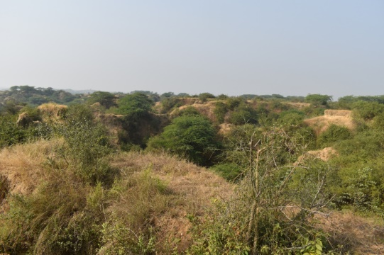

**Figure I: Natural habitat of *Commiphora wightii* in the Chambal ravines, Bhind district, Madhya Pradesh, India.**

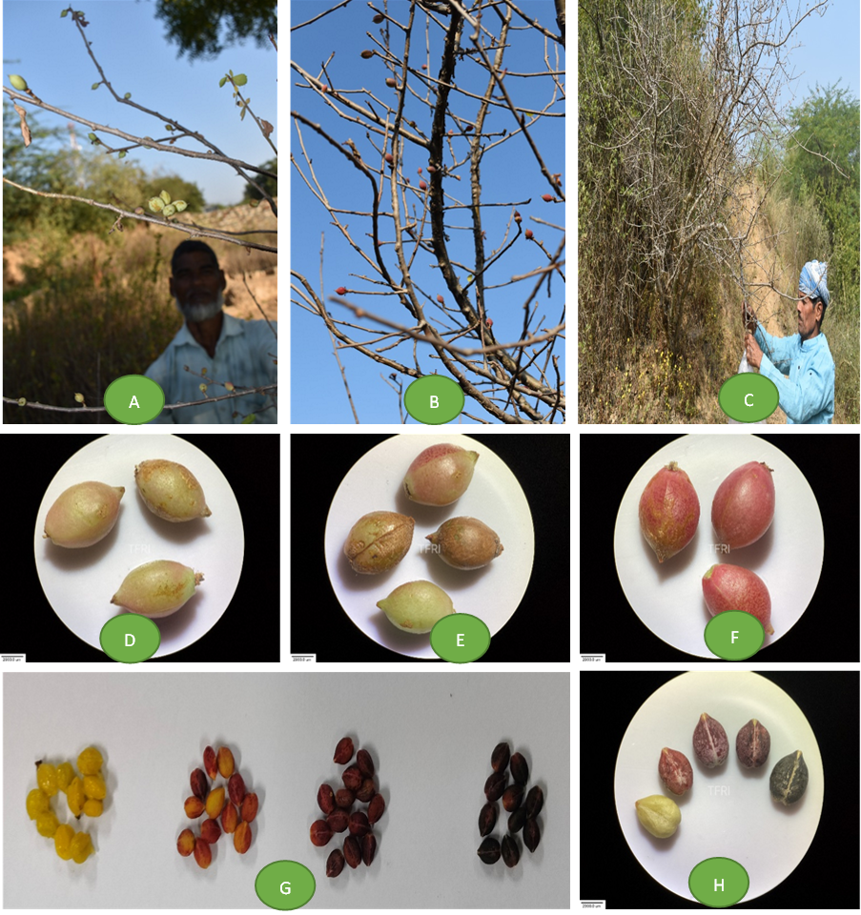

**Figure II: Different stages of fruit/seed maturity assessment A-C: Seed collection; D-F: Fruit maturity stages; G-H: Seed maturity stages**

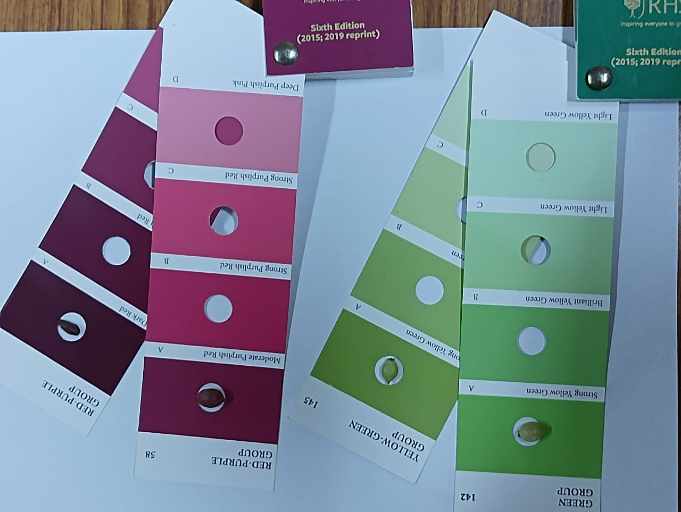

**Figure III: RHS colour measurement of fruit at different stages of maturity in *Commiphora wightii***

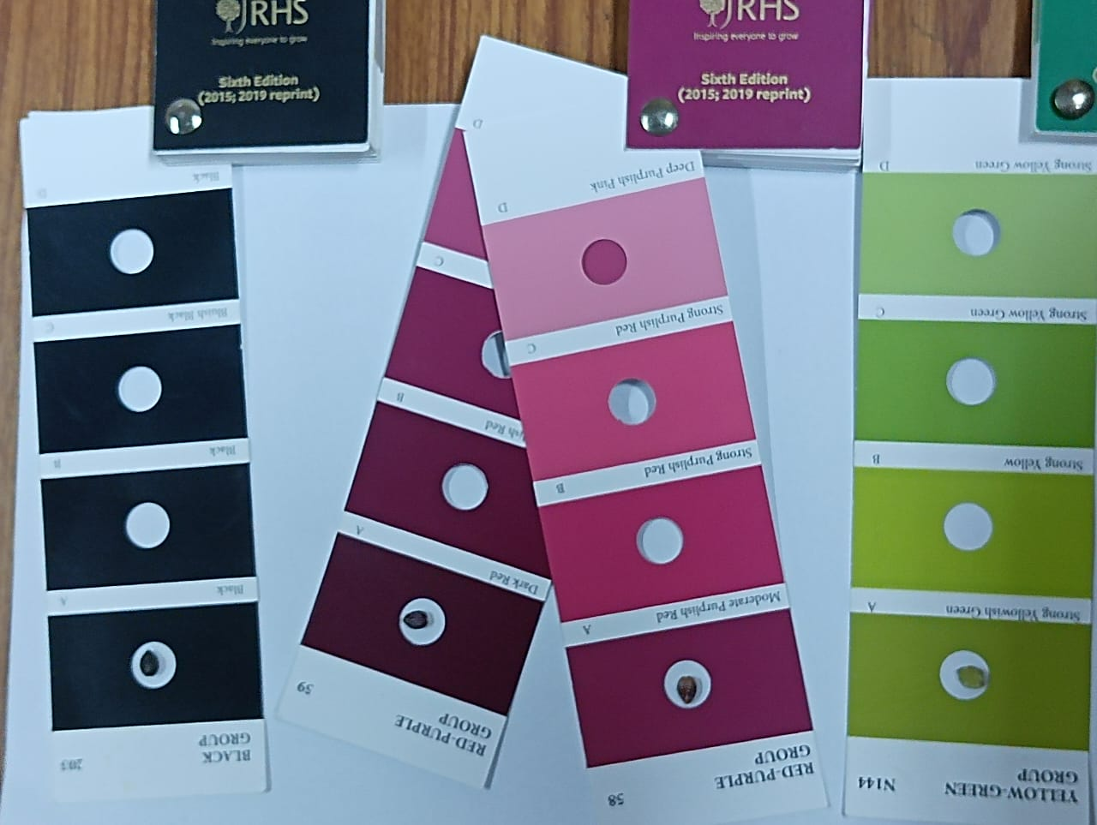

**Figure IV: RHS colour measurement of seed at different stages of maturity in *Commiphora wightii***

**Table I: Change in the fruit growth parameters at different stages of maturity in *Commiphora wightii***

|  |  |  |  |  |  |  |
| --- | --- | --- | --- | --- | --- | --- |
| **Day after Anthesis** | **Fruit Length (Mean ± SE)** | **Fruit Width (Mean ± SE)** | **Fresh Weight of 100 Fruits (g) (Mean ± SE)** | **Weight of 100 Air Dry Fruits (g) (Mean ± SE)** | **Initial Moisture Content (%) Fruit (Mean ± SE)** | **Fruit Colour (RHS colour code)** |
| 40 DAA | 0.79 ± 0.03 | 0.56 ± 0.02 | 13.43 ± 0.48 | 2.31 ± 0.26 | 82.61 ± 2.53 | Green Group 142 (Strong Yellow Green A) |
| 60 DAA | 0.85 ± 0.03 | 0.61 ± 0.02 | 28.17 ± 1.00 | 5.99 ± 0.47 | 78.56 ± 2.40 | Yellow Green Group 145 (Strong Yellow Green A) |
| 80 DAA | 1.03 ± 0.03 | 0.64 ± 0.02 | 42.90 ± 1.52 | 10.80 ± 0.61 | 74.67 ± 2.28 | Red Purple Group 58 (Moderate Purple Red A) |
| 90 DAA | 1.13 ± 0.03 | 0.67 ± 0.02 | 45.91 ± 1.63 | 15.72 ± 0.38 | 65.61 ± 2.01 | Red Purple Group 58 (Moderate Purple Red A) |
| 100 DAA | 1.19 ± 0.03 | 0.70 ± 0.02 | 39.19 ± 1.39 | 19.01 ± 0.09 | 51.40 ± 1.57 | Red Purple Group 59 (Moderate Purple Red A) |
| LSD | 0.09 | 0.06 | 4.07 | 1.29 | 6.98 |  |
| SE(m) | 0.03 | 0.02 | 1.27 | 0.40 | 2.19 |  |
| Significance | < 0.001 | 0.005 | < 0.001 | < 0.001 | < 0.001 |  |

**Table II: Change in the seed growth parameters at different stages of maturity in *Commiphora wightii***

|  |  |  |  |  |  |  |
| --- | --- | --- | --- | --- | --- | --- |
| **Day after Anthesis** | **Seed Length (Mean ± SE)** | **Seed Width (Mean ± SE)** | **Fresh Weight of 100 Seeds (g) (Mean ± SE)** | **Dry Weight of 100 Dry Seeds (g) (Mean ± SE)** | **Moisture Content (%) (Mean ± SE)** | **Seed Colour (RHS colour code)** |
| 40 DAA | 0.59 ± 0.02 | 0.46 ± 0.02 | 1.97 ± 0.05 | 1.05 ± 0.01 | 46.36 ± 1.60 | Yellow Green Group N144 A (Strong Yellow Green A) |
| 60 DAA | 0.61 ± 0.02 | 0.50 ± 0.02 | 2.96 ± 0.08 | 2.13 ± 0.03 | 27.82 ± 0.96 | Red Purple Group 58 (Moderate Purple Red A) |
| 80 DAA | 0.68 ± 0.02 | 0.52 ± 0.02 | 4.72 ± 0.12 | 3.48 ± 0.05 | 26.08 ± 0.90 | Red Purple Group 59 (Dark Red A) 70%  Black Group 203 (Black A) 30% |
| 90 DAA | 0.71 ± 0.02 | 0.53 ± 0.02 | 5.42 ± 0.14 | 4.12 ± 0.06 | 23.96 ± 0.83 | Red Purple Group 59 (Dark Red A) 64%  Black Group 203 (Black A) 36% |
| 100 DAA | 0.73 ± 0.02 | 0.56 ± 0.02 | 4.90 ± 0.13 | 4.19 ± 0.08 | 14.59 ± 0.50 | Red Purple Group 59 (Dark Red A) 55%  Black Group 203 (Black A) 45% |
| LSD | 0.07 | 0.06 | 0.35 | 0.17 | 3.27 |  |
| SE(m) | 0.02 | 0.02 | 0.11 | 0.05 | 1.03 |  |
| Significance | 0.002 | 0.041 | < 0.001 | < 0.001 | < 0.001 |  |

**Table III: Change in the seed physiological parameters at different stages of maturity in *Commiphora wightii***

|  |  |  |  |  |
| --- | --- | --- | --- | --- |
| **Day after Anthesis** | **Fresh Seed Germination % (Mean ± SE)** | **Germination % After desiccation (Mean ± SE)** | **Seedling Length (cm) (Mean ± SE)** | **Seed Vigour Index I (Mean ± SE)** |
| 40 DAA | 0.00 | 0.00 | 0.00 ± 0.00 | 0.00 ± 0.00 |
| 60 DAA | 0.00 | 0.00 | 0.00 ± 0.00 | 0.00 ± 0.00 |
| 80 DAA | 0.00 | 3.83 ±1.20 | 6.83 ± 0.63 | 25.66 ± 7.69 |
| 90 DAA | 5.67 ± 0.93 | 9.17 ±1.21 | 7.67 ± 0.49 | 70.46 ± 10.24 |
| 100 DAA | 14.50 ± 2.31 | 21.50 ±2.04 | 8.55 ± 0.49 | 185.68 ± 27.94 |
| LSD | 3.55 | 4.42 | 1.33 | 43.87 |
| SE(m) | 1.11 | 1.34 | 0.42 | 13.75 |
| Significance | < 0.001 | < 0.001 | < 0.001 | < 0.001 |