**Renewable Energy Integration and Agriculture**

**ABSTRACT**

The growing energy requirement in agriculture, together with the dwindling fossil fuel reserves, requires a transition toward renewable sources of energy. Renewable energy such as solar, wind, biomass, and hydropower offer a sustainable option for the best possible energy management in agriculture. The research presents a comprehensive review of numerous renewable energy technologies used in agriculture, advantages, and limitations of the implementation. Increased use of renewable energy enhances the efficiency of energy, reduces the emissions of greenhouse gases, and aids climate-resilient agriculture. Certain innovative technologies such as agrivoltaics, advanced energy storage units, and conversion of biomass play important roles in developing sustainability. Furthermore, adoption of renewable energy improves rural economies through job opportunities and stabilization of food prices. By the provision of a holistic review of renewable energy use in agriculture, the paper provides useful information to researchers.

**1. INTRODUCTION**

Renewable energy is energy obtained from continuously replenished materials. They are natural and self-renewing, typically having a carbon footprint that is minimal or nonexistent. Wind, solar, hydroelectric (including tidal) power, and bioenergy (burning organic materials for fuel) are examples of renewable energy sources.. That gaining momentum in agricultural practices gives more risk for renewable energy than for energy. Agriculture is a broad sector that consumes nearly 30% of our planet’s energy. The energy that is used today will not impact much the atmosphere at future similarly there are many regions use fossil fuels as a primary energy resources which can provide a huge upsurge in greenhouse effect which results in a global warming [(Rehman 2022)](https://doi.org/10.1016/j.renene.2022.02.065). The supply of these polluting sources is increasing daily. They are inexhaustible and available in all corners of the world in different forms ([Martinho 2018)](https://doi.org/10.1016/j.esr.2018.11.002). Using fossil fuels will lead to greenhouse gas emissions(GHG) which will directly affect the climate and plants  [(Rehman 2022)](https://doi.org/10.1016/j.renene.2022.02.065).

Using enewable energy is harnessing power from natural resources and also Biomass Energy (using biodegradable waste such as animal waste, kitchen waste, agriculture waste, etc.) Renewable energy in various agricultural practices (such as irrigation, use of agricultural residue, etc.) also help lead climate-ambitious farmers [(Bathaei 2023)](https://doi.org/10.3390/su151914307). Electricity prices are directly affected by the power demand of the world which can be counted as 50 percent higher by 2030 (according to some reports) while also responsible for imbalance in the prices of agricultural goods, this disparity also leads to poverty, hunger and severe food security. If any anyone can implement renewable energy then can regulate electricity costs and utilize that money to enhance income areas in the agriculture sector or can harness smart technology.(Majeed 2023[)](https://doi.org/10.1016/j.egyr.2023.06.032) Agriculture is the key activity in the rural sector. Global factors can easily impact the agriculture sector. Farmers adopt processes that are not only technical innovations, but also modernized in nature to the overcome these challenges. Electricity is essential in agriculture for operating irrigation systems, working soils, chemical fertilizers, and raising livestock. It also plays crucial roles in pumping water and in the cooling and drying of agricultural products. Increased energy needs of agriculture associated with the rising demand for these products have led to the encroachment into regions that are not optimally favorable for agricultural production([Puska 2024)](https://doi.org/10.3390/economies12080195). As renewable energy resources are eco-friendly, they are recognized as clean energy sources and are necessary. The use of fossil fuels has resulted in the emission of carbon dioxide, the greenhouse gas issue, and harmed the environment, which is now increasingly being known as the need for a clean environment grows [(Qiza et al.2019).](https://doi.org/10.1109/ACCESS.2019.2906402)

This study offers a detailed review of renewable energy as a promising alternative energy source for optimizing energy management in the agricultural industry. Although prior research has examined renewable energy technologies within agriculture, this review distinguishes itself by presenting an in-depth analysis of several renewable energy sources specifically designed for agricultural use, such as solar, biomass, wind, and geothermal. The paper underscores the potential benefits of implementing renewable energy technologies in agricultural settings while also considering the challenges and opportunities accompanying their adoption. The findings provide critical insights for agricultural stakeholders and researchers interested in transitioning to sustainable energy practices, by delivering a thorough overview of alternative energy sources and their practical applications in energy management. Through this comprehensive review, the paper adds to the existing literature, serving as a valuable reference for those looking to enhance energy management strategies and support sustainable development within the agricultural sector.

**2. DEMAND OF ENERGY IN AGRICULTURE**

The energy consumption globally is growing exponentially, and currently, it is being met by fossil fuels. Regrettably, the world's supply of these fossil fuels is being drained at a very fast pace, and as a result of this imbalance between demand and supply, energy prices are being increased.Along with that, the burning of fossil fuel causes intense carbon emissions, due to which global warming happens at a higher rate. This hike in energy prices and global warming consequences will have deep implications on agriculture. In order to overcome these issues, future farms have to strive for autonomy, and this is possible through the utilization of renewable energy sources[(Majeed et al.2023)](https://doi.org/10.1016/j.egyr.2023.06.032).The energy consumption globally is growing exponentially, and currently, it is being met by fossil fuels. Regrettably, the world's supply of these fossil fuels is being drained at a very fast pace, and as a result of this imbalance between demand and supply, energy prices are being increased.Along with that, the burning of fossil fuel causes intense carbon emissions, due to which global warming happens at a higher rate. This hike in energy prices and global warming consequences will have deep implications on agriculture. In order to overcome these issues, future farms have to strive for autonomy, and this is possible through the utilization of renewable energy sources.[(Raushan et al.2022).](https://doi.org/10.1016/j.seta.2022.102905)

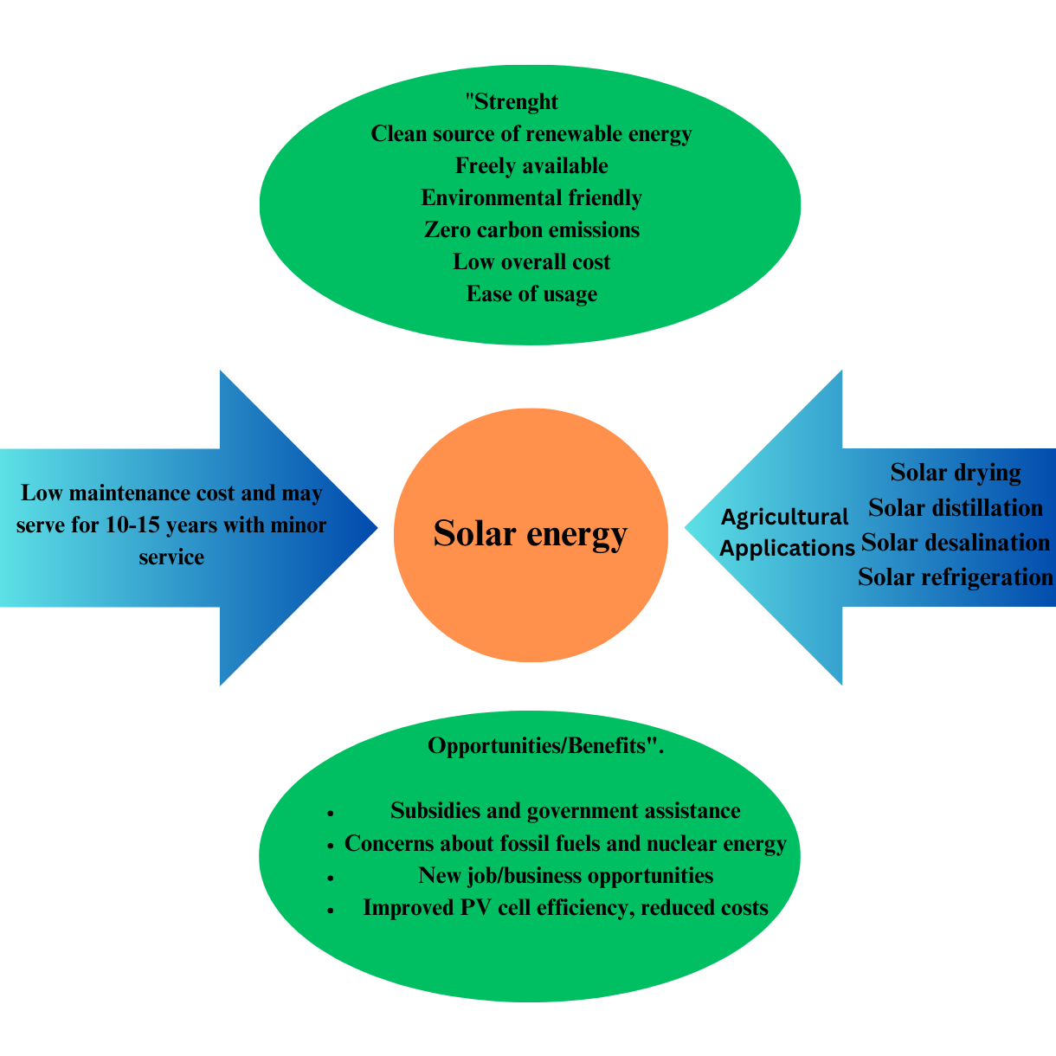

FIGURE 1: Solar energy

**2.1 Energy consumption in agriculture sub sector**

Horticulture involves the cultivation of fruits, vegetables, and ornamental plants. Energy use in this sub-sector is diverse, encompassing natural sources like sunlight and human labor, as well as mechanical inputs for tasks such as irrigation, heating, and cooling. Greenhouse horticulture, in particular, is noted for its high energy demands due to the need for climate control systems. A review of energy use in European Union (EU) greenhouses indicates that energy consumption varies widely, influenced by factors such as geographical location and the complexity of climate control systems[(Paris et al.2022)](https://doi.org/10.3390/app12105150).Field Crops such as cereals, legumes, and oilseeds generally have lower energy requirements compared to greenhouse horticulture. Energy consumption in this sub-sector primarily involves the operation of machinery for soil preparation, planting, maintenance, and harvesting. A critical review of energy use in EU open-field agriculture estimates annual energy consumption to be at least 1,431 petajoules, accounting for approximately 3.7% of the total EU annual energy consumption [(Vandorou et al.2022)](https://www.researchgate.net/publication/357926758_Energy_use_in_open-field_agriculture_in_the_EU_A_critical_review_recommending_energy_efficiency_measures_and_renewable_energy_sources_adoption).Energy consumption in agriculture varies across sub-sectors, with greenhouse horticulture and intensive livestock farming being particularly energy-intensive due to their reliance on controlled environments and mechanization.

|  |  |  |  |  |
| --- | --- | --- | --- | --- |
| **Agriculture Sub-sector** | **Energy Use** | **Key Characteristics** | **Energy Consumption Estimate** | **References** |

|  |  |  |  |  |
| --- | --- | --- | --- | --- |
| **Horticulture** | Diverse energy use, including natural sources (sunlight) and mechanical inputs (irrigation, heating, cooling). | High energy demand in greenhouse horticulture due to climate control systems. | Energy consumption varies widely, influenced by geographical location and complexity of climate control systems. | Paris et al., 2022 |

|  |  |  |  |  |
| --- | --- | --- | --- | --- |
| **Field Crops** | Primarily energy for machinery used in soil preparation, planting, maintenance, and harvesting. | Lower energy demands compared to greenhouse horticulture. | Estimated at least 1,431 petajoules annually, accounting for about 3.7% of the total EU annual energy consumption. | Vandorou et al., 2022 |

**TABLE 1**: ESTIMATE AGRICULTURE SECTOR ENERGY CONSUMPTION

**2.2 Factor influencing energy demands**

Climate significantly affects energy consumption in agriculture, particularly concerning irrigation and heating needs. Energy-intensive irrigation systems are essential to maintain crop yields in regions with limited rainfall. Conversely, areas with adequate natural precipitation may require less energy for irrigation [(Zaharia et al.2019)](https://doi.org/10.3390/su11154147)Regulatory and policy contexts play significant roles in stimulating or discouraging farmers' use of renewable energy in agriculture. Supporting policies such as tax credits and an open and favorable policy climate can stimulate investment. Regulatory risks and bureaucratic obstacles can, in turn, discourage farmers from switching to renewable sources of energyResearch identifies the role of open and welcoming policies towards facilitating the use of renewable energy in agriculture .Farmers' beliefs and awareness regarding renewable energy significantly influence adoption rates. Empirical studies have shown that well-educated and informed farmers are likely to invest in renewable energy technology[(Bodara et al.2024)](https://doi.org/10.3390/en17153682).The deployment of renewable energy systems, especially large-scale ones such as solar farms, demands huge areas of land. This creates a conflict between agricultural use and energy generation. Novel solutions like agrivoltaics, in which solar panels are placed above crops, are being developed to mitigate this conflict by enabling simultaneous land use for energy and food generation. But the feasibility and cost-effectiveness of these systems remain to be assessed[(Brown 2024)](https://www.wsj.com/articles/combining-solar-power-with-farming-is-getting-easier-developers-are-wary-of-added-costs-c0c6c108?utm_source=chatgpt.com) 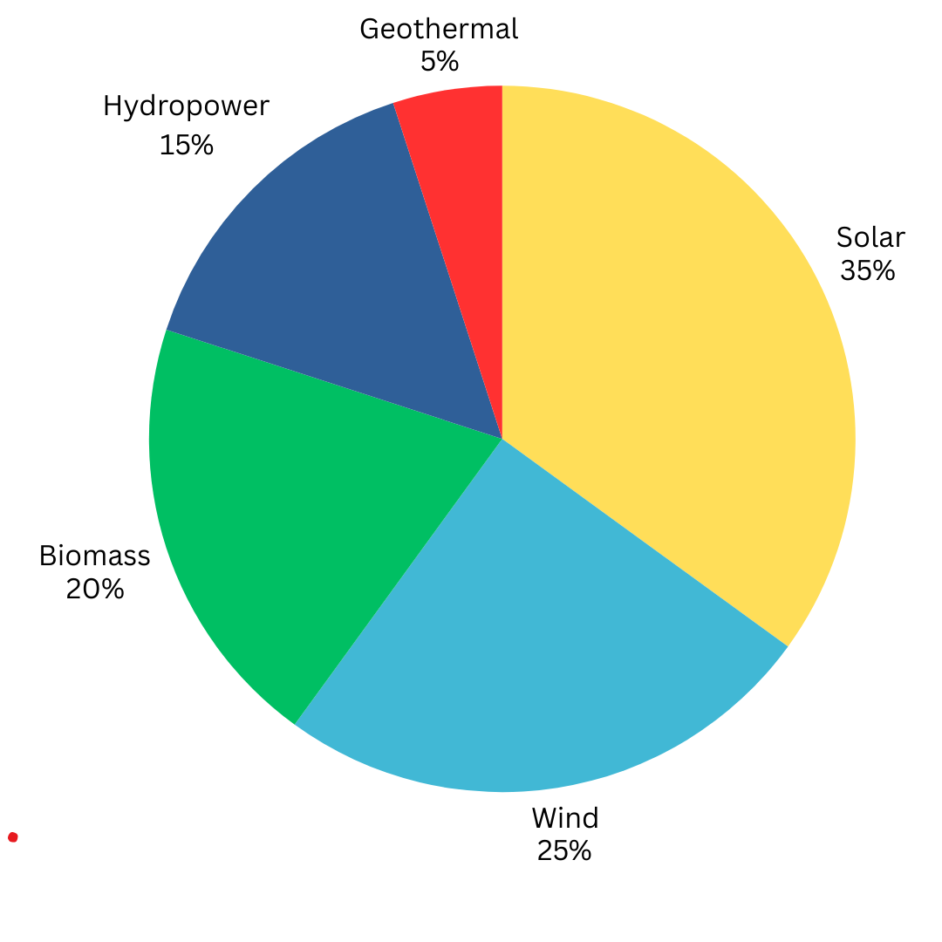

FIGURE 2: Distribution of renewable energy sources

**3. Technological Innovations in Renewable Energy**

Advances in renewable energy technologies have resulted in substantial advancements in photovoltaic materials, wind turbine performance, and biomass conversion technology. Recent discussion of these developments focuses on their ability to revolutionize energy generation and storage in agriculture. The study highlights the need for continued research and development to overcome the existing challenges and optimize the application of these technologies in agriculture[(Mary 2024)](https://www.researchgate.net/publication/384833067_Advancements_in_Renewable_Energy_Technologies_A_Decade_in_Review?utm_source=chatgpt.com). Advancement in technology raised the ability to produce of biogas digester and the biofuels quality. A sustainable report of year 2023 showed the crucial role of bioenergy by enhancing circular agriculture and energy supplies are created by farm residue [(Ahmad and Dalia 2023)](https://doi.org/10.3390/su151914307). Recent innovations have been centered on agrivoltaics— The land is utilized for both purpose solar energy production as well as agriculture. This method maximizes land use and even boosts crop yields by offering partial shading. As per Espitia et al. (2024), the integration of PV systems in greenhouses improves energy efficiency and lowers

operational costs by optimizing heating and cooling operationsThe new turbine technologies manifest greater efficiency and the ability to produce electricity in regions defined by low wind speeds.[(John et al 2024)](https://doi.org/10.3390/agronomy14122791). Advances in photovoltaic (PV) technology have accelerated the innovation of new materials intended to enhance efficiency and sustainability. Researchers have attempted to develop solar cells from abundant, eco-friendly material, in addition to using nanomaterials to optimize light absorption and energy conversion efficiency. Furthermore, flexible solar cells are investigated for their potential uses in various environments. However, resistance to environmental stresses like moisture and UV exposure continues to be an issue, and additional research on protective coatings and encapsulation is necessary[(Etukudoh et al.2024)](https://www.researchgate.net/publication/378296883_RENEWABLE_ENERGY_TECHNOLOGIES_IN_ENGINEERING_A_REVIEW_OF_CURRENT_DEVELOPMENTS_AND_FUTURE_PROSPECTS).Technology of wind power has improved through advanced turbine design, which improves the efficiency of capturing energy. These innovations consist of improvements in rotor blade lengths, aerodynamics, and use of weather-resistant materials. Such advances have a positive effect on improved power production and wind power system reliability.Biomass energy has also been made possible by technological progress in conversion systems to make it possible to efficiently convert organic material into useful forms as energy. Technological advancements in the thermochemical and biochemical processes have increased the quality and quantity of biofuels, making biomass a more viable component of the renewable energy mix [(Wheatley 2024](https://www.researchgate.net/publication/384833067_Advancements_in_Renewable_Energy_Technologies_A_Decade_in_Review)).

The path ahead for renewable energy technologies is to innovate and be more integrated. The emerging areas of study are the development of energy storage technology to compensate for intermittency, smart grid technology to provide efficient delivery of energy, and seeking additional means of renewable energy such as osmotic power.In bringing together policymakers, business heads, and scientists is requested with a view towards moving past current impediments at a faster rate and ushering in an age of sustainable energy.Shortly, innovation through different domains of renewable energy is reshaping how the world is powering up. Continuing research and facilitation policies are critical to maintaining momentum and attaining long-term viability[(Brown 2024](https://www.wsj.com/articles/combining-solar-power-with-farming-is-getting-easier-developers-are-wary-of-added-costs-c0c6c108?utm_source=chatgpt.com)).

**4.Energy storage solution for agriculture**

Maintaining optimal conditions for plant growth in greenhouses frequently requires a substantial amount of energy for heating and cooling. The implementation of thermal energy storage systems, particularly those employing phase change materials (PCMs), has been recognized as an effective strategy for energy conservation and temperature regulation , the use of PCMs in greenhouses offers significant benefits, including enhanced energy efficiency and the ability to sustain comfortable environments for crops [(Aman et al 2024)](https://ieeexplore.ieee.org/document/10795641/). Agricultural waste can be processed into biochar, a material rich in carbon that acts as a mechanism for energy storage. In addition to its ability to sequester carbon, biochar is beneficial for improving soil fertility and storing energy. A review by the Science Publishing Group provides insights into various energy conversion technologies and the applications of agricultural waste, emphasizing the significance of biochar in energy storage solutions[(Yilikal 2024)](https://doi.org/10.11648/j.ajme.20241003.11).The adoption of advanced energy management systems enables real-time oversight and regulation of energy production, storage, and usage on agricultural properties. These systems enhance the efficiency of energy utilization, optimize stored energy, and deliver analytical insights that aid in strategic decision-making. The deployment of such technologies can significantly improve energy efficiency and facilitate the sustainable incorporation of renewable energy sources in farming practices. While typically linked to large-scale energy infrastructures, pumped-hydro storage is increasingly being recognized in agricultural contexts, especially in regions with favorable topographical features. This technique involves elevating water to a reservoir during periods of surplus energy generation and subsequently releasing it through turbines to produce electricity when required. It serves as an effective solution for renewable energy storage, although its feasibility is contingent upon specific geographical [(Panwar et al.2015)](https://www.researchgate.net/publication/257548625_Emergence_of_energy_storage_technologies_as_the_solution_for_reliable_operation_of_smart_power_systems_A_review).While traditionally associated with large-scale energy systems, pumped-hydro storage is gaining attention in agricultural settings, particularly in areas with suitable topography. This method involves pumping water to an elevated reservoir during times of excess energy production and releasing it through turbines to generate electricity when needed. It offers a highly effective means of renewable energy storage, though its applicability depends on specific geographic condition [(Gonzalez et al.2018)](https://doi.org/10.1002/er.4285).

BESS are increasingly utilized on farms to store excess energy generated from renewable sources. These systems provide a reliable power supply during periods when energy generation is low or demand is high. Modern BESS solutions are designed to be scalable, allowing farmers to adjust storage capacity based on their specific energy needs. Implementing BESS can lead to significant reductions in operational costs and enhance energy independence for agricultural operations[(Yilikal 2024)](https://www.sciencepublishinggroup.com/article/10.11648/j.ajme.20241003.11).

**5.RENEWABLE ENERGY AND CLIMATE RESILIENT AGRICULTURE**

Integrating renewable energy into agriculture is essential for developing climate-resilient farming systems. This approach not only reduces greenhouse gas emissions but also enhances the adaptability of agricultural practices to changing climatic conditions. Agrivoltaics involves the simultaneous use of land for both agriculture and solar energy production. This method allows crops to be cultivated beneath solar panels, optimizing land use and providing mutual benefits. For instance, the shade from solar panels can reduce soil moisture evaporation, benefiting water-sensitive crops. A study highlighted that agrivoltaic systems can increase land-use efficiency by up to 70%, offering a sustainable solution for food and energy production[( Dinesh and Pearce 2015)](https://doi.org/10.1016/j.rser.2015.10.024)The use of renewable energy technologies, such as solar irrigation and wind power, is vital for enhancing climate-resilient agriculture. These technologies give farmers stable sources of energy, which contributes to less dependency on fossil fuels as well as improved resilience from climate-associated interruptions of energy supplies. A comprehensive review has highlighted the potential of renewable energy in minimizing the impacts of climate change and enabling sustainable agriculture [(Faldu et al 2015)](https://www.researchgate.net/publication/388659886_CONTRIBUTION_OF_RENEWABLE_ENERGY_TECHNOLOGIES_WITH_CLIMATE_RESILIENT_APPROACH_IN_AGRICULTURAL_SYSTEMS?utm_source=chatgpt.com).Cultivating and breeding climate-resilient crops is necessary to ensure food security in the face of shifting climatic conditions. These crops are designed to be resistant to extreme weather conditions, pests, and diseases. A review introduced climate-resilient crops and stressed their significance in coping with faster climate change and for producing food sustainably([Acevedo et al. 2020)](https://rdcu.be/d9FLd).A comprehensive solar photovoltaic (PV) model specific to agrivoltaic systems has been developed and then coupled with a crop model and a solar radiation model for the investigation of the performance of such systems Performance of the PV system is based on the solar irradiation incident on the PV panels. Likewise, crop yields rely on the efficiency of the process of conversion of radiation, which demonstrates the capability to convert photosynthetically active radiation [(Dinesh and Pearce 2015)](https://doi.org/10.1016/j.rser.2015.10.024).An electrical dynamic solar photovoltaic (PV) model for agrivoltaic systems has been derived and integrated with a crop model and a model of solar radiation to simulate their performance. Efficiency of the PV system is subject to the solar irradiation received by the PV modules. The same applies for crop yield with respect to radiation conversion efficiency that quantifies photosynthetically active radiation conversion to a usable end product[(Ahmed and Dalia 2023)](https://doi.org/10.3390/su151914307).As reported by the International Renewable Energy Agency (IRENA), food prices are prone to sudden changes in the price and availability of fossil fuels. Rising energy prices tend to increase production, processing, and transport costs associated with food. The deployment of renewable energy has the potential to insulate food prices from fossil fuel market volatility, inducing increased stability in the food chain.[(International Renewable Energy Agency 2021)](https://www.irena.org/-/media/Files/IRENA/Agency/Publication/2021/Nov/IRENA_FAO_Renewables_Agrifood_2021.pdf?utm_source=chatgpt.com).

**6. Policy Frameworks for Renewable Energy Integration in Agriculture**

Multiple governments around the world have established financial mechanisms to facilitate the shift towards the use of renewable energy in agriculture. The mechanisms include grants, subsidised credit, and tax credits that are aimed at lowering the up-front cost of renewable energy systems. A case in point is India's Pradhan Mantri Kisan Urja Suraksha evam Utthan Mahabhiyan (PM-KUSUM) program, which provides farmers with subsidies to get solar pumps and grid-connected solar power infrastructure installed, thereby encouraging energy independence in agriculture [(Rastogi et al.2024)](https://www.researchgate.net/publication/378269319_Renewable_Energy_Integration_in_Agriculture).

Establishment of a conducive regulatory environment is essential for the successful integration of renewable energy into agriculture. Programs that enable permitting, offer favorable tariffs, and mandate the utilization of renewable energy can contribute to higher adoption levels. A comprehensive analysis points out the importance of clear and stable regulations, indicating that nations with well-defined policies perform better in integrating renewable energy[(Gastli et al.2015)](https://www.researchgate.net/publication/272239438_Review_of_policies_encouraging_renewable_energy_integration_best_practices).Sound land use planning will provide for reconciling agricultural production with the development of renewable energy schemes. In England, the new Land Use Framework proposes a changeover of some of the agricultural land into locations for solar farms, forests, and nature reserves for the achievement of net-zero emissions by 2050. The strategy will set aside 9% of agricultural land for these non-agricultural purposes while providing for food security through enhanced productivity on the other agricultural land.Policies recognizing interdependence of the water, energy, and food systems are central to sustainable agriculture. A paper offers a framework analyzing the nexus of water, energy, and food and calling for cross-disciplinary policies addressing the multi-faceted issues of agricultural resource management[(Agadi et al. 2023)](https://doi.org/10.3389/frevc.2023.1200703).The integration of circular economy into policy formulation is likely to boost the sustainability of renewable energy practices in agriculture. Public policy measures that foster reducing, reusing, and recycling resources support energy efficiency and the management of wastes in agriculture. A systematic review explains how policy measures focused on circular economy will stimulate the implementation of renewable energy in the agricultural sector([Rocha et al. 2023)](https://doi.org/10.3390/en16010485).Overall, strong policy frameworks including financial incentive, regulatory support, strategic planning, cross-sectoral integration, and circular economy principles are the major drivers of renewable energy integration into agriculture. These policies not only drive the transition towards sustainable sources of energy but also increase the agricultural sector's resilience and production.

|  |  |  |  |  |
| --- | --- | --- | --- | --- |
| **Policy Framework** | **Key Features/Initiatives** | **Examples/Case Studies** | **Impact on Agriculture** | **References** |
| **Financial Mechanisms** | Grants, subsidized credit, tax credits to lower the upfront cost of renewable energy systems. | India's PM-KUSUM Program – Subsidies for solar pumps and grid-connected solar infrastructure for farmers. | Encourages energy independence, lowers financial barriers for farmers to adopt renewable energy technologies. | Rastogi et al., 2024 |
| **Regulatory Environment** | Clear, stable, and favorable regulations, streamlined permitting processes, renewable energy mandates, and attractive tariffs. | Countries with well-defined renewable energy policies tend to perform better in integration. | Facilitates higher adoption of renewable energy, supports long-term growth and stability in the agricultural sector. | Gastli et al., 2015 |
| **Land Use Planning** | Integrating agricultural land use with renewable energy development, setting aside land for non-agricultural uses. | England’s Land Use Framework – Proposes setting aside 9% of agricultural land for renewable energy and nature reserves while ensuring food security. | Balances food production with renewable energy development, contributing to net-zero emissions targets by 2050. | England’s Land Use Framework |
| **Water, Energy, and Food Nexus** | Policies that recognize the interdependence of water, energy, and food systems and encourage cross-disciplinary management. | Framework on Water-Energy-Food Nexus – Analyzes interconnectedness and advocates for integrated policies for agricultural resource management. | Promotes efficient use of resources, enhances agricultural sustainability, and supports renewable energy adoption. | Agadi et al., 2023 |
| **Circular Economy Integration** | Policies that focus on reducing, reusing, and recycling resources, improving energy efficiency, and managing agricultural waste. | Policy Measures for Circular Economy – Support waste management and energy efficiency in agriculture. | Stimulates renewable energy adoption by optimizing resource use and reducing waste, promoting sustainable practices. | Rocha et al., 2023 |

**TABLE 2:**  Policy frameworks for renewable energy integration

**7. Economic Feasibility of Renewable Energy in Agriculture**

The blending of waste-to-energy systems and bioenergy with agriculture offers an environmentally friendly alternative to farm energy self-sufficiency, agricultural residue management, and greenhouse gas emissions reduction. The blending incorporates several significant fields:

**7.1 Biogas Production from Agricultural Waste**

Anaerobic digestion (AD) is the method used for the generation of biogas from farm waste. It is microbial breakdown of organic matter such as crop residues and animal manure under anaerobic conditions. Biogas, a mixture of predominantly methane and carbon dioxide, can be used as a source of energy for electricity, heat, or transport.. The remaining digestate is also a rich energy fertilizer.

There has been a recent study that has focused on the effectiveness of AD in processing various agricultural residues, placing it in the spotlight for sustainable energy generation and waste management systems. What this study emphasizes is the optimization of some of the key operating parameters like temperature and retention time, which would immensely boost the yield of biogas[(Osman et al.2024)](https://doi.org/10.1007/s10311-024-01789-1).

**7.2 Biomass Energy for Heating and Powering Farm Equipment**

Using energy from biomass entails the process of transforming organic materials such as wood chips, agricultural residues, and energy crops into power and heat. This method not only supplies a renewable power source but also helps in effective management of farm wastes.

An intensive review considers the promise of biomass in transforming the energy situation on Earth, based on its utilization as a heat system and agricultural machine fuel. A number of technologies for biomass conversion, such as combustion and gasification, have been discussed to be effective ways of getting energy from biomass [(Yilikal 2024)](https://link.springer.com/article/10.1007/s43621-024-00309-z?utm_source=chatgpt.com).

**7.3 Circular Farming: Integrating Bioenergy into Sustainable Agricultural Cycles**

Circling farming places strong focus on the recycling of resources and waste reduction in agricultural systems. Incorporating bioenergy processes, like anaerobic digestion and utilization of biomass energy, into agricultural operations illustrates this principle through the conversion of waste into useful energy and by-products.A recent study analyzes the interplay between sustainable agriculture and the production of bioenergy, particularly the integration of bioenergy into farming systems for increased resource use efficiency and environmental sustainability. The research points out that integration also yields renewable energy in addition to improved soil fertility and decreased dependency on synthetic fertilizers through the use of digestate[(Mhlongo et al. 2024)](https://doi.org/10.30574/ijsra.2024.11.1.0277).

In total, the application of bioenergy and waste-to-energy technologies in farming is a multidimensional prospect for augmenting sustainability, energy independence, and waste management. Developments in research and technology keep enhancing these processes, which make them increasingly viable and worthwhile for farms.

**8. Hydro power and micro-irrigation system**

Hydropower integration with micro-irrigation systems provides a green solution to enhanced energy efficiency and water management in agriculture. This integration not only optimizes the utilization of resources but also guarantees environmental sustainability.

Micro-hydropower systems capable of generating up to 100 kilowatts of power utilize flowing water's kinetic energy in streams, rivers, or irrigation canals. They are especially appropriate in rural and agricultural societies with high water resources. A recent review identifies micro-hydropower's contribution to sustainable development by citing that it is economical and more dependable than other renewable sources. Further, the study identifies that micro-hydropower plants can be designed to accommodate local conditions, thus being appropriate for decentralized power generation in rural farming communities[(Painter et al.2024)](https://www.researchgate.net/publication/377204247_Micro-hydropower_Generation_for_Sustainable_Development_A_Review).Micro-irrigation system like drip irrigation or sprinkler irrigation supplies water at the level of the root, which raises water use efficiency. Micro-hydropower is integrated using micro-irrigation by utilizing the in situ water flow from irrigation network systems to harness power. By using this source, not only are there electricity units available to drive irrigation hardware but also farming operation costs become reduced. A research study in Spain assessed a micro-hydropower plant erected in an irrigation system, proving that variable-speed technology in such installations can increase electricity generation and economic returns while preventing cavitation problems[(Barbon et al.2023)](https://doi.org/10.3390/app132413096).Practical implementations of this integrated method have been attempted in different areas. The research emphasized that detailed evaluation of site-specific parameters, including water flow rates and seasonal patterns, is important for the successful operation of such systems.Although the combination of hydropower and micro-irrigation systems has various advantages, a number of issues need to be resolved .Technical Complexity Designing systems that effectively integrate energy production with irrigation is a matter of meticulous planning and engineering to handle changing water flows and energy requirements.Initial Investment The initial cost of installing micro-hydropower infrastructure can be high. Yet, this can be recovered over time by reduced energy costs and possible income from excess electricity production.Environmental Impact Protection of local ecosystems and downstream water supply from potentially negative impacts on energy generation via water diversion is vital. Pre-implementation environmental impact assessments are to be conducted [(Jamal and Lewi 2018)](https://doi.org/10.1063/1.5043030).

**9.Socio-Economic Impacts of Renewable Energy in Rural Farming Communities**

Renewable energy integration in rural farm communities has deep socio-economic effects, improving the standard of living, fostering sustainable development, and enabling environmental conservation.The application of renewable technology, such as sun and wind power, has been shown to drive rural economic development. A study on renewable energy projects in America found that the projects resulted in the generation of jobs, expanded the tax bases of local governments, and diversified the economy. Agric farmers were also able to acquire extra revenue from leasing their farms for power production, thus improving their economic living standards[(Moore 2024)](https://www.researchgate.net/publication/381539182_Renewable_Energy_Adoption_and_Its_Effect_on_Rural_Development_in_United_States)**.**Similarly, research on small and rural communities and wind farms too reported net beneficial socio-economic impacts, including job generation and build-up of infrastructure. Besides providing direct jobs at the construction and operational stages, these projects also stimulate the local business community and services that increase the overall economic viability of the location[(Gomez et al.2025)](https://doi.org/10.1007/s10098-024-03113-5). Availability of renewable energy significantly enhances the standard of rural life. One of the extensive studies conducted in Kenya and Nigeria analyzed the social and economic effect of solar mini-grids. The findings noted spectacular gains in productivity, health, and security for connected enterprises and households. Surprisingly, median incomes of members increased fourfold, and notably enhanced gender balance resulted in women gaining better decision-making and business participation opportunities[(Selby et al.2024)](https://doi.org/10.1088/2634-4505/ad4ffb).Availability of clean renewable energy technologies empowers rural communities, generating higher incomes, better living standards, and enhanced gender equality. Nevertheless, some of the problems like the up-front cost of technology adoption and the availability of supporting infrastructure have to be solved in order to achieve these gains fully.A research on solar energy adoption among crop farmers quoted its ability to enhance agricultural productivity and incomes. The study compared adopters and non-adopters of solar energy technologies and indicated that adopters experienced increased crops' yields and incomes. The study added that availability of affordable and reliable energy solutions enhanced the well-being of smallholder farmers [(kassemet al.2024)](https://doi.org/10.3389/fsufs.2024.1364040).

|  |  |  |  |  |
| --- | --- | --- | --- | --- |
| **Impact Area** | **Key Features** | **Examples/Case Studies** | **Socio-Economic Benefits** | **References** |
| **Rural Economic Development** | Renewable energy projects stimulate economic growth by creating jobs and increasing local tax revenue. | America: Renewable energy projects led to job creation, increased tax bases, and economic diversification. | Creates employment opportunities, strengthens local economies, and diversifies rural economies. | Moore, 2024 |
| **Job Creation & Infrastructure Growth** | Renewable energy projects, especially wind farms, create jobs and improve infrastructure. | Wind Farms in Small/Rural Communities: Created direct jobs in construction and operation, boosting local businesses. | Generates jobs at construction and operational stages, stimulates local business growth, and strengthens economic viability. | Gomez et al., 2025 |
| **Improved Standard of Living** | Access to renewable energy enhances the quality of life in rural communities. | Kenya & Nigeria: Solar mini-grids led to increased productivity, improved health, and better security. | Increased productivity, improved health, and enhanced security, leading to a better quality of life for rural communities. | Selby et al., 2024 |
| **Income Growth & Economic Opportunities** | Renewable energy projects help farmers earn additional income and increase crop yields. | Solar Energy Adoption: Farmers who adopted solar technologies experienced higher crop yields and incomes. | Increased agricultural productivity, higher incomes, and economic resilience for rural farmers. | Kassem et al., 2024 |
| **Gender Equality** | Availability of renewable energy empowers women, offering better decision-making and business opportunities. | Kenya & Nigeria: Enhanced gender balance as women gained more opportunities in decision-making and business involvement. | Increased gender equality, giving women better access to economic opportunities and decision-making roles. | Selby et al., 2024 |

TABLE 3:RENEWABLE ENERGY PROJECTS

**10. Renewable energy and food security**

In India, the smallholder farmer usually struggles with keeping perishables fresh because the electricity supply is unreliable and the storage facilities poor, resulting in huge post-harvest losses. The addition of solar-powered cold storage systems has been a game-changer. Decentralized systems bring reliable cooling by renewable energy to the farmer's doorstep, and the shelf life of fruits and vegetables can now be increased. This innovation not only lessens spoilage but also enables farmers to market their crops at better prices in the market, thus raising their revenue. A report by the International Renewable Energy Agency (IRENA) points to the contribution of such renewable energy technologies towards improving food security and sustainable agriculture([IRENA and FAO 2021)](https://www.irena.org/-/media/Files/IRENA/Agency/Publication/2021/Nov/IRENA_FAO_Renewables_Agrifood_2021.pdf?utm_source=chatgpt.com).Grain post-harvest losses are a major issue for Sub-Saharan African smallholder farmers. Conventional sun-drying is usually inefficient and subjects grains to pests and mold. The use of energy-efficient mechanical drying technologies has been demonstrated to address these problems efficiently. An exhaustive review identifies that adopting enhanced drying methods will help in bringing down post-harvest losses to a large extent, allowing a greater percentage of harvested grain to arrive on the market in satisfactory condition. Not only is food availability boosted but the economic security of farmers is also improved[(Ackar and Ivana 2024)](https://doi.org/10.3390/foods13121875).As examples, farmers introduced solar-powered greenhouse heating and solar-powered irrigation schemes, with significant savings in the cost of production and improved yield. Such investments highlight the extent to which the use of renewable energy can influence agricultural operations by making them economical and environmentally sound[(Jisea 2022)](https://www.nrel.gov/docs/fy22osti/81737.pdf?utm_source=chatgpt.com).The major commercial source of energy in most South Asian nations is fossil fuel. Fossil fuel is a volatile and unsustainable source of power with higher emissions, and moreover, the availability of this fuel is subject to price volatility. Even though India and Pakistan have the maximum technically feasible hydropower potential in South Asia, electricity production from both nations is not only dominated by fossil fuels but also shows a growth trend of electricity production from fossil fuels. This has also been reflected in a few of the remaining countries of South Asia[(Ghimire et al.2022)](https://doi.org/10.3389/fsufs.2022.1016093).Highlighted that renewable energy is a key factor in food security since it provides clean and sustainable sources of energy for farming. Also, found that solar irrigation has been successful in improving crop yields and efficiency in irrigation in small farms. In another study, found that wind turbines and biogas digesters are also used in order to supply electricity and heat for food processing and storage facilities, promoting food security in off-grid communities.The study determined that renewable energy would be able to enhance food security by better access to energy for cooking, minimizing post-harvest loss, and better market access for smallholder farmers. Overall, the implication is that renewable energy would be able to enhance sustainable economic growth, industrialisation, and food security for developing nations. Yet it is necessary that more research be conducted to understand the effect of renewable energy on these variables in detail; and what hinders its acceptance[(Agene et al.2024)](https://doi.org/10.1016/j.esr.2024.101503).

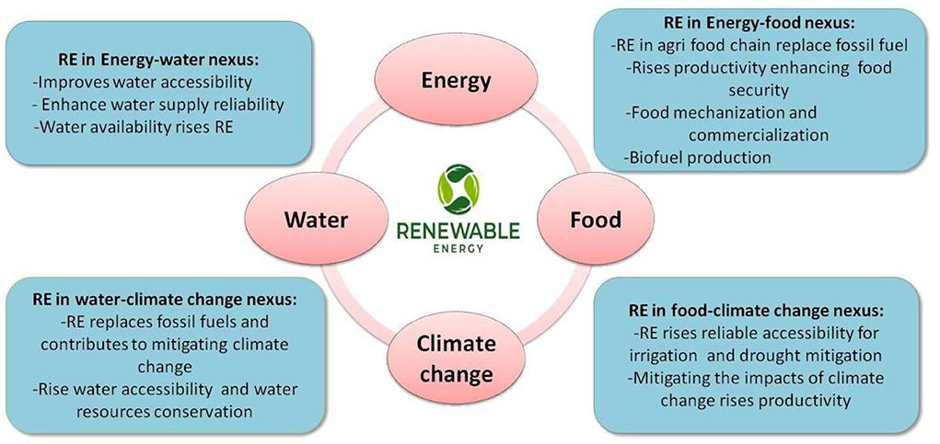

**FIGURE 3:RENEWABLE ENERGY CONTRIBUTION IN AGRICULTURE**

11. **Socio-Economic Impacts of Renewable Energy in Rural Farming Communities**

Research in the rural regions of the United States has indicated that the installation of renewable energy ventures, like solar and wind farms, results in the creation of employment opportunities, enhanced local government revenues, and economic diversification. The ventures offer landowners, such as smallholder farmers, a source of additional revenue through land rental for energy production. The investment in renewable energy projects helps revive rural economies and promotes sustainable farming practices[(Moore 2024)](https://www.researchgate.net/publication/381539182_Renewable_Energy_Adoption_and_Its_Effect_on_Rural_Development_in_United_States).Literature on the socio-economic effects of wind farms within small and rural societies shows that wind farms produce jobs, facilitate the development of infrastructure, and augment local income. The dividends are, nevertheless, optimized with people's involvement and fair benefits' sharing.Having the residents and small-scale farmers participate in decision-making contributes to their smallholder farming society earning more pluses from these kinds of undertakings Evidence regarding the socio-economic effects of wind farms in small and rural towns suggests that wind energy schemes are capable of producing employment opportunities, developing infrastructure, and augmenting local revenues. But when active community participation is ensured along with the equitable distribution of economic returns, benefits are optimized. This ensures that such projects contribute maximally to their positive impacts through involving smallholder farmers and indigenous people in decision-making processes[(Lopez et al. 2025)](https://link.springer.com/article/10.1007/s10098-024-03113-5?utm_source=chatgpt.com).The transition to decentralized electricity with renewable energy technologies is one of the most feasible methods of meeting energy access targets, especially in inaccessible rural regions of developing nations. The United Nations Secretary General's Advisory Group on Energy and Climate (AGECC) has been instrumental in setting these targets and facilitating dialogue among Chief Executive Officers of leading global industries and representatives of the international community on energy and environmental sustainability matters. The progress toward these goals is noteworthy, with stakeholders such as the private sector and Non-Governmental Organizations committed to pursuing measures that deal with energy poverty, especially in the rural parts of developing countries. From 1970 to 1990, there was an overall growth in rural electrification of 10% by the end of every decade[(Manyonga 2018)](https://d1wqtxts1xzle7.cloudfront.net/81481004/53360-libre.pdf?1646091371=&response-content-disposition=inline%3B+filename%3DThe_impact_of_access_to_renewable_energy.pdf&Expires=1740378628&Signature=U6CnzvqGGj60YGgu0kRwyNyvXmbvl7Mz8ZNrn7giYKB3D7Fl1KMh8x5QUbC5pSSFLgm0sCCEa5AJJBFkUKALqezBp6S~-S6~grNtyW5bfJ~bhB01kwwKk0GbUk9AItLZfMMZA4TnjaHEEJBvU~faaZ8iV7GpC1rdwokX5x1CR~vUE0Ftz5GX6exoSRpxKcc2MkiLWk3clSasaq3qZ0uABvT53BlGUzhgP8s9PeXRipMhQVr9ofOBfj8aBH6yz-G-hYfGU3PxFFoXrXwLJFkaxof81F~qntFjqj-APo1cWtYNDVBxThFzh-fzMtcc3T4YD4nfZR8L69zudACETdMrCg__&Key-Pair-Id=APKAJLOHF5GGSLRBV4ZA).

**CONCLUSION**

The use of renewable energy for agriculture is remarkable in addressing high demands for power, reducing greenhouse gas emissions generation, and upholding environmental conservation. Solar energy, wind, biomass, and geothermal power are some renewable energy technologies holding promising alternatives for fossil fuels that avoid climate change issues while contributing a reliable output of power towards agricultural activities. Technologies like agrivoltaics, biomass conversion, and energy storage systems become economical and reduce operating expenses, thus making renewable energy affordable to farmers. Production of bioenergy, smart energy management systems, and innovative wind and solar technologies also enable the efficient use of agricultural energy.Apart from environmental advantages, renewable energy contributes to rural socio-economic growth through the creation of jobs, local revenues, and sustainable agriculture. Decentralized renewable energy technologies enhance rural access to energy and ensure energy price stability and food security

Finally, renewable energy use in agriculture improves climate resilience, productivity, and a sustainable world food future. The transition is pivotal to the realization of global agriculture production efficiency, economic stability, and environmental sustainability. Policy support, infrastructure investment, and farmers' awareness, however, need to be there for successful uptake to renewable energy. Land-use conflict, upfront costs of investment, and regulator hindrances must be catered for universality of take-up.

**REFFERENCES**

Rahman, M. M., Khan, I., Field, D. L., Techato, K., & Alameh, K. (2022). Powering agriculture: Present status, future potential, and challenges of renewable energy applications. Renewable Energy, 188, 731-749.

Martinho, V. J. P. D. (2018). Interrelationships between renewable energy and agricultural economics: An overview. Energy Strategy Reviews, 22, 396-409.

Bathaei, A., & Streimikiene, D. (2023). Renewable Energy and Sustainable Agriculture: Review of Indicators.Sustainability, 15(19), 14307

Majeed, Y., Khan, M. U., Waseem, M., Zahid, U., Mahmood, F., Majeed, F., ... & Raza, A. (2023). Renewable energy as an alternative source for energy management in agriculture. Energy Reports, 10, 344-359.

Puska, A., Nedeljvoik, M., Dudic, B., Stilic, A., & Mittelman, A. (2024). Improving Agricultural Sustainability in Bosnia and Herzegovina through Renewable Energy Integration. Economies, 12(8), 195.

Qazi, A., Hussain, F., Rahim, N. A., Hardaker, G., Alghazzawi, D., Shaban, K., & Haruna, K. (2019). Towards sustainable energy: a systematic review of renewable energy sources, technologies, and public opinions. IEEE access, 7, 63837-63851.

Kumar, C. M. S., Singh, S., Gupta, M. K., Nimdeo, Y. M., Raushan, R., Deorankar, A. V., ... & Nannaware, A. D. (2023). Solar energy: A promising renewable source for meeting energy demand in Indian agriculture applications.

Paris, B., Vandorou, F., Balafoutis, A. T., Vaiopoulos, K., Kyriakarakos, G., Manolakos, D., & Papadakis, G. (2022). Energy Use in Greenhouses in the EU: A Review Recommending Energy Efficiency Measures and Renewable Energy Sources Adoption. Applied Sciences, 12(10), 5150.

Paris, B., Vandorou, F., Balafoutis, A. T., Vaiopoulos, K., Kyriakarakos, G., Manolakos, D., & Papadakis, G. (2022). Energy use in open-field agriculture in the EU: A critical review recommending energy efficiency measures and renewable energy sources adoption. Renewable and Sustainable Energy

Zaharia, A., Diaconeasa, M. C., Brad, L., Lădaru, G.-R., & Ioanăș, C. (2019). Factors Influencing Energy Consumption in the Context of Sustainable Development. Sustainability, 11(15), 4147.

Przygodzka, R., Badora, A., Kud, K., Mioduszewski, J., Woźniak, M., & Stec, A. (2024). The Importance of Public Sources of Financing the Development of Renewable Energy in

Morris, D. Z. (2024, September 15). Combining solar power with farming is getting easier. Developers are wary of added costs. The Wall Street

Wheatley, M. C. (2024). Advancements in renewable energy technologies: A decade in review. Premier Journal of Science, 1, Article

Spitia, J. J., Velázquez, F. A., Rodriguez, J., Gomez, L., Baeza, E., Aguilar-Rodríguez, C. E., Flores-Velazquez, J., & Villagran, E. (2024). Solar Energy Applications in Protected Agriculture: A Technical and Bibliometric Review of Greenhouse Systems and Solar Technologies. Agronomy, 14(12), 2791.

Nwokediegwu, Z. Q. S., Ibekwe, K. I., Ilojianya, V. I., Etukudoh, E. A., & Ayorinde, O. B. (2024). Renewable energy technologies in engineering: A review of current developments and future prospects. Engineering Science & Technology Journal, 5(2), 367–384.

Wheatley, M. C. (2024). Advancements in renewable energy technologies: A decade in review. Premier Journal of Science, 5(2), 100013.

Agrahari, A. K., Dev, R., Bharti, A., & Azam, S. M. (2024, October). Reanalysis of Energy Storage System in Agriculture Greenhouse. In 2024 International Conference on Sustainable Energy: Energy Transition and Net-Zero Climate Future (ICUE) (pp. 1-6). IEEE[.](https://doi.org/10.1109/ICUE63019.2024.10795641)

Assaye, Y. M. (2024). Agricultural Waste for Energy Stora American Journal of Modern Energy,ge, Conversion and Agricultural Applications. 10(3), 38-41.

Abdmouleh, Z., Alammari, R. A., & Gastli, A. (2015). Review of policies encouraging renewable energy integration & best practices. Renewable and Sustainable Energy Reviews, 45, 249-262.

Krishan, O., & Suhag, S. (2019). An updated review of energy storage systems: Classification and applications in distributed generation power systems incorporating renewable energy resources. International Journal of Energy Research, 43(12), 6171-6210.

Dinesh, H., & Pearce, J. M. (2016). The potential of agrivoltaic systems. Renewable and Sustainable Energy Reviews, 54, 299-308.

Faldu, D. J., Dulawat, M. S., Lakhani, A., Kelaiya, S. V., & Makavana, J. M.Contribution of renewable energy technologies with climate resilient approach in agricultural systems.

Acevedo, M., Pixley, K., Zinyengere, N., Meng, S., Tufan, H., Cichy, K., ... & Porciello, J. (2020). A scoping review of adoption of climate-resilient crops by small-scale producers in low-and middle-income countries. Nature plants, 6(10), 1231-1241.

Rastogi, M., Verma, S., & Singh, V. (2024). Renewable energy integration in agriculture. In S. K. Somashekar, G. V. Sumanth Kumar, S. Kumar, M. E. Krishnababu, & S. Kumar (Eds.), Advancements in agronomic practices (pp. 1-20). Golden Leaf Publishers.

Agadi, R., Sakhraoui, K., Dupke, R. K. M., Wiebrow, E., & von Hirschhausen, C. (2023). Integration of renewable energy resources into the water-energy-food nexus: Modeling a demand side management approach and application to a microgrid farm in Morocco. Frontiers in Environmental Economics, 2, Article 1200703.

Nunes, A. M. M., Coelho Junior, L. M., Abrahão, R., Santos Júnior, E. P., Simioni, F. J., Rotella Junior, P., & Rocha, L. C. S. (2023). Public Policies for Renewable Energy: A Review of the Perspectives for a Circular Economy. Energies, 16(1), 485.

Alengebawy, A., Ran, Y., Osman, A. I., et al. (2024). Anaerobic digestion of agricultural waste for biogas production and sustainable bioenergy recovery: A review. Environmental Chemistry Letters, 22, 2641–2668.

Soyombo, O. T., Mhlongo, N. Z., Nwankwo, E. E., & Scholastica, U. C. (2024). Bioenergy and sustainable agriculture: A review of synergies and potential conflicts. International Journal of Science and Research Archive, 11(1), 2082–2092.

Jamakhandikar, A., Painter, R., Doshi, A., & Bade, M. (2022, December). Micro-hydropower generation for sustainable development: a review. In Conference on Fluid Mechanics and Fluid Power (pp. 791-799). Singapore: Springer Nature Singapore.

Barbon, A., Gonzalez-Gonzalez, F., Bayon, L., & Georgious, R. (2023). Variable-Speed Operation of Micro-Hydropower Plants in Irrigation Infrastructure: An Energy and Cost Analysis. Applied Sciences, 13(24), 13096.

Jamal, J., & Lewi, L. (2018, June). Utilization of irrigation flow for the construction of micro-hydro power plant. In AIP Conference Proceedings (Vol. 1977, No. 1). AIP Publishing.

Moore, C. (2024). Renewable Energy Adoption and Its Effect on Rural Development in United States. Journal of Developing Country Studies, 8(2), 15-31.

Almazan-Gomez, M. A., Bielsa, J., Cazcarro, I., et al. (2025)**.** Socioeconomic impacts of wind farms in small and rural areas: A case study in north-eastern Spain. Clean Technologies and Environmental Policy.

Town Carabajal, A., Orsot, A., Elimbi Moudio, M. P., Haggai, T., Okonkwo, C. J., Jarrard III, G. T., & Selby, N. S. (2024). Social and economic impact analysis of solar mini-grids in rural Africa: A cohort study from Kenya and Nigeria. Environmental Research: Infrastructure and Sustainability, 4(1), 012345

Khan, N., Elhindi, K. M., Kassem, H. S., Kazim, R., & Zhang, S. (2024). Unveiling the nexus between solar energy adoption and crop farmer income: Evidence from Pakistan. Frontiers in Sustainable Food Systems, 8, Article 1364040

International Renewable Energy Agency (IRENA) & Food and Agriculture Organization (FAO). (2021). Renewable energy for agri-food systems: Towards sustainable development. IRENA.

Nath, B., Chen, G., O’Sullivan, C. M., & Zare, D. (2024). Research and Technologies to Reduce Grain Postharvest Losses: A Review. Foods, 13(12), 1875.

Steward, D., Mosey, G., Weber, E., & Supple, L. (2022). Highlights of Two Case Studies Illustrate the Diverse Renewable Energy Opportunities for Colorado Agriculture (No. NREL/PR-6A50-81737). National Renewable Energy Lab.(NREL), Golden, CO (United States).

Neupane, N., Chaudhary, P., Rijal, Y., Ghimire, B., & Bhandari, R. (2022). The role of renewable energy in achieving water, energy, and food security under climate change constraints in South Asia. Frontiers in Sustainable Food Systems, 6, 1016093.

He, J., Osabohien, R., Yin, W., Adeleke, O. K., Uduma, K., Agene, D., & Su, F. (2024). Green economic growth, renewable energy and food security in Sub-Saharan Africa. Energy Strategy Reviews, 55, 101503.

Moore, C. (2024). Renewable Energy Adoption and Its Effect on Rural Development in United States. Journal of Developing Country Studies, 8(2), 15-31.

Alzaman-Gomez, M. A., Bielsa, J., Cazcarro, I., Langarita, R., & Rodriguez-Lopez, G. (2025). Socioeconomic impacts of wind farms in small and rural areas: a case study in North-eastern Spain. Clean Technologies and Environmental Policy, 1-14.

Manyonga, I. (2018). The Impact of Access to Renewable Energy Technology on Economic Development and Socio-Cultural Transformation in Remote Rural Areas of Developing Countries, A Case Study for Zimbabwe.