**Original Research Article**

**Molecular docking studies of SOME siderophore-conjugated meropenem derivatives for the treatment of Multidrug resistant-TB**

**ABSTRACT:**

**Aim:** The rise of multidrug-resistant tuberculosis (MDR-TB) presents a significant challenge to existing treatment approaches, highlighting the urgent need for innovative therapeutic strategies. This research focused on designing of siderophore-conjugated meropenem derivatives to target the iron acquisition pathways of M. tuberculosis and tested using docking techniques (IrtAB, PDB ID: 7WIV).

**Methods:** An hydroxamate group was attached to meropenem using various linkers, including disulfide, quaternary ammonium, alkyl, and triazole, to facilitate Fe³⁺ chelation. The docking studies were performed using PyRx software and visualized in chimera and biovia discovery sudio. Initially, meropenem alone was docked to evaluate its interaction with the receptor IrtAB, followed by docking studies with beta-lactamase to assess the compound's resistance to enzymatic degradation, and finally with serine/threonine-protein kinase (PDB ID: 4OW8) to evaluate its antibacterial potential. Later the derivatives with siderophore were docked against IrtAB receptor for evaluating permeability.

**Results:** Meropenem exhibited favorable results in all cases except binding with IrtAB this is due to its hydrophilic nature. Subsequently, docking studies on siderophore-conjugated meropenem derivatives indicated high binding affinities. These affinities increased further upon Fe³⁺ attachment. Compounds with quaternary ammonium group and triazole group as linkers shown best interaction (SW-4A and SW-10A). After the hydroxamate group chelates ferric ions in body, the IrtAB receptor facilitates the transport of the siderophore-conjugated meropenem-ferric complex through the mycolic acid layer.

**Conclusion:** This study provides valuable insights into the potential of siderophore-conjugated meropenem derivatives as a novel therapeutic approach for multidrug-resistant tuberculosis. This mechanism potentially overcomes the less-permeability of meropenem caused by its hydrophilic nature and with the help of its resistance to beta-lactamase enzyme, presents promising avenue for MDR-TB treatment. Furthermore, the meropenem demonstrated resistance against beta-lactamase and proved antibacterial activity by interacting with PknA, a key regulatory protein.

*Keywords:* *Siderophore, Meropenem, Molecular Docking, Tuberculosis, Mycobactin*

1. **INTRODUCTION**

Tuberculosis comes under the category of chronic infectious disease caused by the bacteria mycobacterium tuberculosis. Tb makes to the list of top 10 deaths causing single infectious disease. When the TB caused by mycobacterium strains with resistance to isoniazid and rifampicin is called a multidrug resistance TB (MDR TB). MDR TB can happen due to relapse regimens and short course of treatment, spontaneous mutations, low quality drugs. once if someone is infected with this MDR TB, first line drugs which were considered to be efficient and has less adverse effects show less to no effect over TB bacteria. Due to the failure of first line drugs, the second line drugs like, ethionamide, amikacin, kanamycin, linezolid will be prescribed but these drugs more toxic, less tolerable and should be used for longer time will lead to many problems.1

Siderophores are small molecules secreted by microbes like bacteria and fungi to scavenge iron from their surroundings. They have a strong attraction to ferric iron (Fe³⁺), which is vital for growth but often hard to access, especially in places like the human body where iron is tightly bound to proteins. Siderophores form stable bonds with Fe³⁺ and help transport it into the microbial cells, ensuring their survival. This process is especially important for disease-causing bacteria, as they rely on siderophores to steal iron from their host, making them more effective at causing infections.2

Mycobacterium tuberculosis (Mtb), relies heavily on siderophores for its survival and pathogenicity. These small, iron-chelating molecules, specifically mycobactins (Fig no. 1) and carboxymycobactins, allow Mtb to acquire iron, an essential nutrient that is tightly regulated and restricted by the host immune system. By hijacking iron from host proteins such as transferrin and lactoferrin, siderophores ensure that Mtb can sustain its growth and metabolism, even within the iron-deprived environment of human macrophages. This iron acquisition mechanism plays a critical role in Mtb’s ability to persist, proliferate, and cause disease.3

Multidrug-resistant tuberculosis (MDR-TB) is a growing global health crisis, and finding new ways to treat it is essential. One innovative solution is using siderophore-conjugated antibiotics. These drugs combine a siderophore, which bacteria use to steal iron, with an antibiotic. By mimicking the natural process of iron uptake, these conjugates act like a "Trojan horse," sneaking the antibiotic into the bacterial cell. This approach not only improves how well the drug gets inside the bacteria but also helps overcome resistance, offering a promising new way to fight MDR-TB.4

The primary challenge with using beta-lactam antibiotics to treat tuberculosis (TB) lies in their hydrophilic nature, which limits their ability to penetrate the lipophilic mycolic acid layer of Mycobacterium tuberculosis (Mtb). Additionally, Mtb produces the beta-lactamase enzyme, which efficiently breaks the beta-lactam ring, rendering these antibiotics ineffective. Meropenem, a carbapenem antibiotic within the beta-lactam class, has shown promise as it is more resistant to beta-lactamase compared to other beta-lactams.



**Fig no.1:** structure of siderophore - mycobactin (Hydroxamate) with iron binding sites (red)

The literature survey has shown that meropenem has anti-TB when given with beta-lactamase inhibitors. This research aims to establish meropenem as a potential solution for multidrug-resistant TB (MDR-TB) using the molecular docking as an efficient tool. To overcome its permeability limitations, the study proposes developing a siderophore-conjugated version of meropenem, enabling it to effectively cross the mycolic acid barrier and enhance its antibacterial activity.5

1. **METHODOLOGY**

The software tools used in the current study are from free sources, namely Chemsketch used to design the molecular structure of ligands. Python prescription i.e., PyRx 0.8 used for energy minimization, conversion of ligands into pdbqt format, and for conducting docking studies. Biovia discovery studio used for the preparation of target proteins as well as to visualize the protein-ligand interactions. Chimera (version 1.18) used for preparing protein ligand complex after molecular docking to visualize the metal interactions of Fe3+ complex.

**2.1 Preparation of ligands**

The carbapenem antibiotic, meropenam was selected as the drug molecule to which the siderophores moiety will be attached with the help of linkers. The siderophore moiety selected was hydroxamate group, as it is responsible for iron chelation and transport in TB bacteria i.e., mycobactin. The linkers used are disulfide (SW-2A & 3A), quaternary ammonium salt (SW-4A & 5A), alkyl chain (SW-8A & 9A), also traizole moiety (SW-10A & 11A) can be attached using click chemistry reactions. The linker was attached with meropenem via amide bond and also same for siderophore moiety. The structures of the designed compounds are given in fig no. 2. The structures were drawn in Chemsketch and saved in mol format.

**2.2 Protein selection and preparation**

The proteins selected based upon the extensive literature survey namely, **Iron-Regulated Transporter-Associated Binding protein (IrtAB) (PDB ID: 7WIV), beta-lactamase (BlaC)** (PDB ID: 7A5T) and Serine/threonine-protein kinase (PknA) PDB ID: (4OW8) downloaded from RCSB protein data bank ([www.pdb.org](http://www.pdb.org)). The Biovia Discovery Studio was used to prepare the proteins by deleting the existing heteroatoms and the polar hydrogens were added at the end. The prepared proteins were saved in PDB format. Along with that the Ramachandra plot analysis was also done in the same software for all proteins.

**2.3 Molecular docking**

The molecular docking was performed in PyRx with the help of protocol provided by Trott and Olson with modifications.6 The PyRx uses AutoDock Vina for docking analysis. The prepared protein structure was uploaded into the software, selected as macromolecule. The ligands were selected from open babel option. The ligand energies were minimized, and were converted into pdbqt format. The grid was drawn around the protein molecule and the docking was initiated. The lowest binding energy was considered to be most optimal for our study. In this study, the exhaustiveness of 8 was used for docking as it provides accurate results. The docking complexes were saved into the respective folders, later visualized in Chimera and Biovia Discovery Studio.

 

 

 

 



**Fig no.2:** Structures of designed siderophore conjugated meropenams with linkers (meropenam : blue, linker: black, siderophore (hydroxamate): red)

1. **RESULTS AND DISCUSSION**

In this study, the siderophore-conjugated meropenem derivatives were docked against the Iron-Regulated Transporter-Associated Binding protein (IrtAB) of mycobacterium tuberculosis to extensively analyze the interactions of siderophores with the iron uptake protein and to compare these interactions with those involving Fe³⁺bound siderophores. The hydroxamate group, known for its strong Fe³⁺chelation properties, was included in the design as it structurally resembles the iron-binding moiety of mycobactin, the native siderophore of Mycobacterium tuberculosis. Additionally, one chlorine atom was incorporated to balance the lipophilicity, considering the mycolic layer is lipophilic. Once the siderophore enters the system, the **hydroxamate group of siderophore** will chelate Fe³⁺ in the body, and the bacterial cell will subsequently interact with this chelated complex for iron uptake. Additionally, only the drug molecules without the siderophore moiety were docked against beta-lactamase (BlaC) and Serine/threonine-protein kinase (PknA), as all compounds designed in such a way that the siderophore and linker will be separated by hydrolysis upon entering the bacterial cell. This approach was used to evaluate whether meropenem can resist enzymatic degradation by beta-lactamase and exhibit antimicrobial activity through interaction with PknA. The docking scores are given in table no. 1 and 2.

**Table no.1:** Binding affinities of siderophore conjugated meropenam with TB siderophore (mycobactin) mediating protein IrtAB (PDB ID: 7WIV)

|  |  |  |  |
| --- | --- | --- | --- |
| **Compound code** | **Docking scores (Kcal/mol)** | | |
| **IrtA (chain-A)** | **IrtB (Chain-B)** | **IrtAB (both A and B)** |
| **SW-1A** | -6.8 | -6.3 | -7.1 |
| **SW-2A** | -7.8 | -7.1 | -8.6 |
| **SW-3A** | -8.0 | -7.6 | -8.9 |
| **SW-4A** | -7.6 | -7.7 | -9.4 |
| **SW-5A** | -8.2 | -8.3 | -9.9 |
| **SW-8A** | -8.5 | -7.5 | -10.4 |
| **SW-9A** | -7.8 | -7.3 | -9.9 |
| **SW-10A** | -8.1 | -7.1 | -9.0 |
| **SW-11A** | -7.5 | -8.4 | -9.6 |

**Table no.2:**  Binding affinities of siderophore conjugated meropenam with **beta-lactamase (BlaC)** (PDB ID: 7A5T) and Serine/threonine-protein kinase (PknA) PDB ID: (4OW8)

|  |  |  |
| --- | --- | --- |
| **Compound code** | **Docking scores (Kcal/mol)** | |
| **BlaC** | **PknA** |
| **SW-1A** | -6.9 | -7.8 |

The docking results suggests that, **SW-1A** (meropenem without the siderophore conjugation) shows weaker binding -6.8 Kcal/mol and -6.3 Kcal/mol to both **IrtA** and **IrtB** chains individually, as well as 7.1 Kcal/mol to the **IrtAB** complex. Meropenem is a **beta-lactam** antibiotic, and its binding is not enhanced by interactions with the iron uptake system, resulting in relatively weaker docking scores compared to the siderophore-conjugated derivatives, but when the docking studies were made against beta-lactamase and Serine/threonine-protein kinase it shown good binding -6.9 and 7.8 Kcal/mol respectively suggesting that once release into the cell it will show resistance to beta-lactamase and can show a significant the antibacterial activity along with it. Yet, it is advisable to give this with drug with any beta-lactamase inhibitor like clavulanic acid for its maximum potency. The interaction diagrams are given in fig. no. 3 and 4.

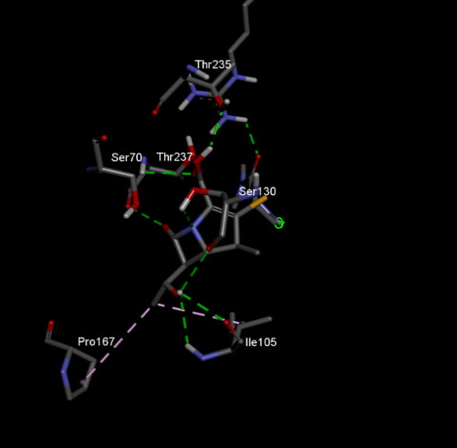 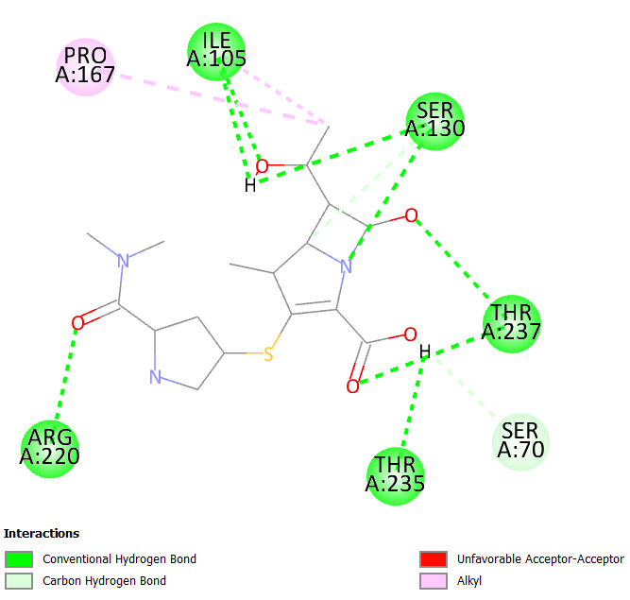

**Fig no. 3:** Protein ligand interaction of SW-1A against protein beta-lactamase

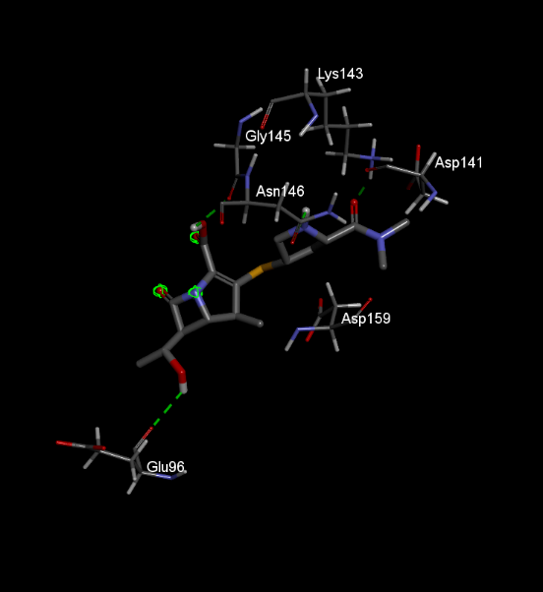 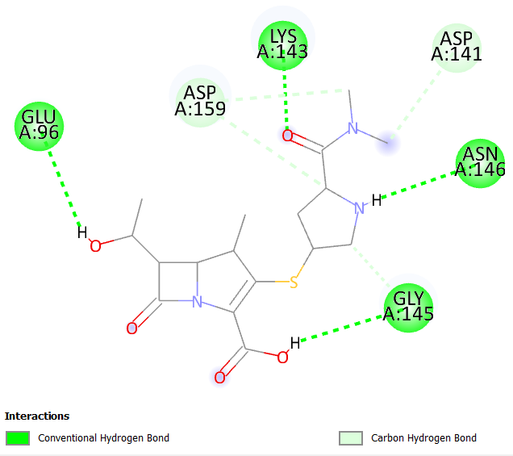

**Fig no. 4:** Protein ligand interaction of SW-1A against protein Serine/threonine-protein kinase

Various linkers were employed for the siderophore conjugation to meropenem derivatives, and their effects on docking interactions with the IrtAB protein were analyzed. For compounds **SW-2A** and **SW-3A**, a **disulfide linkage** was used, which showed favourable docking results for both the siderophore without fe3+ compound (**SW-2A**) and the **Fe³⁺-conjugated siderophore (SW-3A**). The docking scores for these compounds were **-8.6** and **-8.9 kcal/mol** for **SW-3A and SW-2A respectively**. The 2D and 3D interaction diagrams of the compounds with protein are given in fig 5 and 6, by analysing those figures it is evident that the binding with the protein is more when the chelation of fe3+ happens, new ASP 182, ALA 178 bonds are formed.

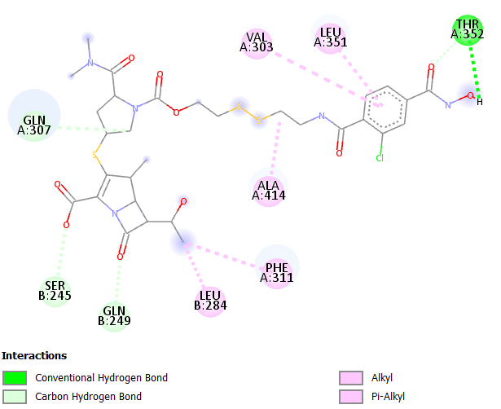

**Fig no. 5:** Protein ligand interaction of SW-2A against protein IrtAB

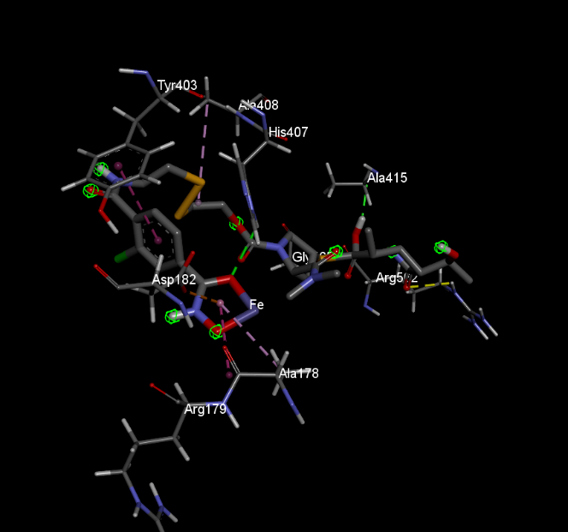 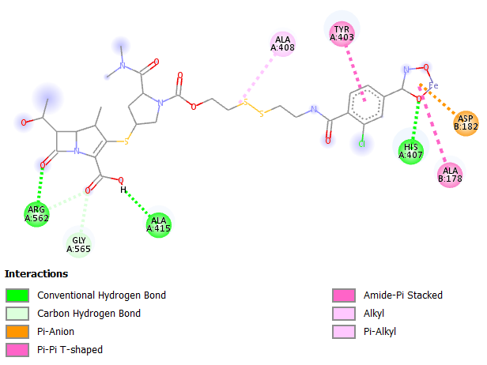

**Fig no. 6:** Protein ligand interaction of SW-3A against protein IrtAB

While for **SW-4A** and **SW-5A**, a **quaternary ammonium salt** was chosen as the linker. Notably, the quaternary ammonium salt acts not only as a linker but also as an integral part of the drug, as it does not detach from the compound once inside the cell. This feature helps stabilize meropenem within the bacterial cell, enhancing its activity. Both shown docking scores of **-9.4 kcal/mol** and **-9.9 kcal/mol**, respectively, indicating that the quaternary ammonium salt linker provides a stable binding environment for the drug. The 2D interactions of those compounds suggests that, there are many important interactions can be seen even with the quaternary ammonium group and after the chelation pi lone pair bond is formed at the chelation spot with amino acid THR 300. The diagrams are given in fig 7 and 8.

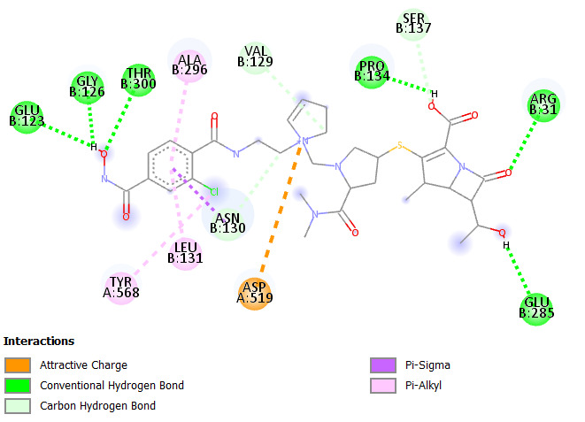

**Fig no. 7:** Protein ligand interaction of SW-4A against protein IrtAB

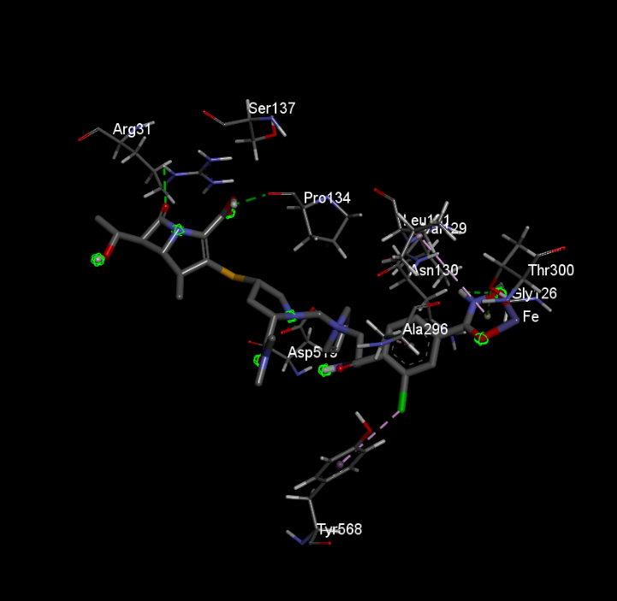 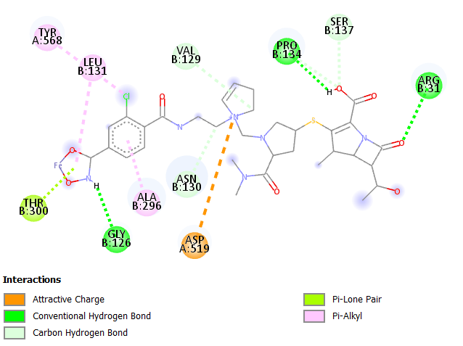

**Fig no. 8:** Protein ligand interaction of SW-5A against protein IrtAB

In contrast, when we tested a **simple amide linkage** with three carbon atoms to assess whether simpler chains could provide better transport, compound SW-8A shown the highest binding affinity of **-10.4 kcal/mol**. However, this binding score decreased once the siderophore was chelated with Fe³⁺, i.e., compound SW-9A suddenly dropped to -9.9 Kcal/mol which was a significant contrast when compared with other set of Fe3+ chelated compounds and may not be a good indication. The reason for this can be observed in the 2D and 3D diagrams that, after the chelation with fe3+ there are no new interactions in that complex. This might be due to the linker we used. The 2D and 3D diagrams are given in fig 9 and 10.

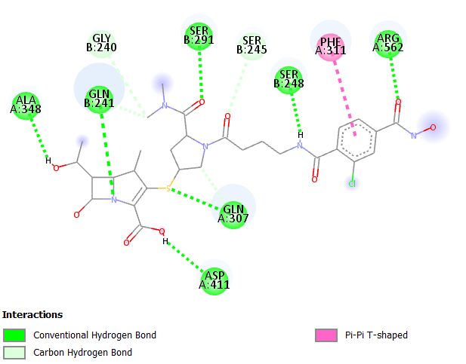

**Fig no. 9:** Protein ligand interaction of SW-8A against protein IrtAB

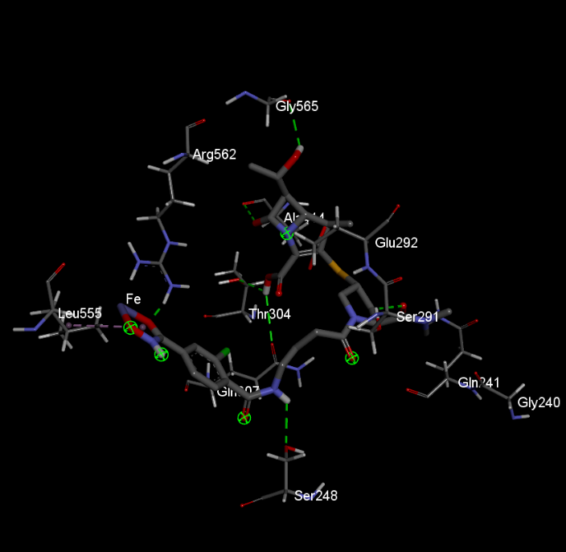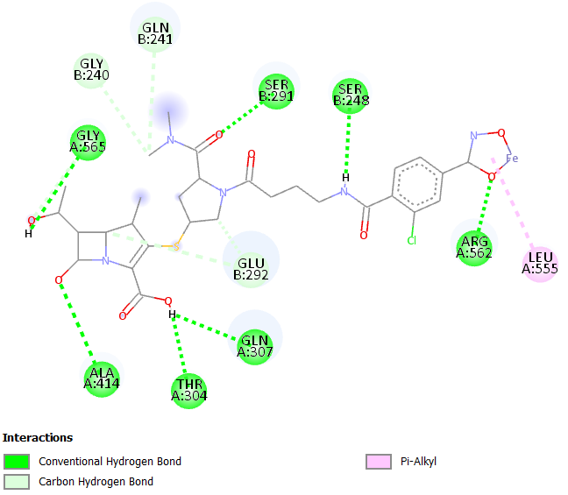

**Fig no. 10:** Protein ligand interaction of SW-9A against protein IrtAB

The results of the **SW-10A** and **SW-11A** compounds further demonstrated the uptrend after iron chelation, with docking scores of **-9.0 kcal/mol** and **-9.6 kcal/mol**, respectively. This behavior indicates that after Fe³⁺ chelation, the siderophore-metal complex exhibited stronger interactions with protein. which can be attributed to the presence of a **triazole ring** in the linker. The triazole ring, which could be synthesized using **click chemistry**, stabilized the compound structure, enhancing binding even after the siderophore chelation with Fe³⁺. The 2D interaction of SW-10A shows low interactions at siderophore and linker site, but once the iron chelates with siderophore the interactions will become more (SW-11A), this is mainly due to the presence of triazole ring, as it with the iron complex forms alkyl, pi-alkyl bond with ALA 561, PRO 286 and hydrogen bond with GLU 285. Interactions are given in fig. 11 and 12.

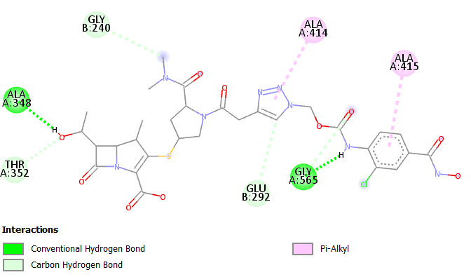

**Fig no. 11:** Protein ligand interaction of SW-10A against protein IrtAB

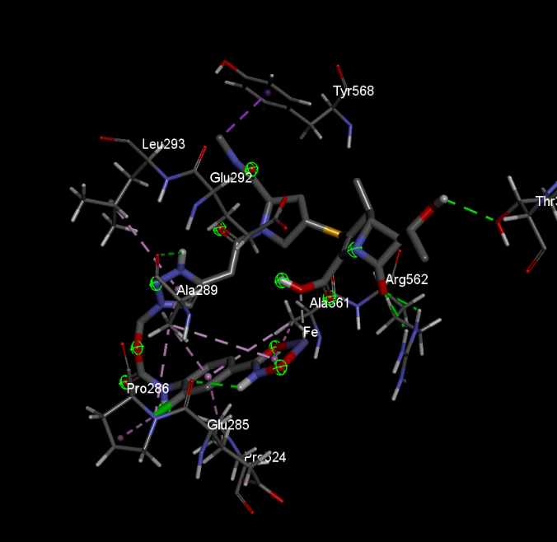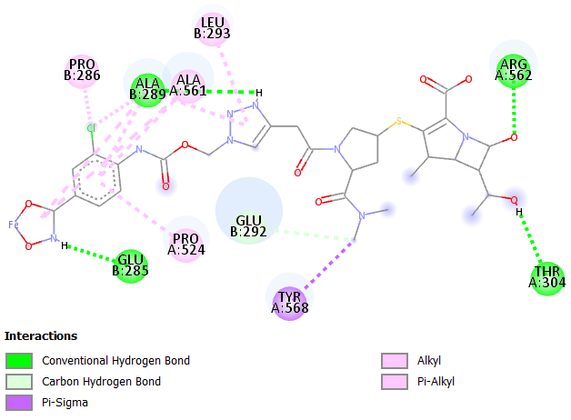

**Fig no. 12**: Protein ligand interaction of SW-11A against protein IrtAB

The docking studies were performed with both chains (IrtA and IrtB) individually to determine whether the compound binds to which part of the protein. The docking scores are given in table no. 1. The data trend given in table no. 1 for each individual chain is similar to that of entire protein. It suggests that the compounds interact with both the chains in protein to produce action. Binding to irtB is crucial because that chain forms the transmembrane domain of the transporter, creating a channel for the siderophore-iron complex to pass through bacterial membrane. As it specifically binds and recognizes the siderophores loaded with iron. It also helps in reduction ferric ion (Fe3+) to ferrous ion (Fe2+) during transport because this form is used up by cellular processes. IrtA is of less importance due to its function being to provide ATP for the transport. However, it can interact with proteins or cytoplasmic contents to regulate transporter activity, hence its necessary to check the binding of compounds with this chain as well. Among the designed compounds SW-4A comes out on top followed by SW-10A, due to the linkers which they possess. As SW-4A has quaternary ammonium with alkyl chains that can act as main drug molecule and this can be even observed in cefedrocol, a siderophore conjugated antibiotic drugs which is passing the clinical trials has this kind of linker cum side chain. Also SW-10A got good binding affinity and with many favourable interactions due to the triazole ring, also that ring possesses biological activities as well.

This study proves the potential of siderophore-conjugated meropenem derivatives as a promising approach for tackling multidrug-resistant tuberculosis (MDR-TB). These compounds hijack the bacterial iron acquisition system via the IrtAB transporter, enables the effective targeting while preserving strong anti-TB activity through interactions with important regulatory proteins such as PknA. Also, this approach helps the meropenem to overcome its problems of hydrophilicty and impermeability. With further experimental validation and refinement, this strategy has the potential to significantly impact global efforts in combating drug-resistant tuberculosis.

1. **CONCLUSION**

This study provides valuable insights into the potential of siderophore-conjugated meropenem derivatives as a novel therapeutic approach for multidrug-resistant tuberculosis (MDR-TB). By incorporating a hydroxamate group for Fe³⁺ chelation, these compounds exploit the iron uptake system of Mycobacterium tuberculosis, mimicking its native siderophore, mycobactin. Among the derivatives, SW-4A and SW-10A exhibited better docking interactions with the IrtAB transporter, particularly with the IrtB chain, which is very important for iron transport into the mycobacterium.

Furthermore, the meropenem demonstrated resistance against beta-lactamase and proved antibacterial activity by interacting with PknA, a key regulatory protein. These properties show siderophore-conjugated meropenem derivatives as promising candidates for overcoming the challenges of drug resistance in MDR-TB. The study focuses on the importance of innovative linker designs, such as quaternary ammonium and triazole rings, in enhancing drug efficacy. Experimental validation is required to assess their clinical viability in MDR-TB management.

**COMPETING INTERESTS DISCLAIMER:**

Authors have declared that they have no known competing financial interests OR non-financial interests OR personal relationships that could have appeared to influence the work reported in this paper.

**References:**

1. Peloquin, C. A., & Davies, G. R. (2021). The treatment of tuberculosis. *Clinical Pharmacology & Therapeutics*, *110*(6), 1455-1466. https://doi.org/10.1002/cpt.2261
2. Schalk, I. J. (2024). Bacterial siderophores: diversity, uptake pathways and applications. *Nature Reviews Microbiology*, 1-17. https://doi.org/10.1038/s41579-024-01090-6
3. Gokhale, K. M., & Iyer, A. M. (2022). Deployment of iron uptake machineries as targets against drug resistant strains of mycobacterium tuberculosis. *Indian Journal of Pharmacology*, *54*(5), 353-363. 10.4103/ijp.IJP_667_20
4. Kumar, G., & Adhikrao, P. A. (2023). Targeting Mycobacterium tuberculosis iron-scavenging tools: A recent update on siderophores inhibitors. *RSC Medicinal Chemistry*, *14*(10), 1885-1913. https://doi.org/10.1039/D3MD00201B
5. Gonzalo, X., & Drobniewski, F. (2022). Are the newer carbapenems of any value against tuberculosis. *Antibiotics*, *11*(8), 1070. https://doi.org/10.3390/antibiotics11081070
6. Trott, O. & Olson, A.J., (2010). AutoDock Vina: improving the speed and accuracy of docking with a new scoring function, efficient optimization, and multithreading. *Journal of computational chemistry*, *31*(2), pp. 455-461. https://doi.org/10.1002/jcc.21334