**Case report**

**A CASE REPORT ON CLOBETASOL INDUCED PURPURA AND CELLULITIS**

**ABSTRACT**

Clobetasol propionate, a superpotent topical corticosteroid, is commonly prescribed for chronic inflammatory dermatoses. However, prolonged use, especially without medical supervision, may result in severe adverse cutaneous effects such as purpura and secondary infections like cellulitis. We present the case of a 75-year-old female with a history of hypertension, who developed bilateral lower limb edema and cellulitis over the right shoulder due to chronic unsupervised clobetasol application. Dermatology evaluation confirmed clobetasol-induced purpura and cellulitis. Prompt withdrawal of the corticosteroid and appropriate medical management led to full recovery. This case underscores the need for careful monitoring of potent topical corticosteroids and patient education.

**KEY WORDS:** Clobetasol, Purpura, Cellulitis, Topical corticosteroids, Adverse drug reaction

**INTRODUCTION**

Topical corticosteroids remain a cornerstone in the management of a wide array of dermatological conditions due to their anti-inflammatory, antiproliferative, and immunosuppressive properties. Clobetasol propionate, classified as a class I superpotent corticosteroid, is commonly prescribed for short-term use in chronic inflammatory dermatoses such as psoriasis, lichen planus, and severe eczema. However, long-term or inappropriate use, especially without medical supervision, is associated with a spectrum of local and systemic adverse effects.[1] Among these, cutaneous side effects such as dermal atrophy, telangiectasia, striae, and purpura are frequently reported. Purpura arises due to corticosteroid-induced thinning of the dermis and increased fragility of dermal blood vessels, leading to spontaneous or trauma-induced bleeding into the skin[2].

Furthermore, the compromised integrity of the skin resulting from prolonged corticosteroid application increases susceptibility to secondary infections, particularly cellulitis. Cellulitis is an acute bacterial infection of the dermis and subcutaneous tissue, most commonly caused by Streptococcus spp. or Staphylococcus aureus. In steroid-compromised skin, even minor trauma or microabrasions can serve as portals of entry for pathogens, leading to rapidly spreading infections. Elderly patients and those with predisposing conditions such as diabetes or chronic venous insufficiency are at greater risk of developing these complications.[3]

Despite awareness of corticosteroid side effects, the progression from clobetasol-induced purpura to cellulitis remains an underreported clinical phenomenon. Early recognition and prompt management are essential to prevent systemic spread and complications. This article aims to present a clinically relevant case of clobetasol-induced purpura complicated by cellulitis, highlighting the need for judicious use of high-potency topical corticosteroids and reinforcing the importance of patient education regarding duration, dosage, and application sites. Through this case, we emphasize the importance of vigilance in monitoring adverse effects associated with potent topical therapies.[4]

**CASE PRESENTATION**

A 75 year old female patient was admitted to General Surgery Department with the complaints of pain, edema in bilateral lower limb, redness over the skin at the right shoulder. The patient had past medical history of Hypertension for 2+ years, and managed with T. AMLO (AMLODIPINE) 2.5mg P/O 1-0-0. Before 1 year, she had an itching all over the body, since then she was applying CLOBETASOL cream locally.

The patient was conscious, oriented, heart sounds were heard, chest was clear, was able to move all limbs and GI was non-tender. During admission, she had a Pulse Rate of 94 beats/min, Respiratory Rate of 24 breaths/min, Blood Pressure of 140/90mmHg. Her laboratory investigation showed an elevation in CRP (15.8mg/L) and decline in Sodium (129mmol/L). Venous Doppler study showed reactive linguinal lymphadenitis, mild diffuse subcutaneous edema in lower leg and foot. (Image 1.1)

Initially Dermatology consultation was done and withheld the CLOBETSASOL cream, validated the intervention and diagnosed as CLOBETASOL induced Purpura, Cellulitis (Image 1.2) and advised with TAB. DAZACT (DESLORATIDINE) 5mg P/O 0-0-1, FUCIBET CREAM (FUSIDIC ACID + BETAMETHASONE) L/A BD, VENUSIA CREAM L/A BD, MUPIROCIN CREAM L/A BD. Other supportive measures were INJ. CEFTRIAXONE 1g IV BD for treating infection condition, INJ. PANTOPRAZOLE 40mg IV 1-0-0 for prevention of gastric irritation, TAB. AMLO (AMLODIPINE) 2.5mg P/O 1-0-0 for Hypertension, SODIUM CHLORIDE 3% INFUSION for first 3 days and then TAB. NATREMIA (TOLVAPTAN) 15mg P/O 1-0-0 for sodium correction. After 7 days of admission patient got symptomatically better and discharged with TAB. DAZACT (DESLORATIDINE) 5mg P/O 0-0-1, FUCIBET CREAM (FUSIDIC ACID + BETAMETHASONE) L/A BD, VENUSIA CREAM (mention generic name) L/A BD, MUPIROCIN CREAM L/A BD, TAB. AMLO (AMLODIPINE0 2.5mg P/O 1-0-0, TAB. CHYMORAL FORTE (mention generic name) P/O 1-0-1 for 5 days.

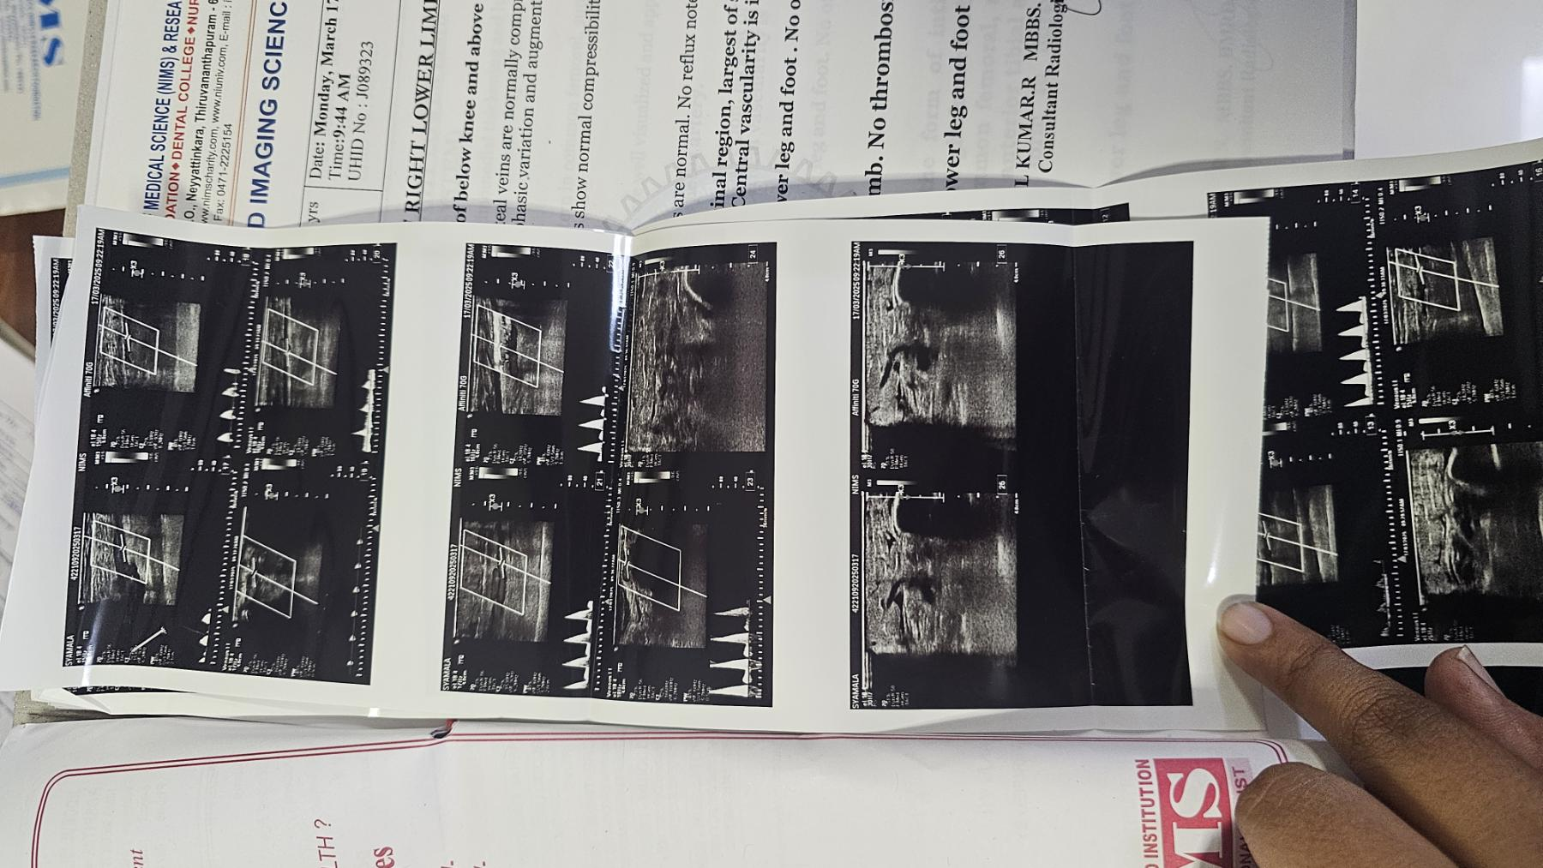

**Image 1: Doppler study**

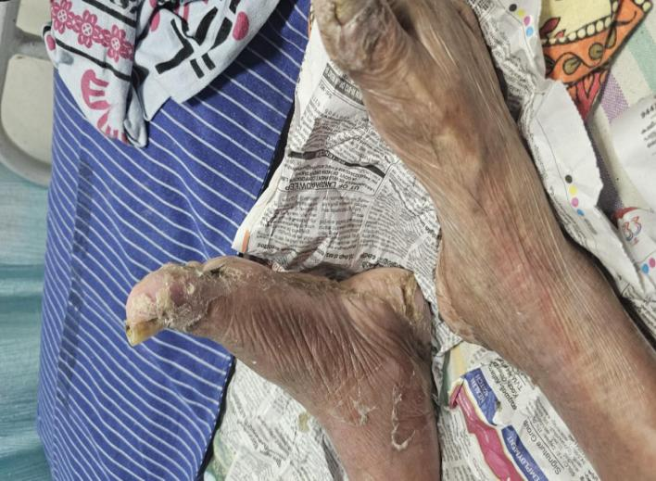 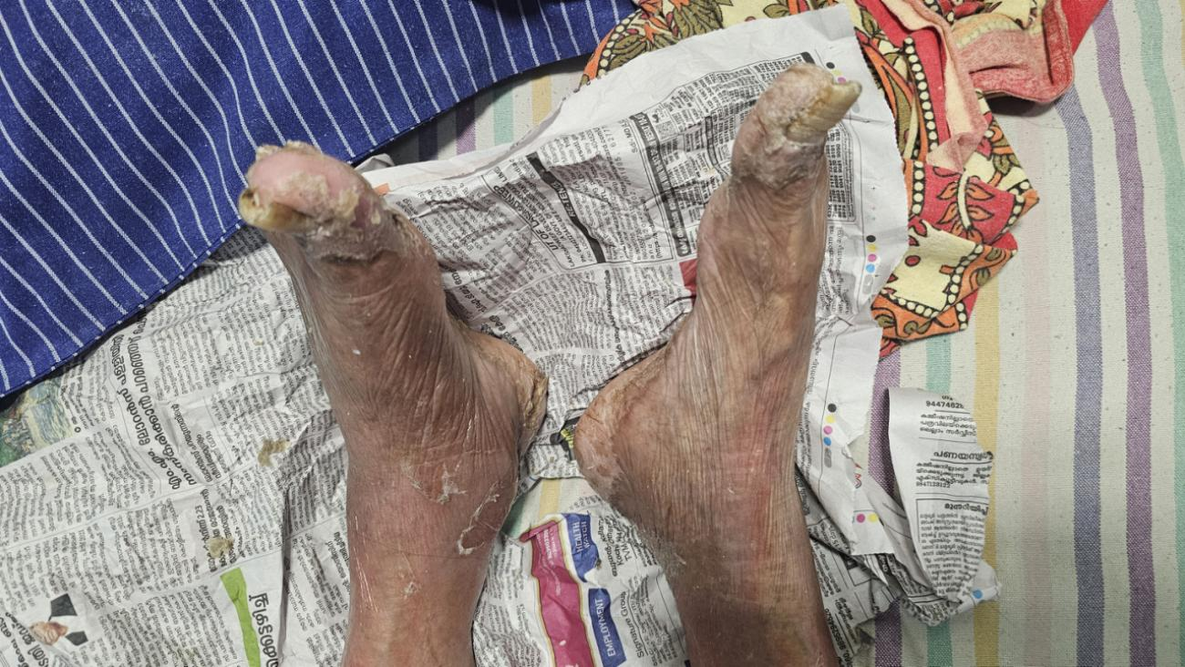

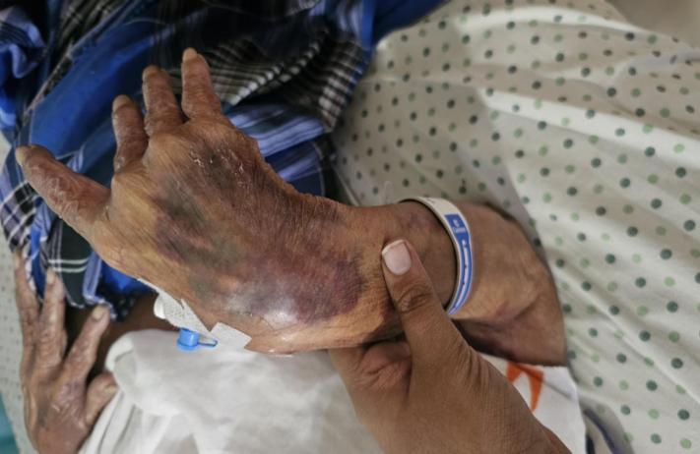 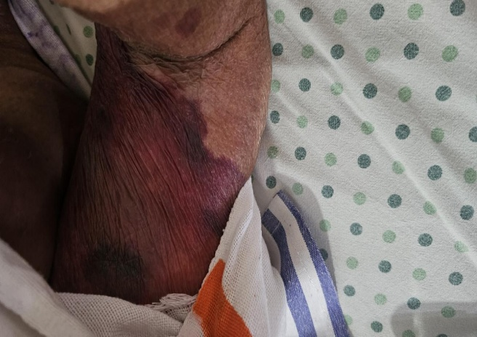

**Image 2: Image of Purpura and cellulitis in limbs**

**DISCUSSION**

The widespread use of topical corticosteroids like clobetasol propionate has significantly improved outcomes in inflammatory dermatoses. However, their misuse or unsupervised prolonged application can result in considerable local adverse effects, including purpura, skin atrophy, and secondary infections like cellulitis. In elderly patients, the skin is inherently more fragile, further increasing the risk.[5,6]

In this case, chronic clobetasol application led to corticosteroid-induced purpura and cellulitis, consistent with findings reported by Tanei and Saeki in Journal of Dermatology, where the authors observed purpuric eruptions and skin fragility in elderly patients using long-term topical corticosteroids [7]. Likewise, Coondoo et al., in a clinical study published in Indian Journal of Dermatology, emphasized that irrational use of potent topical steroids, including clobetasol, was associated with adverse cutaneous effects such as purpura, striae, and secondary infections [8].

The compromised skin barrier due to chronic steroid use creates a portal of entry for pathogens, commonly leading to cellulitis caused by Staphylococcus aureus or Streptococcus pyogenes. Patel and Nadkarni, in Journal of the American Academy of Dermatology, documented cellulitis cases following inappropriate corticosteroid use, linking immunosuppression and dermal thinning to increased infection risk [9].

In this case, the adverse reaction was evaluated using the Naranjo Adverse Drug Reaction Probability Scale, which yielded a score of 7, indicating a “Probable” adverse drug reaction. This score suggests a strong temporal and clinical relationship between the drug and the reaction, especially given the absence of alternative causes and improvement upon withdrawal of the drug.[10]

**CONCLUSION**

This case highlights a significant but often under-recognized adverse effect of prolonged unsupervised use of high-potency topical corticosteroids like clobetasol. Clobetasol-induced purpura followed by secondary bacterial cellulitis in an elderly patient necessitated medical intervention and cessation of the drug. The application of the Naranjo Scale confirmed a probable ADR. This case underlines the importance of rational prescribing, short-term use, and adequate patient counseling regarding application, duration, and risks of potent corticosteroids.

**COMPETING INTERESTS DISCLAIMER:**

Authors have declared that they have no known competing financial interests OR non-financial interests OR personal relationships that could have appeared to influence the work reported in this paper.

**REFERNCE**

1. Hengge UR, Ruzicka T, Schwartz RA, Cork MJ. Adverse effects of topical glucocorticosteroids. American Journal of Clinical Dermatology. 2006;7(6):367–381.
2. Eichenfield LF, Tom WL, Chamlin SL, Feldman SR, Hanifin JM, Simpson EL, et al. Guidelines of care for the management of atopic dermatitis. Journal of the American Academy of Dermatology. 2014;71(1):116–132.
3. Rapaport MJ, Rapaport V. Long-term topical corticosteroid therapy. Cutis. 1999;64(6):397–402.
4. Callen JP. Complications of topical steroid use. Dermatologic Clinics. 1993;11(1):165–170.
5. Narum S, Westergren T, Klemp M. Corticosteroids and risk of skin infections: a review. Clinical Dermatology Research Journal. 2016;1(3):1–6.
6. Thakur K, Sood A, Chaudhary R. Adverse cutaneous drug reactions due to topical corticosteroids. International Journal of Dermatology. 2014;53(10):1226–1231.
7. Tanei R, Saeki H. Drug-induced purpura and skin fragility in elderly patients treated with topical corticosteroids. Journal of Dermatology. 2013;40(3):197–202.
8. Coondoo A, Phiske M, Verma S, Lahiri K. Side-effects of topical steroids: A long overdue revisit. Indian Journal of Dermatology. 2014;59(5):455–463.
9. Patel GK, Nadkarni NJ. Cellulitis following misuse of topical corticosteroids: a case-based review. Journal of the American Academy of Dermatology. 2017;76(1):e3–e4.
10. Naranjo CA, Busto U, Sellers EM, Sandor P, Ruiz I, Roberts EA, et al. A method for estimating the probability of adverse drug reactions. Clinical Pharmacology & Therapeutics. 1981;30(2):239–245.