**PROTECTIVE EFFECT OF *Cucurbita pepo* (PUMPKIN) SEED EXTRACT ON PREGABALINE INDUCED HEPATORENAL TOXICITY**

**ABSTRACT**

The aim of this study was to investigate the effect of aqueous ethanol extract of *Cucurbita pepo (C. pepo)* seed on pregabalin-induced hepatorenal toxicity in male Wistar rats.A total of 30 experimental male rats were randomly grouped into 6 of 5 rats each for daily treatment via oral gavage for 60 days as follows: Group A (normal control) = 0.5ml 5% tween 80 (vehicle); B (negative control) = 75mg/kg pregabalin, group C= 500mg/kg of aqueous ethanol extract of *C. pepo* seed; D = 1000mg/kg of aqueous ethanol extract of *C. pepo* seed, group E = Co-treatment of 75 mg/kg of Pregabalin and 500mg/kg of *C. pepo* seed and group F = co-treatment of 75mg/kg of Pregabalin and 1000mg/kg of *C. pepo* seed.

At the end of treatment, animals were anaesthetised and plasma sera were used to analyse biochemical parameters like alanine transaminase (ALT), alkaline phosphatase (ALP), aspartate aminotransferase (AST), total protein, albumin, bilirubin, urea (Ur), creatinine (Cr), and blood electrolytes. Histopathological examination was carried out on liver and kidney sections.

There was a significant decrease in ALT levels of test group E relative to both controls and a significant decrease in CB and TB levels relative to negative control group B. There was a significant (P<0.01) increase in serum levels of TP, ALB and CB of the treatment group F relative to normal control. The serum concentration levels of Ur and Cr of test groups C, D and E significantly decreased when compared with the negative control. Sodium and potassium levels of group E-treated rats significantly decreased relative to the negative control, while bicarbonate levels decreased in test group D relative to the negative control. None of the treated rats showed abnormal hepatic and renal histomorphology, whereas the negative control group exhibited distorted hepatic and renal architecture.

In conclusion, *C. pepo* seed extract may have a dose-dependent hepato-renal protective effect against pregabalin-induced liver and kidney toxicity. Further studies are recommended to fully demonstrate underlying mechanisms and optimize dosing for potential therapeutic applications.

**Keywords:** *Curcurbita pepo* seed, liver function, kidney function, Pregabalin, Toxicity

**INTRODUCTION**

Pregabalin sold under the brand name LYRICA belongs to the class of drugs known as anticonvulsants or antiepileptic drugs (AEDs) (Terman et al., 2022; Wang et al., 2024). Pregabalin is a medication used to prevent epilepsy and functions as an anticonvulsant, analgesic, and anxiolytic. It is also prescribed to treat a range of conditions, including arthritis, neuropathic pain, general anxiety disorder (GAD) and fibromyalgia (Arango-Dávila & Rincón-Hoyos, 2018; Bernik et al., 2013; Maffei, 2020). Pregabalin produces immediate effects on calcium channel-mediated currents seen at neuromuscular junctions and Calyx of Held excitatory synapses (Alles et al., 2020; Sills, 2006). Nonetheless, other research indicates that the effects of pregabalin are predominantly chronic, achieved via diminishing calcium channel trafficking from the dorsal root ganglia to the primary afferent terminals synapsing in the spinal dorsal horn ((Bauer et al., 2010; Hendrich et al., 2012). However, research findings have reported the potential renal and hepatic toxicity associated with long-term use of Pregabalin (Ebrahem et al., 2022; Ghaleba et al., 2021; Salah et al., 2024). This toxicity is thought to arise from oxidative stress and the metabolites produced by Pregabalin.

*C. pepo* (commonly known as pumpkin) on the other hand, has a variety of uses, especially as food source and for medical conditions. Traditionally, *C. pepo* is a rich source of unsaturated fatty acids, antioxidants, anti-inflammatory, antimicrobial, urodynamic effects and fibers. Known to have anti-atherogenic and hepatoprotective activities (Adsul & Madkaikar, 2021; Patel, 2013; Widy-tyszkiewicz & Widy-tyszkiewicz, 2013) and it’s also low in calories but rich in vitamins and minerals. It’s one of the best-known sources of beta carotene. Consuming *C.* *pepo* reduces the risk of cancer, heart disease, ocular diseases, and obesity as well as improves hepatic and renal functions (Kostecka-Gugała et al., 2020; Samuel-Nakamura et al., 2019).

Although *C. pepo* seeds have been reported to exhibit protective effects against hepatic and renal toxicity (Akomolafe, 2021; Ameen et al., 2023; Oyetayo et al., 2020), this study is aimed at determining the effect of Aqueous ethanol extract of *C. pepo* seed on hepatic and renal biochemical profile in pregabalin-induced hepatic and renal toxicity in male Wistar rats.

**MATERIALS AND METHODS**

**Plant components and authentication**

Fresh *C. pepo* or pumpkin was purchased from Ogbete Lane, Artisan Market, Enugu. It arrived to the Department of Pharmacology, University of Port Harcourt, packed in a polythene bag. Dr Ekeke authenticated the plant species using voucher specimens (Ref No; UPH/PSB/2021/071) kept at the University Herbarium.

**Extract preparation**

Plant components were obtained by solvent extraction using 80% aqueous ethanol. Deshelled seeds were left at room temperature to air-dry for four days. The seeds were ground by a mill. One 1,910g, or two kilogramme, weighing machine measured powdered seeds. For three days, the two kilogramme plant material was macerated under extensive extraction in six litters of eighty percent aqueous ethanol. Three days of solvent filtration using morcelin, following the initial filtration, Marc was macerated once again in equal amounts of 80% aqueous ethanol for 24 hours (48 hrs). This was carried out for the third day, totaling 72 hours. Whitman filtered solvent leftovers using filter paper. The extract was filtered, and then processed in a pharmacognosy laboratory using a rotary evaporator to eliminate ethanol. A water bath with crucible then evaporated the water, leaving the extract. The extract came from refrigerated air-tight sample vials.

**Drugs and Chemicals**

Pregabalin tablets 75mg were purchased from Alpha Pharmacy, Ogbunabali, Port Harcourt, Rivers State, Nigeria. (Manufacturer: Celon Laboratories PVT, Ltd).

## Experimental animals

## Thirty mature male Wistar rats weighing 190 – 200g were used in this study. The animals were procured from the animal house of the pharmacology department of the University of Port Harcourt, acclimatized to the standard laboratory conditions and fed standard commercial diet (Top Feed finisher) and water.

**Experimental protocol and design**

The acute toxicity assessment of *Cucurbita pepo* seed extract, as reported by Anyanwu, (2025), established a lethal dose (LD50) of 5000 mg/kg. This result led us to decide on 20% (1000 mg/kg) as the maximum dose for our study and 10% (500 mg/kg) as the medium dose. Especially, at these given dosages there was no death, morbidity, or side effects.

Thirty male Wistar rats weighing 190g were randomly divided into six groups of 5 rats each for oral gavage treatment for 60 days as follows:

Group 1: (control) vehicle (tween 80)

Group 2: (negative control) 75mg/kg of pregabalin tabs

Group 3: 500mg *C. pepo* seed extract

Group 4: 1000mg *C. pepo* seed extract.

Group 5: Co-administration of 75mg/kg pregabalin and 500mg *C. pepo* seed extract.

Group 6: Co-administration of 75mg/kg pregabalin and 1000mg *C.pepo* seed extract.

**Sacrifice and collection of Samples**

At the end of treatment, the animals were subsequently anaesthetized, and blood samples were obtained through the jugular vein and collected in plain bottles. Following centrifugation at 4000 RPM for 10 minutes, the serum was extracted and stored in cryovials. Liver and kidney tissues were then removed and preserved in 10% formalin for histopathological examination using the method described by Rieger et al., (2020) and stained with Hematoxylin and Eosin.

**Analysis of biochemical parameters**

The protocols outlined by Finley & Tietz, (1996) were used to measure creatinine, urea, uric acid, calcium, phosphorus, chloride, sodium and potassium levels. Serum albumin, bilirubin, protein, ALP, GGT, ALT, and AST, were measured using commercial diagnostic kits from Randox Laboratories, Northern Ireland, as reported by Rastiannasab et al., (2016).

**Statistical Analysis**

Data from results were compiled and statistically evaluated. Results for each group are shown as Mean ± SEM, with statistical assessment using one- way ANOVA and Tukey’s post- hoc test.

**RESULTS**

Table 1 and 2 respectively shows the effects of *Cucurbita pepo* seed extract on hepatic and renal biochemical profile of male wistar rats following treatment with Pregabalin for 60 days. *C. pepo* seed extracts co administered with Pregabalin and given to male wistar rats at doses of 500mg/kg significantly (p˂0.05) decreased ALT levels in comparison with controls, as well as significantly increased total protein and albumin when compared to the normal control. There is a significant decrease in total and conjugated bilirubin in treatment group E relative to the negative control group B. Conversely, although there is no significant variation in serum concentration levels of AST, ALT and ALP in treatment group F relative to both controls, however, there is a significant decrease in total protein and albumin levels of test group F relative to the normal control.

The serum concentration levels of Ur and Cr of test groups C, D and E significantly decreased when compared with the negative control group B. Sodium and potassium levels of group E treated rats significantly decreased in comparison with the negative control, while bicarbonate levels decreased in test group D relative to the negative control

**Table 1: Effect of *Curcurbita pepo* seed extract on hepatic Biochemical parameters following ingestion of Pregabalin for 60 days**

|  |  |  |  |  |  |  |  |
| --- | --- | --- | --- | --- | --- | --- | --- |
| **Groups** | **AST (u/L)** | **ALT (u/L)** | **ALP (u/L)** | **Total Protein (g/L)** | **Albumin (g/L)** | **Total Bilirubin (umol/L)** | **Conjugated Bilirubin (umol/L)** |
| A | 14.60±1.03**β** | 8.66±0.64 | 43.20±4.62 | 59.60±1.86 **β β** | 37.80±0.86 **β β** | 3.52±0.18 **β** | 2.08±0.13 **β β** |
| B | 20.20±0.97* | 10.10±0.58 | 54.60±9.82 | 70.40±1.36** | 45.20±1.07** | 4.62±0.21* | 3.24±0.26 **\*\*** |
| C | 16.40±1.03 | 8.40±0.26 | 45.60±6.74 | 65.20±1.36 | 43.40±1.03* | 3.84±0.25 | 2.24±0.22 **β** |
| D | 20.00±1.14* | 8.56±0.63 | 47.40±3.49 | 69.80±1.53** | 42.40±1.33 | 4.32±0.13 | 2.78±0.18 |
| E | 16.40±0.51 | 5.22±0.22\***ββ** | 32.80±1.36 | 68.20±1.50** | 44.40±1.17** | 3.54±0.14 **β** | 1.90±0.09 **β β** |
| F | 19.00±1.41 | 9.72±0.70 | 54.40±6.06 | 68.80±1.02** | 45.20±0.80** | 4.12±0.28 | 2.30±0.27 **β** |

Values are given as mean ± SEM for each group. Experimental groups are compared with group A (Normal Control) and group B (Negative Control). *p˂0.05, **p<0.01 was considered as significant versus the Normal control (Group A); **β**p < 0.05, **ββ**p<0.01was considered significant versus the Negative Control (Group B). Statistical evaluation was done by one-way ANOVA, followed by Tukey’s post-hoc test.

**Table 2: Effect of *Cucurbita pepo* seed extract on Renal Biochemical Parameters following ingestion of Pregabalin for 60 days**

|  |  |  |  |  |  |  |
| --- | --- | --- | --- | --- | --- | --- |
| **Groups** | **Creatinine (umol/L)** | **Urea (mmol/L)** | **Potassium (mmol/L)** | **Sodium (mmol/L)** | **Chloride (mmol/L)** | **Bicarbonate (mmol/L)** |
| A | 3.68±0.14 | 78.00±1.30 | 3.12±0.19 **β** | 111.40±3.27 **β β** | 73.00±0.71 | 24.00±1.00 |
| B | 4.12±0.14 | 86.40±2.73 | 4.20±0.19* | 136.40±4.02** | 82.60±2.77 | 28.40±0.75 |
| C | 3.32±0.16 **β β** | 70.80±3.20 **β β** | 3.72±0.22 | 121.20±3.65 | 75.40±2.16 | 25.20±1.24 |
| D | 3.42±0.09 **β β** | 69.60±1.44 **β β** | 3.80±0.27 | 124.00±5.57 | 75.60±4.39 | 23.00±0.71 **β** |
| E | 3.44±0.19 **β β** | 72.80±4.12 **β** | 2.90±0.14 **β β** | 108.60±2.42 **β β** | 73.20±1.46 | 24.20±1.24 |
| F | 3.58±0.09 | 75.40±2.84 | 3.96±0.22 | 129.00±4.79 | 78.80±3.76 | 24.20±1.28 |

Values are given as mean ± SEM for each group. Experimental groups are compared with group A (Normal Control) and group B (Negative Control). *p˂0.05, **p<0.01 was considered as significant versus the Normal control (Group A); **β**p < 0.05, **ββ**p<0.01was considered significant versus the Negative Control (Group B). Statistical evaluation was done by one-way ANOVA, followed by Tukey’s post-hoc test.

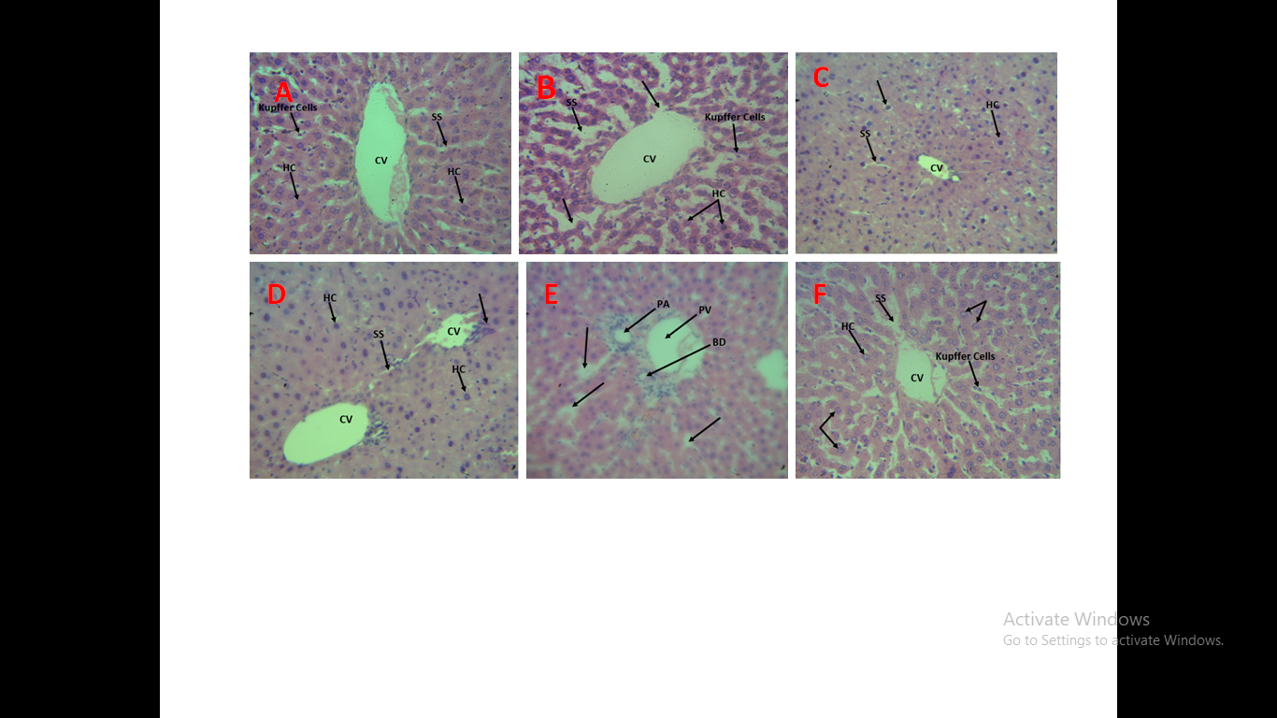

**Figure 1.** Photomicrographs of liver sections of rats from groups A (Normal Control), B (Negative Control), C (500mg/kg of *C. pepo* seed extract), D (1000mg/kg of *C. pepo* seed extract) E and F (500 and 1000mg/kg respectively treated for 60 days; stained with H&E (×400). No obvious histological change in the liver of rats treated with 500 and 1000mg/kg of *C. pepo* seed extract alone. No obvious change in the histoarchitecture of the liver sections of rats treated with *C. pepo* seed extract when compared with the negative control.

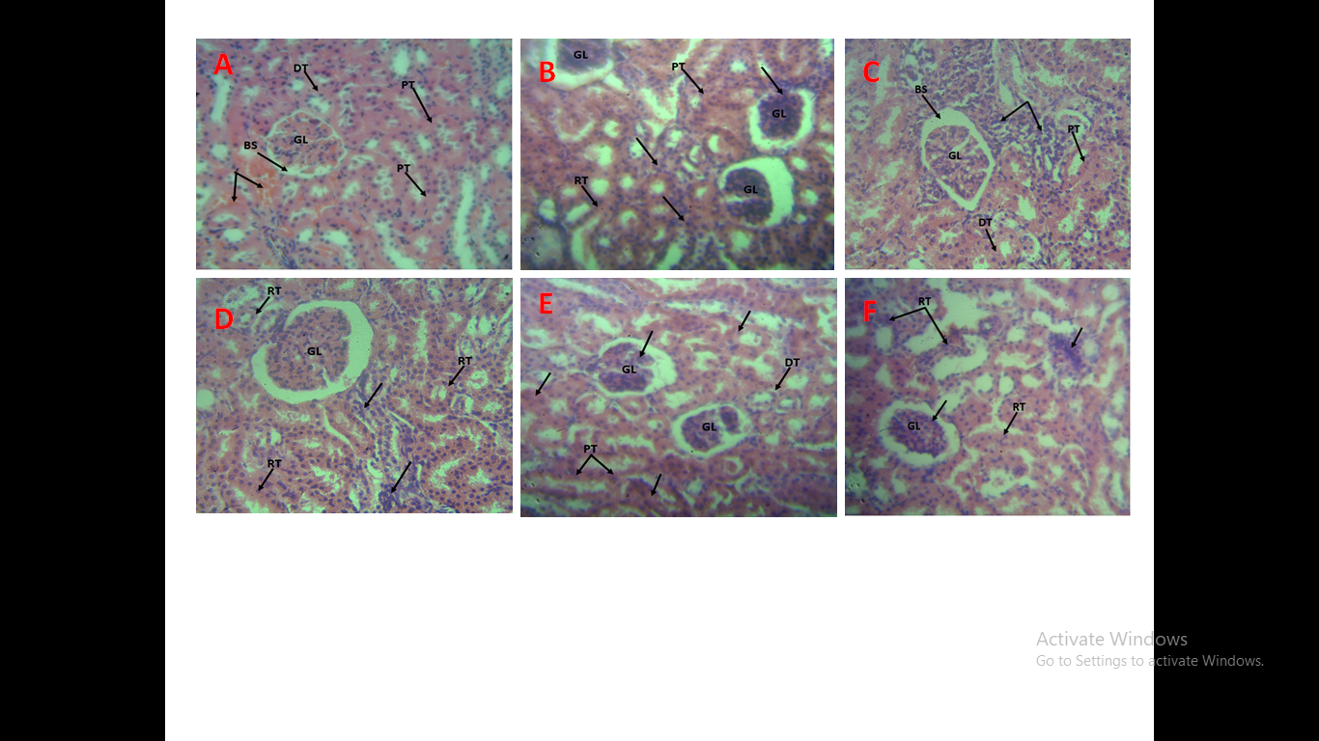

**Figure 2.** Photomicrographs of kidney sections of rats from groups A (Normal Control), B (Negative Control), C (500mg/kg of *C. pepo* seed extract), D (1000mg/kg of *C. pepo* seed extract) E and F (500 and 1000mg/kg respectively treated for 60 days; stained with H&E (×400). No obvious histological change in the kidney of rats treated with 500 and 1000mg/kg of *C. pepo* seed extract alone. No obvious change in the histoarchitecture of the kidney sections of rats treated with *C. pepo* seed extract when compared with the negative control.

**DISCUSSION**

Our result demonstrates that at a dose of (75mg) pregabalin could harm liver and kidney on biochemical and histological level. Our result showed significant increase (p ≤ 0.05) in all liver functions tests: AST, ALT, Bilirubin, Urea and Creatinine for group B (negative control) when compared to group A (normal control). This result is in tandem with that reported by El-Sayed et al., (2019), who reported an increase in congenital malformations as well as hepatic and renal injuries in pregnant rats treated with pregabalin.

The increased serum levels of ALT and AST may have been as a result of cellular leakage, loss of functional integrity of cell membrane and decline in metabolic capacity in liver tissue (Hwang et al., 2011). Pregabalin ingestion may have caused acute toxicity, characterized by hepatocyte necrosis,apoptosis and bile duct obstruction. Cytosolic liver marker enzymes would leak out from swollen and necrotic hepatocytes into blood circulation, resulting in elevated levels with impaired liver function (Elmeligy et al., 2019). Research findings by Jesse et al., (2017) explained the liver effect and cholestasis due to pregabalin idiosyncratic reactions.

Pregabalin is an effective treatment for moderate to severe pain; it has been related to tissue damage due to oxidative stress (Taha et al., 2020). The findings of this study aligns with previous studies that demonstrated the negative impact of pregabalin on hepato-renal parameters as a result of its induced toxicity (Abbas et al., 2023; Ghaleba et al., 2021). Due to the absence of evidence establishing the effect of *C. pepo* seed extract (CPSE) on key oxidative stress indicators of pregabalin-induced toxicity in male Wistar rats, our study investigated its effect on pregabalin administration. The bioactive components in *C. pepo* seed extract may be responsible for the extract’s potential Hepatorenal protective benefits against pregabalin-induced toxicities. Pumpkin seeds include antioxidants such as 9, 12-octadecadienoic acid, oleic acid, polyphenols (phenolic acids, flavonoids), terpenoids (carotenoids) and vitamin E, which prevent oxidative damage to membranes, organelles, protein and play an important role in prophylaxis against many diseases (Abdelmonsef et al., 2024). Pumpkin seed oil contains tocopherols and selenium, which synergistically protect cell membranes from free radical-mediated lipid peroxidation. The natural plant components found in pumpkin could improve the liver against alcohol-induced liver toxicity and oxidative stress. Results from this study demonstrated a dose-dependent impact on biochemical parameters of rats co-administered with pregabalin and CPSE. The biochemical results were corroborated by histological analyses of the liver and kidney, which specifically demonstrated the modulatory impact of the lowest CPSE dosage. These findings point to the possibility that CPSE provides protective benefits by re-establishing redox equilibrium, while pregabalin causes hepatic and renal damage via oxidative stress pathways. The protective effect of CPSE suggested that it could be used to treat pregabalin-related illnesses in minimal dose, but in higher dose might not have any ameliorative effect. The results of this study demonstrated a dose-dependent Hepatorenal protective effect of *Cucurbita pepo* seed. This is evidenced by the decrease in liver and kidney parameters at a dose of 500 mg/kg of *Cucurbita pepo* seed extract in pregabalin- induced Hepatorenal toxicity.

However, at a higher dose of 1000 mg/kg, there was no significant decrease in liver and kidney parameters, suggesting *Cucurbita* *pepo* seed extract may not exhibit an ameliorative effect at that dose.  
All the extract doses did not alter serum ALP levels in comparison with the controls. However, ALT levels were significantly reduced in test group E relative to both controls. This finding is in agreement with Abou Seif, (2014) who reported dramatically lowered activity levels of lactate dehydrogenase, alanine transaminase, aspartate transaminase, and alkaline Phosphatase following treatment with pumpkin seeds against alcohol induced hepatotoxicity.

Serum albumin and total protein levels were significantly increased in the rats treated with *C. pepo* seed (test groups C, E, F). This may imply that pumpkin extract appears to enhance protein synthesis and metabolism. Omer et al., (2016) reported that pumpkin has valuable beta-carotene components that are effective antioxidants and protect against oxidative stress. Test groups C and E had remarkably reduced serum bilirubin levels relative to the control. There was a significant increase in conjugated bilirubin levels of test group F relative to the control.

In the kidney parameters test groups C, D and E treated rats, a significant decrease in creatinine and urea levels was observed compared the negative control group. Additionally, group E showed a significant decrease (p< 0.05) in serum concentration levels of sodium and potassium, while test group D showed a reduction in serum bicarbonate levels relative to the negative control group.

Histomorphologic changes in the liver showed that none of the rats treated with the extract showed abnormal hepatic histomorphology, whereas the negative control group showed severe cytoplasmic vacuolation (CV) and degeneration of the hepatocytes, loss of liver tissue parenchymal secondary to tissue hypertrophy, and lymphocytic invasion of the portal vessels via the sinusoids with cytoplasmic vacuolation showing constriction of the central vein associated with sinusoidal dilatation. Histomorphology changes in the kidney showed that the negative control group exhibited severe lymphocytic invasion of the renal tubules (RT) and glomerulus associated with atrophy secondary to necrosis, glomerular and renal tubular lymphocytic infiltration with interstitial oedema, diffused lymphocytic activities of the renal tubules and glomerulus associated with renal tubular distention. Groups C and D treated with the extract displayed normal kidney architecture with mild inflammation. In contrast, groups E and F exhibited moderate inflammation and kidney tissue degeneration. Interestingly, at a high dose of 1000mg of *C. pepo* extract when compared to the normal control was significantly high but showed no significant difference when compared with the negative control. This work proves that maximum dose of 1000mg of *C pepo* extract was not able to ameliorate the Hepatorenal toxicity of pregabalin but at a minimal dose of 500mg it showed a protective effect on Hepatorenal toxicity. In other words, the protective effect of *C. pepo* is low dose and not effective in high doses. This finding is in consonance with that of Ekpono et al., (2024), who reported a hepato and renal-protective effect of pumpkin seeds at varying doses with a maximum dose of 400mg per kilogram body weight. However, the lack of ameliorative effect observed with *C. pepo* seed extract at maximum dose of 1000mg may be connected with the paradoxical pro-oxidant effect exhibited by certain antioxidants at high concentrations which rather than mitigate oxidative stress, induce it (Halliwell, 2013; Lee & Jeong, 2012; Pérez-Torres et al., 2017).

**CONCLUSION**

Pumpkin may protect hepato-renal function and prevent pregabalin-induced liver and kidney toxicity. Promoting pumpkin's nutritional advantages and collaborating with researchers and industry can result in beneficial pumpkin-based goods.

**Conflict of interest**: All authors declare that there is no conflict of interest in the publication of this article.

**Artificial Intelligence:** No AI tools were used for the completion of this article

**REFERENCES**

Abbas, S., Mahmoud, S., Elhady, K., & Abdou, R. (2023). Assessment of the Possible Oxidative Hepatotoxicity Induced by Cannabis and Pregabalin in Rats. *Suez Canal Veterinary Medical Journal. SCVMJ*, *28*(1), 133–142.

Abdelmonsef, M., Shawky, E., Ghareeb, D. A., El Naggar, E. M. B., & El Newehy, N. M. (2024). Comprehensive metabolomics and chemometrics unravel potential anti-diabetic metabolites of pumpkin (Cucurbita pepo L.) fruits through UPLC-QqQ-MS and GC–MS analyses. *Food Research International*, *192*, 114771.

Abou Seif, H. S. (2014). Ameliorative effect of pumpkin oil (Cucurbita pepo L.) against alcohol-induced hepatotoxicity and oxidative stress in albino rats. *Beni-Suef University Journal of Basic and Applied Sciences*, *3*(3), 178–185.

Adsul, S., & Madkaikar, V. (2021). Pumpkin (Cucurbita pepo) seed. *Oilseeds: Health Attributes and Food Applications*, 473–506.

Akomolafe, S. F. (2021). Effects of roasting on the phenolic phytochemicals and antioxidant activities of pumpkin seed. *Vegetos*, *34*(3), 505–514.

Alles, S. R. A., Cain, S. M., & Snutch, T. P. (2020). Pregabalin as a pain therapeutic: beyond calcium channels. *Frontiers in Cellular Neuroscience*, *14*, 83.

Ameen, A. A., El-Haggar, E. F., & Mohamed, G. G. (2023). Contemplation Impact of Pulp Seeds Cucurbita Pepo L. and its Paste on Oxidative Stress in Rats. *Journal of Advanced Zoology*, *44*.

Anyanwu, C. F. (2025). Reproductive Outcome in Female Wistar Rats Following Treatment with Cucurbita pepo (Pumpkin) Seed Extracts. *British Journal of Healthcare & Medical Research*, *12*(02), 01–12. https://doi.org/10.14738/bjhr.1202.18381

Arango-Dávila, C. A., & Rincón-Hoyos, H. G. (2018). Depressive disorder, anxiety disorder and chronic pain: multiple manifestations of a common clinical and pathophysiological core. *Revista Colombiana de Psiquiatria (English Ed.)*, *47*(1), 46–55.

Bauer, C. S., Rahman, W., Tran-Van-Minh, A., Lujan, R., Dickenson, A. H., & Dolphin, A. C. (2010). The anti-allodynic α2δ ligand pregabalin inhibits the trafficking of the calcium channel α2δ-1 subunit to presynaptic terminals in vivo. *Biochemical Society Transactions*, *38*(2), 525–528.

Bernik, M., Sampaio, T. P. A., & Gandarela, L. (2013). Fibromyalgia comorbid with anxiety disorders and depression: combined medical and psychological treatment. *Current Pain and Headache Reports*, *17*(9), 358.

Ebrahem, N. E., Makboul, R., Elkabsh, M. M., Shaltout, E. S., & Abdellah, N. Z. (2022). Sub chronic Toxicity of Pregabalin and Possible Fibrotic Changes in Ovaries, Kidneys, Heart, and Lungs of Female Rats. *Zagazig Journal of Forensic Medicine*, *20*(1), 175–189.

Ekpono, E. U., Eze, E. D., Adam, A. M., Ibiam, U. A., Obasi, O. U., Ifie, J. E., Ekpono, E. U., Alum, E. U., Noreen, S., & Awuchi, C. G. (2024). Ameliorative potential of pumpkin seed oil (cucurbita pepo L.) against tramadol-induced oxidative stress. *Dose-Response*, *22*(1), 15593258241226912.

El-Sayed, E. S., Sayed, S. A., & Abd El-Rahman, H. A. (2019). Evaluation of Embryotoxicity potentials of Pregabalin in albino rats. *Int J Pharm Sci Rev Res*, *56*, 110–115.

Elmeligy, M. H., Farid, A. S., & Fararh, K. (2019). Antioxidant and hepatoprotective effect of pumpkin seed oil in CCl4-intoxicated rats. *Benha Veterinary Medical Journal*, *36*(2), 77–89.

Finley, P. R., & Tietz, N. W. (1996). *Alan, H. B., & Wu, B. (2006). Tietz clinical guide to laboratory tests. Editorial Elsevier (4o ed. págs. 1-1798).‏*.

Ghaleba, S. S., Eid, A., Michel Zaki, O. G., & Zaki, A. R. (2021). Toxicological Effects of Long Term Pregabalin Abuse on Liver of Adult Albino Rats. *Minia Journal of Medical Research*, *32*(1), 1–8.

Halliwell, B. (2013). The antioxidant paradox: less paradoxical now? *British Journal of Clinical Pharmacology*, *75*(3), 637–644.

Hendrich, J., Bauer, C. S., & Dolphin, A. C. (2012). Chronic pregabalin inhibits synaptic transmission between rat dorsal root ganglion and dorsal horn neurons in culture. *Channels*, *6*(2), 124–132.

Hwang, Y. P., Choi, J. H., Yun, H. J., Han, E. H., Kim, H. G., Kim, J. Y., Park, B. H., Khanal, T., Choi, J. M., & Chung, Y. C. (2011). Anthocyanins from purple sweet potato attenuate dimethylnitrosamine-induced liver injury in rats by inducing Nrf2-mediated antioxidant enzymes and reducing COX-2 and iNOS expression. *Food and Chemical Toxicology*, *49*(1), 93–99.

Jesse, S., Bråthen, G., Ferrara, M., Keindl, M., Ben‐Menachem, E., Tanasescu, R., Brodtkorb, E., Hillbom, M., Leone, M. A., & Ludolph, A. C. (2017). Alcohol withdrawal syndrome: mechanisms, manifestations, and management. *Acta Neurologica Scandinavica*, *135*(1), 4–16.

K Omer, A., A Youssef, G., F Yousf, A., & H Abd El-Wahab, A. (2016). ROLE OF PUMPKIN SEEDS ON HEPATORENAL DYSFUNCTION INDUCED BY AZATHIOPRINE IN ADULT MALE ALBINO RATS. *Al-Azhar Medical Journal*, *45*(1), 111–118.

Kostecka-Gugała, A., Kruczek, M., Ledwożyw-Smoleń, I., & Kaszycki, P. (2020). Antioxidants and health-beneficial nutrients in fruits of eighteen Cucurbita cultivars: Analysis of diversity and dietary implications. *Molecules*, *25*(8), 1792.

Lee, K. H., & Jeong, D. (2012). Bimodal actions of selenium essential for antioxidant and toxic pro-oxidant activities: the selenium paradox. *Molecular Medicine Reports*, *5*(2), 299–304.

Maffei, M. E. (2020). Fibromyalgia: recent advances in diagnosis, classification, pharmacotherapy and alternative remedies. *International Journal of Molecular Sciences*, *21*(21), 7877.

Oyetayo, F. L., Akomolafe, S. F., & Osesanmi, T. J. (2020). Effect of dietary inclusion of pumpkin (Cucurbita pepo L) seed on nephrotoxicity occasioned by cisplatin in experimental rats. *Journal of Food Biochemistry*, *44*(10), e13439.

Patel, S. (2013). Pumpkin (Cucurbita sp.) seeds as nutraceutic: a review on status quo and scopes. *Mediterranean Journal of Nutrition and Metabolism*, *6*(3), 183–189.

Pérez-Torres, I., Guarner-Lans, V., & Rubio-Ruiz, M. E. (2017). Reductive stress in inflammation-associated diseases and the pro-oxidant effect of antioxidant agents. *International Journal of Molecular Sciences*, *18*(10), 2098.

Rastiannasab, A., Afsharmanesh, S., Rahimi, R., & Sharifian, I. (2016). Alternations in the liver enzymatic activity of Common carp, Cyprinus carpio in response to parasites, Dactylogyrus spp. and Gyrodactylus spp. *Journal of Parasitic Diseases*, *40*, 1146–1149.

Rieger, J., Pelckmann, L.-M., & Drewes, B. (2020). Preservation and processing of intestinal tissue for the assessment of histopathology. In *Animal Models of Allergic Disease: Methods and Protocols* (pp. 267–280). Springer.

Salah, B. A., Al-Fathi, M. Y., & Shindala, M. K. (2024). Histological liver, kidney, and brain changes induced by pregabalin drug in albino rats. *Iraqi J Vet Sci*, *38*(3), 555–564.

Samuel-Nakamura, C., Hodge, F. S., Sokolow, S., Ali, A.-M. S., & Robbins, W. A. (2019). Metal (loid) s in Cucurbita pepo in a uranium mining impacted area in Northwestern New Mexico, USA. *International Journal of Environmental Research and Public Health*, *16*(14), 2569.

Sills, G. J. (2006). The mechanisms of action of gabapentin and pregabalin. *Current Opinion in Pharmacology*, *6*(1), 108–113.

Taha, S. H. N., Zaghloul, H. S., Ali, A. A. E. R., Gaballah, I. F., Rashed, L. A., & Aboulhoda, B. E. (2020). The neurotoxic effect of long-term use of high-dose Pregabalin and the role of alpha tocopherol in amelioration: implication of MAPK signaling with oxidative stress and apoptosis. *Naunyn-Schmiedeberg’s Archives of Pharmacology*, *393*, 1635–1648.

Terman, S. W., Lin, C. C., Kerr, W. T., DeLott, L. B., Callaghan, B. C., & Burke, J. F. (2022). Changes in the use of brand name and generic medications and total prescription cost among medicare beneficiaries with epilepsy. *Neurology*, *99*(8), e751–e761.

Wang, S.-J., Zhao, M.-Y., Zhao, P.-C., Zhang, W., & Rao, G.-W. (2024). Research Status, Synthesis and Clinical Application of Antiepileptic Drugs. *Current Medicinal Chemistry*, *31*(4), 410–452.

Widy-tyszkiewicz, E., & Widy-tyszkiewicz, E. (2013). Assessment report on Cucurbita pepo L ., semen. *European Medicines Agency,* *44*(November 2012), 1–44.