EFFECTS OF EXTRACTION METHODS ON PHYSICOCHEMICAL INDICES AND FATTY ACID PROFILE OF *Arachis hypogaea* AND *Melothria sphaerocarpa* OILS FROM ELELE MARKET, RIVERS STATE, NIGERIA

.

ABSTRACT

|  |
| --- |
| **Aim:** This work was designed to study how extraction methods affect some physicochemical indices and fatty acid profile of *Arachis hypogaea* and *Melothria sphaerocarpa* seed oils from Elele in Rivers State.  **Methodology:** The procured seeds of these plants were separately garbled, blended with a blender, divided into four equal parts and oil extracted using solvent (n-hexane), cold, hot and soxhlet extraction methods. Relative density, refractive index, viscosity, pH, moisture content, acid value, percentage free acid and saponification value of these oils were established with standard methods. The fatty acid contents of the oils were analyzed by gas chromatography coupled to mass spectrophotometry (GC/MS).  **Results:** Solvent method afforded more oil yield, cold extracted oils were denser but with refractive indices outside the acceptable limit. The extraction methods did not affect the moisture content, pH and saponification values of extracted oils samples. GC/MS evaluation of *A. hypogaea* seed oils revealed seventeen (17) constituents for soxhlet extracted oil, twelve (12) for cold extracted oil and nineteen (19) each for hot and solvent extracted oils while for *M. sphaerocarpa*, oil extracted with soxhlet method had nine (9) fatty acid components, solvent extracted oil sample had seven (7), cold extracted oil six (6) and hot extracted oil, five (5) constituents.  **Conclusion:** The result of this study provides insight into the role of extraction techniques in the production of oils for both industrial and culinary uses. |

*Keywords: Extraction methods; physicochemical; fatty acid; Arachis hypogaea and Melothria sphaerocarpa*

**1. INTRODUCTION**

*Arachis hypogaea* L. commonly known as groundnut and belonging to the family, Fabaceae is a major component of food in developing nations. Apart from eating the fried seeds, its oil is also widely used in many countries for cooking, frying, drug production, food industry and in cosmetic industries [1,2,3]. The culinary use of groundnut oil is associated with promotion of heart health, reduction of blood glucose level, decreased lipid peroxidation while also acting as antioxidant in patients with insulin dependent diabetes [4,5]. Groundnut oil consumption is also reported to abate colon, breast and prostate cancers [6,7]. These medicinal benefits are linked to the high content of monosaturated fatty acids which they are known to contain.

*Melothria sphaerocarpa* (Cogn.) H. Schaef. & S. S. Renner, commonly known as melon is a climber that is of high medicinal value in tropical and sub-tropical African countries in addition to its culinary applications. Its seeds is a source of edible oils, preparation of traditional cakes, major condiments of stews and soups. Medicinally, melon seeds are reported to have anti-diabetic, anti-angiogenic, antioxidant and anti-carcinogenic effects [9,10]. Its cholesterol content coupled with high contents of unsaturated fatty acid components enhance the heart health. Many useful phytoconstituents have been reported in the seeds, and notably amongst are polyphenols, tocopherols and carotenoids. Oleic acid, palmitic acid, stearic acid, linoleic acid have also been identified as the most abundant fatty acids of the seeds of *M. sphaerocarpa* [10,11].

There is no hard and fast rule for groundnut oil extraction but many methods have been advanced towards the optimization of the quality and quantity of oils extracted from groundnut [2,12,13] and, also users’ applicability. More so, the stability of oils and fats (mostly the edible ones) from time of extraction to storage has been reported to be a function of the extraction methods, chemical components and their ability to resist oxidative deterioration [14,15]. Considering the health benefits and numerous applications of the oils of *A. hypogaea* and *M. sphaerocarpa*, this work was structured to study the physicochemical and fatty acid profiles of oil samples extracted from the seeds of *A. hypogaea* and *M. sphaerocarpa* obtained from Elele, Rivers State, using four different methods.

**2. MATERIALS AND METHODS**

**2.1 Procurement and Preparation of Samples**: Groundnut and melon seeds were purchased from Elele market, Rivers State. They were selected to remove impurities and blended with a Q-link China Model blender and divided into 4 parts with each weighing 520 g for groundnut and 320 g for melon. All extracted oil samples were transferred using 10.0 mL syringes, stored in glass bottles and weights taken with analytical balance.

**2.2 Solvent Extraction**: 520 g weight of the blended groundnut and 320 g melon seed meats were transferred into clean, dry measuring cylinders, macerated with enough volume of n-hexane for 24 hours. They were filtered into a beakers and covered with a perforated Aluminium foil and left overnight for evaporation of the solvent. The resultant groundnut oil and melon oil were coded Ahsol and Mssol, respectively.

**2.3 Hot Extraction**: The method adopted was similar to the one earlier reported with slight modifications [16]. In this method, the blended groundnut seed (520 g) and melon seed (320 g) were washed with enough warm water and filtered. The filtrates were allowed to stand in separating funnels for 2 h and the upper layers (oily layers) collected were further heated in a water bath at a temperature of 100-120 °C for 60 minutes until all the proteins in the oils were denatured and the oils (Ahhot and Mshot) collected.

**2.4 Cold Extraction**: Here oils were extracted according to previous method [18]. Grounded groundnut seed meat (520 g) and melon meat (320 g) were washed with adequate volume of distilled water, filtered and filtrates chilled in a refrigerator overnight after which the upper creamy layers were removed, thawed slowly in a water bath at 50oC and the oils produced were labelled as Ahcol and Mscold were collected.

**2.5 Soxhlet Extraction**: The method adopted was similar to the one earlier reported [17]. The grounded groundnut meat (520 g) and melon meat (320 g) were divided into four parts of equal weight. Each part was wrapped with white cotton cloth and placed in a soxhlet apparatus. Normal hexane (500 mL) was introduced into a round bottom flask for the extraction and a temperature of 60-70 ºC was maintained. Each sequence of extraction was adjudged complete once the colour of the mixture in the thimble lightens. This protocol was repeated for the all the portions of the groundnut and melon meata. The extracted oils were labelled as Ahsox and Mssox, respectively.

**2.6 Physicochemical Evaluation of Extracted oil Samples**

**2.6.1 Percentage Oil recovery:** The determination of oil recovery was calculated according to the initial oil content in the coconut meat to the oil extracted from different extraction methods.

**2.6.2 Relative Density Measurement:** This experiment was carried out at a temperature of 25 0C. A density bottle (25 mL) was washed and treated with acetone, allowed to dry and weight determined. Firstly, the bottle was filled with distilled water and weighted. It was then emptied and dried after which the various extracted oil samples were introduced into the density bottle to the fluid mark and weights also noted. The relative density of the oils was calculated [19].

Relative density = Mass of groundnut oil sample x 100

Mass of equal volume of water

**2.6.3 Refractive Index Measurement:** The refractive indices of the oils were determined at 30 0C using a refractometer (Abbe, Japan). The well shaken oil samples were placed on a dry, clean prism surface individually and the needed adjustment was carried out using the knob for the most distinctive reading to be taken [20,21,22].

**2.6.4 Viscosity Measurement:** The viscosities of the extracted oil samples were determined at ambient temperature using Brookfield Rapid Viscometer Analyzer (RVA) model-NDJ-5S equipped with number one (1) spindle. The spindle was suspended in the oil samples and stirred for 1 min, and reading was recorded once stability on the meter monitor was observed [23, 24, 25].

**2.6.5 PH Measurement:** The pH of the extracted groundnut oils were determined using a pH meter. This measurement was done by introducing the pH meter into the oil samples and allowed to stabilize for 30 sec before readings were taken [26,27].

**2.6.6 Determination of Moisture Contents of Extracted Oils:** The hot air oven drying method was adopted for this determination. Selected crucibles for this protocol were washed, dried and weighed. The groundnut oil samples (3 g) were weighed into crucibles and placed in an oven at a temperature of 105°C for 180 min after which they were left in desiccators to dry and weights retaken. This protocol of drying, cooling and weighing was continuous until a constant weights of the oils were obtained. The moisture content values were represented in percentage [28, 29, 30, 31, 32].

**2.6.7 Acid Value and Percentage Free Acid Determination**:The test oil sample weighing 1 g was dissolved in 20 mL of a mixture of ethanol and ether in a ratio of 1:1, and 3 drops of 1% Phenolphthalein solution was added as an indicator and titrated using 0.1 M aqueous potassium hydroxide solution with continuous agitation until the appearance of pink colour that lasted for 15 sec. and volume of potassium hydroxide noted. A blank determination was carried out without the oil samples and the acid value and percentage free acid calculated as demonstrated in the equations [23, 25, 29, 32].

Acid value = Titer value of oil sample x 56.1

Weight of sample

Percentage free acid = Acid value

2

**2.6.8 Saponification Value Determination:** The test sample weighing 0.5 g was dissolved in 25 mL of 1 M alcoholic KOH and refluxed on a boiling water bath for 1hr, shaken, allowed to cool and back titrated the excess KOH with 1 M Hydrochloric acid using 1 mL phenolphthalein as an indicator. The blank titration was carried out without the groundnut oil samples. This protocol was repeated twice and saponification value calculated with formula below [19, 33, 34].

Saponification value = (Titre value of blank – titre value of oil sample) x 28.05

Weight of oil sample

2.7 GC/MS Analysis: The extracted oil samples were analyzed with GC-MS QP2010 SE model (Schmadzu, Japan). Phases in the equipment were phenylmethylsiloxane (stationary pahse) and helium (mobile phase). 1 µm was injected in the column (DB 5MS; 0.25 mm x 30 mm x 0.10 µm) in the split mode The inlet temperature was 250 ºC and oven temperature 60 ºC for 3.4 min which was remped for 12 ºC /min to 240 ºC. Maintenance of rate of increase occurred when temperature changed to 290 ºC and remained for 2 min. Electron mode with ionization energy (70 eV) was employed for mass spectrometer and scanned within 45-700 dalton. Chemstation software was used for the identification of the constituents of the various oil samples with data from the National Institute of Standard Technology [35]

3. results

The result of the physicochemical properties of the various extracted groundnut oil samples are represented in table 1, while that of melon oil samples are represented in table 2. the result of gcms characterization of the oil types are in tables 3, 4, 5, 6, 8, 9, 10, 11 and figures 1-8, while tables 7 and 12 depict the fatty oil components of the various extracted oils.

Table 1: Physicochemical properties of extracted groundnut oil samples

|  |  |  |  |  |
| --- | --- | --- | --- | --- |
| Test |  | Oil type |  |  |
|  | Ahsox | Ahcold | Ahhot | Ahsol. |
| Percentage oil recovery (%) | 23 | 24 | 21 | 25 |
| Relative Density (g/mL) | 0.90 ± 0.02 | 0.92 ±0.01 | 0.89 ±0.02 | 0.91 ±0.02 |
| Viscosity (mPa.s) | 48.10 ± 2.00 | 48.00 ± 2.00 | 48.50 ± 3.00 | 48.00± 2.00 |
| Refractive index | 1.46 ±0.01 | 1.47 ±0.01 | 1.52 ±0.02 | 1.46 ±0.02 |
| Moisture content | 0.34 ±0.01 | 0.44 ±0.02 | 0.29 ±0.02 | 0.42 ±0.02 |
| pH | 5.44 ±0.11 | 5.52±0.11 | 5.43±0.12 | 5.50±0.13 |
| Acid value (MeqKOH/g) | 1.39±0.02 | 1.30 ±0.01 | 1.31 ±0.01 | 1.31 ±0.01 |
| Free fatty acid (MeqKOH/g) | 0.70 ±0.01 | 0.65 ±0.01 | 0.66 ±0.01 | 0.66 ±0.01 |
| Saponification Value (MeqKOH/g) | 176 ±2.12 | 182 ±2.11 | 175 ±3.12 | 176 ±1.72 |

Where Ahsox = Soxhlet extracted oil, Ahcold = cold extracted oil, Ah hot = hot extracted oil, Ah sol. = solvent extracted oil, n =10 and significant difference at p≤ 0.05 for relative density, viscosity, refractive index and moisture content.

Table 2: Physicochemical properties of extracted melon oil samples

|  |  |  |  |  |
| --- | --- | --- | --- | --- |
| Test |  | Oil type |  |  |
|  | Mssox | Mscold | Mshot | Mssol. |
| Percentage oil recovery (%) | 15 | 17 | 14 | 20 |
| Density (g/mL) | 0.90 ± 0.02 | 0.93 ±0.01 | 0.91 ±0.02 | 0.93 ±0.02 |
| Viscosity (mPa.s) | 51.00 ±2.00 | 52.00±2.00 | 52.00±2.00 | 59.00±1.00 |
| Refractive index | 1.48 ±0.01 | 1.39 ±0.01 | 1.46 ±0.01 | 1.48 ±0.01 |
| Moisture content | 0.33 ±0.01 | 0.43 ±0.02 | 0.31 ±0.01 | 0.41 ±0.02 |
| pH | 6.30 ±0.09 | 5.70±0.12 | 5.64±0.12 | 5.51±0.12 |
| Acid value (MeqKOH/g) | 1.20±0.02 | 1.20 ±0.01 | 1.40 ±0.01 | 1.20 ±0.01 |
| Free fatty acid (MeqKOH/g) | 0.60 ±0.01 | 0.60 ±0.01 | 0.70 ±0.01 | 0.60 ±0.01 |
| Saponification Value (MeqKOH/g) | 198 ±3.14 | 194 ±3.11 | 203 ±2.42 | 193 ±4.32 |

Where Mssox = Soxhlet extracted oil, Mscold = cold extracted oil, Mshot = hot extracted oil, Mssol. = solvent extracted oil, n =10 and significant difference at p≤ 0.05 for relative density, viscosity, refractive index and moisture content of extracted melon oils.

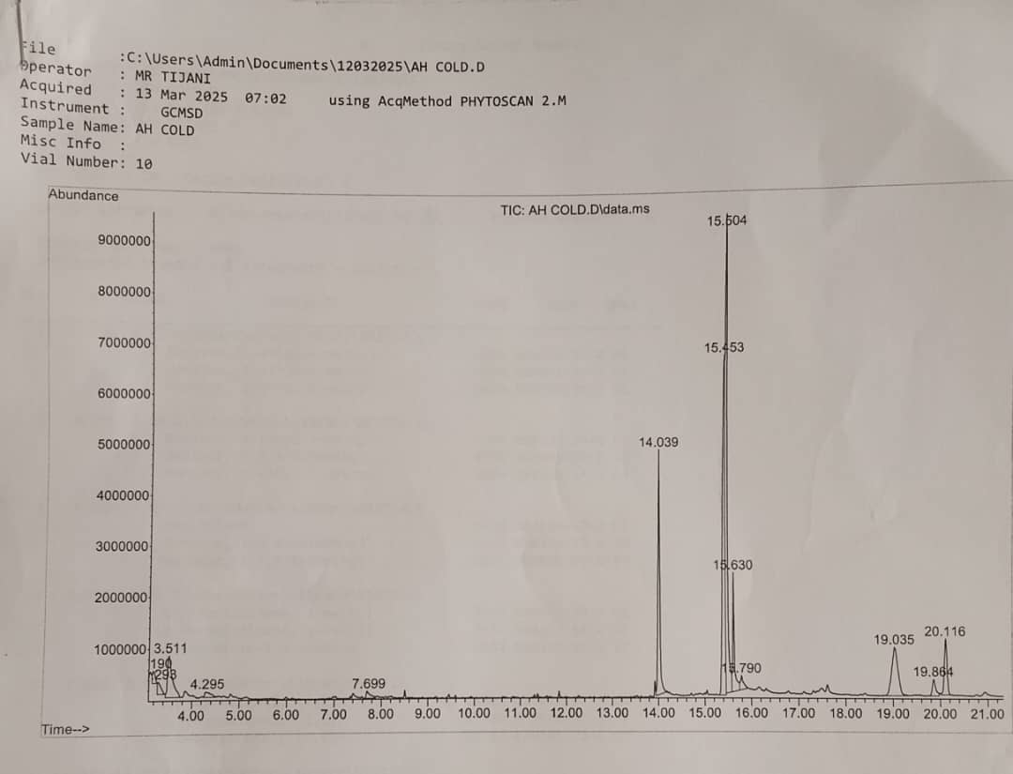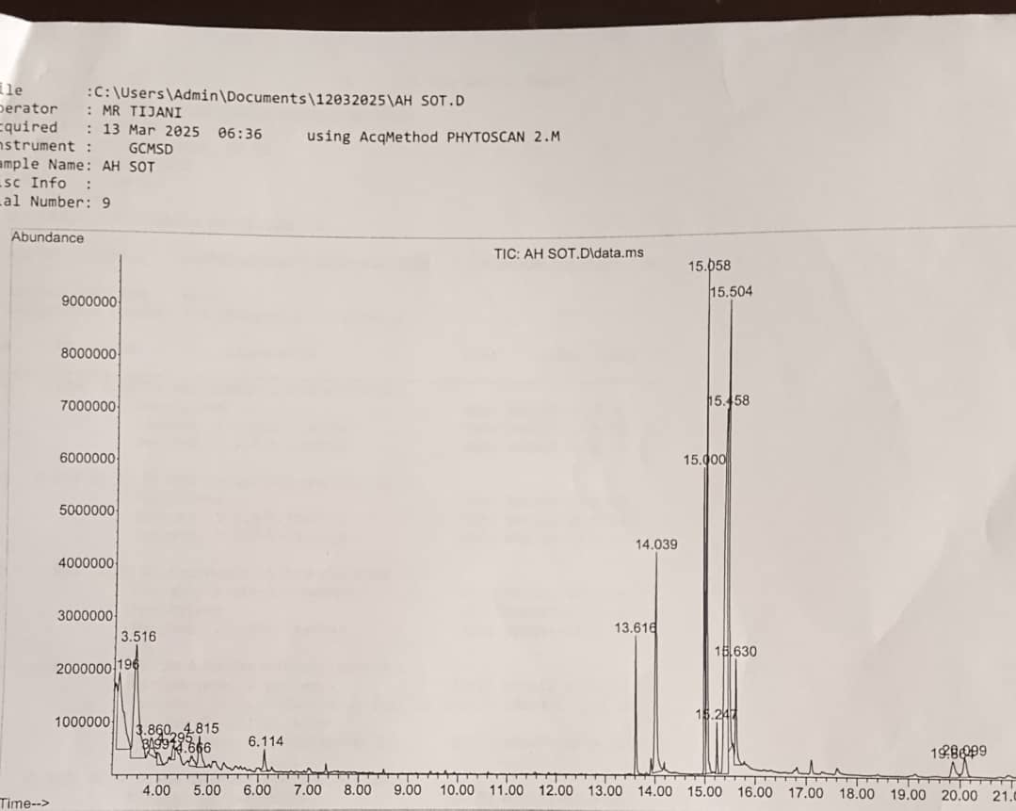

Figure 1: GCMS chromatogram of Ah cold Figure 2: GCMS chromatogram of Ahsox

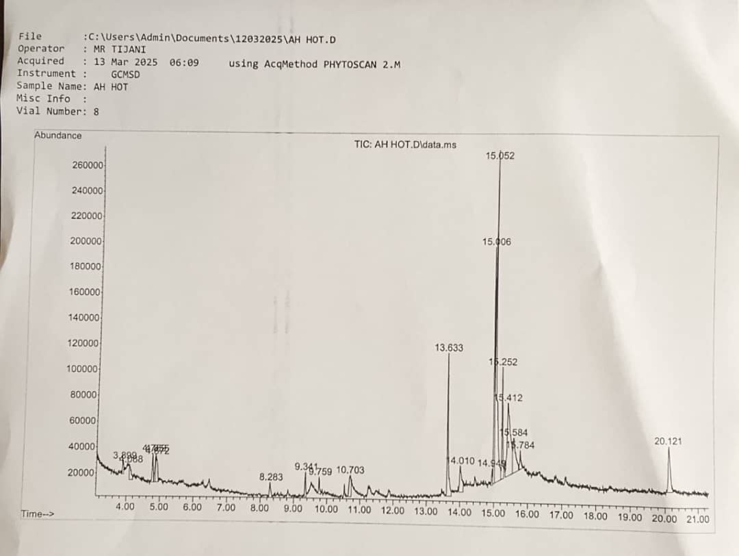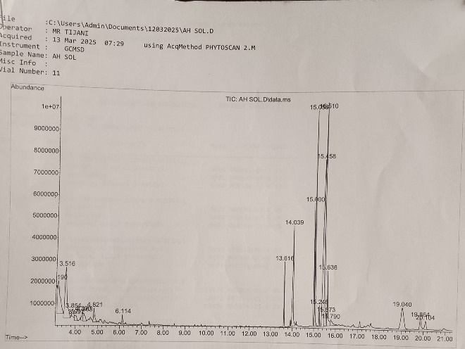

Figure 3: GCMS chromatogram of Ahhot Figure 4: GCMS chromatogram of Ahsol.

Table 3: GCMS characterization of Ahsox oil sample

|  |  |  |  |  |
| --- | --- | --- | --- | --- |
| **Peak** | **Retention  Time** | **Percentage Area** | **Molecular Formular** | **Name of Compound** |
| 1 | 3.196 | 8.36 | C9H12 | Mesitylene |
| 2 | 3.860 | 1.27 | C9H12 | 1-ethyl-4- methylbenzene |
| 3 | 3.991 | 0.77 | C9H16 | Cyclohexane, 2-propenyl- |
| 4 | 4.295 | 0.72 | C10H14 | 1,2-diethylbenzene |
| 5 | 4.666 | 0.76 | C10H14 | 1,2-dimethyl-4-ethylbenzene |
| 6 | 4.815 | 1.85 | C11H24 | Undecane |
| 7 | 6.114 | 0.89 | C12H26 | Dodecane |
| 8 | 13.616 | 3.17 | C17H34O | Pentadecanoic acid, 14-methyl-, methyl ester |
| 9 | 14.039 | 8.78 | C16H32O2 | n-Hexadecanoic acid |
| 10 | 15,000 | 6.78 | C19H34O2 | 9,12-Octadecadienoic acid (Z,Z)- methyl ester |
| 11 | 15.058 | 11.35 | C19H36O2 | 9-Octadecenoic acid (Z), methyl ester |
| 12 | 15.247 | 1.09 | C19H38O2 | Methyl stearate |
| 13 | 15.458 | 23.65 | C18H32O2 | 9,12-Octadecadienoic acid (Z,Z)- |
| 14 | 15.504 | 13.66 | C18H34O2 | 9-Octadecenoic acid, (E) |
| 15 | 15.630 | 3.15 | C18H36O2 | Octadecanoic acid |
| 16 | 19.864 | 1.27 | C15H30O3 | 15-Hydroxypentadecanoic acid |
| 17 | 20.099 | 1.31 | C23H46O2 | Methyl 20-methyl-heneicosanoate |

Table 4: GCMS characterization of Ah cold oil sample

|  |  |  |  |  |
| --- | --- | --- | --- | --- |
| **Peak** | **Retention  Time** | **Percentage Area** | **Molecular Formular** | **Name of Compound** |
| 1 | 3.190 | 0.87 | C9H12 | Benzene, 1-ethyl-4-methyl- |
| 2 | 3.511 | 5.87 | C9H12 | Mesitylene |
| 3 | 4.295 | 0.93 | C5H9NO | 2-Pyrrolidinone, 1-methyl |
| 4 | 7.699 | 0.88 | C10H16O | 2,4-Decadienal, (E,E)- |
| 5 | 14.039 | 13.85 | C16H32O2 | n-Hexadecanoic acid |
| 6 | 15.453 | 27.29 | C18H32O2 | 9,12-Octadecadienoic acid (Z,Z)- |
| 7 | 15.504 | 27.11 | C18H34O2 | 6-Octadecenoic acid, (Z)-Oleic Acid |
| 8 | 15.630 | 5.93 | C18H36O2 | Octadecanoic acid |
| 9 | 15.790 | 1.30 | C19H36O | Cyclopropaneoctanal, 2-octyl- |
| 10 | 19.035 | 8.74 | C30H50 | Supraene |
| 11 | 19.864 | 1.64 | C19H38O4 | Hexadecanoic acid, 2-hydroxy-l-(hydroxymethyl) ethyl ester |
| 12 | 20.116 | 4.48 | C24H38O4 | Bis(2-ethylhexyl) phthalate |

Table 5: GCMS characterization of Ah hot oil sample

|  |  |  |  |  |
| --- | --- | --- | --- | --- |
| **Peak** | **Retention  Time** | **Percentage Area** | **Molecular Formular** | **Name of Compound** |
| 1 | 3.899 | 0.86 | C13H20O2 | Bicyclo(4,1)heptane,-3-cyclopropyl-7-carbethoxy,cis-oxirane |
| 2 | 4.088 | 1.50 | C5H8 | 1,4-pentadiene |
| 3 | 4.769 | 1.85 | C11H24 | Undecane |
| 4 | 4.855 | 1.43 | C10H22 | Decane |
| 5 | 4.872 | 2.39 | C14H30 | Tetradecane |
| 6 | 8.283 | 1.27 | C5H10O2 | Isovaleric acid |
| 7 | 9.341 | 1.48 | C9H10O2 | 2,5-cyclohexadiene-1,4-dione |
| 8 | 9.759 | 1.01 | C11H8O2 | 2H-indeno(1,2-b) furan-2-one |
| 9 | 10.703 | 2.71 | C12H14O4 | Diethyl phthalate |
| 10 | 13.633 | 9.39 | C16H32O2 | Hexadecanoic acid |
| 11 | 14.010 | 3.34 | C15H30O2 | Pentadecanoic acid |
| 12 | 14.949 | 0.90 | C19H38O2 | 1-Heptadecene acetic acid |
| 13 | 15.006 | 12.36 | C18H32O2 | 9,12-Octadecadienoic acid |
| 14 | 15.052 | 26.23 | C19H36O2 | 9-Octadecenoic acid methyl ester |
| 15 | 15.252 | 6.19 | C19H38O | Methyl stearate |
| 16 | 15.412 | 14.54 | C18H32O | 9,17-Octadecadienal |
| 17 | 15.584 | 5.64 | C18H34O2 | E-11-Hexadecenoic acid ethyl ester |
| 18 | 15.784 | 1.30 | C18H34O | 9,12-Octadecadien-1-ol |
| 19 | 20.121 | 5.59 | C24H38O4 | Di-isooctyl phthalate |

Table 6: GCMS characterization of Ah sol. oil sample

|  |  |  |  |  |
| --- | --- | --- | --- | --- |
| **Peak** | **Retention  Time** | **Percentage Area** | **Molecular Formular** | **Name of Compound** |
| 1 | 3.190 | 7.17 | C6H6 | Benzene |
| 2 | 3.516 | 9.75 | C9H12 | Mesitylene |
| 3 | 3.997 | 0.90 | C6H12 | Cyclohexane |
| 4 | 4.363 | 1.34 | C10H8 | Naphthalene |
| 5 | 4.821 | 1.58 | C11H24 | Undecane |
| 6 | 6.114 | 0.74 | C18H37ClO2S | 1-octadecanesulphonyl chloride |
| 7 | 13.616 | 2.67 | C17H34O2 | Pentadecanoic acid, 14-methyl ester |
| 8 | 14.039 | 8.31 | C16H32O2 | N-hexadecanoic acid |
| 9 | 15.000 | 5.55 | C18H32O2 | 9,12-Octadecadienoic acid |
| 10 | 15.058 | 9.05 | C18H34O2 | 9-Octadecenoic acid |
| 11 | 15.246 | 0.89 | C19H38O | Methyl stearate |
| 12 | 15.458 | 21.21 | C18H32O2 | 9,12-Octadecadienoic acid |
| 13 | 15.510 | 14.90 | C18H34O2 | 9- Octadecenoic acid |
| 14 | 15.573 | 0.76 | C8H14O | 9-Oxabicyclo(6,1)nonane |
| 15 | 15.636 | 3.68 | C18H36O2 | Octadecanoic acid |
| 16 | 15.790 | 1.21 | C18H32O2 | 9,12-Octadecadienoic acid |
| 17 | 19.864 | 5.59 | C30H50O2 | Supraene |
| 18 | 19.864 | 1.63 | C15H30O3 | 15-Hydroxypentadecanoic acid |
| 19 | 20.104 | 1.10 | C23H46O2 | Docosanoic acid, methyl ester |

Table 7 Comparison of major fatty acids of the extracted oil samples

|  |  |  |  |  |
| --- | --- | --- | --- | --- |
| Fatty acid constituents |  | Oil | Types |  |
|  | Ahsox | Ahcold | Ah hot | Ahsol. |
| Mesitylene | + | + | - | + |
| 1-ethyl-4- methylbenzene | + | + | - |  |
| Undecane | + | - | + | + |
| N-hexadecanoic acid | + | + | + | + |
| 9,12-Octadecadienoic acid methyl ester | + | - | + | - |
| 9-Octadecanoic acid (Z,Z) | + | + | + | + |
| Methyl stearate | + | - | + | + |
| 9-Octadecenoic acid (E) | + | - | - | + |
| Octadecanoic acid | + | + | - | + |
| 6-Octadecenoic acid(Z) Oleic acid | - | + | - | - |
| 9,12-Octadecenoic acid | - | - | - | + |
| Supraene | - | + | - | + |

- **= absent and + = present**

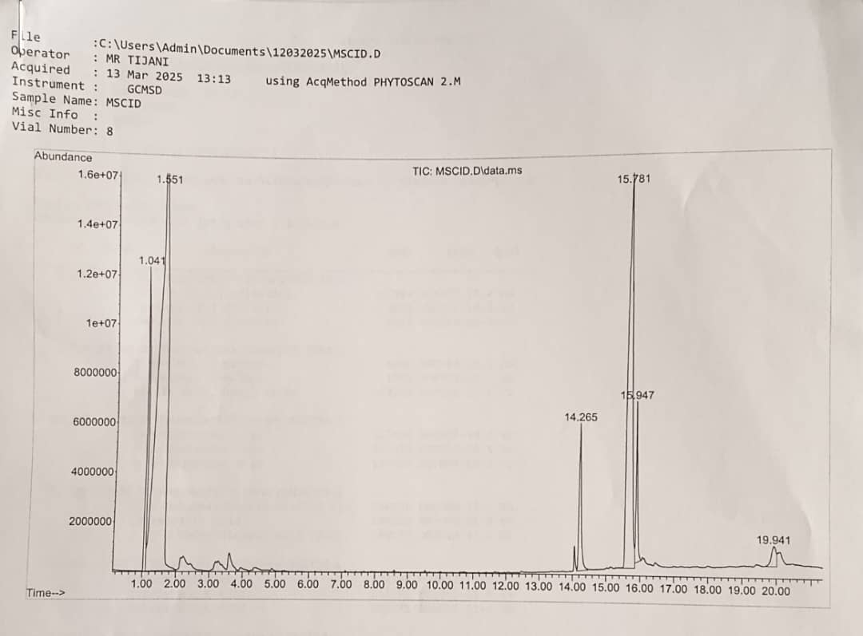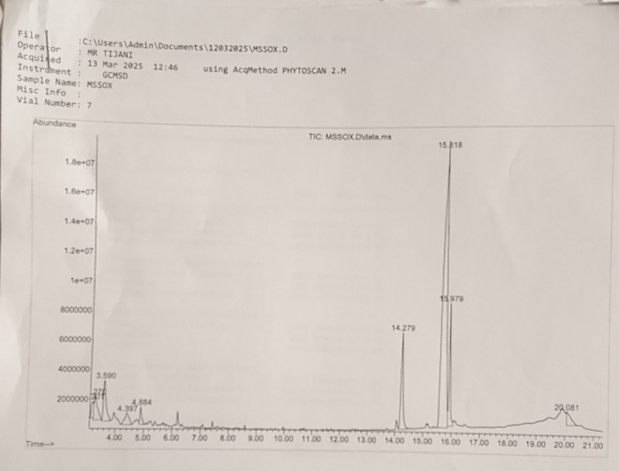

Figure 5: GC/MS chromatogram of Mscold Figure 6: GC/MS chromatogram of Mssox.

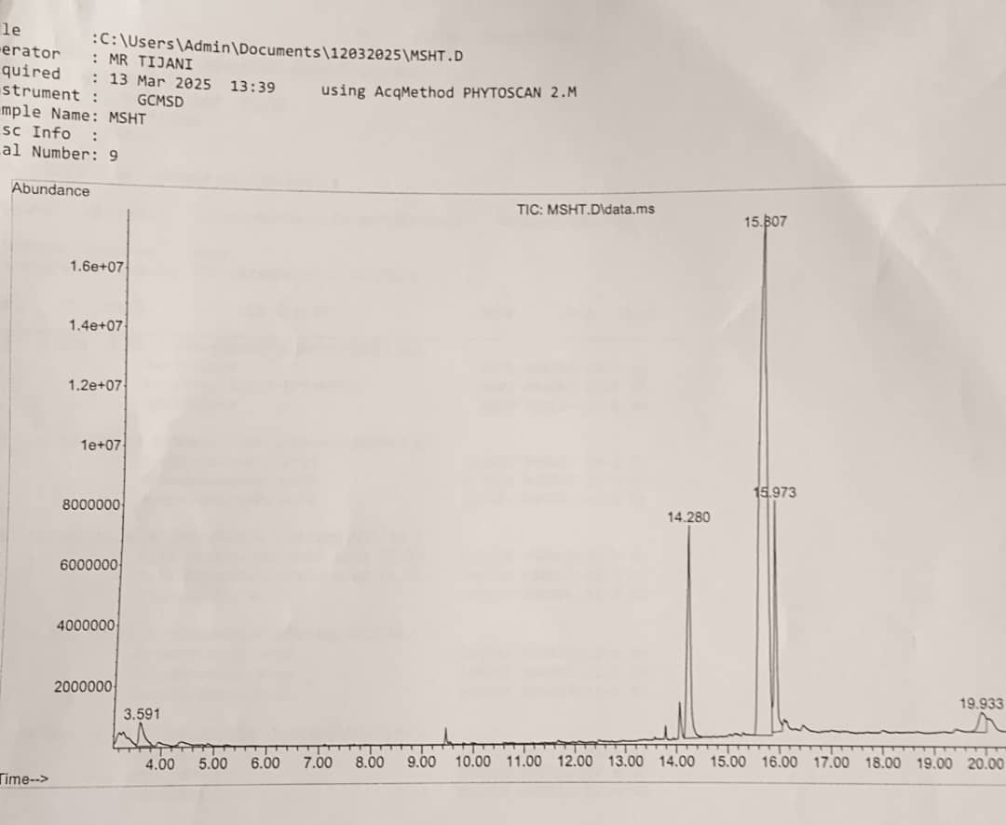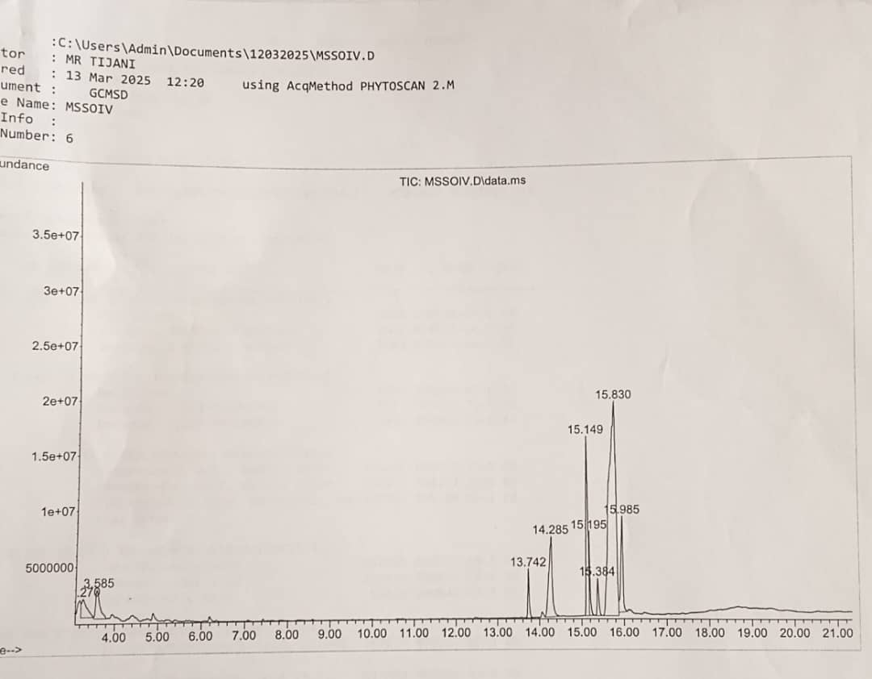

Figure 7: GC/MS chromatogram of Mshot Figure 8: GC/MS chromatogram of Mssolv.

Table 8: GCMS characterization of Mssox oil sample

|  |  |  |  |  |
| --- | --- | --- | --- | --- |
| **Peak** | **Retention  Time** | **Percentage Area** | **Molecular Formular** | **Name of Compound** |
| 1 | 3.201 | 1.86 | C9H12 | Benzene, 1-ethyl-2-methyl- |
| 2 | 3.270 | 4.21 | C9H12 | Benzene, 1-ethyl-2-methyl- |
| 3 | 3.590 | 5.94 | C9H12 | Benzene, 1,2,3-trimethyl-Mesitene |
| 4 | 4.397 | 2.65 | C10H14 | Benzene, 1,4-diethyl- |
| 5 | 4.884 | 1.66 | C11H24 | Undecane |
| 6 | 14.279 | 10.92 | C16H32O2 | n-Hexadecanoic acid |
| 7 | 15.818 | 61.00 | C18H32O2 | 9,12-Octadecadienoic acid (Z,Z)- |
| 8 | 15.979 | 8.90 | C16H36O2 | Octadecanoic acid |
| 9 | 20.081 | 2.88 | C19H40 | Tridecane, 7-hexyl- |

Table 9: GCMS characterization of Mscold oil sample

|  |  |  |  |  |
| --- | --- | --- | --- | --- |
| **Peak** | **Retention  Time** | **Percentage Area** | **Molecular Formular** | **Name of Compound** |
| 1 | 1.041 | 6.93 | C9H20 | Hexane, 2,2,3-trimethyl- |
| 2 | 1.551 | 55.85 | C6H12 | 1-Pentene, 2-methyl- |
| 3 | 14.265 | 5.03 | C16H32O2 | n-Hexadecanoic acid |
| 4 | 15.781 | 27.04 | C18H32O2 | 9,12-Octadecadienoic acid (Z,Z)- |
| 5 | 15.947 | 3.67 | C18H36O2 | Octadecanoic acid |
| 6 | 19.941 | 1.47 | C30H50 | Squalene |

Table 10: GCMS characterization of Mshot oil sample

|  |  |  |  |  |
| --- | --- | --- | --- | --- |
| **Peak** | **Retention  Time** | **Percentage Area** | **Molecular Formular** | **Name of Compound** |
| 1 | 3.591 | 2.34 | C9H12 | Mesitylene |
| 2 | 14.280 | 13.23 | C16H32O2 | n-Hexadecanoic acid |
| 3 | 15.807 | 71.16 | C18H32O2 | 9,12-Octadecadienoic acid (Z,Z)- |
| 4 | 15.973 | 10.74 | C16H36O2 | Octadecanoic acid |
| 5 | 19.933 | 2.53 | C30H50 | Squalene |

Table 11: GCMS characterization of Mssol. oil sample

|  |  |  |  |  |
| --- | --- | --- | --- | --- |
| **Peak** | **Retention  Time** | **Percentage Area** | **Molecular Formular** | **Name of Compound** |
| 1 | 3.270 | 3.46 | C9H12 | Mesitylene |
| 2 | 14.285 | 10.20 | C16H32O2 | n-Hexadecanoic acid |
| 3 | 15.149 | 12.69 | C19H34O2 | 9,12-Octadecadienoic acid, methyl ester |
| 4 | 15.195 | 2.88 | C19H36O2 | 9-Octadecenoic acid (Z)-, methyl ester |
| 5 | 15.384 | 2.22 | C19H38O | Methyl stearate |
| 6 | 15.830 | 54.34 | C18H32O2 | 9,12-Octadecadienoic acid (Z,Z)- |
| 7 | 15.985 | 7.43 | C18H36O2 | Octadecanoic acid |

**Table 12: Comparison of the major fatty acids of melon oil samples**

|  |  |  |  |  |
| --- | --- | --- | --- | --- |
| **Fatty acid constituents** |  | **Oil** | **Types** |  |
|  | **Mssox** | **Mscold** | **Mshot** | **Mssol** |
| Mesitylene | - | - | - | + |
| Hexadecanoic acid | - | - | - | + |
| N-hexaecanoic acid | + | + | - | + |
| 9,12-octadienoic acid methyl ester | - | - | - | + |
| 9-octadecenoic acid (Z) methyl ester | - | - | - | + |
| Methyl stearate | - | - | - | + |
| 9,12-octadecadienoic acid (ZZ) | + | + | + | + |
| Octadecanoic acid | + | + | + | + |
| Squalene | - | + | + | - |

* **= absent and + = present**

**DISCUSSION**

The percentage recovery of both oils revealed the solvent extracted oils (25% for Ahsol and 20% for Mssol) as the most recovered while the oils prepared by hot method was the least (21% for Ahhot and 17% for Mshot). The low recovery of oils prepared by hot method could be as a result of loss due to evaporation and also, incomplete release of oil from the denatured protein in the meat while the high percentages of oil recovery for solvent and cold extracted oils, may be related to ease/efficiency of the methods. For instance, in the cold method, refrigerating the extracted milk allows for total pooling and subsequent removal of the fatty acids containing layer thus affording high yields.

The densities of the extracted oils (table 1) showed that the groundnut oil sample extracted cold method (Ahcold) had the highest density of 0.92 g/mL, followed by solvent extracted oil (Ahsol )while the hot extracted oil had the least density of 0.89 g/mL. Considering the melon oils, the cold extracted oil (Mscold) had a density of 0.92±0.01 g/mL while the least dense oils were soxhlet extracted oil (Mssox) and hot extracted oil (Mshot) with densities of 0.90 ±0.02 g/mL and 0.90 ±0.02 g/mL, respectively. These density values were statistically (p≤ 0.05) significant. Density of oils is a useful parameter for the measurement of adulteration and this is directly related to temperature and the fatty acid components. The density of water was reported to be 1.00 g/mLat 25ºC. Edible oils are expected to be less dense than water and the fact that all the extracted oil samples exhibited density lower than that of water could make them good oils for culinary purposes [36].

The viscosity content of the extracted groundnut and melon oils as represented in tables 1 and 2 revealed values of 48.10 ± 2.00, 48.00 ± 2.00, 48.50±3.00 and 48.00 ± 2.00 for Ahsox, Ahcold, Ahhot and Ahsol, respectively, while that of melon oil samples were 51.00 ± 2.00, 52.00 ± 2.00, 52.00 ± 2.00 and 59.00 ± 2.00 for Mssos, Mscold, Mshot and Mssol., respectively. The viscosities of the samples were not really affected by the methods of extraction except for solvent extracted melon oil which was 0.059±0.02. Viscosity as a critical parameter in food production usually affects the texture, appearance and stability of food products and viscosity control usually leads to delicious taste of food products [37].

In this study, the refractive indices of extracted groundnut oils were 1.46 ± 0.01, 1.47 ± 0.01, 1.52 ± 0.02, 1.46 ± 0.02 for Ahsox, Ahcold, Ahhot, Ahsol, respectively while that of melon oils (Mssox, Mscold, Mshot and Mssol) were 1.45 ± 0.01, 1.39 ± 0.01, 1.46 ± 0.01 and 1.48 ± 0.01. The refractive index is the degree of refraction of a beam of light that occurs when it passes from one transparent medium to another. The refractive index values obtained, ranged from 1.39 to 1.52 for all extracted oils samples. The refractive index values of vegetable oils are pegged by NAFDAC at 1.45-1.46 and also, by JOSC at 1.44-1.47. All the oil samples except Ahcold for groundnut oils and Mscold for melon oils had values within the set limit, the differences were significant at p≤ 0.05 and this is directly related to their fatty acid components, thus a useful physical constant for checking of strength and purity of edible oils [25, 38, 39].

Analyzing the moisture content of oils is essential for understanding the quality of such oils. The moisture contents of the extracted oil samples were 0.34 ± 0.01, 0.44 ± 0.02, 0.29 ± 0.02 and 0.42 ± 0.02 representing Ahsox, Ahcold, Ahhot, Ahsol oil samples. Considering the allowable 2% moisture content limit for vegetable oils, all the extracted oil samples were within this limit and with significant difference (p≤ 0.05). Moisture content of oils is a necessary parameter when considering the storage of oils. This is so because, oils that have higher moisture are liable to deterioration which could be due to microbial growth and poor taste owing to rancidity. In this study, the methods employed did not adversely affect the water content of the oil samples thus guaranteeing their long shelf life [25, 40].

The PH values, which represent the hydrogen ion concentration of the extracted groundnut oil samples were 5.44 ± 0.11, 5.52 ±0.11, 5.52 ± 0.12, 5.50 ± 0.11 and 6.30 ± 0.09, 5.70 ± 0.12, 5.64 ± 0.12, 5.51 ± 0.12 for melon oils; free fatty acid values were 0.70 ± 0.01, 0.65 ± 0.01, 0.66 ± 0.01, 0.66 ± 0.01 and 0.60 ± 0.01, 0.60 ± 0.01, 0.70 ± 0.01, 0.60 ± 0.01, respectively for both groundnut and melon oil samples; saponification values were **176** ± 2.12, **182** ± 2.11, **175** ± 3.12 and **176** ± 1.72 for Ahsox, Ahcold, Ahhot and Ahsol, and 198 ± 3.14, 194 ± 3.11, 203 ± 2.24, 193 ± 4.32 for Mssox, Mscold, Mshot and Mssol, respectively. The NAFDAC limit for groundnut oil and other edible vegetable oils is set at 5.29 - 6.92 and all the four methods employed in this study did not affect the pH of the oils. According to World Health Organisation (WHO) and Food and Agricultural Organisation (FAO), edible oils should not have free fatty acid components more than 1.376% since their release encouraged spoilage. Thus, both the groundnut and melon oils extracted using these methods did not support liberation of higher quantity of free fatty acids [41]. Saponification is a measure of milligrams of KOH required to saponify 1g of oil sample and it is a useful parameter in the production of soap. The data obtained for saponification study were within the NAFDAC limit (190-209 mg/KOH/g), thus, all methods of extraction adopted could be employed in the production of groundnut and melon oils meant for soap production.

GC/MS Analyses of extracted oils

The result of GC/MS evaluation for groundnut extracted oils (Tables 3-6) revealed seventeen (17) constituents for Ahsox, twelve (12) for Ahcold and nineteen (19) each for Ahhot and Ahsol while Mssox furnished nine (9) Mssol seven (7) , Mscold, six (6) and Mshot five (5) constituents, respectively (Tables 8-11). Palmitic acid (n-hexadecanoic acid) and oleic acid (9-octadecanoic acid) were identified in all groundnut oil samples; mesitylene and stearic acid (octadecanoic acid) were also identified in all oil samples except Ahhot while methyl stearate and undecane were identified in all groundnut samples except Ahcold. Elaidic acid (9-octadecanoic acid (ZZ)) was identified in Ahsox and Ahsol., oleic acid methyl ester (9,12-octadecadienoic acid methyl ester) was identified in Ahsox and Ahhot, supraene also known as squalene was identified in Ahcold and Ahsol while linoleic acid (9,12-octadecadienoic acid) was identified in Ahsol (Table 7). The hot and solvent extracted oil samples had more constituents than the soxhlet and cold extracted groundnut oil samples. Also, 9, 12-octadecadienoic acid and octadecanoic acid were the common fatty constituents of all the melon oils with n-hexadecanoic acid present in three oil samples (Mssox, Mscold and Mssol) and squalene identified in Mscold and Mshot (Table 12).

N-hexadecanoic acid, otherwise called palmitic acid is a known ingredient in cosmetics, soaps and even in foods owing to its anticancer, anti-inflammatory and antioxidant properties [42] (Mieremet *et al*., 2019). Oleic acid, an omega-9 fatty acid which is usually present in most edible oils has many usefulness in the heart, skin and brain, most especially, its role in reducing the quantity of bad fats with a concurrent increase in good fats [43] (Santa-Maria *et al*., 2023). In cosmetic industries, it is incorporated into skin care products owing to its ability to enhance skin hydration thus improving skin barrier function. Methyl stearate and stearic acid are also major ingredients in creams and soaps with their attendant emollient and stabilization functions. Linoleic acid’s function is equivalent to that of oleic acid in boosting the levels of good fats thus helping the heart retains its integrity [44] (Yang and Jia, 2024). Supraene (squalene) is a component of the sebum (natural oil of the skin) and is valued in cosmetics for its moisturizing, anti-inflammatory, anti-ageing and stress protection abilities [45] (Lozano-Grande *et al*., 2018).

4. Conclusion

Extraction methods is very crucial in the preparation of oils for culinary applications and in the production of skin care products. The four extraction methods adopted for this study produced oils that were within acceptable limits in their physical and chemical properties and also, contained useful fatty acid such as palmitic acid, oleic acid, methyl stearate, elaidic acid, linoleic acid, stearic acid and squalene. Therefore, this study has clearly demonstrated the influence of various extraction methods in some physicochemical properties and fatty constituents of extracted groundnut and melon seed oils and provides useful data for extraction of oils for culinary and industrial applications.

Consent

Not Applicable

Ethical approval

Not Applicable

References

1. Saiz J, Montealegre C, Marina ML, Garcıa-Ruiz C. (2013). Peanut allergens: An overview. Critical Rev. Food Sc. and Nutr, 2013; 53:722-737.

2. Ahmad RK, Kabir M, Ahmad RK, Kabir M, Muhammad AI, Lawan I, Ahmad HK. Effect of extraction methods on the quality of groundnut oil in some small-scale industries in Kano state. Bayero J. Pure Appl. Sc, 2019; 12 (1):1-8

3. Balasubramanian P, Subbulakshmi B, Balmurugan M, Gurumeenakshi G, Prasanth RC, Deepika R, Surya R. Nutritional profiling and its significance in groundnut: a review. Asian J. Diary Food Res, 2024; 43(4): 615-623

4. Ramesh B, Saravanan,R, Pugalendi KV. Effect of dietary substitution of groundnut oil on blood glucose, lipid profile, and redox status in streptozotocin-diabetic rats. Yale J. Bio. Medicine, 2006; 79: 9-17.

5. Salas-Salvado J, Casas-Agustench P, Salas-Huetos A (2011). Cultural and historical aspects of Mediterranean nuts with emphasis on their attributed healthy and nutritional properties. Nutr Metab Cardiovasc., 2011; 21(1):51-66.

6 Awad AB, Williams H, Fink CS, Kinm U. In vitro and in vivo (SCID) mice effect of phytosterols on the growth and dissemination of human prostrate cancer PC-3 cells. Europ J. Cancer Prev., 2001; 10:507-513.

7. Awad AB, Fink CS. Phytosterols reduce in vitro metastatic ability of MDA-MB-231 human breast cancer cells. Nutr Cancer, 2001; 40(2):157-164.

8. Wang F, Li H, Zhao Y, Qiu P, Li J, Wang S. Antidiabetic activity and chemical composition of Sanbai melon seed oil. Evidence-based Comp. Alt. Medicine, 2018; 5434156

9. Omozuwa OP, Ukhun ME, Igbashio MD. Evaluation of antioxidant properties of *Cucumeropsis mannii* (Melon) oil and its effects on organs to body weight ratio. J. Appl. Sc. Env. Management, 2024; 28(7): 2167-2172.

10. Essien EA, Umoren SA, Essien EE, Udoh AP. Prepararion and evaluation of *Cucumeropsis mannii* Naud. Seed oil metallic soaps as driers in gloss. Paint J. Mat. Env.Science, 2012; 3: 477-484.

11. Olofinnade AT, Onaolapo A, Stefanucci A, Mollica A, Olowe O, Onaolapo OJ*. Cucumeropis manni* reverses high-fat dist induced metabolic derangement and oxidative stress. Front. Biosc., Elite, 2021; 13: 54-76.

12. Samson A. Oyeyinka · Ruth O. Agabje  · Adeshola A. Babayeju  · Deborah O. Opaleke  · Fausat L. Kolawole  Abdulhameed A. Badmos  · Patrick B. Njobeh3 Oluwafemi A. Adebo. Consumer perception and physicochemical properties of crude groundnut oil in comparison with selected vegetable oil, Discover Foods, 2024, 4: 50

13. Samatha B, Naik S. Extraction of edible oil from groundnut by using solvents and enzymes. Int. J. Sc. Pro. Research, 2020; 68(168); 01.

14. Castelo-Branco VN, Santana I, Di-Sarli VO, Freitas SP, Torres AG. Antioxidant capacity is a surrogate measure of the quality and stability of vegetable oils. Eur J Lipid Sci Technol., 2016; 118 (2):224–35.

15.Oyeyinka SA, Agabje RO, Babayeju AA, Opaleke DO, Kolawole FL, Badmos AA, Njobeh PB, Adebo OA Consumer perception and physicochemical properties of crude groundnut oil in comparison with selected vegetable oil. Discover Food, 2024, 4: 50

16. Manikantan MR, Mathew AC, Madhavan K, Arumuganathan T, Arivalagan M, Shameena Beegum, PP, Hebbar KB. Virgin coconut oil: hot and fermentation process, Technical Bulletin, 2016;108:43,

17. Fagbemi KO, Aina DA, Olajuyigbe OO. Soxhlet extraction versus hydrodistillation using the clavenger apparatus: a comparative study on the extraction of volatile compound from *Tamarindus indica* seeds. The Sc. W. Journal, 2021;1:5961586.

18. Raghavendra SN, Raghavarao KSMS. Aqueous extraction and enzymatic destabilization of coconut milk emulsions. J. Amer. Oil Chem. Society, 2011; 88(4):481-487.

19. Akinola FF, Oguntibeju OO, Adisa AW, Owojuyigbe OS. Physico-chemical properties of palm oil from different palm local factories in Nigeria. J. Food Agriculture Environment, 2010; 8(34):264-269

20. Olaniyi AA, Ogungbamila FO (1998). Experimental Pharmaceutical chemistry. Shaneson, Ibadan Nigeria, 1998;81656861.

21. Iwuchukwu AB, Agu HO, Mba JC, Igwe NP. Conformability of five brands of vegetable oil sold in Roban stores,Awka, Nigeria to NAFDAC set standards, Proceedings of the First Faculty of Agriculture International Conference, Nnamdi Azikiwe University, Awka, Nigeria, 2017; 207-212

22. Oginni AO, Adewuyi A, Oderinde RA Physicochemical properties of the seed oil of *Khaya senegalensis*. Food Nutrition Sc.,2024; 15: 171-178.

23. Isaac BA, Adejumo OI. Physicochemical properties of roselle seed oil. J. Nutr. Food Sc., 2016; 40: 186-192

24. Japir AAW, Salimon J, Derawi D, Bahadi M, Al-Shuja’a S, Yusop MR. Physicochemical characteristics of high free fatty acid crude palm oil. Oilseeds & fats Crops and Lipids, 2017; 24(5):D506.

25. Raji RO, Inengite AK, Godwin J, Ajibesin KK. Assessment of proximate and physicochemical properties of crude palm oil from south-west and South-south Nigeria. Afr. J. Pure Appl. Chemistry,2022;16(2) :40-56.

26. Nordstorm DK, Alpers CN. Negative pH, efflorescent mineralogy and consequences for environmental restoration at the iron mountain super fund site, California. Proceeding of the National Academic of Science, 1999;96(7):3455-3462.

27. Gungshik JR, Ibrahim M, Onyemowo OA, Rabiat LA (2023). Comparative Analysis of the Physico-Chemical Properties and Trace Metal Content of Palm Oil, from Selected Markets in Jos South and Jos North LGA, Plateau State, Nigeria. Nig. J. Chem. Research, 2023; 28 (2): 100-111

28. American Oil Chemists' Society. Official Methods and Recommended Practices of the American Oil Chemists Society. 4th Edition. American Oil Chemists Society, 1990; Champaign, California, USA. DOI: 10.4236/fns.2011.24039.

29. Association of Official Analytical Chemists. Official method of analyses association of official analytical chemist 17th edition Washington D.C. USA. 2005. ISBN 0-935584-77-3

30. Salimon J, Ahmed WA (2012). Physicochemical characteristics of tropical Jatropha curcas seed oil. Sains Malaysiana, 2012; 41(3):313-317.

31. Bahadi MA, Japir AW, Salih N, Salimon J. Free fatty acids separation from Malaysian high free fatty acid crude palm oil using molecular distillation. Mal. J. Analy. Science, 2016; 20(5):1042-1051.

32. Kowalska M, Wo´zniak M, Zbikowska A, Kozłowska M. Physicochemical characterization and evaluation of emulsions containing chemically modified fats and different hydrocolloids. Biomolecules, 2020; 10(1):115

33.Glasser CA. Analysis of fixed oils, fats and waxes in pharmaceutical chemistry: theory and application. BS Publisher and Distribution PVT Ltd., New Delhi, India, 1st. Edition, 2008; 405 – 436.

34. Tor PN, Vesuwe RN, Oloruntoba SO, Surma N. Chemical analysis of palm oil used in some parts of Benue State, Nigeria. Intl J. Adv. Res. Chem. Sc., 2017 4(2): 12-17.

35. Odion EE, Ogboru RO, Ighene MO, Identification of compounds in *Elaeis guineensis* fruits using GC-MS, Dhaka University Journal of Pharmaceutical Science, 2020; 19(2): 153-159.

36. Ichu, C. and Nwakanma, H. Comparative Study of the Physicochemical Characterization and Quality of Edible Vegetable Oils. International Journal of Research in Informative Science Application & Techniques, 2019; 3: 1-9.

37. Shahidi F, Hossain A. Role of lipids in food flavor generation. Molecules, 2022; 27(15): 27, 5014

38. Agarwal R, Bosco S. Extraction processes of virgin coconut oil. MOJ Food Process Technol., 2017 4:80-87.

39. Endo Y. (2017). Analytical Methods to Evaluate the Quality of Edible Fats and Oils: The JOCS standard methods for analysis of fats, oils and related materials and advanced methods. J Oleo Sci., 2017; 67(1):1-10.

40. Asemave K, Ahile UJ, Tyohemba RL, Ahundu ST, Atoo TR, Ubwa ST. Determination of moisture content, total aflatoxin content and mould count in purchased and processed groundnut (*Arachis hypogea* L.) products obtained from parts of Benue State-Nigeria. FUW Trends in Sc. & Tech. Journal, 2019; 4(2): 586 – 590

41. Omorodion Nnenna JP, Nnabuihe N. Microflora and Physicochemical Composition of Edible Oil Sold in River State Nigeria. International Journal of Novel Research in Life Sciences, 2022; 9(2): 1-10.

42. Mieremet A, Helder R, Nadaban A, Gooris G, Boiten W, El Ghalbzouri A, Bouwstra JA. Contribution of palmitic acid to epidermal morphogenesis and lipid barrier formation in human skin equivalents. Int. J. Mol. Sci., 2019; 20 (23): 6069.

43. Santa-Maria C, Lopez-Enriquez S, Montserrat-de la Paz S, Geniz I, Reyes-Quiroz ME, Moreno M, Palomares F, Sobrino F, Alba G. Anti-inflammatory molecular mechanisms induced by oleic acid. Nutrients, 2023; 15(1): 224.

44. Wang X, Jia Y. The role of linoleic acid in skin and hair health: a review. Inter. J. Mol. Sciences, 2024; 26 (1):246.

45. Lozano-Grande MA , Gorinstein S, Espitia-Rangel E, D´avila-Ortiz G, and Mart´ınez-Ayal AL..plant sources, extraction methods, and uses of squalene. Int. J. Agronomy, 2018 1829160: 1- 13.