Original Research Article
Can Arm Span and Foot Length be Used to Predict Stature? An Anthropometric Study in Imo State, Nigeria (The title should be in CAPITAL LETTERS, Centered)
Abstract (should not be structured)
Background: Stature estimation is a crucial aspect of physical anthropology, forensic science, and bioarchaeology. It involves determining or predicting an individual’s height using measurable body parameters.
Aim: The primary objective of this study is to investigate the potential of arm span and foot length as predictors of Stature among individuals in Imo State, Nigeria. By examining the correlation between these anthropometric variables and Stature, we aim to provide evidence supporting their use in predicting height. (Body Hight?)
Method: The study, which employed a descriptive cross-sectional design, was conducted with a rigorous methodology. A total sample of 300 subjects (150 males and 150 females) aged 18-35 years were recruited for the study, and the mega-size caliper was used to measure the anthropometric variables. The data analysis, performed using the International Business Machines version of the Statistical Package for the Social Sciences (SPSS, version 23), was robust. The linear regression used to estimate sex and Stature was a reliable statistical method. A probability less than 0.05 (p<0.05) was considered statistically significant, and 95% was denoted as the confidence level, ensuring the validity of the results.
Result: A strong positive correlation existed in all subjects between Stature, arm span, and foot length (R = 0.88). The stature predictive power potential in males (R = 0.83) and females (R =0.76) was also strong. Significant sexual dimorphism was noted in all parameters.
Conclusion: This study has uncovered a strong positive correlation between arm span, foot length, and Stature in the Imo State, Nigeria population. The practical implications of these findings are significant for forensic sciences, anthropology, medical sciences, and bioarchaeology. They provide a basis for developing more accurate methods for estimating Stature when direct height measurements are not possible, such as in cases of amputations, dismemberment, or skeletal fragmentation.
Keywords: Anthropometry; Arm Span; Foot Length; Imo
- INTRODUCTION
Anthropometry, the study of human body measurements, is a fundamental component in the identification process of human remains. This study, which investigates the use of arm span and foot length as predictors of Stature in the Imo State, Nigeria population, makes a unique contribution to the field. It enhances the application of anthropometry in clinical and forensic settings, particularly when direct height measurements (direct methods for longitudinal dimensionality estimation) are not possible.
However, previous research has shown that body measurements, including arm span and foot length, exhibit strong correlations with height (Body height) and can be used as reliable predictors of Stature. A study done by Fawehinmi et al. [6] on the Hausa population indicated that arm span and foot length show a positive correlation with Stature. Shah et al. [7] observed (noted) that foot and hand length can be used to estimate the Stature of both males and females in the Gujarati population.
However, the relationship between (certain) anthropometric parameters and height (Body height) varies across populations due to genetic, environmental, and ethnic factors. This study aims to investigate whether arm span and foot length can be used to predict Stature among individuals in Imo State, Nigeria. By analyzing these relationships within a specific population, the study seeks (try to find and contribute valuable data to the growing field of anthropometry, enhancing its application in clinical and forensic settings.

- MATERIALS AND METHODS
2.1 Study Design
In Imo State, Nigeria indigenous people's anthropometric values were measured using a cross-sectional descriptive research method. The population comprised three hundred subjects (150 males and 150 females) between 18 and 35. The study was conducted in Owerri, Imo State, where the subjects were selected using a multi-stage random proportionate sampling approach.
2.2 Selection Criteria
Inclusion Criteria
This study included individuals whose parents and grandparents are Indigenous people of Imo State. Additionally, only those aged between 18 and 35 years with no history of body surgery were selected.
Exclusion Criteria
Subjects who did not meet all these inclusion criteria were omitted from the study, and those with damage or abnormalities in hand morphology or Stature were excluded.
2.2.1 Anthropometric landmarks
The study used some anthropometric variable measures (Stature, arm span, and foot length), and these variables are defined as follows;
2.2.2 Stature
The Goodcare ZT-160 stadiometer was used to measure this (Body Height). On the level platform of the stadiometer, the subject stood upright and barefoot, contacting the bar with their heels, buttocks, shoulder blades, and back of their heads. The subjects were instructed to keep their arms by their sides and relax. It was taken care of to prevent sagging.
2.2.3 Arm Span
This measurement is taken from the distance between the tips of the middle finger of both hands in a participant’s perpendicular (vertical) upright position with both arms outstretched laterally at 90⁰ shoulder height perpendicular (vertical) to the body and parallel to the floor.
2.2.4 Foot length
This measurement is taken from the distance between the most prominent part of the heel and the most distal part of the longest toe.
2.3 Method of Data Collection
A semi-constructive descriptive questionnaire and a personal interview were used to collect sociodemographic data from the indigenous people of Imo State in Nigeria. This ensured that the subjects met the inclusion criteria and were fit to participate in the study. The arm span and foot length were measured using a mega-size caliper, adopting the appropriate anatomical landmarks. The authors recorded and preserved the data readings.
2.4 Method of Data Analysis
The data obtained were subjected to statistical analysis using the International Business Machines version of the Statistical Package for the Social Sciences (SPSS, version 23). The results obtained were presented in the table as mean ± standard deviation. The t-test was used as an inferential statistic to evaluate sexual differences. Linear regression analysis was used to estimate a Stature model based on the measured variables.
- RESULTS and INTERPRETATION
In this study, Table 1 shows the mean value of Stature was 169.89±8.48cm; arm span was 178.36±11.18cm, and foot length was 25.44±1.82cm. Sexual differences were shown between the Stature, arm span, and foot length in Table 2. Table 3 shows the linear regression analysis for the study population with Stature as the dependent variable and arm span and foot length as the independent variables, and they were statistically significant (p<0.005). The table shows the linear regression model for the Stature of all subjects (R = 0.88), males (R = 0.83), and females (R = 0.76), indicating a strong positive correlation within the population. (Tables must be included in this subchapter!)
- DISCUSSION
This study’s findings show that males had a stature of 176.41±6.95 cm, an arm span of 185.80±8.50 cm, and a foot length of 26.62±1.36 cm, while females had a stature of 164.39±6.27 cm, an arm span of 170.91±8.19 cm, and a foot length of 24.26±1.45 cm. Our findings have shown that males have higher mean values than females, which verifies the gender-based variation in Stature, arm span, and foot length. This aligns with Okoh et al. [8] and Oghenemavwe et al. [9]. This study also indicated statistically significant differences (p<0.005) in gender, and this aligns with previous studies done by Hsieh et al. [10]. Koşar et al. [11] disagree with the study by Dorjee et al. [12], which indicated no significant differences in sex.
However, this study observed that the arm span and foot length estimated from the Stature have shown a strong positive correlation (R = 0.88, SEE = 3.987) among the indigenous people of Imo State. The findings showed they have predictive power for Stature with no statistically significant differences. This aligns with the research of Fawehinmi et al. [6] among the Hausa population in Nigeria and Oghenemavwe et al. [13] in the Northern part of Nigeria.
However, when compared with sexes, the findings show that males' Stature is better predicted using the arm span and foot length (r=0.83, SEE= 3.767) compared to the females (r=0.76, SEE= 4.096), and this could be attributed to some factors influencing estimation such as bone length, muscle mass, and fat distribution. The findings of this study align with Fawehinmi et al. [6] and Oghenemavwe et al. [13]
Moreover, arm span shows the most significant correlation in males (R =0.81) compared to females (R = 0.76), and this is consistent with Debnath et al. [14], Chawla et al. [15], Agrawal et al. [16], and Adebajo et al. [17]. Therefore, this can be attributed to several anatomical, physiological, and developmental factors, which can also be influenced by hormonal factors, particularly the impact of testosterone during puberty, which promotes linear skeletal growth and elongation of the long bones Satoh and Hasegawa [18].
In males, foot length shows a strong correlation (R = 0.75) compared to females (R =0.11), which is weak in correlation, indicating that females exhibit variability in foot size relative to height, influenced by earlier skeletal maturation and the role of estrogen, which accelerates epiphyseal closure Bhattacharjee et al., [19]. However, several studies have indicated that foot length correlates well with Stature in males, Oghenemavwe and Egwede [20], Fawehinmi et al. [6], which is in line with the present study. On the contrary, Sen and Ghosh [21] observed a moderate correlation in both sexes.
- CONCLUSION
This study assesses stature estimation from arm span and foot length of the Indigenous people of Imo State, Nigeria. The results show a strong positive correlation between the subjects. However, arm span and foot length showed a positive correlation with Stature in males but indicated a weak correlation in females. These findings will be useful in forensic sciences, anthropology, medical sciences, and bioarchaeology.
ETHICAL APPROVAL was obtained from the Research Ethics Committee at the University of Port Harcourt, Port Harcourt, Nigeria (UPHCEREMAD/REC/MM/91/046). All subjects were adequately informed about the study procedure, and they gave their write consent. .

Table 1. Descriptive Statistics of the Subjects
Parameter | N | Minimum | Maximum | Mean | Std. Deviation
Stature | 300 | 150.00 | 194.00 | 169.8912 | 8.48765
Arm span | 300 | 152.50 | 211.10 | 178.3610 | 11.18089
Foot length | 300 | 20.40 | 32.50 | 25.4407 | 1.82889

Table 2. (Sexual) Gender Differences of the Subjects
Parameters | Male | Female | T-test | P-value | Inference
S (cm) | 176.41±6.61 | 164.39±6.27 | 14.832 | 0.000 | S
AS (cm) | 185.80±8.50 | 170.91±8.19 | 15.448 | 0.000 | S
FT (cm) | 26.62±1.36 | 24.26±1.45 | 14.535 | 0.000 | S
Legende: N = Sample size, S = Stature, AS = Arm Span, FL = Foot length, S = Significant

Table 3. Linear Regression Analysis for the study population with Stature as the dependent variable and Arm Span and Foot Length as the independent variables.
Variables | R | R-square | Adjusted R Square | Std. Error of the Estimate | Sig. F Change
Arm Span  Males  Females | 0.81  0.76 | 0.660  0.580 | 0.657  0.577 | 3.871  4.082 | 0.000*  0.000*
Foot Length  Males  Females | 0.62  0.11 | 0.382  0.011 | 0.378  0.004 | 5.216  6.265 | 0.000*  0.200*
* = Significant
Table 4. Linear Regression Model for Stature of All Subjects
Subjects | Regression formula | R | RSquare | Adjusted R Square | Std. Error of the Estimate | Sig. F Change
All | S=47.53+(AS)0.617+(FL)0.484 | 0.88 | 0.781 | 0.779 | 3.987 | 0.000*
Males | S=50.83+(AS)0.544+(FL)0.885 | 0.83 | 0.680 | 0.675 | 3.767 | 0.000*
Females | S=64.51+(AS)0.584+(FL)0.001 | 0.76 | 0.580 | 0.574 | 4.096 | 0.000*
Legend: S = Stature, AS= Arm Span, FL= Foot Length, * = Significant, # = Not Significant
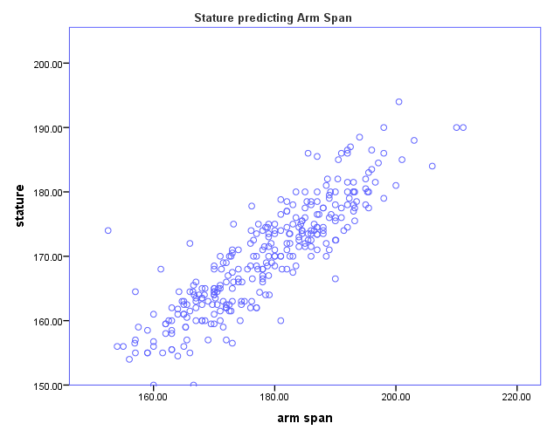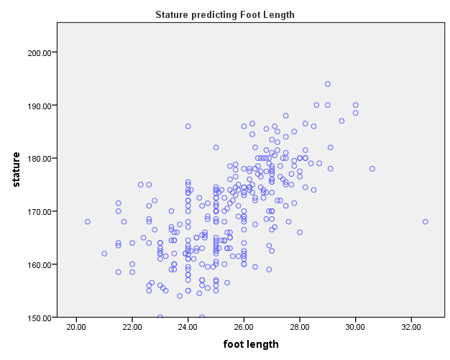
Figgure 1. Showing Graphical Presentation of Stature prediction by Arm span and Foot length.
REFERENCES
- Choong CL, Alias A, Abas R, Wu YS, Shin JY, Gan QF, Thu KM, Choy KW. Application of anthropometric measurements analysis for Stature in the human vertebral column: a systematic review. Forensic Imaging. 2020 Mar 1;20:200360.
- Rissech C. The importance of human anatomy in forensic anthropology. Eur J Anat. 2021;25(S2):1-8.
- Baryah, N., Krishan, K., & Kanchan, T. (2019). The development and status of forensic anthropology in India: A review of the literature and future directions. Medicine, Science and the Law, 59(1), 61-69.
- Fawehinmi HB, Okoh PD, Oghenemavwe LE, Irozulike FC. Stature and Sex Estimation Using Anthropometric Parameters in the Yoruba Ethnic Group of Nigeria.
- Iscan MY, Steyn M. The human skeleton in forensic medicine. Charles C Thomas Publisher; 2013 Sep 1.
- Fawehinmi HB, Oghenemavwe LE, Okoh PD, Ebieto CE, Amadi MA, Irozulike FC. Stature Estimation Using Arm Span, Arm Length, Forearm-hand Length, and Foot Length of the Hausa Ethnic Group of Nigeria. Asian Journal of Medical Principles and Clinical Practice. 2025 Feb 28;8(1):94-100.
- Shah RK, Patel JP, Patel BG, Kanani SD, Patel MD. Estimation of Stature from Foot Length and Hand Length Measurements in Gujarat Region. National Journal of Integrated Research in Medicine. 2014 Nov 1;5(6).
- Okoh PD, Fawehinmi HB, Oghenemavwe LE, Ebieto CE, Amadi MA, Irozulike FC. Discriminant and Multivariate Regression Analysis for Estimating Sex and Stature Model Using Upper Limb Anthropometric Measurements among the Yoruba Ethnic Group of Nigeria. Asian Journal of Advanced Research and Reports. 2025 Mar 26;19(4):41-8.
- Oghenemavwe LE, Okoh PD, Irozulike FC, Amadi MA. Multivariate Regression Model for Stature Estimation from Arm Span, Horizontal Fingertip Reach, and Foot Length of Igbo Ethnic Group of Nigeria. Journal of Complementary and Alternative Medical Research. 2024;25(8):112-7.
- Hsieh MC, Zhu A, Lee YC. Stature estimation from various three-dimensional anthropometric foot measurements of the Taiwanese female population. Legal Medicine. 2022 Feb 1;54:102000.
- Koşar Mİ, Gençer CU, Tetiker H, Yeniçeri İÖ, Çullu N. Sex and stature estimation based on multidetector computed tomography imaging measurements of the sternum in Turkish population. Forensic Imaging. 2022 Mar 1;28:200495.
- Dorjee B, Sen J. Estimation of Stature from arm span, arm length and tibial length among Bengalee. Human Bio Review. 2016;5(2):128-45.
- Oghenemavwe LE, Fawehinmi HB, Okoh PD, Nwofor PN, Asiwe N. Do Upper Arm Length, Arm Span, and Foot Length Serve as Good Predictors of Stature? A Cross-Sectional Study among Northern Nigerians. The foot, 5:10.
- Debnath M, Khatun A. Estimation Of Stature Among Bengali Adolescents Using Arm Span And Arm Length: An Observational Study From North Bengal (West Bengal, India). Antrocom: Online Journal of Anthropology. 2024 Jan 1;20(1).
- Chawla M, Tomar S, Ashoka R. The relationship between arm span and height in adult males of the North Indian Punjabi population. Journal of Evolution of Medical and Dental Sciences. 2013 Jan 28;2(4):332-41.
- Agrawal V, Kumar S, Singh P, Bhardwaj K. Correlation of Stature with arm span along with its significance in north Indian adult population. Indian Journal of Clinical Anatomy and Physiology. 2023 Jan 16;9(3):179-84.
- Adebajo AO, Ojo GB, Adebajo KP, Ojo JH, Ayoade OH, Awolola AM, Uduakabong S. A model for the estimation of height and body mass index from arm span and to determine the sociodemographic characteristics cross-sectional study of Bowen University Students. Discover Psychology. 2024 Oct 7;4(1):130.
- Satoh M, Hasegawa Y. Factors affecting prepubertal and pubertal bone age progression. Frontiers in Endocrinology. 2022 Aug 22;13:967711.
- Bhattacharjee N, Maji S, Pal B, Goswami M. Understanding the role of ethnicity, age, sex, and obesity on foot morphology: a systematic review. Papers on Anthropology. 2024 Nov 22;33(1):15-46.
- Oghenemavwe LE, Egwede OB. Estimation of living Stature from foot dimensions in uturu indigenes of Abia State, Nigeria. European Journal of Medical and Health Sciences. 2022 Feb 10;4(1):67-71.
- Sen J, Ghosh S. Estimation of Stature from foot length and foot breadth among the Rajbanshi: an indigenous population of North Bengal. Forensic Science International. 2008 Oct 25;181(1-3):55-e1.

