Lignin-Derived Carbon Fibers: Opportunities and Challenges — A Mini-Review

**Title is not proper format.**

## Abstract

Carbon fiber, known for its strength, lightness, and rust resistance, has gained popularity in industries like aerospace, automotive, fishing, and sporting goods. However, its high cost compared to steel and aluminum limits widespread adoption. Nevertheless, with increasing demand and decreasing prices, carbon fiber is becoming more accessible.

This paper explores using lignin, a readily available natural polymer considered waste in paper and biofuel industries, as a precursor for carbon fiber production. Obtaining lignin from these industries is cheaper than extracting it from trees, and different types of lignin can impact the carbon fiber synthesis process.

Carbon fiber recycling is challenging due to its composite nature, but by using lignin as a renewable resource, production costs can be reduced. Current recycling methods retain a significant portion of the original fiber's strength.

The production process involves using synthetic polymers like polyacrylonitrile (PAN) or alternative sources such as rayon or petroleum pitch. Electrospinning and melt-spinning are the primary methods employed, with considerations for lignin's thermal properties and spinnability. Each method has advantages and limitations, such as fiber shape control and coating requirements.

**AI suspected.**

In summary, using lignin as a precursor for carbon fiber production offers opportunities to lower costs, utilize a renewable resource, and address recycling challenges. This promotes more sustainable and economical manufacturing of carbon fiber.

**Write the keywords**

INTRODUCTION

## Background On Carbon Fiber

Carbon fiber (Graphite fiber) remains an important polymer in many industries due to its high tensile strength, lightweight and its inability to rust. It is nearly five-times stronger than steel, three times lighter, twice as stiff and has better yield strength [[1]](https://www.zotero.org/google-docs/?mPWDoX). Because of this, many weight bearing metals like steel and aluminum can be replaced by carbon fiber. As the price has been dropping steadily over the last couple years, the demand has steadily grown as well. The global demand for carbon fiber has grown from 46,000 tons in 2011 to 140,000 tons in 2020 [[2]](https://www.zotero.org/google-docs/?mHDRFN). That being said, the price of carbon fiber is still significantly more expensive than steel and aluminum. This has led to the trend where products being made with carbon fiber are significantly more expensive than the same items made with other materials. A good example of this is seen in the bicycle industry. Most bike frames are made out of either aluminum or steel. These bikes are in the $50-3,000 range. But if you were to buy a bike over $3,500, you would mostly find the frames to be made of carbon fiber and these bikes can go up way higher, sometimes up to 10,000 to 15,000 dollars. The average person does not require a carbon fiber bike, but the people that do buy them are usually people who need the performance boost. This can be seen in many industries as well including the automotive, fishing, sporting goods, and aerospace industry.

|  |  |  |  |  |
| --- | --- | --- | --- | --- |
| Material | Price per lb ($) | Tensile Strength (mPa) | Density (g/cc) | Modulus of Elasticity (Gpa) |
| Carbon Fiber | 12.00-15.00 | 2550 | 1.57 | 120 |
| Aluminum | 1.40-2.00 | 570 | 2.81 | 70.1 |
| Steel Alloy | .40-.80 | 1275 | 7.85 | 205 |

**Table 1.** Comparison of carbon fiber to its material competitors [[3]](https://www.zotero.org/google-docs/?vtjTya)

In the aerospace industry, carbon fiber and composites make up about 50% of the total number of parts where a plane takes about 6 million parts to complete. Carbon fiber materials make up the fuselage, or main body, of the plane, as well as parts of the wings and tail. In addition to fuel efficiency, using carbon and other composite materials allows for less maintenance as they do not corrode or fatigue like metals do. Less maintenance means more flight time, making carbon fiber planes more profitable [[4]](https://www.zotero.org/google-docs/?fgXYXS). Carbon fiber is more aerodynamic than other metal composites used today in the industry. Replacing these composite parts with carbon fiber will reduce the total drag on the aircraft. The composite fabrication processes can produce very smooth geometries. And because of the stiffness of the composite, new commercial designs can be introduced that would be more aerodynamic and in turn reduce fuel usage. For example, Swept wing designs (where the fuselage and wings blend together) in commercial aircrafts would reduce fuel consumption by 5% by reducing aerodynamic drag and improving the lift-to-drag ratio. A carbon fiber plane can save up to 20% versus the weight of a traditional aluminum plane [[5]](https://www.zotero.org/google-docs/?RM2wE8). This creates profound savings over the lifetime of the plane. For each kilogram of weight reduction, experts at NASA estimate a savings of about 1 million dollars over the total lifetime [[6]](https://www.zotero.org/google-docs/?dUvXaM).

The commercial use of carbon fiber in the aerospace industry would also contribute to lower manufacturing costs as carbon fiber is normally molded, many parts can be combined on each mold which means the shear number of parts would significantly decrease as well as manufacturing time. And because these parts will weigh less, fewer workers would be needed to assemble them.

## Why lignin?

Lignin is the second most abundant natural polymer found on Earth (Behind cellulose). Lignin is considered waste in paper mills as it does not create desirable paper qualities so most paper mills burn the excess lignin for fuel. It is also considered a waste product in the ethanol industry. These two industries create about 100-120 million tons of lignin alone which is all regarded as trash [[7]](https://www.zotero.org/google-docs/?bQ62nk). Although these industries consider them trash, there are still many potential applications that include lignin that could be converted to valuable products. Some applications include fuel additives, filler in cement, adhesives, surfactants and even could have a role in paper coatings as lignin is notoriously hydrophobic. There are plenty of potential uses which makes lignin an incredibly diverse polymer. There are some companies already utilizing this polymer including BorregaardLignotech and Rayonier where they sell binding agents, dispersing agents, emulsion stabilizers, and complexing agents all made from lignin[[8]](https://www.zotero.org/google-docs/?O1SuTs).

Because lignin is considered waste to paper and biofuel industries, these industries would be willing to sell the lignin to a carbon fiber plant as long as there would be a greater profit rather than burning the lignin to save some money on energy costs. Another solution would be to build a carbon fiber plant directly connected to the paper mill which would allow the company to make more profits as it would be selling two materials; paper and carbon fiber.

There are four types of lignin, which come from what type of pulping the papermill uses. There is Kraft lignin, Organosolv lignin, soda lignin, and lignosulfonates. These types of lignin are only relatively slightly different structurally from each other, but could lead to interesting outcomes during synthesis processes, especially for high purity/quality products like carbon fiber.

**Fig 1. Comparison of common lignins**[**[9]**](https://www.zotero.org/google-docs/?hEQbYI)

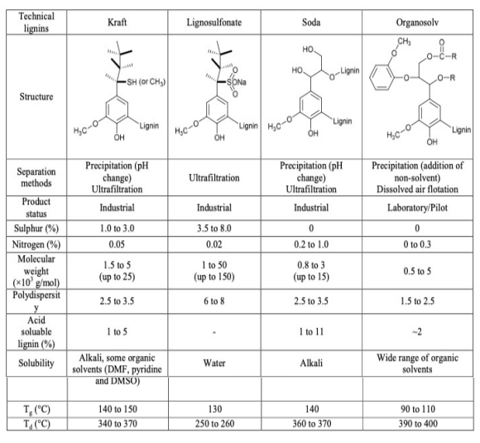 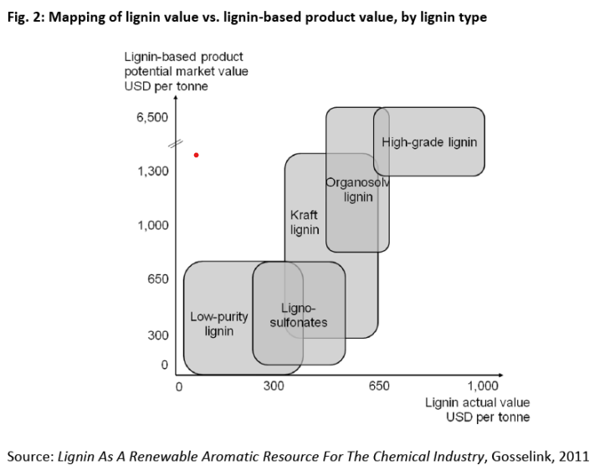

There are also slight differences inside lignin structures when they come from hardwood vs. softwood trees. Hardwood lignin is less condensed, more soluble and less stable than softwoods. This is due to softwoods' higher -OH count, a lower amount of β-O-4’ bonding, and higher molecular mass. It is important to note that β-O-4’ bonding contributes to roughly 50% of the total bonds in softwood lignin and 60% in hardwood lignin. β-O-4’ bonding is the most common bond inside lignin. The rest of the bonding can contribute 0.5-15% of its total bonds although more research is required because these percentages are highly debated [[10]](https://www.zotero.org/google-docs/?2KrNf8). These bonds can be seen in figure 4.

## Potential Issues with Lignin

Lignin is made up of primarily H, G, and S units.

**Fig 3.** Monomer units that make up lignin [[11]](https://www.zotero.org/google-docs/?Rv86FC) **Fig 4.** Bonds between monomer units [[12]](https://www.zotero.org/google-docs/?GiiJG5)

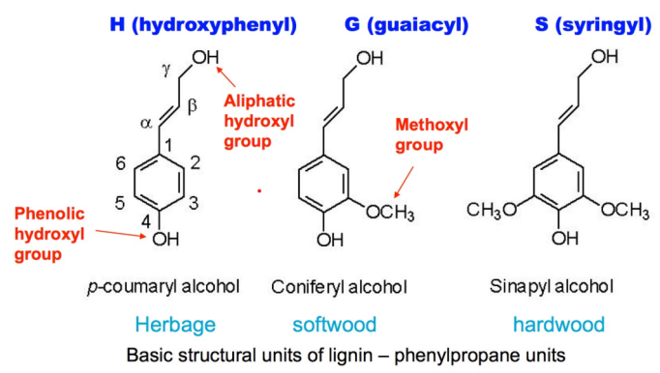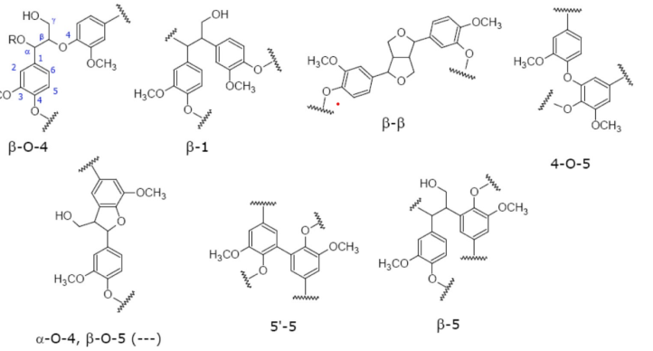

|  |  |  |  |
| --- | --- | --- | --- |
| Lignin Units | Herbaceous | Softwoods | Hardwoods |
| H Unit | 10-25% | .5-3.5% | Trace |
| G Unit | 25-50% | 90-95% | 25-50% |
| S Unit | 25-50% | 0-1% | 50-75% |

**Table 2.** Percentages of the monomer units that make up lignin [[13]](https://www.zotero.org/google-docs/?sT7mux)

There are also many different types of bonds between each of these units which can be seen in the figure above. Lignin usually has at least one percent composition of all of the bonds seen in the above figure in each polymer no matter which plant the lignin came from. This creates a heterogeneous polymer that has a complex structure and linkages, multi monomers, and multi linkages. This could lead to impurities when trying to synthesize lignin to carbon fiber. The way carbon fiber is made normally, is from the synthetic, homogeneous polymer polyacrylonitrile (PAN) and only requires heat to synthesize into carbon fibers. But because of the homogeneity of the polymer, it allows for very little amounts of impurities as long as the PAN has time to complete the reaction [[14]](https://www.zotero.org/google-docs/?8z73Mx).

Lignin may contain units which are not produced from lignin precursors known as cinnamyl alcohols. These includedihydroconiferyl alcohol, vanillin, and coniferaldehyde. These units have their own usage in various industries when isolated, but increase the number of impurities that could introduce issues during the synthesis of carbon fiber. These impurities will most likely negatively affect many of the desirable properties. Impurities can prevent fusion and flow during melt-spinning, cause defects on the surface of carbon fibers, and decrease fiber carbon yield. It was found that blending lignin from a different species can improve the fiber spinning, stabilization rates, and properties of lignin-based carbon fibers [[15]](https://www.zotero.org/google-docs/?5sW9vi).

## Recycling Carbon Fiber

Being able to synthesize carbon fiber from lignin could be a possible solution to help make carbon fiber less expensive and simultaneously be produced from renewable resources. Lignin is the second most common polymer found in nature. Still, current technologies require 14 times the energy to create carbon fiber than steel. But carbon fiber typically has a much longer life cycle, meaning it has to be replaced less often than counterpart steel products. Steel does have an advantage of being recyclable indefinitely [[16]](https://www.zotero.org/google-docs/?jgH2j7). Carbon fiber is harder to recycle as it is usually made into composites, creating an issue where it is difficult to separate the initial materials without damaging the fibers. Currently, carbon fiber is recycled either through the process of pyrolysis or solvolysis. Pyrolysis being the process of thermochemically decomposing the organic part of the composite material between 450-700 degrees celsius with little to no oxygen. Solvolysis is the use of a chemical treatment to degrade the organic part of the composite. The recycled fibers do change their properties, which would change the usage of recycled fibers vs virgin fibers. With current technology, pyrolysis and solvolysis maintain 50-85% of the tensile strength from the original fibers [[17]](https://www.zotero.org/google-docs/?2VXIll).

## How is carbon fiber made?

There are two ways that carbon fiber is currently produced in the market. The process where about 90% of the total carbon fiber is created comes from the synthetic polymer polyacrylonitrile (PAN) which is a synthetic thermoplastic polymer. It is unsure what happens in the process but it is thought that the heat causes the cyano repeat units to form cycles. PAN is converted to carbon fiber in 3 main stages of heating. Once from about 200°C to 700°C. And once more at 400-600°C. In this stage, a double bond between 2 carbon atoms is added which makes each pyridine ring contain 2 double bonds. And another time from 600 to up to 1300°C. Each cycle allows the polymer to form a sheet rather than a single chain. When the individual fibers form sheets, the nitrogens get replaced by carbon atoms and get released as N2 gas. When this happens, we are left with pure carbon in the graphite form except for the outsides of the sheet where a single nitrogen atom is left over [[18]](https://www.zotero.org/google-docs/?M622qV). This can be seen in figure 5.

**Fig 5.** Derivation of carbon fiber from PAN [[19]](https://www.zotero.org/google-docs/?YyKrWl)

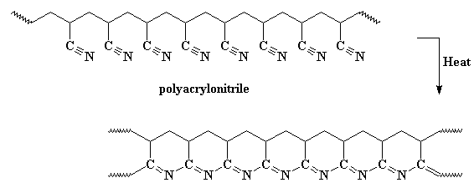

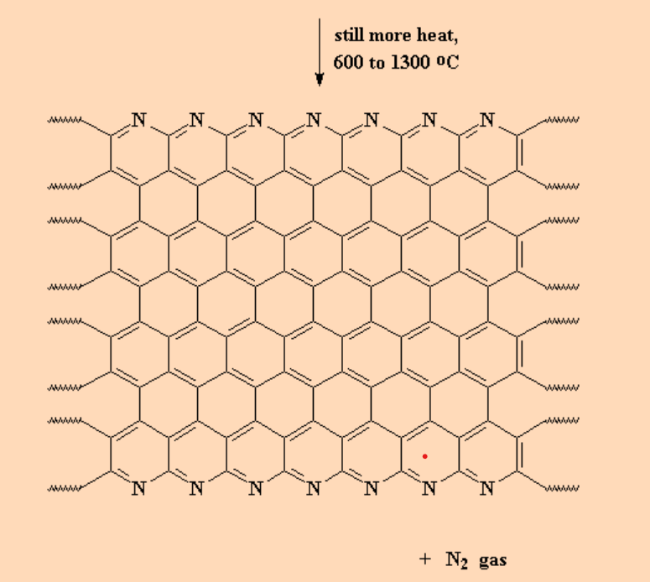

The other 10% comes from rayon or petroleum pitch. Pitch is known to have more benzene-like carbon structures than PAN which causes the carbon fiber formed from these processes to form better sheets than carbon fiber formed from PAN, where these carbon fibers are more granular. Pitch fibers are generally more crystalline than PAN fibers which allows Carbon fiber derived from pitch, to be generally stiffer but more brittle, more expensive to produce, and contain a higher electrical/thermal conductivity. There are fewer makers of pitch fibers as most companies do not have access to an oil refinery. It is also important to note that carbon fiber from pitch requires much higher heat than PAN fibers. PAN fibers require a high of 1300°C whereas pitch fibers require 2500-3000°C [[20]](https://www.zotero.org/google-docs/?Sa4nc6). It is commonly seen that these two different carbon fibers are mixed together to form a composite to influence the stiffness and strength.

**Figure 6.** Summary of the petroleum pitch process [[21]](https://www.zotero.org/google-docs/?9GlPmt)

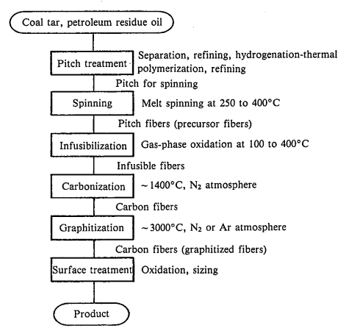

The current technology used that yields the best results is called electrospinning. This process only requires a syringe, a pump, a high voltage power source, and a collector. In our case, the lignin would be pumped out at a constant rate from the syringe. The added voltage changes the shape of the fiber and creates a Taylor cone. The fiber will eject sporadically, forming no shape which would just leave a non-woven fiber mat. The fiber would then need to be woven in another process to form a carbon fiber sheet. The fibers would then need to be coated to protect them from damage and unweaving. The coatings that are typically used with regular carbon fiber are epoxy, polyester, nylon, and urethane [[22]](https://www.zotero.org/google-docs/?KfmwSg).

**Fig. 7.** Basics of the Electrospinning Process [[23]](https://www.zotero.org/google-docs/?Zywz6o)

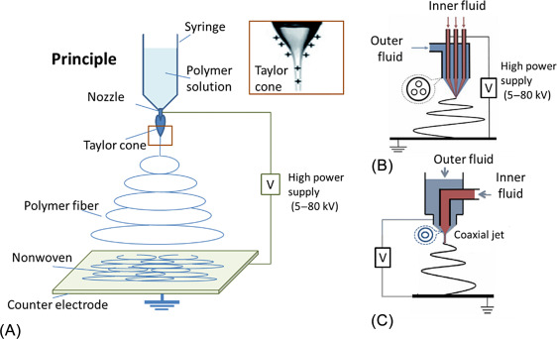

Melt-spinning is another alternative to electrospinning. This method is commonly used to manufacture fiberglass. Melt-spinning requires lignin to be fusible and without undergoing extensive thermal-induced depolymerization. Depolymerization would lead to pores on the surface of the fibers. Hardwood lignin, especially Organosolv lignin has shown to exhibit greater thermal mobility and better spinnability, while lignin from softwoods and herbaceous plants have better performance during thermostabilization and conversion processes. Organosolv lignin, because of its lower number of hydroxyl groups and phenolic acid chains, presented better spinnability. It was found that lignin with a higher concentration of G units limited the thermal mobility and caused issues during spinning. But the thermal stabilization was faster which reduced the carbon fiber production time.

Melt-spinning is a relatively simple process where the molten polymer is forced through a die at high pressure and elongated to form thin fibers. Fibers can be extruded in parallel to make the process take less time and therefore become more energy efficient. When the fibers hit the cool air, the fibers will solidify. The basic requirement to be able to use the melt-spinning process is for the polymer/s being used to be easily meltable. Melt-spinning emits polymer at a speed anywhere between 825- 4500 ft/min [[24]](https://www.zotero.org/google-docs/?TTi9Gd).

**Fig 8.** Outline of the melt-spinning process [[25]](https://www.zotero.org/google-docs/?sVFVhh)

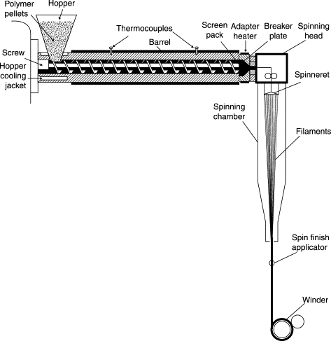

Dry-spinning and wet-spinning are used for polymers that need to be dissolved in a solvent. Both methods could be useful in laboratory settings but because they only emit polymer at a speed of 210-1200 feet per minute and require the use of solvents that would most likely be flammable and require extra washing, these processes would not be useful in a scale-up operation[[26]](https://www.zotero.org/google-docs/?9WcqbQ),[[27]](https://www.zotero.org/google-docs/?1im6nm).

**Review are not proper format.**

References

[[1] F. Yin, “Can Carbon Fiber replace Steel in Automotive &Aerospace machining | LinkedIn.” Accessed: Dec. 18, 2023. [Online]. Available: https://www.linkedin.com/pulse/can-carbon-fiber-replace-steel-automotive-aerospace-machining-yin/](https://www.zotero.org/google-docs/?5KpYIF)

[[2] “Future of Carbon Fiber | ZOLTEK Corporation.” Accessed: Dec. 18, 2023. [Online]. Available: https://zoltek.com/carbon-fiber/the-future-of-carbon-fiber/](https://www.zotero.org/google-docs/?5KpYIF)

[[3] “Online Materials Information Resource - MatWeb.” Accessed: Apr. 28, 2025. [Online]. Available: https://www.matweb.com/](https://www.zotero.org/google-docs/?5KpYIF)

[[4] McCaw, Billy, “Carbon FIber in Aerospace Applications,” *PCMI MFG*, [Online]. Available: https://www.pcmi-mfg.com/blog/carbon-fiber-in-aerospace-applications#:~:text=Carbon%20fiber%20materials%20make%20up,or%20fatigue%20like%20metals%20do](https://www.zotero.org/google-docs/?5KpYIF)

[[5] “(PDF) Advanced Composite Materials for Aerospace Applications.” Accessed: Apr. 28, 2025. [Online]. Available: https://www.researchgate.net/publication/383874153_Advanced_Composite_Materials_for_Aerospace_Applications](https://www.zotero.org/google-docs/?5KpYIF)

[[6] “NASA.” Accessed: Apr. 28, 2025. [Online]. Available: https://www.nasa.gov/](https://www.zotero.org/google-docs/?5KpYIF)

[[7] “Lignin Valorization: Improving Lignin Processing in the Biorefinery | Science.” Accessed: Apr. 28, 2025. [Online]. Available: https://www.science.org/doi/10.1126/science.1246843](https://www.zotero.org/google-docs/?5KpYIF)

[[8] “Borregaard and rayonier invest in new lignin operation.” Accessed: Apr. 28, 2025. [Online]. Available: https://www.borregaard.com/company/news-archive/borregaard-and-rayonier-invest-in-new-lignin-operation](https://www.zotero.org/google-docs/?5KpYIF)

[[9] W. Yang, Y. Zhu, Q. Wang, R. Ou, and P. Ma, “Chapter 14 - Biopolymer/nanolignin films with enhanced toughness,” in *Micro and Nanolignin in Aqueous Dispersions and Polymers*, D. Puglia, C. Santulli, and F. Sarasini, Eds., Elsevier, 2022, pp. 433–458. doi: 10.1016/B978-0-12-823702-1.00008-6.](https://www.zotero.org/google-docs/?5KpYIF)

[[10] “Lignin, the Lignification Process, and Advanced, Lignin-Based Materials.” Accessed: Apr. 28, 2025. [Online]. Available: https://www.mdpi.com/1422-0067/24/14/11668](https://www.zotero.org/google-docs/?5KpYIF)

[[11] madshansen, “BIOFUELS AND THE PROSPECT OF CONVERTING PLANT FIBRES INTO GASOLINE USING ENZYMES | SCQ.” Accessed: Apr. 28, 2025. [Online]. Available: https://www.scq.ubc.ca/biofuels-and-the-prospect-of-converting-plant-fibres-into-gasoline-using-enzymes/](https://www.zotero.org/google-docs/?5KpYIF)

[[12] A. T. Ogunbiyi, W. Li, and B. Zhang, “6 - Chemo-catalytic conversion of lignin,” in *Biomass, Biofuels, Biochemicals*, T. Bhaskar and A. Pandey, Eds., Elsevier, 2021, pp. 109–128. doi: 10.1016/B978-0-12-820294-4.00003-X.](https://www.zotero.org/google-docs/?5KpYIF)

[[13] “1 Lignocellulose and lignin composition for softwoods, hardwoods, and... | Download Table.” Accessed: Apr. 28, 2025. [Online]. Available: https://www.researchgate.net/figure/Lignocellulose-and-lignin-composition-for-softwoods-hardwoods-and-grasses-21-33_tbl1_318158851](https://www.zotero.org/google-docs/?5KpYIF)

[[14] “Carbon Fibers: Formation, Structure, and Properties.” Accessed: Apr. 28, 2025. [Online]. Available: https://www.researchgate.net/publication/327529967_Carbon_Fibers_Formation_Structure_and_Properties](https://www.zotero.org/google-docs/?5KpYIF)

[[15] “Lignin-based carbon fiber: A current overview | Request PDF.” Accessed: Apr. 28, 2025. [Online]. Available: https://www.researchgate.net/publication/324044589_Lignin-based_carbon_fiber_A_current_overview](https://www.zotero.org/google-docs/?5KpYIF)

[[16] “Comparative life cycle assessment of carbon fiber reinforced compositecomponents for automotive industry | Request PDF,” ResearchGate. Accessed: Apr. 28, 2025. [Online]. Available: https://www.researchgate.net/publication/350862535_Comparative_life_cycle_assessment_of_carbon_fiber_reinforced_compositecomponents_for_automotive_industry](https://www.zotero.org/google-docs/?5KpYIF)

[[17] S. Pimenta and S. T. Pinho, “Recycling carbon fibre reinforced polymers for structural applications: Technology review and market outlook,” *Waste Manag.*, vol. 31, no. 2, pp. 378–392, Feb. 2011, doi: 10.1016/j.wasman.2010.09.019.](https://www.zotero.org/google-docs/?5KpYIF)

[[18] “(PDF) Structural Evolution of Polyacrylonitrile Fibers in Stabilization and Carbonization,” *ResearchGate*, doi: 10.4236/aces.2012.22032.](https://www.zotero.org/google-docs/?5KpYIF)

[[19] “ISTF2006: Carbon Fiber.” Accessed: Apr. 28, 2025. [Online]. Available: http://mainland.cctt.org/istf2006/Carbon_Fiber.asp](https://www.zotero.org/google-docs/?5KpYIF)

[[20] “Carbon Fibers From Pan and Pitch,” ResearchGate. Accessed: Apr. 28, 2025. [Online]. Available: https://www.researchgate.net/publication/251160400_Carbon_Fibers_From_Pan_and_Pitch](https://www.zotero.org/google-docs/?5KpYIF)

[[21] “The main processes in the production of carbon fibers from coal and /... | Download Scientific Diagram.” Accessed: Apr. 28, 2025. [Online]. Available: https://www.researchgate.net/figure/The-main-processes-in-the-production-of-carbon-fibers-from-coal-and-or-petroleum-pitch_fig2_356635895](https://www.zotero.org/google-docs/?5KpYIF)

[[22] “Electrospun Carbon Nanofibers and Their Applications in Several Areas | ACS Omega.” Accessed: Apr. 28, 2025. [Online]. Available: https://pubs.acs.org/doi/10.1021/acsomega.3c01114](https://www.zotero.org/google-docs/?5KpYIF)

[[23] B. Joshi, E. Samuel, Y. Kim, A. L. Yarin, M. T. Swihart, and S. S. Yoon, “Progress and potential of electrospinning-derived substrate-free and binder-free lithium-ion battery electrodes,” *Chem. Eng. J.*, vol. 430, p. 132876, Feb. 2022, doi: 10.1016/j.cej.2021.132876.](https://www.zotero.org/google-docs/?5KpYIF)

[[24] “A Review on Melt-Spun Biodegradable Fibers.” Accessed: Apr. 28, 2025. [Online]. Available: https://www.mdpi.com/2071-1050/15/19/14474](https://www.zotero.org/google-docs/?5KpYIF)

[[25] A. Rawal and S. Mukhopadhyay, “4 - Melt spinning of synthetic polymeric filaments,” in *Advances in Filament Yarn Spinning of Textiles and Polymers*, D. Zhang, Ed., Woodhead Publishing, 2014, pp. 75–99. doi: 10.1533/9780857099174.2.75.](https://www.zotero.org/google-docs/?5KpYIF)

[[26] Y. Imura, R. M. C. Hogan, and M. Jaffe, “10 - Dry spinning of synthetic polymer fibers,” in *Advances in Filament Yarn Spinning of Textiles and Polymers*, D. Zhang, Ed., Woodhead Publishing, 2014, pp. 187–202. doi: 10.1533/9780857099174.2.187.](https://www.zotero.org/google-docs/?5KpYIF)

[[27] A. RohaniShirvan, A. Nouri, and A. Sutti, “A perspective on the wet spinning process and its advancements in biomedical sciences,” *Eur. Polym. J.*, vol. 181, p. 111681, Dec. 2022, doi: 10.1016/j.eurpolymj.2022.111681.](https://www.zotero.org/google-docs/?5KpYIF)

**Reference are wrong format.**