Bibliometric Analysis of Coastal Protection Building Types at Oil and Gas Logistics Ports Using VOSviewer

|  |
| --- |
| Bibliometric analysis is a statistical technique enabling quantitative assessment of research papers on a specific subject using a mathematical approach. The outcomes of bibliometric analysis manifest as visual mappings of networks, periods, and data density, presented in graph form. This research utilized the VOSviewer application, specialized software designed for visualizing and analyzing bibliometric networks, to generate research mapping. The identification of research sources was facilitated through the Publish or Perish application. The primary objective of this study is to discern the contemporary research trends concerning the selection of building types for coastal protection, along with associated indicators. This is achieved through a bibliometric analysis employing the Publish or Perish search tool, supplemented by VOSviewer software, to explore global research developments comprehensively. The bibliometric approach provides a quantitative foundation conducive to meta-analyses, mainly supporting research that scrutinizes building types for coastal protection in port environments. By discerning trends in research, collaborations among researchers, and impactful works through citation, network, and keyword analyses, this study aims to gain insights and guide further advancements in selecting building types for coastal protection at ports. Research sources encompass civil engineering journals globally, with bibliometric analysis methods as the primary means for mapping relevant literature and information. Top Top of Formresearch trends related to coastal protection building type analysis are often visualized across Europe, particularly in 2021. This was due to many policy changes, technological advances, and global events, including a significant increase in COVID-19 cases that began that year. |

*Keywords: Ports; Coastal Protection Buildings; Shoreline Changes; Abrasion; Erosion*

1. INTRODUCTION

Ports are central to the country's economic growth (Fratila, Gavril, Nita, & Hrebenciuc, 2021). Ports serve as custodians for both workers and communities, bolstering and upholding socioeconomic priorities (Ma, Jia, She, Haralambides, & Kuang, 2021). Numerous ports manage seaborne commerce as gateways to international trade, with 80% of global work conducted via maritime routes. Furthermore, there is a consistent 4% growth in international seaborne business (Yau, Peng, Qadir, Low, & Ling, Towards Smart Port Infrastructures: Enhancing Port Activities Using Information and Communications Technology, 2020). More than 2,200 European port operators engage a workforce exceeding 110,000 individuals dedicated to loading and unloading ships and providing port-based services such as warehousing and logistics. During the year 2018, a total of approximately 98,140 vessels facilitated the transportation of 11 billion tons of seaborne trade. These statistics denote a significant contribution to global business, comprising about 80% of volume and 60-70% of its corresponding value (Alamoush, Ballini, & Ölçer, 2021). Concurrently, maritime transportation catalyses economic expansion among regions and nations. Fuelled by globalization and containerization, international seaborne trade attained 10.7 billion tons in 2017, exhibiting a growth rate of 4 percent over the preceding five years (Lim, Pettit, Abouarghoub, & Beresford). The port is considered an essential national infrastructure. For economic development for communities living in coastal areas and shipping activities where the loading and unloading of goods takes place, port authorities are under increasing pressure to address the negative environmental and social impacts associated with the operation and development of the port (Lawer, Herbeck, & Flitner, 2019). The development and operation of ports are not only guided by economic considerations. Still, they must follow environmental and energy regulations to monitor and mitigate the negative impacts of their activities and operations (Lalla-Ruiz, Heilig, & Voß, 2018).

Coastal regions, recognized as the most intricate and dynamic natural surface systems, represent transitional zones where land interfaces with the sea (Yang, et al., 2023). These areas are abundant in natural resources and hold significant economic value in sustaining the livelihoods of coastal communities (Rumahorbo, Warpur, & Hamuna, Detection of Shoreline Changes due to Abrasion and Accretion Using Landsat Imagery – A Case Study in the Coastal Areas of Supiori Regency, Indonesia, 2023). As the interface between land and sea, coastal areas exhibit diverse shapes. They are markedly influenced by waves, ocean currents, tides, storms, and other physical processes inherent to coastal environments (Rumahorbo, Hamuna, & Keiluhu, An assessment of the coastal ecosystem services of Jayapura City, Papua Province, Indonesia, 2020). Hence, coastal areas are susceptible to environmental influences due to their positioning in the transitional zone between terrestrial and marine environments. As per the research findings, despite covering less than 20% of the Earth's land surface, coastal areas accommodate over 45% of the global population. Scholars approximate that approximately 39% of the world's human population resides within a proximity of 100 kilometers from coastlines (Ahmed, Howlader, Al-Amin Hoque, & Pradhan). This rapid development is driven by the pressing demands of diverse human necessities, including establishing port areas. A noteworthy observation is that over 70% of global coastal regions exhibit a persistent tendency toward long-term erosion. This phenomenon is attributed to the ongoing discharge of coastal materials, such as sand or clay, subjected to the impact of ocean waves and alterations in the equilibrium of sediment transport within coastal waters. The consequential loss of land in coastal regions is commonly referred to as abrasion (Sui, Wang, Yang, & Wang, 2020). Bruise is caused by human activities (anthropogenic) such as mangrove logging, inshore coral harvesting, port construction, and other coastal buildings (CAHYANINGSIH, et al., 2022).

The environmental impact caused by port activities, docking vessels, and emissions from intermodal transportation serving the port's interior is causing changes in the coastline (Nogué-Algueró, 2020). The shoreline at the port site can be subjected to various ship-induced forces. These forces result from waves generated at the bow and stern of the ship, a decrease in the water level or withdrawal from the vessel's displacement, and an increase in the speed of both the wave and the return speed. Return speed, such as withdrawal, results from a moving ship moving water as it moves forward (Maynord, 2007). Changes in the port's coastline can affect the waters' depth around the port (Galiatsatou, Makris, Krestenitis, Prinos, & Aretxabaleta, 2021). The lack of water depth makes it difficult for large ships to enter and exit the port. It can affect ship navigation around the harbor by appearing in shallow areas due to coastal accretion, an obstacle for ships to lean. To prevent damage caused by sea waves, several protection solutions can be chosen according to the purpose of coastal area land use, such as prevention, land use arrangements and coastal area buildings, coastal protection in the form of non-structural greenbelt buildings and structural buildings for strengthening coastal areas such as making coastal protection buildings such as breakwaters, groins, jetties, quay walls, Seawall, Sea Dike, Dolphin and Revetment (Basco, 2020).

By making coastal protection buildings, increasing sediment supply, and carrying out integrated coastal management, coastal structures can protect the beach against damage due to wave attacks and currents from ships that will lean (AbSaragi, et al., 2022). In choosing the type of coastal protection building at the port location so that the installation can function optimally, it is necessary to consider the problems that exist on the beach under study, namely If the situation arises due to the transportation of perpendicular coastal sediment that causes beach abrasion (Elnabwy, et al., 2020), So proper beach security is a form of beach crossing such as seawalls, revetments, and breakwaters. Beach-aligned buildings used in ports that effectively protect the coast due to waves coming perpendicular or obliquely to the shoreline and occur due to sediment transport along or parallel to the coast, which results in sediment transfer (erosion) (Prats & Serra, 2020), the suitable beach security is a dolphin, jetty, and quay wall. This perpendicular coastal building protects the coast due to longshore transport generated by breaking waves obliquely against the coastline (Almarshed, Figlus, Miller, & Verhagen, 2020). It can be used to determine the shape of the hypotenuse breakwater. The hypotenuse building is suitable for use in water conditions that are not too deep and suitable for beaches with soft bottom soil. At the same time, parallel positions can help prevent tombolo formation (Lestari, Hisyam, & Gunawan, 2022).

This study aims to determine the development of research trends related to choosing the type of coastal protection building and other relevant indicators with the primary source in the search for research using Publish or Perish, with the next stage using VOSviewer software. The insights derived from bibliometric studies can look at the latest and most recent research developments in the world thoroughly and offer a quantitative foundation for conducting meta-analyses to advance further research addressing the analysis of coastal protection building types in ports. Consequently, bibliometric analysis is valuable for furnishing datasets that can enhance scholarly research quality. By identifying dominant research trends, significant collaborations between researchers, and works that have a major impact in this field through citation analysis methods, network analysis, and keyword analysis to understand the latest research developments and better development directions in selecting coastal protection building types at the port.

2. LITERATURE REVIEW

2.1 Port Growth and Development

Over the past five years, a large amount of literature has emerged that discusses the development of the port in various ways. Port development and activities are exciting research in building economic growth in Indonesia [23]. Port is one of the infrastructures that can support the National Logistics System in Indonesia because Indonesia is an archipelagic country [24]. As an island nation, it faces severe challenges in achieving the efficiency of the maritime logistics system. Indonesia is ranked 46th for logistics performance globally or number 4 in Southeast Asia, following Singapore, Thailand, and Malaysia, according to the World Bank (2018) [25]. Logistics plays a role in the movement of goods flows within and outside the country [26]. The conceptualization of ports through a logistics approach and supply chain management has much to do with port performance [27]. The Indonesian government has enacted the Indonesian Maritime Policy through Presidential Regulation Number 16 of 2017, adopted on February 23, 2017. This policy serves as a strategic framework for realizing the objectives outlined in the global marine agenda. It emphasizes that Indonesia's maritime economy extends beyond a mere focus on natural resources; instead, it includes developing these resources into a comprehensive system encompassing port logistics [28].

The improvement or development of the port has been carried out significantly, and in-depth knowledge is required to investigate trends affecting port development and the economy during COVID-19 [29]. Likewise, numerous research initiatives have been launched to scrutinize the progress of seaports, dry ports, and development corridors and their implications on regional development in India. Notably, scholars such as Dwarakisha and Salim have thoroughly investigated the pivotal role of ports in the comprehensive development of a nation. The port has significantly contributed to Indonesia's economic growth, dating back to the colonial era. During the Dutch colonial rule, sophisticated port management systems and maritime logistics were established to facilitate the transportation of commodities across the islands and their subsequent export to the colonial powers' home countries [31]. Indonesia's largest port for cargo traffic is located at Tanjung Priok, and its growth trend is increasing, especially for container cargo. This port has attracted many companies to search nearby. The Indonesian government provides a particular area as an option for these companies to do business, called Kawasan Berikat Nusantara (KBN, Jakarta, Indonesia) [32]. The loading and loading activities of goods and the berthing of large ships affect the coastal dynamics and changes in the coastline [33].

Sea transport is an essential component of the worldwide transportation network. Sea transport, including deep-sea and short-sea shipping, has significantly facilitated European economic progress and prosperity [34]. Maritime transport enables the movement of considerably larger volumes than alternative modes such as air, rail, or road transport. Advancements in naval engineering have played a crucial role in the substantial growth of the shipping sector. Ocean transport constitutes 80% of global goods transportation, facilitating the annual movement of 10 billion tons of cargo [35]. International shipping routes have evolved into highly trafficked pathways across the world's oceans, complemented by the development of ports. These interconnected ports play a crucial role in linking global economies and facilitating the swift expansion of international trade, driving the demand for ocean transportation. Current projections anticipate a demand growth of nearly 40% for seaborne business by 2050 [36].

The escalating expansion of international trade underscores the profound significance of maritime logistics, given that over 85% of the world's cargo traffic is conducted via sea routes and ports. The energy demand associated with international shipping, encompassing ports, has exhibited an average annual increase of 1.6% between 2000 and 2015 [37]. As the global economy increasingly relies on sea transportation, ports encounter mounting pressure to enhance their efficiency in addressing economic, environmental, energy, and functional challenges that influence sustainability. Researchers are exploring the concept of intelligent ports as a progressive development in port infrastructure [38]. Smart ports are integral to intelligent cities that leverage technological innovations to enhance port activities and services. The overarching goal is to provide a socioeconomic uplift to cities and regions, fostering improved international trade competitiveness by integrating advanced technologies [39]. An internationally acknowledged standard definition for a smart port is currently unavailable. However, UNESCAP (2021) states that an intelligent port autonomously manages port operations and enhances logistics flows by applying innovative and advanced technologies [40].

2.2 Causes of Coastline Change

Earlier studies indicated that as an archipelagic nation, Indonesia, comprising 17,258 islands with approximately two-thirds of its territory consisting of the sea, should receive a positive response in enhancing transportation infrastructure, particularly in the maritime sector [41]. The beach will experience damage such as abrasion or erosion caused by natural or human intervention factors. Und beaches are estimated to erode by 0.6 meters annually worldwide [42]. Port development has a negative impact in the form of changes in sea flow patterns, waves, and instabilities in coastlines, mainly due to port pools and breakwater construction. One of the negative implications of this development is the change in coastline. The loading and unloading of goods and the docking of large ships at the port will affect coastal dynamics processes such as coastline changes. This is evidenced by looking at the condition of the waters in Kendal Port, which experience silting caused by sedimentation and abrasion processes.

Kendal waters are included in the waters of the North Coast of Java Island, where the seas have a predominantly shallow depth due to high abrasion on land that carries sediments into the sea [43]. Changes in the coastline in the port can be abrasion or accretion [44], Where abrasion occurs due to sea currents and residential areas, resulting in coastal erosion. In contrast, aggregation occurs due to port activities around the waters, which cause more sediment accumulation around the seas [45]. Coastal abrasion refers to the erosion of coastal areas resulting from the persistent impact of waves on the coastline. This abrasion typically affects coastal regions lacking protective beaches [46], leading to flooding and erosion. Generally, beach abrasion can be attributed to two primary factors: natural processes and human activities. Instances of beach abrasion are widespread, with the United Kingdom experiencing an estimated 17% of shoreline change due to coastal erosion, while in Ireland, the estimate is 20% [47].

In its conceptualization, sedimentation comprises various viewpoints, with individuals presenting distinct interpretations and insights into the phenomenon. Sedimentation entails introducing sediment loads into a specific aquatic environment through water media, resulting in their deposition in environmental media. Significantly, sediment predominantly influences coastal morphology, encompassing topography and bathymetry. Coastal sediment transport concerns the displacement of sediments in coastal areas propelled by the waves and currents they generate. This investigation centers on sediment transport occurring in the region between the breaking wave and the coastline. Coastal sediments can be classified as undergoing onshore, offshore, and long-coast transport. The movement to and from the coast typically demonstrates an average direction perpendicular to the coastline, while the action along the beach follows a more intermediate trend along the coast. Calculating coastal sediment transport involves employing the empirical equation for longshore sediment transport [48].

The expanding practice of coastal reclamation in Indonesia aims to augment natural and economic resources as part of coastal management and enhance the surrounding communities' well-being. The progression of coastal reclamation brings about positive outcomes and negative repercussions. These include the disturbance of coastal ecosystems, heightened risk of flooding, alterations in ocean current patterns, changes in sedimentation rates, modifications and degradation of seawater quality, the proliferation of invasive species, social conflicts, disruption of shipping lanes, and impact on the natural resources associated with capture fisheries [49]. Beach reclamation represents an endeavour to convert unproductive and waterlogged land into a functional area through methods such as drying or landfilling. The primary objective of reclamation is to create a resilient landscape that harmonizes aesthetically and environmentally with the adjacent undisturbed area. The land reclamation process encompasses landscaping, physical stabilization, monitoring of groundwater and surface quality, erosion control, restoration of topsoil, introduction of suitable plant species through revegetation, and establishment of wildlife habitats [50]. Common sites for marine environment reclamation include coastal and offshore marine environments. According to the 2007 Coastal Area Management Law, the authorization for reclamation is contingent upon demonstrating that the accrued social and economic benefits outweigh the associated social and economic costs [51].

2.3 Coastal Protection Building Type

Coastal protection buildings are used to protect the beach against damage due to wave attacks and sea currents. They are made of masonry, concrete, concrete pipe piles, turnips, wood, and natural stone piles. Coastal protection buildings built around the port can also be called piers. Piers along the coastal zone are essential for establishing safe and efficient navigation channels and port areas. The presence of docks can change the hydrodynamic regime, and sediment erosion and deposition are consequently created or redistributed [52]. Constructing piers can alter the direction of tidal-induced currents, influence changes in bed levels, and instigate sedimentation and erosion processes. Additionally, it may diminish wave height and flushing rates while concurrently amplifying sedimentation and pollution [53].

Some types of coastal protection buildings in the port include ponds (groin), sea walls, slope reinforcement (revetment), breakwaters, Protective Pillars (Dolphin), Jetties, and port embankments (quay wall) [54]. Of the seven, the quay wall is the most numerous in Indonesian ports, usually for large docks, and the second is the jetty, which is in more remote areas [55]. The type of coastal building is generally determined by the availability of materials at the job site, seabed conditions, water depth, and equipment for the execution of the work. Crushed stone is one of the primary materials used to make buildings. Another critical factor is the characteristics of the seabed that support such structures under the influence of waves.

Quay wall is erected with a structure parallel to the coast in the form of a wall consisting of a beach with concrete caisson construction or piles of steel sheets and provides a solid berth for ships docked in the harbor. Coastal protective buildings such as quay walls are often called natural harbors, usually located in unsloping coastal locations not too far from the shoreline. Various quay walls serve the purpose of mooring and berthing floating vessels, including barges, container ships, and general cargo ships. These quay walls constitute integral components of port infrastructure, and their demand is rising due to escalating cargo volumes and larger ship sizes. The construction of a quay wall involves a deep foundation system utilizing reinforced hollow cylindrical steel piles for offshore landing piers and concrete sheet piles for coastal protection projects. These structures are crucial in providing ballast for cargo ships' mooring in transporting final oil and gas products [56].Top of Form

While a jetty is a coastal protection building that protrudes into the sea or river from the beach or harbor, jetties are often built using stone, concrete, or other construction materials. Jetties are also often used to lean passenger ships that do not require robust construction to accommodate heavy cargo goods. Traditionally, the fishing port of Pekalongan has held a prominent status as one of the largest traditional ports in Southeast Asia. The estuary of the Pekalongan River features a Jetty designed to shield coastal areas from the impact of waves and sediments [57]. Based on the type, jetties are divided into 2, namely rubble and rigid. Heap-type jetties are divided into two types based on the material: natural materials (stone) and concrete blocks. In comparison, rigid-type jetties are divided into two types, namely concrete walls and river masonry. Material selection depends on environmental conditions, material availability, and budget allocation.

3. Materials and Methods

This research uses this method by sending sources from around the world in journals and courses. The journals listed are based on research topics studied in civil engineering [58]. Research on the types of coastal protection buildings most widely used at the port will use bibliometric analysis methodologies to map the literature review and information needed. Bibliometric analysis is a statistical method that can quantitatively analyze a person's concern about a particular topic through mathematical means [59]. The results of the bibliometric analysis mapping will later be reviewed from the visual form of the network and period to density processed in the form of graphs and detailed data.

By identifying dominant research trends, significant collaborations between researchers, and works that have a major impact in this field through citation analysis methods, network analysis, and keyword analysis to understand the latest research developments and better development directions in selecting Coastal protection building types. Visualizing images and graphs with quantitative data processing will change the data collected. The relationship between analysis and quantitative methods becomes very related because this research requires data that will produce numbers.

This research employed the VOSviewer application to generate mapping outcomes for the study. VOSviewer is a software tool for visualizing and analyzing bibliometric networks [60]. With VOSviewer, researchers can import bibliometric data from various sources, such as scientific databases and research websites, to produce interactive visualizations in network maps. The software helps users to analyze and visualize the relationship between scientific journals based on citations and collaboration between authors. Network maps generated by VOSviewer can assist researchers in understanding relationships between journals, such as citation patterns, collaboration density, and author centrality within the network. VOSviewer is particularly useful for researchers and academics in bibliometric analysis and network mapping.

The application that will be used to find this research's source is the Publish or Perish application. This application helps measure the performance of journal publications by providing metrics such as the number of citations and indexes and assisting researchers in finding journals relevant to the publication of researchers' journal works. Use the Publish or Perish application to search for publication works that you want to analyze and evaluate by entering keywords from the research to be done in the "search" option. The application will search relevant databases to gather the necessary information for bibliometric analysis, research trends, and collaboration between researchers and academic networks. The results of the collected data will later be processed again using the VOSviewer application.

4. results and discussion

The results and discussions from this research are based on data generated by the Publish or Perish application and VOSviewer. Data is collected with the help of various keywords entered, such as coastal protection buildings, port development, changes in coastline, coastal engineering, abrasion, sediment, and abrasion. Results from using the Publish or Perish app can include metrics such as publication jumps, citation indexes, journal impact factors, and other metrics that provide an overview of the impact and productivity of a person's research. Then, network with the VOSviewer application, presenting data in network visualizations or maps showing relationships between elements, such as keywords or authors. VOSviewer will provide a visual overview of the structure and patterns of interconnectedness in scientific literature.

After conducting research through the VOSviewer and Publish or Perish applications, the data needed as data processing material was obtained. The resulting data includes the author’s name, journal title, number of publications, citation index, H-index, network map, quantitative metrics, linkage matrix, and Histogram. Then, the data is imported into the following application, Microsoft Excel, to facilitate data processing and presentation. Data processed is then converted into images, tables, and graphs to promote education on data processing results.

**4.1 Relationship Between Research Keywords**

In this section, descriptive and evaluative analysis is generated using the VOSviewer application, v, which visually visualizes the network of relationships between keywords, as shown in Figure 1. This visualization is generated from the database after going through the filtering stage by the Publish or Perish application. Keyword selection occurs based on events and levels of relevance during the screening process, which also determines the size or complexity of the network in the visualization results.

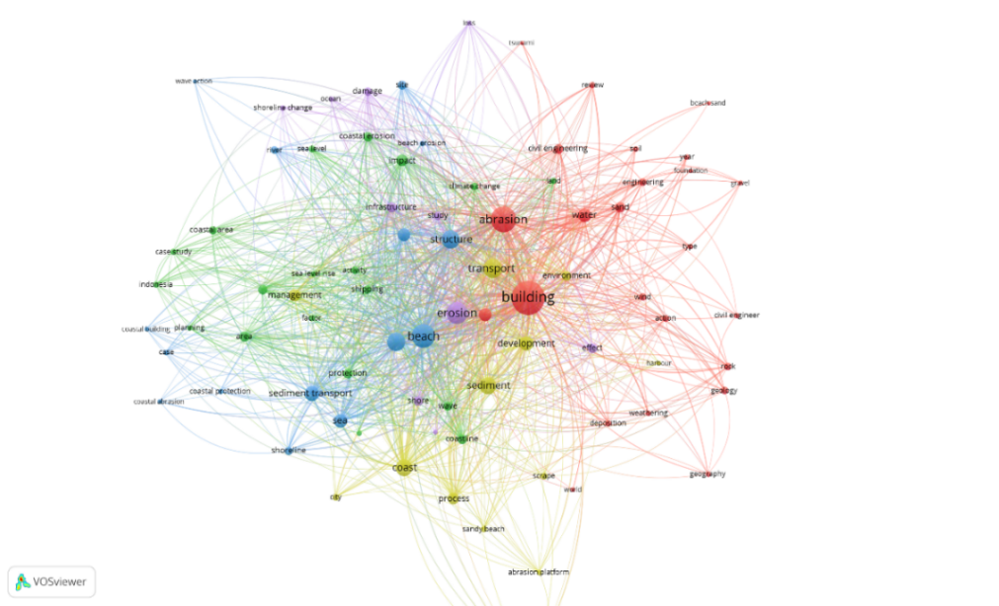

**Fig. 1. Network visualization of co-word**

The results of network visualization in Figure 1 above show the relationship and interaction between keywords in a dataset to identify related keyword clusters. The first keyword in Figure 1 is building, which has a significant influence and is related to other keywords. Furthermore, the second keyword is abrasion and beach, followed by the third keyword, erosion and transport. This can be adjusted to the research focus on analyzing coastal protection building types in the next few years. This visualization aims to present graphically and structurally the relationships and interactions between elements in a dataset using research keywords.

**Fig. 2. Keyword graph by event**

In Figure 2, there are visualization results that present visual information in graphic form related to keywords related to events that have been successfully selected based on their frequency and relevance. The keyword that appears most often is sediment transportation, with 119 occurrences in each study. This finding is the foundation for determining the main keywords in this type of coastal protection building analysis research framework.

**Fig. 3. Keyword graph by relevance**

The visualization results in Figure 3 above illustrate that the relevance-based foundation keyword emerges as the most dominant frequency and the extent to which it is relevant to the context or data available. These two graphs show various other keywords with varying levels of occurrence and relevance, showing that although the significance level is not so striking, it is still related to the scope of the study.

**4.2 Collection of Publications in Each Year**

Dissemination of research analysis results by year using the VOSviewer application. The data obtained through VOSviewer is used to analyze the number of global research publications annually. Data from the selection of international research journals are calculated cumulatively and presented through Microsoft Excel in graphic form, facilitating the visualization of results. The data processing results from 2002 to 2023 are shown in Figure 4 in the graph below.

**Fig. 4. Cumulative data of research from different years**

The graphic data in Figure 4 shows that in the networking year, from 2000 to 2023, there were 989 journals. The study circulation in the past 23 years illustrates variations that include periods of decline and increase each year. It can be seen in Figure 4 that a substantial increase occurred in the last ten years, from 2014 to 2023, with the highest research year taking place in 2021 of 66 studies. A less drastic decline lasted for nine years, from 2000 to 2009. Research publications on coastal protection building type analysis peaked in 2021 with 66 journals. This increase can be attributed to many policy changes, technological developments, and global events, including a significant rise in COVID-19 cases that began that year.

**4.3 Frequency of Use of Keywords in Research**

The analysis results of using VOSviewer are the frequency of keyword use in research or visualization density: coastal protection buildings, shoreline changes, sea waves, abrasion, and erosion. Researchers can compile relevant previous literature from these keywords so that the author can use it as a reference source. Visualization of research results using the VOSviewer application illustrates the density level between studies based on the keywords used. This provides a detailed picture of the relationship and concentration of relevant research themes.

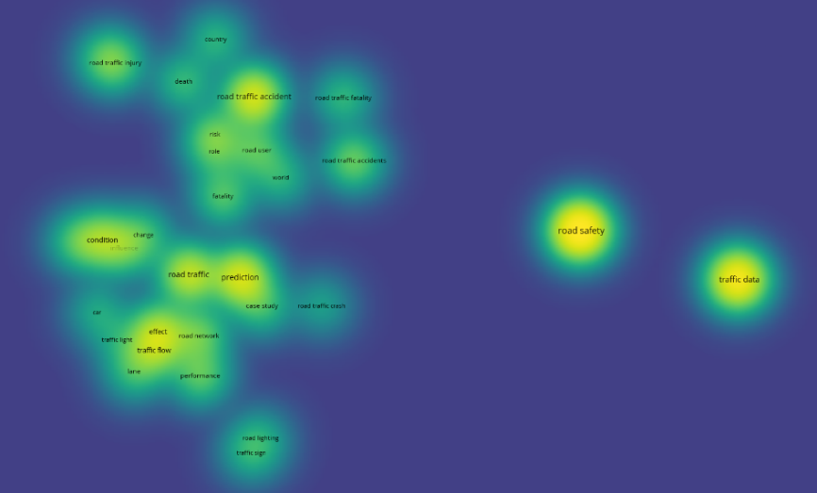

**Fig. 5. Frequency of use of keywords in research**

The result of using VOSviewer is in the form of network density in Figure 5 from clarity in a silhouette-like distribution. The tissue density level associated with creativity and thinking ability can be identified from the highest light brightness level. This reflects the era's relationship between the intensity of Light and the creative and thoughtful aspects exhibited by the network. Building, abrasion, erosion, beach, and transport are widely used in researching coastal protection buildings in the port.

**Table 1.** **Research keyword density data.**

|  |  |
| --- | --- |
| **Keywords** | **Number of Research** |
| Building | 145 |
| Abrasion | 60 |
| Erosion | 45 |
| Transport | 55 |
| Total (Percentage) | 305 (30,5%) |

Detailed data about the main keywords from the VOSviewer density visualization results above have been neatly arranged in Table 1. The results of the data in Table 1 show that there is data on the highest number of keywords found in the keyword "building," with research in as many as 145 journals. The lowest number of studies is on the keyword transport, with 30 journals.

**4.4 Study Classification by Type and Publisher**

After networking, the research collected came from a variety of different publishers. Thus, the accumulated data covers a wide variety of publishing sources. This data indicates that the diversity of publishers can provide valuable support for progress in the development of science. A combination of publishing sources creates an environment rich in diverse contributions, stimulating the holistic growth of knowledge. Data on the distribution of research publishing are presented in Table 2 below.

**Table 2. Research publisher distribution data.**

|  |  |
| --- | --- |
| **Publisher** | **Amount** |
| Google Books | 179 |
| Springer | 74 |
| ResearchGate | 42 |
| ProQuest | 42 |
| Elsevier | 36 |
| CiteSeerX | 27 |
| Academia Edu | 23 |
| ICE Virtual Library | 23 |
| NOAA Institutional Repository | 23 |
| MDPI | 21 |

This study identified various types of research, including articles, books, citations, HTML, and PDFs. These publications are also related to the publisher's source of each study. Therefore, in analysing the types of coastal protection buildings in the next few years, information, references, and literature sources will be drawn from various types of research that have been netted. The graph in Figure 6 below provides an overview of the research types identified in this study, creating a solid foundation for in-depth analysis and a holistic understanding of the topic—top of form.

**Fig. 6. Classification of research types**

**4.5 Relationships Between Authors in A Field of Research**

One of the conclusions obtained from the VOSviewer analysis relates to the relationships between authors in a research domain. Considering the significant amount of research and publishing, the results of the emerging network of authors from research journals can be observed. The results of this network visualization illustrate patterns of connection and collaboration between authors involved in a scientific field or unique topic. This network map is essential to deepening understanding of the dynamics of collaborative relationships among researchers and research groups in an academic context.

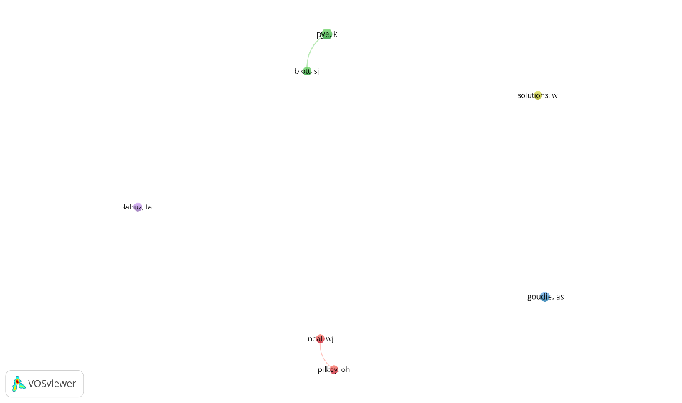

**Fig. 7. Co-author network visualization**

From the visualization results in Figure 7 above, the nodes in the author's name have the same magnitude. This shows that the seven authors related to analyzing the type of coastal protection buildings in the port are similar. The relationships between nodes in a network map are usually represented by lines or arrows connecting one node to another. There are four nodes with two related green nodes and two related red nodes, and this indicates a relationship, collaboration between authors, or interaction between authors in a particular research domain or topic. Meanwhile, nodes that do not have arrow lines are caused by the research dataset being too small or limited, and the collaboration data or institutional affiliation needs to be completed. Meanwhile, nodes that do not have arrow lines are caused by continental and regional differences in the author's research of a journal or article.

4. Conclusion

In summarizing this research, bibliometric analysis has provided an in-depth look related to the network of research topics, the relevance of literature sources, and the latest developments in research on the impact of lane widening on sustainable road performance. The results of this study make an essential contribution to understanding and developing our knowledge of the critical aspects involved in the topic. Thus, this research becomes a valuable foundation for further research and policy development that focuses on selecting the type of coastal protection building in the port. Publish or Perish produced 1000 research articles from 2000 to 2023, comprising 469 research journals, 188 books, 98 PDFs, 26 HTML, and 25 Citations. Data is also distributed to research publishers, totalling 537 from 13 publishers. The data results are then processed using the VOSviewer application, which produces five dominant research keywords in the network map: building, abrasion, erosion, beach, and transport. Based on the data of the research year on the analysis of coastal protection building types, it can be concluded that development continues from 2000 to 2023. The number of studies has increased significantly, peaking with 66 studies in 2021. During this period, seven authors were involved in this investigation. In network maps between authors, there are cases where the relationship between authors is indicated by interconnected lines, while there are also situations where some authors have unclear line linkages. Nonetheless, these lines still reflect the degree of similarity or interconnectedness among these authors.

References

AbSaragi, Y., Sidabutar, R. A., Pasaribu, H., Hutagalung, B., Simanjuntak, S., & Lumbangaol, P. (2022). Selection of Beach Safety Building Type Sigapiton Village, Toba Regency. Journal of Community Service, 2(1), 24-33.

Achmadi, T., & Khaqiqi, A. S. (2020). Calculation Model for Port Concession Application in Indonesia. Scientific Journal of Maritime Technology, 14(2), 73-82.

Ahmed, N., Howlader, N., Al-Amin Hoque, M., & Pradhan, B. (n.d.). Coastal erosion vulnerability assessment along the eastern coast of Bangladesh using geospatial techniques .

Akbar, S. A., Wiyono, R. U., & Hidayah, E. (2023). Planning of Beach Protector Building in Pesisir Besuki Village, Situbondo Regency. TERAS JOURNAL, 13(1), 85-98.

Alamoush, A. S., Ballini, F., & Olcher, A. I. (2021). Revisiting port sustainability as a foundation for the implementation of the United Nations Sustainable Development Goals (UN SDGs). Journal of Shipping and Trade, 6(1).

Almarshed, B., Figlus, J., Miller, J., & Verhagen, H. J. (2020). Innovative Coastal Risk Reduction through Hybrid Design: Combining Sand Cover and Structural Defenses. Journal of Coastal Research, 36(1), 174-188.

Amin, C., Mulyati, H., Anggraini, E., & Kusumastanto, T. (2021). Impact of maritime logistics on archipelagic economic development in eastern Indonesia. The Asian Journal of Shipping and Logistics, 37(2), 157-164.

António, M. H., Fernandes, E. H., & Muelbert, J. H. (2020). Impact of jetty configuration changes on the hydrodynamics of the subtropical patos lagoon estuary, Brazil. Water (Switzerland), 12(11), 1-27.

Arianto, D., Marpaung, E., Malisan, J., Humang, W. P., Puriningsih, F. S., Mutharuddin, . . . Kurniawan, A. (2022). Cost Efficiency and CO2 Emission Reduction in Short Sea Shipping: Evidence from Ciwandan Port–Panjang Port Routes, Indonesia. Sustainability (Switzerland), 14(10).

Basco, D. (2020). Design of Coastal Hazard Mitigation Alternatives for Rising Seas.

CAHYANINGSIH, A. P., DEANOVA, A. K., PRISTIAWATI, C. M., ULUMUDDIN, Y. I., KUSUMAWATI, L., & SETYAWAN, A. D. (2022). Review: Causes and impacts of anthropogenic activities on mangrove deforestation and degradation in Indonesia. International Journal of Bonorowo Wetlands, 12(1), 12-22.

Cullinane, K., & Haralambides, H. (2021). Global trends in maritime and port economics: the COVID-19 pandemic and beyond. Maritime Economics and Logistics, 23(3), 369-380.

Elnabwy, M. T., Elbeltagi, E., El Banna, M. M., Elshikh, M. M., Motawa, I., & Kaloop, M. R. (2020). An approach based on landsat images for shoreline monitoring to support integrated coastal management - A case study, ezbet elborg, nile delta, Egypt. ISPRS International Journal of Geo-Information, 9(4).

Fajrunnajah, M. (2020). THE DOCK CONSTRUCTION OF INTER-ISLAND IN INDONESIA. Applied Research on Civil Engineering and Environment, 02(01), 1-3.

Fancello, G., Serra, P., Aramu, V., & Vitiello, D. M. (2021). Evaluating the efficiency of Mediterranean container ports using data envelopment analysis. Competition and Regulation in Network Industries, 22(3-4), 163-188.

Fratila, A., Gavriil, I., Nita, S., & Hrebenciuc, A. (2021). The importance of maritime transport for economic growth in the european union: A panel data analysis. Sustainability (Switzerland), 13(14).

Galiatsatou, P., Makris, C., Krestenitis, Y., Prinos, P., & Aretxabaleta, L. (2021). Marine Science and Engineering Nonstationary Extreme Value Analysis of Nearshore Sea-State Parameters under the Effects of Climate Change: Application to the Greek Coastal Zone and Port Structures. J. Mar. Sci. Eng, 9.

Indrawan, I. N., Damayanti, A., & Rustanto, A. (2019). Abrasion and accretion at West of Buleleng subdistrict's coastal area, Bali (case study: Gerokgak Regency, Seririt Regency, Banjar Regency, and Buleleng Regency). IOP Conference Series: Earth and Environmental Science, 311(1).

Iris, C., & Lam, J. S. (2019). A review of energy efficiency in ports: operational strategies, technologies and energy management systems.

Irsadi, A., Anggoro, S., Soeprobowati, T. R., Helmi, M., & Khair, A. S. (2019). Shoreline and mangrove analysis along semarang-demak, Indonesia for sustainable environmental management. Jurnal Pendidikan IPA Indonesia, 8(1), 1-11.

Irsadi, A., Martuti, N. K., Abdullah, M., & Hadiyanti, L. N. (2022). Abrasion and Accretion Analysis in Demak, Indonesia Coastal for Mitigation and Environmental Adaptation. Nature Environment and Pollution Technology, 21(2), 633-641.

Kurniati, P. S., Saputra, H., & Fauzan, T. A. (2022). A Bibliometric Analysis of Chemistry Industry Research Using Vosviewer Application with Publish or Perish. Moroccan Journal of Chemistry, 10(3), 428-441.

Lalla-Ruiz, E., Heilig, L., & Voß, S. (2018). Environmental Sustainability in Ports. Sustainable Transportation and Smart Logistics, 65-89.

Lawer, E. T., Herbeck, J., & Flitner, M. (2019). Selective adoption: How port authorities in Europe and West Africa engage with the globalizing 'green port' idea. Sustainability (Switzerland), 11(18).

Lestari, A. D., Hisyam, E. S., & Gunawan, I. (2022). Coastal Protection Structure Planning in the Pesaren Belinyu Coastal Area, Bangka Belitung Islands Province. Theoretical and Applied Journal of Civil Engineering, 10(2), 201-210.

Lim, S., Pettit, S., Abouarghoub, W., & Beresford, A. (n.d.). Port Sustainability and Performance: A Systematic Literature Review.

Ma, Q., Jia, P., She, X., Haralambides, H., & Kuang, H. (2021). Port integration and regional economic development: Lessons from China. Transport Policy, 110, 430-439.

Makkawan, K., & Muangpan, T. (2021). A conceptual model of smart port performance and smart port indicators in Thailand. Journal of International Logistics and Trade, 19(3), 133-146.

Maynord, S. T. (2007). Ship Forces on the Shoreline of the Savannah Harbor Project. Washington, DC: U.S. Army Engineer Research and Development Center.

Moeis, A. O., Desriani, F., Destyanto, A. R., Zagloel, T. Y., Hidayatno, A., & Sutrisno, A. (2020). Sustainability assessment of the Tanjung Priok port cluster. International Journal of Technology, 11(2), 353-363.

Molavi, A., Lim, G. J., & Race, B. (2020). A framework for building a smart port and smart port index. International Journal of Sustainable Transportation, 14(9), 686-700.

Mueller, N., Westerby, M., & Nieuwenhuijsen, M. (2023). Health impact assessments of shipping and port-sourced air pollution on a global scale: A scoping literature review. Environmental Research, 216.

Nogué-Algueró, B. (2020). Growth in the docks: ports, metabolic flows and socio-environmental impacts. Sustainability Science, 15(1), 11-30.

Ogunwole, D. A., & Akinwumi, I. I. (2019). Geotechnical characteristics of a selected shallow marine area considered for quay wall construction. IOP Conference Series: Materials Science and Engineering, 640(1).

Patawari, A. M., Anna, Z., Hindayani, P., Dhahiyat, Y., Hasan, Z., & Putri, I. A. (2022). Sustainability status of small-scale fisheries resources in Jakarta Bay, Indonesia after reclamation. Biodiversity, 23(4), 1715-1725.

Phanomphongphaisarn, N., Rukvichai, C., & Bidorn, B. (2020). Impacts of long jetties construction on shoreline change at the western coast of the gulf of Thailand. Engineering Journal, 24(4), 1-17.

Piccardi, M., Pranzini, E., & Rombai, L. (2018). Historical cartography and coastal dynamics of the Apuan littoral in the modern and contemporary periods: the port of Marina di Carrara (Tuscany, Italy). E-Perimetron, 13(1), 32-49.

Prats, F. R., & Serra, A. F. (2020). Long-term morphodynamic evolution of the Llobregat Delta under climate change conditions . Escola Tècnica Superior d'Engineering de Telecomunicació de Barcelona.

Ratnawati, E., Towadi, M. S., & Pandamdari, E. (2021). HIGHLIGHTING THE OPPORTUNITIES AND CHALLENGES OF PORT PERFORMANCE IN INDONESIA BY THE REGULATORY ASPECTS. Journal of Legal, Ethical and Regulatory Issues, 24(3).

Ricardianto, P., Fonataba, Y., Veronica, Marzuki, S., Priyohadi, N. D., Wijonarko, G., . . . Endri, E. (2023). Determinants of logistics effectiveness on port operational performance: Empirical evidence from Indonesia. Uncertain Supply Chain Management, 11(2), 799-810.

Risanti, A. A., & Marfai, M. A. (2020). The effects of hydrodynamic processes and mangrove ecosystem on sedimentation rate in Kendal coastal area, Indonesia. IOP Conference Series: Earth and Environmental Science, 451(1).

Rochwulaningsih, Y., Sulistiyono, S. T., Masruroh, N. N., & Maulany, N. N. (2019). Marine policy basis of Indonesia as a maritime state: The importance of integrated economy. Marine Policy, 108.

Rumahorbo, B. T., Hamuna, B., & Keiluhu, H. J. (2020). An assessment of the coastal ecosystem services of Jayapura City, Papua Province, Indonesia. Environmental and Socio-Economic Studies, 8(2), 45-53.

Rumahorbo, B. T., Warpur, M., & Hamuna, B. (2023). Detection of Shoreline Changes due to Abrasion and Accretion Using Landsat Imagery – A Case Study in the Coastal Areas of Supiori Regency, Indonesia. Ecological Engineering and Environmental Technology, 24(7), 161-171.

Sari, Y. A., & Pamadi, M. (2019). The Smart Port Concept of Batu Ampar Port in Batam. IOP Conference Series: Earth and Environmental Science, 343(1).

Setiawan, I. E., Zhang, Z., Corder, G., & Matsubae, K. (2021). Evaluation of environmental and economic benefits of land reclamation in the Indonesian coal mining industry. Resources, 10(6).

Sudrajat, A., Sudirman, I., & Prasetyo, R. (2020). Digitalization of Logistics Processes and Comparison with Several Asian Countries Related to Logistics Information Systems: Propositions of National Logistics System Architecture. Solid State Technology, 63(3).

Sui, L., Wang, J., Yang, X., & Wang, Z. (2020). Spatial-temporal characteristics of coastline changes in Indonesia from 1990 to 2018. Sustainability (Switzerland), 12(8), 1-28.

Sunitiyoso, Y., Nuraeni, S., Pambudi, N. F., Inayati, T., Nurdayat, I. F., Hadiansyah, F., & Tiara, A. R. (2022). Port performance factors and their interactions: A systems thinking approach. Asian Journal of Shipping and Logistics, 38(2), 107-123.

Susanti, I., Nurlatifah, A., Martono, Maryadi, E., Slamet, S. L., Siswanto, B., & Suhermat, M. (2021). Abrasion and accretion dynamics as impact of climate change in coastal area of Yogyakarta. *AIP Conference Proceedings, 2331*.

Trends and research issues of augmented reality studies in architectural and civil engineering education-A review of academic journal publications. (2019). *Applied Sciences (Switzerland), 9*(9), 2-19.

Turisno, B. E., & Dewi, I. G. (2021). Impact of coastal reclamation on environmental sustainability and tourism-based economy on the north coast of java. *International Journal of Criminology and Sociology, 10*, 695-702.

Umar, H., Baeda, A. Y., Husain, F., & Taufiqurrahman. (2020). Study of Longshore Sediment Transport on Erosion and Sedimentation Beaches in South Sulawesi. *IOP Conference Series: Materials Science and Engineering, 875*(1).

Wahyudi, R. N., Wahyudi, S. I., & Husni, F. (2019). Wave Simulation to Compare Existing and Extended Jetty in River Estuary, Pekalongan, Central Java,. *Advances in Engineering Research, 187*, 127-131.

Wesstein, R., De Gijt, J. G., Heeres, O. M., & Roubos, A. A. (2019). Relationship between the construction costs and the reliability index of quay walls. *IOP Conference Series: Materials Science and Engineering, 615*(1).

Yang, F., Zhang, L., Chen, B., Li, K., Liao, J., Mahmood, R., . . . Sutrisno, D. (2023). Long-Term Change of Coastline Length along Selected Coastal Countries of Eurasia and African Continents. *Remote Sensing, 15*(9).

Yau, K. L., Peng, S., Qadir, J., Low, Y. C., & Ling, M. H. (2020). Towards Smart Port Infrastructures: Enhancing Port Activities Using Information and Communications Technology. *IEEE Access, 8*, 83387-83404.

Yu, Y., Li, Y., Zhang, Z., Gu, Z., Zhong, H., Zha, Q., . . . Chen, E. (2020). A bibliometric analysis using VOSviewer of publications on COVID-19. *Annals of Translational Medicine, 8*(13), 816-816.