QUAIL (Coturmix coturmix) EGG SHELL AND SNAIL (Cornu asperum) SHELL USED AS ADSORBENTS IN THE TREATMENT OF OIL SPILL CONTAMINATED WATER.

PREPARATION AND CHARACTERIZATION OF ADSORBENTS FROM QUAIL EGG SHELL AND SNAIL SHELL FOR THE TREATMENT OF OIL SPILL CONTAMINATED WATER

ABSTRACT
Oil spills in oil-producing areas present major environmental risks. Various adsorbents used to clean oil spills have demonstrated significant potential in removing pollutants; however, they also present challenges such as toxicity, high cost, and non-biodegradability. This study was designed to investigate the use of cost-effective and environmentally sustainable alternatives such as Quail Egg Shell (QES) and Snail Shell (SS) as potential adsorbents for oil spill remediation.

Separately, 300g each of QES and SS samples were crushed and oven-dried at 120⁰C for 48 hours. The dried materials were ground into two particle sizes, 106µm and 425µm. The 106µm mesh size (sieve) was chosen due to its higher surface area. Fourier-transform infrared spectroscopy (FTIR) was used to charaterise the 106µmm samples and identify their major functional peaks(groups). These samples were then used for batch adsorption equilibrium studies to evaluate the effects of temperature, rotational speed, adsorbent dosage, adsorbate concentration, and contact time on adsorption efficiency. Using isotherm models, the equilibrium isotherm for the adsorption was determined. The FTIR data confirmed the presence of metal carbonyl groups at 1789.17cm⁻¹ for QES and 1642.5cm⁻¹ for SS adsorbents. respectively, for the QES and SS adsorbents(not necessary). The removal efficiency of the adsorbents ranged between 25.0–77.5% for QES and 40.0–95.0% for SS, comparable to that of commercial adsorbents. The findings also showed that both QES and SS contain high levels of metal oxides (which analysis reveals this?), which contribute to their strong recovery potential in polluted sites resulting from oil spills. As a result (not needed), Therefore QES and SS present themselves as effective alternative adsorbents because they are both(not needed), cost-efficient and environmentally sustainable.

Keywords: Adsorption, contaminants, oil spillage, snail shell, quail egg shell.

1.0 INTRODUCTION
Since the discovery of crude oil, oil spills have posed significant global challenges. These spills can result from natural disasters such as earthquakes, as well as from intentional sabotage, warfare, human error, or negligence. The majority of oil spill incidents occur during oil utilization, leading to environmental hazards and energy loss (Omole & Falode, 1998; Beyer et al., 2016). Transporting oil is particularly risky, and any spill demands swift intervention. In the aftermath of a spill, it is crucial that cleanup efforts focus on rapidly collecting or absorbing the bulk of the discharged oil (Annunciado et al., 2005).
Oil spills have caused extensive damage to marine ecosystems and have had severe economic impacts on sectors such as agriculture, tourism, and energy supply (Ayotamuno et al., 2005(2006); AlaaH-Din et al., 2017(2018)). Oil leaks via pipelines, refineries, runoff from oil spills, and occasionally process effluent from petrochemical and petroleum refineries also affect inland water bodies adversely. Existing spill removal techniques that are often employed include dispersants, oil booms, skimmers, in situ burning, and others. However, many of these adsorbents (do not require any adsorbents to operate the mentioned methods) are expensive and toxic, making them making them( Repeated) less accessible and often impractical, despite the urgent need for pollution control (Hussein et al., 2009). Moreover, the dispersants are flammable, and pose health risks to operators. They can also harm aquatic life, damage vegetation, foul shorelines, and contaminate water sources.

Adsorption has proven to be a cost-effective method of reducing the negative environmental effects of pollution and oil spill cleanups (Bhatnagar et al., 2010; Ahmad et al., 2015). One of the cheapest and most effective ways of controlling oil spills is to utilize suitable adsorbents. This is due to the adsorbents’ low water pickup, high oil uptake capacity, ease of high recovery using simple methods, reusability, good buoyancy, as well as their widespread availability and affordability (Ifelebuegu and Momoh, 2015; Bailey et al; 1999).

Oil sorbents can be classified into three main categories: inorganic mineral materials, organic natural products, and organic synthetic products. Most commercially available oil sorbents are made of organic synthetic polymers like polypropylene and polyurethane. Inorganic materials like exfoliated graphite, vermiculites, zeolites, are also utilized as oil adsorbents (Bandura, 2017; Tryba, 2003). However, many of these materials have powdery morphologies, which result in them having low oil sorption capability, low oil recovery, low reusability, and low buoyancy, complicating their use in field applications. Although exfoliated graphite and silica gel are highly effective oil sorbents, they are expensive and mostly derived from non-biodegradable sources. Due to these constraints, there has been a growing interest in finding substitute materials, particularly naturally occurring agro-based biodegradable materials.

Agricultural waste is inexpensive, readily accessible, plentiful, and often underutilized. Over time, many researchers have explored the potential of using agricultural waste-derived materials as affordable solutions for removing contaminants from oil and water. There have also been reports on how these materials may be used effectively to improve reusability, reduce disposal costs, and benefit the environment. In response, scientists and governments across several countries are collaborating to develop more effective, eco-friendly methods for oil spill cleanup (Akinsanoye, 2022, Akinsanoye et al; 2025). The current research specifically was designed to investigate the potential of SS and QES as low-cost, environmentally friendly alternatives to conventional adsorbents used in oil spill treatment.

In a study conducted by Falode et al. (2016), the researchers assessed the effectiveness of a biosurfactant derived from pineapple waste for enhanced oil recovery. The biosurfactant was produced using hydrocarbon-degrading bacteria isolated from heavy oil-contaminated soil. The efficiency of oil recovery was evaluated through surface tension reduction and surfactant adsorption analyses, and the performance results were compared accordingly.

2.0 METHODOLOGY (Materials and Methods)

2.1 Samples collections and Pretreatment
Quail egg shells and snail shells were collected from Bodija and Lalupon, respectively, in the Oyo State, Nigeria, metropolitan council area of Ibadan. They underwent a thorough washing, a distilled water rinse, sun drying, and mechanical crushing. For 48 hours, the crushed materials were oven dried at 120 degrees Celsius. They were ground to (pulverized to) 106 (106µm) and 0.425 mm in size, respectively. The ground up (pulverized) materials were kept in airtight receptacles until additional examination, delineation, and utilization. And named as PQES (Pulverized Quail Egg Shell) and PSS (Pulverized Snail Shell)

2.2 Characterisation of the Adsorbents.
The (The pulverized) snail shells and quail egg shells were characterised using Perkin Elmer Fourier Transformation infrared (FTIR) spectroscopic analyses to determine the functional groups present in the shells. The spectra were measured from 500 to 4000cm⁻¹.

2.3 Preparation of Simulated Oil Spill
An oil spill simulation was conducted by mixing 20 grams of crude oil with 1000 milliliters of distilled water in a beaker, resulting in an initial concentration of 0.020 g/L.

2.4 Batch Adsorption Equilibrium Studies
100ml of the simulated crude oil spill of initial concentration(C_{o}) of 0.020g/L (C_{o}) was used for each set of experiment. . The equilibrium concentration of crude oil in water for each measured sample was determined using UV-VIS spectrophotometer. The weight (m) of the adsorbents, the corresponding equilibrium concentration (C_{e}) and volume (V) of the simulated oil spill were recorded. For each batch run, the amount of crude oil adsorbed per unit weight of adsorbent denoted as (q_{e}) was determined, denoted with equation (1) expressed by (Uzojie et al. 2011). The mean values were calculated and utilised after double runs.
(1) `
The percentage removal is expressed as:
(2)

2.5 Effect of adsorbent dose on shells(Shell)adsorbents
50ml of 0.020 g/L crude oil sample was added to mixtures of 1.0g, 2.0g, 3.0g, 4.0g and 5.0g of 106µm SS respectively in a 100ml beaker. This was placed on an orbital shaker and stirred to 200rpm at 25ºC for an hour. Adsorbance(Absorbance-UV Spectrometer gives absorbance based on concentration with the support of Beer lamberts law) values were recorded using a UV-VIS spectrophotometer at a wavelength of 450nm during the experiments and this was also repeated for the quail egg shell(QES).

2.6 Effect of temperature on shells(Shell) adsorbents
Adsorption experiments were carried out at 15,30,45,60 and 75ºC. For each test, 2g of SS and QES were mixed with 0.020g/L oil sample at 200rpm for 1 hour at the specified temperatures. After mixing, the oil-water mixture was filtered through a 150mm filter paper (Is it possible for the author to filter powders with particle sizes of 160 µm and 0.425 mm using a 150 mm diameter filter paper? If so, how would effective separation be achieved?) Actually it’s a Whatman Filter Paper). The adsorbent was then removed from the beaker, and the remaining filtrate was analyzed using a UV-VIS spectrophotometer at a wavelength of 450nm. The absorbance values were recorded accordingly.

2.7 Effect of contact time on shells(Shell) adsorbents
50ml of 0.020g/L crude oil sample was mixed with 2g of 106µm SS in a 100 ml beaker, the beaker was then placed on an orbital shaker and stirred at 200rpm for various contact time of 15mins, 30mins, 45mins, 1hour and 1hour 15mins. After stirring, the samples were withdrawn at each time interval and filtered through a 150mm filter paper. The adsorbent was then removed from the beaker, and the filtrate measured using a UV-VIS Spectrophotometer at a wavelength of 450nm. The experiment was also repeated for the QES, while absorbance values were recorded in all experiments.

2.8 Effect of pH on shells adsorbents
The effect of pH on crude oil adsorption was studied by mixing 2g of each shell with 200ml of the prepared samples (0.020g/L) across pH range of 5- 11. The mixtures were stirred for 1 hour to reach equilibrium. The pH of the solution was adjusted to desired value by drop wise addition of 0.1M HCL and 0.1M NaOH. After mixing, the oil-water mixtures were filtered through a 150mm filter paper (Whatman Filter Paper), the adsorbent was removed and the filtrate was analyzed using a UV-VIS spectrophotometer at 450nm. The absorbance values were recorded.

2.9 Effect of adsorbate dose on shells adsorbents
2g of each shell were mixed with 2g, 4g, 6g, 8g and 10g of crude oil in 100mL of water mix to obtain varying concentrations. The mixtures were stirred at 200 rpm for 1 hour at constant ambient temperature. After agitation, the oil-water mixtures were filtered through 150 mm filter paper (Whatman Filter Paper), the adsorbents were removed, and the filtrates were analyzed using a UV-VIS spectrophotometer at 450 nm. Absorbance values were then recorded.

2.10 Effect of rotational speed on shells adsorbents
50ml of 0.020g/L oil sample was added to 2g of 106µm shell particles in a 100mL beaker. The beaker was placed on an orbital shaker and stirred at room temperature for 1 hour using different rotational speeds of 100, 200, 300, 400 and 500rpm. After stirring, samples were removed at specified time intervals, filtered through 150mm filter paper (Whatman Filter Paper), , the adsorbent was removed and the filtrate was analyzed using a UV-VIS Spectrophotometer at 450nm. The procedure was repeated for the QES.

3.0 RESULTS AND DISCUSSION

3.1 Quail and Snail eggs shells and the Pulverised States
The QES and pulverised QES, as well as, SS and pulverised SS are presented in figures 1a-2b(Not mentioned clearly). The essence of pulverizing the egg shells is to increase the surface area of the respective adsorbent and study their effectiveness in remediating oil spill. The pulverized QES show finer sizes than the ordinary QES. Similar observation was found in the SS and PSS.
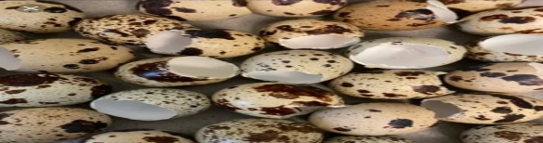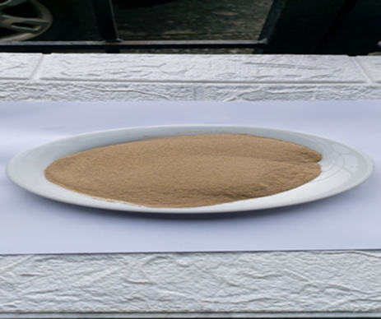
Figure 1a: Quail eggs shells Figure 1b: Pulverised quail eggs shell
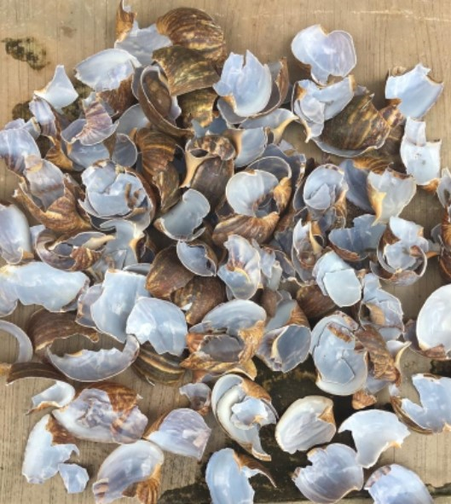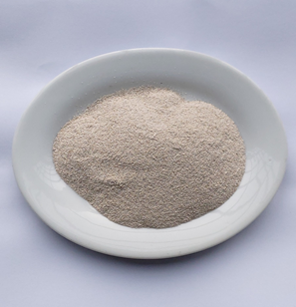
Figure 2a: Snail egg shell Figure 2b: Pulverised snail shell

3.2 Fourier Transform Infra-Red Radiation (Fourier Transform Infrared Spectroscopy) Analysis of the Adsorbents
The FTIR spectrum of quail egg shell and snail shell are presented in Figure 3 below.
Quail egg shell (A)
Figure 3 (a): FTIR spectra for Quail egg shell
Snail shell (B)
Figure 3 (b): FTIR spectra for snail shell
Figure 3: FTIR spectra for Quail egg shell and snail shell
Spectrum A is the IR spectrum of QES (Figure 3(a) shows FTIR spectrum of pulverized QES). The spectrum shows a strong and broad peak C-H band at 2969.08cm⁻¹ to confirm metal-oxide peak in the pulverized egg-shell moiety. The sharpness of this peak is evident of high amount of the free metal-oxide peak within the QES moiety. Studies by previous authors suggest that metal oxides are good adsorbents (Somaia et al., 2015; Kudaibergenov et al., 2013). The band at 1424.16cm⁻¹ resulted from C=C bending within the metal oxide. The possible reason for this observation is the tendency of the central metal or its oxide to form partially stable structure with the carbonate group. The partial instability may have resulted from the polarizing ability of the central cation involved in the metal-oxide group. Peaks at 874.83cm⁻¹,712.68cm⁻¹ may have resulted from vibrations of M-C-O stretch. The limited peak at 1642.5 cm⁻¹ must have occurs due to carbonyl group in the carbonate structure of shell. The FTIR confirm the compound to be rich in metal oxide carbonates. The presence of this bond is evident of the presence of metal-oxides that are generally adsorbents. The high presence of these carbonates suggests that the material can be a good adsorbent material. The application of this material in this study eventually confirms this. A observation was reported by Babatope et al, in 2017 on different eggshells (egg shells).
B (Figure (3b)) shows the FTIR spectrum of pulverised snail shells. The prominent band in the spectrum are 2917.41cm⁻¹ and 2848.60cm⁻¹. The broad and multi banded peaks were evidence of clear metal to oxide peaks similar to those found in sample A. The peak at 1789.17cm⁻¹ is evidence of C=O stretch in CO₃²⁻ and that highlighted the snail shells being rich in carbonate peaks. Peaks at 1159.30cm⁻¹, 1082.96cm⁻¹ were evidences of M-C-O stretch, which further establishes the evidence of the presence of metal- carbonates in in the snail shells. Peaks at 861.31cm⁻¹ ,712.51cm⁻¹ ,700.07cm⁻¹ ,658.11cm⁻¹ are evidences of C-H band of carbonates. The result is in tandem with what has been reported in literatures that egg shells are rich in metal carbonates. Omotosho and Akinsanoye, 2015 reported the use of shells as adsorbents for heterogenerous (heterogeneous) catalysis in biodiesel production in a comprehensive review. The FTIR results in this study showed that these shells are rich in metal oxide carbonates. This suggests that they can be tried as cheaper, environmentally friendly alternatives to the adsorbents commonly sold in the market that are from petroleum sources and complements the existing ones from biomass.

3.3 Batch Adsorption Results
3.3.1 Effect of adsorbent dose on shells adsorbent (oil adsorption)
The effect of adsorbent dose studied at 25ºC for 1hour using 0.020g/L simulated oil sample with different doses of adsorbents is presented in Table 1.0. The result shows that the rate of adsorption increases with increase in the mass of the adsorbent dose (Figures 4a & 4b). At 1.0g, the SS had a higher recovery rate than the QES. This trend continues for all the masses under consideration. This suggests that SS has a higher oil recovery rate than QES. This observation further establishes that the SS is majorly metal carbonate and richer in metal oxides that enhances it to be a better adsorbing agent than QES. The result also shows that SS may be richer in d-electron metal oxides which enables it to undergo the adsorption mechanism processes than the QES. This result is in tune with the Langmuir, Freundlich, Dubinin-Radushevish and Termskin isotherm studies for the adsorbent dose on the egg shells (Figures 5a&b: 6a&b: 7a&b and 8a&b:7a&b) with R² values between 0.8-1.00 for all the adsorbate studies. The FTIR table also agree with this experimental observation for the two samples. QES also show higher recovery rate with the 5.0g producing 77.5% recovery. The samples show high removal rate for the two shell adsorbate samples (Figures 4a&b). The ability of SS at 5.0g to successfully reduce oil contamination in water to 5% (Table 1) suggests that SS can replace conventional adsorbents in the market with similar or lower oil spill recovery rates. It is therefore a local, economically friendly alternative to costly, imported, greenhouse enhancing adsorbents. The increase in the adsorption percentage with increase in dose of adsorbent was due to the increase in active sites which made easier penetration of the crude oil molecules into the adsorption sites easier (Figure 4a). The result obtained in this study further showed that both quail eggs and snail shells adsorbed to a reasonable level, but snail shell had higher adsorption capacity, hence can be used as an effective adsorbent for oil spill removal.

Table 1: Effect of a quail eggs shell and snail shell adsorbents doses on rates of adsorption.
S/N | M(g) | C_{o}(g/L) | C_{e} (g/L) | C_{o} - C_{e} (g/L) | q_{e} | % Removal
1QES  SS |  | 0.020  0.020 | 0.0150  0.0120 | 0.0050  0.0080 | 0.5000  0.8000 | 25  40
2QES  SS |  | 0.020  0.020 | 0.0120  0.0120 | 0.0080  0.0080 | 0.4000  0.6000 | 40  60
3QES  SS |  | 0.020  0.020 | 0.0080  0.0040 | 0.0120  0.0160 | 0.4000  0.5333 | 60  80
4QES  SS |  | 0.020  0.020 | 0.0050  0.0020 | 0.0150  0.0180 | 0.3750  0.4500 | 75  90
5QES  SS |  | 0.020  0.020 | 0.0045  0.0010 | 0.0155  0.0190 | 0.3100  0.3800 | 77.5  95

3.3.2 Effect of temperature on shells adsorbent
The effects of temperature on the shells show that the shells are more effective at low temperatures (Table 2). SS shows very high recovery rate at a temperature of 15⁰C. These observations show that at higher temperature, the carbonate group is unstable. This observation may be due to the polarizing effect of the cation involved in forming the carbonates present in the metal carbonate found in the shells. The carbonate group may tend to disintegrate at high temperature if the central atom has strong polarizing effect on the carbonate group. QES showed a recovery rate of 60% at this temperature to also establish that SS has higher adsorbing metal oxides and carbonate groups than QES. Similar trend was found with 30⁰C, 45⁰C, 60⁰C and 75⁰C. The result establishes that the shells will be more effective at room or lower temperatures. It even shows a tendency that at extremely low temperatures, recovery could near 100% (Figure 4b). This further makes these shells more economic in oil spill recovery because the cost of providing high temperature is ruled out. The various adsorption adsorption equilibrium studies are in line with the observations from Table 2. The result also in tandem with what has been reported by authors on the effect of temperatures on metal carbonates (Reller, 1991).

Table 2: Effect of temperature on the rate of adsorption of quail egg shell and snail shell
S/N | Temp (ºC) | C_{o}(g/L) | C_{e} (g/L) | C_{o} - C_{e} (g/L) | q_{e} | % Recovery
1QES  SS | 15 | 0.020  0.020 | 0.0080  0.0030 | 0.0120  0.0170 | 0.6000  0.8500 | 60  85
2QES  SS | 30 | 0.020  0.020 | 0.0085  0.0050 | 0.0115  0.0150 | 0.5750  0.7500 | 57.5  75
3QES  SS | 45 | 0.020  0.020 | 0.0090  0.0070 | 0.0110  0.0130 | 0.5500  0.6500 | 55  65
4QES  SS | 60 | 0.020  0.020 | 0.0100  0.0100 | 0.0100  0.0100 | 0.5000  0.5000 | 50  50
5QES  SS | 75 | 0.020  0.020 | 0.0120  0.0125 | 0.0080  0.0075 | 0.4000  0.3750 | 40  37.5

3.3.3 Effect of contact time on shells adsorbent
The percentage removal of crude oil by the two adsorbents (Snail shell and Quail egg shell) is presented in Table 3. This was found to increase as the contact time increased from 15 to 75mins. This shows that over prolonged period of time, the adsorbents will exhibit a remediation close to 100% with very minimal environmental impairment. The SS also showed higher removal rates for all the periods under study than what was generally observed in the QES. The SS producing a removal rate of 92.5% after 75 minutes study shows that the adsorbent is effective in adsorbing oil from an oil spill region within a short time (Figure 4c). It can therefore be recommended as a local alternative in solving this problem.

Table 3: Effect of contact time on adsorption of quail eggs shell and snail shell
S/N | Time(mins) | C_{o}(g/L) | C_{e} (g/L) | C_{o} - C_{e} (g/L) | q_{e} | % Removal
1QES  SS | 15 | 0.020  0.020 | 0.0150  0.0080 | 0.0050  0.0120 | 0.2500  0.6000 | 25  60
2QES  SS | 30 | 0.020  0.020 | 0.0100  0.0065 | 0.0100  0.0135 | 0.5000  0.6750 | 50  67.5
3QES  SS | 45 | 0.020  0.020 | 0.0070  0.0050 | 0.0130  0.0150 | 0.6500  0.7500 | 65  75
4QES  SS | 60 | 0.020  0.020 | 0.0050  0.0020 | 0.0150  0.0180 | 0.8000  0.9000 | 75  90
5QES  SS | 75 | 0.020  0.020 | 0.0030  0.0015 | 0.0170  0.0185 | 0.9000  0.9250 | 85  92.5

3.3.4 Effect of pH on shells adsorbent
The result of the pH on shells adsorbent was studied to ascertain that the adsorbents will be viable under different conditions. The results showed that both adsorbents were more effective under alkaline conditions than acidic (Table 4). At pH 5, SS shows a removal rate of 50% while QES removes 25%. QES shows a drastically low value at this pH, this shows that the shell is less effective at this pH. At a pH of 7 (neutral), SS removal rate is 60% while QES is 35%. The closeness in values suggests that QES works better at neutral pH than acidic. Under alkaline studies, QES also show improved recovery rate. The removal rate of SS was also better under alkaline conditions (Table 4). pH 13 produced 85% removal rate to show that SS will work very well under strong alkaline conditions. This observation may have resulted from the nature of carbonates in the shells moiety and their respective stability (Figure 4d). In general, the results show that the adsorbents will work effectively at different pH. SS however showed improved tendencies of oil spill clean-up than QES at varying temperatures.

Table 4: Effect of pH on adsorption of quail eggs shell and snail shell
S/N | pH | C_{o}(g/L) | C_{e} (g/L) | C_{o} - C_{e} (g/L) | q_{e} | % Removal
1QES  SS | 5 | 0.020  0.020 | 0.0150  0.0100 | 0.0050  0.0100 | 0.2500  0.5000 | 25  50
2QES  SS | 7 | 0.020  0.020 | 0.0130  0.0080 | 0.0070  0.0120 | 0.3500  0.6000 | 35  60
3QES  SS | 9 | 0.020  0.020 | 0.0120  0.0070 | 0.0080  0.0130 | 0.4000  0.6500 | 40  65
4QES  SS | 11 | 0.020  0.020 | 0.0100  0.0050 | 0.0100  0.0150 | 0.5000  0.7500 | 50  75
5QES  SS | 13 | 0.020  0.020 | 0.0095  0.0030 | 0.0105  0.0170 | 0.5250  0.8500 | 52.5  85

3.3.5 Effect of adsorbate concentration
The concentration of the adsorbates was also studied and the result is presented in Table 5. The batch experiments revealed that adsorption of crude oil decreased with increase in adsorbate (crude oil) concentration for both adsorbents, and this can be explained in terms of available active sites. At low adsorbate concentration, the ratio of surface-active sites to crude oil was high, hence the crude oil interacted with the sorbent to occupy the active sites on the central metal surface sufficiently, but with the increase in adsorbate concentration, the number of active adsorption sites was not enough to accommodate the crude oil molecules (Figure 4e). The highest removal was obtained with a weight of 2g/50ml. The results show that the viability of these materials for cleaning up does not solely lie on quantity. Little amounts of the SS and QES are required for clean-up exercise in an oil polluted landsite. This makes the technology more cost effective apart from offering environmental gains as opposed to adsorbents from non-biodegradable source like petroleum.

Table 5: Effect of adsorbate concentration on adsorption of quail eggs shell and snail shell
S/N | W(g) | C_{o}(g/L) | C_{e} (g/L) | C_{o} - C_{e} (g/L) | q_{e} | % Removal
1QES  SS | 2 | 0.020  0.020 | 0.0060  0.0040 | 0.0140  0.0160 | 0.7000  0.8000 | 70  80
2QES  SS | 4 | 0.020  0.020 | 0.0180  0.0060 | 0.0120  0.0140 | 0.6000  0.7000 | 60  70
3QES  SS | 6 | 0.020  0.020 | 0.0090  0.0080 | 0.0110  0.0120 | 0.5500  0.6000 | 55  60
4QES  SS | 8 | 0.020  0.020 | 0.0100  0.0100 | 0.0100  0.0100 | 0.5000  0.5000 | 50  50
5QES  SS | 10 | 0.020  0.020 | 0.0120  0.0110 | 0.0080  0.0090 | 0.4000  0.4500 | 40  45

3.3.6 Effect of rotational speed
The batch adsorption experiments at different rotational speed were studied. The result showed that the adsorption of oil onto the adsorbents increases with increased speed (Table 6). This was observed to be higher in SS than QES. This is in tandem with the other results obtained. Increase in rotational speed resulted in a reduction in surface film resistance, thereby allowing residual oil to reach the particle surface more easily (Figure 4f). Surface film resistance hinders rate of adsorption. The results showed that the rate of adsorption increased with speed.

Table 6: Effect of rotational speed on adsorption (quail egg shell)
S/N | R(rpm) | C_{o}(g/L) | C_{e} (g/L) | C_{o} - C_{e} (g/L) | q_{e} | % Removal
1QES  SS | 100 | 0.020  0.020 | 0.0140  0.0100 | 0.0060  0.0100 | 0.3000  0.5000 | 30  50
2QES  SS | 200 | 0.020  0.020 | 0.0120  0.0080 | 0.0080  0.0120 | 0.4000  0.6000 | 40  60
3QES  SS | 300 | 0.020  0.020 | 0.0100  0.0075 | 0.0100  0.0125 | 0.5000  0.6250 | 50  62.5
4QES  SS | 400 | 0.020  0.020 | 0.0080  0.0060 | 0.0120  0.0140 | 0.6000  0.7000 | 60  70
5QES  SS | 500 | 0.020  0.020 | 0.0060  0.0030 | 0.0140  0.0170 | 0.7000  0.8500 | 70  85

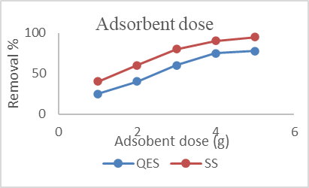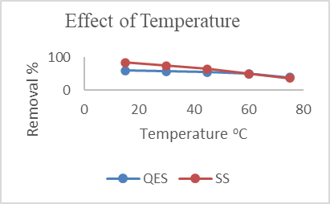
Figures 4a & 4b: Effect of adsorbent doses and temperature on % removal of crude oil.

Figure 4a shows the effect of adsorbent doses on the % removal of crude oil using 106µm snail shell and quail eggs shell at 0.020g/L initial oil concentration, pH of 7.6, 200rpm and 25º C for 1 hour each. Figure 4b shows the effect of temperature on the % removal of crude oil using 2g of 106µm snail shell and quail eggs shell at 0.020g/L initial oil concentration, pH of 7.6, 200rpm speed at 1 hour each.

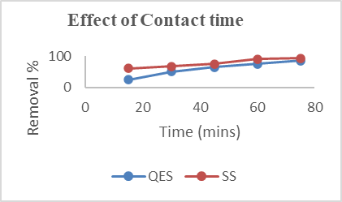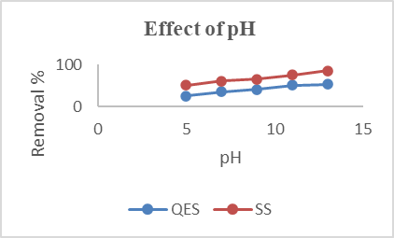
Figures 4c & 4d: Effects of contact time and pH on % removal of crude oil

Figure 4c shows the effect of contact time on the % removal of crude oil using 2g of 106µm snail shell and quail egg shell at 0.020g/L initial oil concentration, pH of 7.6, 200rpm speed and 25ºC at 1 hour each. Figure 4d shows the effect of pH on the % removal of crude oil using 2g of 106µm snail shell and quail egg shell at 0.020g/L initial oil concentration, 200rpm speed and 25ºC temperature at 1 hour each.
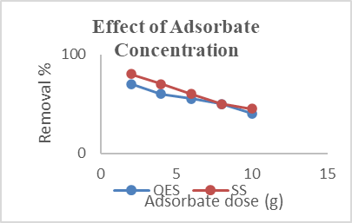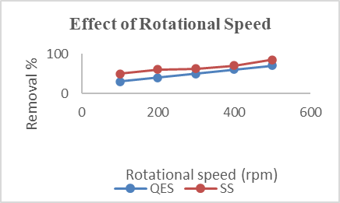
Figures 4e & 4f: Effects of adsorbate concentration and rotational speed on % removal of crude oil.

Figure 4e shows the effect of adsorbate concentration on % removal of crude oil using 2g of 106µm snail shell and quail eggs shell at 200rpm and 25º C temperature at 1 hour each.
Figure 4f shows the effect of rotational speed on the % removal of crude oil using 2g of 106µm snail shell and quail eggs shell at 0.020g/L initial oil concentration and 100-500rpm rotational speed.

3.4 Adsorption Isotherms
Adsorption isotherms are important for optimizing the sorption processes and describing the sorption mechanism. The Langmuir, Freundlich, Temkin and Dubinin- Radushkevich isotherms were used to investigate sorption processes in the current study and were expressed with appropriate equations (Foo et al., 2009(2010)).

3.4.1 The Langmuir Isotherm
The Langmuir adsorption isotherm which has been used successfully for many adsorption processes of monolayer adsorption assumes that adsorption takes place at specific homogenous sites within the adsorbent. The linearized Langmuir equation according to researchers is given in equation 3 (Alawode & Falode (2019), Aljeboree et al., (2017), Olufemi & Otolorin (2017), Darlington & Uchenna (2010), Demirbas et al., (2009), Foo & Hameed (2010) and Freundlich & Heller (1939)) is given as:

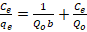 (3)
C_{e}/q_{e} is plotted against C_{e} a straight line with gradient 1/Q_{o} and intercept of 1/Q_{ob} is obtained.

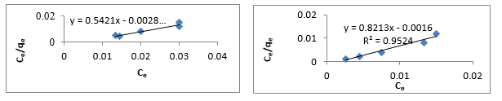
Figures 5a & 5b show the Langmuir isotherm for quail egg shell and snail shell adsorption on
adsorbent doses.
Langmuir Adsorption Isotherm of Quail Eggshell and Snail Shell at Different Adsorbent Doses
Langmuir isotherm of BB 41 dye adsorption onto JC_{HNO3}
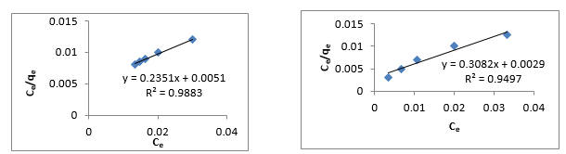
Figures 5c & 5d show the Langmuir isotherm for quail egg shell adsorption on temperatures
Langmuir Adsorption Isotherm of Quail Eggshell and Snail Shell at Different Temperatures

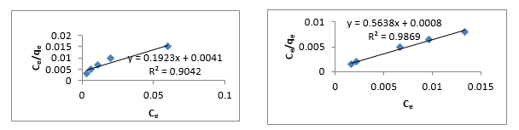
Figures 5e & 5f: Langmuir isotherm for quail egg shell and snail shell adsorption on contact time
Langmuir Adsorption Isotherm of Quail Eggshell and Snail Shell at various contact times

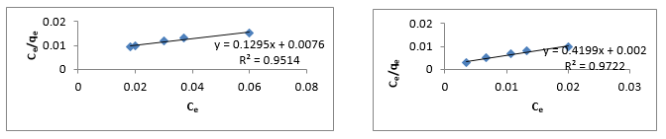
Figures 5g & 5h: Langmuir isotherm for quail shell and snail shell adsorption on pH
Langmuir Adsorption Isotherm of Quail Eggshell and Snail Shell at Different pH

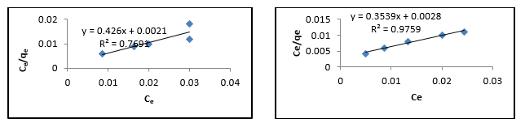

Figures 5i & 5j: Langmuir isotherm for quail egg shell and snail shell adsorption on adsorbate concentration.
Langmuir Adsorption Isotherm of Quail Eggshell and Snail Shell at Different Adsorbate concentration.

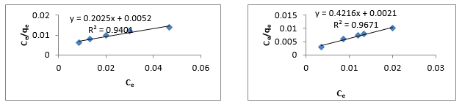
Figures 5k & 5l: Langmuir isotherm for quail egg shell and snail shell adsorption on rotational
speed
Langmuir Adsorption Isotherm of Quail Eggshell and Snail Shell at Different rotational
Speed.

3.4.2 The Freundlich Model
The Freundlich is an empirical equation used to describe heterogeneous systems, and which can be expressed in its logarithmic form as:
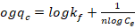 (4)
Values of k_{f} and n may be obtained by plotting log (qe) versus log (Ce), and the slope is equal to 1/n while the intercept is equal to log(k_{f}). But the Freundlich model is based on an exponential distribution of sorption sites and energies, as an empirical model not limited to monolayer coverage alone but also describes multilayer (i.e. heterogeneous systems) adsorption (Freundlich and Heller, 1939).

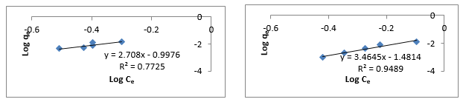

Figures 6a & 6b: Freundlich isotherm for quail egg shell and snail shell adsorption on adsorbent dose.
Freundlich Adsorption Isotherm of Quail Eggshell and Snail Shell at Different Adsorbent doses.

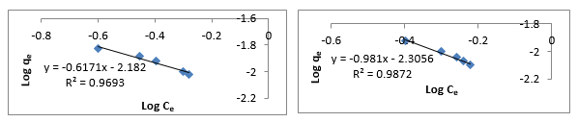
Figures 6c & 6d: Freundlich isotherm for quail egg shell and snail shell adsorption on temperature.

Freundlich Adsorption Isotherm of Quail Eggshell and Snail Shell at Different Temperatures
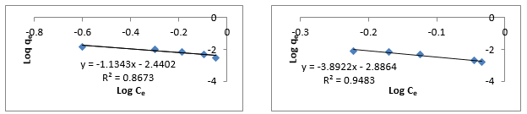
Figures 6e & 6f: Freundlich isotherm for quail egg shell and snail shell adsorption on contact time

Freundlich Adsorption Isotherm of Quail Eggshell and Snail Shell at Different contact times

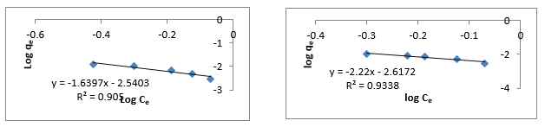
Figures 6g & 6h: Freundlich isotherm for quail egg shell and snail shell adsorption on pH
Freundlich Adsorption Isotherm of Quail Eggshell and Snail Shell at Different pH.
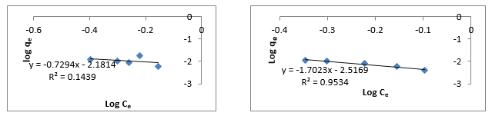
Figures 6i & 6j: Freundlich isotherm for quail egg shell and snail shell adsorption on adsorbate concentration.
Freundlich Adsorption Isotherm of Quail Eggshell and Snail Shell at Different Adsorbate Concentrations
.

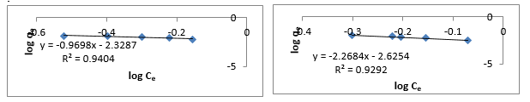

Figures 6k & 6l: Freundlich isotherm for quail egg shell and snail shell adsorption on rotational speed.
Freundlich Adsorption Isotherm of Quail Eggshell and Snail Shell at Different Rotational Speeds.

3.4.3 Dubinin- Radushkevich Isotherm
The Dubinin – Radushkevich isotherm was chosen to estimate the characteristics porosity of the biomass and the apparent energy of adsorption. The model can be expressed as:
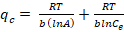 (5)
Where, B_{D} is related to the free energy of sorption per mole of the sorbate as it migrates to the surface of the adsorbent from infinite distance in the solution and q_{D} is the Dubinin-Radushkevich isotherm constant related to the degree of sorbate sorption by the biosorbent surface (Demirbas et al., 2009). The Linear form of equation (5) is given as:
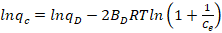 (6)
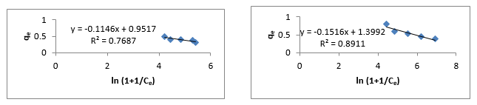

Figures 7a & 7b: Dubinin- Radushkevich isotherm for quail egg shell and snail shell on adsorbent dose.
Dubinin- Radushkevich Adsorption Isotherm of Quail Eggshell and Snail Shell at Different Adsorbent Doses.

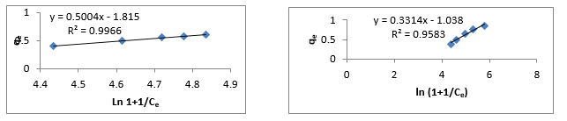
Figures 7c & 7d: Dubinin- Radushkevich isotherm for quail egg shell on temperature
Dubinin- Radushkevich Adsorption Isotherm of Quail Eggshell and Snail Shell at Different Temperatures.

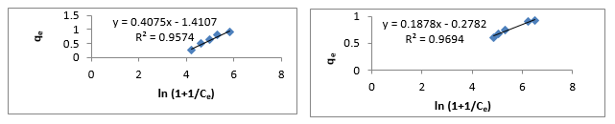
Figures 7e & 7f: Dubinin- Radushkevich isotherm for quail egg shell and snail shell on contact time.
Dubinin- Radushkevich Adsorption Isotherm of Quail Eggshell and Snail Shell at Different Contact Times.

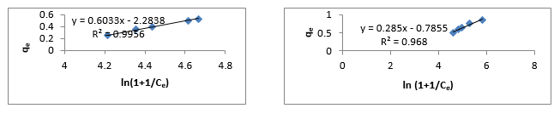
Figures 7g & 7h: Dubinin- Radushkevich isotherm for quail egg shell and snail shell on Ph
Dubinin- Radushkevich Adsorption Isotherm of Quail Eggshell and Snail Shell at Different pH.

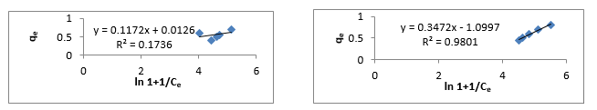

Figures 7i & 7j: Dubinin- Radushkevich isotherm for quail egg shell and snail shell on adsorbate concentration.
Dubinin- Radushkevich Adsorption Isotherm of Quail Eggshell and Snail Shell at Different Adsorbate Concentrations.

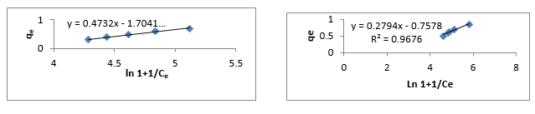
Figures 7k & 7l: Dubinin- Radushkevich isotherm for quail egg shell and snail shell on rotational speed
Dubinin- Radushkevich Adsorption Isotherm of Quail Eggshell and Snail Shell at Different Rotational Speeds.

The Temkin Adsorption Isotherm
This assumes that the fall in the heat of sorption is linear rather than logarithmic as implied in the Frendluich equation. The Temkin isotherm has generally been applied to the following form (Ho et al., 1999: Półka et al., 2015).
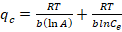 (7)
Where, R is the universal gas constant, T is the absolute temperature, A and b are constants based on the biosorbent.
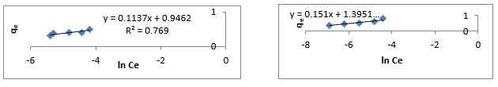
Figures 8a & 8b: Temkin Isotherm for quail egg shell and snail shell on adsorbent dose.

Temkin Adsorption Isotherm of Quail Eggshell and Snail Shell at Different Adsorbent Doses.

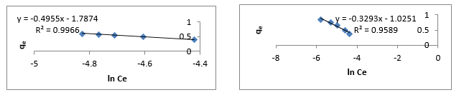
Figures 8c & 8d: Temkin Isotherm for quail egg shell and snail shell on temperature.

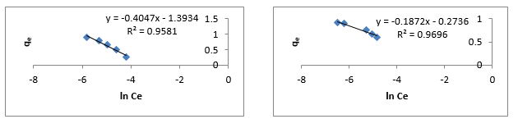

Figures 8e & 8f: Temkin Isotherm for quail egg shell and snail shell on contact time
Temkin Adsorption Isotherm of Quail Eggshell and Snail Shell at Different Contact Times

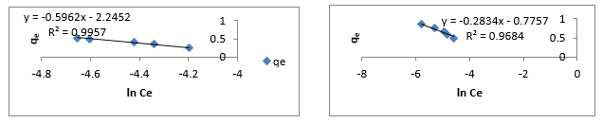

Figures 8g & 8h: Temkin Isotherm for quail egg shell and snail shell on pH

Temkin Adsorption Isotherm of Quail Eggshell and Snail Shell at Different pH.
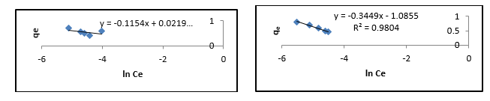
Figures 8i & 8j: Temkin Isotherm for quail egg shell and snail shell on adsorbate concentration
Temkin Adsorption Isotherm of Quail Eggshell and Snail Shell at Different Adsorbate Concentrations.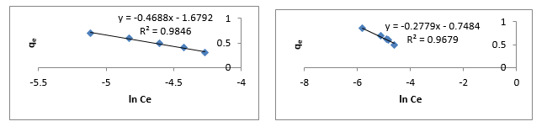
Figures 8k & 8l: Temkin Isotherm for quail egg shell and snail shell on rotational speed.
Temkin Adsorption Isotherm of Quail Eggshell and Snail Shell at Different Rotational Speeds

Table 7: Coefficient of Determination (R²) for Quail Egg Shell and Snail Shell
S/N | Varied Parameters | langmuir | Freundlich | Temkin | Dubinin -Radushkevich
1QES  SS | Adsorbent dose(g) | 0.9373  0.9524 | 0.7725  0.9489 | 0.7690  0.8918 | 0.7681  0.8911
2QES  SS | Temperature (ºC) | 0.9883  0.9497 | 0.9872  0.9050 | 0.9966  0.9589 | 0.9966  0.9583
3QES  SS | Contact time (mins) | 0.9042  0.9869 | 0.8673  0.9483 | 0.9581  0.9696 | 0.9574  0.9694
4QES  SS | pH | 0.9514  0.9722 | 0.9693  0.9338 | 0.9957  0.9684 | 0.9956  0.9680
5QES  SS | Adsorbate-concentration(g/L) | 0.7691  0.9759 | 0.1439  0.9534 | 0.1722  0.9804 | 0.1736  0.9801
6QES  SS | Speed (rpm) | 0.9401  0.9671 | 0.9404  0.9292 | 0.9846  0.9679 | 0.9843  0.9676

The R² value for the Freundlich are within the acceptable range of 0.1 to 0.99 (Figures 5a, b c, d e and f). This shows that the oils were adsorbed on the surface of the adsorbent at a very high rate with majority of the result close to 1 in SS. This shows that the simulated oil was almost adsorbed on the surface areas of the adsorbent within the short period of study. The result confirmed that SS has higher adsorbing rate than QES. The Langmuir studies presented in Figures 6a, b, c, d, e and f) follows a similar trend. The high significance in values for both samples (QES and SS) here show that most of the oils were trapped into the high surface area central metals present in the adsorbents by the adsorption mechanism. The Langmuir studies show that the oils were trapped highly by physisorption and chemisorption techniques unto the oil surface. The temkin’s model studies (Figures 7a, b, c, d, e, f) shows that the adsorption is characterized by regular binding energy. The results of the adsorption isotherms show that the metal oxides and metal carbonates are very stable and possess the energy needed to ensure majority of the removal of the simulated oil pollution area. The high values obtained also suggests that this happens up to the highest binding energy within the oil moiety. This explains why there is high rate of adsorption of the samples for both QES and SS (Table 7). Dubinin –Radushkevich model reveals high values for both QES and SS. The isotherm confirm that the reaction occurs by chemisorption techniques upon the surface of the central atom in the adsorbate (Figures 8a, b, c, d, e and f). The trend of the isothermal studies suggest that the adsorption mechanism follows the physisorption and chemisorption mechanisms commonly found in heterogenous catalysts and adsorbents. General reactions involving enthalpy processes, desorption and diffusion from central metal surface. The central atoms provide the surface areas upon which these reactions occur.
CONCLUSION
The possibility of Quail egg shell and Snail shell as natural adsorbents to remove crude oil contamination in a simulated crude oil polluted water was investigated in this research. The results shows that crude oil removal by adsorption onto Snail shell and Quail egg shell is feasible, effective, economical and environmentally friendly compared to existing adsorbents. The adsorption and percentage removal of crude oil was found to be dependent at various levels on adsorbent dose, adsorbate concentration, contact time, temperature and pH as well as speed of agitation. The considered adsorption temperature range was between 15 to 60ºC with the maximum adsorption observed at 15ºC. The results of the experiment demonstrated that snail shells had better adsorption capacity than Quail egg shell. It also shows comparative advantage over the commercial adsorbents by being biodegradable and raw agricultural waste. The correlation coefficient indicated various dependencies on parameters utilised by the adsorption process. The equilibrium adsorption isotherm analysis with Langmuir, Freundlich, Temkin and Dubinin presented fitted the equilibrium data reasonably well for the snail shells than quail egg shells. The adsorption isotherms shows that the metal oxides in the shells are very stable and hence possess the activation energy needed to ensure the internal energies of the pollutants and the oil were chattered and leads to improve removal rates.

RECOMMENDATIONS
The Quail egg shell and Snail shell should also be pulverised to other sizes aside the one used for this research, to compare the adsorption capacities. A blend of these samples can also be studied at the same and different mesh sizes. Other agricultural waste products should also be encouraged to open up opportunity for local materials at no cost. Government and industries should take advantage of adsorption technologies by developing these natural adsorbents for household and industrial purposes.

REFERENCES
Ahmad, M. A., Ahmad, N., & Bello, O. S. (2015). Removal of Remazol Brilliant Blue reactive dye
from aqueous solutions using watermelon rinds as adsorbent. Journal of Dispersion Science and Technology, 36(6), 845–858. https://doi.org/10.1080/01932691.2014.925400

Akinsanoye, O. A. (2022). Laterite as a binder for remediation of polluted landsites. Global Scientific
Journal, 10(5), 1660–1671.
https://www.globalscientificjournal.com/journal_volume10_issue5_May_2022_edition_p5.html

Akinsanoye, O. A., Omotoso, M. A., & Falode, O. A. (2005, June). Industrial precursors from
agricultural wastes. In Proceedings of the 4th International Conference of the Turkish Journal of Agriculture – Food Science and Technology (TURJAF 2025), Turkey.

Alaa El-Din, G., Amer, A. A., Malsh, G., & Hussein, M. (2018). Study on the use of banana peels for
oil spill removal. Alexandria Engineering Journal, 57(3), 2061–2068. https://doi.org/10.1016/j.aej.2017.05.020

Alawode, A. J., & Falode, O. A. (2019). Development of a new Type-I isotherm for correction of
Langmuir isotherm’s over-estimation of adsorption at higher pressures. Physical Science International Journal, 23(3), 1–26. https://doi.org/10.9734/psij/2019/v23i330157

Aljeboree, A. M., Alshirifi, A. N., & Alkaim, A. F. (2017). Kinetics and equilibrium study for the
adsorption of textile dyes on coconut shell activated carbon. Arabian Journal of Chemistry, 10(Suppl. 2), S3381–S3393. https://doi.org/10.1016/j.arabjc.2014.01.020

Annunciado, T. R., Sydenstricker, T. H. D., & Amico, S. C. (2005). Experimental investigation of
various vegetable fibers as sorbent materials for oil spills. Marine Pollution Bulletin, 50(11),
1340–1346. https://doi.org/10.1016/j.marpolbul.2005.04.043

Ayotamuno, M. J., Kogbara, R. B., Ogaji, S. O. T., & Probert, S. D. (2006). Bioremediation of a
crude-oil polluted agricultural soil at Port Harcourt, Nigeria. Applied Energy, 83(11), 1249–
1257. https://doi.org/10.1016/j.apenergy.2006.01.003

Bailey, S. E., Olin, T. J., Bricka, R. M., & Adrian, D. D. (1999). A review of potentially low-cost
sorbents for heavy metals. Water Research, 33(11), 2469–2479. https://doi.org/10.1016/S0043-1354(98)00475-8

Bandura, L., Woszuk, A., Kołodyńska, D., & Franus, W. (2017). Application of mineral sorbents for
removal of petroleum substances: A review. Minerals, 7(3), 37. https://doi.org/10.3390/min7030037

Beyer, J., Trannum, H. C., Bakke, T., Hodson, P. V., & Collier, T. K. (2016). Environmental effects
of the Deepwater Horizon oil spill: A review. Marine Pollution Bulletin, 110(1), 28–51.
https://doi.org/10.1016/j.marpolbul.2016.06.027

Bhatnagar, A., & Sillanpää, M. (2010). Utilization of agro-industrial and municipal waste materials
as potential adsorbents for water treatment – A review. Chemical Engineering Journal, 157(2–3), 277–296. https://doi.org/10.1016/j.cej.2010.01.007

Darlington, B. N., & Uchenna, A. (2010). Adsorption of crude oil using meshed groundnut husk.
Chemical Product and Process Modeling, 5(1), Article 1. https://doi.org/10.2202/1934-2659.1433

Demirbas, E., Dizge, N., Sulak, M. T., & Kobya, M. (2009). Adsorption kinetics and equilibrium of
copper from aqueous solutions using hazelnut shell activated carbon. Chemical Engineering
Journal, 148(2–3), 480–487. https://doi.org/10.1016/j.cej.2008.09.027

Falode, O. A., Oluwadero, T. A., Nwadike, B., & Fagade, O. E. (2016). Performance of biosurfactant
produced from pineapple waste for improving oil recovery. Chemical Science International Journal, 15(4), 1–14. https://doi.org/10.9734/ACSJ/2016/27205

Foo, K. Y., & Hameed, B. H. (2010). Insights into the modeling of adsorption isotherm systems.
Chemical Engineering Journal, 156(1), 2–10. https://doi.org/10.1016/j.cej.2009.09.013

Freundlich, H., & Heller, W. (1939). The adsorption of cis- and trans-azobenzene. Journal of the
American Chemical Society, 61(8), 2228–2230. https://doi.org/10.1021/ja01877a071

Maciel, G., Lazzari, E., Bjerk, T. R., Ahmad, S., Carvalho, A. P., Nogueira, J., & Caramão, E. B.
(2017). Trace analysis of carbazole in commercial diesel by using adsorption on activated biochar from rice husk pyrolysis. International Journal of Engineering Research and Science, 3(8), 46–57. https://doi.org/10.25125/engineering-journal-IJOER-AUG-2017-14

Ho, Y. S., & McKay, G. (1999). Pseudo-second order model for sorption processes. Process
Biochemistry, 34(5), 451–465. https://doi.org/10.1016/S0032-9592(98)00112-5

Husseien, M., Amer, A. A. R., El-Maghraby, A., & Taha, N. A. (2009). Availability of barley straw
application on oil spill clean-up. International Journal of Environmental Science and Technology, 6(1), 123–130. https://doi.org/10.1007/BF03326066

Ifelebuegu, A. O., Nguyen, T. V. A., Ukotije-Ikwut, P. R., & Momoh, Z. (2015). Liquid-phase
sorption characteristics of human hair as a natural oil spill sorbent. Journal of Environmental Chemical Engineering, 3(2), 938–943. https://doi.org/10.1016/j.jece.2015.02.015

Lin, Q., & Mendelssohn, I. A. (2012). Impacts and recovery of the Deepwater Horizon oil spill on
vegetation structure and function of coastal salt marshes in the northern Gulf of Mexico. Environmental Science & Technology, 46(7), 3737–3743. https://doi.org/10.1021/es203552p

Olufemi, B. A., & Otolorin, F. (2017). Comparative adsorption of crude oil using mango (Mangifera
indica) shell and mango shell activated carbon. Environmental Engineering Research, 22(4), 384–392. https://doi.org/10.4491/eer.2017.011

Omole, O., & Falode, A. O. (1998). Analysis of petroleum pollution incidents in the Nigerian
petroleum industry. Journal of Science Research, 4, 25–33.

Omotoso, M. A., & Akinsanoye, O. A. (2015). A review of biodiesel generation from non-edible
seed oils crop using non-conventional heterogeneous catalysts. Journal of Petroleum Technology and Alternative Fuels, 6, 1–12. https://doi.org/10.5897/JPTAF2014.0108

Półka, M., Kukfisz, B., Wysocki, P., Polakovič, P., & Kvarčak, M. (2015). Efficiency analysis of the
sorbents used to adsorb the vapors of petroleum products during rescue and firefighting actions. Przemysł Chemiczny, 94(3), 331–335. https://doi.org/10.15199/62.2015.3.13

Reller, A., Emmenegger, R., Padeste, C., & Oswald, H.-R. (1991). Thermochemical reactivity of
metal carbonates. CHIMIA International Journal for Chemistry, 45(9), 262–267.
https://doi.org/10.2533/chimia.1991.262

Somaia, M., Sahar, M. A., Abdel, B., & El-Desouki, D. (2015). Activated carbon derived from
Egyptian banana peels for removal of cadmium from water. Journal of Applied Life Sciences
International, 3(2), 77–88. https://doi.org/10.9734/JALSI/2015/16652

Tryba, B., Morawski, A. W., Kalenczuk, R. J., & Inagaki, M. (2003). Exfoliated graphite as a new
sorbent for removal of engine oils from wastewater. Spill Science & Technology Bulletin, 8(5), 569–571. https://doi.org/10.1016/S1353-2561(03)00070-7

Uzoije, A. P., Onunkwo, A., & Egwuonwu, N. (2011). Crude oil sorption onto groundnut shell
activated carbon: Kinetic and isotherm studies. Research Journal of Environmental and Earth
Sciences, 3(5), 555–563.

