Original Research Article
Response of germination stimulants and their Purification produced by Sesame (Sesamum indicum L.) on Striga hermonthica (Del.) Benth. germination

Abstract
Root parasitic weeds, a serious problem in agriculture, severely reduced yield of several economically important crops in tropical and semi-tropical region in Africa. The Striga seeds of these weeds may remain viable in soil for many years until germination is stimulated by a chemical signal exuded by roots of host and some non-host plants. Sesame, a major crop in Striga endemic areas, plant residues, irrespective of parts, drying method and amount of powder induced considerable Striga germination and haustorium initiation. However, germilings resulting from seeds stimulated to germinate by sesame powder, irrespective of plant parts and drying method, reduced radicle extension in comparison to positive control. Root exudates collected from hydroponically grown plants, induced 60% germination of S. hermonthica seeds. Sesame aqueous extract applied during conditioning reduced Striga germination and radicle extension in response to subsequent GR24 treatments in a concentration dependent manner. Striga seeds previously conditioned in Sesame aqueous extract for 3-15 days and applied with GR24 stimulated considerable number of haustoria (70 -100%). The germination activity of the crude root exudates on S. hermonthica seed was comparable to that of the synthetic germination stimulant GR24 at 0.1 ppm. A bioassay guided column and high-performance liquid chromatography (HPLC) confirmed the stimulatory activity of the root exudates on S. hermonthica germination.
Further analysis using HPLC connected to tandem mass spectrometry (LC/MS/MS) showed that the active fraction from sesame has a mass spectrum different from those of the natural strigolactones (strigol, sorgolactone) and is probably not a strigolactone.
Keywords: Sesame, Striga hermonthica, germination stimulants, strigolactones, haustorium

Introduction
Striga spp., Orobanchaceae, are the most devastating as they cause severe reductions in yields of many important crops sorghum, maize , millet , rice and cowpea. Cereal yield losses due to Striga damage varying from 10% to complete crop loss (100%), depending on crop variety, climatic conditions and the parasite seed bank (Rodenburg et al., 2005) The parasite, which are difficult to control, produce thousands of tiny seeds that remain viable in soil for several decades (Satoko and Ken, 2009). The seeds need a pre-treatment period (2-14 days) and a suitable temperature prior to exposure to a germination stimulant exuded by host and some non-host plants (Babiker et al., 2007). Subsequent to germination the parasite displays an orderly sequence of events comprising radicle extension, attachment to the host root, penetration and establishment of a connection with the host xylem. Following connection with the xylem the parasite remains underground for 6-8weeks where it inflicts most of its damaging effects. Several methods of control have been recommended, however, their performance is often erratic. The notable spatial and temporal inconsistency of performance is attributable to copious seed production by the parasite and prolonged seed viability leading to a buildup of a huge seed bank, shortly after initiation of infestation (Mahmoud et al., 2016). Hence depletion of Striga seed bank through induction of germination in absence of or away from the host root, suicidal germination, may be of potential as a measure for Striga management.
Drought and fitful rains are determinant factors limiting cropping system in the northern part of the central clay plains of the Sudan. The climatic and edaphic conditions, in the northern part of the plain, where drought and heavy clays predominate, make sorghum and sesame (Sesamum indicum L.) the crops of choice. However, problems associated with harvest preclude expansion of sesame planting and compel farmers to plant sorghum in a monoculture. Sorghum monoculture has led to a buildup of heavy Striga infestations entailing considerable yield losses. Available reports indicate the effectiveness of sesame as a trap crop for S. hermonthica on sorghum and millet (Hamad-Elneel, 2011). Furthermore, sesame stalk and residues are usually left over in fields after harvest.
The present study was therefore set to investigate the activity of germination stimulants produced by Sesame (Sesamum indicum L.) on Striga hermonthica germination.

Materials and Methods
Plant Materials
Sesame seeds (Sesamum indicum cv. Bromo) were obtained from the Agricultural Research Corporation (ARC), Algadarif, Sudan.
Striga hermonthica seeds, used in this study, were collected from parasitic plants growing under sorghum in 2012 at the Gadarif State.

Striga hermonthica seeds sterilization and conditioning
S. hermonthica seeds, collected in 2012 from plants growing under sorghum at Gadarif, eastern Sudan, were surface sterilized as described by Babiker (2007) and kept at ambient temperature till used. For pre-conditioning sterilized glass fiber filter papers discs (GFFPD), placed in 9cm Petri dishes lined with a single sheet of GFFPD, were moistened with 5 ml of sterilized distilled water or the respective test solutions. About 25-50 surface disinfection sterilized S. hermonthica seeds were sprinkled on each of the GFFPD. The Petri dishes, sealed with Parafilm to avoid moisture loss, were wrapped with aluminum foil and incubated in the dark at 30 ᵒC, for 14 days. For germination glass fiber filter discs containing S. hermonthica seeds were dapped on a filter paper to remove excess water and transferred to sterile Petri dishes. Each disc was treated with a 20µl aliquot of the respective test solution. Apiece of filter paper moistened with sterilized distilled water was placed in the centre of each Petri dish to maintain moist conditions during the test period. Seeds were re-incubated in the dark at 30ᵒC and examined for germination 24 h later using a binocular stereomicroscope. Treatments were arranged in a Complete Randomized Design (CRD) with 4 replicates. All experiments were repeated at least three times and the data presented was from a typical experiment.
Preparation of sesame aqueous extracts
Samples of the sesame shoot dried powder (10g), placed in Erenmayer flasks, were extracted at ambient temperature in 100ml sterilized distilled water on a table shaker set at 160 rpm for 6 h. Then the extract was filtered through two layers of filter papers and a series of dilutions (20, 40, 60 and 80 % of original extract) were made using sterilized distilled water.

Effects of sesame residues on Striga hermonthica germination
Sesame residues (leaves and stems) were evaluated for effects on germination, radicle extension and haustorium initiation in S. hermonthica using the sandwich method as described by Fuji (2003). Briefly low-temperature melting agar powder (7.5g), mixed with 1 L of distilled water, was autoclaved at 121ᵒC at 15 bars for 15min. Aliquots of the agar (5ml, each), previously brought to 40ᵒC in a water bath, were dispensed, each, into a well of multi micro-plates. The agar was allowed to solidify and fixed weights of sesame powder (5, 10, 20, 30, 40 and 50mg/well), were placed on top. Another layer of gel (5ml) was placed on top of each of the samples and allowed to solidify. Conditioned S. hermonthica, on glass fiber discs as described above, are placed on top of the second gel layer. The multiwall plates, sealed with parafilm, wrapped with aluminum foil, were incubated in the dark at 30ᵒC for 24hour prior to examination for germination. In each experiment Striga seeds, similarly conditioned and placed on agar, without testing material, was included as control for comparison.
Effects of sesame extracts applied during conditioning on S. hermonthica germination:-
Surface disinfection S. hermonthica seeds, sprinkled on GFFPD placed in 9cm Petri dishes lined with a single sheet of glass fiber filter paper, was moistened with 5ml of the respective aqueous sesame shoot extract (20, 40, 60, 80 and 100 %) or sterilized distilled water as control. The Petri dishes were incubated as previously described. GFFPD containing Striga seeds, sampled at 3, 6, 9, 12 and 15days, were subsequently transferred to Petri dishes and treated, each, with 20µl of GR24 at 0.1 ppm. The Petri dishes were re- incubated in the dark at 30 ᵒC, for 24h and the seeds were subsequently examined for germination, radicle length and haustorium initiation under a stereomicroscope.
Purification of germination stimulants from sesame root exudates
This experiment was conducted at Division of Applied Chemistry in Bioscience, Graduate School of Agricultural Science, Kobe University, Kobe, Japan. Sesame seeds were germinated on a moistened filter paper in Petri dishes for 4 days at 30°C in the dark. Seedlings were transferred to a piece of cork and placed inside a plastic box (W 43.5 x D 28.7 x H 14.5cm- width x depth x height) containing 2L of 40% Long Ashton Solution and filled with the tap water so as to moisten the cork. The seedlings were grown under greenhouse condition. Four plastic boxes, each box carrying 20 seedlings were used in this experiment. Root exudates released into the culture medium were adsorbed on activated charcoal and the medium was continuously circulated with a pump. The plants were grown for 4 weeks and the activated charcoal was changed every week. The root exudates were collected weekly. The root exudates absorbed on charcoal were eluted with acetone for 2weeks at 4ᵒC and then evaporated to remove acetone. The residual aqueous solution (ca. 50mL) extracted with Ethylacetate (EtOAc) three times (50ml × 3). The Ethyl acetate extracts were washed with 0.2M K₂HPO₄, dried over Na₂SO₄ and concentrated in vacuo. These crude extracts were stored in sealed glass vials at 4ᵒC until use.
The crude EtOAc extracts (concentrated) of sesame were subjected to column chromatography over silica gel (20g) using a gradient system of n-hexane–EtOAc (100:0–0:100, step, 40ml x2 in each step) (100:0−0:100) as eluent to obtain 11 fractions (Scheme 2-2). All fractions were concentrated and analyzed by LC−MS/MS. as a mobile phase and subsequent Methanol (MeOH) to give fractions 1-23. Each fraction diluted 10 and 100-fold. The fractions collected from sesame root exudates were tested.
The active fraction was further purified by HPLC on (C18) column. The crude extract of sesame was dissolved in 60% methanol and 20 µl was injected. The mobile phase was 60 % methanol in water. The column was then washed with 60% methanol for 60 minute and fractions were collected every minute. The flow rate was 0.2 ml / min. HPLC fractions of root exudates were assayed for S. hermonthica germination.
The root exudate of sesame was analyzed by LC–MS ⁄ MS for the presence of strigolactones. For this, 10ml of the methanol fractions after C18 purification obtained was transferred to a glass vial and the methanol evaporated. Subsequently, 100 µL of 25% acetonitrile was added. Each sample was then cleaned manually by syringe filter and subjected to LC–MS⁄MS analysis. The identification of strigolactones was done by comparing retention times and mass transitions with those of available strigolactone standards, such as orobanchol, 5-deoxystrigol, sorgolactone, strigol, and solanacol and orobanchyl acetate.
Germination bioassay
Conditioned Striga seeds, on moistened glass fiber discs were prepared as described above. For germination sesame extracts containing organic solvent, 20µl were applied to each discs of GFFP, then allowed to dry for 1hour at room temperature. Conditioned S. hermonthica seeds were placed on top of each treated disk and moistened with sterilized distilled water (40µl). Seeds were re-incubated at 30ᵒC in the dark. A control treated with sterilized distilled water and GR24 used as the negative and positive control, respectively were included for comparison. The seeds were subsequently examined for germination and haustorium initiation 24h later using a binocular stereo-microscope. Seeds were considered germinated when the radicle protruded through the seed coat. Germination percentage (%) was calculated by dividing of germinated seeds with total seeds.
Statistical analysis
Data were tested for normality and homogeneity using Shapiro- Wilks- W-Test and Levene- test, respectively prior to analysis of variance (ANOVA). Germination percentage data were arcsine-transformed prior to statistical analysis. The data were subjected to ANOVA analysis using SAS 9.1 statistical packages (SAS Inst., Car, North Carolina, USA). Means were tested for significance by the Tukey honestly significance test at P < 0.05.
Results and discussion
On germination
Effects of sesame powder on S. hermonthica germination and radicle length
In all experiments, S. hermonthica seeds conditioned in water and subsequently treated with distilled water displayed no germination. GR24, on the other hand induced high germination (> 80 %) (data not shown). Sesame residues, irrespective of parts, drying method and amount of powder induced considerable germination.
Sesame leaf dry powder, induced germination of S. hermonthica seeds, the germination increased with increased powder amount from 5 mg/well to 40mg/well and then declined (Fig 1A-B).
Powder from freeze-dried sesame leaves at 5mg/well induced 22% germination (Fig 1A). An increase in powder amount to 40mg/well increased germination to 64.5%. However, increasing leaf powder to 50mg/well reduced germination, albeit not significantly (Fig 1A). Powder from leaves dried in shade at 5 mg/well induced 28.5 % germination (Fig 1B). Leaf powder at 10-40 mg/well increased germination to 52-72%. A further increase in powder to 50mg/well decreased germination significantly. However, powder from sun-dried sesame leaves, at 5mg/well, induced 46 % germination (Fig 1C). At 10mg/well germination was increased significantly to 87 %. A further increase in powder to 20 mg/well decreased germination, albeit not significantly. However, at 30-40 mg/well germination decreased significantly to 51-56%.
Moreover, powdered freeze-dried sesame stems at 5, 10 and 20mg/well induced 64, 78 and 83% germination, respectively (Fig 1D). A further increase in powder to 30 mg/well or more reduced germination, albeit not significantly. Powder from shade-dried stems at 5mg/well induced 80% germination. At 10-30 mg/well the powder induced 86-100 % germination (Fig 1E). A further increase in powder amount to 40 and 50mg/well decreased repressed germination to 63 and 54 %, respectively.
Powder from sun-dried sesame stems, at 5mg/well, induced 57% germination. At 10 mg/well germination displayed an insignificant increase, whereas at 20-40mg/well a significant increase in germination was achieved. However, a further increase in powder to 50mg/well repressed germination, albeit not significantly (Fig 1F).
Effects of Sesame aqueous extracts applied during conditioning on S. hermonthica
S. hermonthica seeds, previously conditioned in distilled water showed high response to GR24. S. hermonthica conditioned in water for 3, 6, 9, 12 and 15days and subsequently treated with GR24 at 0.1ppm displayed 51.6, 58.3, 79.5, 83.7 and 86.6 % germination, respectively (Fig 4).
Conditioning in sesame aqueous extract reduced germination in response to subsequent GR24 treatments in a concentration dependent manner (Fig 4.)
S. hermonthica seeds conditioned in diluted sesame extract 20 % of the original, for 3, 6, 9, and 12 and 15 days and subsequently treated with GR24 at 0.1ppm displayed 28.9, 37.9, 52.7, 76.2 and 76.8% germination, respectively (Fig 4). Seeds similarly conditioned in 40% sesame extract for 3, 6, 9, 12 and 15 days and subsequently, treated with GR24 displayed 6.3, 15.7, 32.6, 32.1 and 61.9% germination. Seeds similarly conditioned in 60% of the original extract, retrieved and similarly treated with GR24 displayed 0, 11.1, 11.5, 13.2 and 35.9% germination. Seeds conditioned in 80% extract or undiluted extract, displayed slight to negligible (0-32.2%) germination, irrespective of the conditioning period. Bouwmeester et al. (2003) reported that Striga seeds did not germinate in absence of the germination stimulant, whereas germination is highly sensitive to strigolactones These results indicated that sesame root produce germination stimulants and these germination stimulants induce the parasite in the absence of the host. The stimulation of such "suicidal germination" may be considered as an attractive approach to demise seedbank in the soil below a threshold level. Various germination stimulants for root parasitic plants have been identified in the root exudates of host and non-host plants (Xie et al., 2010). Among them, strigolactones (SLs) are the most potent stimulants, which can induce the seed germination of root parasites (Kim et al., 2010). These findings were in partial agreement with the results obtained by Zhang et al. (2013), who reported the germination rates of O. cumana induced by 10-fold dilutions of stem extracts of soybean were positively correlated with those induced by 10-fold dilutions of root extracts. Similar relationships were also observed by Ma et al. (2012), who demonstrated that stem extracts could be used to assay the allelopathic potential of cotton toward O. minor. Rezig et al. (2016) reported that, cowpea T198K-317- 2 root powders (5 to 15 mg) gave the most active on S. hermonthica induce germination (79-86%). Thus, the relationships among the induction ability of sesame organs will provide important basis for the studies on the stimulants transportation, although the type and concentration of allelopathic substances might differ among plant organs (Khan et al., 2005).
Variations in germination inducing activity with sesame, amount of root, leaves and stem powder and root exudates on Striga germination, could be attributed to variations in qualitative and quantitative composition of the active substances (Sato et al., 2005; Yoneyama et al., 2010 ), simultaneous production of germination stimulants and inhibitors (Muller et al., 1992).
Effects of sesame on S. hermonthica radicle length
On sesame powder
Germilings from seeds induced to germinate with GR24 at 0.1ppm displayed 0.9-3.4 µm10⁻² radicle extension. Germilings resulting from seeds stimulated to germinate by sesame powder, irrespective of plant parts and drying method, showed reduced radicle extension in comparison to those stimulated by GR24 (Fig 3).
Sesame powder from freeze or shade dried leaves at 5mg/well did not reduce radicle extension. However, powder from sun dried leaves at 5mg/well reduced radical length by 21.8 % in comparison to GR24 control (Fig 3 A, B and C). Sun, freeze and shade dried powder at 10 mg/well reduced radical extension by 36, 38 and 49%, respectively. A further increase in powder amount to 20mg/well or more reduced radical length significantly (57-86 %).
Freeze and shade dried stem powder at 5mg/well reduced radicle extension by 30.9 and 25.6%, respectively. However, sun dried powder at 5mg/well did not reduce radicle extension (Fig 3 D, E and F). Irrespective to drying method, increasing stem powder amount from 10 to 50mg/well reduced radical length by43.5-95 %.
Sesame aqueous extracts
Sesame aqueous extract irrespective of conditioning period and concentrations reduced radicle extension and the observed reductions progressively increased with concentration length considerably, the observed reduction increased with increasing Sesame concentration. S. hermonthica seeds conditioned in water for 3- 15 days and applied with GR24 at 0.1ppm showed the longest radical length (0.5- 0.9µm10⁻²).
Shortening of Striga radicles due to curtailment of cell extension and/or precocious initiation of haustoria away from host roots, may, as observed with Desmodium spp. for S. hermonthica and a variety of resistant sorghum genotypes for S. asiatica, lessen the frequency of attachment and subsequently parasitism (Khan et al., 2008). A similar shorting in S. hermonthica radicle, on exposure to root exudates of Desmodium uncinatum (Jacq), attributable to allelochemicals including di-C-glycosylflavone, was reported by Khan et al. (2008).
Effects of Sesame on S. hermonthica haustorium initiation
On sesame powder
Concurrently with germination, sesame powder, irrespective of plant part or drying method, induced haustoria. However, the extent of haustorium induction varied with plant part and the amount of powder used (Fig 2 A, B and C). Haustorium induction in germilings from seeds induced to germinate by powder from freeze, shade or sun dried sesame leaves at 5mg/well was 33, 58 and 88%, respectively. Increasing powder amount to 10 mg/well or more, increased haustorium induction to over 90 %.
Sesame stem powder, irrespective of drying method induced haustorium formation in S. hermonthica germilings (Fig 2D, E and F). Powder from freeze dried stems at 5 and 10mg/well induced haustoria in 20 and 37% of the resulting germilings, respectively (Fig 2D). Increasing powder amount to 20mg/well or more, increased haustorium formation to over 90 %. Powder from shade dried stems at 5 mg/well induced haustorium formation in 65 % of the resulting germilings. Increasing amount of powder to 10mg/well or more increased the number of germilings showing haustria to 100% (Fig 2E). Sun dried stem powder at 5 and 10mg/well induced haustorium formation in 77 and 86 % of the developed germilings. At 20 mg/well or more haustoria were concurrently induced with germination in all germilings (Fig 2F).
On sesame aqueous extraction
Striga seeds conditioned in water for 3 -15 days and subsequently treated with GR24 at 0.1ppm did not induce haustorium (Fig 6). However, Striga seeds previously conditioned in Sesame aqueous extract for 3-15 days and applied with GR24 stimulated considerable number of haustoria (70 -100%) (Fig 6).
Effects of root exudates as a germination stimulants activities on Striga germination
S. hermonthica seeds treated with distilled water did not germinate. S. hermonthica seeds applied with GR24 at 1µM displayed 56 % germination (Data not shown).
Results revealed that sesame root exudates induce Striga germination (Plate 1). Sesame root exudates collected 1, 2 and 4weeks after germination and applied to Striga displayed negligible germination. However, sesame undiluted root exudates collected after 3weeks and applied to S. hermonthica seeds displayed 60% germination (Fig 7). The results showed that sesame seedlings produce large amounts of germination stimulants at third weeks after germination and then declined in the fourth weeks.
Recent studies showed that a plant species may produce several strigolactones with differing germination inducing activity and that the stereochemistry of a stimulant plays a crucial role in germination and in host specificity (Matusova et al., 2005).
Purification germination stimulants
The root exudates were subjected to solvent partitioning to give a neutral EtOAc fraction. This was purified by silica gel column chromatography using n-hexane–EtOAc gradients as eluants. One distinct stimulant activities, inducing germination of S. hermonthica by 40%, were eluted in the 60% EtOAc fraction. The two levels of stimulant extracts displayed negligible germination. The first active fraction of the sesame root exudates (F9) was separated further on an analytical HPLC column (Fig. 7). Two active fractions were observed in the sesame exudates, with retention times (Rt) of 7 and 45 min (Fig. 8). Using LC/MS to identified of the germination stimulant of sesame root exudates in compounds 7 and 45, the results of the analysis detected that the fraction 7 produce stimulant in retention time 5.98 min (Fig 9), and is probably not a strigolactone. In general the highest germination inducing activity was attained by root exudates sampled 8 DAIOE and was maintained without a significant change throughout the experiment.
A bioassay guided column and HPLC confirmed the stimulatory activity of the root exudates on S. hermonthica. Further analysis using HPLC connected to LC/MS/MS showed that the active fraction from sesame has a mass spectrum different from those of the natural strigolactones (strigol, sorgolactone) and is probably not a strigolactone.
Some new stimulants but not known SLs were consequently identified in root exudates, which were considered as secondary metabolites with allelopathic activity (Yoneyama et al., 2010).
Sustainable Striga control should ideally lead to the depletion of the Striga seed bank, and this can be achieved by inducing suicidal Striga germination through application of germination stimulants, produced from Sesame, in the absence of host plants.
.

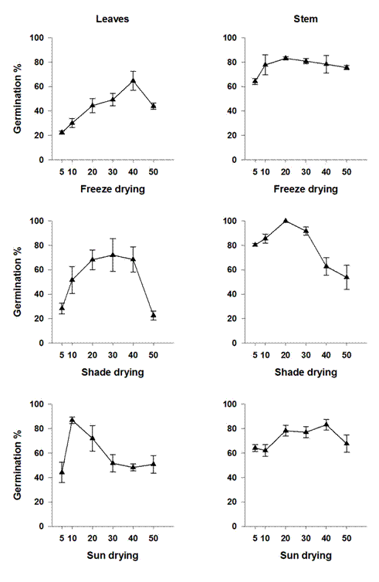
A
D
B
E
FF
C
Fig 1. Effects of Sesame powder on S. hermonthica germination. Vertical bars represent S.E ±

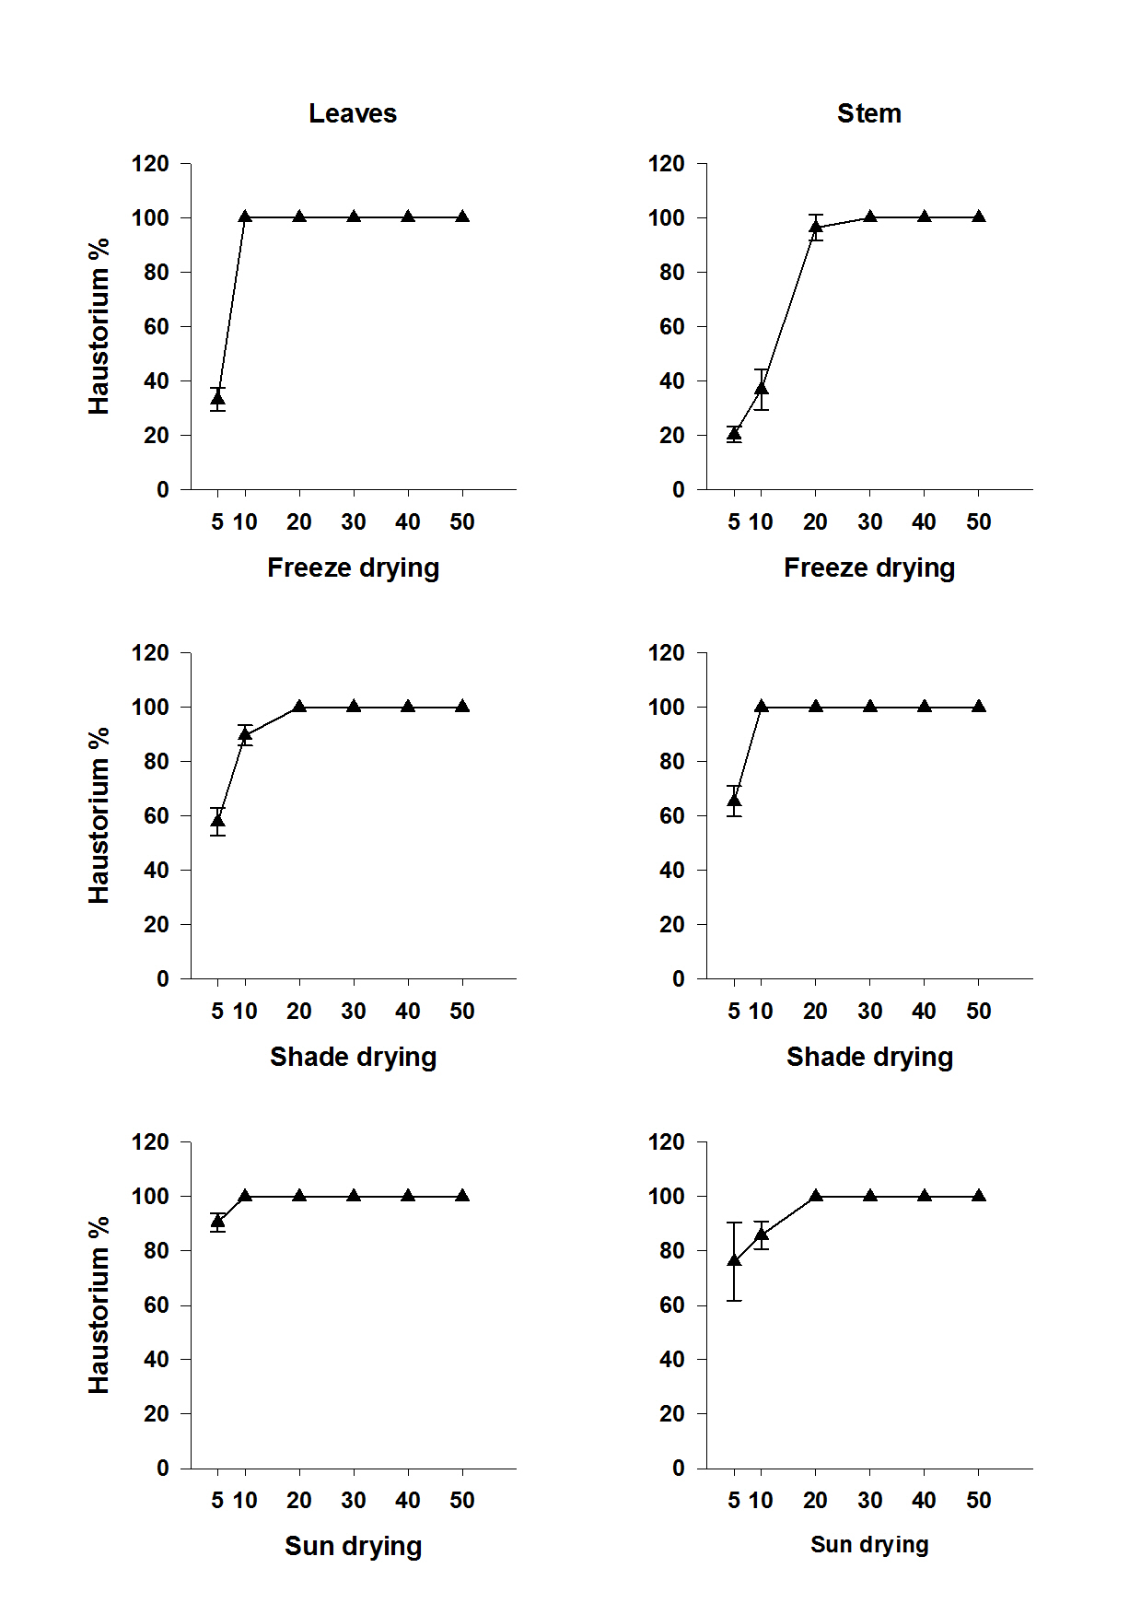
A
D
B
E
FF
C
Fig 2. Effects of Sesame powder on S. hermonthica haustorium initiation. Vertical bars represent S.E ±

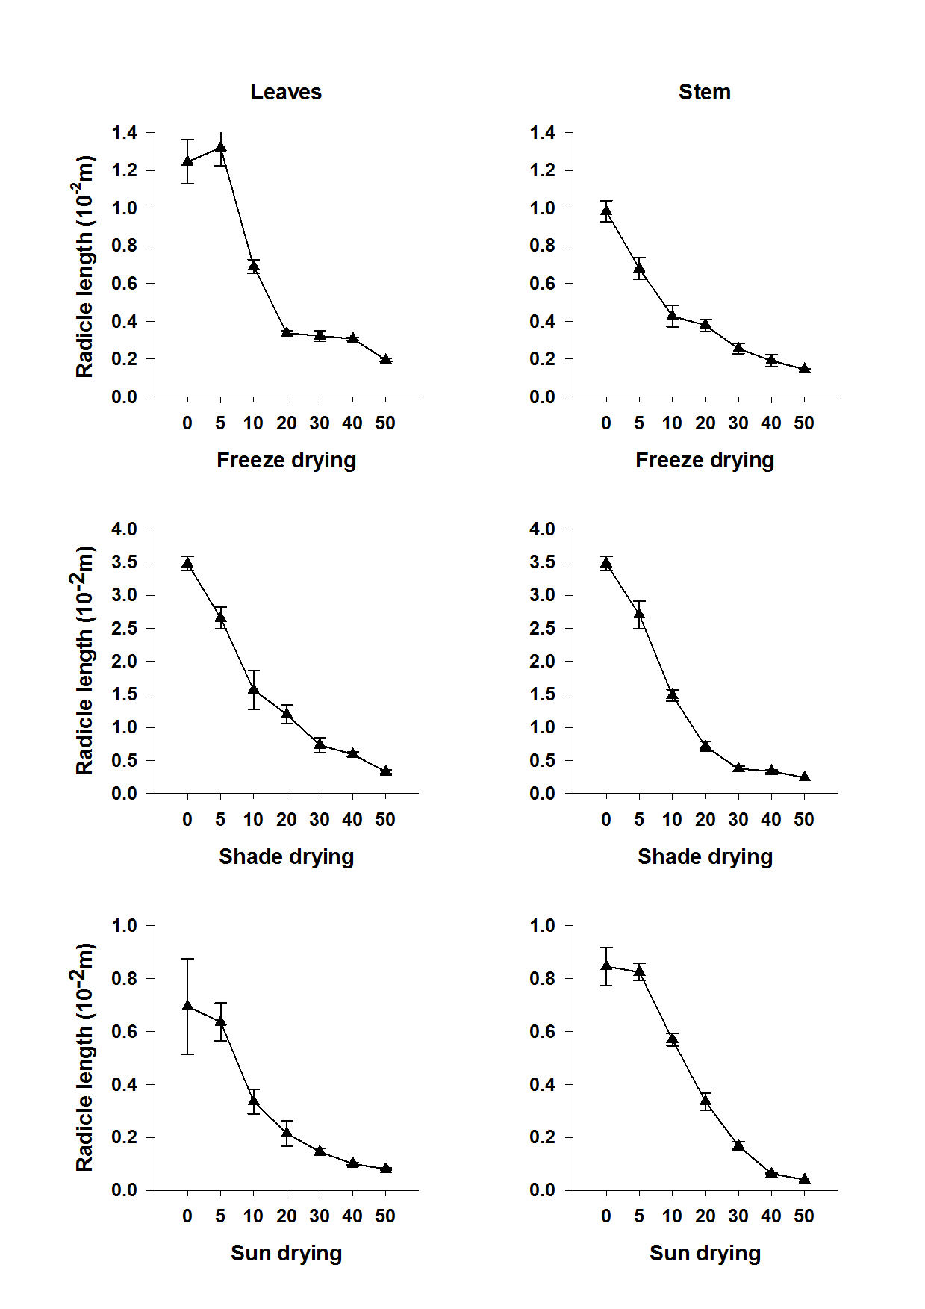
A
D
B
E
FF
C
Fig 3. Effects of Sesame powder on S. hermonthica radicle extension. Vertical bars represent S.E ±

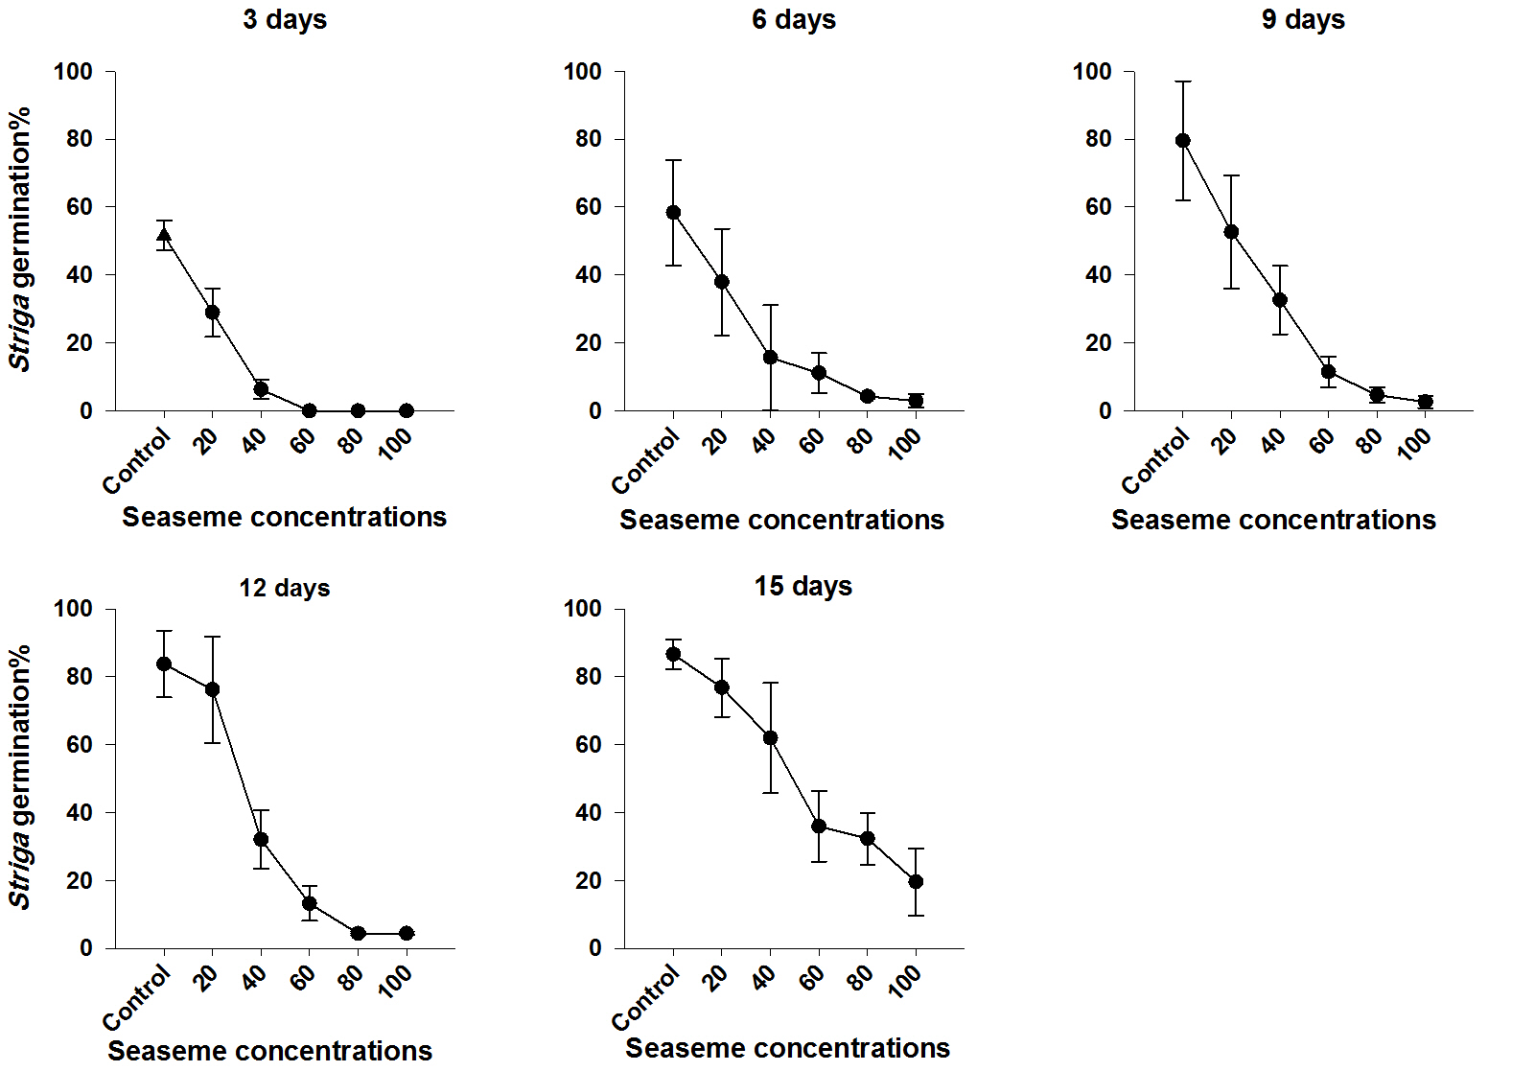
A
B
C
D
E
Fig 4. Effects of sesame aqueous extract applied during conditioning on S. hermonthica germination. Vertical bars represent S.E ±

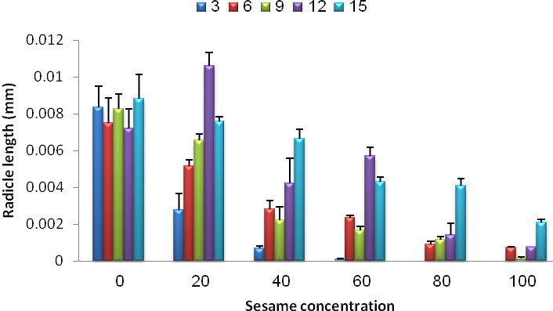
Fig 5. Effects of Sesame aqueous extract applied during conditioning on radical length of S. hermonthica. Vertical bars represent S.E ±

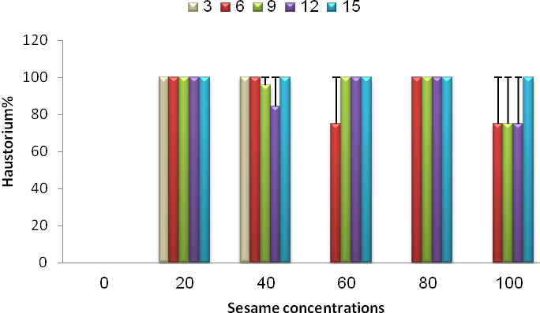
Fig 6. Effects of Sesame aqueous extract applied during conditioning on haustorium initiation of S. hermonthica. Vertical bars represent S.E ±

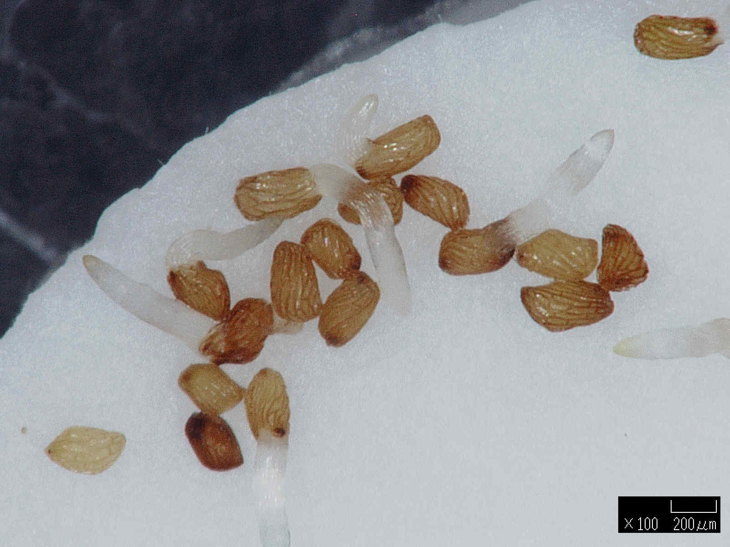
Radicle
Plate. 1. Sesame root exudates induced germination of S. hermonthica

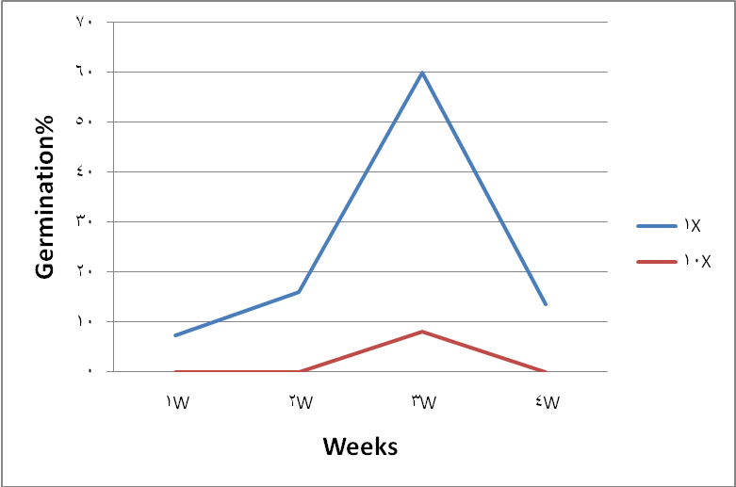
Fig.7. Effect of Sesame root exudates on S. hermonthica

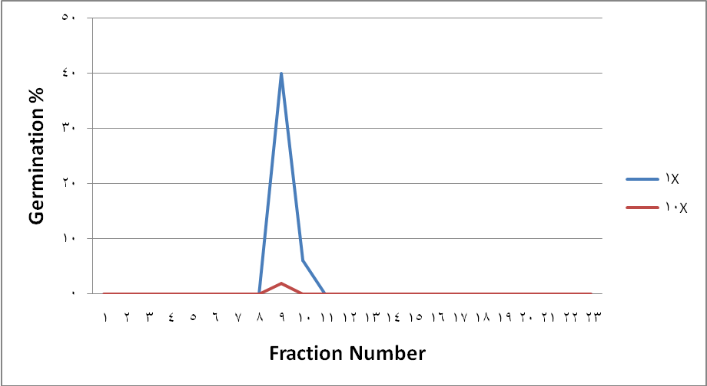
Fig.8. Effects of Sesame root extraction by Silica Colum Chromatography on S. hermonthica

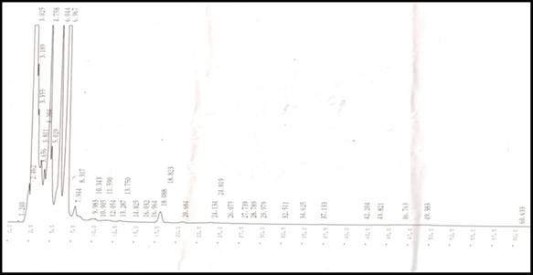
Fig. 9. HPLC chromatogram for the active fraction of sesame root exudates

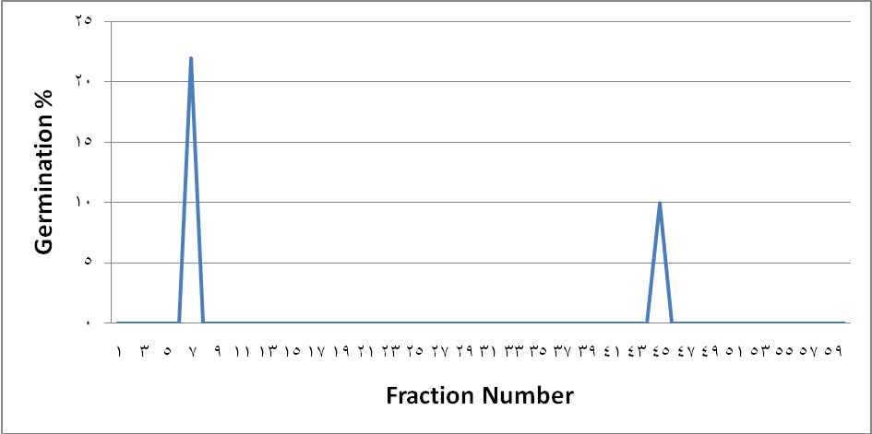
Fig. 10. Effect of sesame fractions collected by HPLC on S. hermonthica

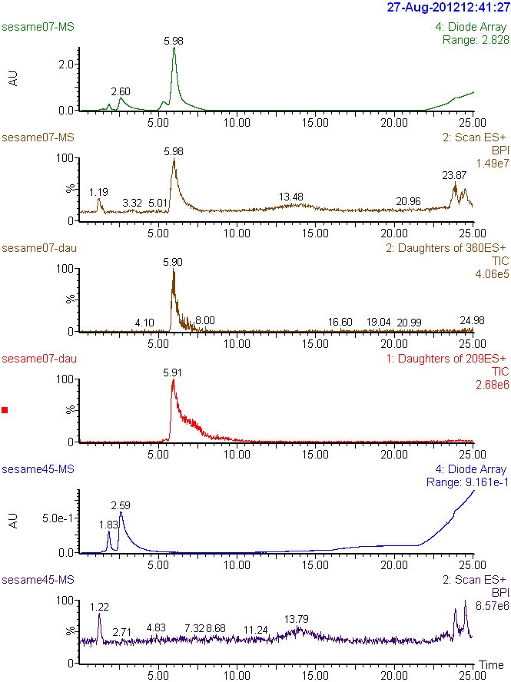
Fig. 11. LC-MS/MS analysis of the active fraction (7) of sesame

Fig. 12. LC-MS/MS analysis of the active fraction (45) of sesame

COMPETING INTERESTS DISCLAIMER:

Authors have declared that no competing interests exist. The products used for this research are commonly and predominantly use products in our area of research and country. There is absolutely no conflict of interest between the authors and producers of the products because we do not intend to use these products as an avenue for any litigation but for the advancement of knowledge. Also, the research was not funded by the producing company rather it was funded by personal efforts of the authors.

References

Babiker, A. G. T. (2007). Striga: The spreading scourge in Africa. Regulation of Plant growth and Development, 42: 74-87.
Babiker, A. G. T. Ahmed, E. A. Dawoud, D, A. and Abdella, N, K. (2007). Orobanche species in Sudan: History, Distribution and management.Sudan Journal of Agricultural Research, 10:107-114.
Bouwmeester, H. J; Matusova, R; Zhongkui S, Beale, M. H. (2003). Secondary metabolites signalling in host-parasitic plants interactions. Current Opinion in Plant Biology, 6: 358–364.
Fujii, Y; Parvez, S. S.; Parvez, M. M.; Ohmae, Y.; Iida, O. (2003). Screening of 239nmedicinal plant species for allelopathic activity using the sandwich method. Weed Biology and Management, 3: 233-241.
Hamad-Elneel, A. H. (2011). Integration of Cultural Practices For witchweed (Striga hermonthica (Del.) Benth.) Mangement in Sorghum. Ph.D Thesis Sudan University of Science and Technology. pp 121.
Khan, T.D., Hong, N.H., Xuan, T.D. and Chung, I.M. (2005). Paddy weed control by medicinal and leguminous plants from Southeast Asia. Crop Protection, 24:421–431.
Khan, Z. Midega, C., Njuguna, E. Amudavi, D., Wanyama, J. and Pickett,J.( 2008). Economic performance of the push-pull technology for stem borer and Striga control in smallholder farming systems in western Kenya, Kenya. Crop protection, 27(7):1084-1097.
Kim H Il, Xie X, Kim HS, Chun JC, Yoneyama K, Nomura T, Takeuchi Y, Yoneyama K. 2010. Structure–activity relationship of naturally occurring strigolactones in Orobanche minor seed germination stimulation. Journal of Pesticide Science 35: 344–347.
Ma, Y.Q., Lang, M., Dong, S.Q., Shui, J.F. and Zhao, J.X. (2012). Screening of some cotton varieties for allelopathic potential on clover broomrape germination. Agronomy Journal, 104:569–574.
Mahmoud E.A., Rezig A.A.M., Hassan M.M., Elslahi R.H., Ahmed M.M., Abiker R.E., Abusin R.M.A., Abdel Gani M.E., Babiker A.G.T. (2016). Cowpea (Vigna unguiculata) and bacterial inoculation: A plausible components of an integrated management strategy for the root parasitic weed Striga hermonthica on sorghum, Advances in Environmental Biology 10(7): 1-11.
Matusova R, Rani K, Verstappen, F.W.A, Franssen, M.C.R, Beale, M.H and Bouwmeester, H.J. (2005). The strigolactone germination stimulants of the plant-parasitic Striga and Orobanche spp. are derived from the carotenoid pathway. Plant Physiology, 139:920–934.
Muller, S., Hauck, C. and Schildknecht, H. (1992). Germination stimulants produced by Vigna unguiculata Walp cv Saunders Upright. Journal of Plant Growth Regulation, 11: 77-84.
Rezig A.M., Abdelhalim T.S., Hassan M.M., Abusin R.M., Eltayeb A.H., Samejima H. and Babiker A.G.T. (2016). Influence of cowpea root powder and exudates on germination and radicle length in Striga hermothica, sorghum and pearl millet strains. African Journal of Agricultural Research, 11(24): 2082-2091.
Rodenburg, J., Bastiaans, L., Weltzien, E and Hess, D. E. (2005). How can field selection for Striga resistance and tolerance in sorghum be improved? Field Crops Research, 93: 34-50.
Sato D, Awad, A.A, Chae, S.H, Yokota T, Sugimoto Y, Takeuchi, Y and Yoneyama, K. (2003). Analysis of strigolactones, germination stimulants for Striga and Orobanche, by high-performance liquid chromatography/tandem mass spectrometry. Journal of Agriculture Food Chemistry, 51:1162–1168.
Sato, D.; Awad, A. A.; Takeuchi, Y. and Yoneyama, K. (2005). Confirmation and quantification of strigolactones, germination stimulants for root parasitic plants Striga and Orobanche, produced by cotton. Bioscience Biotechnology and Biochemistry, 69: 98- 112.
Satoko, Y and Ken, Sh. (2009). Multiple layers of incompatibility to the parasitic witchweed, Striga hermonthica. New Phytologist, 183:180-189.
Xie, X. Yoneyama, T, and Yoneyam, K. (2010). The strigolecton story. Annual Review of phytopathology, 48: 93-117
Yoneyama, k, Ayman, A, Xie, X, Yoneyama, K and Takeuchi, Y. (2010). Strigolactones as Germination Stimulants for Root Parasitic Plants. Plant Cell Physiol. 51(7): 1095–1103.
Zhang, W., Ma, Y., Wang, Z., Ye, X and Shui, J. (2013). Some soybean cultivars have ability to induce germination of sunflower broomrape. PLoS ONE. 8:e59715.

