**Development and Characterization of transgenic pigeon pea (*Cajanus cajan* [L.] Millsp.) plants overexpressing *OsLecRLK* using *Agrobacterium* meditated genetic transformation**

**ABSTRACT**

|  |
| --- |
| **Abstract**  **Aim**: Pigeon pea productivity is affected by various types of abiotic stresses such as salinity, drought, high and low temperatures etc. Salt stress has become the major environmental constrain which leads to yield loses. Therefore, the development of salt tolerant varieties is the sole need of time and engineering crops to attain their maximum potential is the best option.  **Methodology**: In the present study, transgenic pigeon pea (cv. Manak) plants carrying *OsLecRLK* gene, has been developed for salinity tolerance by using a robust and efficient transformation protocol, called *inplanta* transformation protocol. *Agrobacterium* strain LBA4404 harbouring pCAMBIA1301 containing *OsLecRLK* gene was used for the transformation of pigeon pea (cv. Manak) using *Agrobacterium*-mediated transformation protocol for which patent has already been granted.  **Results**: Putative transformants were screened through PCR amplification using gene specific primers and 16 plants out of 86 plants were found positive giving a transformation efficiency of 18.6%. Higher yielding lines were selected and checked for stable transgene integration. Southern hybridization and Real-time PCR analysis was done to find out the copy no. of transgene in selected transgenic lines. Seeds from T0 pigeon pea plants were sown to raise T1 generation and further screened for the presence of *OsLecRLK* gene.  **Interpretation**: Transgenic pigeon pea plants were produced harbouring *OsLecRLK* gene with a rapid and efficient non tissue culture based transformation method with an efficiency of 18.6 %. This method can be used for transformation in other modal plants. Five out of six selected lines confirm single copy insertion through Southern Blotting and Real Time PCR, which is highly recommended in case of transgenic plants. |

**Key words**: *Inplanta* transformation*,* *OsLecRLK* gene, Pigeon pea, Real Time PCR, Southern Blotting,

**Introduction**

Drought/osmotic stress, salt stress and extreme temperature stress have been found to be the most devastating abiotic stresses for crops as far as the yield is concerned (Rani *et al*. 2021). Among these, salinity an important abiotic factor affects many parts of the world, especially irrigated lands limiting agricultural production in ~1000 mha (Kumar *et al*., 2021, Kumar *et al*., 2023). Pigeon pea, an important legume crop globally-sown in area exceeds 7.03 mha, with a production of 4.89 million tons and productivity of 695 kg/ha (FAOSTAT). More than 85% of world pigeon pea production and usage takes place in India (Singh *et al*. 2019). Most of the legumes are known to be salt sensitive and die before maturity in the field where salinity rises to 100 mM NaCl (Munns*,* 2002).

Plant growth and productivity is influenced unpropitiously due to a series of molecular, physiological and biochemical changes under salinity stress (Sharma *et al*., 2024). Salinity has an impact on crop production by causing water stress, ionic stress, oxidative stress, and nutritional instability (Kumar *et al*., 2016). Salinity causes osmotic stress, which leads to drought-like symptoms and ionic imbalance. Various genes are upregulated in response to high salinity stress, and their products are either directly or indirectly engaged in plant defence (Shivakumara *et al*., 2017). Overall, plant sensitivity or tolerance to high salinity stress is the result of a coordinated action of several stress sensitive genes that also interact with other components of stress signalling pathways. The intricacy and polygenic nature of salt stress makes breeding salt-tolerant crop cultivars challenging (Zhu *et al*., 2000; Flowers, 2004; Jangra *et al*., 2017). Traditional breeding has long been employed to generate stress-tolerant and high-yielding agricultural plants by screening resistant germplasm and crossing it with cultivated cultivars, but this technique is time-consuming, expensive, and labor-intensive and also suffers from poor selectivity due to the transfer of undesirable linked traits along with desirable traits (Ashraf, 2010; Yu *et al*., 2016). Furthermore, because of the reproductive barrier and the limited degree of genetic diversity in the genetic pool, it is a time-consuming procedure. To overcome the limitations of conventional breeding, biotechnology technologies such as genetic engineering can be used to get better outcomes in less time. Hence, it is necessary to develop tolerant varieties for abiotic stresses through breeding or genetic engineering methods for sustainable increase in production.

In India's dry and semi-arid regions, pigeon pea cultivation is very common and the physiological drought that results from elevated soil salt content has a significant impact on the crop's output. With dwindling agricultural acreage and inconsistent production processes, salt-affected soil restoration looks to be an economically tough endeavour. As a result, a likely approach would be to improve the plant genotype to make it more resilient to salt stress. Attempts have been made to instil resistance to salt stress in plants in order to fulfil the expanding food demand for the growing population. Molecular breeding tactics have been used in crop development initiatives for a variety of crops, including legumes like soybean and common bean, as well as attempts to enhance field pea. Genetic engineering and recombinant DNA technology can aid in enhancing pigeon pea plants' tolerance to salt (Bhatnagar-Mathur and Sharma, 2016). There aren't many studies in the literature on successfully transforming the salt tolerance gene in pigeon pea. There are reports of salt tolerance gene transformation experiments in rice, alfalfa, pea, *Glycine roja*, *Vicia faba*, and other plants. But, studies are limited in pigeon pea regarding salinity responsive gene being transferred successfully. Therefore, the development of transgenic pigeon pea with salinity tolerance will be more useful.

**MATERIALS AND METHODS**

**Plant material**

Dry and mature seeds of pigeon pea cultivar Manak were obtained from Pulses Section, Department of Genetics & Plant Breeding, CCS HAU, Hisar. This cultivar matures in 130-135 days and is tolerant to drought and wide range of temperature.

**Vector for transformation**

*Agrobacterium tumefaciens* strain LBA4404 harbouring pCAMBIA 1301- *OsLec-RLK* gene (Figure 1) was used for the genetic transformation. The strain is a binary vector carrying hygromycin and kanamycin-resistance and GUS marker genes.

**Obtaining stock culture and Isolation of plasmid DNA**

Stock culture of *Agrobacterium* strain was procured from the laboratory of Dr Narender K. Tuteja, ICGEB, New Delhi. *E. coli* DH5α cells were grown overnight in LB medium containing kanamycin (50μg/ml) at 37º C and 100 rpm in an orbital shaking incubator. Plasmid DNA was isolated from these bacterial cells using QIAprep® Spin Miniprep kit.

**Identification of the recombinant plasmid pCambia 1301 in the *Agrobacterium* strain LBA4404**

The *OsLecRLK* gene construct in pCambia 1301 was ascertained primarily by culturing the *Agrobacterium* strain LBA4404 in petri dish containing Luria-Bertani (LB) medium supplemented with streptomycin (50 µg/ml), kanamycin (50 µg/ml), rifampicin (50 µg/ml and agar (15 g/L). PCR amplification of the recombinant plasmid DNA and the bacterial colony was done using the transgene-specific primers to ascertain the presence of the gene construct in the *Agrobacterium* strain. The PCR amplified product was checked through 1.7% (w/v) agarose gel electrophoresis.

**Inoculum culture and preparation from stock culture**

The stock culture was initially streaked on LB agar plates containing streptomycin, kanamycin and rifampicin, each at a concentration of 50 µg/ml. The plates were incubated overnight at 28 °C. Inoculum culture for further studies was prepared in LB broth wherein a single colony from the LB agar plate was inoculated in 10 ml LB broth containing streptomycin, kanamycin and rifampicin - each at a concentration of 50 µg/ml.LB broth with the *Agrobacterium* inoculum was incubated at 28 °C and 120 rpm in an orbital shaking incubator overnight. O.D. of the culture was recorded at a wavelength of 600 nm.

**Agrobacterium –mediated transformation of pigeon pea with *OsLec-RLK* gene**

Pigeon pea seeds were surface sterilized with 0.1 % HgCl2 solution for 10 minutes. The seeds were then washed with sterilized distilled water multiple times so as to eliminate any traces of mercuric chloride. Post sterilization and washing the seeds were incubated in the *Agrobacterium* culture (O. D.= 0.6) overnight in an orbital shaker at 100rpm. The incubated seeds were washed with distilled water and transferred to potted soil.

**Isolation of Genomic DNA from putative transgenic plants and Screening of putative transgenic pigeon pea plants carrying *OsLec-RLK* gene**

Plants were raised in a transgenic greenhouse from seeds incubated with *Agrobacterium*.Genomic DNA was isolated from the young leaves of the putative transformed plants. *OsLec-RLK* gene specific primers (*OsLec-RLK*-F 5’-ATGGTGCTTCCCAAACCAGAAATGCCG- 3’′ and *OsLecRLK*-R 3’-TCATCTACCTCCAGAGAGGTCAGAGAA- 5’) were employed for screening the putative transgenic plants by PCR amplification. Genomic DNA isolated from putative transgenic pigeon pea plants (T0 generation) in C 1000 TouchTM Thermal Cycler (Bio-Rad, USA) for detection of transgene. PCR amplification was initiated with a primary denaturation at 94 °C for 5 min, followed by 40 cycles 94 °C for 1 min, 57.5 °C for 1 min and 72 °C for 1 min of denaturation, annealing, and extension respectively; lastly a final extension of 8 min at 72 °C. Plasmid DNA was taken as the positive control and genomic DNA isolated from non-transformed wild type pigeon pea plants were used as the negative control.

For Southern Hybridization, method reported by Khatodia *et al*. (2014b) was used. Using a Total Blot + nylon membrane, a Biotin Decalabel DNA Labelling Kit, and a Biotin Chromogenic Detection Kit, we were able to measure the amount of transgene integration and copy number in T0 transgenic plants (Fermentas, USA). The plasmid DNA was employed as the positive control, whereas genomic DNA extracted from non-genetically modified pigeon pea plants was used as the negative control. After being digested with Kpn1, the recovered genomic DNA was processed through an electrophoresis procedure on a one percent agarose gel and then deposited onto a Total BLOT+ nylon membrane. In order to hybridise with the target DNA, a PCR-amplified fragment of the OsLec-RLK gene was biotinylated using a Biotin Decalabel DNA Labelling Kit (Thermo Scientific) and then deployed as a probe. The hybridization was accomplished during an overnight incubation at 42 °C in the hybridization oven with minimum shaking. Using a Biotin Chromogenic Detection Kit and streptavidin coupled with alkaline phosphatase, the hybridised transgene was identified (Fermentas, USA).

**Determination of copy number of *OsLecRLK* using Real-Time PCR**

Transgene copy number in transgenic plants was determined by quantitative real-time PCR procedure also. Real-Time PCR was carried out in Step One Real-Time PCR Detection System. In this method, WT plant was used as negative control. The gene-specific primers mentioned in Table 1 were designed to amplify a 100-bp fragment of the *OsLecRLK gene and* were used employing SYBER Green 1 in Applied-Biosystems Step OneTM Real-Time PCR System using 96-well microtiter plates. The annealing temperature of 60 °C was used for these primers. Standard curve was generated using Real-time PCR which represented Ct values against log10. A linear curve was obtained with R2 (correlation coefficient) of 0.99 and efficiency 95.35 %.This standard curve was used to obtain transgene copy number in transgenic pigeon pea through regression equation.Standard curve was generated using different known concentration of the recombinant pCAMBIA1301. The template concentration was determined using ND-1000 Nano-drop spectrophotometer. The ABI 7500 Detection Software was used for data analysis and determination of threshold cycle (Ct). At the end of the elongation step of each PCR cycle the fluorescence of SRBR Green I was monitored. After amplification, a melting curve was acquired by heating at 95°C for 20 min with data collection at 0.2°C intervals, using ABI7500 software. The transgene copy number of unknown samples was determined by interpolation from standard curve Ct values generated using known amount of starting DNA concentrations.

**Results and Discussion**

**Plasmid DNA isolation and confirmation of the transgene:**

Competent *E. coli* DH5 cells were grown overnight in Luria-Bertani (LB) liquid medium with kanamycin (50 g/ml) at 37 °C and 100 revolutions per minute in an orbital shaking incubator after transformation with (pCambia 1301-OsLecRLK; see Figure 1A).

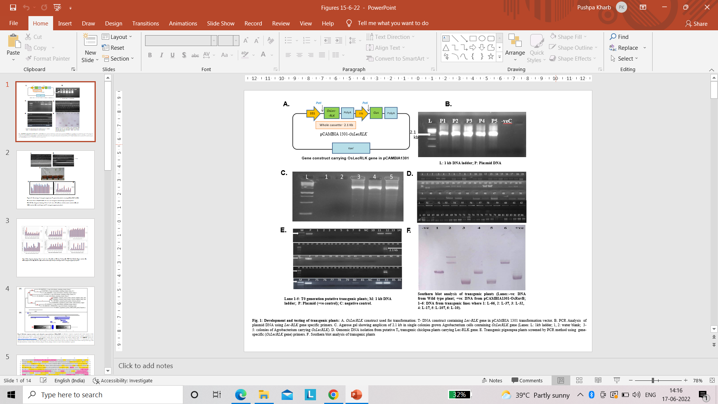

**Figure 1.** Development and testing of transgenic plants: A. *OsLecRLK* construct used for transformation, B. PCR Amplified plasmid DNA using *OsLec-RLK* gene specific primers. C. Agarose gel showing amplicon of 2.1 kb in single colonies grown *Agrobacterium* cells containing *OsLecRLK* gene (Lanes: L: 1kb ladder; 1, 2: water blank; 3-5: colonies of *Agrobacterium* carrying *OsLecRLK*). D. Genomic DNA isolated from putative T0 transgenic plants E. Agarose gels showing amplicon of 2.1 kb in transgenic lines, F. Southern blot analysis of transgenic plants Using a kit called QIAprep ® Spin Miniprep, the plasmid DNA was isolated from the transformed cells, and it was then amplified by PCR using OsLecRLK-specific primers. On an agarose gel with a concentration of 1.7 % (w/v), PCR products were fractioned. Presence of an amplicon of 2.1 kb proved the presence of thetransgene in the recombinant DNA vector (Figure 1B).

**Colony PCR for confirming the presence of the *OsLec-RLK* gene in recombinant *pCambia1301* in *Agrobacterium tumefaciens* strain LBA 4404**

The colonies of *Agrobacterium* grown on LB-agar plates containing kanamycin (50mg/µl), streptomycin (50 mg/µl), rifampicin (50 mg/µl) and the recombinant plasmid DNA were subjected to PCR amplification with primers for transgene only. The amplification of anticipated 2.1kb fragment proved the presence of the gene *OsLecRLK* in pCambia1301 and bacterialstrain LBA4404 (Figure 1C).

**Development and characterization of transgenic plants**

The genetically transformed pigeon pea plants (cv. Manak) carrying *OsLec-RLK* transgene were developed by using the transformation protocol developed by Kharb *et al* (2018); for which patent has been granted. These plants were further characterized as under:

**Genomic DNA isolation and Screening of putative transgenic plants**

Leaves were taken from putative transformed and non-transformed (wild type) plants and used for isolation of genomic DNA. The isolated genomic DNA and Lambda DNA (50 ng/µl) were also run on 0.8 % agarose gel for comparing the band intensity. Single discrete bands of isolated genomic DNA indicated that it was free from RNA and any mechanical or enzymatical degradation (Figure 1D). For detection of trans gene genomic DNA isolated from the T0 transformed plants subjected to PCR amplification using primers specific for *OsLecRLK* transgene. An amplicon of 2.1 kb resolved on 1.7% agarose gel electrophoresis confirmed the presence of *OsLecRLK*gene whereas, no such amplification was observed in non-transformed wild-type plants (Figure 1E). 16 plants were found to carry the gene of interest out of a total 86 transformed plants screened, representing a transformation efficiency of 18.6%.

**Determination of copy number by Southern Hybridization and Real-Time PCR**

To confirm the stable integration and copy number of the transgene in the T0 transgenic pigeon pea lines Southern Hybridization was performed by isolating genomic DNA (20µg) of transgenic pigeonpea plants followed by fully digested with *kpnI*, separated on a 0.8 % agarose gel, and then blotted on nylon membrane (McCabe *et al*. 1997). The PCR-amplified *OslecRLK* gene fragment (used as a probe) was eluted from the gel with the QIAquick Gel Extraction Kit (Qiagen Inc., USA) and labeled non-radioactively with Biotin, following the manufacturer's instructions (Biotin DecaLabel™ DNA Labeling Kit, Fermentas). The hybridized biotin-labeled probe on the nylon membrane was detected using the Biotin Chromogenic Detection Kit (Fermentas), adhering to the provided kit instructions. The genomic DNA from wild type pigeon pea plants was used as a negative control and plasmid DNA was used as positive control.

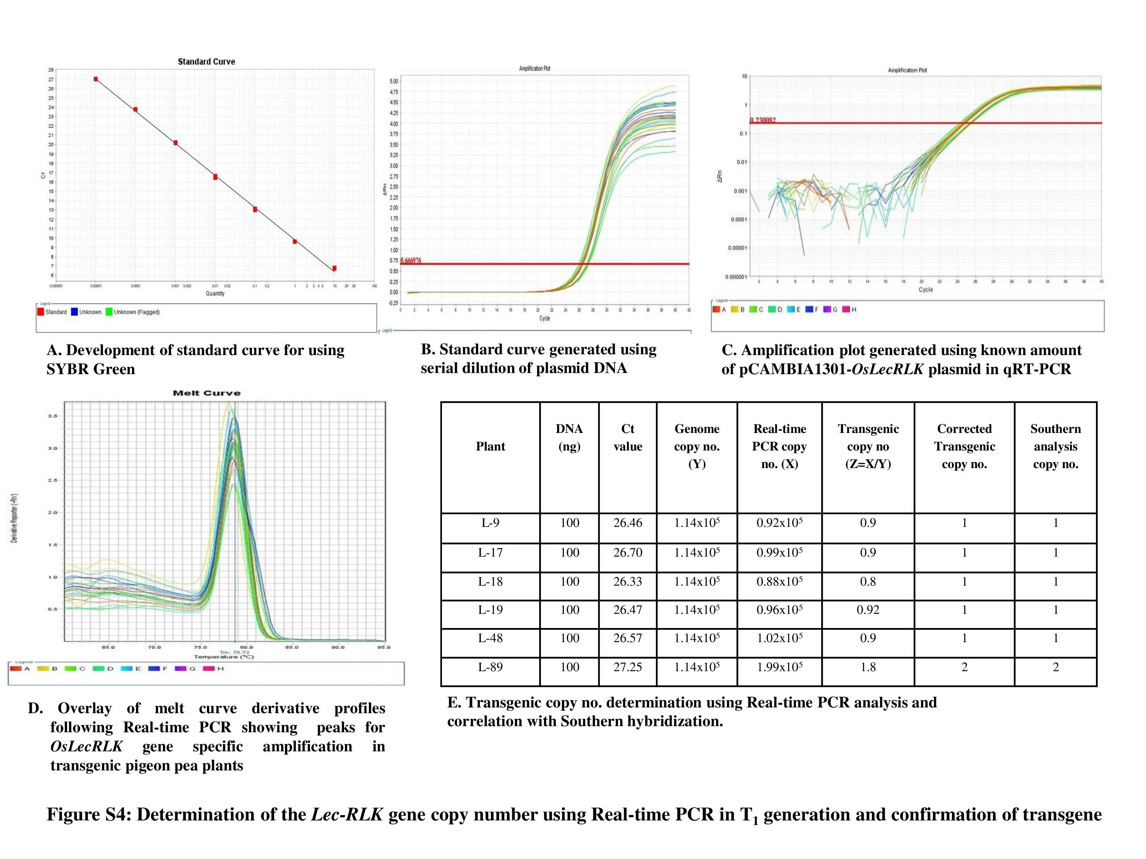

**Figure 2.** Determination of the *OsLec-RLK* gene copy number using Real-Time PCR in T0 generation and confirmation of transgene**.**

Transgene integration and copy number of transgene in transgenic pigeon pea plants was determined by simple quantitative real-time PCR procedure. Real-Time PCR was carried out in Applied-Biosystems Step One™ Real-Time PCR Detection System. Gene specific primers designed to amplify100 bp fragment (Table 1 ) for *OsLecRLK* gene were used to increase the specificity and sensitivity of the real-time PCR using SYBER Green 1 as described by Ahmad *et al.,* (2005). WT plant was used as negative control. Standard curve was generated using Real-time PCR which represented Ct values against log10. A linear curve was obtained with R2 (correlation coefficient) of 0.99 and efficiency 95.35 %. This standard curve was used to obtain copy number in transgenic pigeon pea through regression equation. For each sample a single peak obtained represented amplification of specific product. Results showed single copy insertion in five lines (L-9, L-17, L-18, and L-19 & L-48) and two copies of transgene in L-89 (Fig. 2 A-D). It was found that Southern hybridization results significantly correlated with the Real-Time PCR based method (Fig. 2 E).

Development of salt tolerant varieties is the sole need of time and engineering crops to attain their maximum potential is the best option. In present study, transgenic pigeon pea plants (cv. Manak) harbouring *OsLecRLK* gene for salt tolerance have been developed. The transgenic plants were screened and characterized by PCR, Southern hybridization and Real-time PCR analysis. Genetic engineering and recombinant DNA technology can help in improving salt tolerance in pigeon pea plants (Bhatnagar-Mathur and Sharma, 2016). Not many reports are there in literature for successful transformation of salt tolerance gene in pigeon pea. There are reports for transformation experiments for salinity tolerance genes in rice, alfalfa, pea, *Glycine soja*, *Vicia faba* etc. But only a few reports are there for stable and successful transfer of salinity responsive gene in pigeon pea. Therefore, it will be of greater application to develop transgenic pigeon pea with salinity tolerance. *Agrobacterium tumefaciens* is known to cause infection in plant species, but it is the best natural genetic engineer known so far**.** Scientists have explored its potential in developing transgenic plants from early 1980s. *Agrobacterium* method is preferred over other transformation techniques such as gene gun, electroporation etc. because of its several advantages such as higher efficiency, high carrying capacity, low copy no. insertion etc. (Komari *et al*., 2004; Nester, 2015; Karthik *et al*., 2018). The present study was undertaken with a major objective to develop transgenic pigeon pea plants carrying *OsLecRLK* gene for salinity tolerance. *Agrobacterium* strain LBA4404 carrying pCAMBIA1301 harbouring *OsLecRLK* gene procured from Dr. N. K. Tuteja, ICGEB, New Delhi was used to transform Manak variety of pigeon pea using *Agrobacterium*-mediated transformation method developed by Kharb *et al*. (2018). The transformation efficiency in the present study was 18.6%. Singh *et al*. (2020) reported the transformation efficiency of 35% for developing transgenic pigeon pea harboring *OsRuvB* gene for salinity tolerance. Khatodia *et al*., (2014a) and Jain (2014) reported 41% and 45% transformation efficiency for developing Bt-chick pea and Bt-pigeon pea respectively.

In present study, T0 generation transformed plants were screened for the presence of *OsLecRLK* gene by isolating their DNA (Fig. 1A) and then were subjected to PCR by using gene specific primers. An amplicon size of 2.1 kb was observed in both T0 and T1 generations. In T0 generation 16 out of 86 plants confirmed the presence of foreign gene *OsLecRLK*, indicating the transformation efficiency of 18.6 %. Stable integration and copy no. of transgenic plants was analysed through Southern hybridization and Real-time PCR. Six selected transgenic lines: L-9, L-17, L-18, L-19, L-48 and L-89 were subjected to Southern blotting and single copy insertion was obtained in five lines whereas, L-89 was having two copies of *OsLecRLK* gene (Fig. 1 E). Real-time PCR analysis was done to further confirm the integration and copy no. calculation of foreign gene. The data obtained through Real-time PCR analysis was compared and correlated with Southern hybridisation analysis and results were found consistent (Fig. 2 F). The work also demonstrates the utility of SBYR green in real-time PCR for counting the number of transgene copies in transgenic pigeon pea plants. The method for determining the copy number of a transgene disclosed in the current work is simple, dependable, and reasonably priced. It can be used to identify transgenes at the earliest stages of development. This SYBR Green-based assay employs gene-specific primers and has excellent sensitivity and accuracy for detecting the copy number in less time. Singh *et al*. (2020) and Preeti and Kharab (2019) reported stable transformation of *OsRuv*B gene in pigeon pea and chick pea respectively. They further analysed the integration and copy number of *OsRuv*B gene by Real-time PCR and Southern blotting and single copy of transgene *OsRuv*B was reported in five transgenic lines of pigeon pea and chick pea. Similar results of stable transgene integration have been reported by Khatodia *et al*., (2014b) and Jain *et al*., (2017) in Bt-chick pea and pigeon pea respectively using gene specific primers. They also studied the transgene integration and copy number by Real-time PCR and Southern hybridization analysis.

**Conclusions:**

From the results, it can be concluded that pigeon pea plants that have undergone *OsLecRLK* transformation could be able to impart better tolerance to salinity stress. Better plant growth, better management of plant activity, and increased yields under salt stress can all be facilitated by the transformation. Based on improved transformation effectiveness obtained in the current work, *OsLecRLK* integrated transgenic pigeon pea may offers more potential for studying plant physiology under stress and in other scenarios. Transgenic copy no. and integration was confirmed through Southern hybridization and Real-time PCR analysis in T0 generation. Transgenic lines L-9, L-17, L-18, L-19 and L-48 carried single copy insertion of gene whereas, line L – 89 was found to carry two copies of the transgene.

**Research content:** Transgenic pigeon pea plants harbouring *OsLecRLK* a gene for abiotic stress has been produced and have been characterized by PCR, Southern Blotting and Real Time PCR. These transgenic plants can be further analysed on physio-biochemical parameters.

**Ethical approval:** The above research followed ethical parameters.

**Consent to publication**: I Pratibha, the undersigned, give my consent for the publication of identifiable details, which can include photograph(s) case history and/or details within the text (“Material and methods”) to be published in the above Journal and Article.

**References**:

Ahmad, S., A. Wahid, E. Rasul and A. Wahid: Comparative morphological and physiological responses of green gram genotypes to salinity applied at different growth stages. *Bot. Bull. Acad. Sin.,* **46**, 135-142 (2005).

Ashraf, M.: Inducing drought tolerance in plants: recent advances. *Biotechnology advances*, **28(1)**, 169-183 (2010).

Bhatnagar-Mathur, P. and K.K. Sharma: Genetic transformation of pigeonpea: An overview. *Legume Perspectives*, **11**, 35-36 (2016).

FAOSTAT, http://www.fao.org/faostat/en/#data/QC 2017.

Flowers, T.J.: Improving crop salt tolerance. *Journal of Experimental botany*, **55(396)**, 307-319 (2004).

Jain, M.: Development and characterization of Bt pigeon pea (*Cajanus cajan* L. Millspaugh) plants for resistance against *Helicoverpa armigera* (Hübner). Ph.D. Thesis submitted to CCS Haryana Agricultural University, Hisar (2014).

Jain, M., S. Khatodia, P. Kharb P. Batra and V.K. Chowdhury: Determination of *Cry1Ac* copy number in transgenic pigeonpea plants using quantitative real time PCR. *Legume Research: An International Journal*, **40(4)**, 1-6 (2017).

Jangra, S., A. Mishra, D. Kamboj, N.R. Yadav and R.C. Yadav: Engineering abiotic stress tolerance traits for mitigating climate change. In: Plant biotechnology: recent advancements and developments (Eds.: S.K. Gahlawat, R.K. Salar, P. Siwach, J.S. Duhan, S. Kumar, P. Kaur). Springer, Singapore, pp. 59-73 (2017).

Karthik, S., G. Pavan, S. Sathish, R. Siva, P.S. Kumar and M. Manickavasagam: Genotype-independent and enhanced in planta *Agrobacterium tumefaciens*-mediated genetic transformation of peanut (*Arachis hypogaea* L.). *3 Biotech,* **8(4)***,* 1-15 (2018). doi:10.1007/s13205-018-1231-1.

Kharb, P., P. Batra and R. Singh: An efficient process of genetic transformation in pigeon pea using *Agrobacterium.* Patent Application No. 201811012099 (2018).

Khatodia, S., P. Kharb, P. Batra and V.K. Chowdhury: Development and characterization of transgenic chickpea (*Cicer arietinum* L.) plants with *Cry1Ac* gene using tissue culture independent protocol. *International Journal of Advanced Research* **2(8)**, 323–331 (2014a).

Khatodia, S., P. Kharb, P. Batra and V.K. Chowdhury: Real time PCR based detection of transgene copy number in transgenic chickpea lines expressing *Cry1Aa3* and *Cry1Ac*. *International Journal of Pure & Applied Bioscience,* **2(4)**: 100-105 (2014b).

Komari, T., Y. Ishida and Y. Hiei: Plant Transformation Technology: *Agrobacterium* – mediated transformation. In: Handbook of Plant Biotechnology (Eds.: P Christou and H Klee). John Wiley & Sons, Ltd Chichester, UK. (2004).

Kumar, P., P.K. Joshi, and S. Mittal: Demand *vs* supply of food in India - futuristic projection. *Proc. Indian Nat. Sci. Acad.* **82**, 1579–1586 (2016).

Kumar, A., Singh, S., Mukherjee, A., Rastogi, R. P., & Verma, J. P. (2021). Salt-tolerant plant growth-promoting Bacillus pumilus strain JPVS11 to enhance plant growth attributes of rice and improve soil health under salinity stress. *Microbiological Research*, *242*, 126616.

Kumar, R., Sagar, V., Verma, V. C., Kumari, M., Gujjar, R. S., Goswami, S. K., ... & Prasad, P. V. (2023). Drought and salinity stresses induced physio-biochemical changes in sugarcane: an overview of tolerance mechanism and mitigating approaches. *Frontiers in Plant Science*, *14*, 1225234.

McCabe, M. S., Power, J. B., de Laat, A. M., & Davey, M. R. (1997). Detection of single-copy genes in DNA from transgenic plants by nonradioactive Southern blot analysis. *Molecular biotechnology*, *7*, 79-84.

Munns, R., Salinity, growth and phytohormones. In: Salinity: environment-plants-molecules (Eds.: A. Läuchli and U. Lüttge). Kluwer Academic Publishers, Dordrecht, The Netherlands, pp. 271-290 (2002).

Nester, E.W.: *Agrobacterium*: Nature's genetic engineer. *Frontiers in Plant Science,* **5***,* 730 (2015).

Preeti, Kharab, P., 2020. Engineering chickpea variety HC-1 with OsRuvB gene for salt stress tolerance. *Legume Research-An International Journal*, *1*, p.6.

Rani, S., Kumar, P., & Suneja, P. (2021). Biotechnological interventions for inducing abiotic stress tolerance in crops. *Plant Gene*, *27*, 100315.

Sharma, M., Sorathia, K., Jayanthi, G., & Karthikeyan, K. (2024). Study on Plant Growth Promoting Traits of PGPR Isolates from Semi-Arid Kachchh, Gujarat under Salt Stress Conditions.

Singh, Y. P., Singh, S., & Singh, A. K. (2019). On farm abiotic stress management in pigeon pea (Cajanus cajan) and its impact on yield, economics and soil properties. *Legume Research-An International Journal*, *42*(2), 190-197.

Singh, R., Sharma, S., Kharb, P., Saifi, S., & Tuteja, N. (2020). OsRuvB transgene induces salt tolerance in pigeon pea. *Journal of Plant Interactions*, *15*(1), 17-26.

Shivakumara, T. N., Sreevathsa, R., Dash, P. K., Sheshshayee, M. S., Papolu, P. K., Rao, U., ... & UdayaKumar, M. (2017). Overexpression of Pea DNA Helicase 45 (PDH45) imparts tolerance to multiple abiotic stresses in chili (Capsicum annuum L.). *Scientific reports*, *7*(1), 2760.

Yu, N., L. Li, N. Schmitz, L.F. Tian, J.A. Greenberg and B.W. Diers: Development of methods to improve soybean yield estimation and predict plant maturity with an unmanned aerial vehicle based platform. *Remote Sensing of Environment*, **187**, 91-101 (2016).

Zhu, J.K.: Genetic analysis of plant salt tolerance using Arabidopsis. *Plant physiology*, **124(3)**, 941-948 (2000).